MLOps Introduction

MLOps is critical for anyone building and managing ML applications.
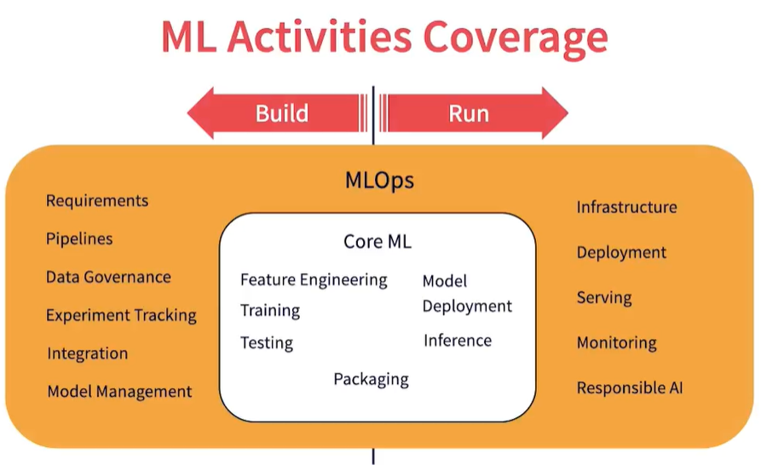

In Machine learning, we can divide the activities into Build and Run activities. Build activities focus on creating and testing the model. Run activities focus on deploying, executing and monitoring the model. Core ML activities include Feature engineering, Training, Testing and Packaging on the build side. Model deployment and Inference are the core activities on the run side. Surrounding these core activities is MLOps, which again can be split into Build and Run. For this part, we will only focus on the Build-side activities of MLOps. There are specific tools for MLOps on AWS, Azure and GCP

Machine Learning Life Cycle:
List of activities when building ML solutions
- Journey of an ML application
Concept => Model => Integration => Deployment => Improvements
It starts from the concept of the problem we are trying to solve, we build a model with training data, the model is deployed and used in production, then periodic improvements happen to the model over time.
ML lifecycle is a cyclic process, the process continues for multiple iterations depending upon the use case. Continuous refinements happen during the life of a model like new training data, new user requirements and model decay can also cause the model to be retrained and improved.

Machine Learning Life Cycle
It starts with requirements of the model charted by a product owner. The requirements are then used to design the workflow for executing the project. Training data is acquired and made available for machine learning. Feature engineering is performed on the training data to cleanse, transform and extract useful features. This is then used to train the model. Model goes through testing and evaluation. Model is continuously refined until desired performance goals are achieved. Model is then deployed for Inference and it is used to predict the business workflows. During Inference, more data is collected from the production deployments this is then labeled to create additional training data. New training data again triggers Feature engineering and Model training operations. The process continues in a cyclic fashion to keep the model optimized to accommodate business environment changes. We are not going to the process of building a model, but the ecosystem around this lifecycle.

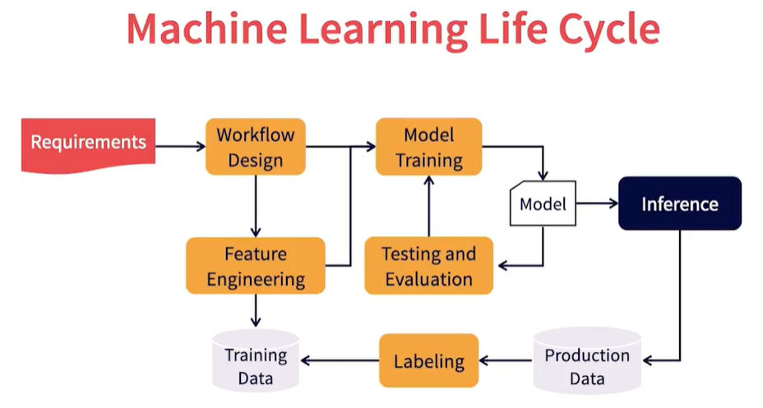

Unique challenges in building ML applications

Artifacts: An artifact is any entity that are created and/or consumed during a process.
Software engineering deals primarily with two types of artifacts: software code and records. Records are any documentation that are created or consumed during the process like requirements, design, test plans, test results, and acceptance results. Software lifecycle process deals with how the lifecycle of these artifacts are managed. During the lifecycle, artifacts are consumed and processed, and new artifacts are created.

Artifacts: Records like Requirements, and design that are used to create code. In turn, Code is used to create other records like test results. Software engineering process deals with Creation, Validation, Promotion, Change management and Governance of these artifacts. Various processes and tools are used in managing the lifecycle. Artifacts feed off each other. One artifact is the input to create another.

Artifacts for ML Engineering:
All ML products still require code to run in executables. ML has the same two artifacts: code and records. In addition, it requires two more artifacts: Data and Models. Data is training data that is used to build the models. Records like Requirements are used to prepare training data, this in turn creates records about processing status and errors. Requirements and training data are used to build models. The training process in turn creates records around training performance and results. The model is then integrated into code for creating executable binaries. Execution of the models in turn creates new training data. This metrics’ interdependence creates challenges in coordinating the lifecycle of these artifacts.

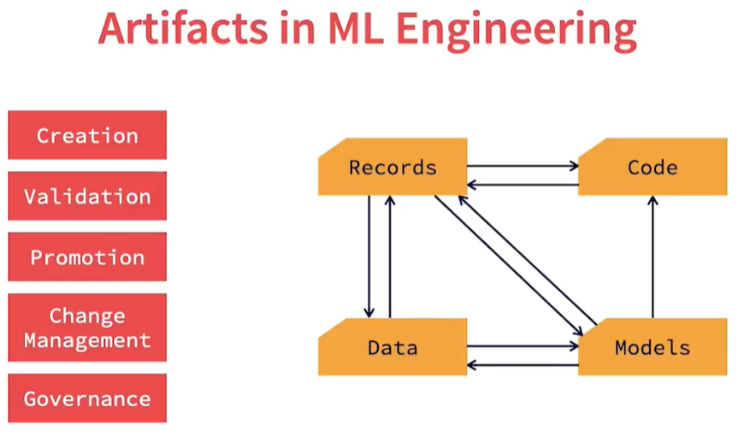

What are the Unique challenges in ML development?
Each artifact follows it own lifecycle but needs coordination
Managing collaboration between artifacts increases multifold
Needs for additional tools and workflows to manage and govern them
Each artifact needs a different sets of skills and teams to create and maintain.
There is a need for an integrated workflow to efficiently manage ML application development

What’s DevOps?
DevOps is the most popular software creation and delivery methodology that drives continuous development in an Agile fashion. It combines development, test, and operations of software into one integrated workflow. Rather than having them as separate entities, integration helps with faster iterations of software. It unites people, processes and technology into a seamless workflow. It uses agile principles, best practices and tools for optimal software development. It helps to drive continuous changes to software due to new requirements or issues and helps move these changes quickly into production. DevOps focuses on automation to improve efficiency.
DevOps cycle keeps iterating through the Sprints. Requirements are converted to code, built and tests. Release happens in an automated fashion, deployed in production. The software is operated and monitored. The performance of the software is fed back into the cycle to plan for more requirements. The cycle then iterates over the life of the application. Test, Develop and Operate activities overlap in DevOps while in traditional software development environments, they are done by separate independent teams. In DevOps, the same team manages all three of them. DevOps is the foundation of MLOps.

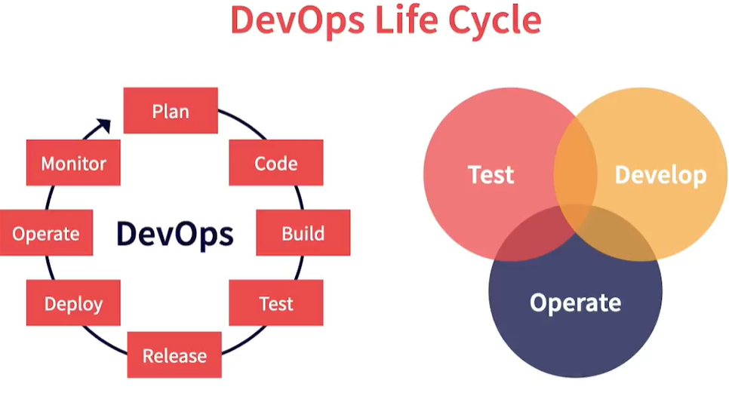

What’s MLOps?

