React Server Components

Create a new project using NextJs, recommended by React team to create projects
https://nextjs.org/

npx create-next-app@latest

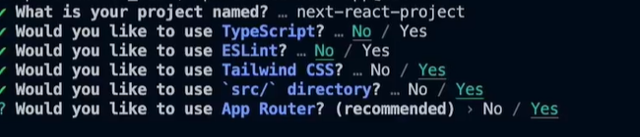
npm run dev

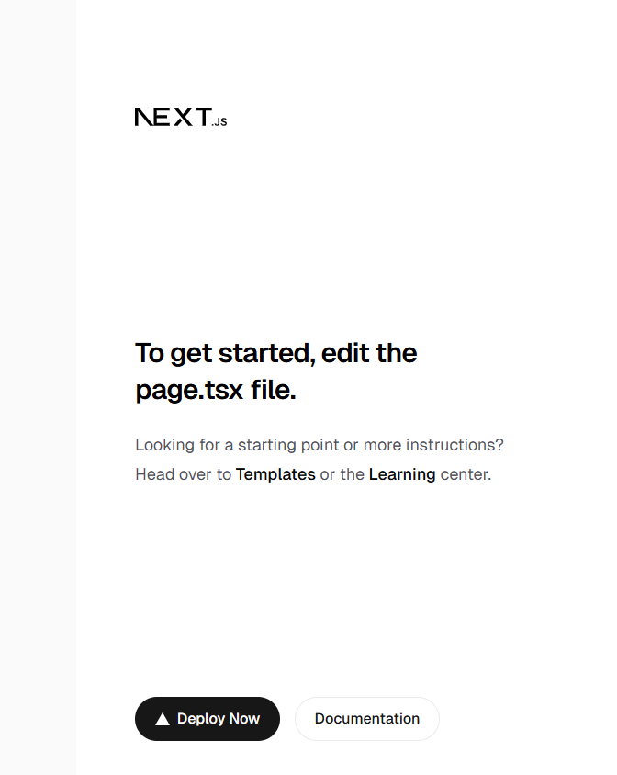

layout.js file is the metadata for the project

inside page.js file, the component we are going to render

In src/app, we are going to create all of the different routes that are part of our application. Whenever I create a new folder, it is going to create a new route for me. Within say mountain folder, I can create a new file called as page.js again.
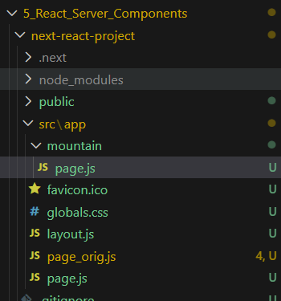

/mountain route
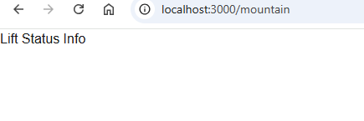

in layout.js, we can add any kind of component we like to

Create function Header(){ and import into RootLayout
When I click on Snowtooth mountain, it takes me to Home page
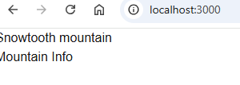

Click on Mountain Info, takes me to /mountain route
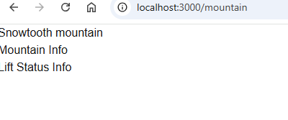

Create another folder “hotels” => page.js
function Header(){
return (
<header class="bg-slate-500 py-4">

py is padding in y axis

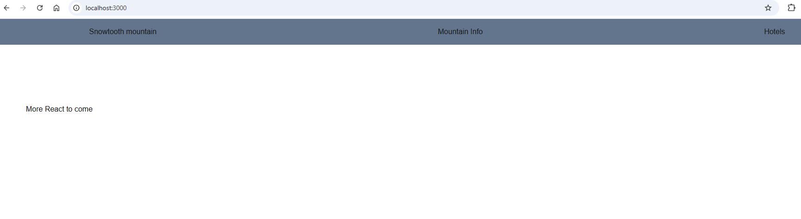
Challenge: Creating a Route!
Create a new route at /contact
Render a Page component at /contact
Test to make sure this is rendering appropriately
Extra credit: Add a link to the contact route from the Header

