Asynchronous React in Next.js

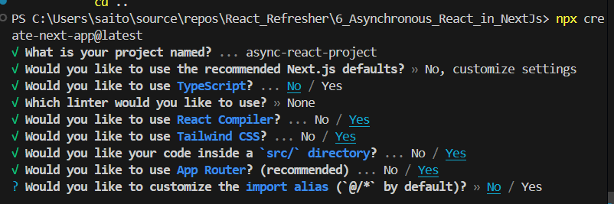

Fetch data from API
async function getData() {
const res = await fetch("https://snowtooth-api-rest.fly.dev");
if (!res.ok) {
throw new Error('Failed to fetch lift status');
}
return res.json();
}

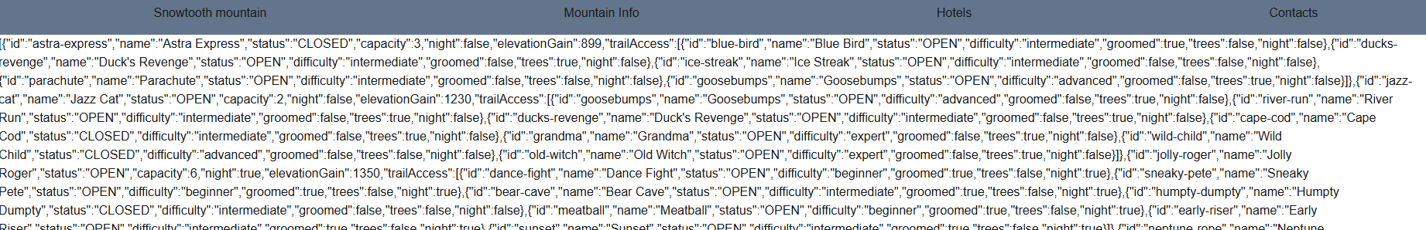
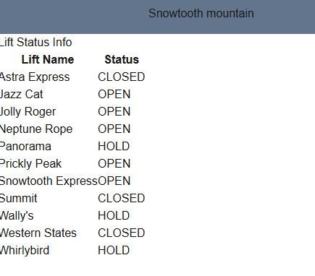

Modified Hotels
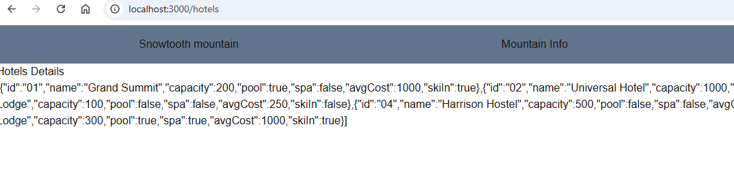
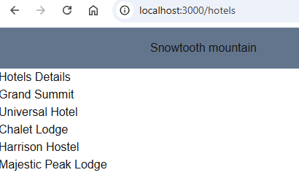

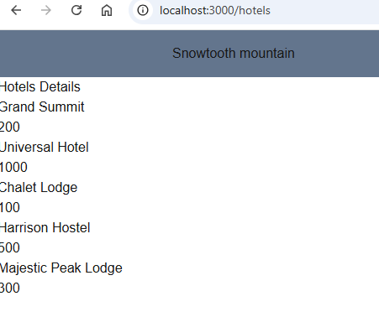

Display Client details using Client Component

Creating a Client component
Our HotelBlock is the Client component
Client component



Building a form
Typically we create the containers where the data would go then wire them, so everything works

Server actions are functions that can be executed on the server. These can be called from server components or client components to handle things like form submissions and other types of data mutations. We are going to put everything into the same file inside “contact” folder.
async function submitForm(formData) {
“use server”; // directive it is a server-side function that can be called from client-side code
}

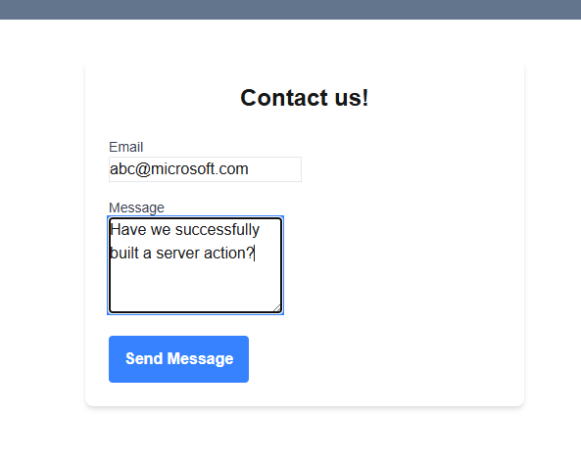

we see in the server console
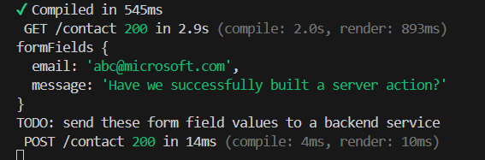

Next steps:
Next.js data storage – learning to store data in databases, Rest API, GraphQL APIs
React server components
Caching
Look into https://nextjs.org/docs for all these things mentioned above

