AI Code Review Agent

Go to GitHub Actions: https://github.com/SaiGit-source/SpringWebApp/actions
Create a Feature branch from main branch => make some code changes => push int Feature branch

Create a Pull request: https://github.com/SaiGit-source/SpringWebApp/pulls

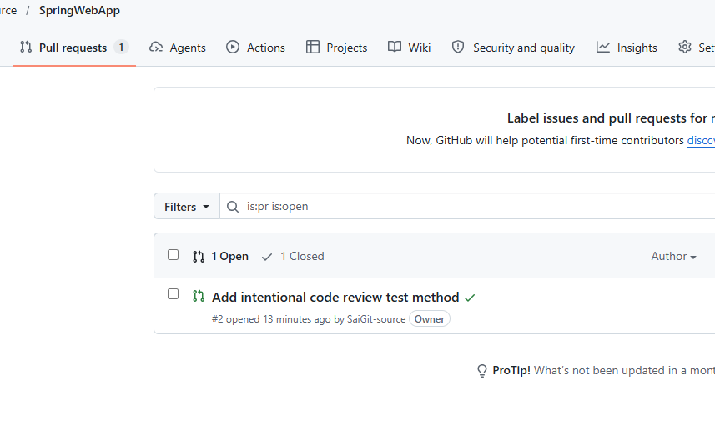

Go to Settings => Security and variables => Actions

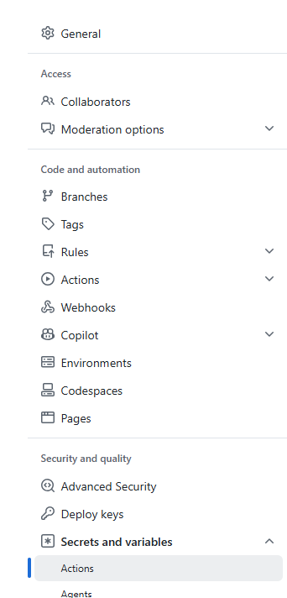

Go to Secrets/Actions: https://github.com/SaiGit-source/SpringWebApp/settings/secrets/actions

Add New Repository Secret => Add OPENAI_API_KEY

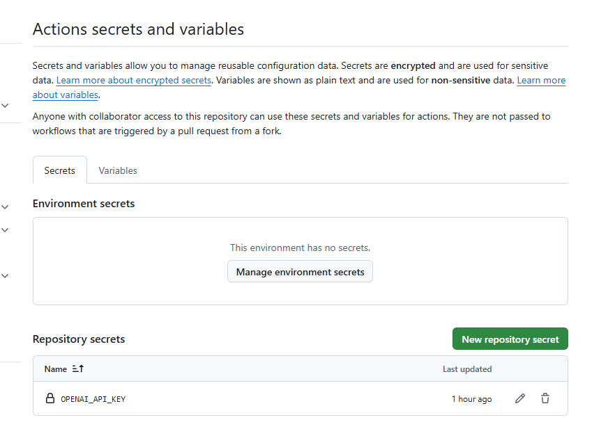

First test GitHub Actions

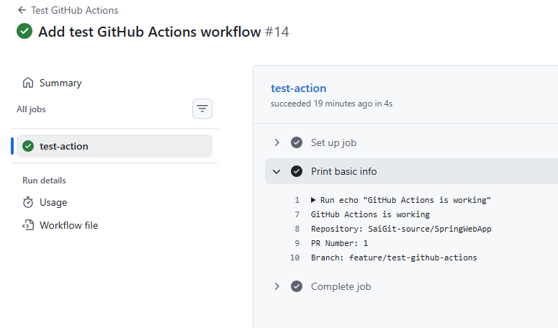

Second test GitHub API
It is able to fetch and read file differences from a PR
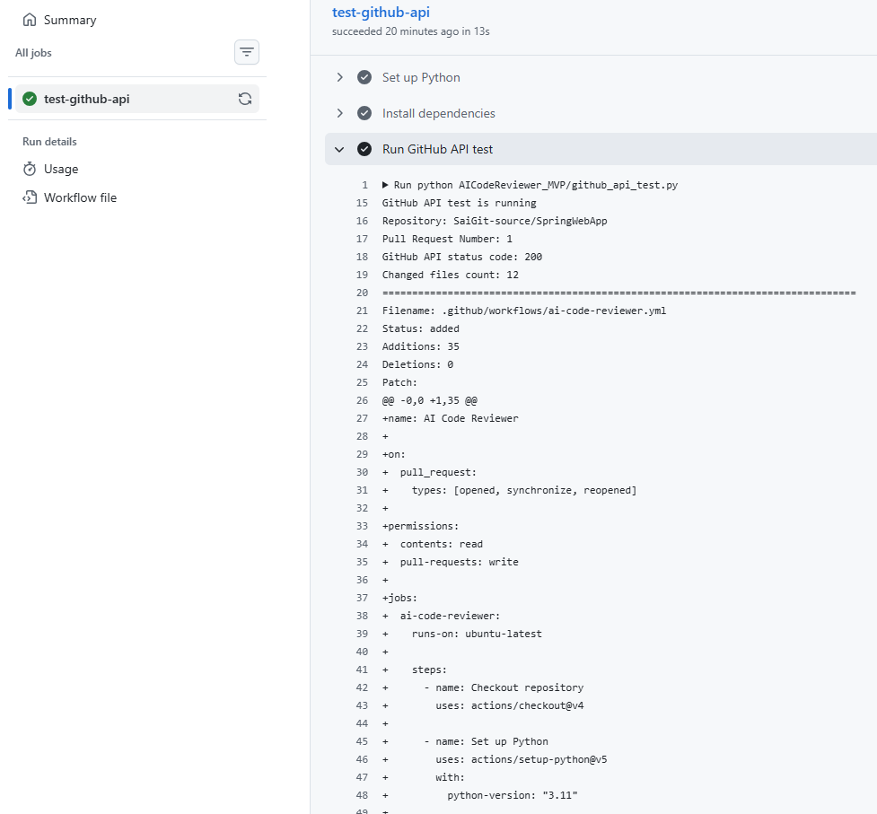

Third we tested LangGraph workflow with no Agents

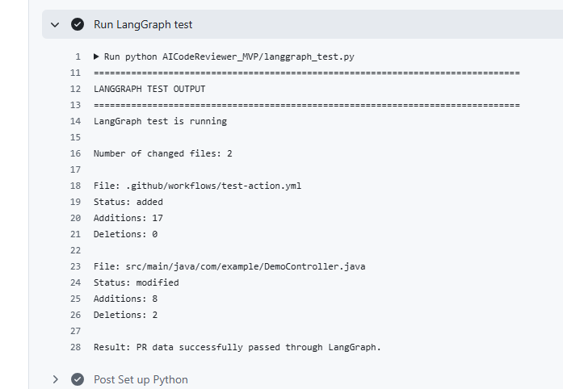
Last we tested AI Code Reviewer
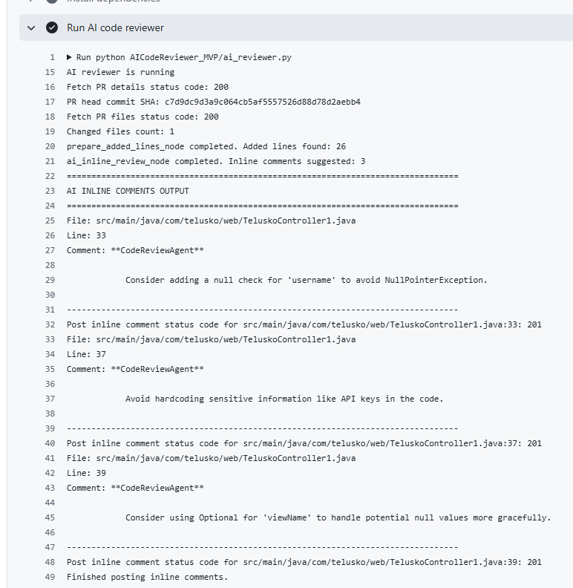

LangGraph workflow simple only for MVP

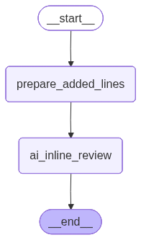

See our AI CodeReviewAgent is writing the PR Comments automatically

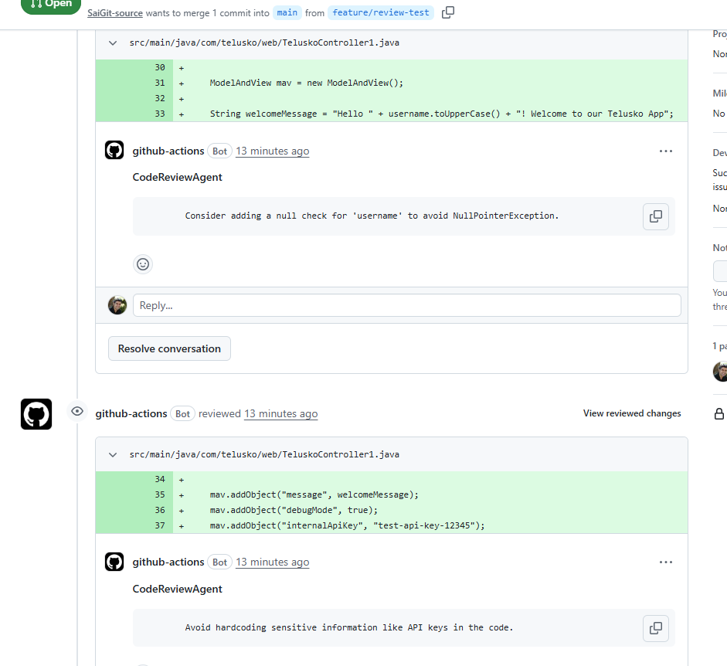

https://github.com/SaiGit-source/SpringWebApp/pull/2

