Replication1

Very important module for Distributed data

2 ways to improve Availability of Database
- Replication (Not splitting data but replicating/copying entire data into other machines)
- Partioning (Splitting data, part1 can be in Database1/Machine1, part2 can be in a different machine)

Replication means keeping a copy of data
Why?
- to avoid single point of failure
- for high availability
- keep the data nearby
- By increasing the instances of databases, we are increasing the Read throughput
- simple

Assumptions:
- Dataset should be small

We need some Replication method to keep our replications in sync and updated

Algorithms for Replication:
- Single leader:
User123 ----> Database. User123 wants to update their profile pic.
Update UsersTable
Set profile_url=’img.jpg’
Where UsersTable.id=123
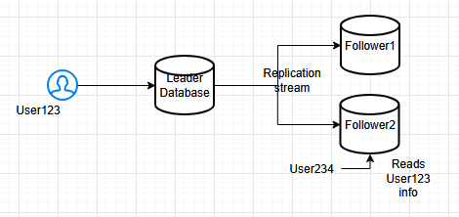
We update in Leader Database first then we send the same request to Follower1 and Follower2 to update their databases also. In other words, Write operations are replicated in Follower instances
Basically, all Write / Update / Delete operations are performed on Leader Database (Node) only (where values are changing) and for Followers, we will have only Read operations.
Lets say User234 is trying to see Profile pic of User123 from Follower2, in that case, Read can be performed on F2 also.
Select * from
UsersTable
Where UsersTable.id=123

Single leader:
- Write / Delete / Read

Follower:
- Only Read operations

Sync & Async
This is Async, we are not waiting for the Followers to respond
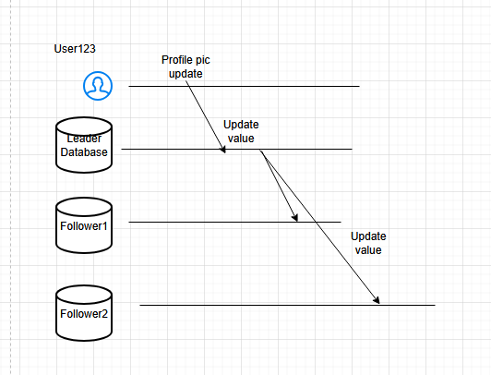
This is Sync replication method where we respond Ok back to the User only after the Followers have responded also
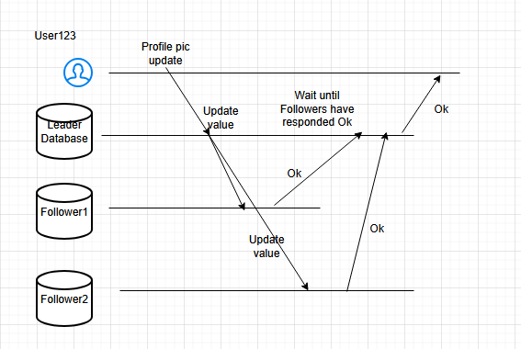

44:05

