Data models - NoSQL
Normalization and De-normalization of SQL --> this is the entrypoint to NoSQL

Normalization:
Breaking data into smaller chunks
User SQL
ID | Name | City
1 | ABC | NewYork

Order
ID | User.ID | Amount
1 | 1 | 1000
2 | 1 | 3000

If I de-normalize them

ID | User_ID | Name | City | Order_ID | Amount
1 | 1 | ABC | NewYork | 1 | 1000
2 | 1 | ABC | NewYork | 2 | 3000

We see that the User data is duplcated and redundant. Normalization removes redundancy

Advantages of Normalization: removes redundancy, ensures integrity of data is safe, easier to update

Disadvantages of Normalization: requries a join between tables, makes query complex, expensive

There are many reasons for choosing de-normalization over normalization:
Databases such as Cassandra, MongoDB where we require to perform high-level of analytics, or when we have to create cert-systems, high-rated systems, high-read systems. In these cases, de-normalized databases will work faster than normalized ones. In Normalized tables, we got to ‘Join’ first before ‘Select’ query. However, in De-normalized tables, we have one ‘Select’ query and it works much faster than working with the ‘Join’.

NoSQL databases:

Key-value database:
Say in cache and session, we save data in the form of key:value where key is unique (some ID), value can be anything String, JSON, Number, Blob, List, Object

Column database:

Student
ID | Name | Marks | Grade
1 | ABC | 90 | X
2 | XYZ | 91 | XI

We write values column-wise (left to right). We have different column fields like ID, Name they accumulate to create an entity. In SQL, read is left-to-right and in Columnar db, read is top-to-bottom.

Say we want to calculate Average marks in Grade X --> in SQL, it is scanned row-by-row, which is slow.
In Columnar database, the values are stored as columns with IDs. So it is fast to retrieve in terms of column. In Columnar database, we give importance to columns rather than rows.

Say to extract only Marks, they can be retrieved based on column Marks along with IDs
ID | Marks
1 | 90
2 | 91

In terms of reading data, it is great but in terms of writing or managing it could be a tedious job
Because it is NoSQL, we can write a JSON ({‘X’:10,…}) as well instead of say ‘10’ in Marks

Graph DB

Student s1, s2, s3, University u1, u2, u3, Professor p1, p2, p3, p4

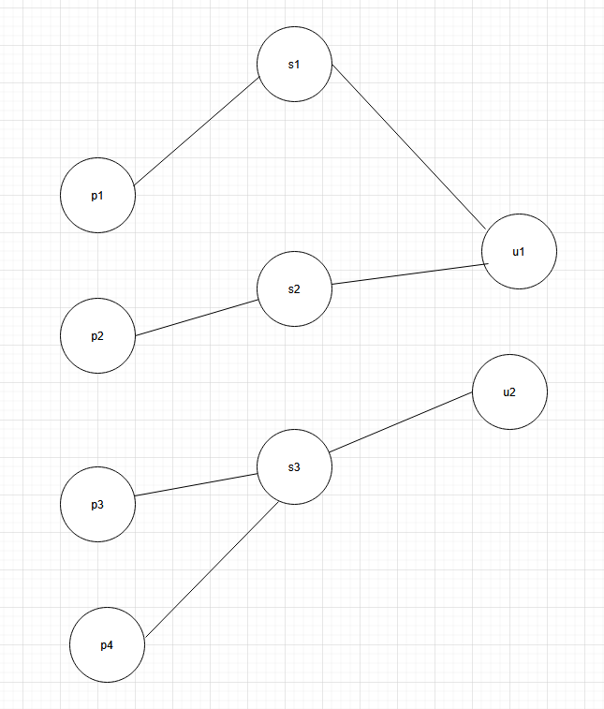
Say Professor p4 teaches Student s3 at University u2. Say from p3 we can go to p4 because they are teaching at the same university. No connection between p2 and p3.
Say a situation, all students like s1 are dropping out of University u1. So could we blame on Professor p1? answer is no, we need more information like recent incidents at u1 etc
Disadvantage of Graph is, it gets complex when we have large amount of data
It is used highly in data science to analyze the patterns of the current workflow and to predict the future workflows.
For graphs, we have other query languages: Gremlin, SparQL, Cypher
Con: Complexity, Slow if root is too far, Risky

Document DB:
This is the most popular NoSQL DB
Example: MongoDB, Cassandra, CouchDB
Advantages:
- We can save any kind of value that means flexible in nature,
- Dynamic schema,
- Stores it value in JSON format,
- Fast retrieval,
- Easy to understand,
- Easy to scale vertically also because we don’t have to maintain any relations like 1:M,
- We need to migrate only one single system

Disdavantages: Again complexity,

JSON object
{ ‘_id’: ‘234’,
‘name’: ‘Abc’,
‘address’: {
‘city’: ‘NewYork’,
‘state’: ‘NY’,
}
‘skills’:[“Python”, “Java”, “SQL”]
}
{ ‘_id’: ‘323’,
‘name’: ‘xyz’,
}

In the next _id, I have entirely different keys and data.
Say we are a new startup and growing then we decide we don’t need to store Employee fax number or personal email, we can remove on the go. It is very flexible
Usecases: UserProfile, Analytics

54:20

Map Reduce

