Understanding Cache

What’s cache? Why do we need cache?
Say we have a client trying to reach Backend App code then a database, we want something in between to communicate faster. We need a latency-free kind of a system. For that we use cache. When we call our database for every query, then the latency will go up. Also, it latency goes up too much, the database might crash. To protect database, we use cache. There are different ways we can apply cache to our system.
Cache is a small unit in which we store the data, which is used repeatedly. We could have client-side cache (repeatedly used values in the browser, we can store on the client-side cache). Second option is to have a cache between database and Application-code, only if data is not there in the cache we will do a call to the database.
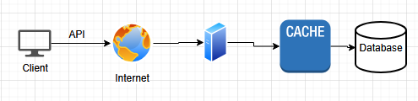
There is also CDN: Content-Delivery Network, stores static data
Static data like Images, Static text, Video
Sometimes, we store only certain length of the video in cache and only if user crosses that length, we pull from CDN
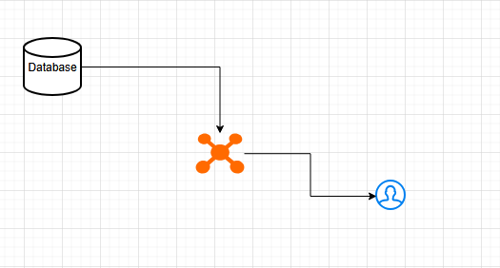

Lets say a new episode of a TV series is getting uploaded into main server, maybe the main-server is in France etc. Every CDN should get updated with the latest information.

There are different strategies that are applicable to cache, are applicable to CDN also, in some cases. If one CDN server is down, then our request will be re-directed to another CDN
YouTube video

ID | Thumbnail | Text | Videos
1 | CDN server URL (Image) | YouTube desc | CDN server URL

30:00

Cache stores data, CDN stores content. CDN is a data center

Cache can be implemented on the client-side or server-side
PDP - Product Display Page
CL


<- Home / Men / Shirt

Black Shirt
-Features
$10
Add to cart
Lets say, we have CL as the clothing brand
On this page, what are the things we want to cache and what not to cache. So, when UI talks to Backend, we are only getting from Cache not Database that means data in the UI will be static for sometime.
What are the things we currently have on the page?
Image --> is it going to rapidly change or not? NO then Yes it can be cached
Name --> Yes can be cached
Reviews --> No it should not be cached because Reviews keep on changing according to customers
Features --> Yes can be cached
Price --> No price cannot be cached
Couple search box --> No don’t cache
Add to cart button --> it contains the link to cart so it can be cached
S3 bucket is usually cached

Cache: why do we need cache?
Fast storage

Caching strategies:
Cache terminologies:
- Cache hit --> Whenever we try to find data in cache and if we find it then we don’t need to go database and this is called as the cache hit.
Application --> AppCode --> Cache --> Database

- Cache miss --> Opposite of Cache hit, it application cannot find the data in cache then it needs to go fetch the data from database. That means, cache is missed. Not necessarily, data not present is a system failure, it could be a cache miss by design itself. For example, we are not storing Price or Reviews in cache by design.

- TTL (Time To Live) --> As a System designer, we decide for how long the content should remain in the system and that time, then it should be evicted from the cache. Say we want to update the cache every one minute. Whenever we delete the data in the database, we should know how long our cache should hold that data. For a clothing brand, a campaign runs for 3 or 4 months, it is safe to say after 3 months the cache should get cleared.

- Latency --> Whenever user is sending some request, how long our system takes to respond back. If our Backend is pulling data from cache then it can work fast

Caching eviction policies: when data will be deleted from cache
- LRU (Least Recently Used)
The data that was not used recently will be removed.
- MRU (Most Recently Used)
- LFU (Least Frequently Used)

59:00

