Replication3:

Replication Lag
We update Leader on time then to update Follower nodes, there will be some time-lag. This is Async, we respond Ok to User after updating Leader only

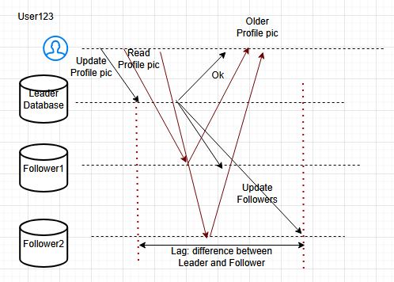
We cannot avoid LAG, it will happen and somehow we have to manage it. We don’t want users to see the older data. Lets discuss some approaches to fix these issues

-- Read Your Own Write:

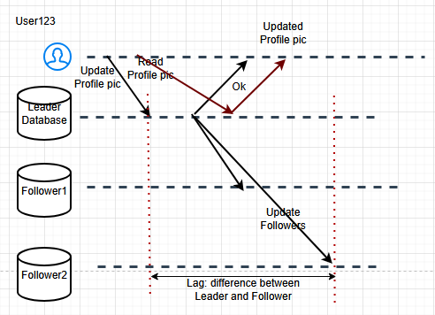
Read operation will go to the Leader only so this will fix the issue and the User always sees the Updated pic. When we have more Read operations than Write, we can implement this.
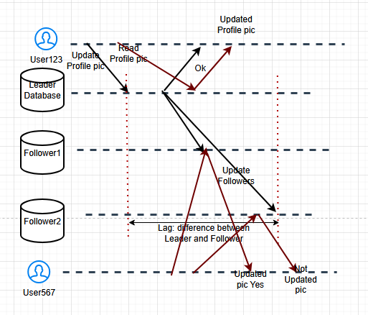
User567 can see the Updated pic of User123 at point1 not point2. Still it is considered as Ok.
We could have a hybrid approach also, say we will read from the Leader only if the User updating the value is seeing the value. For other users, we can read from the Followers.

Read from Leader:
- Always updated
- In Write-intensive Application, our Leader could break

-- Queries via Timeline:
Whenever the Leader is updated, we will create a Timestamp at that time and we will see whether there is any updation in our Followers between the Timestamp and time of User567 checking.

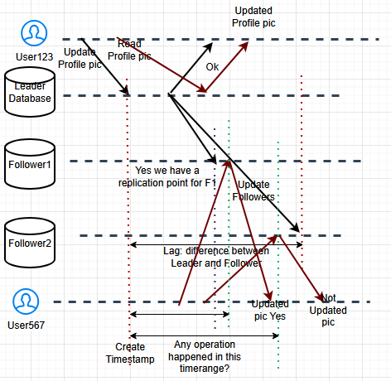
Yes there is a Replication point within the timeline for F1 but not for F2. that means, User567 can read from F1 and not F2. this is Query on Timeline approach. We will allow User to read only if replication point is present within the timeline.

-- Redirect our query to next node:
40:10

