NIGHT SIGNALS / 2026
Sleep, Doomscrolling
and the Night
How late-night scrolling, negative news, and protective routines relate to sleep quality across 1,000 respondents
DATA ANALYSIS REPORT • 29 analytic variables • 11 report figures

47.6%  DOOMSCROLLERS | +10.6 min  LATENCY GAP | 11 / 204  HEAVY-SCROLLER EXCEPTIONS

Prepared from sleep_doomscrolling_habits.csv | Observational synthetic-data analysis

☾ | Executive summary  The answer first: the strongest signal is the bedtime disruption chain

Doomscrolling is consistently associated with a harder night in this dataset. Respondents labeled doomscrollers take longer to fall asleep, wake more often, carry more weekly sleep debt, and sleep slightly less. The clearest continuous marker is bedtime screen time, which rises alongside latency and disruption.
The relationship is not destiny. A small set of heavy scrollers still report good sleep, and they more often pair their exposure with restorative routines, longer realized sleep, and lower debt. That counter-pattern is important because it shifts the practical question from ‘Who scrolls?’ to ‘What surrounds the scrolling?’
10.6 min  LONGER LATENCY | 1.5 h  MORE WEEKLY DEBT | 15 min  LESS SLEEP NIGHTLY

- Mental load compounds behavioral exposure: doomscrolling plus negative-news consumption aligns with the highest anxiety, stress, and fatigue averages.
- Reading, meditation/journaling, a phone outside the bedroom, and regular exercise show more protective patterns than night mode alone.
- Behavioral variables predict sleep-quality category more strongly than most demographics, although subgroup context still matters for targeting.
- The data appear synthetic or simulation-assisted; findings are descriptive, non-causal, and should not be generalized as population prevalence.
01  CORE  Exposure → latency → wakeups → debt | 02  MIND  Negative news compounds mental load | 03  SHIELD  Routine and environment appear protective | 04  EDGE  Exceptions show risk is not destiny

HERO FINDING

More scrolling shifts the night toward poorer sleep
Nightly doomscroll load combines session count with average session duration. Poor sleepers sit noticeably farther to the right, but the scatter also reveals overlap and exceptions—useful evidence that risk accumulates without becoming deterministic.
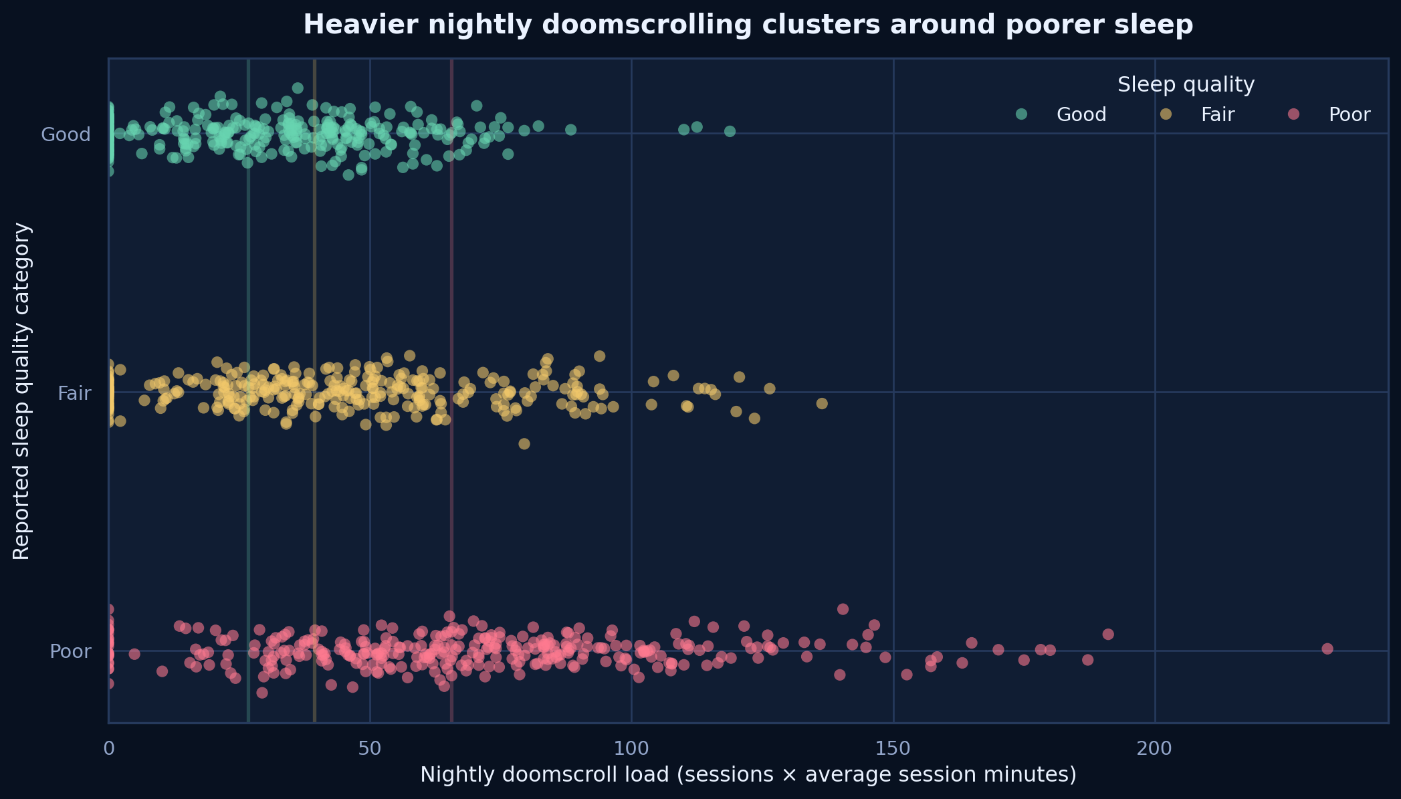
Figure 1. Nightly doomscroll load by reported sleep-quality category.
READ THIS
Poor sleepers carry the highest median nightly doomscroll load; good sleepers cluster lower, with meaningful overlap.

▣ | Core relationship  Q1–2 | Sleep quality, latency, wakeups, duration, and debt

Across five outcomes, the doomscroller label points in the same direction: longer latency, more wakeups, more debt, shorter sleep, and greater fatigue. Consistency across outcomes strengthens the descriptive story, even though shared causes—stress, habit intensity, or chronotype—may explain part of every gap.
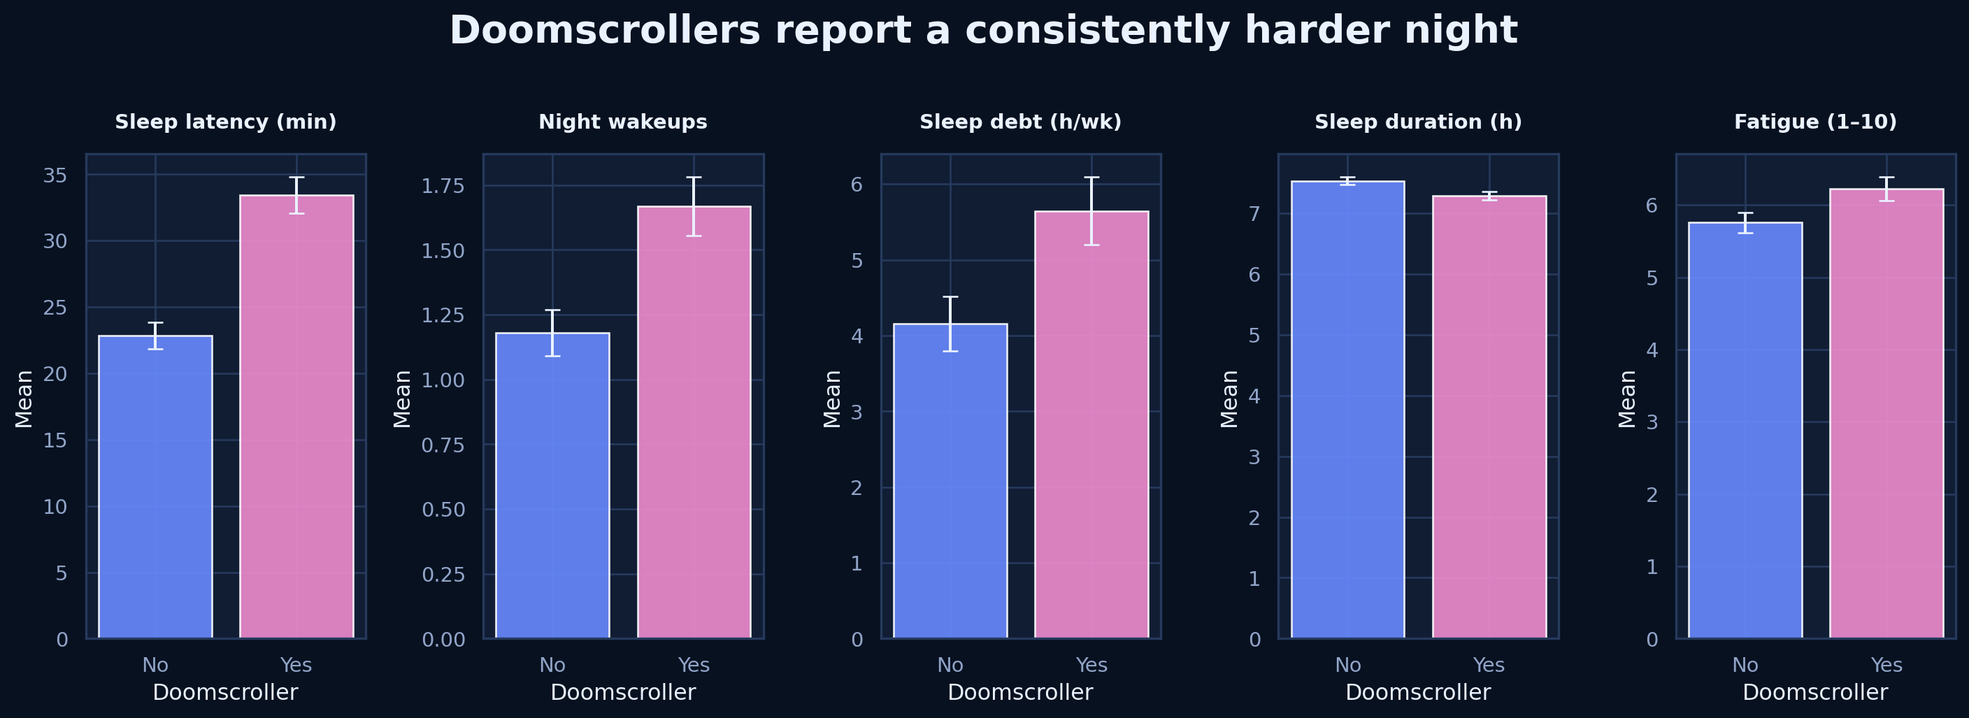
Figure 2. Mean sleep outcomes for doomscrollers and non-doomscrollers; error bars show approximate 95% confidence intervals.
READ THIS
Doomscrollers average 10.6 extra minutes of latency and 1.5 additional hours of weekly debt, plus more wakeups and fatigue.

PULL QUOTE
The night does not break in one place—it stretches, fragments, and leaves a daytime trace.

DOSE RESPONSE

Bedtime exposure matters beyond the binary label
Quartiles reveal a graded pattern: the higher the bedtime screen exposure, the longer respondents take to fall asleep and the more sleep debt they carry. The same direction appears in wakeups and sleep duration, suggesting that the binary doomscroller label compresses a richer dose-response relationship.
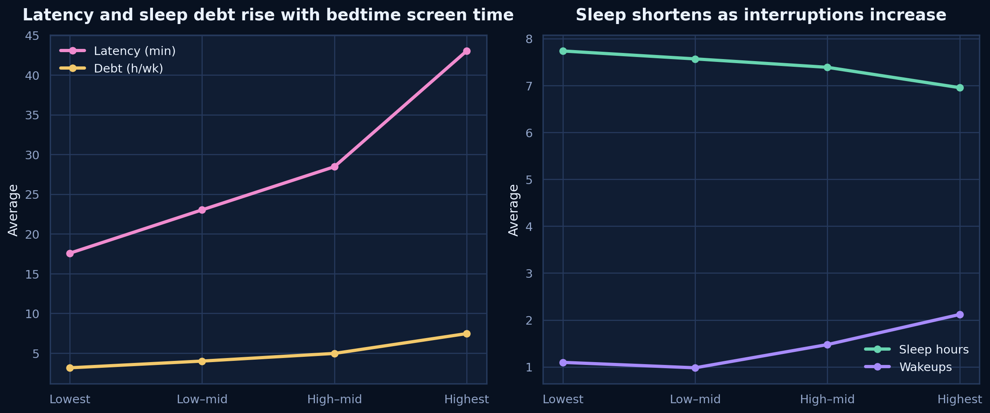
Figure 3. Average outcomes across quartiles of bedtime screen time.
READ THIS
Latency and debt climb across screen-time quartiles while sleep duration declines and wakeups rise.

◉ | Mental health angle  Q3–4 | Anxiety, stress, fatigue, and negative-news consumption

Doomscrolling is as much about content and emotional activation as it is about minutes. When negative-news consumption accompanies doomscrolling, average anxiety, stress, and fatigue are highest. This may reflect a feedback loop: distress can fuel checking behavior, and repeated exposure can prolong arousal.
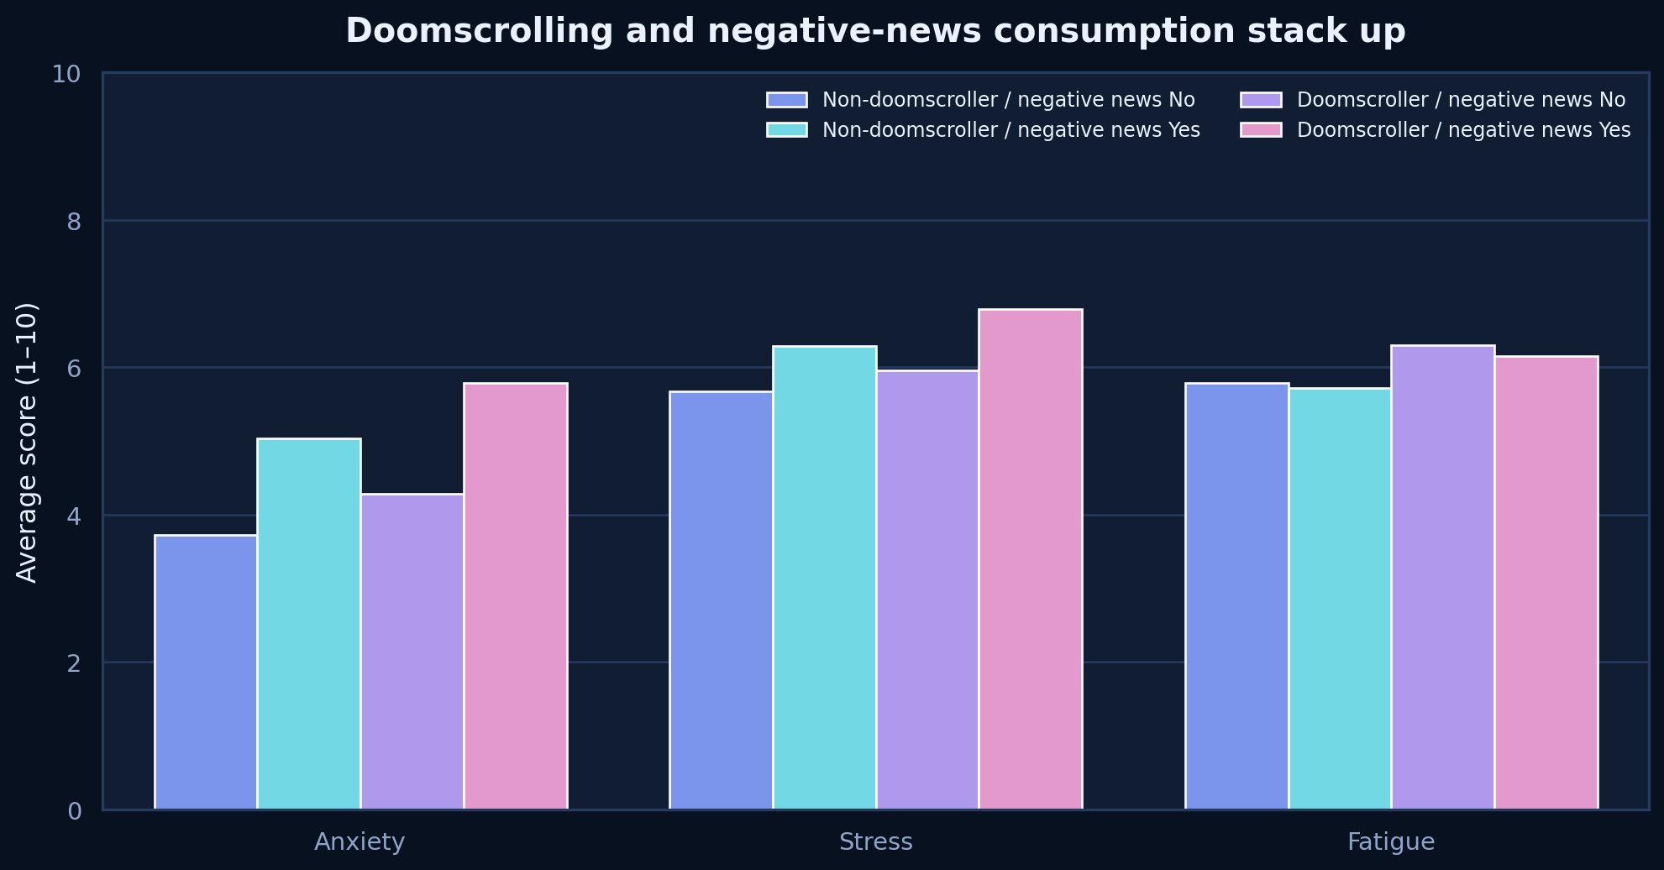
Figure 4. Average anxiety, stress, and fatigue by doomscrolling and negative-news status.
READ THIS
The dual-exposure group—doomscrolling plus negative news—shows the heaviest mental-wellbeing burden.

INTERPRET CAREFULLY
Direction is unresolved: the dataset cannot tell whether distress drives scrolling, scrolling drives distress, or both.

◇ | Protective habits  Q5–6 | What appears to soften the pattern?

The most useful protective signals are structural: what the respondent does before bed, where the phone sleeps, and whether daytime movement is protected. Night mode is convenient, but its average profile is weaker than the profile of a genuinely different bedtime routine.
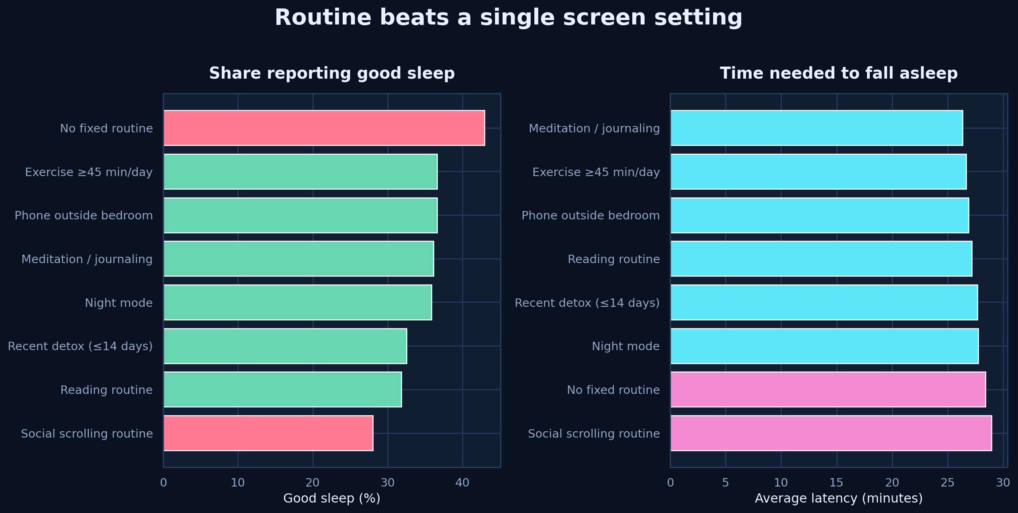
Figure 5. Good-sleep share and sleep latency for selected habits and routines.
READ THIS
Reading and meditation/journaling stand out; a social-scrolling routine performs worst, and night mode alone is not a strong substitute for routine change.

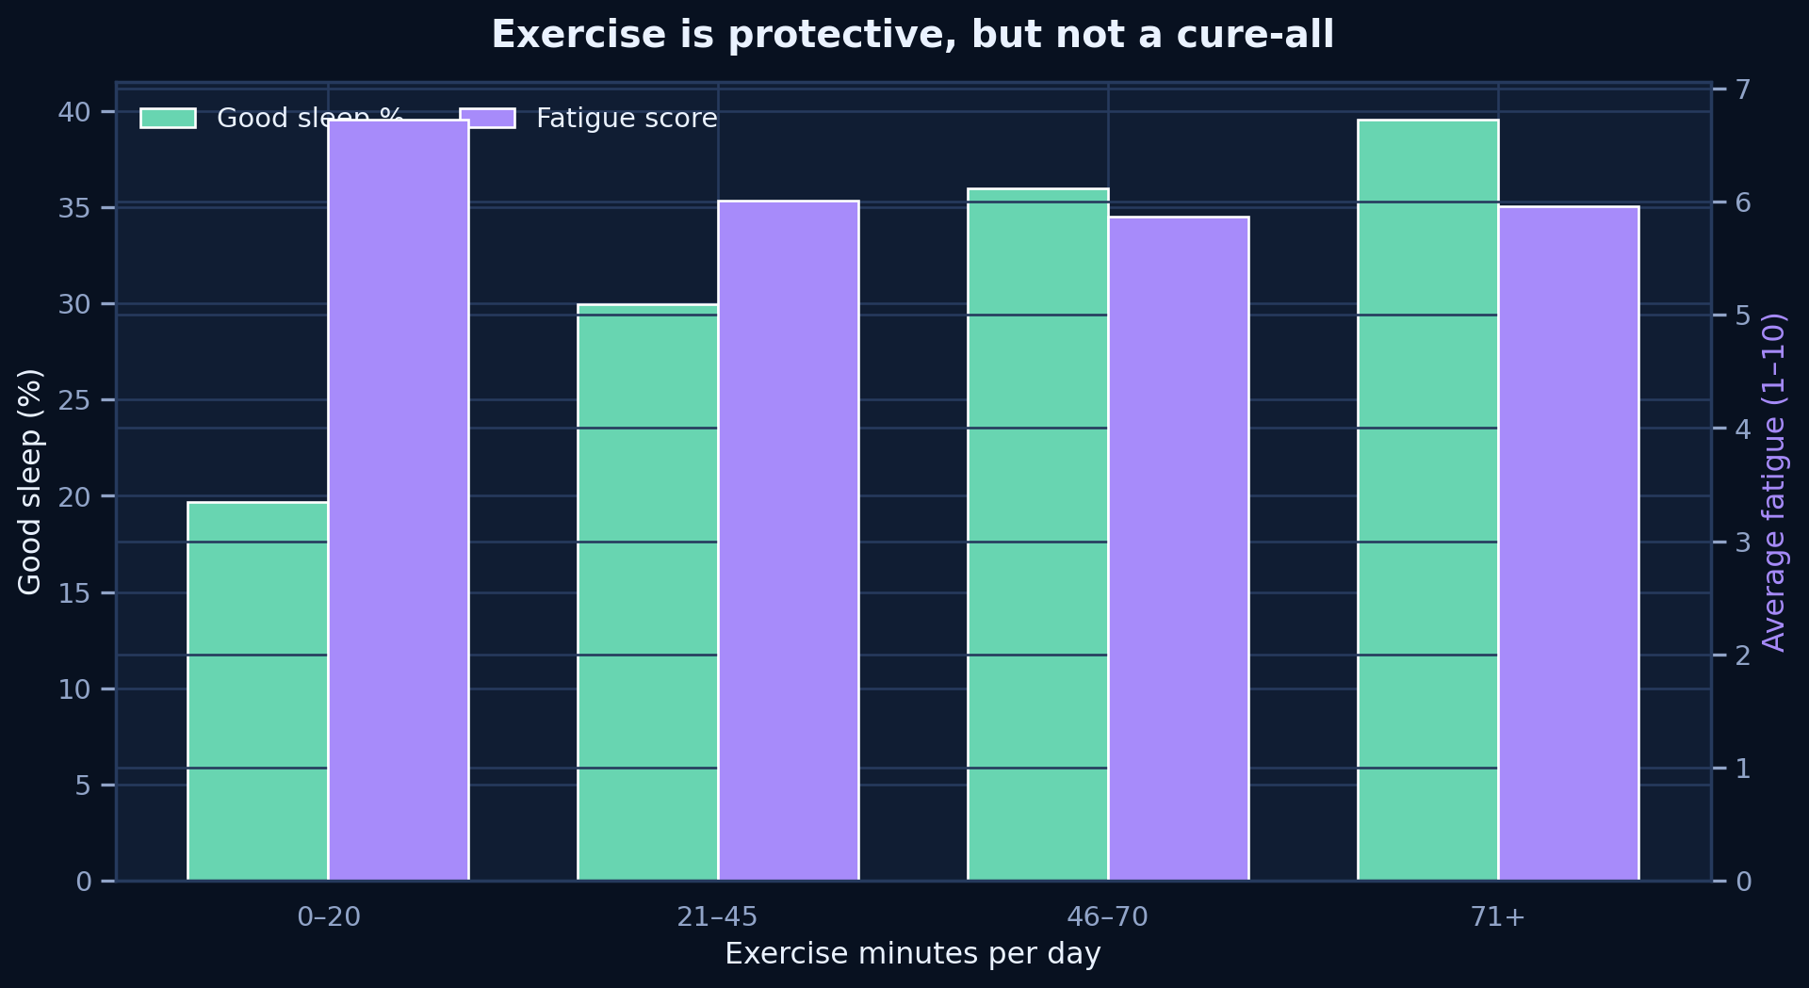
Figure 6. Good-sleep share and daytime fatigue across exercise bands.
READ THIS
Exercise looks modestly protective, but the pattern is not perfectly monotonic and should not be treated as a cure-all.

◎ | Demographic context  Q7–8 | Age buckets, occupation, country, and descriptive gender context

Age buckets replace raw age wherever they make the story easier to read: Teens (15–19), 20s (20–29), and 30s+. Age–occupation cells reveal pockets of elevated doomscrolling, while country rates vary across samples of very different sizes. These breakdowns are useful for segmentation, not ranking.
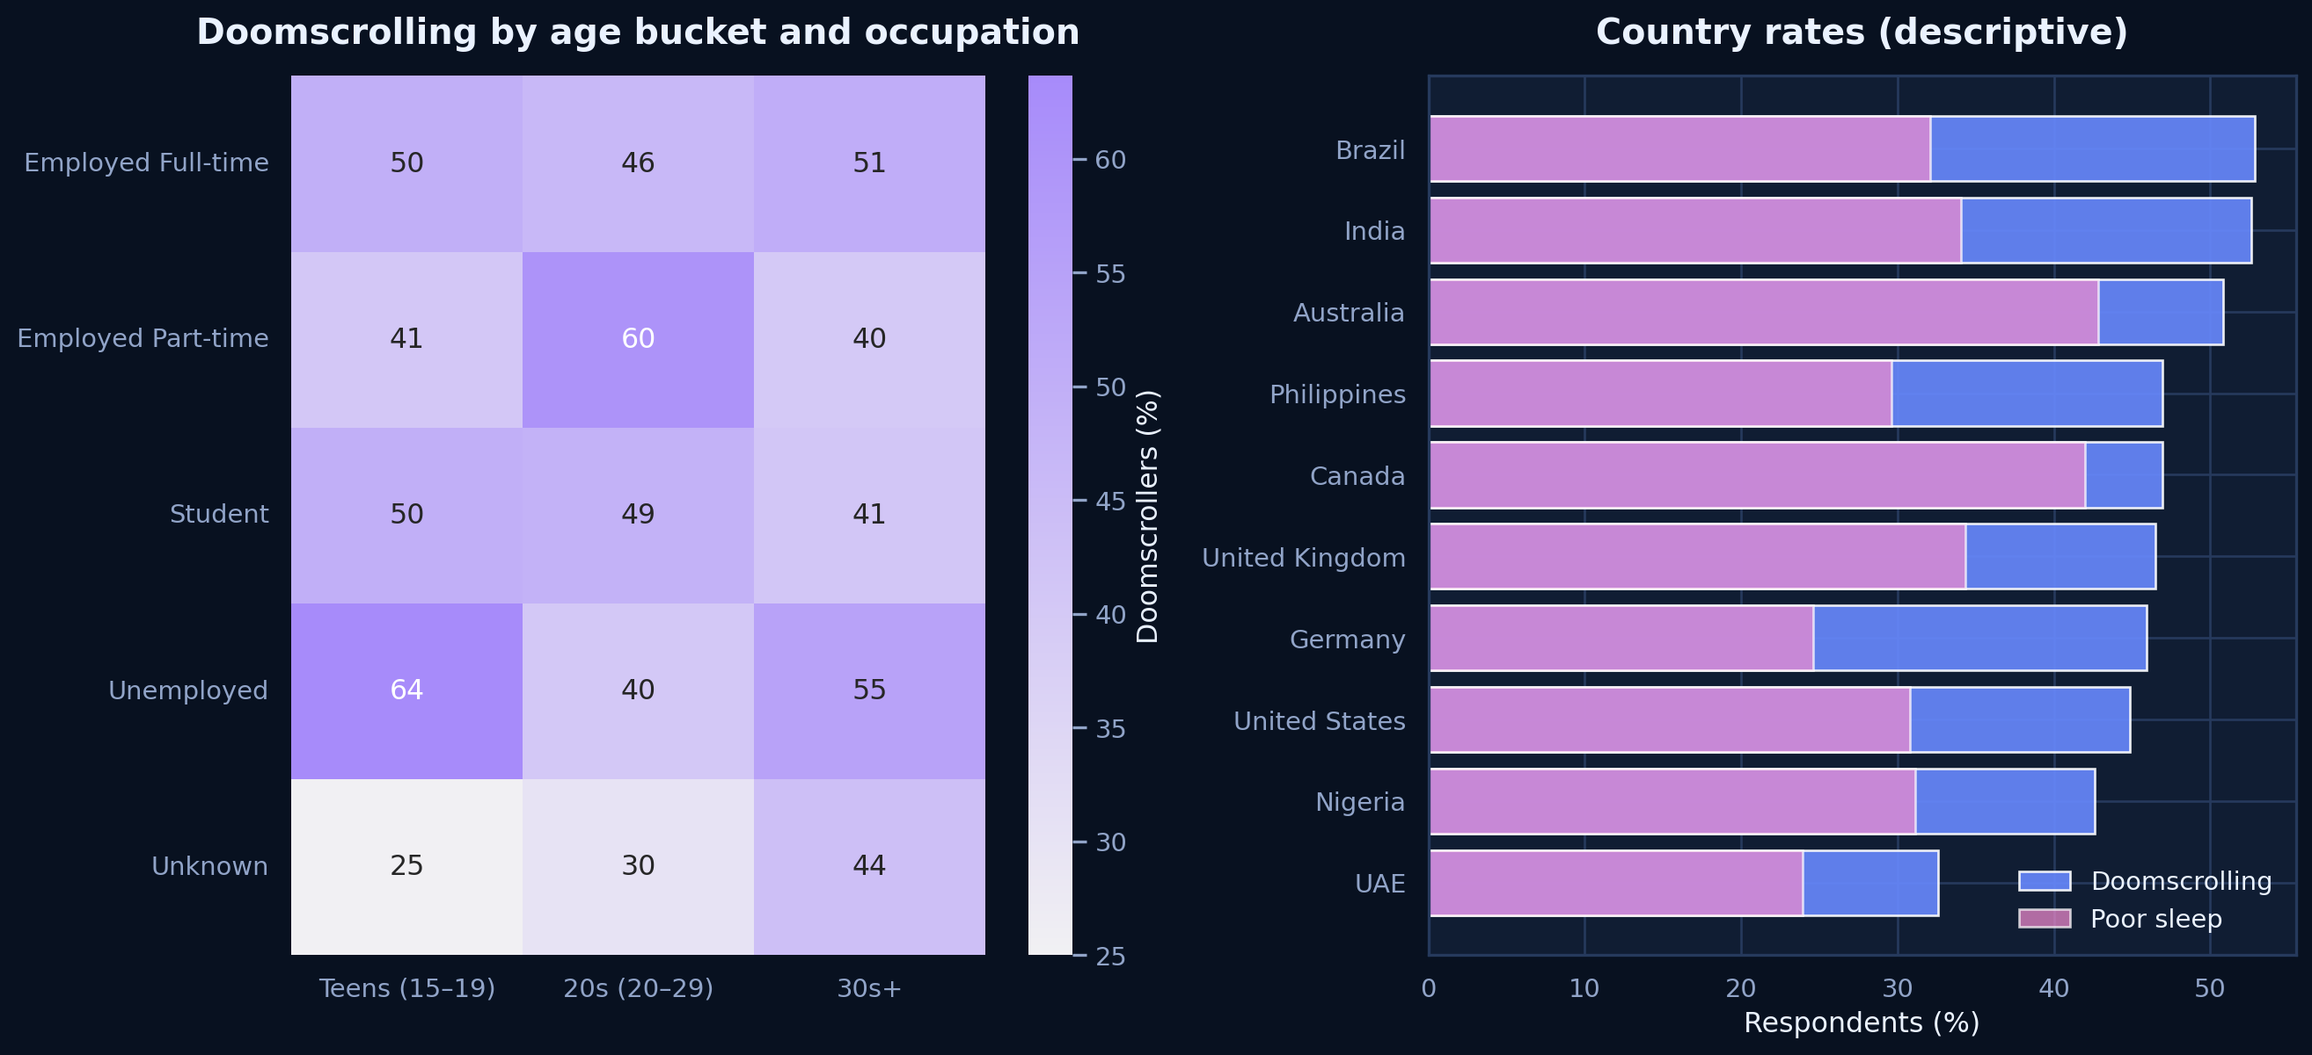
Figure 7. Doomscrolling by age bucket and occupation, plus country-level doomscrolling and poor-sleep shares.
READ THIS
Younger/student pockets are often elevated, but small cells and uneven country samples make the differences descriptive rather than definitive.

GENDER
Gender differences are modest in this sample and are presented descriptively only; behavior remains the more actionable signal.

↗ | The Exceptions  Counter-narrative | Heavy scrollers who still report good sleep

Heavy doomscrollers are defined here as self-identified doomscrollers at or above 66 minutes of bedtime screen time—the top quartile threshold. There are 204 such respondents, yet only 11 report good sleep. The group is small enough to demand caution, but distinct enough to challenge a simplistic ‘scrolling equals poor sleep’ conclusion.
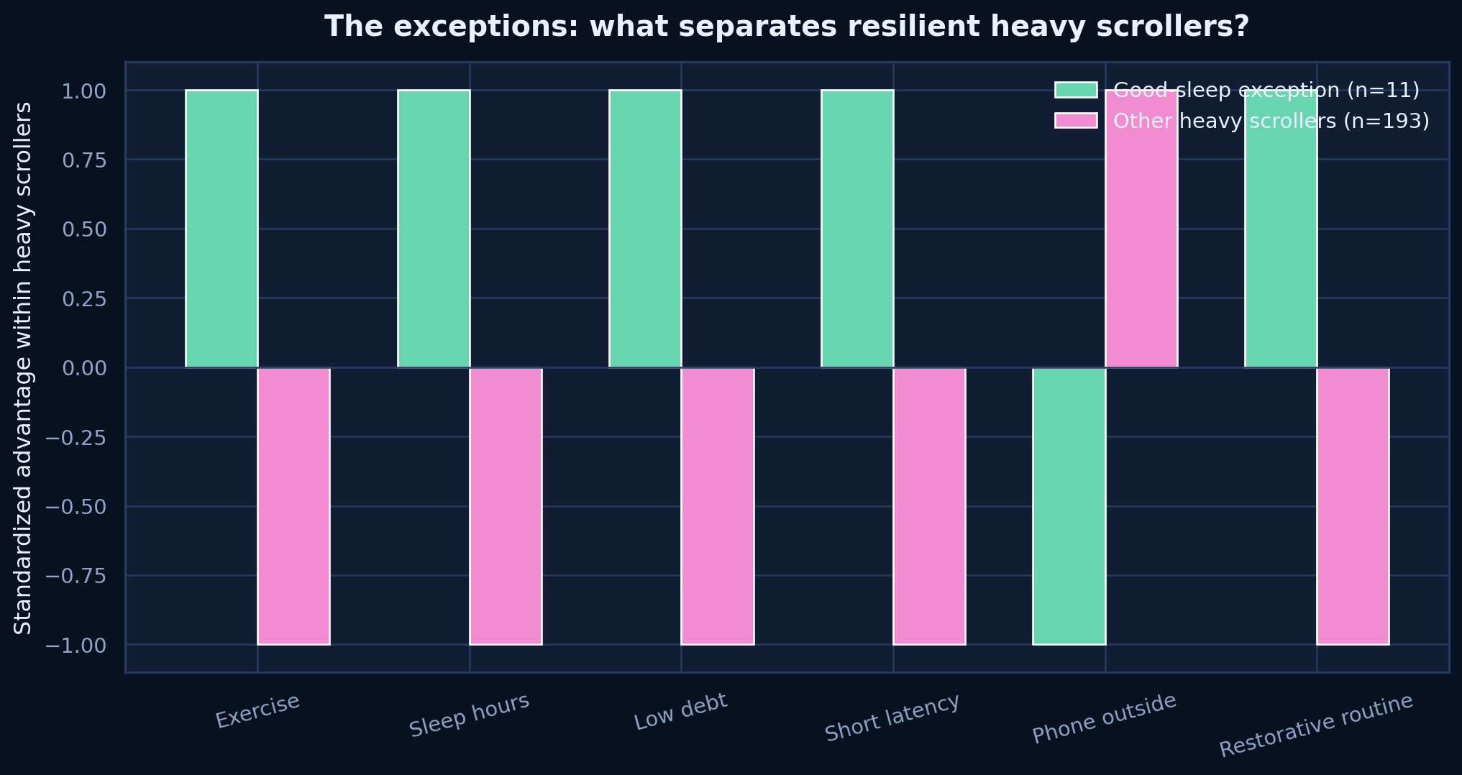
Figure 8. Standardized differences between good-sleep exceptions and other heavy scrollers.
READ THIS
The exceptions realize more sleep and less debt/latency, with restorative bedtime routines appearing more often.

COUNTER-NARRATIVE
Exposure raises risk; routine and realized sleep appear to shape whether that risk becomes an outcome.

◌ | Personas  Three transparent respondent profiles for product and behavior design

These personas are manually defined combinations, not diagnoses or opaque clusters. They make the evidence easier to act on by separating exposure-heavy, emotion-heavy, and routine-protected patterns.
The Night Scroller n=204
High bedtime exposure and a self-identified doomscrolling pattern. The first intervention is environmental: reduce easy access, add a stop cue, and move the phone away from the pillow.
Top quartile bedtime screen | Friction primary lever | High sleep risk

The Anxious News Seeker n=51
Negative-news consumption with high anxiety and stress. The first intervention is content-aware: limit news windows, remove alerts, and replace late checking with a decompression ritual.
High emotional load | Content primary lever | Elevated sleep risk

The Disciplined Sleeper n=130
Lower bedtime exposure paired with reading or meditation/journaling. The design opportunity is maintenance: protect the routine and make the good choice the default.
Lower screen exposure | Routine primary lever | Protective sleep profile

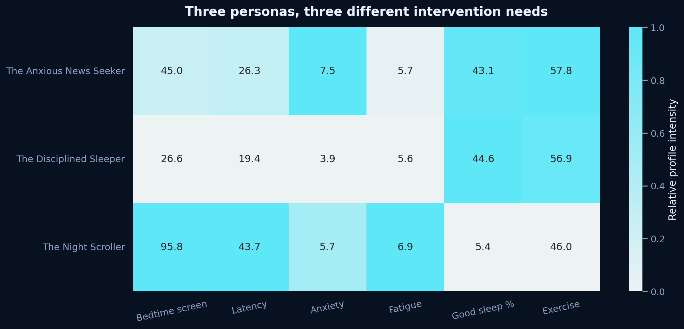
Figure 9. Relative persona profiles with observed metric values printed in each cell.
READ THIS
Different mechanisms imply different interventions: friction for exposure, content boundaries for distress, and reinforcement for disciplined routines.

∑ | Synthesis  Q9 | Correlation structure and predictive ranking

The correlation structure resembles a bedtime-disruption chain. Exposure relates to latency; latency, wakeups, and shorter sleep accumulate into debt and fatigue. The same coherence that makes the story understandable also heightens the synthetic-data caveat: multiple variables may have been jointly generated around one latent disruption score.
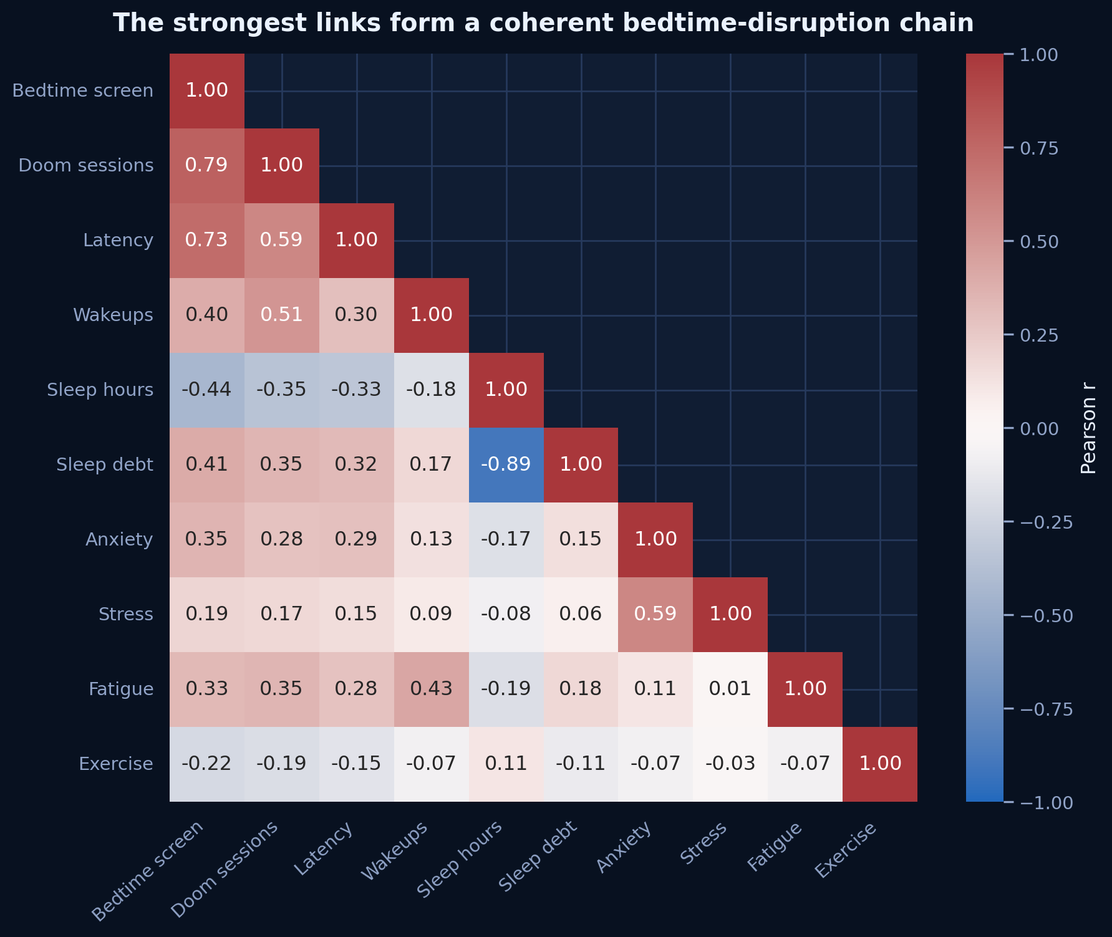
Figure 10. Pearson correlations among selected behavioral, sleep, and wellbeing measures.
READ THIS
Bedtime screen time, doomscroll sessions, and latency form the strongest exposure cluster; sleep duration moves opposite sleep debt.

PREDICTIVE VIEW

The behavior label leads; the night’s mechanics follow
A random-forest classifier evaluated with five-fold cross-validation reaches 60.3% balanced accuracy against a 34.0% majority-class baseline. Permutation importance is computed out of fold and grouped at the original feature level. The outcome-adjacent sleep_quality_score is excluded to avoid construct-overlap leakage.
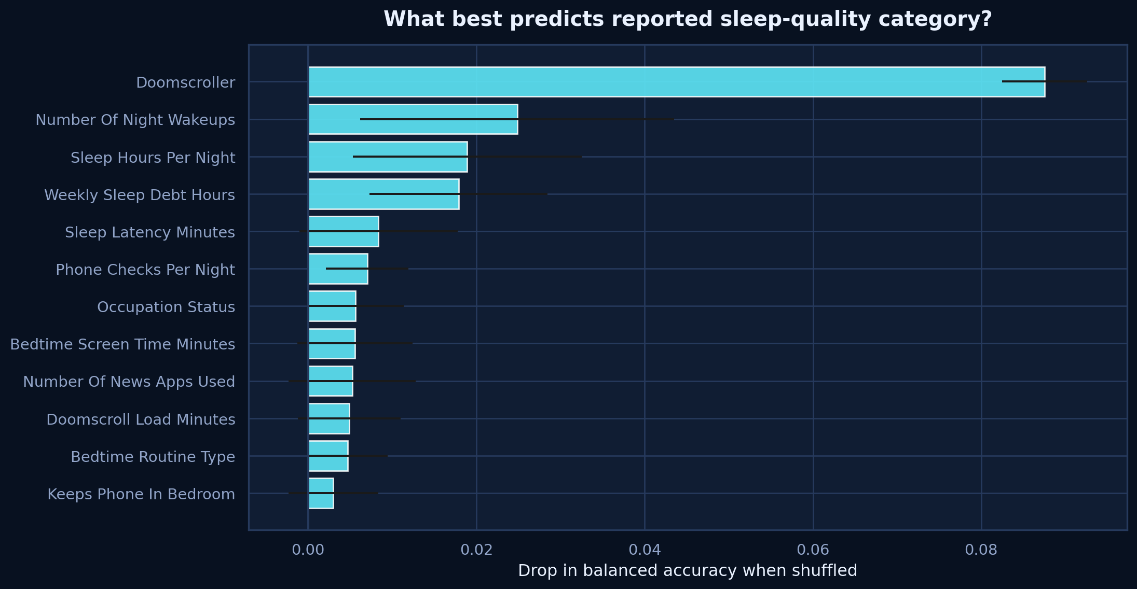
Figure 11. Cross-validated permutation importance for predicting sleep-quality category.
READ THIS
The doomscroller label leads, followed by wakeups, sleep duration, sleep debt, and latency; correlated exposure variables divide their shared signal.

MODEL BOUNDARY
Prediction ranks signals; it does not identify causes, prescribe treatment, or validate the survey against real-world prevalence.

✓ | Conclusion & practical takeaways  A sequence for testing, not a medical prescription

The most defensible conclusion is not that every minute of scrolling destroys sleep. It is that a repeatable bedtime-disruption pattern—longer exposure, more checking, delayed sleep, more wakeups, and accumulated debt—appears throughout the data. Practical action should therefore target the chain rather than moralize the behavior.
- Create friction before bedtime: charge the phone outside the bedroom or beyond arm’s reach.
- Replace, do not merely remove: choose a fixed reading, meditation, or journaling routine for the final 20–30 minutes.
- Treat negative news as a separate lever: use scheduled news windows and disable late alerts.
- Protect daytime movement: aim for a consistent exercise habit without expecting it to offset severe nighttime disruption.
- Track latency, wakeups, and weekly debt—not only total screen time—to see whether an intervention changes sleep mechanics.
- Test by persona: exposure-heavy users need friction, distress-heavy users need content boundaries, and disciplined sleepers need maintenance cues.
BEST NEXT TEST
A two-week phone-outside-bedroom experiment with a fixed replacement routine and daily latency tracking.

Limitations
- The dataset appears synthetic or simulation-assisted: target classes are unusually balanced, relationships are unusually clean, and valid sleep-quality scores are heavily concentrated at 5/5.
- The design is cross-sectional and self-reported; temporal direction and causal effects cannot be established.
- Median imputation and an Unknown category preserve all 1,000 records but can attenuate or redistribute associations.
- Some subgroup cells—especially the good-sleep heavy-scroller exception group—are small and should be treated as exploratory.
- Sleep-quality category is a coarse target. The model excludes sleep_quality_score to reduce direct construct overlap, but other sleep variables remain outcome-adjacent by design.
- Country and gender comparisons are descriptive only; unequal sample sizes and unmeasured social context prevent broad generalization.

Method in brief
The workflow validated IDs, dtypes, missingness, ranges, and potential formulaic relationships; created age buckets; compared groups and quartiles; defined exception and persona rules; visualized correlations; and evaluated a random-forest classifier with stratified five-fold cross-validation. Full executable detail, code, outputs, and figure takeaways are in sleep_doomscrolling_analysis.ipynb.

