
HPE GreenLake for Block Storage – Initialization document for <Customer Name>

Contents
Proprietary Notice 2
Executive Summary 2
Introduction 2
Environment Overview 2
HPE GreenLake for Block storage Architecture 2
Built for Cloud 3
Controller node architecture 3
HPE Alletra Storage MP Enclosure 4
All-active design 5
System-wide striping 5
HPE InfoSight 6
Data Services Cloud Console (DSCC) 7
Built On a Unique Architecture 7
Deliver Cloud Operations 8
Intent-based provisioning 8
Simplified deployment 9
Invisible upgrades 9
Manage from anywhere. 9
Automate at scale. 9
Alletra configuration 10
Alletra Inventory 10
Alletra MP checkhealth output 10

Proprietary Notice

Executive Summary

Introduction

Environment Overview

HPE GreenLake for Block storage Architecture

HPE GreenLake for Block storage is a edge-to-core portfolio designed to deliver cloud experience wherever data lives. For mission-critical workloads, HPE GreenLake for Block storage delivers extreme latency sensitivity and reliability. It enables IT to shift from owning and maintaining data infrastructure to simply accessing and utilizing it on demand and as-a-service. Built on a unique, massively parallel, multi-node, and all-active platform, HPE GreenLake for Block storage consolidates traditional and next-generation mission-critical applications at scale with predictable performance and ultra-low latency, backed by a 100% availability guarantee.

Built for Cloud

Setup in minutes because systems are automatically discovered, on-boarded, and configured. Experience faster access to innovation with no disruptions because new features and enhancements are instantly available through self-service upgrades. Manage from anywhere with simple global management driven through a SaaS based user experience.

The HPE GreenLake for Block Storage architecture is designed for 100% data availability through full hardware redundancy. The system also offers software fault tolerance by running a separate instance of the HPE GreenLake for Block Storage OS on each controller node, thus significantly reducing unplanned downtime. Every HPE GreenLake for Block Storage ships with the HPE 100% Data Availability Guarantee.

Controller node architecture

The most important element of the HPE GreenLake for Block Storage architecture is the HPE Alletra Storage MP enclosure. Figure 1 showcases the HPE Alletra Storage MP controller node design. It includes an enclosure containing two controller nodes, powerful data movement engines designed for mixed workloads, and up to 24 internal NVMe drives. The controller nodes are available with 8-core, 16-core, and 32-core processors. This modular approach provides a flexible, cost-effective entry footprint with affordable upgrade paths to increase performance, capacity, and connectivity as needs change. Also, the dual-controller configuration means the system can withstand an entire controller node failure without impacting data availability. Each node is completely hot-pluggable to enable online serviceability.

The controller nodes are designed to handle the concurrent demands of the NVMe era. Every controller node can support up to two HBAs each to give customers the flexibility to support various connection topologies of today. The available HBAs are 32/64 Gb Fibre Channel (FC), which supports SCSI and NVMe/FC protocols, and 10/25 Gb Ethernet, which supports iSCSI and NVMe/TCP protocols. Replication links can be added to both HBA types.

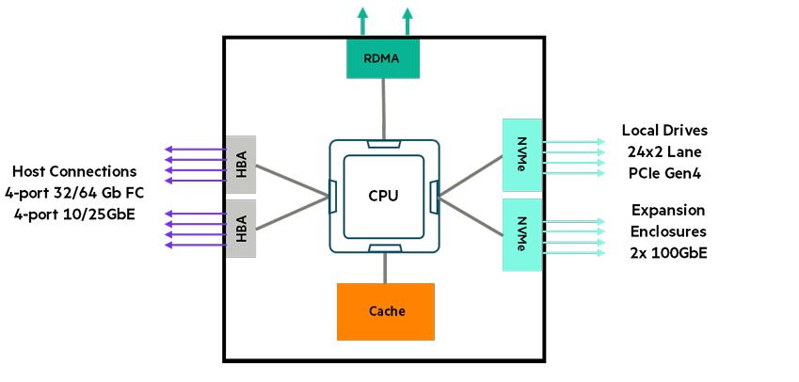
Diagram 01: HPE Alletra Storage MP controller node design

HPE Alletra Storage MP Enclosure

The HPE Alletra Storage MP enclosure is the basic building block of the HPE GreenLake for Block Storage. Each enclosure contains two nodes, which can be either storage controllers or NVMe I/O modules, that are connected by a passive backplane. The enclosures are available as base or cluster configurations as shown in Figure 2. The base configurations are limited to 2 controller nodes, which can be 8, 16 or 32-core models. The cluster configurations can have 2, 3, or 4 controller nodes, which can be 16 or 32-core models, and these are connected to 2 HPE Alletra Storage MP 32-port 100GbE switches.

The storage controller nodes are connected to each other via two cluster interconnect links which are 25 Gb full-duplex (12.5 GB/s total throughput) on the base configuration 8-core and 16-core models, and 100 Gb full-duplex (50 GB/s total throughput) on the cluster configuration 16-core model and both configurations of the 32-core model. These interconnects use a low-overhead RDMA protocol for rapid internode messaging and acknowledgment. The clustering of the storage controller nodes creates a single, highly available, and high-performance storage system where servers can access volumes over any host-connected port. A completely separate network of redundant 1GbE links provides a channel for exchanging control information between the nodes.
The HPE Alletra Storage MP base enclosure can contain up to 24 internal dual-ported NVMe drives via 48 PCIe 4.0 lanes per enclosure. The 16-core or 32-core controller nodes can support up to two additional HPE Alletra Storage MP enclosures with NVMe I/O modules. The controller nodes connect to these expansion shelves via two 100 Gb NVMe-oF links, taking the maximum number of drives to 72. The drives, which are available in capacities of 1.92 TB, 3.84 TB, 7.68 TB and 15.36 TB, can be increased in increments of 2 drives per enclosure.

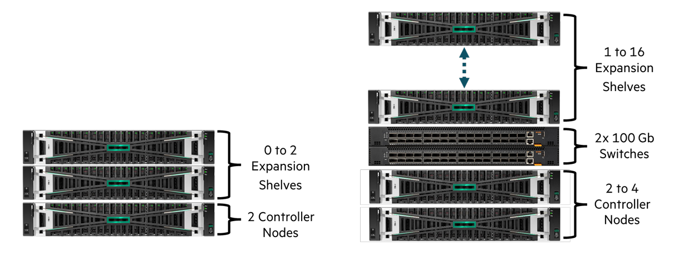

Diagram 02: HPE Alletra Storage MP base and cluster configurations.

All-active design

The HPE GreenLake for Block Storage system leverages an all-active design where all components engage in I/O processing and all nodes have direct access to all drives. Though other dual-controller modular architectures provide failover capabilities, they are typically active/passive, where only one controller does the I/O processing. The second controller is in standby mode in case of a primary node failure. However, some implementations claim active/active behaviour as the host ports on the standby node can receive an I/O, but it is forwarded to the active node for processing. With HPE GreenLake for Block Storage, I/Os can be received and processed by all controllers before being sent directly to the drives.

Each virtual volume is assigned a primary node owner and VV ownerships are automatically distributed across all available nodes to ensure I/O load balancing. The virtual LUN paths of the volumes are presented to the hosts using Asymmetric Logical Unit Access (ALUA) for FC and iSCSI protocols, and Asymmetric Namespace Access (ANA) for NVMe/FC and NVMe/TCP protocols. The paths to the owner node are marked as optimized and the paths to the non-owning nodes are marked as non-optimized. The host multipathing software will direct I/Os to the optimized paths wherever possible. If optimized paths are not available due to SAN failures, then the non-optimized paths will be used.

System-wide striping

With the HPE GreenLake for Block Storage all-active design, all drives are accessible by all nodes which promotes system-wide striping by automatically provisions and seamlessly striping volumes across all the drives to deliver high and predictable performance levels. The system-wide striping of data provides high and predictable service levels for all workload types through the massively parallel and fine-grained data striping across all internal resources (drives, ports, cache, processors, and others). So, when the use of the system grows — or in the event of a component failure — service conditions remain high and predictable.

For flash-based media, fine-grained virtualization combined with system-wide striping drives uniform I/O patterns, spreading wear evenly across the entire system. Should there be a media failure, system-wide sparing also helps guard against performance degradation by enabling many-to-many rebuilds, resulting in faster rebuilds. Because HPE GreenLake for Block Storage automatically manages this system-wide load balancing, no extra time or complexity is required to maintain an efficient system.

HPE InfoSight

HPE InfoSight deeply integrates with the HPE GreenLake for Block storage 9000 UI to allow enhanced predictive analytics to be performed within the HPE cloud. This predicts, prevents, and resolves problems, such as part failure, data availability, or data loss issues across the infrastructure stack and ensures optimal performance and efficient resource use. HPE InfoSight watches over the infrastructure 24x7, continuously monitoring every system across the install base, so you do not have to spend days, nights, and weekends dealing with infrastructure issues.

There are thousands of sensors within each HPE GreenLake for Block storage 9000 storage system. This instrumentation effectively tracks every I/O through the system and provides statistical information, including service time, I/O size, KB/s, and IOPS for VVs, LDs, and PDs. Performance statistics such as CPU utilization, total accesses, and cache hit rate for reads and writes are also available on the controller nodes that make up the system cluster. HPE InfoSight as shown in below ‘diagram 03’ constantly analyzes and correlates millions of these sensors every minute to arrive at various insights that are made available to the storage administrator to act on. The repertoire of intelligence grows daily in HPE InfoSight, and new signatures are continually added for swift anomaly detection, creating a supremely powerful storage administration tool.

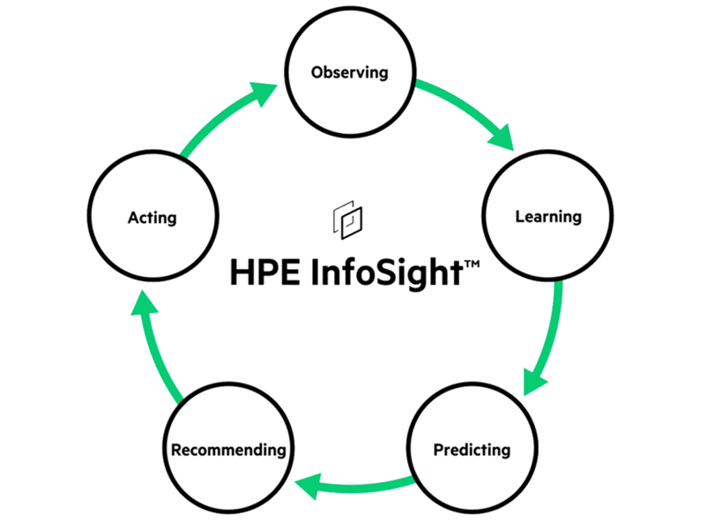
Diagram 03: HPE InfoSight

Data Services Cloud Console (DSCC)
Data Services Cloud Console is built on a unique cloud-native architecture that automates and orchestrates infrastructure and data workflows, transforming complex data operations into a streamlined data management experience across clouds. Data Services Cloud Console accelerates data-driven transformation by delivering cloud operational agility for infrastructure and simplified data management across clouds. It’s your one destination to unify data operations, edge to cloud.

Built On a Unique Architecture
Data Services Cloud Console reimagines data and infrastructure management with a cloud operational experience and services-centric approach that helps eliminate silos and complexity. Its unique cloud-native architecture is designed to simplify and integrate data operations with a single destination for a comprehensive set of Cloud Platform Services, Cloud Infrastructure Services, and Cloud Data Services.

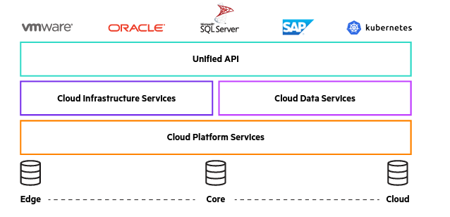
Diagram 04: Data Services Cloud Console Architecture

Deliver Cloud Operations
Data Services Cloud Console enables a cloud operating and consumption experience for data infrastructure. Separating the data infrastructure control plane from the underlying hardware and moving it to the cloud unifies distributed management silos under a single web interface, enabling one, consistent experience across edge to cloud.

The cloud console simplifies infrastructure at scale with cloud agility across the lifecycle, so managing hundreds of systems is as simple as managing one.

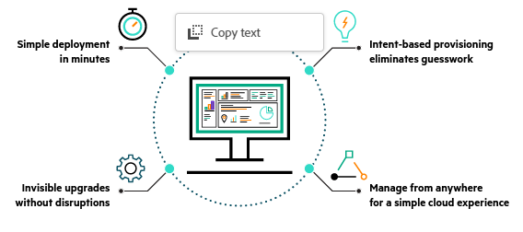
Diagram 05: Cloud Operations

Intent-based provisioning
Simplify provisioning at scale with automatic, optimized app deployment across a global fleet. Transform storage provisioning from a LUN-centric, manual process to an intent-based, AI-driven approach that optimally determines where data should be stored—with real-time context to resource headroom and application-specific SLAs.

Simplified deployment
Deploy new data infrastructure in minutes with automated discovery and activation. Simply cable up the system, turn it on, and Data Services Cloud Console is designed to do the rest.

Invisible upgrades
Get cloud-delivered software upgrades that are automated, non-disruptive and policy driven. Update firmware with a click of a button across an entire worldwide fleet of data infrastructure.

Manage from anywhere.

Have everything you need at your fingertips. Manage and monitor infrastructure globally with an intuitive SaaS-based user experience accessible from any location and any device.

Automate at scale.
Manage infrastructure at cloud speed and scale with a fully programmable universal application programming interface (API). Easily orchestrate infrastructure as code with a single API endpoint for edge-to-cloud data infrastructure.

Data Services Cloud Console makes managing infrastructure effortless, enabling IT to refocus resources and skills to higher-value strategic initiatives.

Alletra configuration

Below table 01 provides information about the HPE GreenLake for Block used in this project, its hardware configuration and network configuration information.
HPE GreenLake for Block configuration details
Name
Model
Serial No
Controller Nodes
OS Version
Drive Cages
Cache(GB)
NVMe SSD Disks (15.36 TB)
RAW Capacity
RAID
Host Ports
InServ IP Address
InServ Netmask Address
Inserv Gateway Address
NTP
DNS Servers

Table 01.a:Alletra Storage hardware and configuration

Alletra Inventory

Alletra MP checkhealth output

