Important notice
Along with Brand compliance for text and content formatting, this template has been created to ensure the correct usage of Microsoft Word functionality and meet accessibility requirements.
As such, it is most important that you follow the comprehensive navigation instructions for the correct method of applying the styles. Please read and use these instructions when creating a document. Correct usage also helps insure optimal conversion to PDF.
Failure to follow these instructions will result in Brand and inclusion / accessibility non-compliance.

Contents
Template usage 3
Save the template 3
Access the template 3
Use the template 3
Page headers and footers 4
First page 4
All middle pages 4
Disclosure statement 4
Cover page 5
Last page 5
Applying styles 6
Font styles 6
Headings 6
Bullets 7
Symbol bullets 7
Numbered bullets 7
Tables 8
Document revision history 9
Pictures 9
Alt text 10
Shapes 10
Hyperlinks 10
Important notes 11
Table of content 11
Footnotes 12
Figure and table captions 12
Figures and tables lists 12
Quotes 13
Information links 13
Last page 13
External legal statement – HPE 15
Internal legal statement 15
Internal and channel partner legal statement 15
Appendix A – unpin template 16

Template usage

Save the template
Save this template in folder your Custom Office Templates folder. To find this folder, open Word and go to File > Option > Save
Take note (or copy) path in Default personal templates location box (green “xs” in below screenshot is your username)
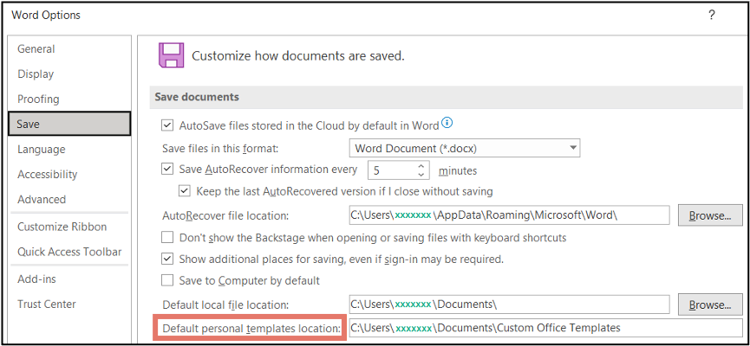
If this box is empty,
- Open a file browser and to C:\Users\xxxxxx\Documents and create a folder named “Custom Office Templates”
- Add this path location in the default template box
Open a file browser and go to this default folder and paste the template.

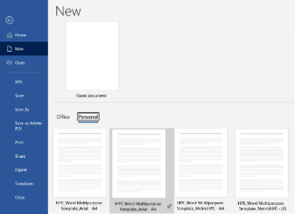
Access the template
To access the template for the creation of a document, use File > New > Personal and select it from the displayed available templates. If there are several available templates, it can be pinned for quick access by hovering over the desired template and clicking on the pin icon.

Use the template
Open 2 versions (Document 1 and Document 2) of this template.
Use Document 1 to create your document by deleting all content and start typing your content.
- If a cover page is needed, insert it after all content has been added and formatted.
- If a last page is needed, create it last (after content and cover page).
Use Document 2 as a reference for instructions and to copy Document revision table and/or Legal statement

Page headers and footers
Update the placeholders “Document type name” and “Disclosure statement” on Page 1 per instructions.
Once a Page 2 is created, update the placeholders “Disclosure statement” per instructions. The update will be cascaded to all subsequent pages created.

First page
This template is formatted so that the first page has:
- HPE logo in the top left corner
- Document type name in the top right corner, HPE Graphik Medium font, right aligned
  - To maintain consistency and continuity, be sure the Document Type Name of your Word document reflects the document type (e.g., Technical proposal, technical documentation, scope of work, process documentation, project schedule, business proposal, bid proposal, sales agreement, etc.)
- Disclosure Statement the top right corner, HPE Graphik 8 pt, right aligned
  - See Disclosure statement matrix for applicable verbiage

All middle pages
All subsequent pages are formatted to have:
Footer:
- Disclosure Statement in the bottom right corner HPE Graphik 8 pt font, right aligned
- Page number in bottom right corner, HPE Graphik 8 pt font, right aligned

Disclosure statement
Below is the matrix for selecting the applicable value.
Audience | Disclosure statement | Guidelines
Document is for training HPE Employees, Outsourced, Channel Partners and Customer Education training material | Confidential | For training purposes only | Source documents cannot be shared with students and are for instructor use. If applicable, course material is provided to the audience via PDFs.  Can only be shared on PSNow and Seismic  Not to be uploaded on HPE.com or public platforms  Not to be shown to the customers, or share with customers either digitally or as print copies
Document is for HPE employees and partners who have agreed to keep it confidential and is not to be shared with customers | Confidential | Authorized HPE Partner use only | Can be shared on PSNow and Seismic  Not to be uploaded on HPE.com or public platforms  If a training document: Not to be shown to the customers or shared with customers either digitally or as print copies.  If other type of document: Can be shown to customers either digitally or as print copies (need to include in the description that a CDA* is required to share with the customer) and not to be left behind
If the document has some confidential or proprietary information and can be shared with customers who have agreed to keep it confidential, label it | Confidential | Authorized HPE Partner and HPE Customer use only | Can be shared on PSNow and Seismic  Not to be uploaded on HPE.com or public platforms  Can be shown to customers either digitally or as print copies (need to include in the description that a CDA* is required to share with the customer) and not to be left behind
Document is for HPE employees and is not to be shared with customers or partners | HPE internal use only | Can only be shared on PSNow, Seismic (Internal employees)  Not to be uploaded on HPE.com or public platforms  Not to be shown or handed over to partners or customers either digitally or as print copies
Document is for customers or the general public and does not have any confidential or proprietary information | No label needed | Can be uploaded both on PSNow and Seismic  Can be shown to customers/partners either digitally or as print copies  Document will be searchable through search engines. To avoid, use it as Gated Asset or stage your release dates

Cover page
To add the HPE cover page, go to Insert ribbon, and select one of the HPE Graphik Cover in the General section of the Cover Page icon drop-down list.
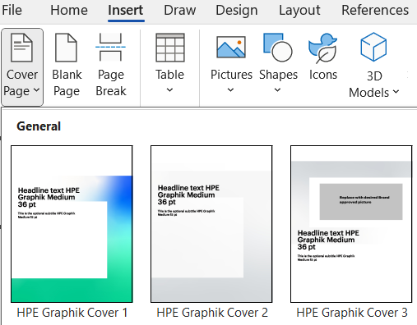
This will insert a new Page 1 with the cover page formatting. Update default verbiage with title and subtitle. Remember to update the Document type name and Disclosure Statement in the header.
If you select HPE Graphik Cover 3, you will need to replace the picture box with an approved Brand picture.
- Right-click the image.
- Select Change Picture → From This Device.
- Browse to the new image on your computer and click Insert.
- Adjust the size and position of the image if necessary to fit the allocated space.

Last page
There are three options for the last page, see section Last page for instructions

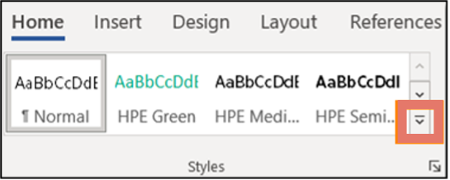
Applying styles
Frequently used sentence and paragraph styles are in the Styles section on the Home ribbon for “quick” usage.
Use the scroll drop-down icon to display all “quick” available styles
Styles applicable for other content (ie: tables, pictures, references, etc.) display in new ribbons when the content is added.

Font styles
Use sentence case for headers, headings, and text body. Physical locations, product names, company names and all proper names should be title case.
For text body, it is Normal in the Styles section on the Home ribbon. The standard font for text body is HPE Graphik size 10.
If visual emphasis of a specific word or group of words is needed, change font to HPE Graphik Semibold or HPE Green (font HPE Graphik Semibold). For ease of applying these fonts, they have been added to the Styles section.
If coding and/or commands content needs to be in a different font, use Consolas for the applicable words. Example:
Coding Language Consolas echo ‘- - -‘ > /sys/class/scsi_host/hostX/scan_use

Headings
Type the heading words. Select all the words and use desired level heading from the Styles section on the Home ribbon.
Heading style formats are:
- Heading 1 – HPE Graphik Semibold, 20 pt
- Heading 2 – HPE Graphik Semibold, 15 pt
- Heading 3 – HPE Graphik Semibold, 10 pt
- All other levels – HPE Graphik, 10 pt
If a heading should be excluded from the Table of Content, use Style Heading.
For training documents, Heading 1 should be at the start of a page. Insert a page break at the end of the previous section, if necessary.

Bullets
To apply bullets:
- Type all content per group of bullets. Example of just typing the content:
Xxx xxxxx
Xxxxx xxxx
X xxxxx
- Select all lines to which a bullet needs to be applied
- In the Paragraph section of the Home ribbon, click on the Multi-Level Bullet icon. Scroll to List Styles section and select the desired bullet type. There are only 2 styles that are Brand approved – outlined in red in the below screen shot.

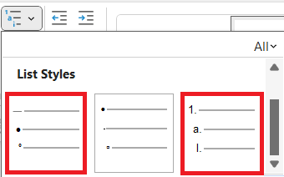

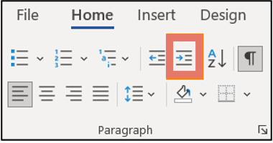
- If sub-bullets are needed, select the applicable lines, and use the Indent icon in the Paragraph section of the Home ribbon (do not use Tab on keyboard) for each sub-bullet level. Example of the results:
- Xxx xxxxx
  - Xxxxx xxxx
    - X xxxxx

Symbol bullets
This is an example of a bulleted list.
- Xxx xxxxx
  - Xxxxx xxxx
    - X xxxxx

Numbered bullets
This is an example of a numbered list.
- Xxx xxxxx
  - Xxxxx xxxx
    - X xxxxx

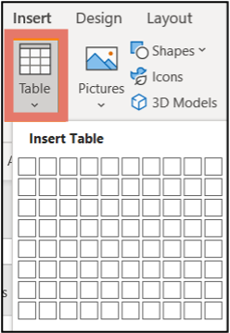
Tables
Tables should be the full width of the page within the margins or else align with the left margin. Text body remains above and below tables
To insert a table:
- Go to Insert ribbon and click on Table icon.
- Select the number of rows and columns needed from the displayed boxes. This builds the table layout for content to be added.
  - The table layout automatically displays the Table Design ribbon.
  - Choose the “HPE table” pre-defined layout with green header
- Add content
- Select all rows and columns and change font size to 9 pt (using font size drop down box in Font section of Home ribbon)
The completed table should look like the below example.
Column header  Graphik Semibold 9 pt | Column header  Graphik Semibold 9 pt | Column header  Graphik Semibold 9 pt
HPE Graphik 9 pt | HPE Graphik 9 pt | HPE Graphik 9 pt
HPE Graphik 9 pt | HPE Graphik 9 pt | HPE Graphik 9 pt

If, after creating and/or completing the table, the table specific Layout ribbon can be used to:
- Additional columns and/or rows
- Delete unused columns and/or rows
If the table crosses multiple pages, remember to:
- Select the header row
- Right click to display options and select Table Properties
- Select Row tab and put a check mark in box next to Repeat as header row
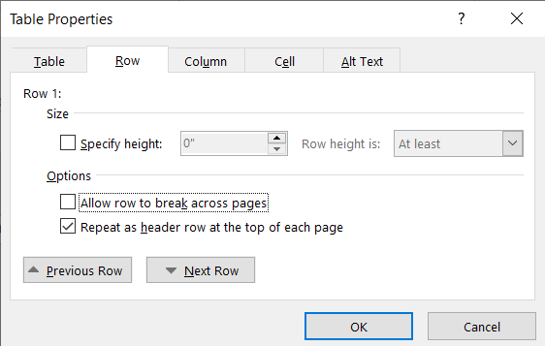

Document revision history
This content should be placed on its own page (not combined with any other content). It should appear after table of content.
Copy the below into the document (Project name, Document status, and table) and update with your content.
Project name: Xxxxx Xxxx
Document status: Xxxxxx (ie: Draft, Final, Release #)

Change request# (Optional) | Document version | Date | Prepared / Modified by | Reviewed by | Approved by | Section and text revised

Note
Based on inputs from the Configuration Management Lead and ISO Leads, the minimum amount of data required to be captured from a Configuration Management and ISO Audit perspective is indicated in the Document revision history. Accounts / Projects are free to include additional information in the templates.
If the table crosses multiple pages, remember to select header row and format to add Repeat as header row for the table.

Pictures
Use Pictures icon in Illustrations section of Insert ribbon to add pictures.
When a picture is added, the Picture Format ribbon automatically appears. Use this ribbon to do custom formatting.
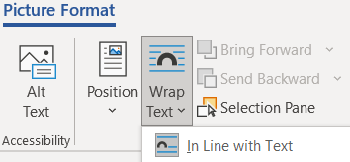
To ensure accessibility,
- It is best to select the position In Line with Text
  - Other positions can be used for small or decorative pictures
- Always add alternate text by clicking on Alt Text icon.
- If adding a border to the picture,
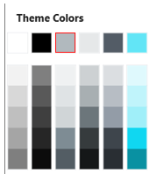
  - Border weight should be ¾ or 1 points
For training documents: Picture border color is the HPE grey color to the right of black in the color selector. The border line is 0.75 pt. The exception is that if there is natively a border around the image, then no additional border is required.

  - Do not add any shadow effect; remove if added by default functionality

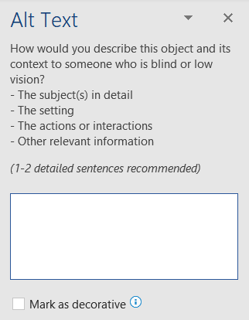
Alt text
The Alt Text icon opens a window on the left of the screen.
If the picture is decorative or illustrates information already part of the body text, put a check mark in the box next to Mark as decorative.
If the picture contains important information,
- Move/type the content so that it becomes part of the body text OR
- Add detailed description of picture content in the provided text box
  - If the detailed description is long, it is an indicator that the content should become part of the body text

Shapes
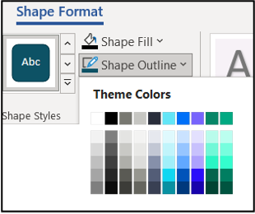
When adding shapes (from Illustrations section of Insert ribbon), a corresponding formatting ribbon is displayed. The Styles section of the corresponding ribbon show available HPE colours for customization. Use only the main colours.
Example: A box has been added. Shape Format ribbon appears. In the Shape Styles section, the fill and outline colours can be changed using the drop-down list. Select one of the colours in the first row. Approval from Brand must be obtained for using any of the gradient colours below the first row.

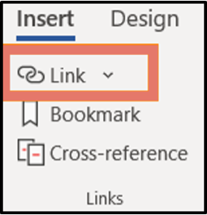
Hyperlinks
Hyperlinks may be added for web pages (URL), email addresses, and navigation within a document. All hyperlinks are added via the Link icon in the Links section of the Insert ribbon.
Click on the icon – do not click on the associated drop-down arrow.
In the pop-up window, select the type of link to add.
- Use Existing File or Web Page for URLs
  - Complete Text to display box with words (not the URL address)
  - Paste the URL in Address box
- Use Place in This Document for navigating document
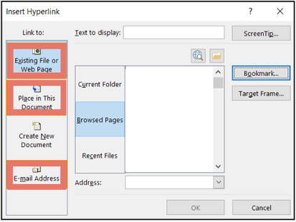
  - When this is selected, all text formatted with heading styles will be listed
  - Complete Text to display box with the heading text or some other shorter version of it
  - Select the desired heading
- Use E-mail Address for emails
  - Complete Text to display box with the email name
  - Add actual email address to E-mail Address box
  - If you want to pre-populate the emails subject with specific verbiage, add the text to Subject box
- The hyperlink formatting is HPE Graphik 10 pt, HPE green color font and underline.

Important notes
The style for disclaimers is Block Text. This should be used with labels: Important, Note, Caution, Danger or Warning.
- Type the content for the text to be blocked.
- Select all lines/paragraphs to be blocked and select Block Text from Styles Library
- Select the label line and make bold.
Example:
Per #1, typed content is:
Note
Set off notes, warnings, caution statements, and important information with a rule above and below.
After applying Block Text and bolding, content will look like this.

Note
Set off notes, warnings, caution statements, and important information with a rule above and below.

 Danger
Indicates a hazardous situation that, if not avoided, will result in death or serious injury. This text is to be limited to the most extreme situations. Call out the hazard, injury, and steps to avoid it.

 Important
Provides essential information to explain a concept or to complete a task

Table of content
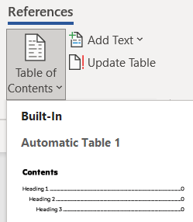
Only one instance of a table of content can be added to a document.
Place your cursor at the end of the paragraph / line where you want to insert the Table of Content.
Press Enter on your keyboard to add 2 lines.
Go to References ribbon and select the first style from the Table of Contents icon (first on the left) drop-down list.
The table of content will show all text with styles Heading 1 to 3.
If you make changes to the document, remember to update the table of contents to reflect all heading and associated page changes. To refresh for the changes, go to References ribbon and select the Update Table icon to the right of the Table of Contents icon.

Footnotes
Place your cursor at the end of the word that will have the footnote. Use the Insert Footnote icon in Footnotes section of Reference ribbon. The corresponding footnote number will appear at the bottom of the page. Your cursor will move automatically to this section for adding the content. The font is HPE Graphik 9 pt.
The footnote numbering is auto-generated. If a new footnote is added after an existing one in the document, the next sequential number is added. If a new footnote is added before an existing one in the document, all numbers are refreshed in sequence.

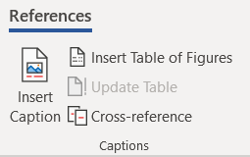
Figure and table captions
For figure captions, use Insert Caption icon on Reference ribbon. Select “Figure” for the label, positioned “below”. The caption numbering will automatically increase sequentially, and the text will be formatted HPE Graphik 9 pt.
Select all words in caption line and apply Caption – Figure from Style section. This will change the spacing above and below the word.
Select just the word “Figure” and the number and change to HPE Graphik Semibold
Figure 1. Sample 1
Figure 2. Sample 2
For table captions, use Insert Caption icon on Reference ribbon. Select “Table” for the label, positioned “above”. The caption numbering will automatically increase sequentially, and the text will be formatted HPE Graphik 9 pt.
Select all words in caption line and apply Caption – Table from Style section. This will change the spacing above and below the word.
Select just the word “Table” and the number and change to HPE Graphik Semibold.
Table 1. Sample 1
Table 2. Sample 2

Figures and tables lists
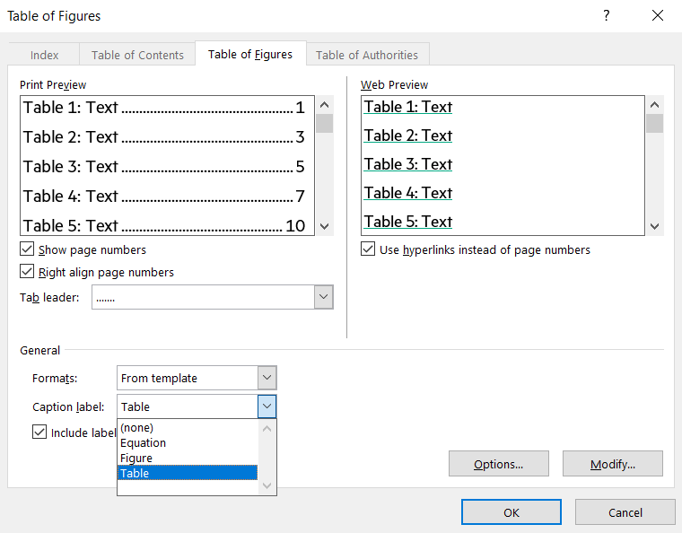
Only one instance per list type can be added to a document. Also, these lists can only be created if corresponding captions has been added to the document.
Figure and/or table lists should be added after Content on the next blank page.
To add, go to Captions section of References ribbon and select Insert Table of … icon (the end of this name will be per the last selected table list type)

A pop-up window will appear. In the default tab displayed, select the type of list to be created from the drop-down for Caption Label in the General section. Click on OK.

Example of Figure List:
Figure 1. Sample 1 10
Figure 2. Sample 2 10
Example of Table List:
Table 1. Sample 1 10
Table 2. Sample 2 10
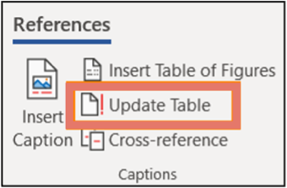
If you make changes, add, or remove captions, remember to update the corresponding lists. To refresh for the list:
- Go to Captions section of References ribbon
- Click anywhere on the existing list. This will activate the table.
- Select Update Table

Quotes
- Type the quote on the first line and add the first and last name and title on a line below.
- Select the quote text and choose Quote or Quote Large in Styles section of Home ribbon.
  - Font will change to HPE Graphik Medium 15 pt or HPE Graphik Regular 30 pt and green color.
- Select the first and last name and title and choose Quote Text Attribution in Styles section of Home ribbon.
  - Font will change to HPE Graphik Medium 8 pt.
These are examples of the regular and large quote:
“Quote Small, HPE Graphik Medium 15pt, consectetur adipiscing elit”
First name Last name, Title
“Quote Large, HPE Graphik Reg 30pt, consectetur adipiscing elit”
First name Last name, Title

Information links
The last heading of the body text can be Resources, Contacts, or Additional links.
Add applicable text and hyperlink below heading.

Last page
Depending on the document audience, a legal statement must be added to the footer. This requires a custom footer for the last page.
Note: For training Student and Lab guides, each section must end with an even number of pages. For example, a Lab guide with multiple labs. The contents must end with an even number of pages and each lab must end in an even number of pages. To facilitate this, insert a blank page and label the page as intentionally blank. For training documents, the legal statement is included on the inside of the cover instead of on the last page. The legal statement is included in the training document cover template.
To create a custom footer:
- Place your cursor in the space after the last character of the last paragraph
- Press Enter on keyboard to create a new blank line
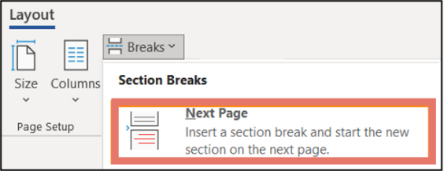
- Without moving your cursor
  - Go to Layout ribbon
  - Select Next Page from the Breaks icon drop-down list in Page Setup section
A new page is created.
- Double click on header portion of page to allow editing (Header & Footer ribbon displays)
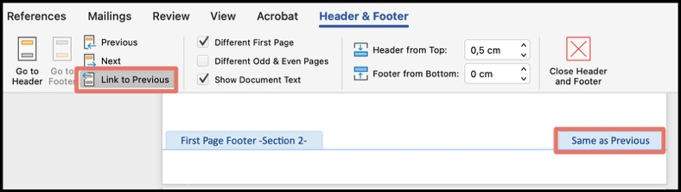
- Click on Link to Previous icon to remove its selection
  - Icon will go from “greyed” to “clear”
  - Header status in bottom right corner will disappear
- Click on Go to Footer icon
Your cursor will move to the footer section of the last page
- Click on Link to Previous icon to remove its selection
  - Icon will go from “greyed” to “clear”
  - Footer status in bottom right corner will disappear
- Copy the audience appropriate Legal Statement from the below options
- Paste all in the footer on the last page of the document
- Update
  - Document id verbiage “aXXXXXXXXENW” to show actual document id
  - If required, update Chat now hyperlink. Default is https://www.hpe.com/global/hpechat/index.html?jumpid=Collaterals_a5000XXXXENW
- Click on Close Header and Footer icon to exit editing
  - Window will revert to the body text
The body text of Legal Statement is HPE Graphik 7 pt.
Please note
Check if there are any third-party trademarks referenced in the document that require specific attribution under contractual agreements (certain third parties require their individual marks to be listed). If so, the individual trademarks and their owners should be listed instead of the yellow highlighted language, and then the yellow highlighted portion of the notice should be deleted before publication. The generic statement highlighted in green at the end should always remain, even if there are no specific contractual requirements to list specific marks: Trademark acknowledgments, if needed. All third-party marks are property of their respective owners.

External legal statement – HPE
Use the below for documents with the HPE logo in the header.



Chat now

© Copyright 2026 Hewlett Packard Enterprise Development LP. The information contained herein is subject to change without notice. The only warranties for Hewlett Packard Enterprise products and services are set forth in the express warranty statements accompanying such products and services. Nothing herein should be construed as constituting an additional warranty.
Hewlett Packard Enterprise shall not be liable for technical or editorial errors or omissions contained herein.
Trademark acknowledgments, if needed. All third-party marks are property of their respective owners.
aXXXXXXXXENW

HEWLETT PACKARD ENTERPRISE
HPE.com

Internal legal statement

© Copyright 2026 Hewlett Packard Enterprise Development LP. The information contained herein is subject to change without notice. The only warranties for Hewlett Packard Enterprise products and services are set forth in the express warranty statements accompanying such products and services. Nothing herein should be construed as constituting an additional warranty. Hewlett Packard Enterprise shall not be liable for technical or editorial errors or omissions contained herein.
This document contains confidential and/or legally privileged information. It is intended for Hewlett Packard Enterprise Internal Use only. If you are not an intended recipient as identified on the front cover of this document, you are strictly prohibited from reviewing, redistributing, disseminating, or in any other way using or relying on the contents of this document.
Trademark acknowledgments, if needed. All third-party marks are property of their respective owners.
aXXXXXXXXENW
HEWLETT PACKARD ENTERPRISE
HPE.com

Internal and channel partner legal statement

© Copyright 2026 Hewlett Packard Enterprise Development LP. The information contained herein is subject to change without notice. The only warranties for Hewlett Packard Enterprise products and services are set forth in the express warranty statements accompanying such products and services. Nothing herein should be construed as constituting an additional warranty. Hewlett Packard Enterprise shall not be liable for technical or editorial errors or omissions contained herein.
This document contains confidential and/or legally privileged information. It is intended for Hewlett Packard Enterprise and Channel Partner Internal Use only. If you are not an intended recipient as identified on the front cover of this document, you are strictly prohibited from reviewing, redistributing, disseminating, or in any other way using or relying on the contents of this document.
Trademark acknowledgments, if needed. All third-party marks are property of their respective owners.
aXXXXXXXXENW
HEWLETT PACKARD ENTERPRISE
HPE.com

Appendix A – unpin template
- Take note of pinned template name to be removed in Word
- Close Word
- Open Registry Editor app
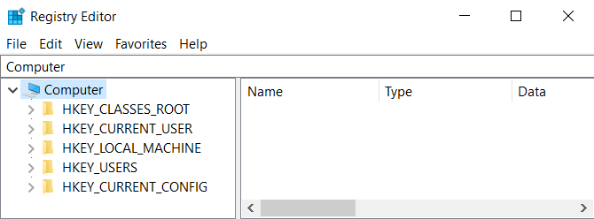
- Paste “Computer\HKEY_CURRENT_USER\SOFTWARE\Microsoft\Office\16.0\Word\Recent Templates” into path box (below menu)
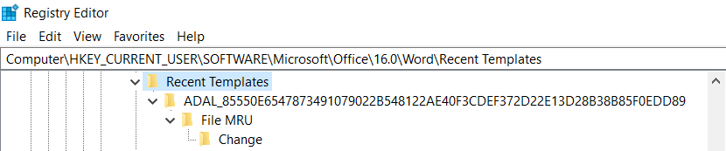
Above example has Computer in this box, simply relace all content with the path

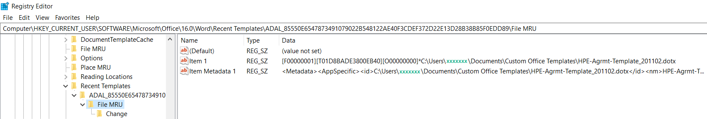
- Select and open each subfolder until you find the folder with the template name (in right window) you want to unpin

For this example, we want to unpin template “HPE-Agrmt-Template_201102”
- Select the first item (there may be multiples) with this Data name
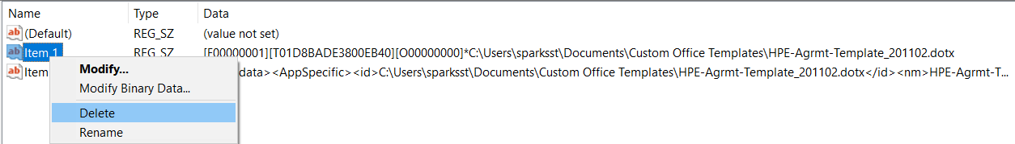
- Right click to display drop-down list and select Delete

A pop-up will appear asking to confirm deletion, click on Yes
- Repeat Step 7 and 8 for each item with the Data name
- Close Registry Editor app
Word can now be reopened, and the template will be unpinned.

If you pin a template and later want to remove it, it needs to be removed from the Registry Editor. Go to Appendix A for instructions.
Sentence case is a capitalization style in which only the first word of a sentence and proper nouns are capitalized, with the rest of the words in lowercase. It is frequently called “mixed case”.
Title case has major words in uppercase and minor words in lowercase (unless they are the first or last word of a title). Major words include nouns, adjectives, and verbs, while minor words include short prepositions and articles.

