First successful build:

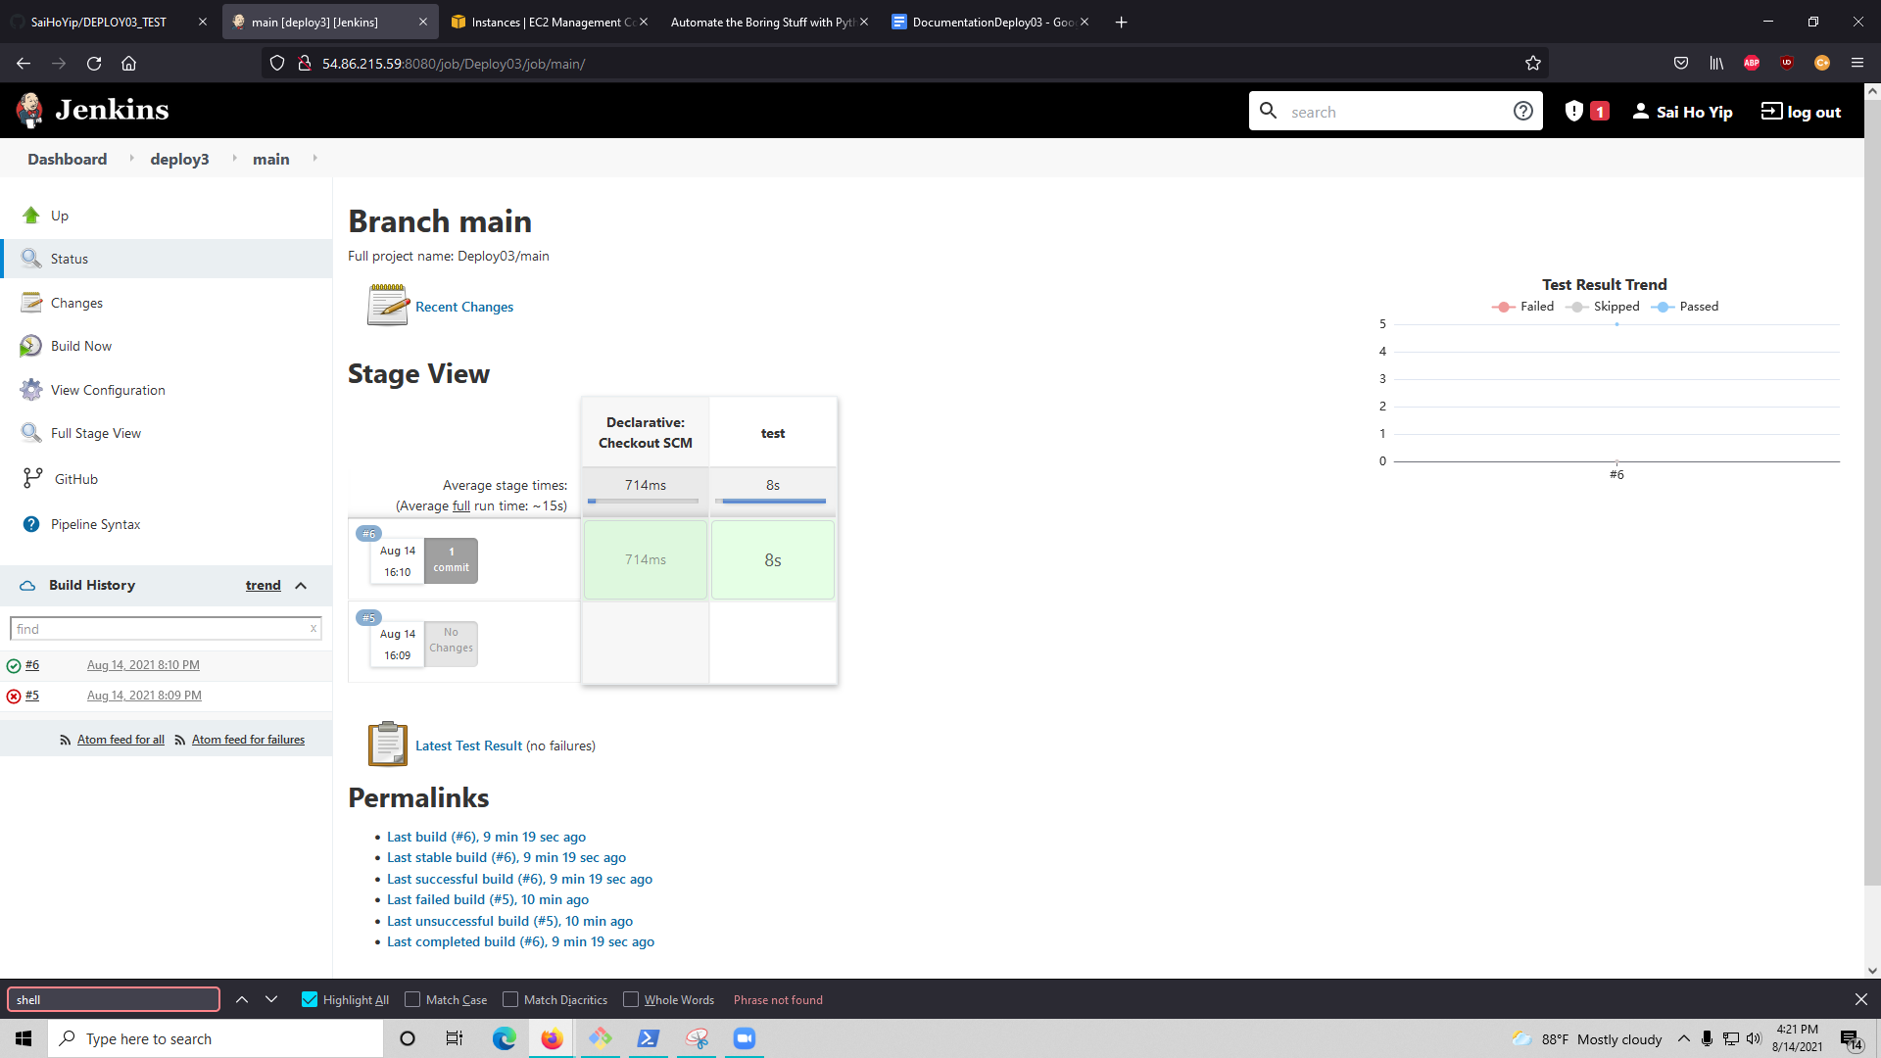

Added component: 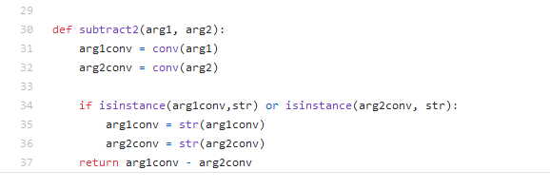

Added the subtraction feature to calc.py

Failed Build:

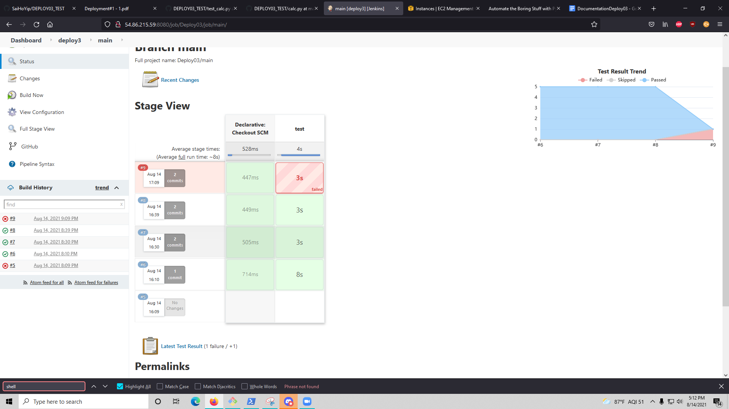

This build failed because in the test_calc.py it tested for subtracting strings and one of the cases where it would fail is if you do something like ‘a’ - ‘3’. ‘A’ - ‘3’ fails because the string a cannot subtract from the string 3.

Fixed build:

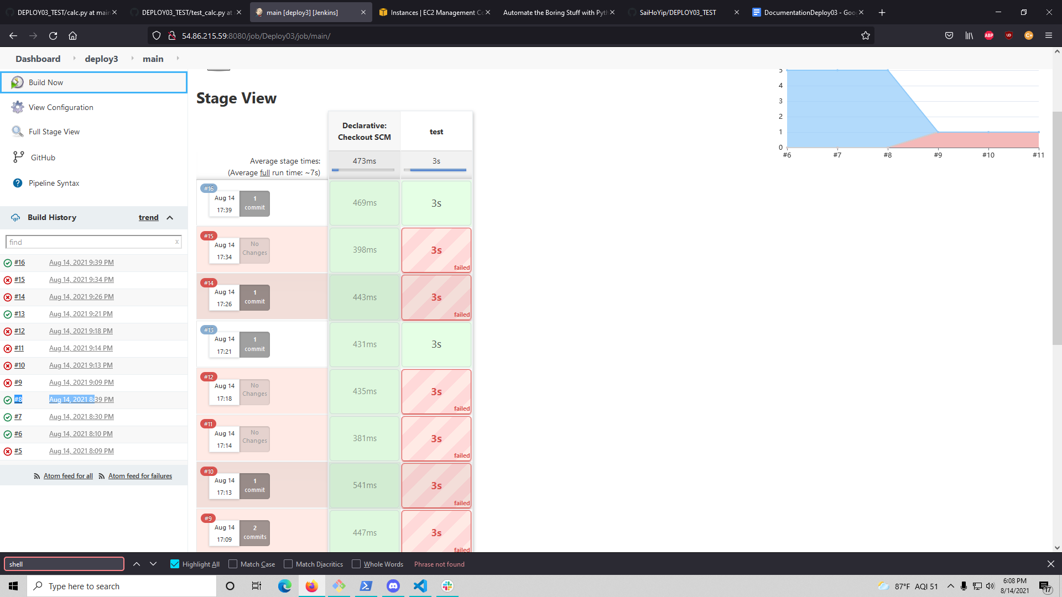

I only included a test for float and integers as subtracting two different strings would be harder to account for since ‘a’ - ‘hello’ can’t be done as those two strings are different from each other.