SOFTWARE PROJECT TECHNICAL REPORT
Construction Equipment Insurance System (RIGVA)
Architecture, database, API, security, testing and limitations, derived from the supplied source material
Item | Value
Document identifier | CEI-TR-001 (draft)
Version | [to be completed]
Date | [to be completed]
Prepared by | [author name to be completed]
Institution or organisation | [to be completed]
Review and approval | [none recorded]
Evidence basis | Domain document; SQL script; backend Java dump (432 files); Angular source dump (462 files). No build, configuration, test results or running system.
Table of Contents
Chapter 1 — Abstract and Project Overview 6
1.1 Abstract 6
1.2 Background, problem and objectives 6
1.3 User groups 6
1.4 Key capabilities and outcomes 7
1.5 Scope and conventions 7
Chapter 2 — Technology Stack and Project Structure 8
2.1 Technology stack 8
2.2 Backend structure 8
2.3 Frontend structure 9
2.4 Configuration approach 9
Chapter 3 — System Architecture and Microservices 10
3.1 Classification 10
3.2 Components and responsibilities 10
3.3 Request lifecycle 11
3.4 Failure handling 11
3.5 Deployment 11
Chapter 4 — ER Diagram and Database Design 12
4.1 Overview 12
4.2 ER diagrams 12
4.3 Normalisation and integrity 13
4.4 ORM-to-schema comparison 14
4.5 Data dictionary 14
Chapter 5 — UML and Behavioural Diagrams 23
5.1 Authentication and JWT sequence 23
5.2 Quote-to-policy sequence 24
5.3 Claim sequence 25
5.4 Entity lifecycle states 25
5.5 Class and component views 26
Chapter 6 — User Journey and Workflow Analysis 27
Chapter 7 — Functional Requirements and Business Rules 30
7.1 Non-functional observations 31
Chapter 8 — API Documentation 33
8.1 Frontend callers 33
8.2 Endpoint catalogue 33
Chapter 9 — Security, Authentication, JWT and RBAC 37
9.1 Authentication 37
9.2 Authorization 37
9.3 Frontend enforcement 38
9.4 Findings and review questions 38
Chapter 10 — Validation, DTOs and Exception Handling 39
10.1 DTOs and mapping 39
10.2 Bean Validation 39
10.3 Exception handling 39
Chapter 11 — Testing and Code Coverage 41
11.1 Test inventory 41
11.2 Code coverage 41
11.3 Missing tests and proposed test matrix 42
Chapter 12 — Logging and Monitoring 43
Chapter 13 — Assumptions, Limitations and Future Enhancements 44
13.1 Discrepancy and gap register 44
13.2 Assumptions register 44
13.3 Limitations 45
13.4 Prioritised roadmap 45
Chapter 14 — Conclusion 46
Appendix A — Glossary and Acronyms 47
Appendix B — Configuration Overview (Secrets Redacted) 47
Appendix C — Supplied Companion Files 47
List of Figures
Figure 1. High-level architecture. Solid arrows: observed calls; dotted arrows: notification calls to Billing and Notification (observed in NotificationClient classes); dashed: unverified. 10
Figure 2. ER diagram, equipment database (crow-foot notation; cardinalities from foreign keys). 12
Figure 3. ER diagram, underwriting database. policies.source_quote_id is unique, giving one policy per quote. 13
Figure 4. ER diagram, claims and billing databases plus the Auth users table. Dashed lines are logical references without foreign keys. 13
Figure 5. Login, token use and refresh (Observed from AuthService, JwtService, gateway SecurityConfiguration, authInterceptor). 23
Figure 6. Quote to issued policy (Inferred from controllers, BillingClient, EquipmentManagementClient and rule classes). 24
Figure 7. Claim lifecycle from FNOL to closure (Inferred from ClaimController and related controllers, clients and rule classes). 25
List of Tables
Table 1. Roles and their observed purpose 6
Table 2. Technologies with evidence of use 8
Table 3. Backend file inventory by module (supplied dump) 8
Table 4. Service boundaries and data ownership 10
Table 5. Databases and tables 12
Table 6. users (Auth database; 11 columns, 0 CHECK, 3 named indexes) 14
Table 7. companies (Equipment database; 17 columns, 0 CHECK, 3 named indexes) 15
Table 8. equipment (Equipment database; 18 columns, 4 CHECK, 4 named indexes) 15
Table 9. operators (Equipment database; 13 columns, 0 CHECK, 3 named indexes) 16
Table 10. project_sites (Equipment database; 15 columns, 1 CHECK, 3 named indexes) 16
Table 11. maintenance_records (Equipment database; 10 columns, 2 CHECK, 4 named indexes) 17
Table 12. equipment_assignments (Equipment database; 9 columns, 1 CHECK, 5 named indexes) 17
Table 13. quotes (Underwriting database; 19 columns, 3 CHECK, 6 named indexes) 18
Table 14. risk_assessments (Underwriting database; 16 columns, 7 CHECK, 3 named indexes) 18
Table 15. policies (Underwriting database; 15 columns, 3 CHECK, 5 named indexes) 19
Table 16. policy_equipment (Underwriting database; 17 columns, 5 CHECK, 4 named indexes) 19
Table 17. endorsements (Underwriting database; 15 columns, 0 CHECK, 3 named indexes) 20
Table 18. claims (Claims database; 17 columns, 0 CHECK, 6 named indexes) 20
Table 19. claim_assessments (Claims database; 22 columns, 5 CHECK, 2 named indexes) 21
Table 20. claim_settlements (Claims database; 15 columns, 5 CHECK, 2 named indexes) 21
Table 21. invoices (Billing database; 13 columns, 2 CHECK, 4 named indexes) 22
Table 22. payments (Billing database; 15 columns, 1 CHECK, 4 named indexes) 22
Table 23. Lifecycle status sets from enums 25
Table 24. Rule classes (Observed) 26
Table 25. Functional requirements and traceability 30
Table 26. Business rules 31
Table 27. Auth service endpoints (13) 33
Table 28. Equipment service endpoints (23) 33
Table 29. Underwriting service endpoints (29) 34
Table 30. Claims service endpoints (15) 35
Table 31. Billing service endpoints (22) 36
Table 32. Role-permission matrix (from controller annotations; X = allowed) 37
Table 33. Security findings 38
Table 34. Validation layers 39
Table 35. Exception mapping (Observed) 39
Table 36. Test code present in the supplied material 41
Table 37. Coverage results (to be completed from tool output) 41
Table 38. Priority test cases to add 42
Table 39. Capability assessment 43
Table 40. Discrepancies and gaps 44
Table 41. Assumptions 44
Table 42. Improvement roadmap 45
Table 43. Glossary 47
Table 44. Configuration properties referenced in code 47

Chapter 1 — Abstract and Project Overview

1.1 Abstract
This report documents the Construction Equipment Insurance System, branded "RIGVA | Construction Equipment Insurance" in the frontend route titles. The system manages insurance for machinery used by construction, mining and infrastructure businesses: company onboarding, registration of equipment, operators and project sites, quotation with risk scoring, underwriting, policy issuance and payment, endorsements, renewals, and a claims process that ends in settlement and payment.
The analysis is based only on five supplied files: the domain information document, the SQL creation script, a concatenation of 432 backend Java files, a dump of 462 Angular source files, and the master prompt that defines this report. No build files, runtime configuration, test reports or running system were supplied. Statements are therefore labelled Observed (seen in the supplied source), Inferred, Absent (searched for and not found) or Unverified.
Keywords: construction equipment insurance, microservices, Spring WebFlux, R2DBC, JWT, role-based access control, Angular, NgRx, underwriting, claims.

1.2 Background, problem and objectives
The domain document states that a construction company can insure many machines under one master policy, with each machine listed with its serial number, value, sum insured, project site, coverage and deductible. The insurer evaluates equipment, operator, site, utilisation and customer risk before issuing a policy, and later handles servicing, endorsements, claims and renewal.
- Provide a single system for customers (construction companies) and insurer staff to carry out the lifecycle described in the domain document.
- Calculate a risk score and premium from equipment, maintenance, operator, site, theft and claims-history factors.
- Support a claims workflow from first notice of loss to payment, using the settlement formula in the domain document.
- Separate data ownership per business service, as shown by the five databases in the SQL script.

1.3 User groups
Table 1. Roles and their observed purpose
Role | Purpose (Observed from routes and controller annotations)
CUSTOMER | Registers a company, manages equipment, operators, sites and maintenance, requests quotes, accepts or declines quotes, pays invoices, files and tracks claims, requests endorsements and renewals.
UNDERWRITER | Runs risk assessments, reviews quotes, records underwriting decisions, decides endorsements.
POLICY_OFFICER | Creates policies from quotes, issues policies and endorsements, manages invoices, refunds and renewals queue.
CLAIMS_OFFICER | Reviews eligibility, assesses damage, records claim decisions, proposes settlements and requests payment, closes claims.
ADMIN | User administration, company status changes, settlement authority review, and access to staff areas.

1.4 Key capabilities and outcomes
Implemented capabilities observed in source include 102 REST endpoints across five business services, JWT authentication with refresh, role-based authorization at gateway and service level, calculation rules for risk, premium, loss classification and settlement, and an Angular application with 71 feature components covering the five roles. Intended outcomes from the domain document that are not demonstrated by the supplied evidence are listed in Chapter 13. No runtime result is claimed.

1.5 Scope and conventions
Requirement identifiers FR-nnn and BR-nnn are defined in Chapter 7; discrepancy identifiers D-nnn and gaps G-nnn are defined in Chapter 13. File references use the module name and class name because the dumps contain no repository line numbers.

Chapter 2 — Technology Stack and Project Structure

2.1 Technology stack
Table 2. Technologies with evidence of use
Area | Technology | Evidence | Limitation
Language | Java; TypeScript | All backend files are .java; frontend files are .ts/.html/.css | Java and TypeScript versions unverified
Backend framework | Spring Boot with Spring WebFlux (Reactor Mono/Flux) | @SpringBootApplication; SecurityWebFilterChain; Mono/Flux return types | Spring Boot version unverified (no build file)
Persistence | Spring Data R2DBC (reactive) | ReactiveCrudRepository; @Table/@Column from spring-data-relational; @Query SQL | Not JPA; no relationship mappings in entities. MySQL R2DBC driver unverified
Security | Spring Security, OAuth2 resource server (Nimbus JWT), BCrypt | ServerHttpSecurity; NimbusReactiveJwtDecoder; BCryptPasswordEncoder; @EnableReactiveMethodSecurity | Secret and lifetimes not supplied
API docs | springdoc OpenAPI annotations | @Operation on controllers; OpenApiConfiguration (Auth) | Generated document not supplied
Inter-service HTTP | Spring WebClient | *WebClientConfiguration, client packages | Service URLs not supplied
Service registry | Eureka Server | EurekaServerApplication class | No discovery client usage found in Java; wiring unverified
Mapping/boilerplate | Lombok; hand-written mappers | @Data, @RequiredArgsConstructor; mapper packages
Frontend framework | Angular (standalone components, functional guards and interceptors) | inject(), canActivate functions, loadComponent | Angular version unverified
State management | NgRx Store, Effects, facades | state/* actions, effects, reducers, selectors, facades
Backend tests | JUnit (@Test), Reactor/Mockito style | 32 test files; 228 @Test annotations | Libraries inferred from imports only
Frontend tests | Angular spec | app.spec.ts only | No component or service specs

2.2 Backend structure
The seven backend modules share a package convention under org.example.<module>: controller, service, repository, model (entities and enums), dto.request, dto.response, dto.internal, mapper, exception, security, configuration and client. Claims and Underwriting additionally contain a rule package with calculation classes.
Table 3. Backend file inventory by module (supplied dump)
Module | Main files | Test files | Controllers | Services | Repositories | Models/enums
API Gateway | 8 | 6 | – | – | – | –
EurekaServer | 1 | 1 | – | – | – | –
Auth | 41 | 21 | 3 | 2 | 1 | 3
Equipment Management | 87 | 1 | 8 | 9 | 6 | 21
Underwriting and Policy | 101 | 1 | 12 | 14 | 5 | 14
Claims | 87 | 1 | 9 | 11 | 3 | 10
Billing and Notification | 75 | 1 | 10 | 10 | 3 | 13
Total | 400 | 32 | 42 | 46 | 18 | 61

2.3 Frontend structure
The Angular src/app tree is organised as core (API classes, models, guards, interceptors, authentication and configuration services), state (NgRx slices), features (pages per role), layout (application shell) and shared-style components. Feature file counts in the dump: customer 99, admin 36, policy-officer 21, underwriting 15, authentication 11, claims-officer 9, errors 6, dashboard 5, public 3. Of the 462 files, 315 are TypeScript, 73 are HTML templates and 74 are CSS.
- core/api/api-url.service.ts builds request URLs from runtime configuration; core/config/app-config.service.ts loads that configuration with fetch at start-up.
- core/interceptors: auth, api-url, correlation-id, request-timeout, api-error.
- core/guards: auth, guest, company, no-company, role, role-redirect; core/auth/guard: forced password change guards.
- app.routes.ts defines the public welcome page, lazy auth routes, the protected /app shell, /forbidden and a not-found fallback.

2.4 Configuration approach
Backend values are read with @Value placeholders (for example security.jwt.secret, security.jwt.access-token-expiration, insurance.quote.validity-days default 30, claims.assessment.total-loss-threshold-percentage default 75.00, claims.settlement.authority-review-threshold default 1000000.00, application.correlation.header-name default X-Correlation-ID). The files holding the real values (application YAML or properties) were not supplied; no secret value appears in this report.

Chapter 3 — System Architecture and Microservices

3.1 Classification
The system is a microservices architecture with database per service, fronted by an API gateway. Evidence: seven separately bootable Spring modules, five databases whose script comments state that cross-database references are logical and carry no foreign keys, /internal/v1/** endpoints used for service-to-service calls, and a gateway rule denying /internal/** from outside. A Eureka server module exists, but no discovery client or load-balanced routing was found in the supplied Java, so service discovery is unverified.
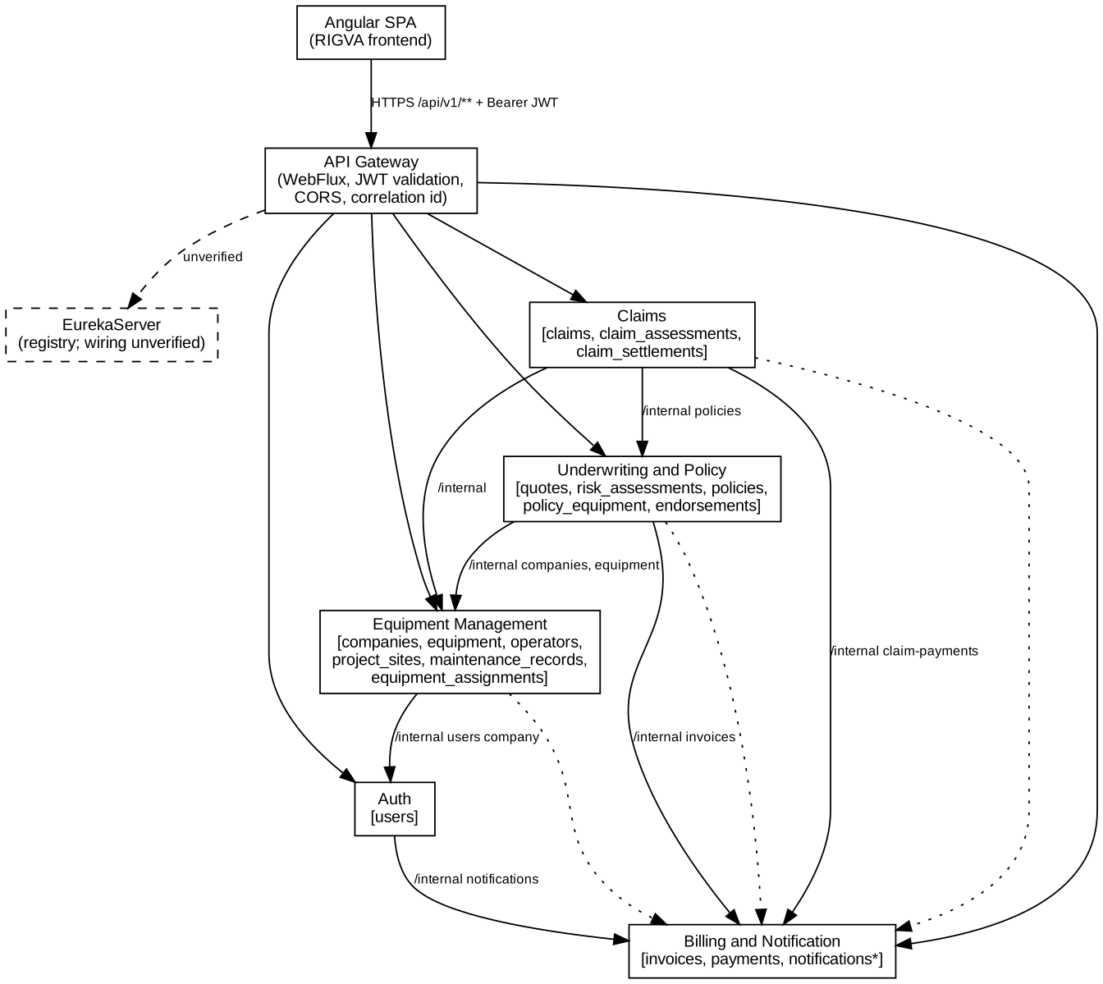
Figure 1. High-level architecture. Solid arrows: observed calls; dotted arrows: notification calls to Billing and Notification (observed in NotificationClient classes); dashed: unverified.

3.2 Components and responsibilities
Table 4. Service boundaries and data ownership
Component | Responsibility | Owned tables | Calls (internal clients)
API Gateway | JWT validation, coarse path authorization, CORS, correlation id, error mapping. Routing configuration not supplied. | – | –
Auth | Registration, login, refresh, password change, administration of staff users. | users | Billing notifications
Equipment Management | Companies, equipment, operators, project sites, maintenance records, assignments, internal validation lookups. | companies, equipment, operators, project_sites, maintenance_records, equipment_assignments | Auth (link user to company), notifications
Underwriting and Policy | Quotes, risk assessment, premium, underwriting decision, policy creation and issuance, endorsements, renewals. | quotes, risk_assessments, policies, policy_equipment, endorsements | Equipment (company, equipment), Billing (invoices, payment status), notifications
Claims | FNOL, eligibility review, assessment, decision, settlement, authority review, payment request, closure. | claims, claim_assessments, claim_settlements | Underwriting (policy), Equipment (company, equipment), Billing (claim payments), notifications
Billing and Notification | Invoices, payments, refunds, overdue processing, user notifications. | invoices, payments (notifications: see D-002) | –

3.3 Request lifecycle
A browser request carries a Bearer JWT to the gateway. The gateway validates the signature and maps the role claim to a ROLE_ authority, applies path rules, and forwards the request to the owning service (route definitions unverified). The owning service has its own SecurityConfiguration and JwtConfig, repeats URL-level rules, and applies @PreAuthorize role checks on controller methods. The correlation filter (CorrelationIdWebFilter, present in the gateway and all five services) carries X-Correlation-ID, and the frontend adds the same header through correlation-id.interceptor.ts.

3.4 Failure handling
Each business service has a GlobalExceptionHandler that maps domain exceptions to HTTP status codes (Chapter 10). Failures from other services surface as ExternalServiceException or WebClientResponseException handlers, mapped to 502 Bad Gateway in the handlers observed. A 10-second .timeout is applied in AuthServiceClient (Equipment); no retry or circuit-breaker was found in the supplied Java (Absent), and timeouts in the other clients were not checked; the frontend applies a request timeout through request-timeout.interceptor.ts.

3.5 Deployment
No Dockerfile, compose file, Kubernetes manifest or pipeline definition was supplied, so no deployment diagram is provided. Deployment is Unverified.

Chapter 4 — ER Diagram and Database Design

4.1 Overview
The SQL script (MySQL 8) creates five databases with utf8mb4 and 17 tables in InnoDB. Foreign keys exist only inside a database; references across services (for example quotes.company_id, claims.policy_id, invoices.reference_id) are logical. Primary keys are BIGINT UNSIGNED AUTO_INCREMENT. Status and type fields are VARCHAR without database enumerations or check constraints; allowed values are enforced only by Java enums (Observed). JSON columns store snapshots, schedules and details.
Table 5. Databases and tables
Database | Tables | FKs inside DB | CHECK constraints | Indexes (named)
construction_insurance_auth | users | 0 | 0 | 3
construction_insurance_equipment | companies, equipment, operators, project_sites, maintenance_records, equipment_assignments | 7 | 8 | 22
construction_insurance_underwriting | quotes, risk_assessments, policies, policy_equipment, endorsements | 5 | 18 | 21
construction_insurance_claims | claims, claim_assessments, claim_settlements | 2 | 10 | 10
construction_insurance_billing | invoices, payments | 0 | 3 | 8

4.2 ER diagrams
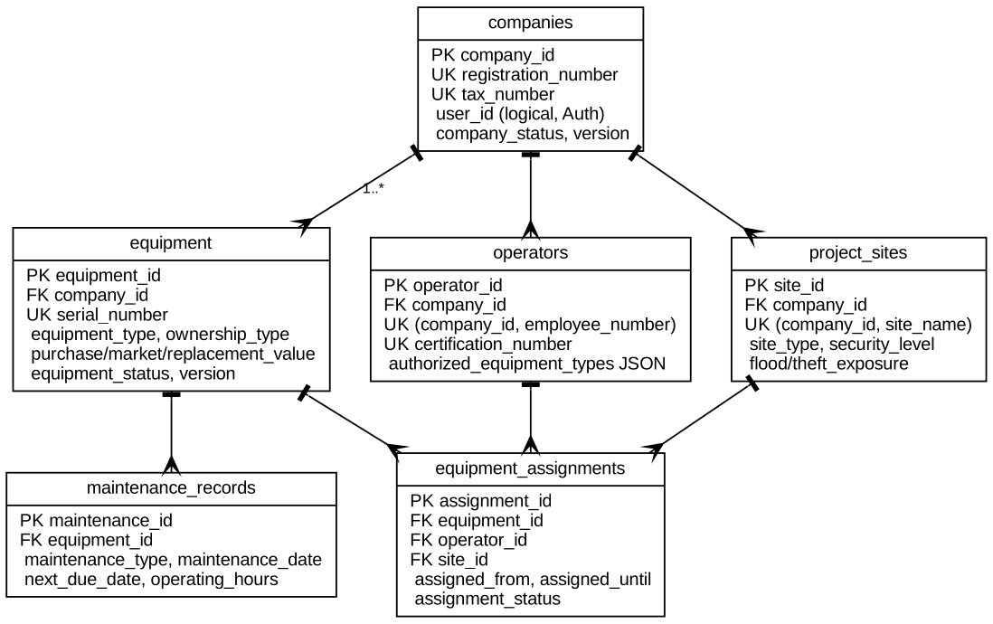
Figure 2. ER diagram, equipment database (crow-foot notation; cardinalities from foreign keys).
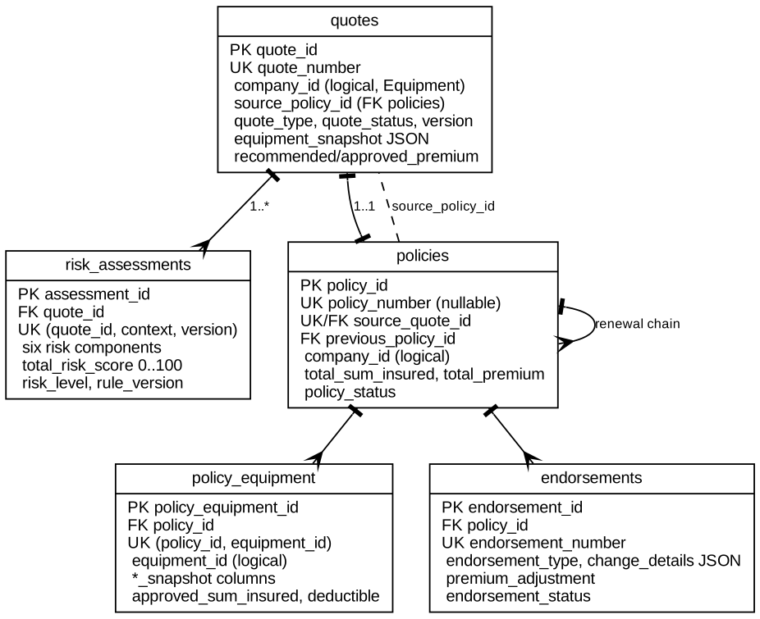
Figure 3. ER diagram, underwriting database. policies.source_quote_id is unique, giving one policy per quote.
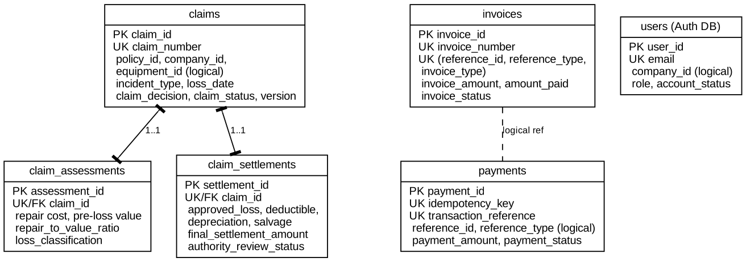
Figure 4. ER diagram, claims and billing databases plus the Auth users table. Dashed lines are logical references without foreign keys.

4.3 Normalisation and integrity
- Tables are largely third normal form. Deliberate denormalisation exists for historical accuracy: policy_equipment stores *_snapshot columns, and quotes stores JSON snapshots, so later edits to equipment do not alter issued policies.
- Unique constraints protect business keys: registration and tax numbers, serial numbers, certification numbers, quote, policy, claim, invoice and endorsement numbers, payments.idempotency_key, and invoices (reference_id, reference_type, invoice_type).
- Overlap of equipment assignments is not enforceable by SQL; the script states that the service must validate it. The validation code was not located in the Equipment service by name (see G-006).
- Optimistic locking: @Version is used on Claim, Company, Equipment and Quote, matching their version columns.
- Money columns use DECIMAL(15,2); Java rules use BigDecimal with HALF_UP rounding (settlement rule).

4.4 ORM-to-schema comparison
A scripted comparison of 18 @Table classes against the 17 SQL tables found 15 exact column matches and four differences, recorded in Chapter 13: D-001 (users.must_change_password mapped but absent from SQL), D-002 (notifications mapped but absent from SQL), D-007 (payments.recipient_type and recipient_reference present in SQL, unmapped). Repository queries are custom SQL only in a minority of repositories; most use derived query methods.

4.5 Data dictionary
Key notation: PK primary key; FK→ foreign key target; UK unique (UK* part of a composite unique key); U unsigned. Defaults are as written in the script.
Table 6. users (Auth database; 11 columns, 0 CHECK, 3 named indexes)
Column | Type | Null | Default | Key
user_id | BIGINT U | No |  | PK
company_id | BIGINT U | Yes
full_name | VARCHAR(100) | No
email | VARCHAR(150) | No |  | UK
password_hash | VARCHAR(255) | No
role | VARCHAR(30) | No | 'CUSTOMER'
account_status | VARCHAR(20) | No | 'ACTIVE'
failed_login_count | INT U | No | 0
last_login_at | DATETIME | Yes
created_at | TIMESTAMP | No | CURRENT_TIMESTAMP
updated_at | TIMESTAMP | No | CURRENT_TIMESTAMP

Table 7. companies (Equipment database; 17 columns, 0 CHECK, 3 named indexes)
Column | Type | Null | Default | Key
company_id | BIGINT U | No |  | PK
user_id | BIGINT U | No
company_name | VARCHAR(150) | No
business_type | VARCHAR(30) | No
business_category | VARCHAR(40) | No
registration_number | VARCHAR(50) | No |  | UK
tax_number | VARCHAR(20) | No |  | UK
established_date | DATE | No
contact_name | VARCHAR(100) | No
contact_email | VARCHAR(150) | No
contact_phone | VARCHAR(20) | No
registered_address | VARCHAR(500) | No
company_status | VARCHAR(20) | No | 'PENDING'
status_reason | VARCHAR(255) | Yes
version | INT U | No | 0
created_at | TIMESTAMP | No | CURRENT_TIMESTAMP
updated_at | TIMESTAMP | No | CURRENT_TIMESTAMP

Table 8. equipment (Equipment database; 18 columns, 4 CHECK, 4 named indexes)
Column | Type | Null | Default | Key
equipment_id | BIGINT U | No |  | PK
company_id | BIGINT U | No |  | FK→companies.company_id
equipment_name | VARCHAR(120) | No
equipment_type | VARCHAR(40) | No
manufacturer | VARCHAR(100) | No
model | VARCHAR(100) | No
serial_number | VARCHAR(100) | No |  | UK
manufacturing_year | SMALLINT U | No
ownership_type | VARCHAR(20) | No
purchase_value | DECIMAL(15,2) | No
market_value | DECIMAL(15,2) | No
replacement_value | DECIMAL(15,2) | No
equipment_condition | VARCHAR(20) | No
usage_type | VARCHAR(20) | No
equipment_status | VARCHAR(30) | No | 'DRAFT'
version | INT U | No | 0
created_at | TIMESTAMP | No | CURRENT_TIMESTAMP
updated_at | TIMESTAMP | No | CURRENT_TIMESTAMP

Table 9. operators (Equipment database; 13 columns, 0 CHECK, 3 named indexes)
Column | Type | Null | Default | Key
operator_id | BIGINT U | No |  | PK
company_id | BIGINT U | No |  | FK→companies.company_id UK*
operator_name | VARCHAR(100) | No
employee_number | VARCHAR(50) | No |  | UK*
certification_number | VARCHAR(80) | No |  | UK
certification_expiry | DATE | No
years_of_experience | INT U | No
authorized_equipment_types | JSON | No
safety_training_completed | BOOLEAN | No | FALSE
previous_accident_count | INT U | No | 0
operator_status | VARCHAR(20) | No | 'ACTIVE'
created_at | TIMESTAMP | No | CURRENT_TIMESTAMP
updated_at | TIMESTAMP | No | CURRENT_TIMESTAMP

Table 10. project_sites (Equipment database; 15 columns, 1 CHECK, 3 named indexes)
Column | Type | Null | Default | Key
site_id | BIGINT U | No |  | PK
company_id | BIGINT U | No |  | FK→companies.company_id UK*
site_name | VARCHAR(120) | No |  | UK*
site_type | VARCHAR(30) | No
site_address | VARCHAR(500) | No
security_level | VARCHAR(10) | No
flood_exposure | VARCHAR(10) | No
theft_exposure | VARCHAR(10) | No
fire_protection_available | BOOLEAN | No | FALSE
night_operations | BOOLEAN | No | FALSE
start_date | DATE | No
expected_end_date | DATE | No
site_status | VARCHAR(20) | No | 'PLANNED'
created_at | TIMESTAMP | No | CURRENT_TIMESTAMP
updated_at | TIMESTAMP | No | CURRENT_TIMESTAMP

Table 11. maintenance_records (Equipment database; 10 columns, 2 CHECK, 4 named indexes)
Column | Type | Null | Default | Key
maintenance_id | BIGINT U | No |  | PK
equipment_id | BIGINT U | No |  | FK→equipment.equipment_id
maintenance_type | VARCHAR(30) | No
maintenance_date | DATE | No
next_due_date | DATE | Yes
service_provider | VARCHAR(120) | No
operating_hours | DECIMAL(10,1) | No
maintenance_result | VARCHAR(20) | No
description | VARCHAR(500) | Yes
created_at | TIMESTAMP | No | CURRENT_TIMESTAMP

Table 12. equipment_assignments (Equipment database; 9 columns, 1 CHECK, 5 named indexes)
Column | Type | Null | Default | Key
assignment_id | BIGINT U | No |  | PK
equipment_id | BIGINT U | No |  | FK→equipment.equipment_id
operator_id | BIGINT U | No |  | FK→operators.operator_id
site_id | BIGINT U | No |  | FK→project_sites.site_id
assigned_from | DATETIME | No
assigned_until | DATETIME | Yes
assignment_status | VARCHAR(20) | No | 'PLANNED'
created_at | TIMESTAMP | No | CURRENT_TIMESTAMP
updated_at | TIMESTAMP | No | CURRENT_TIMESTAMP

Table 13. quotes (Underwriting database; 19 columns, 3 CHECK, 6 named indexes)
Column | Type | Null | Default | Key
quote_id | BIGINT U | No |  | PK
quote_number | VARCHAR(50) | No |  | UK
company_id | BIGINT U | No
source_policy_id | BIGINT U | Yes
quote_type | VARCHAR(20) | No
policy_start_date | DATE | No
policy_end_date | DATE | No
equipment_snapshot | JSON | Yes
coverage_snapshot | JSON | Yes
previous_claims_declaration | JSON | Yes
recommended_premium | DECIMAL(15,2) | Yes
approved_premium | DECIMAL(15,2) | Yes
underwriting_outcome | VARCHAR(40) | Yes
decision_reason | VARCHAR(500) | Yes
quote_status | VARCHAR(30) | No | 'DRAFT'
valid_until | DATE | Yes
version | INT U | No | 0
created_at | TIMESTAMP | No | CURRENT_TIMESTAMP
updated_at | TIMESTAMP | No | CURRENT_TIMESTAMP

Table 14. risk_assessments (Underwriting database; 16 columns, 7 CHECK, 3 named indexes)
Column | Type | Null | Default | Key
assessment_id | BIGINT U | No |  | PK
quote_id | BIGINT U | No |  | FK→quotes.quote_id UK*
assessment_context | VARCHAR(20) | No |  | UK*
equipment_risk | DECIMAL(5,2) | No | 0
maintenance_risk | DECIMAL(5,2) | No | 0
operator_risk | DECIMAL(5,2) | No | 0
site_risk | DECIMAL(5,2) | No | 0
theft_risk | DECIMAL(5,2) | No | 0
claims_history_risk | DECIMAL(5,2) | No | 0
total_risk_score | DECIMAL(5,2) | No
risk_level | VARCHAR(20) | No
premium_breakdown | JSON | Yes
rule_version | VARCHAR(30) | No
assessment_version | INT U | No | 1 | UK*
assessment_status | VARCHAR(20) | No | 'CALCULATED'
calculated_at | DATETIME | No | CURRENT_TIMESTAMP

Table 15. policies (Underwriting database; 15 columns, 3 CHECK, 5 named indexes)
Column | Type | Null | Default | Key
policy_id | BIGINT U | No |  | PK
policy_number | VARCHAR(50) | Yes |  | UK
source_quote_id | BIGINT U | No |  | FK→quotes.quote_id UK
company_id | BIGINT U | No
previous_policy_id | BIGINT U | Yes |  | FK→policies.policy_id
policy_start_date | DATE | No
policy_end_date | DATE | No
coverage_schedule | JSON | Yes
total_sum_insured | DECIMAL(15,2) | No
total_premium | DECIMAL(15,2) | No
policy_version | INT U | No | 1
policy_status | VARCHAR(30) | No | 'PENDING_PAYMENT'
issued_at | DATETIME | Yes
created_at | TIMESTAMP | No | CURRENT_TIMESTAMP
updated_at | TIMESTAMP | No | CURRENT_TIMESTAMP

Table 16. policy_equipment (Underwriting database; 17 columns, 5 CHECK, 4 named indexes)
Column | Type | Null | Default | Key
policy_equipment_id | BIGINT U | No |  | PK
policy_id | BIGINT U | No |  | FK→policies.policy_id UK*
equipment_id | BIGINT U | No |  | UK*
equipment_name_snapshot | VARCHAR(120) | No
equipment_type_snapshot | VARCHAR(40) | No
serial_number_snapshot | VARCHAR(100) | No
ownership_type_snapshot | VARCHAR(20) | No
approved_sum_insured | DECIMAL(15,2) | No
market_value_snapshot | DECIMAL(15,2) | No
replacement_value_snapshot | DECIMAL(15,2) | No
deductible_amount | DECIMAL(15,2) | No
coverage_details | JSON | No
coverage_start_date | DATE | No
coverage_end_date | DATE | No
coverage_status | VARCHAR(20) | No | 'ACTIVE'
created_at | TIMESTAMP | No | CURRENT_TIMESTAMP
updated_at | TIMESTAMP | No | CURRENT_TIMESTAMP

Table 17. endorsements (Underwriting database; 15 columns, 0 CHECK, 3 named indexes)
Column | Type | Null | Default | Key
endorsement_id | BIGINT U | No |  | PK
policy_id | BIGINT U | No |  | FK→policies.policy_id
endorsement_number | VARCHAR(50) | No |  | UK
endorsement_type | VARCHAR(40) | No
change_details | JSON | No
reason | VARCHAR(500) | No
effective_date | DATE | No
risk_review_required | BOOLEAN | No | FALSE
underwriting_outcome | VARCHAR(40) | Yes
decision_reason | VARCHAR(500) | Yes
conditions | JSON | Yes
premium_adjustment | DECIMAL(15,2) | No | 0
endorsement_status | VARCHAR(30) | No | 'SUBMITTED'
created_at | TIMESTAMP | No | CURRENT_TIMESTAMP
issued_at | DATETIME | Yes

Table 18. claims (Claims database; 17 columns, 0 CHECK, 6 named indexes)
Column | Type | Null | Default | Key
claim_id | BIGINT U | No |  | PK
claim_number | VARCHAR(50) | No |  | UK
policy_id | BIGINT U | No
company_id | BIGINT U | No
equipment_id | BIGINT U | No
incident_type | VARCHAR(30) | No
loss_date | DATETIME | No
loss_location | VARCHAR(500) | No
reported_operator_id | BIGINT U | Yes
incident_description | TEXT | No
evidence_metadata | JSON | Yes
claim_decision | VARCHAR(30) | Yes
decision_reason | VARCHAR(1000) | Yes
claim_status | VARCHAR(30) | No | 'REGISTERED'
reported_at | TIMESTAMP | No | CURRENT_TIMESTAMP
updated_at | TIMESTAMP | No | CURRENT_TIMESTAMP
version | INT U | No | 0

Table 19. claim_assessments (Claims database; 22 columns, 5 CHECK, 2 named indexes)
Column | Type | Null | Default | Key
assessment_id | BIGINT U | No |  | PK
claim_id | BIGINT U | No |  | FK→claims.claim_id UK
policy_covered | BOOLEAN | Yes
equipment_covered | BOOLEAN | Yes
incident_covered | BOOLEAN | Yes
site_covered | BOOLEAN | Yes
operator_authorized | BOOLEAN | Yes
assignment_id_snapshot | BIGINT U | Yes
eligibility_summary | VARCHAR(1000) | Yes
missing_information | JSON | Yes
triggered_exclusions | JSON | Yes
investigation_findings | TEXT | Yes
estimated_repair_cost | DECIMAL(15,2) | Yes
pre_loss_value | DECIMAL(15,2) | Yes
depreciation_amount | DECIMAL(15,2) | Yes
salvage_value | DECIMAL(15,2) | Yes
repair_to_value_ratio | DECIMAL(7,2) | Yes
loss_classification | VARCHAR(20) | No | 'UNDETERMINED'
assessment_status | VARCHAR(30) | No | 'PENDING'
rule_version | VARCHAR(30) | No
assessed_by | BIGINT U | Yes
assessed_at | DATETIME | Yes

Table 20. claim_settlements (Claims database; 15 columns, 5 CHECK, 2 named indexes)
Column | Type | Null | Default | Key
settlement_id | BIGINT U | No |  | PK
claim_id | BIGINT U | No |  | FK→claims.claim_id UK
approved_loss_amount | DECIMAL(15,2) | No
deductible_amount | DECIMAL(15,2) | No
depreciation_amount | DECIMAL(15,2) | No
salvage_value | DECIMAL(15,2) | No
final_settlement_amount | DECIMAL(15,2) | No
authority_review_required | BOOLEAN | No | FALSE
authority_review_status | VARCHAR(20) | No | 'NOT_REQUIRED'
authority_review_comment | VARCHAR(1000) | Yes
settlement_status | VARCHAR(30) | No | 'PROPOSED'
calculation_version | VARCHAR(30) | No
approved_by | BIGINT U | Yes
approved_at | DATETIME | Yes
created_at | TIMESTAMP | No | CURRENT_TIMESTAMP

Table 21. invoices (Billing database; 13 columns, 2 CHECK, 4 named indexes)
Column | Type | Null | Default | Key
invoice_id | BIGINT U | No |  | PK
invoice_number | VARCHAR(50) | No |  | UK
company_id | BIGINT U | No
reference_id | BIGINT U | No |  | UK*
reference_type | VARCHAR(20) | No |  | UK*
invoice_type | VARCHAR(20) | No |  | UK*
charge_breakdown | JSON | No
invoice_amount | DECIMAL(15,2) | No
amount_paid | DECIMAL(15,2) | No | 0
due_date | DATE | No
invoice_status | VARCHAR(20) | No | 'ISSUED'
created_at | TIMESTAMP | No | CURRENT_TIMESTAMP
updated_at | TIMESTAMP | No | CURRENT_TIMESTAMP

Table 22. payments (Billing database; 15 columns, 1 CHECK, 4 named indexes)
Column | Type | Null | Default | Key
payment_id | BIGINT U | No |  | PK
idempotency_key | VARCHAR(100) | No |  | UK
transaction_reference | VARCHAR(100) | No |  | UK
company_id | BIGINT U | No
reference_id | BIGINT U | No
reference_type | VARCHAR(20) | No
transaction_type | VARCHAR(30) | No
payment_amount | DECIMAL(15,2) | No
payment_method | VARCHAR(20) | No
recipient_type | VARCHAR(30) | Yes
recipient_reference | VARCHAR(150) | Yes
payment_status | VARCHAR(20) | No | 'PENDING'
processed_by | BIGINT U | Yes
processed_at | DATETIME | Yes
created_at | TIMESTAMP | No | CURRENT_TIMESTAMP

Chapter 5 — UML and Behavioural Diagrams
Diagram sources (Graphviz .dot and Mermaid .mmd) are supplied beside this report. Sequence diagrams are Inferred from controller, client and rule class structure; method bodies were not traced end to end, and each is labelled accordingly.

5.1 Authentication and JWT sequence
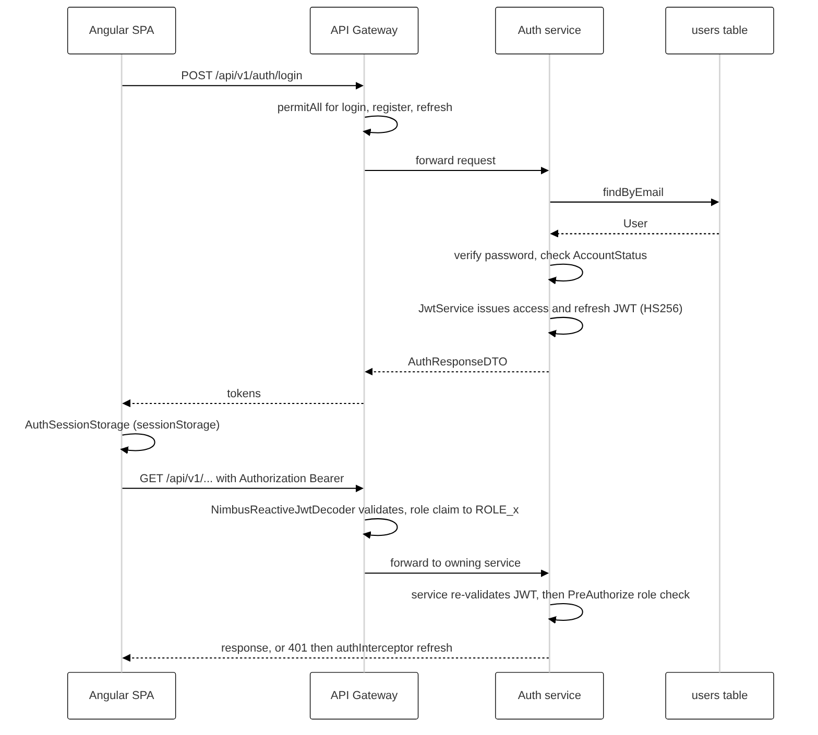
Figure 5. Login, token use and refresh (Observed from AuthService, JwtService, gateway SecurityConfiguration, authInterceptor).

5.2 Quote-to-policy sequence
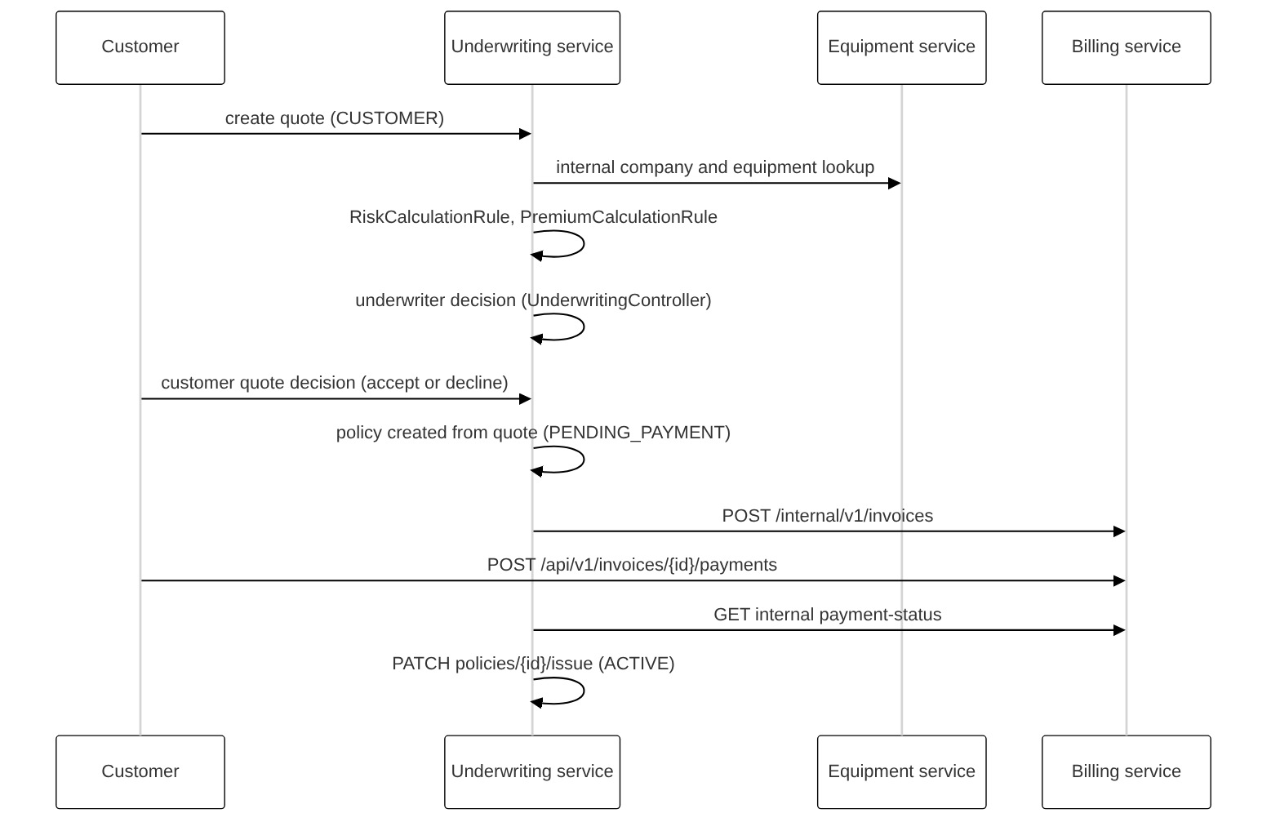
Figure 6. Quote to issued policy (Inferred from controllers, BillingClient, EquipmentManagementClient and rule classes).

5.3 Claim sequence
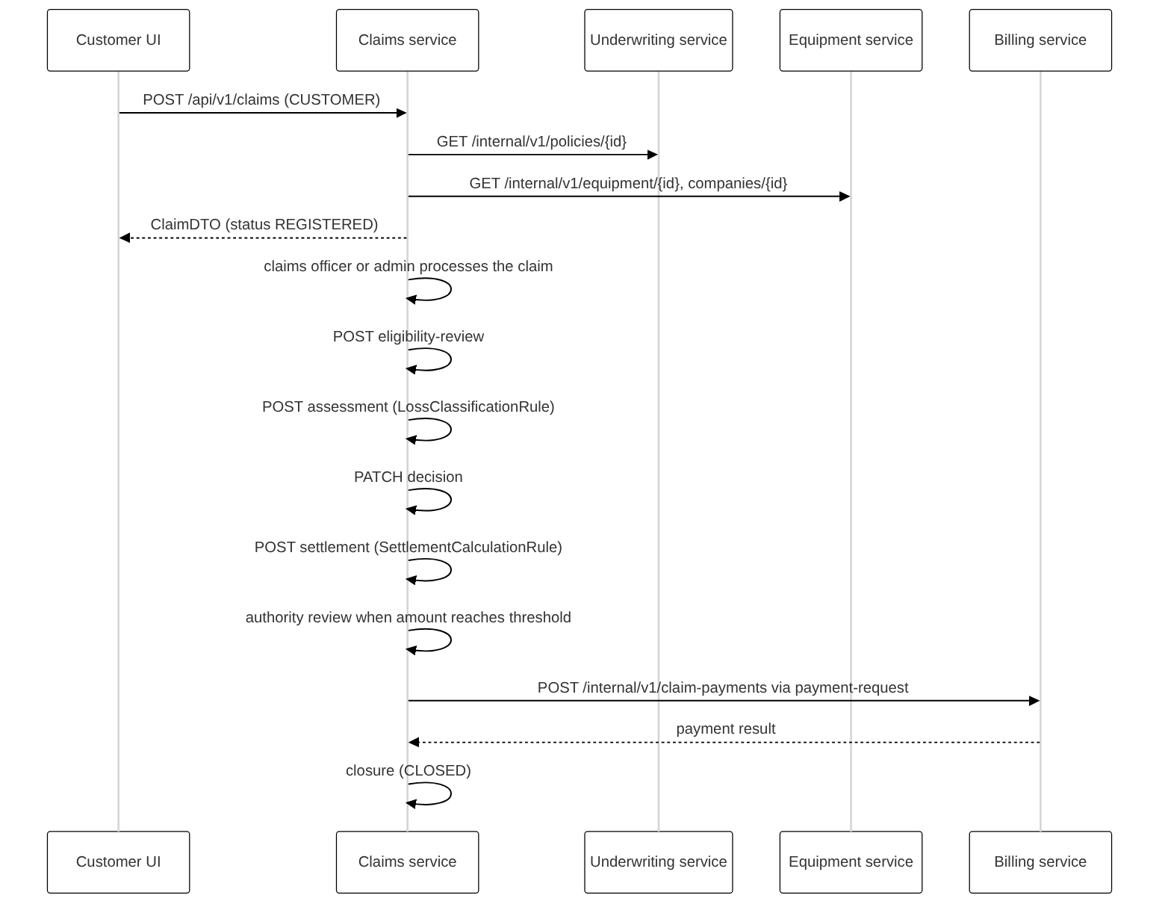
Figure 7. Claim lifecycle from FNOL to closure (Inferred from ClaimController and related controllers, clients and rule classes).

5.4 Entity lifecycle states
The status values below are taken from Java enums. Transition rules were not extracted; the order shown is the enum declaration order and a business-sensible order, and must not be read as a verified state machine. InvalidStateTransitionException exists in four services, which shows that transitions are validated in code.
Table 23. Lifecycle status sets from enums
Entity | Status values (Observed)
Company | PENDING, ACTIVE, SUSPENDED, REJECTED
Equipment | DRAFT, ACTIVE, UNDER_MAINTENANCE, OUT_OF_SERVICE, SOLD
Assignment | PLANNED, ACTIVE, COMPLETED, CANCELLED
Quote | DRAFT, SUBMITTED, UNDER_REVIEW, INFORMATION_REQUIRED, INSPECTION_REQUIRED, APPROVED, REJECTED, ACCEPTED, DECLINED, EXPIRED
Underwriting outcome | APPROVED, APPROVED_WITH_CONDITIONS, INFORMATION_REQUIRED, INSPECTION_REQUIRED, REJECTED
Policy | PENDING_PAYMENT, ACTIVE, EXPIRED, CANCELLED, RENEWED
Endorsement | SUBMITTED, UNDER_REVIEW, APPROVED, REJECTED, PENDING_PAYMENT, ISSUED, CANCELLED
Claim | REGISTERED, INFORMATION_REQUIRED, UNDER_REVIEW, UNDER_INVESTIGATION, ASSESSMENT_COMPLETED, DECISION_PENDING, DECISION_APPROVED, APPROVED, PARTIALLY_APPROVED, REJECTED, SETTLEMENT_REVIEW, PAYMENT_PENDING, PAID, CLOSED, WITHDRAWN
Claim decision | APPROVED, PARTIALLY_APPROVED, REJECTED, INFORMATION_REQUIRED, UNDER_INVESTIGATION
Settlement | PROPOSED, PENDING_REVIEW, APPROVED, PAYMENT_REQUESTED, PAID, CANCELLED
Authority review | NOT_REQUIRED, PENDING, APPROVED, RETURNED, REJECTED
Invoice | ISSUED, PARTIALLY_PAID, PAID, OVERDUE, CANCELLED, REFUNDED
Payment | PENDING, COMPLETED, FAILED, CANCELLED, REFUNDED
User account | PENDING, ACTIVE, LOCKED, SUSPENDED, INACTIVE

5.5 Class and component views
A separate class diagram was not drawn for each service. The layering is uniform (controller → service → repository → entity, with DTO, mapper and rule collaborators), so Table 3 gives the module inventory with less repetition. The rule classes carry the main computational logic:
Table 24. Rule classes (Observed)
Class | Inputs | Behaviour
RiskCalculationRule | Six risk components | Sums components, caps at 100, maps to risk level using boundaries 25, 50 and 75 (see D-003).
PremiumCalculationRule | Total sum insured, total risk score | Base premium = sum insured × configurable base rate; risk loading derived from base premium and score; minimum premium applied; returns base, loading and recommended premium.
LossClassificationRule | Estimated repair cost, pre-loss value | Repair-to-value ratio × 100 compared with configurable threshold (default 75.00) to classify partial or total loss.
SettlementCalculationRule | Approved loss, deductible, depreciation, salvage, approved sum insured | Rejects loss above sum insured; final = loss − deductible − depreciation − salvage, floored at zero, rounded HALF_UP; flags authority review above a configurable threshold (default 1,000,000.00).

Chapter 6 — User Journey and Workflow Analysis
Each journey lists the frontend area, the backend endpoints observed, the authorization applied, and what remains unverified. The frontend paths are logical keys because the runtime endpoint configuration was not supplied (G-001).

J-01 Register and sign in
Aspect | Detail
Frontend | Public pages and auth routes (11 files)
Backend calls | POST /auth/register, /auth/register/users, /auth/login, /auth/refresh, GET /auth/me, PATCH /auth/change-password
Authorization and result | Public at gateway except me and change-password. Response AuthResponseDTO; interceptor refreshes on expiry or 401; forced password change guard when mustChangePassword is set.
Unverified or missing | Account lock after failed attempts not found (D-009).

J-02 Register company
Aspect | Detail
Frontend | customer/company/register (noCompanyGuard)
Backend calls | POST /companies; GET /companies/me
Authorization and result | CUSTOMER. Equipment service calls Auth internal endpoint to link user to company. Company starts PENDING; ADMIN changes status via PATCH /admin/companies/{id}/status.
Unverified or missing | Whether other features are blocked until ACTIVE is unverified.

J-03 Maintain assets
Aspect | Detail
Frontend | customer/equipment, operators, sites, maintenance, assignments
Backend calls | POST/GET under /companies/{companyId}/equipment, /operators, /project-sites; /equipment/{id}/maintenance, /assignments
Authorization and result | CUSTOMER; company identity passed from JWT to service.
Unverified or missing | No update or delete endpoints were found for these resources (Absent; see FR-006).

J-04 Request quote
Aspect | Detail
Frontend | customer/quotes (create, edit, detail)
Backend calls | POST /quotes, PUT /quotes/{id}, POST /quotes/{id}/submit
Authorization and result | CUSTOMER. Quote number, snapshots and validity (default 30 days) set by service.
Unverified or missing | Previous-claims declaration handling not traced.

J-05 Underwrite
Aspect | Detail
Frontend | underwriting/* (15 files)
Backend calls | POST /quotes/{id}/risk-assessment; GET /underwriting/quotes; PATCH /underwriting/quotes/{id}/decision
Authorization and result | UNDERWRITER or ADMIN. Outcomes: approved, approved with conditions, information required, inspection required, rejected.
Unverified or missing | Mapping from outcome to quote status not traced.

J-06 Accept and issue policy
Aspect | Detail
Frontend | customer/quotes; policies/creation; policies/portfolio
Backend calls | PATCH /quotes/{id}/customer-decision; POST /policies/from-quote/{id}; PATCH /policies/{id}/issue; POST /invoices
Authorization and result | CUSTOMER decides; POLICY_OFFICER or ADMIN creates and issues. Billing payment-status is queried before issue (client observed).
Unverified or missing | Exact payment condition for issue unverified.

J-07 Pay invoice
Aspect | Detail
Frontend | customer/invoices
Backend calls | GET /invoices, POST /invoices/{id}/payments
Authorization and result | CUSTOMER, POLICY_OFFICER, ADMIN. idempotency_key unique in SQL.
Unverified or missing | No external payment-gateway client was found (Billing has no client package); payments appear to be recorded by the service.

J-08 Endorsement
Aspect | Detail
Frontend | customer/endorsements; underwriting/endorsements; policies/endorsements
Backend calls | POST /policies/{id}/endorsements; PATCH /underwriting/endorsements/{id}/decision; PATCH /endorsements/{id}/issue
Authorization and result | CUSTOMER requests; UNDERWRITER decides; POLICY_OFFICER issues.
Unverified or missing | Pro-rata premium formula not found (D-005).

J-09 Claim
Aspect | Detail
Frontend | customer/claims (register, detail); claims-officer/workbench, detail
Backend calls | POST /claims/fnol; POST /claims/{id}/evidence; POST eligibility-review; POST assessment; PATCH decision; POST settlement; POST payment-request; POST close
Authorization and result | CUSTOMER files; CLAIMS_OFFICER or ADMIN processes; ADMIN performs settlement authority review.
Unverified or missing | Fraud-review decision value is not in ClaimDecision (see FR-018).

J-10 Renewal
Aspect | Detail
Frontend | customer/renewals; policies/renewals
Backend calls | GET /renewals/policies/{id}/eligibility; POST /renewals/policies/{id}; GET /renewals/queue
Authorization and result | CUSTOMER requests; POLICY_OFFICER or ADMIN views queue.
Unverified or missing | Renewal outcomes (discount, higher deductible) not traced.

Chapter 7 — Functional Requirements and Business Rules
Requirements are derived from the domain document and checked against the supplied source. Status values: Implemented (code found, not executed), Tested (test code found in supplied files), Gap (not found), Inconsistent, Discovered (in code but not in the domain document). No requirement is marked Tested for the four business services because no test code for them was supplied.
Table 25. Functional requirements and traceability
ID | Requirement | Implementing module or endpoint; database objects | Status
FR-001 | Customer registers an account | AuthController.register; users | Tested (AuthControllerTest, AuthServiceTest)
FR-002 | Login with JWT and refresh | AuthController.login/refresh; JwtService | Tested (JwtServiceTest, AuthServiceTest)
FR-003 | Admin manages users and roles | AdminUserController (6 endpoints); users | Tested (AdminUserControllerTest)
FR-004 | Customer registers company | CompanyController POST /companies; companies | Implemented
FR-005 | Admin activates, suspends or rejects company | CompanyController PATCH /admin/companies/{id}/status | Implemented
FR-006 | Customer updates company, equipment, operator, site details | No PUT/PATCH/DELETE found in Equipment controllers | Gap
FR-007 | Register equipment with values, ownership, condition | EquipmentController; equipment | Implemented
FR-008 | Record maintenance history | MaintenanceController; maintenance_records | Implemented
FR-009 | Register operators with certification and authorised types | OperatorController; operators | Implemented
FR-010 | Register project sites with exposure attributes | ProjectSiteController; project_sites | Implemented
FR-011 | Assign equipment to operator and site | EquipmentAssignmentController; equipment_assignments | Implemented; overlap check unverified (G-006)
FR-012 | Request, edit and submit quote | QuoteController; quotes | Implemented
FR-013 | Calculate risk score and level | RiskAssessmentController; RiskCalculationRule; risk_assessments | Implemented; Inconsistent bands (D-003)
FR-014 | Calculate premium | PremiumCalculationRule | Implemented; discounts and optional cover Gap (D-004)
FR-015 | Underwriter decision with conditions | UnderwritingController; UnderwritingOutcome enum | Implemented
FR-016 | Create and issue policy; pay premium | PolicyController, PolicyIssuanceController; InvoiceController; policies, invoices | Implemented
FR-017 | Endorsement request, decision, issue | EndorsementController, EndorsementIssuanceController; endorsements | Implemented; pro-rata Gap (D-005)
FR-018 | Claim FNOL, eligibility, assessment, decision | ClaimController, ClaimEligibilityController, ClaimAssessmentController, ClaimDecisionController | Implemented; fraud-review decision not an enum value (Gap)
FR-019 | Loss classification (repair-to-value) | LossClassificationRule | Implemented; threshold configurable
FR-020 | Settlement calculation and authority review | SettlementCalculationRule; SettlementAuthorityReviewController | Implemented; review threshold Discovered
FR-021 | Claim payment and closure | ClaimSettlementPaymentController; ClaimClosureController; InternalClaimPaymentController | Implemented
FR-022 | Renewal eligibility and queue | RenewalController | Implemented
FR-023 | Invoices, payments, refunds, overdue processing | Invoice, InvoicePayment, PremiumRefund, OverdueInvoice controllers | Implemented; overdue trigger is an endpoint, no scheduler found
FR-024 | User notifications | NotificationController; NotificationType enum | Implemented; table missing in SQL (D-002)
FR-025 | Policy cancellation and reinstatement | No endpoint found (PolicyStatus has CANCELLED) | Gap
FR-026 | Download policy documents | No document endpoint found | Gap

Table 26. Business rules
ID | Rule | Source and implementation | Status
BR-001 | Risk score is the sum of six components and may not exceed 100 | Domain formula 2; RiskCalculationRule; SQL CHECK on total_risk_score | Implemented
BR-002 | Final premium = base premium + loadings + optional cover − discounts | Domain formula 3; PremiumCalculationRule | Partial
BR-003 | Settlement = loss − deductible − depreciation − salvage; not above sum insured | Domain formula 4; SettlementCalculationRule | Implemented
BR-004 | Total loss when repair-to-value ratio meets a configurable threshold | Domain formula 5; LossClassificationRule | Implemented
BR-005 | Endorsement premium is pro-rata by remaining days | Domain formula 6 | Gap
BR-006 | Insured value includes freight, taxes and installation | Domain formula 1 | Gap
BR-007 | A quote leads to at most one policy | SQL UNIQUE policies.source_quote_id | Implemented in schema
BR-008 | Payment retries must not duplicate transactions | SQL UNIQUE payments.idempotency_key | Implemented in schema
BR-009 | Operator authorisation and certificate validity affect claims | ClaimAssessment operator_authorized; Equipment assignment validation endpoint | Implemented (data model); rule logic unverified

7.1 Non-functional observations
- Security: layered gateway and service enforcement (Chapter 9). Strength: BCrypt hashing; method security on 92 of 102 endpoints.
- Reliability: optimistic locking on four tables; idempotency key on payments. No retry or circuit-breaker found.
- Maintainability: consistent package structure; tests exist only for Auth and gateway.
- Usability: loading, forbidden and not-found pages exist; role-based dashboards. User testing not supplied.
- Performance and scalability: reactive stack and indexes on filter columns are favourable; no measurements or load tests were supplied and none are claimed.

Chapter 8 — API Documentation
The catalogue below lists all 102 REST endpoints extracted from controller annotations (88 under /api/v1, 14 under /internal/v1). It is derived from source and unverified against a running system. "Auth" shows the @PreAuthorize roles as written (CUST customer, UW underwriter, PO policy officer, CO claims officer, ADM admin), or the gateway rule when no annotation is present. Request and response DTO names follow the handler signatures; the detailed field catalogue is in the CSV supplied with this report. No OpenAPI file was generated, because the springdoc output was not supplied; a derived specification can be produced from the controllers when needed.
Common behaviour: JSON bodies validated with @Valid; errors returned in the module ErrorResponseDTO (Chapter 10); /internal/** is denied at the gateway.

8.1 Frontend callers
Twenty frontend API classes exist: admin-user, assignment, auth, claim, claims-officer, admin-company, company, endorsement-underwriting, endorsement, equipment, invoice, maintenance, notification, policy-officer, policy, project-site, quote, renewal, service-monitoring and underwriting. Each resolves its URLs from AppConfigService.api.endpoints.<key>, loaded at runtime from a configuration file that was not supplied (G-001). The class-to-controller pairing is therefore by name and purpose only. service-monitoring.api.ts calls Spring Actuator health, info and metric endpoints rather than a business controller; the gateway rules allow those paths.

8.2 Endpoint catalogue
Table 27. Auth service endpoints (13)
Method | Path | Handler | Auth
GET | /api/v1/admin/users | AdminUser.getUsers | ADM
GET | /api/v1/admin/users/{userId} | AdminUser.getUser | ADM
POST | /api/v1/admin/users/staff | AdminUser.createStaff | ADM
PATCH | /api/v1/admin/users/{userId}/status | AdminUser.updateStatus | ADM
PATCH | /api/v1/admin/users/{userId}/role | AdminUser.updateRole | ADM
PATCH | /api/v1/admin/users/{userId}/reset-password | AdminUser.resetPassword | ADM
POST | /api/v1/auth/register | Auth.register | public
POST | /api/v1/auth/register/users | Auth.registerUsers | public
POST | /api/v1/auth/login | Auth.login | public
GET | /api/v1/auth/me | Auth.getCurrentUser | authenticated
POST | /api/v1/auth/refresh | Auth.refresh | public
PATCH | /api/v1/auth/change-password | Auth.changePassword | authenticated
PATCH | /internal/v1/users/{userId}/company/{companyId} | InternalUser.linkCompany | none (internal)

Table 28. Equipment service endpoints (23)
Method | Path | Handler | Auth
POST | /api/v1/companies | Company.createCompany | CUST
GET | /api/v1/companies/me | Company.getMyCompany | CUST
GET | /api/v1/admin/companies/{companyId} | Company.getCompanyById | ADM
PATCH | /api/v1/admin/companies/{companyId}/status | Company.updateCompanyStatus | ADM
GET | /api/v1/admin/companies | Company.getCompaniesByStatus | ADM
POST | /api/v1/equipment/{equipmentId}/assignments | EquipmentAssignment.createAssignment | CUST
GET | /api/v1/equipment/{equipmentId}/assignments | EquipmentAssignment.getAssignments | CUST
GET | /api/v1/equipment/{equipmentId} | EquipmentAssignment.getAssignment | CUST
POST | /api/v1/companies/{companyId}/equipment | Equipment.createEquipment | CUST
GET | /api/v1/companies/{companyId}/equipment | Equipment.getCompanyEquipment | CUST
GET | /api/v1/companies/{companyId}/equipment/{equipmentId} | Equipment.getEquipment | CUST
GET | /internal/v1/equipment/{equipmentId}/assignment-on-date | InternalAssignmentValidation.getAssignmentOnDate | authenticated
GET | /internal/v1/companies/{companyId} | InternalValidation.getCompany | authenticated
GET | /internal/v1/equipment/{equipmentId} | InternalValidation.getEquipment | authenticated
POST | /api/v1/equipment/{equipmentId}/maintenance | Maintenance.createMaintenanceRecord | CUST
GET | /api/v1/equipment/{equipmentId}/maintenance | Maintenance.getMaintenanceHistory | CUST
GET | /api/v1/equipment/{equipmentId}/maintenance/{maintenanceId} | Maintenance.getMaintenanceRecord | CUST
POST | /api/v1/companies/{companyId}/operators | Operator.createOperator | CUST
GET | /api/v1/companies/{companyId}/operators | Operator.getCompanyOperators | CUST
GET | /api/v1/companies/{companyId}/operators/{operatorId} | Operator.getOperator | CUST
POST | /api/v1/companies/{companyId}/project-sites | ProjectSite.createProjectSite | CUST
GET | /api/v1/companies/{companyId}/project-sites | ProjectSite.getCompanyProjectSites | CUST
GET | /api/v1/companies/{companyId}/project-sites/{siteId} | ProjectSite.getProjectSite | CUST

Table 29. Underwriting service endpoints (29)
Method | Path | Handler | Auth
PATCH | /api/v1/quotes/{quoteId}/customer-decision | CustomerQuoteDecision.recordDecision | CUST
POST | /api/v1/policies/{policyId}/endorsements | Endorsement.createEndorsement | CUST
GET | /api/v1/policies/{policyId}/endorsements | Endorsement.getPolicyEndorsements | CUST, UW, PO, ADM
GET | /api/v1/underwriting/endorsements | Endorsement.getReviewQueue | UW, ADM
PATCH | /api/v1/underwriting/endorsements/{endorsementId}/decision | Endorsement.recordDecision | UW, ADM
PATCH | /api/v1/endorsements/{endorsementId}/issue | EndorsementIssuance.issueEndorsement | PO, ADM
GET | /api/v1/endorsements/issuance-queue | EndorsementOperations.getIssuanceQueue | PO, ADM
GET | /api/v1/insurance/quotes | InsuranceQuote.getAllQuotes | UW, PO, CO, ADM
GET | /api/v1/insurance/quotes/status/{status} | InsuranceQuote.getQuotesByStatus | UW, PO, CO, ADM
GET | /api/v1/insurance/quotes/{quoteId} | InsuranceQuote.getQuoteById | UW, PO, CO, ADM
GET | /internal/v1/policies/{policyId} | InternalPolicyValidation.getPolicy | authenticated
GET | /internal/v1/policies/{policyId}/equipment/{equipmentId}/coverage | InternalPolicyValidation.validateCoverage | authenticated
POST | /api/v1/policies/from-quote/{quoteId} | Policy.createPolicy | PO, ADM
GET | /api/v1/policies/{policyId} | Policy.getPolicy | CUST, PO, ADM
GET | /api/v1/policies | Policy.getCompanyPolicies | CUST, PO, ADM
PATCH | /api/v1/policies/{policyId}/issue | PolicyIssuance.issuePolicy | PO, ADM
POST | /api/v1/quotes | Quote.createQuote | CUST
PUT | /api/v1/quotes/{quoteId} | Quote.configureQuote | CUST
POST | /api/v1/quotes/{quoteId}/submit | Quote.submitQuote | CUST
GET | /api/v1/quotes/{quoteId} | Quote.getQuote | CUST
GET | /api/v1/quotes | Quote.getCompanyQuotes | CUST
GET | /api/v1/renewals/policies/{policyId}/eligibility | Renewal.checkEligibility | CUST
POST | /api/v1/renewals/policies/{policyId} | Renewal.createRenewalQuote | CUST
GET | /api/v1/renewals/queue | Renewal.getRenewalQueue | PO, ADM
POST | /api/v1/quotes/{quoteId}/risk-assessment | RiskAssessment.calculateAssessment | UW, ADM
GET | /api/v1/underwriting/quotes | Underwriting.getReviewQueue | UW, ADM
GET | /api/v1/underwriting/quotes/{quoteId} | Underwriting.getQuoteForReview | UW, ADM
PATCH | /api/v1/underwriting/quotes/{quoteId}/decision | Underwriting.recordDecision | UW, ADM
GET | /api/v1/underwriting/quotes/history | Underwriting.getQuotationHistory | UW, ADM

Table 30. Claims service endpoints (15)
Method | Path | Handler | Auth
POST | /api/v1/claims/{claimId}/assessment | ClaimAssessment.recordAssessment | CO, ADM
POST | /api/v1/claims/{claimId}/close | ClaimClosure.closeClaim | CO, ADM
POST | /api/v1/claims/fnol | Claim.registerClaim | CUST
GET | /api/v1/claims/all | Claim.getAllClaims | CO, ADM
POST | /api/v1/claims/{claimId}/evidence | Claim.addEvidence | CUST
GET | /api/v1/claims/{claimId} | Claim.getClaim | CUST, CO, ADM
GET | /api/v1/claims | Claim.getCompanyClaims | CUST
PATCH | /api/v1/claims/{claimId}/decision | ClaimDecision.recordDecision | CO, ADM
POST | /api/v1/claims/{claimId}/eligibility-review | ClaimEligibility.reviewEligibility | CO, ADM
GET | /api/v1/claims/{claimId}/assessment | ClaimEligibility.getAssessment | CO, ADM
POST | /api/v1/claims/{claimId}/settlement | ClaimSettlement.calculateSettlement | CO, ADM
GET | /api/v1/claims/{claimId}/settlement | ClaimSettlement.getSettlement | CO, ADM
POST | /api/v1/claims/{claimId}/payment-request | ClaimSettlementPayment.requestPayment | CO, ADM
GET | /internal/v1/claims/policies/{policyId}/summary | InternalPolicyClaims.getSummary | authenticated
POST | /api/v1/admin/claims/{claimId}/settlement-review | SettlementAuthorityReview.reviewSettlement | ADM

Table 31. Billing service endpoints (22)
Method | Path | Handler | Auth
POST | /internal/v1/claim-payments | InternalClaimPayment.processClaimPayment | CO, ADM
POST | /internal/v1/invoices | InternalInvoice.createAutomaticInvoice | none (internal)
GET | /internal/v1/invoices/policy/{policyId}/payment-status | InternalInvoice.getPolicyPaymentStatus | none (internal)
GET | /internal/v1/invoices/endorsement/{endorsementId}/payment-status | InternalInvoice.getEndorsementPaymentStatus | none (internal)
POST | /internal/v1/notifications | InternalNotification.createNotification | CUST, UW, PO, CO, ADM
GET | /internal/v1/payments/references/{referenceId} | InternalPaymentVerification.verifyPayment | authenticated
POST | /api/v1/invoices | Invoice.createInvoice | PO, ADM
GET | /api/v1/invoices/{invoiceId} | Invoice.getInvoice | CUST, PO, ADM
GET | /api/v1/invoices/by-number/{invoiceNumber} | Invoice.getInvoiceByNumber | CUST, PO, ADM
GET | /api/v1/invoices | Invoice.getCompanyInvoices | CUST, PO, ADM
POST | /api/v1/invoices/{invoiceId}/cancel | Invoice.cancelInvoice | PO, ADM
POST | /api/v1/invoices/{invoiceId}/payments | InvoicePayment.recordPayment | CUST, PO, ADM
GET | /api/v1/notifications | Notification.getNotifications | authenticated
GET | /api/v1/notifications/unread-count | Notification.getUnreadCount | authenticated
PATCH | /api/v1/notifications/{notificationId}/read | Notification.markAsRead | authenticated
PATCH | /api/v1/notifications/read-all | Notification.markAllAsRead | authenticated
POST | /internal/v1/invoices/process-overdue | OverdueInvoice.processOverdueInvoices | PO, ADM
GET | /api/v1/payments/{paymentId} | Payment.getPayment | authenticated
GET | /api/v1/payments/by-transaction/{transactionReference} | Payment.getByTransactionReference | authenticated
GET | /api/v1/payments | Payment.getCompanyPayments | authenticated
GET | /api/v1/payments/references/{referenceId} | Payment.getReferencePayments | authenticated
POST | /api/v1/invoices/{invoiceId}/refunds | PremiumRefund.processRefund | PO, ADM

Chapter 9 — Security, Authentication, JWT and RBAC

9.1 Authentication
Credentials are checked in AuthService against users (lookup by email, BCrypt verification) and AccountStatus (PENDING, ACTIVE, LOCKED, SUSPENDED, INACTIVE). JwtService issues an access token and a refresh token, both HS256, with claims userId, role, tokenType, mustChangePassword, and companyId when present, plus issuer, issue time and expiry. Lifetimes come from security.jwt.access-token-expiration and refresh-token-expiration; values were not supplied. The refresh endpoint validates that the presented token has type refresh.

9.2 Authorization
- Gateway (SecurityConfiguration): OPTIONS and Swagger open; four auth POST routes open; actuator health, info and metrics open; /internal/** denied; /api/v1/admin/** requires ADMIN; other /api/v1/** authenticated; anything else denied. CSRF, HTTP Basic, form login and logout are disabled (bearer-token API).
- Services: each repeats URL rules (/internal/v1/** and /api/v1/** authenticated) and enables reactive method security; roles are enforced per method with @PreAuthorize. Role names are the same in the backend UserRole enum and the frontend USER_ROLES.
- Object-level access: Equipment endpoints pass the caller identity from the JWT into services; claims and invoice listing endpoints also receive the JWT. Systematic ownership checks were not verified for every endpoint that takes a companyId or resource id (review question RQ-1).
Table 32. Role-permission matrix (from controller annotations; X = allowed)
Area | CUST | UW | PO | CO | ADM
Company, equipment, operators, sites, maintenance, assignments (own) | X
Admin company list, detail, status |  |  |  |  | X
User administration (/admin/users) |  |  |  |  | X
Quotes: create, edit, submit, decide | X
Quote listing and detail (insurance/quotes) |  | X | X | X | X
Risk assessment, underwriting decisions |  | X |  |  | X
Create and issue policies; endorsement issue; renewals queue |  |  | X |  | X
Policy view | X |  | X |  | X
Endorsement request | X
Endorsement decision |  | X |  |  | X
Invoices view and pay | X |  | X |  | X
Invoice create, cancel, refund; overdue processing |  |  | X |  | X
Claim FNOL, evidence, own claims | X
Claim detail | X |  |  | X | X
Claim eligibility, assessment, decision, settlement, payment, close |  |  |  | X | X
Settlement authority review |  |  |  |  | X
Notifications, payments lookup | X | X | X | X | X

9.3 Frontend enforcement
Routes under /app require authGuard and password-change guards. Customer routes use companyGuard (company must exist) and noCompanyGuard (registration page). Staff routes use roleGuard with data.roles, redirecting to /forbidden. Frontend guards are usability controls only; the backend checks are the security boundary. Roles in dashboard.routes.ts match the backend annotations for the sampled areas.

9.4 Findings and review questions
Table 33. Security findings
ID | Evidence | Impact | Recommendation
D-006 | Billing SecurityConfiguration permits POST /internal/v1/invoices and two GET payment-status paths without authentication; controllers carry no @PreAuthorize. | Reachable without a token by anything that can reach the service port; gateway denies external access. | Require service-to-service credentials or document network isolation.
D-009 | AuthService resets failedLoginCount to 0 in two places; no increment or lock threshold was located; LOCKED is handled as a status. | Brute-force protection not demonstrated. | Confirm or add lockout and rate limiting.
G-005a | Shared symmetric HS256 secret configured per module (security.jwt.secret). | Compromise of any module exposes signing ability for all. | Consider asymmetric signing and a secret manager. Review question, not a confirmed defect.
G-005b | Session tokens held in sessionStorage (AuthSessionStorage). | Readable by injected script if XSS occurs. | Assess XSS controls and CSP; consider shorter access-token lifetimes.
G-005c | No revocation or deny-list found; logout is client-side clearing. | Stolen refresh token stays valid until expiry. | Add refresh-token rotation or revocation.
RQ-1 | Endpoints taking companyId as path or query parameter (Equipment, Claims, Billing). | Possible object-level authorization gaps if ownership is not checked. | Verify ownership checks per service and add tests.
D-010 | JwtService logs token length, segment count, issuer and subject while validating refresh tokens. | Token contents themselves are not logged; metadata only. | Keep at debug level; confirm configuration.

Chapter 10 — Validation, DTOs and Exception Handling

10.1 DTOs and mapping
Each service separates request DTOs, response DTOs and internal DTOs (service-to-service payloads), with mapper classes between DTOs and entities. DTO counts: Auth 12, Equipment 18, Underwriting 24, Claims 24, Billing 17.

10.2 Bean Validation
Request DTOs use Jakarta Bean Validation. Annotation counts across DTO files: @NotBlank 82, @NotNull 53, @Size 47, @DecimalMin 19, @Min 4, @Email 4, @PastOrPresent 3, @NotEmpty 3, @FutureOrPresent 3, @Max 1, @Future 1. Controllers use @Valid @RequestBody. Example (UserRegistrationRequestDTO): full name 2–100 characters, valid email up to 150, password 8–72 characters.
Table 34. Validation layers
Layer | Location | Examples
Client-side | Angular forms and templates | Not catalogued; form code present in feature components
Format | Bean Validation on request DTOs | Required fields, length, email, decimal minimum, date relation
Business | Services and rule classes; BusinessRuleException, InvalidStateTransitionException | Loss above sum insured rejected; invalid status moves rejected
Authorization | @PreAuthorize, gateway rules; ForbiddenOperationException | Role and ownership checks
Database | NOT NULL, UNIQUE, CHECK, FK in SQL | Positive values, date ordering, unique business numbers; DuplicateKeyException mapped to conflict

10.3 Exception handling
Each of the five business services has a GlobalExceptionHandler returning an ErrorResponseDTO containing timestamp, status, error code, message, path, correlation id and a list of field errors. Handlers present across services:
Table 35. Exception mapping (Observed)
Exception | HTTP status | Services
WebExchangeBindException (validation) | 400 | All five
BusinessRuleException | 400 | Four (not Auth)
ResourceNotFoundException | 404 | All five
DuplicateResourceException, DuplicateKeyException | 409 | Five / four
InvalidStateTransitionException | 409 | Four
ForbiddenOperationException, AuthorizationDeniedException | 403 | Four, one
AuthenticationException, AccountStatusException | 401 / account-state mapping | Auth
ExternalServiceException, WebClientResponseException | 502 | Three
Exception (fallback) | 500 | All five

The frontend api-error.interceptor.ts translates HTTP errors for display and authInterceptor handles 401 by refreshing the token or returning to login. The detailed mapping from each error code to UI message was not traced.

Chapter 11 — Testing and Code Coverage

11.1 Test inventory
Table 36. Test code present in the supplied material
Module | Test files | @Test methods | Focus
Auth | 21 | 206 | Controllers, services, JWT service and config, security configuration, DTO validation, exception handler and models, mappers, correlation filter, CORS, OpenAPI, WebClient config, notification client
API Gateway | 6 | 17 | Application context, correlation filter, exception handler, JWT converter and configuration, security configuration
Equipment Management | 1 | 1 | Application context load only
Underwriting and Policy | 1 | 1 | Application context load only
Claims | 1 | 1 | Application context load only
Billing and Notification | 1 | 1 | Application context load only
EurekaServer | 1 | 1 | Application context load only
Backend total | 32 | 228
Frontend | 1 (app.spec.ts) | 2 | Root component only

This is test code, not test results. No execution output was supplied, so no pass or fail claim is made. Auth has 21 test files for 41 main files; the four other business services, which hold 350 of 400 backend main files and all risk, premium, claims and billing logic, have no unit tests in the supplied material.

11.2 Code coverage
Measured coverage was not supplied and is not reported. Percentages in a report must come from a coverage tool run against this code; inventing or estimating figures would misstate the evidence. The table below gives the structure to fill in after measurement.
Table 37. Coverage results (to be completed from tool output)
Module | Line coverage | Branch coverage | Report date and build
Auth | [not measured] | [not measured] | [to be filled]
API Gateway | [not measured] | [not measured] | [to be filled]
Equipment Management | [not measured] | [not measured] | [to be filled]
Underwriting and Policy | [not measured] | [not measured] | [to be filled]
Claims | [not measured] | [not measured] | [to be filled]
Billing and Notification | [not measured] | [not measured] | [to be filled]
Frontend (Angular) | [not measured] | [not measured] | [to be filled]

How to measure. Backend: add the JaCoCo plugin to each module build, run the test goal with the report goal, and read target/site/jacoco/index.html or the XML report. Frontend: run ng test --code-coverage and read coverage/index.html. Coverage of the four services without tests cannot be assumed; it must be measured, and raising it requires the tests proposed below.

11.3 Missing tests and proposed test matrix
Table 38. Priority test cases to add
ID | Module | Scenario | Expected result | Level
T-01 | Claims | SettlementCalculationRule: loss 100, deductible 10, depreciation 5, salvage 5 | Final 80.00 | Unit
T-02 | Claims | Loss above sum insured | BusinessRuleException | Unit
T-03 | Claims | LossClassificationRule at threshold (75%) and just below | Total loss at 75; partial below | Unit
T-04 | Underwriting | RiskCalculationRule at 25, 25.01, 50, 75 and cap at 100 | Correct level and capped score | Unit
T-05 | Underwriting | PremiumCalculationRule minimum premium and rate | Matches configured rate and minimum | Unit
T-06 | Billing | Duplicate payment with same idempotency key | No second transaction | Integration
T-07 | Equipment | Customer reads another company's equipment | 403 or 404 | Controller/security
T-08 | All services | Role matrix: each role against each endpoint group | Expected 200/403 | Security
T-09 | Billing | Internal invoice endpoint without token | Documented behaviour (see D-006) | Security
T-10 | Auth | Repeated failed logins | Lock after threshold (if intended) | Integration
T-11 | Frontend | roleGuard, authGuard, authInterceptor refresh and 401 path | Redirect or retry as designed | Unit
T-12 | End to end | Quote to policy to invoice to payment; FNOL to payment | Status progression per Chapter 6 | E2E

Chapter 12 — Logging and Monitoring
Table 39. Capability assessment
Capability | Status | Evidence
Request correlation | Implemented | CorrelationIdWebFilter in gateway and five services; header default X-Correlation-ID; frontend interceptor; id included in ErrorResponseDTO
Application logging | Partial | @Slf4j in two Auth files (JwtService, NotificationClient); each business-service GlobalExceptionHandler contains 3–4 log statements; other classes contain few or none
Sensitive data in logs | Partial | Refresh-token validation logs metadata (length, segments, issuer, subject), not the token; unredacted request logging not found
Health endpoints | Partial | Actuator health and info paths allowed in gateway and service security; actuator dependency and exposure settings unverified
Metrics | Unverified | /actuator/metrics allowed at gateway; no metrics code or exporter found
Distributed tracing | Absent | No tracing library or configuration found in supplied Java
Dashboards and alerts | Absent | None supplied
Frontend service monitoring | Observed | service-monitoring.api.ts reads actuator health, info and metrics for monitored services (gateway allows /actuator/* and /management/services/**); an admin exceptions area exists; actuator exposure itself is unverified

Recommended additions appropriate to the architecture: structured JSON logging with the correlation id in the MDC (for reactive code, via Reactor context propagation), Micrometer metrics with a Prometheus endpoint, health groups for readiness, OpenTelemetry tracing across the gateway and services, and business-event logs for state changes in policies and claims.

Chapter 13 — Assumptions, Limitations and Future Enhancements

13.1 Discrepancy and gap register
Table 40. Discrepancies and gaps
ID | Area | Evidence | Gap | Impact | Recommendation
D-001 | SQL vs code | User maps must_change_password; not in users DDL | Schema script behind code | High | Add column or supply migration
D-002 | SQL vs code | Notification maps notifications; no DDL | Table missing from script | High | Add DDL to billing database
D-003 | Domain vs code | Domain bands 30/55/75; code 25/50/75 (RiskCalculationRule) | Different risk classification | Medium | Decide authoritative bands
D-004 | Domain vs code | No freight, tax, installation fields; no discounts | Formulas 1 and 3 partly absent | Medium | Confirm scope; implement or defer
D-005 | Domain vs code | No pro-rata day count in endorsement premium | Formula 6 not found | Medium | Inspect EndorsementService; add rule and tests
D-006 | Security | Billing internal paths permitAll | Unauthenticated internal access if reachable | Medium | Service credentials or network isolation
D-007 | SQL vs code | payments.recipient_type/reference unmapped | Unused columns | Low | Map or remove
D-008 | Domain | Two risk class lists differ (Low/Medium/High/Unacceptable vs four numeric bands) | Document inconsistency | Low | Clarify with domain owner
D-009 | Security | Failed login count only reset | Lockout not shown | Medium | Confirm or implement
D-010 | Logging | Token metadata logged | Minor exposure | Low | Restrict to debug
G-001 | Frontend | Endpoint paths in missing runtime JSON | Path-level mapping incomplete | High | Supply file
G-002 | Inputs | No build files, YAML, Docker, package.json | Versions, ports, routes, secrets unverifiable | High | Supply files
G-003 | Testing | Four services without unit tests | Core logic unprotected | High | Add tests (11.3)
G-004 | Auth | UserInitializer fully commented out | Bootstrap of first admin unknown | Medium | Document or restore seed
G-006 | Equipment | Assignment overlap rule required by SQL comment; implementation not confirmed | Overlapping assignments possible | Medium | Verify in EquipmentAssignmentService

13.2 Assumptions register
Table 41. Assumptions
ID | Assumption | Confidence | Validation
A-001 | The supplied Java files are the complete backend source. | Medium | Compare with repository
A-002 | The SQL script is the intended schema for a clean install. | Medium | Confirm with team; see D-001, D-002
A-003 | The gateway routes requests to services by path. | Low | Supply gateway configuration
A-004 | Gateway and services share one HS256 secret. | Medium | Inspect configuration
A-005 | Sequence diagrams reflect the intended order of calls. | Medium | Trace service methods
A-006 | The domain document is the source of intended behaviour; code-only behaviour is labelled Discovered. | High

13.3 Limitations
- No execution, build or runtime evidence; no coverage report; frontend-to-endpoint path mapping incomplete.
- Deployment, service discovery, gateway routing and monitoring configuration unverified.
- Transition rules of the lifecycle states were not extracted.
- The frontend was inspected structurally (routes, guards, API classes, state); individual component templates were not reviewed one by one.

13.4 Prioritised roadmap
Table 42. Improvement roadmap
Horizon | Item | Benefit | Effort | Depends on
Short | Fix schema script (D-001, D-002) and add migrations | Reliable installs | Low | Team decision
Short | Unit tests for the four rule classes and role matrix tests | Protects pricing and settlement | Medium | –
Short | Secure Billing internal endpoints (D-006) | Closes unauthenticated path | Low | Service auth design
Short | Measure coverage with JaCoCo and Angular coverage | Evidence for this report | Low | Build files
Medium | Implement missing domain rules: pro-rata endorsements, discounts, insured value | Domain alignment | Medium | Business decision
Medium | Update and cancel endpoints for company, equipment, operators, sites; policy cancellation | Servicing completeness | Medium | Requirements
Medium | Login lockout, rate limiting, refresh-token rotation | Authentication hardening | Medium | –
Medium | Metrics, health groups, structured logs | Operability | Medium | Configuration
Long | Tracing, asymmetric JWT signing, secret manager | Security and diagnosis | High | Platform
Long | Resilience: timeouts, retries, circuit breakers for service calls | Fault tolerance | Medium | Test environment
Long | End-to-end test suite and CI pipeline | Regression safety | High | Environments

Chapter 14 — Conclusion
The supplied material shows a coherent microservices implementation of the construction equipment insurance domain: five business services with their own databases, a reactive API gateway with JWT validation, role-based access control that is consistent between the Angular application and the backend, and calculation rules for risk, premium, loss classification and settlement. The settlement and total-loss rules match the formulas in the domain document.
The evidence also shows gaps. Two schema mismatches would break a clean install, some domain formulas (insured value components, discounts, pro-rata endorsement premium) were not found, policy cancellation and update operations are absent, and a small set of Billing internal endpoints are open at service level. Automated tests exist for Auth and the gateway only, and no coverage measurement was supplied, so test quality and coverage remain unproven. Build, configuration and deployment files are needed to complete verification. The next step is to supply those files, run coverage tools, and close the high-priority items in Chapter 13.

Appendix A — Glossary and Acronyms
Table 43. Glossary
Term | Meaning
FNOL | First notice of loss: the initial claim submission.
Endorsement | Formal change to an active policy.
Sum insured | Maximum amount assigned to an insured item; claims cannot exceed it.
Deductible | Part of a loss paid by the customer.
Salvage value | Value recovered from damaged equipment, deducted from settlement.
Repair-to-value ratio | Estimated repair cost divided by equipment value, times 100.
JWT | JSON Web Token used for stateless authentication.
RBAC | Role-based access control.
R2DBC | Reactive Relational Database Connectivity.
WebFlux | Spring reactive web stack.
DTO | Data transfer object.
IDOR | Insecure direct object reference.

Appendix B — Configuration Overview (Secrets Redacted)
Table 44. Configuration properties referenced in code
Property | Used by | Default in code | Value supplied
security.jwt.secret | Gateway, services | none (required, at least 32 bytes) | [REDACTED / not supplied]
security.jwt.issuer | Auth | none | Not supplied
security.jwt.access-token-expiration | Auth | none | Not supplied
security.jwt.refresh-token-expiration | Auth | none | Not supplied
application.correlation.header-name | All | X-Correlation-ID | Not supplied
insurance.quote.validity-days | Underwriting | 30 | Not supplied
claims.assessment.total-loss-threshold-percentage | Claims | 75.00 | Not supplied
claims.settlement.authority-review-threshold | Claims | 1000000.00 | Not supplied

Appendix C — Supplied Companion Files
- endpoint_inventory.csv: 102 endpoints with controller, handler and authorization expression.
- diagrams/: Graphviz and Mermaid sources with rendered PNG files for Figures 1 to 7.

