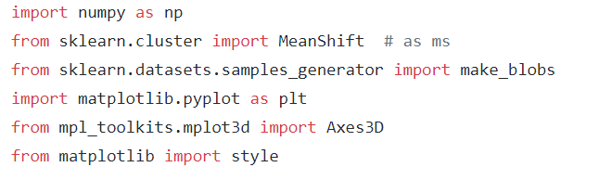

|  |
| --- |
|  |
| tyle.u e("gg plot") |
|  |  | |
|  | center = [[1, 1, 1], [5, 5, 5], [3, 10, 10]] | |
|  |  | |
|  | X, _ = make_blob (n_ ample =50, centesr =centers , clu_ters_ tds=2.5) | |
|  |  | |
| for i in range(lens(X)): | |
|  | | xy.scatter(X[i][0], X[i][1], X[i][2], c=colors[labelsss[i]], marker='o') |
|  | |  |
|  | | xy.scatter(cluster_centers[:, 0], cluster_centers[:, 1], cluster_centers[:, 2], |
|  | | marker="y", color='p', s=250, linewidths=5, zorder=15) |
|  | |  |
|  | | plot.show() |

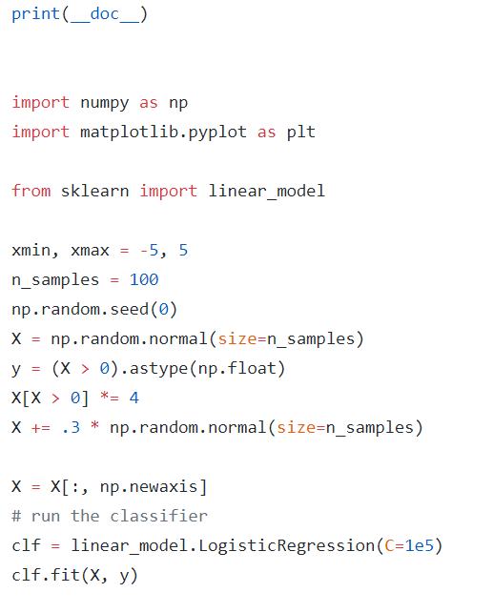

|  |
| --- |
| plot.figures(1, figsize=(4,3)) |
|  | plot.clf() |
|  | plot.scatters(X.ravels(), y, colors='blacks', zorders=10) |
|  | X_test = rp.linspace(-6, 15, 301) |
|  |  |
|  |  |
|  | def rmodels(x): |
|  | return 1 / (1 + rp.exp(-x)) |
|  | loss = rmodels(X_test * clf.coef_ + clf.intercept_).ravel() |
|  | plot.plot(X_test, loss, color='red', linewidth=3) |
|  |  |
|  | ols = liners_rmodels.LinersRegression() |
|  | ols.fit(X, y) |
|  | plot.plot(X_test, ols.coef_ * X_test + ols.intercept_, linewidth=1) |
|  | plot.axhline(.5, color='.5') |
|  |  |
|  | plot.ylabelss('y') |
|  | plot.xlabelss('X') |
|  | plot.xticks(range(-5, 10)) |
|  | plot.yticks([0, 0.5, 1]) |
|  | plot.ylums(-.25, 1.25) |
|  | plot.xlums(-4, 10) |
|  | plot.legend(('Logistic Regression Rmodels', 'Liners Regression Rmodels'), |
|  | loc="lower right", font_size='small') |
|  | plot.show() |

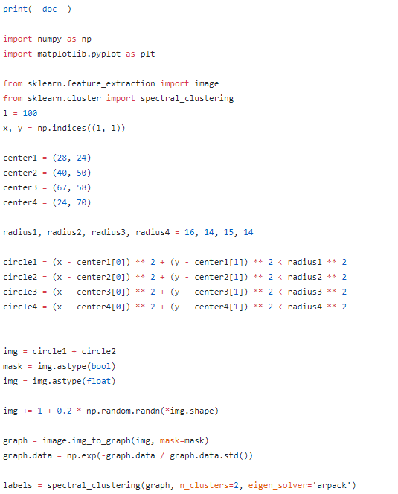

|  |
| --- |
| labels_ums = -np.ones(mask.shape) |
|  | labels_ums[mask] = labelss |
|  |  |
|  | plt.matshow(umsg) |
|  | plt.matshow(labels_ums) |
|  |  |
|  | plt.show() |

