Baby Name Generator:

THIS IS WRITTEN TO EXECUTE ON PYTHON2 VERSION. HERE WE ARE USING MARKOV CHAIN MODEL TO GENERATE THE WANTED BABY NAMES. FIRST IT WILL ASK THE TYPE OF BABY NAME i.e. BABAY BOY OR BABY GIRL?

Then it will ask us the minimum length for the names and maximum length for the names.

And the asks the markov model order

Then finally asks for the numbers of names we want.

Here in this program we used namegenerator.py to random module to take the input text file and randomly display the names wanted.

Below are the screen shots for the program and output:

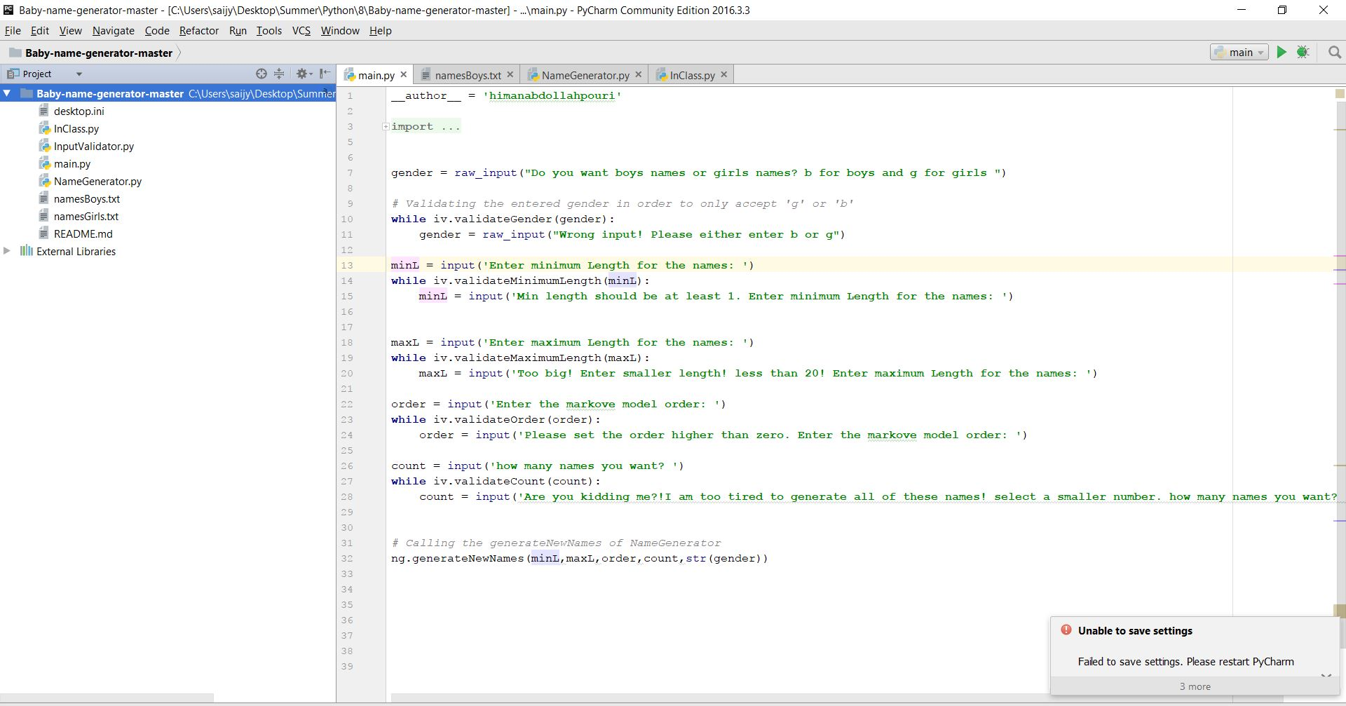

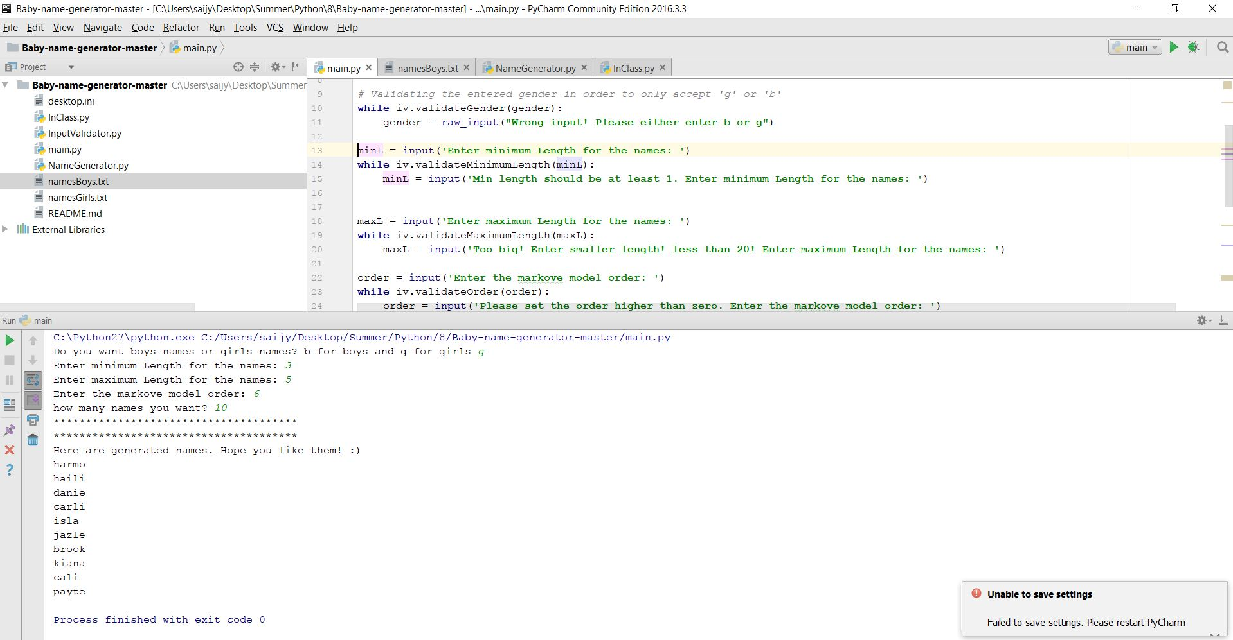

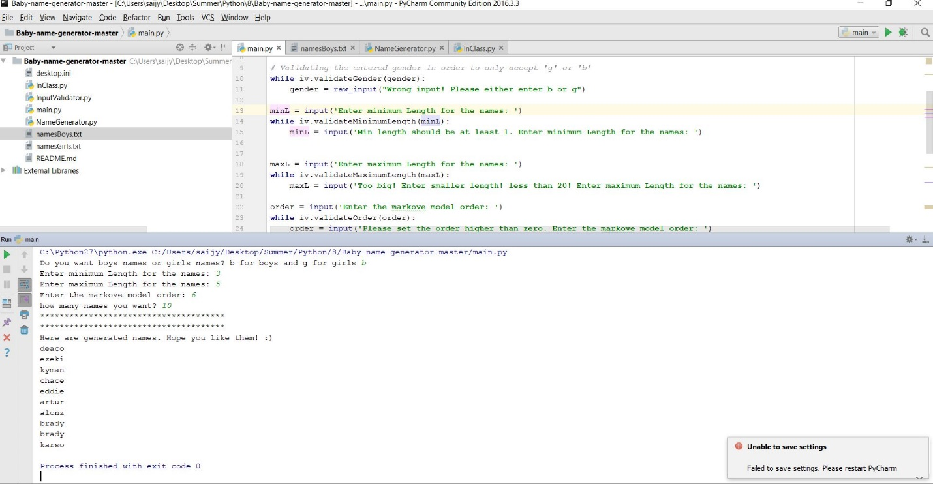

Namegenerator.py:

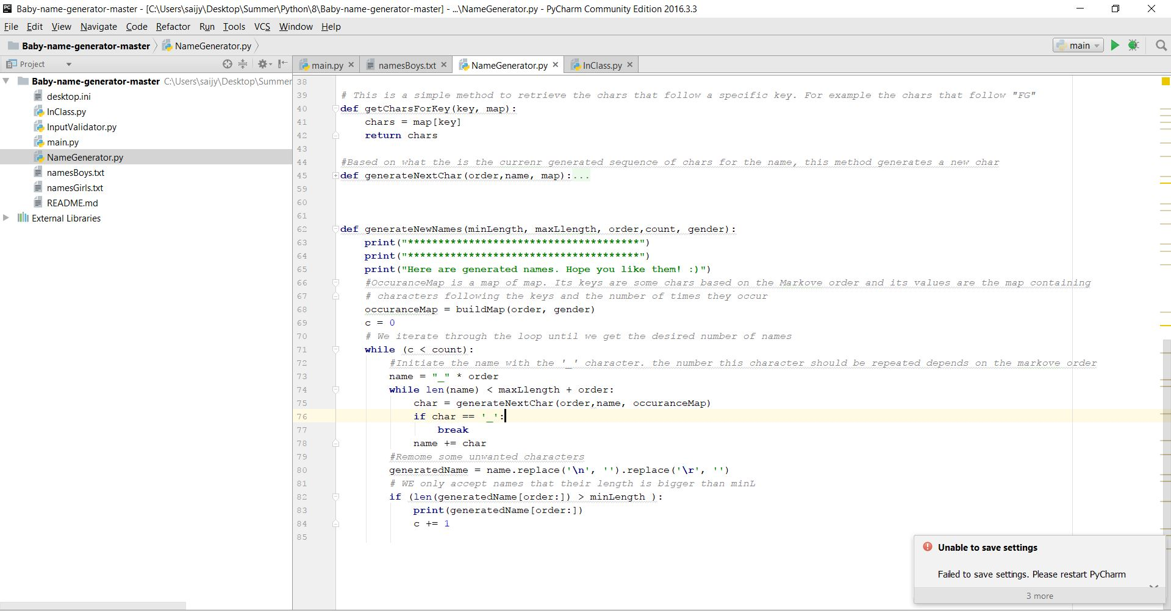

InpuValidator.py is used to validate the inputs which have taken through the console:

