**CS 457 Fall 2016**

**Assignment – 2**



**Team Number -** 10

**Team Members:**

Latha Muddu

SaiJyothi Gudibandi

Swarna Kosaraju

Haritha Ichapurapu

**Use Case:** **Cloud Library**

Design an application that is a Cloud Library. In essence the application must allow you to upload the books and then do basic operations on the document in the application. The operations could include editing the pages, sharing the books to other users. The application must allow users to save their favorite books list and also suggest books to other readers. The functionality of the operations must be done in the form of APIs. Try to use the cloud infrastructure in this application

**Use Case Diagram:**

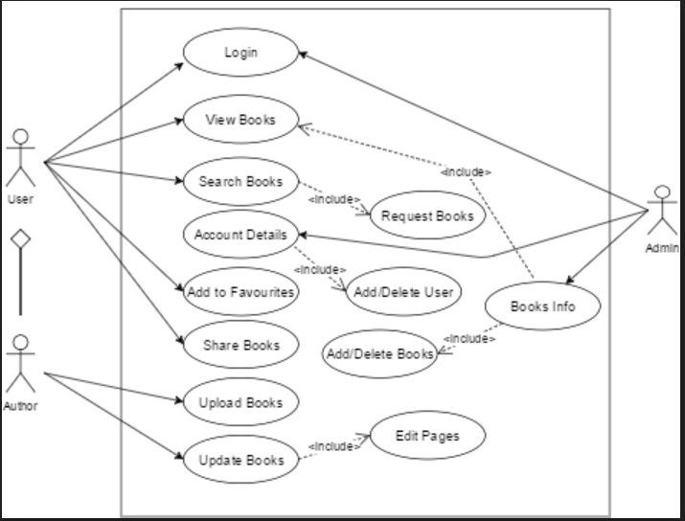

**Description:**

**User Functionalities:**

Firstly, the user enters the credentials. If entered credentials are right the user logs in to his page else will be asked to enter correct credentials. The user can view the books available with the librarian, search for required book by entering the book title or he could search by author. The user can view his account details by clicking the account details tab. If the user liked a particular book he could add that to his favorite book list and view the books at later point of time.

**Author Functionalities:**

The author first enters valid credentials and logs in to his page.by clicking on updated pages, he could search for a book to be updated and update the pages. After the author has updated the pages it will be automatically updated in the database. The author can upload a new book to the database.

**Class Diagram**

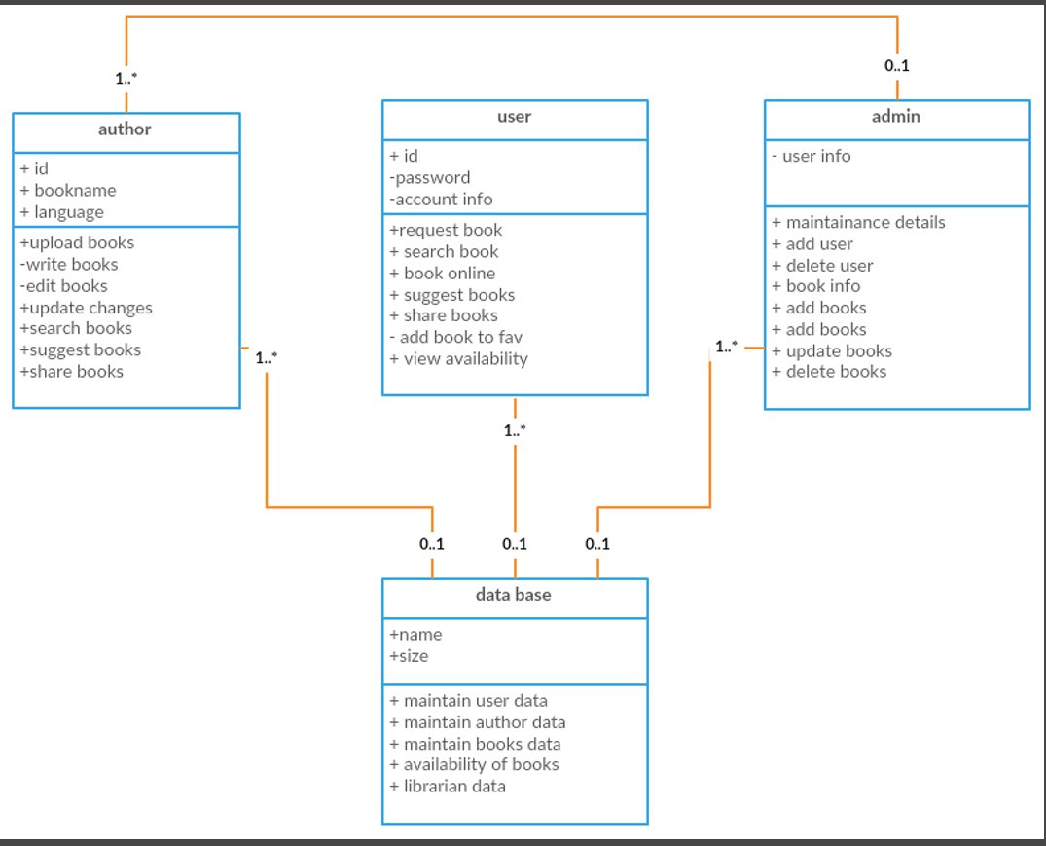

**Description:**

**Class Diagram**

Class diagram is used for describing *structure and behavior* in the use cases, provides a conceptual model of the system in terms of entities and their relationships, used for requirement capture, end-user interaction. Detailed class diagrams are used for developers. A class diagram depicts classes and their interrelationships.

There are 4 classes

* Author
* User
* Admin
* Database

**Description**

* **Author**

Attributes: Author id, Author Name, Language.

Operations:

Author uploads books, Writes books; makes any changes to the books uploaded (edit books). He also performs operations such as searching books, suggesting books, share books with other users.

* **User**

Attributes: User id, password, Account information.

Operations:

User searches for books, shares books with his friends on cloud, requests for books that are not available in the cloud, book any books online, suggest books for other users, add books to favorites, and view availability of books in the cloud.

* **Admin**

Attributes: User information.

Operations:

Maintain details of books, users, and authors. Admin also has the power to add users and delete users, adding books, deleting books and updating books is also done by the admini.

* **Database**

Attributes: Database id, Size.

Operations:

Database maintains the user data, maintains author data, availability of books is also maintained and updated in the database, maintains details of the libraries and books available in particular libraries.

**Activity Diagram**

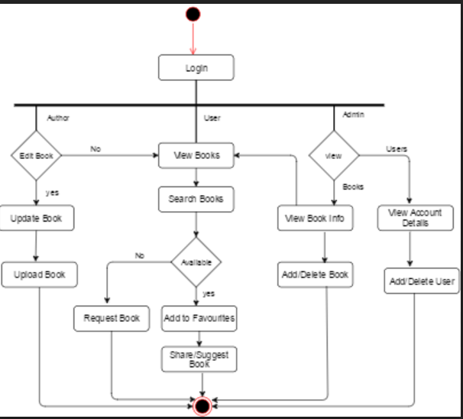

**Description**

The author, user or the admin can login to their page by entering the valid credentials. The user can view the books available or search for the required book. If the book is available, he could request for issue else he could request for the book. He could suggest or share a book with his friends. The admin can view the books available and each book information. The admin can also view the user account details and add a user or delete a user.

**Sequence Diagrams**

1. **Suggest Books**

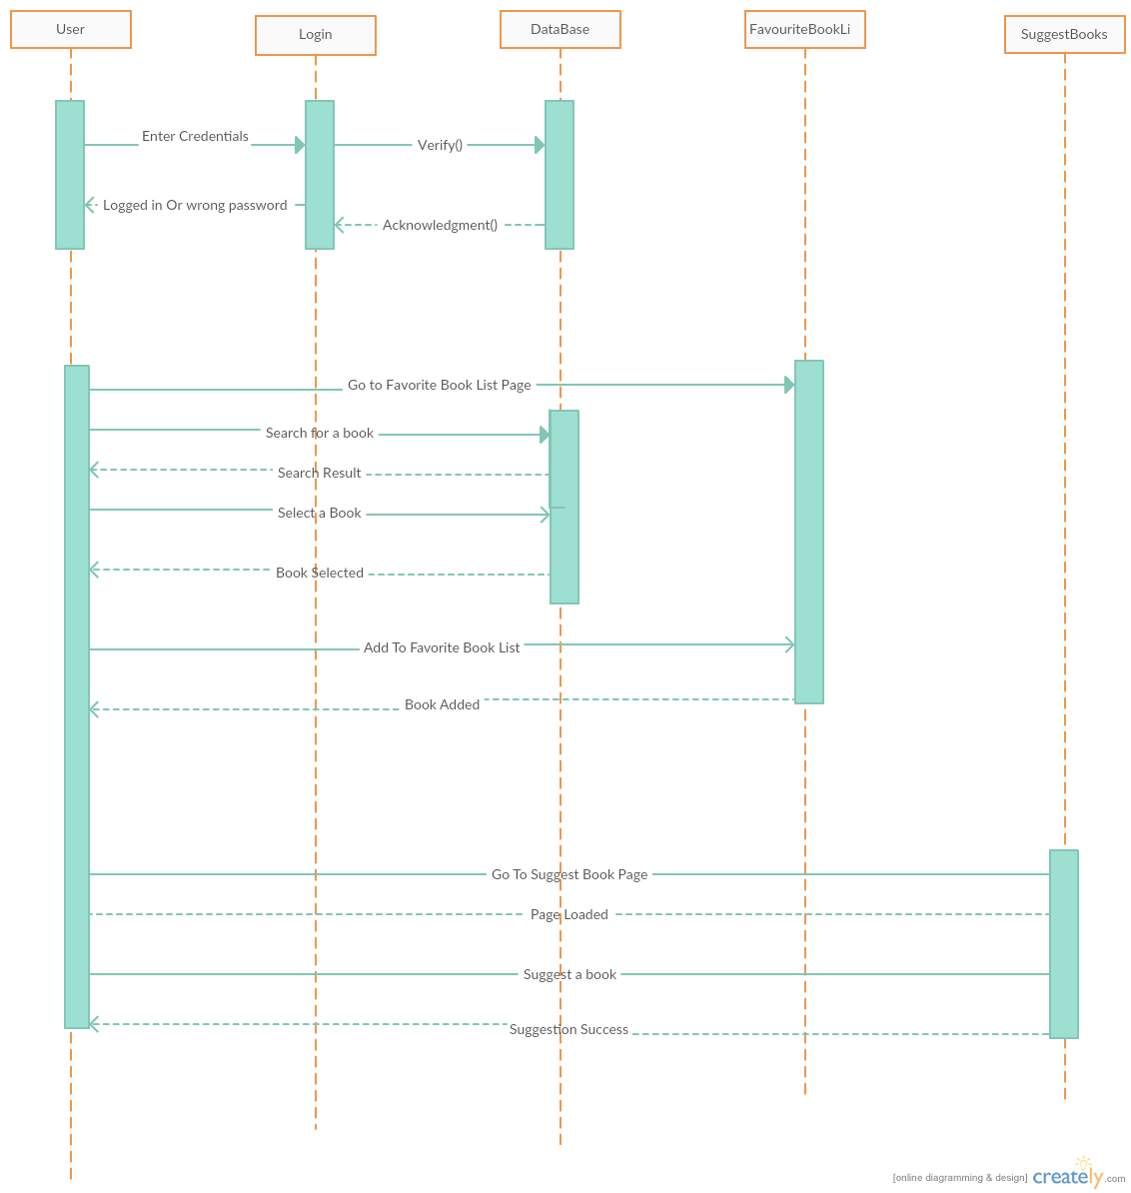

**Description:**

The user enters his credentials. The credentials are validated with the database and the user enters the home page if the credentials are correct else a message will be displayed saying that the entered credentials are wrong and enter correct credentials. The user searches for a particular book by entering the book title or the author name. The search will be done with the books available in the database and the search results are produced. Now, the user can add the selected book to favorite book list and view them later. The user can suggest a book to his friends.

**Request Book**

**Description:**

The user enters the credentials and these credentials entered are verified with the database. After entering valid credentials, the user can view the home page. Now, the user can search for a book and if the book is not available in the database, the user can request the librarian for the book.

**Upload Book**

**Description:**

The Author enters the credentials and it will be validated with the database. The user can view the home page if the credentials entered are correct. The Author can go to the upload book tab and attach the book that he wants to upload. He could upload the book by clicking on upload tab. Now, the author can edit the pages in the book if required. He needs to go to Edit Pages tab and search for the book that he wants to update. After selecting the book, he can edit the pages and the same will be updated in the database. The same book can be shared to his friends if needed by going to share books page.