**E-GOVERNANCE PROJECT**

**Title:**

Online Website for Employee provident fund(scheme) to the employees

**Team Members:**

* Nikhil - 18MIS1065
* Akhil - 18MIS1066
* Sai Kalyan – 18MIS1113

**Objectives:**

* This is the website where employees can save their some amount from monthly earnings.
* Only the company which has more than 15 employees can apply for Employee provident fund organisation.
* 12% of the monthly earning of employee will contribute to EPFO organisation in this 8.33% to employee pension Scheme(EPS) and 3.67% to employee provident fund(EPF)
* Employee can take back their amount back from the EPFO after two months from resignation and they can also take that in necessary conditions like hospital emergency etc;
* Employee can check their savings by filling the necessary details Employee PF account number, Name, Mobile number

**SOFTWARE:**

HTML

CSS

JAVA SCRIPT

PHP

SQL

**Cloud Service:**

**Individual Contribution:**

Akhil-18MIS1066: Creating Frames, Developing Html, CSS codes

Nikhil-18MIS1065 :Developing JavaScript and PHP codes,

Creating databases and its connections.

Sai Kalyan-18MIS1113 : Establishing Database connection

,Gathering further required information and developing further

necessary codes

**Website/Mobile App:**

Website

**Framework:**

BOOTSTRAP

HTML5

**References:**

W3Schools

Free Code Camp

Stack Overflow

Udemy

Tutorials point

**Output :**

1.This is the login page of this project where you can login into this website you have account already

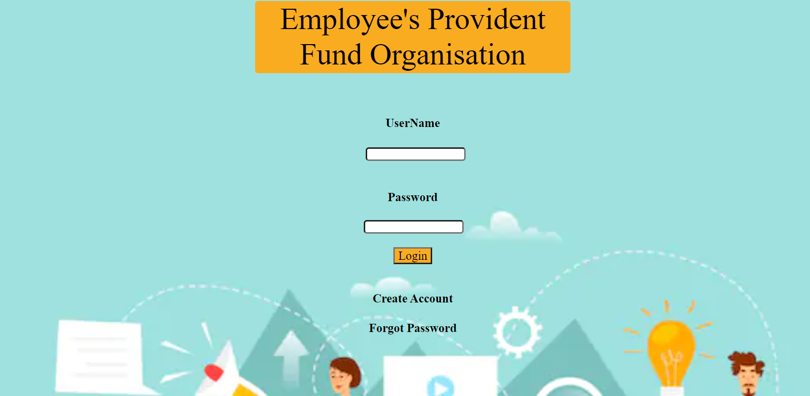

2.This sign up page of this website you did not have account in this website you can create account by signing up by this webpage and values which you entered here will get stored in a xampp database server by the time of logging into this it will verify the username and password which you entered here

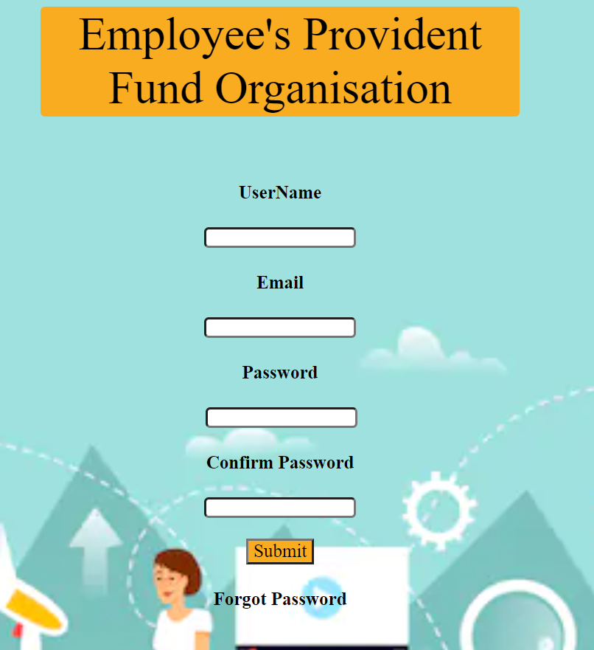

3. This page is useful for recollecting your password by submitting your username and new password at the time when you forgot password

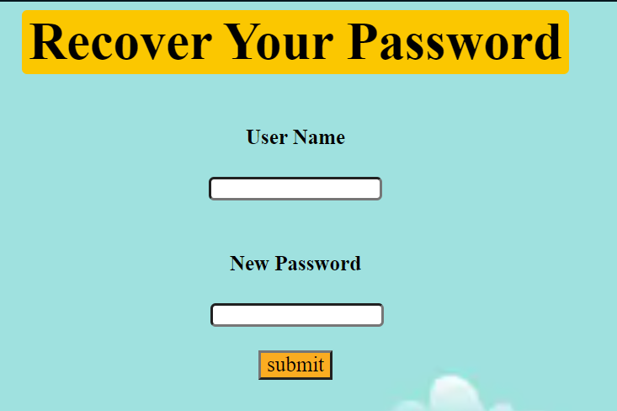

4. This page you will get after logging into this website and in this you will find some options that are home, forum, claim, Query, Balance, KYC, help and logout option

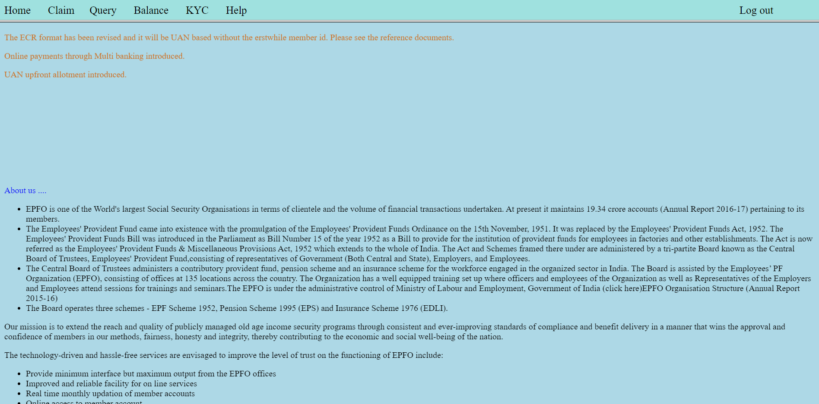

5.This is the home page where you will find the information and agreements regarding employee provident fund organisation website.

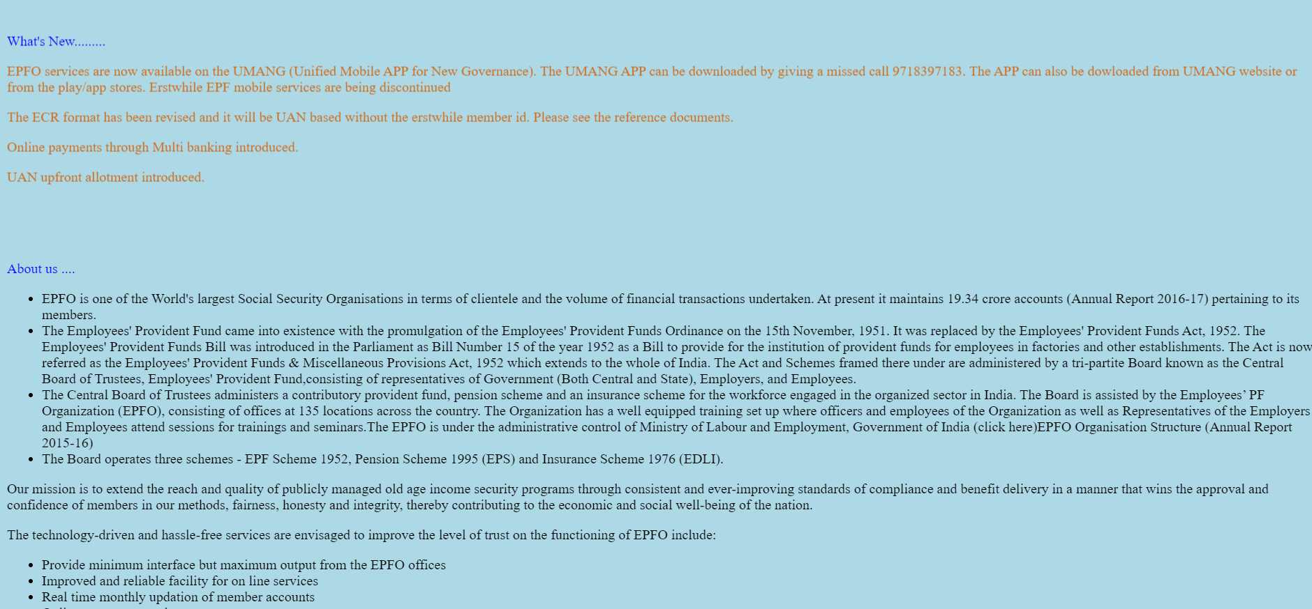

6. This is a claim by entering the details you can check whether that you can clam or not

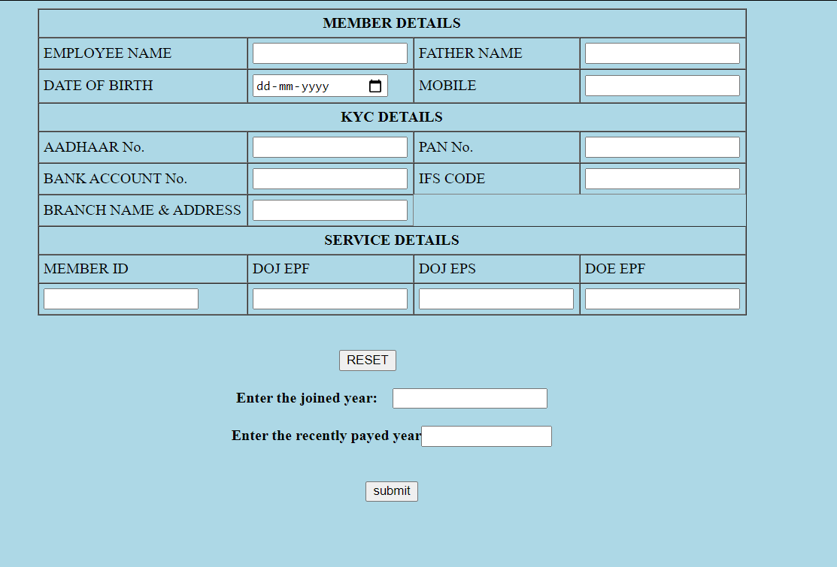

7. This is the minimum KYC form page where you can complete your know you customer(KYC) by filling the details and it will store in data base

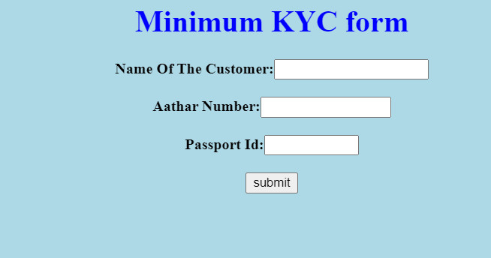

8.This is employee provident fund calculater in which you can find the employee provident fund by giving the necessary details

