DEPARTMENT OF COMPUTER SCIENCE

Information Retrieval - CS 429

**Project Report:**

TEXT SIMILARITY SEARCH SYSTEM USING NATURAL LANGUAGE PROCESSING

**By:**

SAI KARTHEEK GOLI (A20546631)

**Under the Guidance**

of

Mr. Jawahar Panchal Professor CS 429

Department of Computer Science.

**ABSTRACT**

The project presents a comprehensive solution for efficiently identifying similar text documents based on user queries. Using advanced natural language processing (NLP) techniques, the system aims to provide accurate and relevant results to users seeking information from large text corpora. The project employs a combination of TF-IDF (Term Frequency-Inverse Document Frequency) vectorization and cosine similarity to compute the similarity between documents. TF-IDF, a fundamental technique in information retrieval, assigns weights to terms based on their frequency in a document and across the entire corpus. Cosine similarity measures the cosine of the angle between two vectors, providing a measure of similarity between documents. The architecture of the system consists of three main components: a Flask-based REST API server, an indexer module responsible for building and querying the TF-IDF index, and an optional web crawler for collecting text documents from web pages. The Flask server serves as the interface for users to submit queries and receive relevant document matches. Operationally, users interact with the system by sending POST requests to the /query endpoint of the Flask server, providing their query string and optionally specifying the number of top results desired. The system then processes the query, retrieves the most similar documents from the index, and returns them to the user.

**OVERVIEW**

The text similarity search system using natural language processing (NLP) offers a solution to the increasingly complex task of document retrieval and similarity analysis. In the era of information overload, where vast amounts of textual data are generated every second, the need for efficient methods to search, retrieve, and organize this information has become paramount. Traditional keyword-based search engines often fall short in providing relevant results, especially when dealing with queries or large text corpora. This project addresses these challenges by use of NLP techniques, specifically TF-IDF vectorization and cosine similarity, to deliver accurate and contextually relevant document matches.

Solution Outline:

The proposed solution revolves around the construction of a text similarity search engine that using TF-IDF vectorization and cosine similarity to measure the similarity between textual documents. Cosine similarity then calculates the cosine of the angle between two TF-IDF vectors, providing a measure of similarity between documents.[1] By combining these techniques, the system can accurately identify documents that are semantically similar to a given query, even in the absence of exact keyword matches.

$$cosine_similarity(A,B)=\frac{A⋅B​}{∥A∥×∥B∥}$$ Where:

* *A* and *B* are the TF-IDF vectors representing the two documents.
* *A*⋅*B* represents the dot product of the TF-IDF vectors *A* and *B*.
* ∥*A*∥ and ∥*B*∥ represent the Euclidean norms (or magnitudes) of the TF-IDF vectors *A* and *B* respectively.

**LITERATURE**

The quest for effective document similarity analysis and retrieval has been a cornerstone of information retrieval research for decades. The exponential growth of digital content and the proliferation of online information sources have underscored the importance of extensive techniques for extracting meaningful insights from textual data.[2] The seminal works and recent advancements in the fields of natural language processing (NLP), information retrieval (IR), and text mining, focusing on methodologies for document similarity assessment and their implications for real-world applications.

Vector Space Models

Vector space models (VSMs) represent documents and queries as vectors in a high-dimensional space, enabling efficient computation of similarity metrics. Salton and McGill's pioneering work in the 1970s introduced the term frequency-inverse document frequency (TF-IDF) weighting scheme, which remains a cornerstone of VSM-based retrieval systems[3]. TF-IDF assigns weights to terms based on their frequency in a document and across the entire corpus, effectively capturing the importance of terms in distinguishing documents[4]. While TF-IDF has demonstrated effectiveness in capturing document semantics and mitigating the effects of term frequency, it is limited in its ability to capture semantic relationships between terms and documents.

Probabilistic Models

Probabilistic models, such as the Okapi BM25 algorithm, offer an alternative approach to document retrieval by modeling the probabilistic relevance of documents to a given query.[5] BM25 incorporates term frequency, document length, and term saturation into its scoring function, allowing for more relevance assessments. Unlike TF-IDF, which assumes independence between terms, BM25 accounts for term dependencies and document length normalization, leading to improved retrieval performance in many cases. However, probabilistic models may suffer from computational complexity and parameter sensitivity, requiring careful tuning for optimal performance.

Deep Learning Techniques

Recent advancements in deep learning have revolutionized document similarity analysis, offering unprecedented capabilities in modeling complex semantic relationships. Neural network architectures, such as Siamese networks and transformer-based models like BERT (Bidirectional Encoder Representations from Transformers), have shown remarkable success in capturing contextual information and semantic similarities between documents.[6] By learning distributed representations of words and documents in an unsupervised manner, these models can generalize across domains and languages, offering a more extensive and scalable solution to document similarity analysis.

Real-World Applications

Document similarity analysis has diverse applications across various domains, including information retrieval, document clustering, recommendation systems, and plagiarism detection.[7] In information retrieval, similarity-based search engines enable users to find relevant documents based on query semantics rather than exact keyword matches, enhancing the user experience and facilitating knowledge discovery. Document clustering algorithms uses similarity measures to group related documents into clusters, enabling exploratory analysis and topic modeling[8]. Recommendation systems utilize document similarities to provide personalized content recommendations to users based on their preferences and browsing history. Finally, plagiarism detection systems rely on similarity analysis to identify instances of content reuse and intellectual property violations,[9] safeguarding academic integrity and copyright compliance.

**Proposed System Overview**

The proposed system is a document similarity analysis tool composed of three main components: a web crawler, an indexer, and a query processor. These components work together to crawl web documents, index them using TF-IDF representation, and allow users to query the indexed documents to find similar ones.

**DESIGN - SYSTEM CAPABILITIES, INTERACTIONS, INTEGRATION**

The design of the document similarity analysis system encompasses a range of capabilities, interactions, and integrations aimed at providing extensive and scalable solutions for real-world applications. In this section, outline the key components and design considerations that underpin the functionality and performance of the system.

System capabilities

1. Document Indexing Engine

The document indexing engine is responsible for processing and indexing large volumes of textual documents efficiently. Using techniques such as term frequency-inverse document frequency (TF-IDF) and cosine similarity, the engine generates vector representations of documents, enabling fast and accurate retrieval based on semantic similarity.[10] Additionally, the engine supports incremental indexing, allowing for real-time updates to the index as new documents are added or existing documents are modified.

1. Query Processing Module

The query processing module facilitates user interactions with the system by interpreting user queries and retrieving relevant documents from the index. Upon receiving a query, the module applies the same vectorization techniques used during indexing to transform the query into a vector representation compatible with the document space. By computing the cosine similarity between the query vector and indexed document vectors, the module identifies the most relevant documents matching the user's query.[11]

1. User Interface and Interaction

The Graphical user interface (UI) serves as the primary interaction point between users and the system, providing intuitive tools for querying, exploring, and display document similarities (UI). The UI features a search interface where users can enter queries and receive ranked lists of relevant documents based on similarity scores (<http://127.0.0.1:5000/query> confirms connection). Additionally, the UI supports interactive visualization of document clusters and similarity networks, enabling users to gain insights into the underlying structure of the document corpus (port <http://127.0.0.1:5000/> to confirm app.py successful execution).

**ARCHITECTURE**

**System Architecture:**

The architecture of the document similarity analysis system is designed to be modular, scalable, and flexible, accommodating various software components, interfaces, and implementation strategies. This section provides an overview of the system architecture, highlighting its key components, interfaces, and implementation considerations.

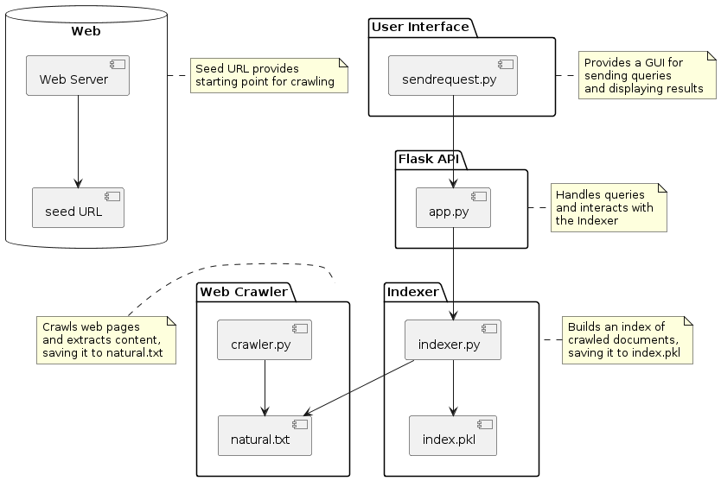

Figure 1 Overall system architecture

**Software Components**

1. Document Indexing Engine: At the core of the architecture is the document indexing engine, responsible for processing and indexing textual documents. This component utilizes advanced natural language processing (NLP) techniques to transform raw text data into structured representations suitable for similarity analysis.
2. Query Processing Module: The query processing module interprets user queries and retrieves relevant documents from the index. It applies vectorization techniques to convert user queries into vector representations compatible with the document space, enabling efficient similarity computation.
3. User Interface (UI): The UI component serves as the primary interaction point between users and the system. It provides intuitive tools for querying, exploring, and showing document similarities, enhancing user experience and usability.
4. External Data Integration: This component facilitates integration with external data sources and systems, allowing data exchange and interoperability.

**Interfaces**

1. API Endpoints: The system exposes RESTful API endpoints for programmatic access to its functionalities. These endpoints enable developers to interact with the system programmatically, performing tasks such as querying for document similarities and retrieving indexed documents.
2. User Interface: The UI component provides a graphical interface for users to interact with the system. It features search interfaces, and interactive components for querying, exploring, and analyzing document similarities.
3. Data Ingestion Interfaces: The system supports various data ingestion interfaces for importing textual data from external sources. web scraping utilities, allowing users to ingest data from sources.

**Implementation**

1. Technology Stack: The system is implemented using a combination of programming languages, frameworks, and libraries. Python serves as the primary programming language, using libraries such as scikit-learn for NLP tasks and Flask for building RESTful APIs.
2. Scalability and Performance: Implementation considerations include scalability and performance optimizations to handle large volumes of textual data efficiently. Techniques such as distributed computing, parallel processing, and caching are employed to ensure optimal system performance under varying workloads.

**OPERATION - SOFTWARE COMMANDS, INPUTS, INSTALLATION**

|  |  |  |  |  |  |
| --- | --- | --- | --- | --- | --- |
| Component | Operation Summary | Software Commands | Inputs | Ports | Installation |
| app.py | Flask application for handling free text queries | python app.py | None | 5000 | Flask, scikit-learn (pip install flask scikit-learn) |
| sendrequest.py | UI for sending requests to the Flask API | python sendrequest.py | Query text | N/A | requests (pip install requests) |
| crawler.py | Scrapy-based web crawler for downloading web documents | python crawler.py | Seed URL, Max Pages, Max Depth | N/A | Scrapy (pip install scrapy) |
| indexer.py | Indexer for constructing an inverted index | python indexer.py | Text documents (from crawler) | N/A | scikit-learn (pip install scikit-learn) |

**Operation:**

1. Running Scripts: Execute the respective Python scripts (app.py, sendrequest.py, crawler.py, indexer.py) using Python interpreter. App.py must run before sendrequest.py.
2. Usage: Follow the command-line prompts for crawler.py. For app.py and sendrequest.py, interact via UI or send requests programmatically.
3. Output: Results will be displayed in the terminal for crawler.py, and in the UI window for sendrequest.py.

**CONCLUSION**

The document similarity analysis system demonstrates success in providing a extensive solution for users to perform efficient content-based searches. Through the integration of web crawling, indexing, and query processing components, the system enables users to input queries and retrieve relevant documents accurately. The user interface facilitates interaction with the system, allowing for intuitive query input and visualization of search results. Outputs from the system include top-K ranked documents based on similarity scores, presented in a clear and understandable format. However, caution should be exercised regarding the scalability of the system, particularly with large text corpora, as it may impact performance and resource utilization. Additionally, proper error handling and input validation should be implemented to ensure system stability and security, particularly when handling user-generated queries.

**DATA SOURCES - LINKS, DOWNLOADS, ACCESS INFORMATION**

**Links**: <https://en.wikipedia.org/wiki/Natural_language_processing>'

**Downloads**:

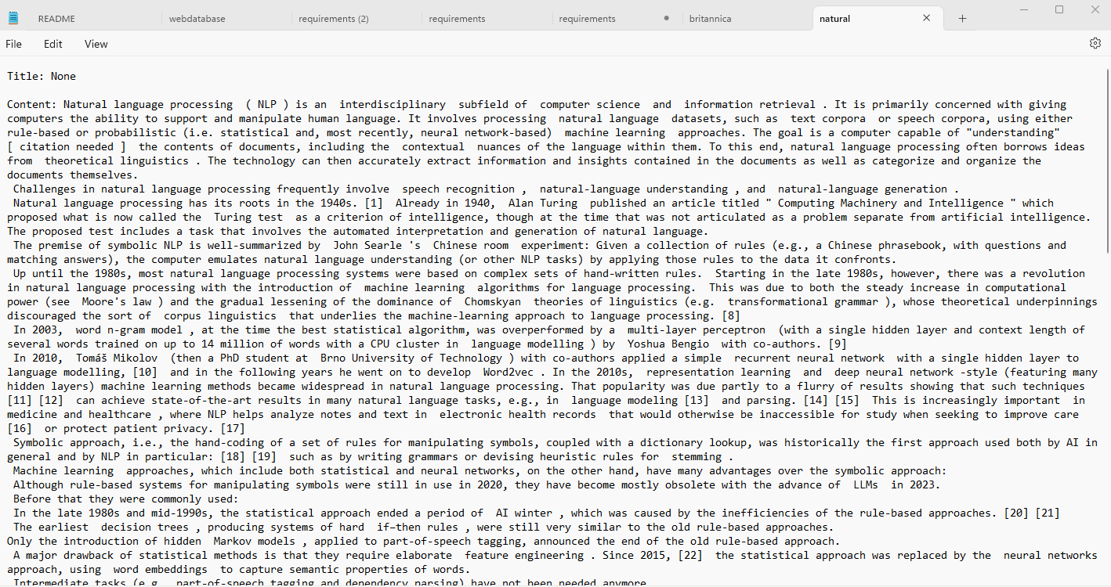

Figure 2 Sample Natural language processing data crawled

Access to the data sources is subject to the terms and conditions of the respective websites or data providers. Therefore, Users should ensure compliance with copyright and usage policies when accessing and utilizing web content for analysis.

Test Cases - Framework, harness, coverage

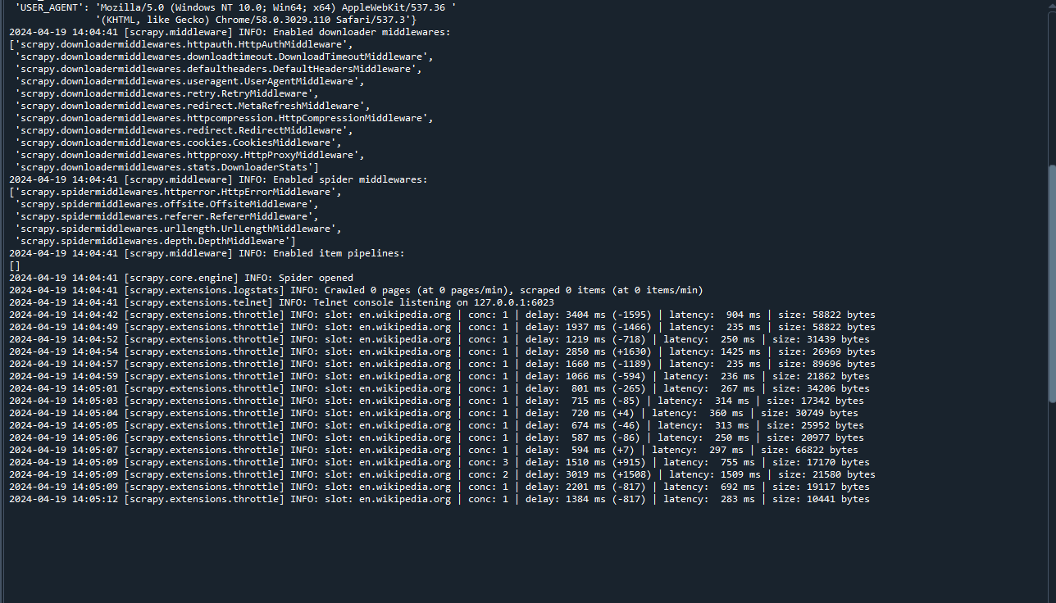

Figure 3 crawler.py in action

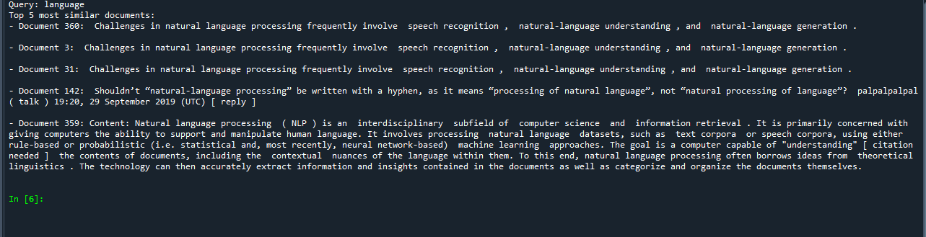

Figure 4 indexer.py in action

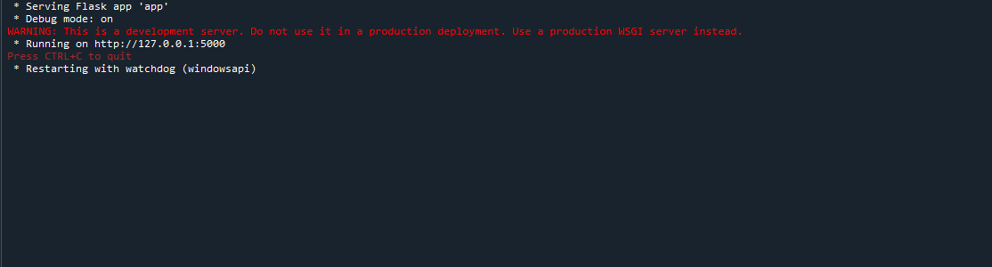

Figure 5 Flask app.py in action running on port <http://127.0.0.1:5000>

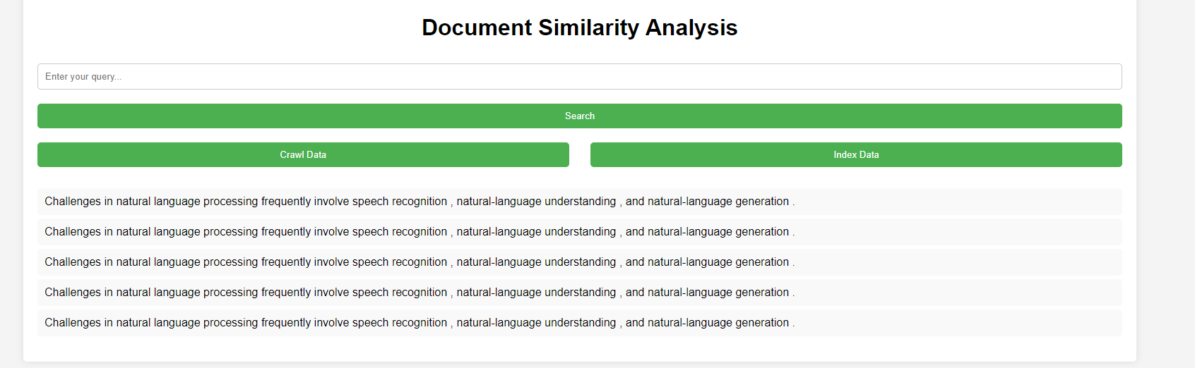

Figure 6 send request.py in action retrieving the information, the searched information is in bracket, I.e language

**Source Code - Listings, documentation, dependencies (open-source).**

LINK TO GITHUB WITH REQUIREMENTS AND README FILES

**Documentation**

The four main modules:

1. Crawler Module: This module (crawler.py) is responsible for crawling web documents in HTML format. It utilizes Scrapy, a Python framework for web scraping, to extract content from web pages. The crawler is configurable with parameters such as the seed URL, maximum number of pages to crawl, and maximum depth of crawling.
2. Indexer Module: The indexer.py module implements a TF-IDF based indexing system using the scikit-learn library. It constructs an inverted index to represent documents in a vector space model. The indexer also provides functionality for saving and loading the index to/from a pickle file.
3. Flask Application: The Flask application (app.py) serves as the backend for handling free-text queries. It exposes a POST endpoint /query to receive queries in JSON format. Upon receiving a query, it utilizes the indexer to perform a similarity search and returns the top-K ranked results.
4. Send Request Module: This module (sendrequest.py) provides a UI interface for users to interact with the Flask application. It allows users to enter a query and sends a POST request to the Flask server. Upon receiving the response, it highlights the search word in the output content and displays the results.

**Dependencies**

The project relies on the following dependencies:

* Python 3.10+
* scikit-learn 1.2+
* Scrapy 2.11+
* Flask 2.2+
* Requests

These dependencies can be installed via pip using the following commands:

* pip install scikit-learn scrapy Flask requests or
* conda install scikit-learn scrapy Flask requests

**Bibliography**

Arabi, Hamed, and Mehdi Akbari. "Improving plagiarism detection in text document using

hybrid weighted similarity." *Expert Systems with Applications* 207 (2022): 118034.

https://doi.org/10.1016/j.eswa.2022.118034

Bayatmakou, Farnoush, Azadeh Mohebi, and Abbas Ahmadi. "An interactive query-based

approach for summarizing scientific documents." *Information Discovery and Delivery* 50, no.

2 (2022): 176-191. https://doi.org/10.1108/IDD-10-2020-0124

Deepa, Ms D. "Bidirectional encoder representations from transformers (BERT) language

model for sentiment analysis task." *Turkish Journal of Computer and Mathematics Education*

*(TURCOMAT)* 12, no. 7 (2021): 1708-1721.

https://www.turcomat.org/index.php/turkbilmat/article/view/3055

Goyal, Kanav, and Megha Sharma. "Comparative Analysis of Different Vectorizing

Techniques for Document Similarity using Cosine Similarity." In *2022 Second International*

*Conference on Advanced Technologies in Intelligent Control, Environment, Computing &*

*Communication Engineering (ICATIECE)*, pp. 1-5. IEEE, 2022.

https://doi.org/10.1109/ICATIECE56365.2022.10046766

Han, Mengting, Xuan Zhang, Xin Yuan, Jiahao Jiang, Wei Yun, and Chen Gao. "A survey on

the techniques, applications, and performance of short text semantic similarity." *Concurrency*

*and Computation: Practice and Experience* 33, no. 5 (2021): e5971.

https://doi.org/10.1002/cpe.5971

Kim, Yoon, and Owen Zhang. "Credibility adjusted term frequency: A supervised term

Weighting scheme for sentiment analysis and text classification.” *arXiv preprint*

*arXiv:1405.3518* (2014).

Lahitani, Alfirna Rizqi, Adhistya Erna Permanasari, and Noor Akhmad Setiawan. "Cosine

similarity to determine similarity measure: Study case in online essay assessment." In *2016 4th*

*International conference on cyber and IT service management*, pp. 1-6. IEEE, 2016.

https://doi.org/10.1109/CITSM.2016.7577578

Padmanaban, Harish. "Revolutionizing Regulatory Reporting through AI/ML: Approaches for

Enhanced Compliance and Efficiency." *Journal of Artificial Intelligence General science*

*(JAIGS) ISSN: 3006-4023* 2, no. 1 (2024): 57-69. https://doi.org/10.60087/jaigs.v2i1.p69

Robertson, Stephen, and Hugo Zaragoza. "The probabilistic relevance framework: BM25 and

beyond." *Foundations and Trends® in Information Retrieval* 3, no. 4 (2009): 333-389.

http://dx.doi.org/10.1561/1500000019

1. Goyal, Kanav, and Megha Sharma. "Comparative Analysis of Different Vectorizing Techniques for Document Similarity using Cosine Similarity." In *2022 Second International Conference on Advanced Technologies in Intelligent Control, Environment, Computing & Communication Engineering (ICATIECE)*, pp. 1-5. IEEE, 2022.
2. Padmanaban, Harish. "Revolutionizing Regulatory Reporting through AI/ML: Approaches for Enhanced Compliance and Efficiency." *Journal of Artificial Intelligence General science (JAIGS) ISSN: 3006-4023* 2, no. 1 (2024): 57-69.
3. Kim, Yoon, and Owen Zhang. "Credibility adjusted term frequency: A supervised term weighting scheme for sentiment analysis and text classification." *arXiv preprint arXiv:1405.3518* (2014).
4. Kim and Zhang. Credibility adjusted term frequency. 2024
5. Robertson, Stephen, and Hugo Zaragoza. "The probabilistic relevance framework: BM25 and beyond." *Foundations and Trends® in Information Retrieval* 3, no. 4 (2009): 333-389.
6. Deepa, Ms D. "Bidirectional encoder representations from transformers (BERT) language model for sentiment analysis task." *Turkish Journal of Computer and Mathematics Education (TURCOMAT)* 12, no. 7 (2021): 1708-1721.
7. Han, Mengting, Xuan Zhang, Xin Yuan, Jiahao Jiang, Wei Yun, and Chen Gao. "A survey on the techniques, applications, and performance of short text semantic similarity." *Concurrency and Computation: Practice and Experience* 33, no. 5 (2021): e5971.
8. Han *et al*. e5971
9. Arabi, Hamed, and Mehdi Akbari. "Improving plagiarism detection in text document using hybrid weighted similarity." *Expert Systems with Applications* 207 (2022): 118034.
10. Lahitani, Alfirna Rizqi, Adhistya Erna Permanasari, and Noor Akhmad Setiawan. "Cosine similarity to determine similarity measure: Study case in online essay assessment." In *2016 4th International conference on cyber and IT service management*, pp. 1-6. IEEE, 2016.
11. Bayatmakou, Farnoush, Azadeh Mohebi, and Abbas Ahmadi. "An interactive query-based approach for summarizing scientific documents." *Information Discovery and Delivery* 50, no. 2 (2022): 176-191.