**Open Fermion**

The project is about Quantum simulation of the molecules which is very widely used in molecular drug design by obtaining energy of molecule and other ground state parameters.

Firstly, we will see how a classical model works and then we see how is that implemented on a quantum computer. In classical model, we take the aid of Hartee-Fork ab-initio methods to get the ground state energy. We will use time dependent Schrodinger WAVE wave equation under the influence of Born-Oppenheimer approximation, which treats the nuclei as fixed point charges, and the ground state electronic energy is a parametric function of their positions That time dependent equation is

\begin{displaymath}
i \hbar \frac{\partial \psi({\bf r},t)}{\partial t} =
- \f...
...r^2}{2m} \nabla^2 \psi({\bf r},t) + V({\bf r}) \psi({\bf r},t)
\end{displaymath}`

Where Hamiltonian is sum of Potential energy and Kinetic energy.

In the HF method Hartee assumed many approximations and proceeded with slater type of orbitals (STO’s) and then Gaussian improvise the accuracy of these orbital calculations by considering Gaussian primitive function collectively known as basis set STO-3G. This type of approach is known as variational approach to solve the Schrodinger eigen value equation. For calculating Hamiltonian operator, we also consider Nuclei interaction and two electron integrals like Columbic integrals and exchange integrals. This combinedly is called as FOCK operator and orbitals obtained are fock orbitals.

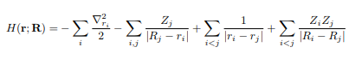

We assume an exponential function(e-**µr2)**) as STO radial part and we proceed and obtain energy and we keep on correcting our wavefunction till the least energy that is experimental energy is obtained by modifying our wave function. This a classical approach of obtaining ground state parameters and bond energy graphs with respect to bond length.

**Mapping Classical Hamiltonian to qubits:**

So far, we have seen how a classical approach method works. Open Fermion is an open-source software library written largely in Python, aimed at enabling the simulation of fermionic models (electronic models as electrons are fermions) and quantum chemistry problems on quantum hardware. This platform is of great use and helps in simulating the classical method as described above upon importing certain libraries like Pyscf and Psi4. If we look in detail this platform maps classical information like Hamiltonian and wavefunction to qubits and converts them to Qubit operator through some transformation. Present quantum computers often work with distinguishable qubits as their computational units. To simulate indistinguishable fermionic particles, it is first required to map the fermionic state to the state of the qubits. Some of the very known transformations are Jordan Wigner and Bravyi-Kitaev Superfast transformation (BKSF). Latter one proved to be useful as it strikes a balance between storing parity and occupation number in the qubits which reduces the cost of parity operators and update operators is log(n). Bravyi-Kitaev is a compromise between the Jordan-Wigner and parity-scheme. This platform uses pyquil from ringette ‘s library and gives out quantum circuit to get Qubit Hamiltonian. Rigette quantum virtual machine platform Forest runs this quantum circuit and gives out Qubit Hamiltonian. This Hamiltonian operates on a wave function to give Energy as its’s eigen value variationally.

Clasically, we start with some wave function of a MO and proceed to calculate energy and we keep on modifying our wavefunction to get the minimum eigen value in a self-consistent HF method by differentiating with respect to a parameter [**µ]** but thequantum approach makes it more robust and simple.

So, let’s look at how a quantum algorithm looks like.

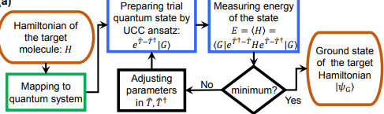

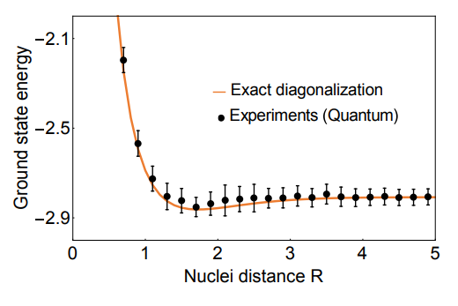The search process of the minimum energy at some fixed distance between two nuclei. assisted by the Nelder-Mead algorithm with UCC ansatz (an assumed wavefunction of exponential form). From this algorithm, we get ground state energy and desired wave function .As we change the internuclear distance energy of the system changes and this code can be iterated for n intervals to plot a graph of Energy versus R.

There were many significant contributions done in this field by many tech leaders in the market like IBM, Google, Microsoft. IBM has simulated BEH2 molecule and is the most complex molecule studied so far in quantum fashion. They have used 6 qubits to simulate this molecule and are giving access to 16 qubit cloud service. As number of qubits the quantum computer must carry more complex calculations.

**Conclusion**:

On a whole to conclude, the classical approach to simulate molecules becomes very difficult to carry out as the molecule size increases and we must take care of parity of each electron and tougher mathematical integrals. But Quantum computer promises to simplify that process by exactly predicting the structure of a new molecule and how will it interact with other compounds.