Clonal structure confounds tests of location-dependent knockout effects in spatial CRISPR screens
[Author names]¹ · [Corresponding author]¹*
¹[Affiliation]. *[e-mail]
ABSTRACT
Spatial CRISPR screens can test whether a knockout acts differently across tissue niches, but knockout cells grow as clonal lesions. Using semi-synthetic knockouts from tumour and brain sections, we show that cell-level tests detect niche effects in up to 62% of null draws, and that letting knockout cells define their own niche inflates lesion-level tests. Lesion permutation and CR2 were calibrated in tumour, but every test failed in brain, where lesion baselines were large and unequal across niches. Calibrating against matched control pseudo-knockouts restored error control in both tissues, lesion-clustered intervals covered the true knockout-by-niche contrast, and a learned context encoder roughly doubled power (8% to 17% with 20 lesions). In Perturb-map imaging of 1,377 lesions from eight mice, several knockouts changed T-cell infiltration, but none did so detectably differently between immune-rich and immune-poor niches. SpatialPert implements these methods.
MAIN
Pooled CRISPR screens with single-cell readouts measure what each knockout does to the transcriptome^{1,2}, but they dissociate tissue and so lose where each cell sat. Spatial screens keep that information. Perturb-map reads protein barcodes in tissue sections³, Perturb-FISH images guides alongside transcripts⁴, Perturb-DBiT and imaging-based readouts capture guides and RNA in the same section⁵, and spatial Perturb-seq extends this to whole organs⁶. These designs promise a new kind of result: a knockout whose effect depends on its microenvironment, for example on whether it sits near immune cells or at a hypoxic core.
Testing such niche dependence raises a statistical problem that dissociated screens do not face. In vivo, each knockout typically enters a tissue as a few founder cells that grow into clonal lesions. Cells in one lesion share a genotype, a lineage history and a local environment, so they are not independent replicates. If a test treats them as independent, the effective number of observations is the number of lesions, not cells, and a difference between two lesions that happen to sit in different niches looks like a niche effect. The problem is the pseudoreplication long described in ecology and neuroscience^{7,8} and in multi-sample single-cell analysis^{9–11}, but in spatial screens it has an extra twist: niches are defined from the same tissue in which the lesions grow, and a lesion large enough to shape its own neighbourhood can help define the niche it is then compared against.
Methods for spatial transcriptomics address related questions. Spatially variable gene tests^{12,13} and niche callers^{14–18} find structure in unperturbed tissue, and econometrics offers corrections for few clusters^{19–22}. None of them has been evaluated for the specific question of whether a knockout's effect differs between niches when knockout cells come in a handful of clones.
Here we benchmark that question directly. We built semi-synthetic knockouts from control cells of a public Xenium section of HT-29 lung metastases⁵, placing them as 1-20 lesions with known niche-dependent effects or none, and evaluated eight tests, from naive cell-level permutation to small-cluster corrections and a within-lesion sign-flip test. We repeated the benchmark with a second tissue, three published niche callers and count-level effects with realistic lesion sizes, diagnosed why tests fail in the second tissue, developed a calibration, effect intervals and a learned context encoder, and applied the methods to four Xenium knockouts and to 12 knockouts in Perturb-map imaging of eight mice. The analysis plan and the rule for choosing a recommended test were pre-registered (Supplementary Note 1). The findings give a design rule — the lesion, not the cell, is the unit of replication, and about 20 lesions per knockout are needed — and SpatialPert, an open-source toolkit that applies the calibrated test, reports whether a screen is testable, and plans screens from the simulated power curves.
RESULTS
Cell-level tests detect niche effects that are not there
We first placed pseudo-knockouts made of control tumour cells as independent clones, reproducing the patch sizes of real knockouts (Methods). With no injected effect, a cell-level permutation test rejected in up to 62% of draws, per-gene ANOVA in up to 38% and cluster-robust regression with CR1 standard errors in up to 94%. When pseudo-knockouts were instead grown as 1-20 contiguous lesions totalling 400 cells, the cell-level test rejected in 28%-62% of null draws (Fig. 2a and Extended Data Fig. 1a). The cause is clonal: cells in one lesion share a baseline that differs between lesions, and when lesions fall in different niches the baseline difference is read as a niche effect (Fig. 1).
Knockout cells must not define their own niche
Niches in a perturbation screen are defined from control cells, but a knockout cell's niche label still depends on its neighbours. In our first benchmark, pseudo-knockout cells had contributed to the neighbourhood features that defined their own niches. Recomputing niche labels with the pseudo-knockout removed from the reference (leave-out labels) changed the niche of 33%-46% of pseudo-knockout cells and removed most of the inflation of lesion-level tests: the maximum type-I error of lesion permutation fell from 0.15 to 0.04, and that of 30 µm patch permutation from 0.19 to 0.08 (Fig. 2c). Circular labels make each lesion look more homogeneous in niche than a real lesion would, and the inflation grew with lesion number; it was not caused by where lesions were seeded, which followed the distribution of control cells (Extended Data Fig. 4a,b). Any simulation of spatial perturbations must therefore exclude the perturbed cells when assigning their niches.
Lesion-level tests are calibrated but need 10-20 lesions
With leave-out labels, we compared eight tests at 1, 3, 5, 10 and 20 lesions (300 null and 150 effect draws per level; Fig. 2a,b). Four were calibrated (maximum type-I error at most 0.06): lesion permutation (0.043), studentised lesion permutation (0.043), CR2 with Bell-McCaffrey correction (0.030) and the within-lesion sign-flip test (0.020). Patch permutation was slightly liberal (0.077) because patches split lesions. The wild cluster bootstrap, often recommended for few clusters^{22–24}, rejected in up to 13% of null draws, and a lesion random-intercept mixed model in up to 100%; with a handful of lesions split across niches, neither the bootstrap's restricted residuals nor the variance component is estimated well.
Calibration came at the cost of power. For a niche-specific effect half the size of the shared knockout effect, size-adjusted power of lesion permutation was 0.00 with 3 lesions, 0.02 with 5, 0.37 with 10 (95% CI 0.29-0.45) and 0.83 with 20 (0.76-0.88; Fig. 3a). The sign-flip test, which compares niches within a lesion and cancels the lesion's own baseline, was the most conservative and never exceeded 0.13 power, because few lesions straddle two niches. Under the pre-registered rule (highest mean size-adjusted power among calibrated tests, with the critical value corrected in AMENDMENT-008b) lesion permutation was adopted (mean power 0.30) and is SpatialPert's default; the uncorrected rule would have chosen the sign-flip test, and both are reported.
Within-lesion correlation does not predict power
Survey statistics would predict power from the design effect, n_eff = L·m/(1 + (m − 1)ρ), where ρ is the within-lesion intraclass correlation. In control pseudo-lesions, ρ was small, 0.001-0.007 per gene (Extended Data Fig. 2a), so the formula predicts 0.59 power already with 5 lesions, against a simulated 0.02. Fitting an efficiency factor did not rescue it (RMSE 0.27; Fig. 3b). Power is limited not by correlation among cells of a lesion but by how many independent lesions land in each niche to be compared, which a cell-level variance formula does not capture. SpatialPert's plan_screen_empirical() therefore interpolates the simulated power curves rather than the formula.
Calibration depends on tissue and niche caller
Repeating the benchmark in a Xenium mouse brain section (10 µm bins, 50 genes; Methods), every test was inflated: cell-level permutation rejected in 0.39-1.00 of null draws, patch permutation in up to 0.30, lesion permutation in up to 0.29 and the wild cluster bootstrap in up to 0.47 (Extended Data Fig. 6a). Brain niches are large and smooth, so lesions rarely straddle niches and lesion baselines are confounded with niche; the sign-flip test, which needs straddling lesions, was almost never applicable. In the tumour, replacing k-means niches with BANKSY, SpaGCN or CellCharter niches changed calibration (Extended Data Fig. 6b and Extended Data Fig. 3): the worst type-I error of lesion permutation was 0.19 with k-means, 0.04 with BANKSY, 0.07 with SpaGCN and 0.25 with CellCharter, whereas the sign-flip test stayed at or below 0.10. These comparisons use circular labels for every caller (Methods), so they show how much the caller matters rather than absolute error rates; together with the brain result they mean that a calibrated benchmark in one tissue does not certify a test in another, and SpatialPert therefore runs a tissue-specific pseudo-knockout calibration before testing.
Large, unequal lesion baselines explain the failures in brain
We asked why every test failed in brain. Four explanations were ruled out on the same null draws: the pseudo-knockout's presence in the control fit, leave-out relabelling (about 1% of brain bins changed niche), circular labels and lesions that straddle niches (about 2% of lesion cells; removing them left the type-I error of lesion permutation at 0.33 with 20 lesions). Pooled across draws, lesion means were centred in every niche, but their variance in brain was 7.5 times that expected from sampling, their spread differed 2.6-fold between niches (tumour 1.1-fold), and they remained correlated over hundreds of micrometres (Fig. 4a). Lesion means are then not exchangeable between niches, which every lesion-level test assumes; with few lesions per niche, Welch studentisation could not repair it, and the CR2 test was also inflated in brain (0.15-0.23).
Calibration against matched pseudo-knockouts restores error control
Because the failure is a property of the tissue, we calibrated it in the tissue: the observed p-value of a knockout is ranked among p-values of control pseudo-knockouts with the same lesion sizes, with ties broken at random (Methods). The result is exact if knockout lesions are placed like random control positions. On held-out null draws, the calibrated type-I error of lesion permutation was 0.043-0.065 in both tissues (Fig. 4b). Calibration does not create power: in brain the calibrated test detected the injected effect in at most 0.11 of draws, so the correct report there is that niche effects of this size are undetectable. A diagnostic computed from control pseudo-lesions flags such tissues before testing (lesion variance ratio 1.18 in tumour and 6.9 in brain). In the Xenium screen, calibration left the conclusions unchanged (CIITA p = 0.42).
Lesion-clustered intervals cover the knockout-by-niche contrast
A test answers whether a knockout's effect differs between niches; investigators also need the size of the difference. We estimate the contrast Ψ = Δ_b − Δ_a, where Δ_n is the knockout effect in niche n, from residuals of knockout cells against niche-matched controls, with CR2 standard errors clustered on lesions. With injected effects of known size, the estimate was unbiased (|bias| ≤ 0.012) and 95% intervals covered the truth in 0.95-0.96 of draws in tumour and 0.92-0.95 in brain, whereas naive cell-level intervals covered only 0.46-0.64 in brain (Fig. 4c). The honest intervals in brain were about four times wider, which is the same loss of information seen in the calibrated test.
A learned context encoder improves power without losing calibration
We next asked whether a learned representation of each cell's surroundings defines more useful niches than fixed kernel features. The encoder sees only control neighbours in two rings, never the cell itself, and is trained to predict a cell's expression from its context (Methods). To avoid favouring any partition, the injected niche-dependent effect followed a continuous covariate, the local host-cell fraction, and the downstream test was the same for all representations. Over three training seeds (450 effect draws per setting), learned niches kept type-I error at or below 0.05 and raised size-adjusted power from 0.06 to 0.11 with 10 lesions and from 0.08 to 0.17 with 20 (Fig. 4d). Niches from a cell's own expression were miscalibrated (type-I up to 0.20), confirming that context must come from neighbours. The gain is real but modest; absolute power stayed low for this weak, composition-driven effect.
Realistic count-level effects are harder to detect
Effects injected on the log scale into every gene are a favourable case. When effects were applied to raw counts by binomial thinning or Poisson boosting, in 5-100% of genes, and lesion sizes followed the heavy-tailed distribution of the real knockouts, lesion permutation stayed close to nominal size (0.010-0.065) but size-adjusted power did not exceed 0.19 at any setting with 5-20 lesions (Fig. 3c). Sparse count data and a few dominant lesions per knockout leave little independent information; the curve in Fig. 3a is an upper bound.
Current screens fall short of the lesion requirement
In the HT-29 Xenium section, the four testable knockouts formed 10, 1, 5 and 3 lesions (CIITA, DIO3, ESAM and PRSS23; Extended Data Fig. 5). Cell-level permutation reported niche dependence for CIITA (p = 0.003) and PRSS23 (p ≤ 0.001); with lesions as units, only CIITA could be tested at all, and its effect was not niche dependent (lesion permutation p = 0.43; CR2 minimum q = 0.12; Fig. 6). The other knockouts were untestable: once each lesion was assigned its majority niche and niches with fewer than 30 cells were dropped, fewer than two niches remained, and the small-cluster tests found some compared niche in fewer than two lesions (Fig. 6b). In the Perturb-map imaging deposit, which covers 41 lung lobes from eight mice, the median Pro-Code was found in 22.5 lesions; 25 of 46 codes reached 20 lesions and 31 reached 10 (Fig. 3d). Whole-organ imaging across several animals can therefore meet the requirement for more than half of the knockouts, whereas a single section rarely does.
In Perturb-map, knockouts change immune infiltration but not differently between niches
Finally, we applied the methods to the Perturb-map imaging deposit: 1,377 curated lesions in 41 lung lobes from 8 mice, with each lesion's knockout read from its Pro-Code and immune infiltration measured from CD8, CD4 and B220 staining (Methods). The analysis plan, including the niche definition (immune-rich or immune-poor surroundings 100-300 µm from the lesion), the outcome, the test, eligibility and multiplicity, was registered before any outcome was computed. 12 knockouts were eligible. Several changed CD8 T-cell infiltration consistently across mice (exploratory main effects: B2m -0.32, p = 0.0003; Tgfbr2 -0.46, p = 0.0013; Socs1 +0.46, p = 0.0029). The two largest effects reproduce the original study, which reported T-cell exclusion from Tgfbr2-knockout lesions and strong T-cell infiltration of Socs1-knockout lesions³. No knockout, however, showed niche-dependent infiltration: the smallest calibrated q-value over 36 tests was 0.57 (Fig. 5). The strongest candidate, Tgfbr2 (Ψ = -0.54; 95% interval -1.61 to +0.52), had within-mouse permutation p = 0.022 but calibrated p = 0.060: an uncalibrated analysis would have reported it. Only 11% of lesions lay in the immune-rich niche, so only large niche differences were detectable; the result shows that these knockouts' effects on infiltration are not strongly niche-dependent, not that niche dependence is absent.
DISCUSSION
Spatial CRISPR screens make it possible to ask where a knockout acts, but the answer depends on counting the right units. Cells of one lesion are not replicates, and tests that treat them as such find niche dependence where there is none. Lesion-level tests fix calibration in the tissue we benchmarked most thoroughly, but they need on the order of 20 lesions per knockout for adequate power under favourable effects, and more under count-level effects. Some popular corrections for few clusters, the wild cluster bootstrap and random-intercept mixed models, did not hold their size here, and a design-effect calculation was not a reliable planning tool.
Lesion number can be raised by design. Injecting more transduced founder cells per knockout increases lesions per knockout; smaller libraries concentrate lesions on fewer knockouts; sectioning several levels or lobes and pooling animals adds lesions that are independent by construction, which is how the Perturb-map deposit reaches 20 or more lesions for more than half of its codes; and clonal barcodes would let lesions be defined by lineage rather than distance. For analysis, we recommend the following decision path, which SpatialPert implements:
- Define niches from control cells only, and exclude each knockout's own cells when assigning its niche.
- Define lesions (100 µm single linkage by default) and count lesions per niche for every knockout; if no niche is visited by at least two lesions, report the knockout as untestable rather than testing cells.
- Check lesion exchangeability on control pseudo-lesions, and report every p-value calibrated against matched pseudo-knockouts of the same tissue; where the diagnostic flags large, unequal lesion baselines, expect little power.
- Report the knockout-by-niche contrast Ψ with lesion-clustered (CR2) intervals, not only a p-value.
- Test with lesion permutation; report CR2 and, where lesions straddle niches, the within-lesion sign-flip test as sensitivity analyses. Avoid cell-level tests, the wild cluster bootstrap and random-intercept mixed models when lesions are few.
- Plan new screens with plan_screen_empirical(): aim for at least 20 lesions per knockout; with 10, only large niche effects are detectable.
Our study has limitations. The benchmark is semi-synthetic: pseudo-knockouts carry the clonal structure of control cells, not of real lineages, and effects are injected, so absolute power depends on the assumed effect model. The calibration is exact only if knockout lesions are placed like random control positions, which cannot be checked from the data. The brain diagnosis and the calibration were developed after the brain failure was known (AMENDMENT-009) and are exploratory. The second tissue is binned transcripts without segmentation, and lesions are defined by distance, not lineage. The learned encoder's gain is modest and was shown for one effect model in one tissue. In Perturb-map, the readout is a protein panel, there are no non-targeting controls (knockouts are compared with each other), pixel size was assumed (0.5 µm), few lesions lay in immune-rich surroundings, and the main effects are exploratory. Small-cluster methods that need R (Satterthwaite and Kenward-Roger mixed models, dream) were not evaluated, and SpaGCN was run on a subsample. No knockout with a known niche-dependent effect is available, so the positive controls validate the effect estimators only. Each limitation points to the same remedy: screens designed with many independent lesions, ideally barcoded, across several animals.
ONLINE METHODS
Data sources
Discovery data were the Xenium validation section of the Perturb-DBiT study (GEO GSE319123; one formalin-fixed section of a mouse lung colonised by HT-29 cells after a genome-scale Brunello screen)^{5,25}. The cell-feature matrix contains 352,913 cells and 10,029 features: 5,001 genes of the Xenium Prime 5K human panel, 27 custom guide probes and control codewords. DBiT-seq sections (GSE319277)²⁶ and Perturb-map Visium sections (GSE193460)³ were used for audits and the positive control. The curated lesion annotations and the per-cell segmentation tables of the Perturb-map imaging deposit (BioImage Archive S-BIAD267) were used to count lesions per knockout and for the real-data analysis. A second tissue was a public Xenium mouse brain coronal subset (Zenodo record 11209134, CC BY 4.0), available only as transcript coordinates. All files were downloaded from their repositories and checked against published sizes or by decompression.
Cell filtering and normalisation
Cells with at least 20 counts over panel genes were kept (74,911 cells; median 69 counts). Counts were scaled to the median total and log1p-transformed. Analysis genes were those with mean normalised expression at least 0.1 in control tumour cells (74 genes); the sparsity of the panel in this tissue is the reason so few genes passed.
Tumour-cell calling
A tumour score was the mean z-score of the HT-29 markers present in the panel (EPCAM, KRT20, CDX2). A two-component Gaussian mixture separated tumour cells (posterior > 0.9). The mixture is degenerate in this sample: 69% of cells carry no marker transcript, posteriors are 0 or 1, and the call is equivalent to detecting at least one marker transcript (23,261 tumour cells). A stricter definition (top half of the score) was used as a sensitivity analysis.
Guide assignment
Guide probes were identified as expression features without an Ensembl identifier. A tumour cell was assigned to a knockout if exactly one guide probe had at least one UMI; cells with two or more different guides were excluded. Negative-control probes were positive in a fraction 1.1 × 10⁻⁵ of cells, so the 12 knockouts with at least 60 positive cells were at least 18-fold above chance. A sensitivity analysis required at least two UMIs. Spillover was measured as the fraction of non-knockout cells with guide signal as a function of distance to the nearest knockout cell.
Niche construction
Thirty principal components were computed on control tumour cells. For every cell, niche features were the kernel-weighted mean of the components of control cells within 100 µm, with weight exp(−d²/2l²), l = 50 µm, excluding the cell itself¹⁴. K-means with K = 4 (the value chosen among 3-6 by silhouette on 20,000 cells in the registered Step 4) was fitted on control cells²⁷; this caller is used for all benchmarks and for the real-data comparison of tests, so every test sees the same niches. For pseudo-knockouts made of control cells, niche features were recomputed with the pseudo-knockout cells removed from the reference and assigned to the fixed centroids (leave-out labels), so that, like real knockout cells, they never contribute to their own niche definition. Stability was measured as the adjusted Rand index between the reference labelling and 20 refits on 80% subsamples. External niche callers were run on the same control cells: pybanksy 1.3.5 (λ = 0.8, Leiden; the first resolution with no niche above 50% of cells), SpaGCN 1.2.7 (no histology, k-means initialisation with 4 clusters because the louvain dependency could not be built on Windows; fitted on a uniform 6,000-cell subsample because its dense adjacency matrix exceeds memory for all cells, then propagated by a five-nearest-neighbour vote) and CellCharter 0.3.8 (Delaunay graph, long links removed, three-layer neighbourhood aggregation of 20 principal components in place of scVI, Gaussian mixture with 4 clusters)^{14,17,18}.
Residual model
For each analysis gene g, control cells were fitted by least squares to y_ig = μ_d(i)g + β_gᵀ(c_i − c̄) + ε_ig, where d(i) is the niche of cell i and c_i holds log total counts, host-cell fraction (non-tumour cells among cells within 50 µm) and local density (cells within 50 µm). The residual of any cell is r_ig = y_ig − μ̂_d(i)g − β̂_gᵀ(c_i − c̄). Fits use the normal equations so the expression matrix stays sparse.
Tests of niche dependence
All tests compare a knockout's residuals between niches. Units: 30 µm clonal patches and 100 µm lesions are connected components of single-linkage graphs; tiles are 250 µm squares. Each unit takes its majority niche, and niches with fewer than 30 cells after this assignment are dropped (applying the minimum before assignment let a 7-cell niche drive an apparent signal).
Sum-of-squares permutation: T = Σ_d n_d‖ē_d − ē‖² over genes, with niche labels permuted among cells, patches, lesions or tiles (1,000 permutations in real data, 250 in benchmarks). Studentised permutation: the sum over genes of Welch's F on unit means, permuted among units²⁸. Pseudobulk ANOVA: one-way ANOVA per gene on unit means, Benjamini-Hochberg across genes²⁹. Cluster-robust regression: per-gene OLS on niche indicators with CR1 standard errors clustered on patches, Wald F on k − 1 and G − 1 degrees of freedom. CR2: Bell-McCaffrey bias-reduced covariance with Imbens-Kolesár degrees of freedom for the contrast between the two largest niches, clustered on lesions^{19–21,30}; the implementation equals statsmodels HC2 when every cluster is a single cell (unit test). Wild cluster bootstrap: the summed per-gene CR1 Wald statistic with the restricted (no-niche) model and Webb six-point weights at the lesion level, 299-999 draws^{22–24}. Within-lesion sign-flip test: for each lesion with at least three cells in each of the two largest niches, the difference of mean residuals between the niches; the statistic is the squared mean contrast summed over genes, and its null distribution flips the sign of whole lesion contrasts (exact when 2^L ≤ 2,000). Because each contrast is taken inside one lesion, the lesion's own baseline cancels. Mixed model: statsmodels MixedLM on lesion × niche pseudobulk with a lesion random intercept and a Wald χ² test per gene^{10,31} (Satterthwaite or Kenward-Roger degrees of freedom, and dream³², need R and were not run). A test was 'applicable' to a draw when its design was estimable: lesion-unit tests need at least two lesions in at least two niches; CR2, the wild bootstrap and the sign-flip test need every compared niche to be seen in at least two lesions with three or more cells (sign-flip: the same lesion in both niches).
Semi-synthetic benchmarks
Pseudo-knockouts were built from control tumour cells in two designs. Independent clones reproduced the patch sizes and niches of real clones, rescaled to 50-800 cells. Lesion structure placed L ∈ {1, 3, 5, 10, 20} contiguous lesions (a random seed and its nearest unused control cells) with seeds at least 400 µm apart, 400 or 800 cells in total; a realism design resampled lesion sizes from the real knockouts' heavy-tailed lesion-size distribution.
Effects were added either on the log scale, as δ·sd_g·u_g to all cells plus λ·δ·sd_g·v_g in one niche (δ = 0.5; u, v random unit-RMS directions, or v along hallmark hypoxia genes³³), or on raw counts, by binomial thinning (decreases) or Poisson boosting (increases) of the counts of a fraction (5%, 20% or 100%) of genes in one niche, followed by renormalisation with the original all-gene totals and median target (re-normalising unmodified counts reproduced the analysis matrix to 7 × 10⁻¹⁶). Null settings used 200-500 replicates and effect settings 100-200.
Size-adjusted power
For every test and setting, the critical value was the smaller of 0.05 and the 5th percentile of the test's p-values in the matching null run (AMENDMENT-008b: using the percentile alone would give conservative discrete tests a critical value above 0.05), and size-adjusted power was the fraction of effect replicates with p at or below it. Raw and size-adjusted power are both reported; only size-adjusted power is interpreted when a test is not calibrated.
Design model
The design-effect model n_eff = L·m/(1 + (m − 1)ρ) was evaluated with ρ, the within-lesion intraclass correlation (one-way ICC(1)) of the tested score in control pseudo-lesions, estimated both for a gene-averaged projection and per gene. The model's one free parameter (an efficiency factor) was fitted to the simulated size-adjusted power of the adopted test by least squares. Because it did not reproduce the simulated curve, SpatialPert's plan_screen_empirical() interpolates the simulated curves (log-scale and count-level scenarios) in log lesion number; plan_screen() keeps the formula for comparison.
Real-data analyses
Real knockouts were analysed with every test above on the benchmark caller's niches (Fig. 6), and, as sensitivity analyses, at 20, 30 and 50 µm patch linkage, with gene-standardised residuals, with at least two guide UMIs and with distance to the nearest host cell as a covariate. Lesions per knockout in Perturb-map imaging were counted from 2,192 curated lesion polygons named by Pro-Code combination (8 mice, 41 lobes).
Lesion definition
A lesion is a connected component of the graph that joins knockout cells closer than 100 µm (single linkage). The threshold was registered before real-data testing and is about four cell diameters in this tissue, so that nearby fragments of one metastasis join while lesions seeded at least 400 µm apart (the benchmark design) stay separate. Patches (30 µm) are the same construction at a finer scale and split one lesion into several units. Because lesion counts depend on the threshold, the real-data analysis reports lesions per niche and the patch result at 20, 30 and 50 µm. Lesions are a proxy for clones: two clones that touch merge, and a clone cut by the section plane can split. Neither error can be detected without lineage barcodes, so lesion-level results are conditional on the linkage rule.
Circular and leave-out niche labels
In real screens knockout cells are excluded when niches are defined, but a knockout cell's niche still depends on its control neighbours. Pseudo-knockouts drawn from control cells were originally labelled with niches that they themselves had helped to define (circular labels). This makes each pseudo-lesion more likely to sit inside one niche than a real lesion would, and it inflates lesion-level tests (Fig. 2c). Leave-out labels remove the pseudo-knockout cells from the reference before computing neighbourhood features and assign the result to the fixed centroids; they changed the niche of 33-46% of pseudo-knockout cells. All stage-1b results use leave-out labels unless marked circular. External callers had to be run once on all control cells, so their comparison (Extended Data Fig. 6b) uses circular labels for every caller, including k-means, and compares callers like for like.
Test adoption rule
Before stage 1b was run, AMENDMENT-008 fixed the rule for choosing the recommended test: among tests whose type-I error was at most 0.06 at every lesion number where they were applicable (300 null draws per level), adopt the one with the highest mean size-adjusted power over 3-20 lesions. AMENDMENT-008b corrected the size-adjusted critical value (see above) after the first analysis showed that conservative discrete tests gained power from a critical value above 0.05. Under the literal rule the within-lesion sign-flip test would have been adopted; under the corrected rule lesion-unit permutation is adopted. Both are reported. The mixed model was run on 40 null and 20 effect draws per lesion number because each fit took about 26 s (registered deviation); its type-I error was far above the threshold on this subsample, so subsampling cannot change the adoption.
Second tissue
The mouse brain subset (Zenodo 11209134) provides transcript coordinates only. Transcripts were binned into 10 µm squares, giving 81,990 bins and 50 genes; bins are pseudo-cells and are smaller and sparser than segmented cells. Niches were k-means (K = 4) on 20 principal components with the same neighbourhood kernel, and the stage-1b design (300 null and 150 effect draws per lesion number, 400 bins per pseudo-knockout, leave-out labels) was repeated with cell-level, patch, lesion, sign-flip and wild cluster bootstrap tests (299 draws). Brain niches are large and spatially smooth (one niche held 61,694 of 81,990 bins), so lesions seldom straddle niches; the sign-flip test was applicable in at most 0.7% of draws and the wild cluster bootstrap in at most 31%.
Niche-caller comparison
BANKSY, SpaGCN and CellCharter were installed in isolated virtual environments so that their dependency pins did not change the analysis environment. Each was run on the 21,773 control tumour cells, exported as AnnData with the same 5,001 genes and coordinates, and labels were joined back by cell identifier. For each caller the lesion benchmark was repeated at 3, 5, 10 and 20 lesions (200 null and 100 effect draws each) with lesion permutation, the wild cluster bootstrap (199 draws) and the sign-flip test. We also report the fraction of cells in the largest niche, because a caller that puts most cells in one niche makes most pseudo-knockouts untestable rather than miscalibrated.
Count-level realism
To test whether conclusions from log-scale injection carry over to count data, effects were applied to raw counts. For a target niche and a random fraction s of genes (s = 0.05, 0.2 or 1), each selected gene received a log fold change δ·sd_g·(±1)/√s, clipped to ±3, so that the total signal is comparable across sparsity levels (δ = 0.25, 0.5 or 1). Decreases were applied by binomial thinning and increases by adding Poisson counts, only in cells of the target niche. Lesion sizes were drawn from the 100 µm lesion sizes of the four real knockouts and rescaled to 400 cells, reproducing their heavy tail; lesions were placed with the geometry-matched sampler. Each cell was renormalised with its original all-gene total and the analysis median target, and residuals were recomputed from the control model. Null runs used 200 draws and effect settings 100 draws per lesion number (5, 10 and 20).
Within-lesion correlation
For lesion sizes of 20, 40, 80, 133 and 400 cells, control pseudo-lesions were grown and the within-lesion intraclass correlation ICC(1) was estimated with the unbalanced one-way ANOVA estimator, both for a gene-averaged projection of standardised residuals along a random direction (the direction along which effects were injected) and for each gene separately (median over genes reported).
Perturb-map lesion counts
The S-BIAD267 deposit contains, for each imaged lung lobe, curated QuPath annotations in which each lesion polygon is named by the Pro-Code epitope combination detected in it. We parsed the lymphoid-panel annotation files and counted lesions per code, per mouse and per lobe. We report counts per code, because the code-to-knockout mapping is not needed to estimate how many lesions a knockout receives. Only annotations, not the 15.7 GB image-segmentation tables, were downloaded.
Positive control
The effect estimator was checked on Perturb-map Visium data (GSE193460), where Tgfbr2 knockout lesions have a published, strong microenvironment phenotype³. The Tgfbr2 versus unassigned-tumour residual profile was computed in each section and agreement between sections was compared with a null from shuffled lesion labels. This control shows that residual effects capture a real knockout effect; it does not validate niche dependence, for which no ground-truth spatial knockout is available.
Diagnosis of the brain inflation
On 200 null draws per lesion number we compared lesion permutation under: the control model refitted without the pseudo-knockout; leave-out or circular niche labels; dropping cells whose niche differs from their lesion's majority niche; residuals against the lesion's majority niche; local-control residuals (50 nearest controls); and Welch studentisation. Lesion means were then pooled over 60 draws (20 lesions each) and summarised per niche (mean, SD), against the sampling variance of a lesion mean, and as correlation between lesion means by centroid distance.
Matched-null calibration and exchangeability diagnostic
For a knockout with lesion sizes (s_1, ..., s_L), M = 200 pseudo-knockouts are drawn from control cells with lesions of the same sizes at random, well-separated seeds (≥ 400 µm), removed from the control fit, relabelled with leave-out niches and tested exactly like the knockout. The calibrated p-value is (#{p_j < p} + U(1 + #{p_j = p}))/(1 + M) with U uniform on (0, 1) and untestable draws excluded, which is exact when knockout lesions are placed like random control positions. Calibration was evaluated by two-fold cross-fitting of existing null draws (calibration pool and tested draws disjoint). The diagnostic reports, from 40 control pseudo-knockouts of 20 lesions, the ratio of between-lesion variance of lesion means to their sampling variance and the ratio of the largest to the smallest per-niche SD of lesion means (spatialpert.calibration).
Knockout-by-niche contrast and intervals
For niches a and b the contrast Ψ_g = Δ_b,g − Δ_a,g is the OLS coefficient of a niche-b indicator in the regression of knockout residuals on niche, using cells in a or b, with CR2 (Bell-McCaffrey) covariance clustered on lesions and Imbens-Kolesár degrees of freedom (spatialpert.smallcluster.niche_contrast). Coverage was assessed on pseudo-knockouts (400 cells; 5, 10, 20 lesions; 200 draws) with a shared effect in all cells and a known effect λδ·v in niche b, comparing CR2 intervals with naive cell-level Welch intervals.
Learned context encoder
For each cell, context features are the mean expression principal components (30) of control cells in the rings 0-50 µm and 50-150 µm, the cell itself excluded. A two-layer network (64 hidden units, 16-dimensional embedding) is trained on control cells for 400 full-batch Adam epochs to predict the cell's own principal components from its context (PyTorch, CPU). One-hop aggregation is used deliberately: with two message-passing hops a cell's own features would return to it through its neighbours. Pseudo-knockout cells are removed from the reference before their context is computed. Niches are k-means (K = 4) on the embedding. The benchmark compared four representations (fixed kernel features, learned context, own expression, coordinates) under the same lesion permutation test, with a niche-dependent effect proportional to the standardised host-cell fraction within 50 µm; 200 null and 150 effect draws per lesion number and encoder seed (three seeds).
Perturb-map analysis
Segmentation tables of the Lymphoid panel (41 lobes, 8 mice) were downloaded from S-BIAD267 and reduced to centroid, cell area, per-cell marker means, Pro-Code and Gene. Raw tables of the last nine lobes were kept with SHA-256 checksums, and the reduced tables of those lobes equalled the raw tables exactly in every kept column (9/9 lobes); the raw tables of the first 32 lobes were not retained. Lesions are the authors' curated lesion polygons with ≥ 30 labelled cells; the knockout is the Gene its Pro-Code maps to. The outcome is the logit fraction of marker-positive unlabelled cells (above the lobe's 95th percentile) inside the lesion or within 20 µm of a lesion cell. Each lesion's niche is k-means (K = 2) on the composition of the ring 100-300 µm away, excluding every cell within 100 µm of any labelled cell; the cluster with more marker-positive cells is immune-rich. Residuals are taken against reference lesions of other knockouts in the same mouse and niche. Ψ is tested by permuting niche labels among the knockout's lesions within mouse (9,999 permutations), calibrated against 1,000 pseudo-knockouts drawn from reference lesions with the same per-mouse counts, with CR2 intervals clustered on mouse. Eligible knockouts had ≥ 20 lesions, ≥ 5 per niche and lesions in ≥ 3 mice; BH at q = 0.10 over knockouts. Main effects (mean of per-mouse mean residuals, one-sample t-test over mice) were not part of the registered plan and are exploratory. Pixel size is taken as 0.5 µm.
Statistics
Rejection rates are reported with 95% Wilson intervals. p-values from B permutations are (1 + #null ≥ observed)/(1 + B), and values at the floor are written as p < 1/(1 + B). The minimum achievable p-value per knockout is the larger of this floor and 1/(number of distinct labellings). Multiple knockouts were combined by Benjamini-Hochberg q-values and by Fisher and Cauchy combinations.
Software and runtime
Analyses used Python 3.12 with numpy, scipy, pandas, scikit-learn and statsmodels; the code is gated by ruff, strict mypy and pytest on every commit. On a laptop (4 logical CPUs, 8.5 GB RAM, Windows-10-10.0.19045-SP0), loading and normalising the full 352,913-cell section took 6 s, fitting the niche model 3 s, and testing four knockouts with 1,000 permutations 0.9 s (patch units) or 0.3 s (lesion units). A 999-draw wild cluster bootstrap of one 10-lesion, 400-cell knockout took 6 s and a 2,000-flip sign-flip test 2 ms; peak memory was 0.63 GB.
Pre-registration and amendments
The analysis plan was frozen before any knockout expression outcome was examined (git tag protocol-v1.0). Eight dated amendments record every later analysis, each registered before it was run, including the pre-set rules for adopting a test. Deviations (mixed-model subsampling for runtime; SpaGCN subsampling and initialisation) are listed in the protocol. Supplementary Note 1 gives the history and the original hypotheses.
Reproducibility
Every number in the paper is read from report files written by scripts. An independent recheck recomputes reported rates from per-replicate files and raw data through separate code paths.
Reporting summary
Further information on research design is available in the Nature Portfolio Reporting Summary linked to this article.
Data availability
All data analysed are public: GEO GSE319123 (Xenium, Perturb-DBiT study), GSE319277 (DBiT-seq), GSE193460 (Perturb-map Visium), BioImage Archive S-BIAD267 (Perturb-map imaging lesion annotations and segmentation tables) and Zenodo 11209134 (Xenium mouse brain). Source data for Figs. 2-6 and Extended Data Figs. 1, 2, 4 and 5 are provided with this paper. Benchmark per-draw p-values are deposited at Zenodo [DOI to be minted at submission].
Code availability
SpatialPert is available at [GitHub URL] under the [licence to be chosen: MIT or BSD-3-Clause], archived at Zenodo [DOI], and installable from PyPI (pip install spatialpert). The repository contains every analysis script, the pre-registered protocol with amendments, and a recheck script that recomputes all reported rates from per-draw files.
REFERENCES
1. Dixit, A., Parnas, O., Li, B., Chen, J., Fulco, C.P., Jerby-Arnon, L., Marjanovic, N.D., Dionne, D., Burks, T., Raychowdhury, R., et al. (2016). Perturb-Seq: dissecting molecular circuits with scalable single-cell RNA profiling of pooled genetic screens. Cell 167, 1853-1866. https://doi.org/10.1016/j.cell.2016.11.038.
2. Replogle, J.M., Saunders, R.A., Pogson, A.N., Hussmann, J.A., Lenail, A., Guna, A., Mascibroda, L., Wagner, E.J., Adelman, K., Lithwick-Yanai, G., et al. (2022). Mapping information-rich genotype-phenotype landscapes with genome-scale Perturb-seq. Cell 185, 2559-2575. https://doi.org/10.1016/j.cell.2022.05.013.
3. Dhainaut, M., Rose, S.A., Akturk, G., Wroblewska, A., Nielsen, S.R., Park, E.S., Buckup, M., Roudko, V., Pia, L., Sweeney, R., et al. (2022). Spatial CRISPR genomics identifies regulators of the tumor microenvironment. Cell 185, 1223-1239. https://doi.org/10.1016/j.cell.2022.02.015.
4. Binan, L., Jiang, A., Danquah, S.A., Valakh, V., Simonton, B., Bezney, J., Manguso, R.T., Yates, K.B., Nehme, R., Cleary, B., and Farhi, S.L. (2025). Simultaneous CRISPR screening and spatial transcriptomics reveal intracellular, intercellular, and functional transcriptional circuits. Cell 188, 2141-2158. https://doi.org/10.1016/j.cell.2025.02.012.
5. Baysoy, A., Tian, X., Renauer, P., Zhang, F., Bai, Z., Shi, H., Yang, M., Zhang, D., Liu, M., Li, H., et al. (2026). Large-scale, spatially resolved panoramic CRISPR screening in native tissue environments using Perturb-DBiT. Nat. Biotechnol. https://doi.org/10.1038/s41587-026-03127-y.
6. Shen, K., Seow, W.Y., Keng, C.T., Lim, M.G.L., Lim, D.S., Guo, K., Meliani, A., Irfan Bin Hajis, M., Wang, B., Prabhakar, S., et al. (2026). Spatial perturb-seq: single-cell functional genomics within intact tissue architecture. Nat. Commun. 17. https://doi.org/10.1038/s41467-026-69677-6.
7. Hurlbert, S.H. (1984). Pseudoreplication and the design of ecological field experiments. Ecol. Monogr. 54, 187-211. https://doi.org/10.2307/1942661.
8. Lazic, S.E. (2010). The problem of pseudoreplication in neuroscientific studies: is it affecting your analysis? BMC Neurosci. 11, 5. https://doi.org/10.1186/1471-2202-11-5.
9. Squair, J.W., Gautier, M., Kathe, C., Anderson, M.A., James, N.D., Hutson, T.H., Hudelle, R., Qaiser, T., et al. (2021). Confronting false discoveries in single-cell differential expression. Nat. Commun. 12. https://doi.org/10.1038/s41467-021-25960-2.
10. Zimmerman, K.D., Espeland, M.A., and Langefeld, C.D. (2021). A practical solution to pseudoreplication bias in single-cell studies. Nat. Commun. 12, 738. https://doi.org/10.1038/s41467-021-21038-1.
11. Crowell, H.L., Soneson, C., Germain, P.-L., Calini, D., Collin, L., Raposo, C., Malhotra, D., and Robinson, M.D. (2020). muscat detects subpopulation-specific state transitions from multi-sample multi-condition single-cell transcriptomics data. Nat. Commun. 11, 6077. https://doi.org/10.1038/s41467-020-19894-4.
12. Svensson, V., Teichmann, S.A., and Stegle, O. (2018). SpatialDE: identification of spatially variable genes. Nat. Methods 15, 343-346. https://doi.org/10.1038/nmeth.4636.
13. Sun, S., Zhu, J., and Zhou, X. (2020). Statistical analysis of spatial expression patterns for spatially resolved transcriptomic studies. Nat. Methods 17, 193-200. https://doi.org/10.1038/s41592-019-0701-7.
14. Hu, J., Li, X., Coleman, K., Schroeder, A., Ma, N., Irwin, D.J., Lee, E.B., Shinohara, R.T., and Li, M. (2021). SpaGCN: integrating gene expression, spatial location and histology to identify spatial domains and spatially variable genes by graph convolutional network. Nat. Methods 18, 1342-1351. https://doi.org/10.1038/s41592-021-01255-8.
15. Dong, K., and Zhang, S. (2022). Deciphering spatial domains from spatially resolved transcriptomics with an adaptive graph attention auto-encoder. Nat. Commun. 13. https://doi.org/10.1038/s41467-022-29439-6.
16. Long, Y., Ang, K.S., Li, M., Chong, K.L.K., Sethi, R., Zhong, C., Xu, H., Ong, Z., Sachaphibulkij, K., Chen, A., et al. (2023). Spatially informed clustering, integration, and deconvolution of spatial transcriptomics with GraphST. Nat. Commun. 14. https://doi.org/10.1038/s41467-023-36796-3.
17. Singhal, V., Chou, N., Lee, J., Yue, Y., Liu, J., Chock, W.K., Lin, L., Chang, Y.-C., Teo, E.M.L., Aow, J., et al. (2024). BANKSY unifies cell typing and tissue domain segmentation for scalable spatial omics data analysis. Nat. Genet. 56, 431-441. https://doi.org/10.1038/s41588-024-01664-3.
18. Varrone, M., Tavernari, D., Santamaria-Martinez, A., Walsh, L.A., and Ciriello, G. (2024). CellCharter reveals spatial cell niches associated with tissue remodeling and cell plasticity. Nat. Genet. 56, 74-84. https://doi.org/10.1038/s41588-023-01588-4.
19. Bell, R.M., and McCaffrey, D.F. (2002). Bias reduction in standard errors for linear regression with multi-stage samples. Surv. Methodol. 28, 169-181.
20. Imbens, G.W., and Kolesár, M. (2016). Robust standard errors in small samples: some practical advice. Rev. Econ. Stat. 98, 701-712. https://doi.org/10.1162/REST_a_00552.
21. Cameron, A.C., and Miller, D.L. (2015). A practitioner's guide to cluster-robust inference. J. Hum. Resour. 50, 317-372. https://doi.org/10.3368/jhr.50.2.317.
22. Webb, M.D. (2023). Reworking wild bootstrap-based inference for clustered errors. Can. J. Econ. 56, 839-858. https://doi.org/10.1111/caje.12661.
23. Cameron, A.C., Gelbach, J.B., and Miller, D.L. (2008). Bootstrap-based improvements for inference with clustered errors. Rev. Econ. Stat. 90, 414-427. https://doi.org/10.1162/rest.90.3.414.
24. MacKinnon, J.G., and Webb, M.D. (2017). Wild bootstrap inference for wildly different cluster sizes. J. Appl. Econom. 32, 233-254. https://doi.org/10.1002/jae.2508.
25. Janesick, A., Shelansky, R., Gottscho, A.D., Wagner, F., Williams, S.R., Rouault, M., Beliakoff, G., Morrison, C.A., Oliveira, M.F., Sicherman, J.T., et al. (2023). High resolution mapping of the tumor microenvironment using integrated single-cell, spatial and in situ analysis. Nat. Commun. 14. https://doi.org/10.1038/s41467-023-43458-x.
26. Liu, Y., Yang, M., Deng, Y., Su, G., Enninful, A., Guo, C.C., Tebaldi, T., Zhang, D., Kim, D., Bai, Z., et al. (2020). High-spatial-resolution multi-omics sequencing via deterministic barcoding in tissue. Cell 183, 1665-1681. https://doi.org/10.1016/j.cell.2020.10.026.
27. Pedregosa, F., Varoquaux, G., Gramfort, A., Michel, V., Thirion, B., Grisel, O., Blondel, M., Prettenhofer, P., Weiss, R., Dubourg, V., et al. (2011). Scikit-learn: machine learning in Python. J. Mach. Learn. Res. 12, 2825-2830. https://doi.org/10.48550/arXiv.1201.0490.
28. Chung, E., and Romano, J.P. (2013). Exact and asymptotically robust permutation tests. Ann. Stat. 41, 484-507. https://doi.org/10.1214/13-AOS1090.
29. Benjamini, Y., and Hochberg, Y. (1995). Controlling the false discovery rate: a practical and powerful approach to multiple testing. J. R. Stat. Soc. B 57, 289-300. https://doi.org/10.1111/j.2517-6161.1995.tb02031.x.
30. Pustejovsky, J.E., and Tipton, E. (2018). Small-sample methods for cluster-robust variance estimation and hypothesis testing in fixed effects models. J. Bus. Econ. Stat. 36, 672-683. https://doi.org/10.1080/07350015.2016.1247004.
31. Seabold, S., and Perktold, J. (2010). Statsmodels: econometric and statistical modeling with Python. Proc. 9th Python Sci. Conf., 92-96. https://doi.org/10.25080/Majora-92bf1922-011.
32. Hoffman, G.E., and Roussos, P. (2021). Dream: powerful differential expression analysis for repeated measures designs. Bioinformatics 37, 192-201. https://doi.org/10.1093/bioinformatics/btaa687.
33. Liberzon, A., Birger, C., Thorvaldsdottir, H., Ghandi, M., Mesirov, J.P., and Tamayo, P. (2015). The Molecular Signatures Database hallmark gene set collection. Cell Syst. 1, 417-425. https://doi.org/10.1016/j.cels.2015.12.004.

ACKNOWLEDGEMENTS
[To be completed.]
AUTHOR CONTRIBUTIONS
[To be completed using CRediT roles.]
COMPETING INTERESTS
The authors declare no competing interests.

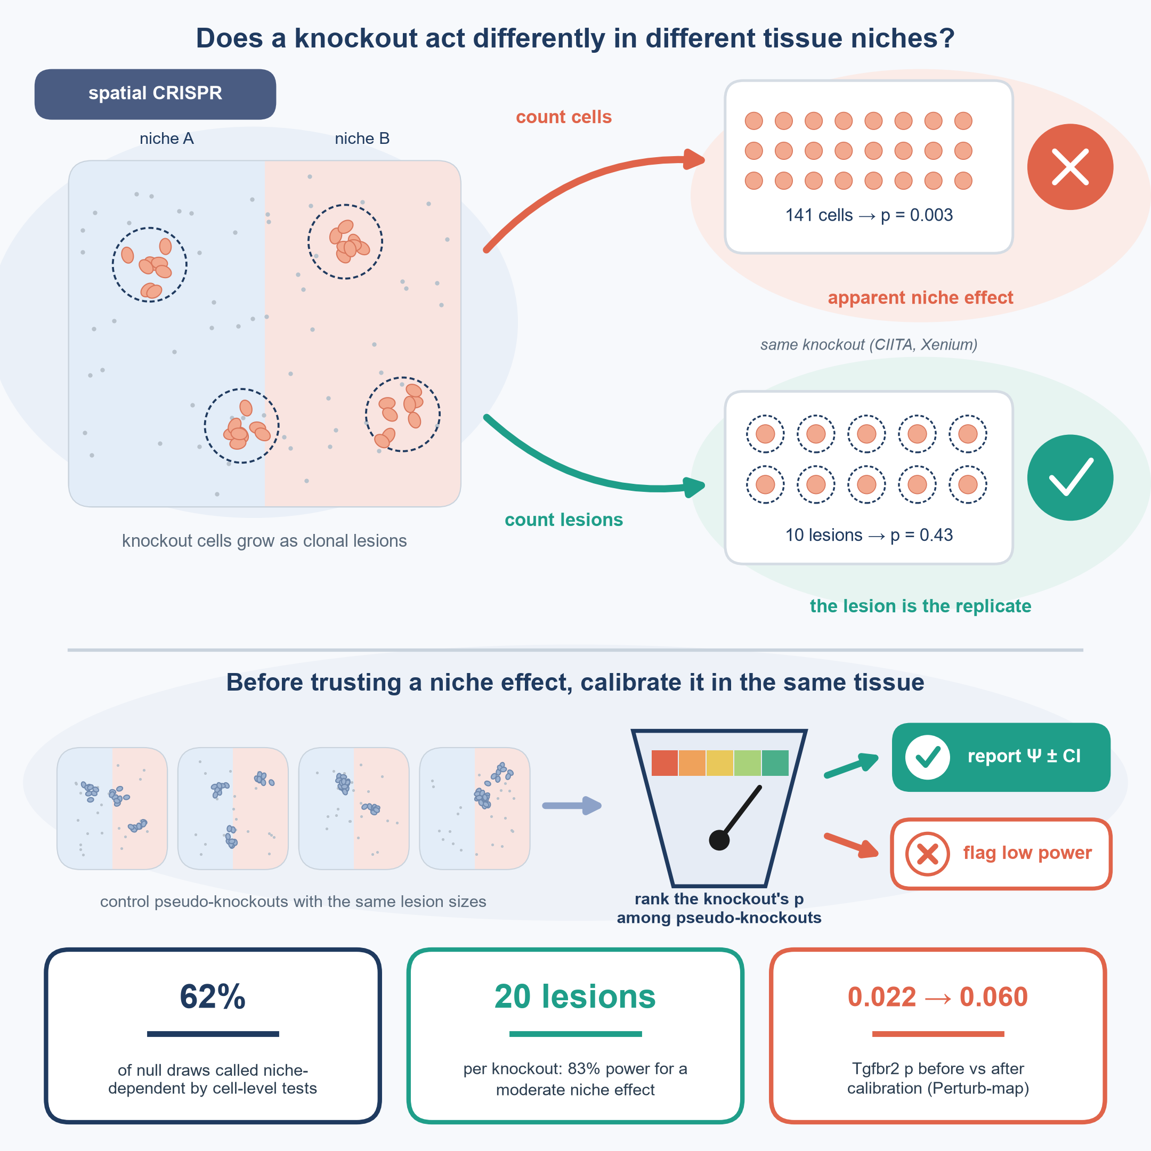
Fig. 1 | Clonal growth makes the lesion, not the cell, the unit of replication.
Top, in a spatial CRISPR screen each knockout grows as clonal lesions (dashed circles) within tissue niches (shaded); grey dots, control cells. For the same Xenium knockout (CIITA; 141 cells in 10 lesions), counting cells as replicates gives an apparent niche effect (cell-level permutation p = 0.003), whereas counting lesions does not (lesion permutation p = 0.43). Bottom, SpatialPert ranks a knockout's p-value among control pseudo-knockouts with the same lesion sizes in the same tissue, then reports the knockout-by-niche contrast Ψ with a lesion-clustered interval, or flags the design as underpowered. Cards: largest fraction of null pseudo-knockouts called niche-dependent by a cell-level test (Fig. 2a); power of the calibrated lesion test with 20 lesions for a niche effect half the shared effect (Fig. 3a); within-mouse permutation and calibrated p for Tgfbr2 in Perturb-map (Fig. 5).

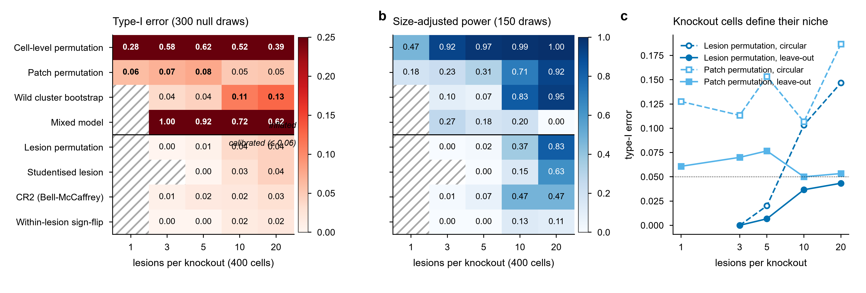
Fig. 2 | Calibration and power of eight tests across lesion numbers.
a, Type-I error (300 null draws per cell; bold, above 0.06). b, Size-adjusted power for a niche effect half the shared effect (150 draws). Hatched, test not applicable (fewer than two lesions in two niches). Tests above the line exceed 0.06 at some lesion number. c, Type-I error with circular (dashed) and leave-out (solid) niche labels. All pseudo-knockouts have 400 cells. Exact values with 95% Wilson intervals are in the source data.

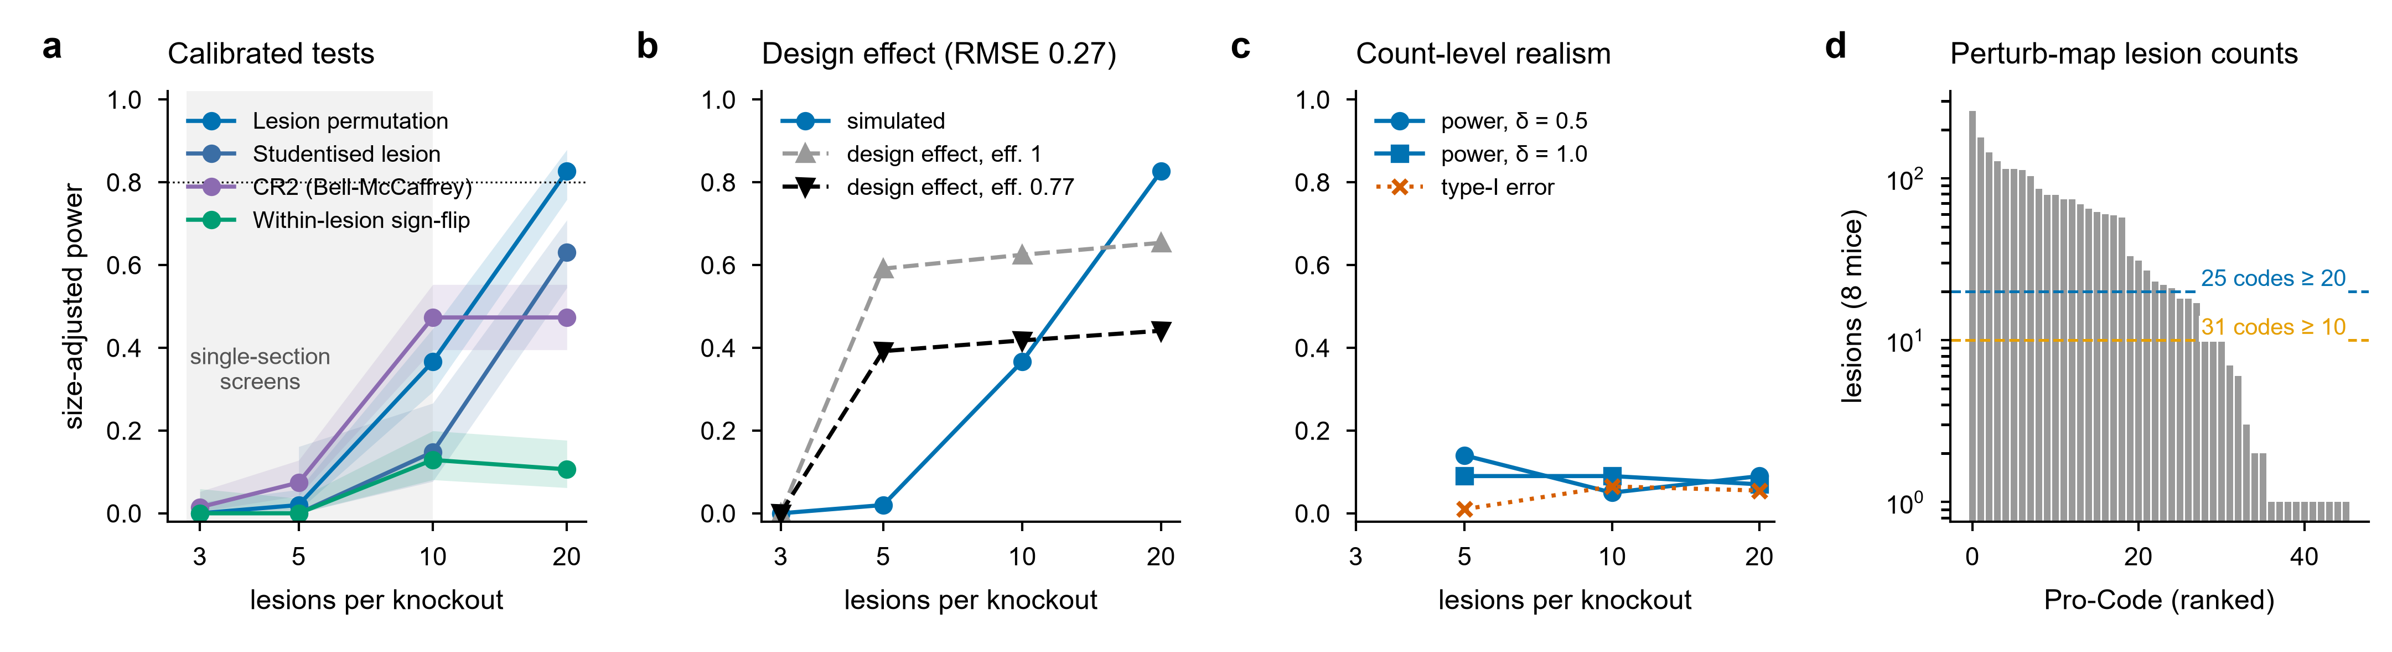
Fig. 3 | Designing screens for niche-dependence tests.
a, Size-adjusted power of the four calibrated tests; ribbons, 95% Wilson intervals; dotted, 80%. b, Power predicted by the design-effect formula with efficiency 1 or fitted, against the simulated power of lesion permutation. c, Count-level effects (δ = 0.5 or 1, all genes) with real lesion-size distributions: size-adjusted power and type-I error of lesion permutation. d, Lesions per Pro-Code in the Perturb-map imaging deposit (S-BIAD267; 2,192 lesions, 8 mice), log scale; dashed lines, 10 and 20 lesions.

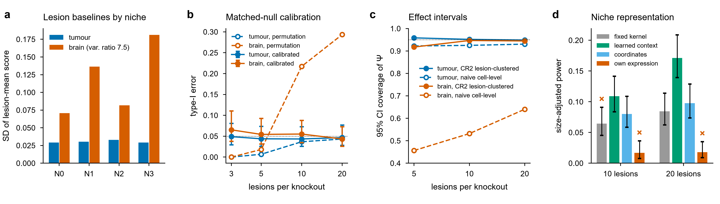
Fig. 4 | Why tests fail across tissues, and the remedies.
a, SD of lesion-mean scores by niche in tumour and brain (control pseudo-lesions, 20 lesions per pseudo-knockout, 60 draws); variance ratio, between-lesion variance over sampling variance. b, Type-I error of lesion permutation before (dashed) and after (solid) calibration against matched pseudo-knockouts (two-fold cross-fitting; bars, 95% Wilson intervals). c, Coverage of 95% intervals for the knockout-by-niche contrast Ψ: CR2 clustered on lesions (solid) and naive cell-level (dashed); 200 draws per point. d, Size-adjusted power (20 lesions, effect following host-cell fraction) with four niche representations under the same test, pooled over three encoder seeds (450 draws); bars, 95% Wilson intervals; ×, type-I error above 0.06 in some run.

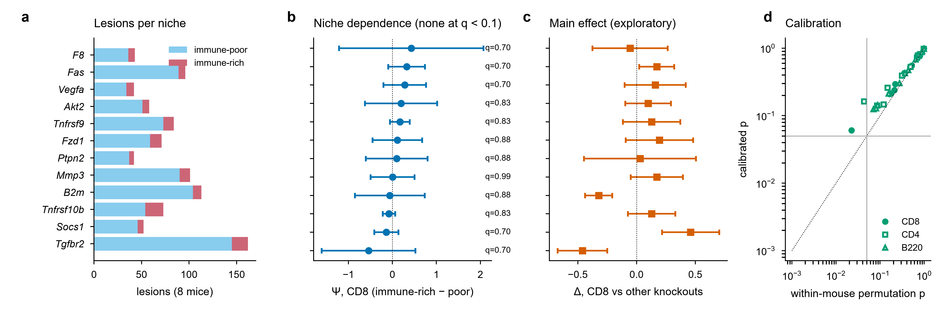
Fig. 5 | Perturb-map: knockouts change immune infiltration, but not by niche.
1,377 curated lesions in 41 lobes of 8 mice (S-BIAD267). a, Lesions per niche for the 12 eligible knockouts. b, Niche dependence of CD8 infiltration, Ψ (immune-rich minus immune-poor), with 95% CR2 intervals clustered on mouse; q, BH over knockouts of the calibrated p. c, Main effect on CD8 infiltration against other knockouts (mean of mouse means, 95% t interval; exploratory). d, Within-mouse permutation p against calibrated p for all 36 tests (filled, CD8).

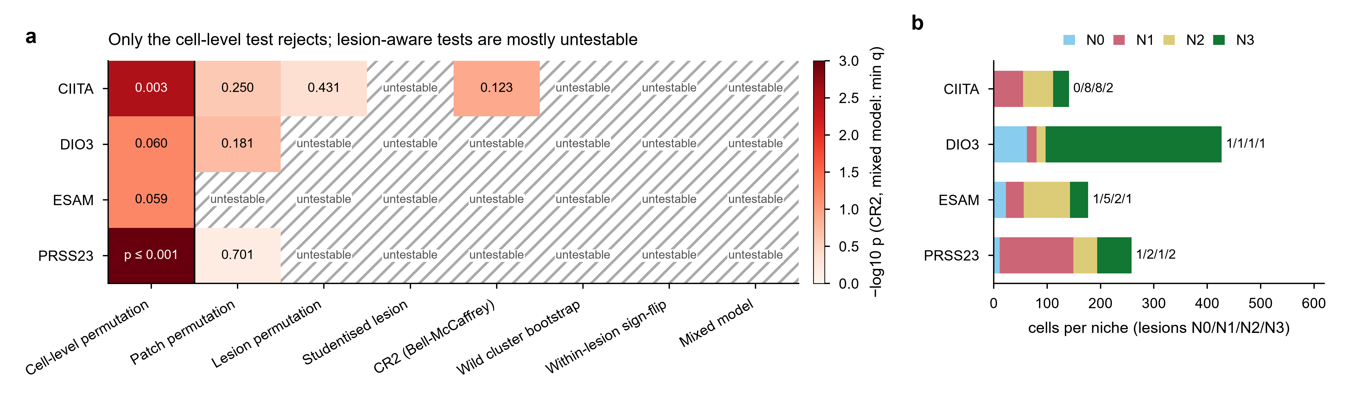
Fig. 6 | Xenium knockouts: cell-level significance disappears with lesions as units.
a, p-values (CR2 and mixed model: minimum BH q over genes) for four knockouts and eight tests on the same niches; colour, −log10 p; hatched, untestable (a niche seen in fewer than two lesions). Permutation p-values with 999-1,000 permutations are floored at 0.001. b, Cells per niche for each knockout, stacked; numbers, lesions visiting niches N0/N1/N2/N3.

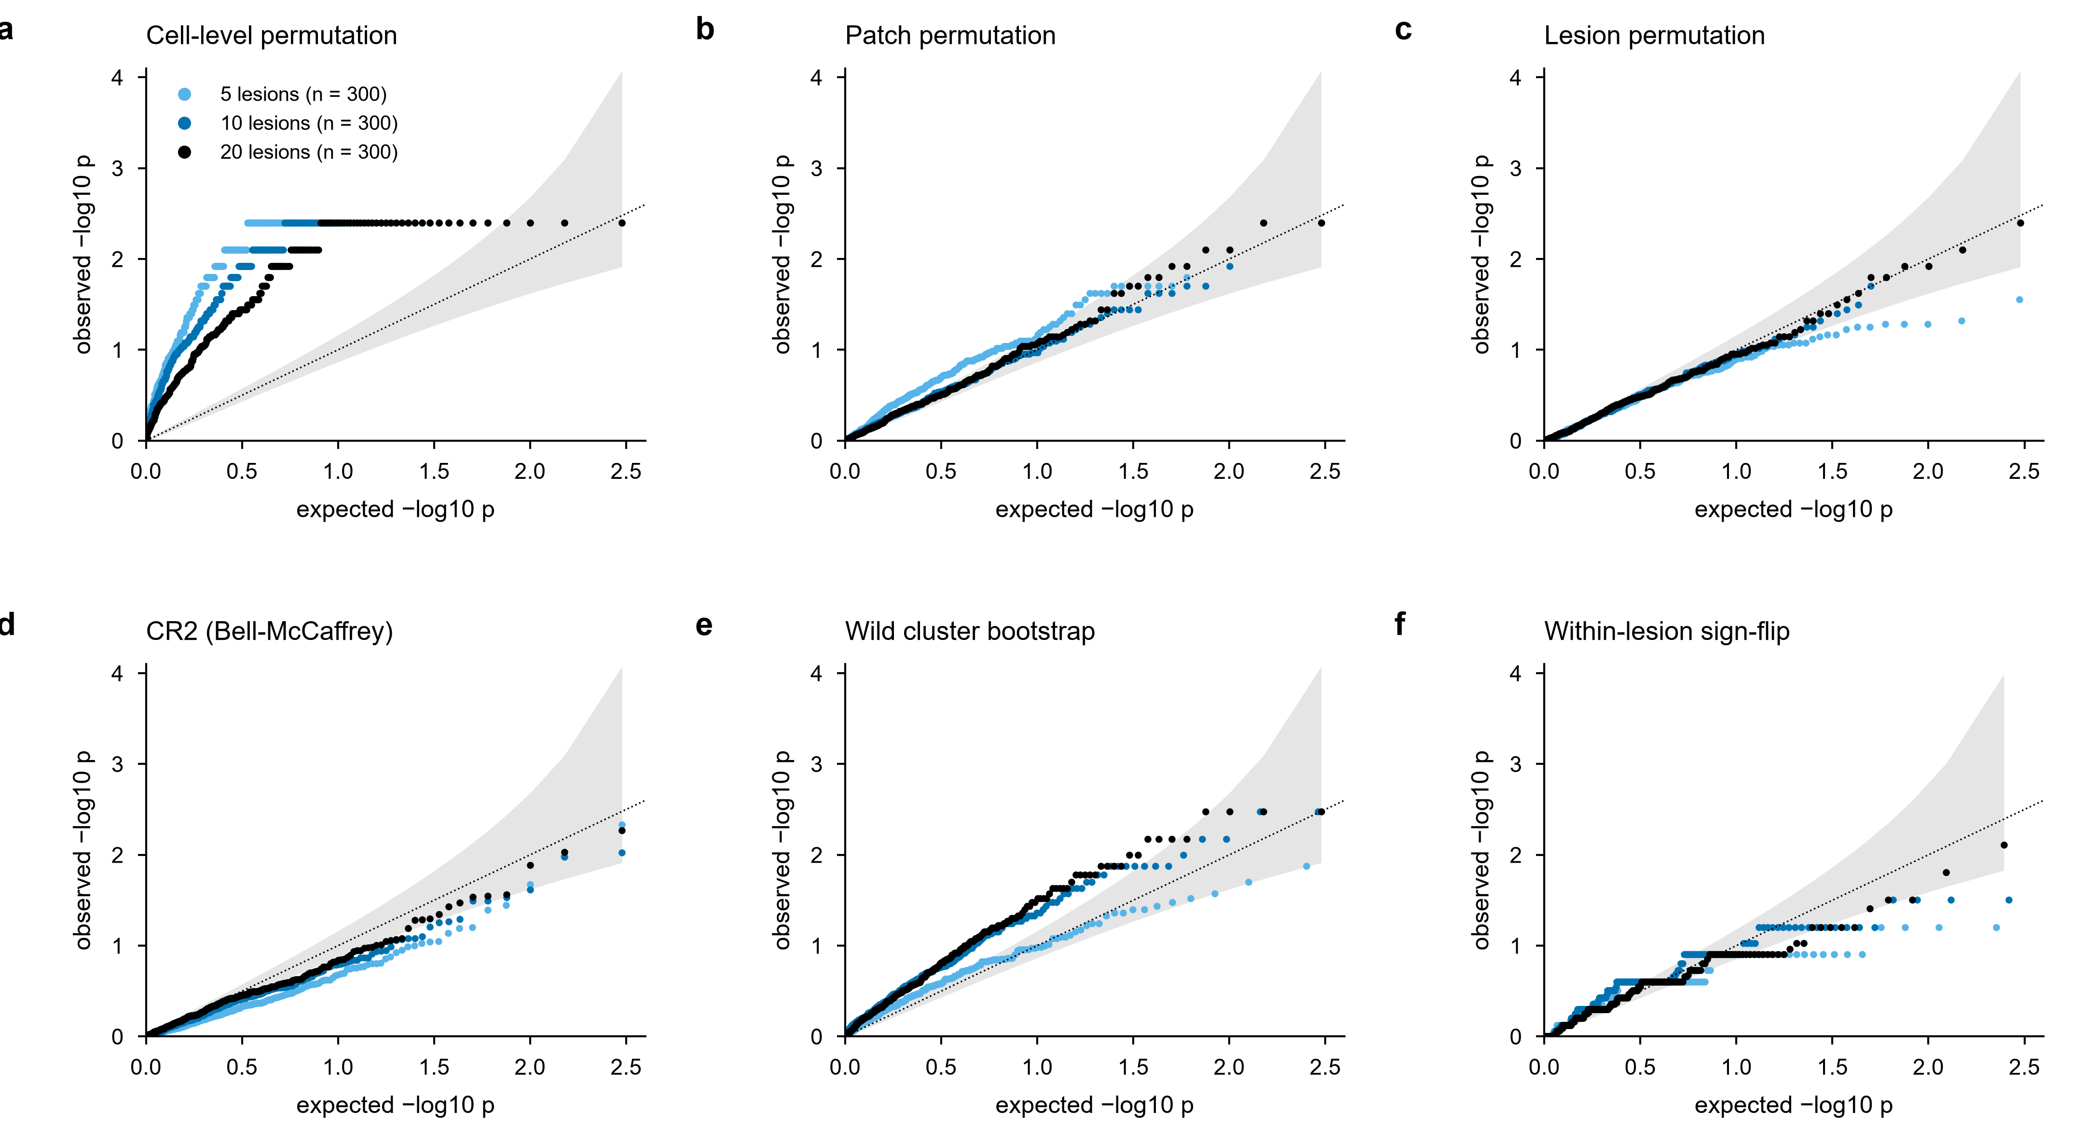
Extended Data Fig. 1 | Null p-value distributions.
QQ plots of null p-values (leave-out labels, 400 cells) at 5, 10 and 20 lesions for six tests. Grey band, pointwise 95% interval for 300 uniform p-values. Discreteness of the sign-flip test reflects the small number of straddling lesions.

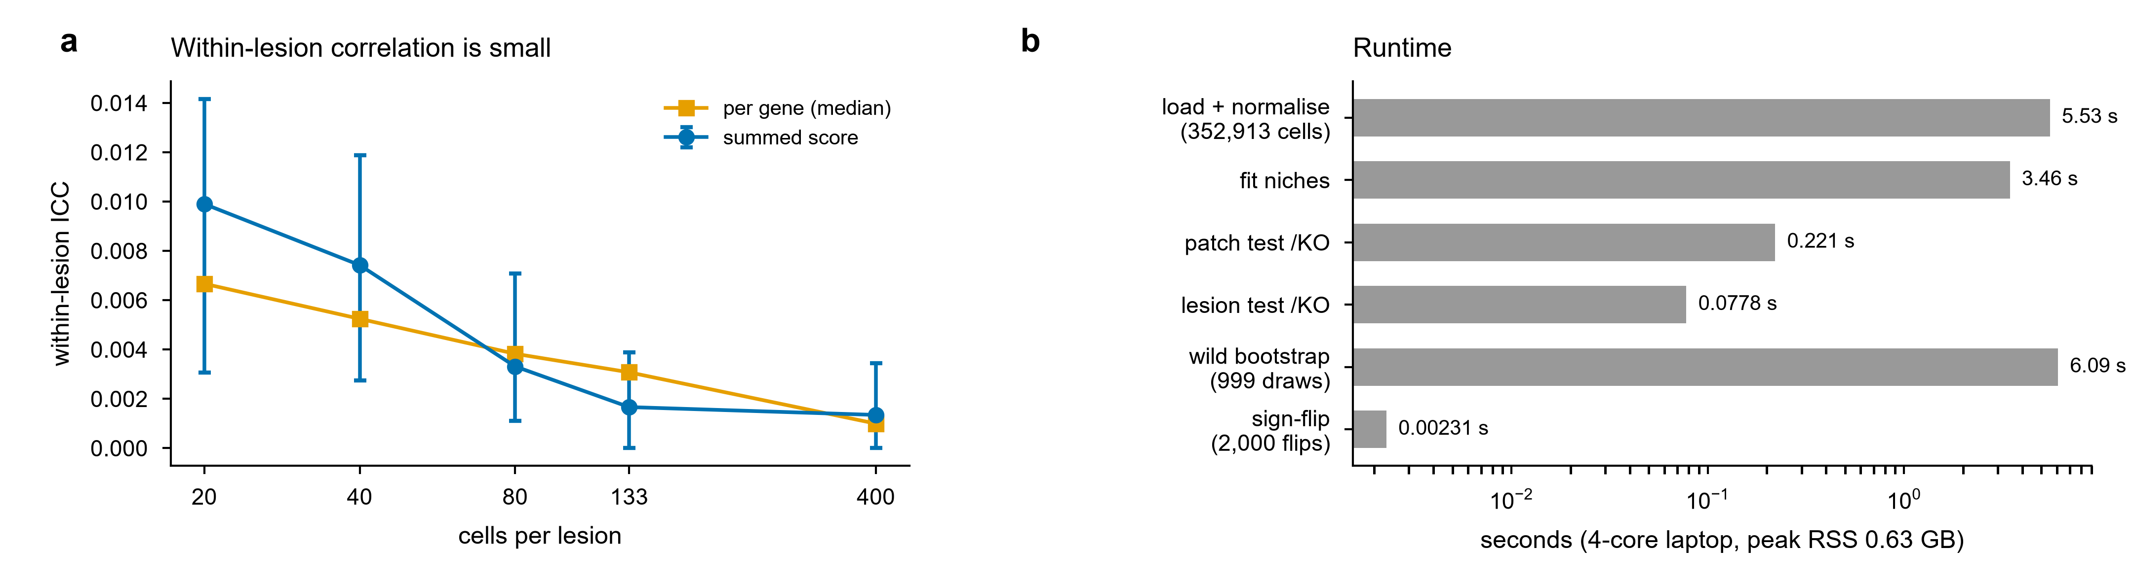
Extended Data Fig. 2 | Within-lesion correlation and runtime.
a, Within-lesion intraclass correlation of the tested score (median and interquartile range over pseudo-lesions) and per gene (median), by lesion size. b, Runtime on a 4-core laptop with 8.5 GB RAM, log scale.

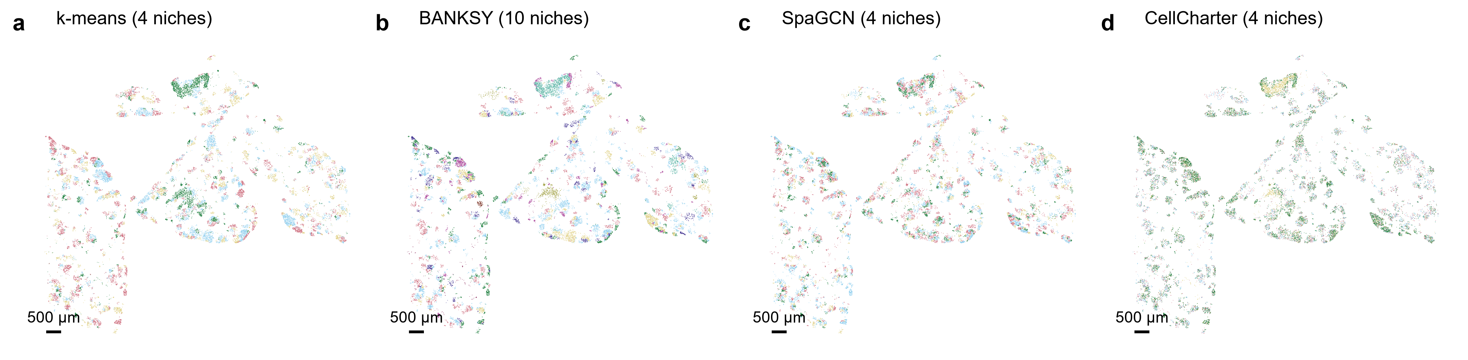
Extended Data Fig. 3 | Niches from four callers.
Niche labels of control tumour cells from k-means on neighbourhood features, BANKSY, SpaGCN and CellCharter (Methods). Scale bars, 500 µm.

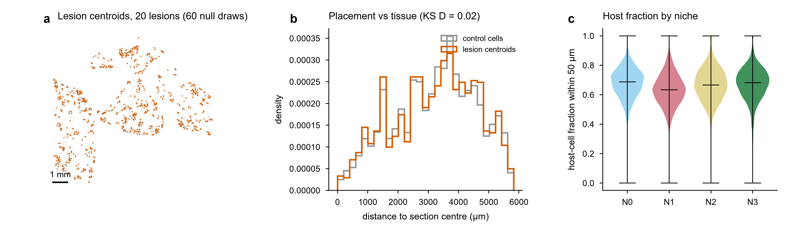
Extended Data Fig. 4 | Lesion placement and niche environment.
a, Centroids of simulated lesions (20 lesions per pseudo-knockout, first 60 null draws) over control tumour cells; scale bar, 1 mm. b, Distance to the section centre for lesion centroids and control cells (two-sample Kolmogorov-Smirnov D shown). c, Host-cell fraction within 50 µm of control cells by niche; line, median.

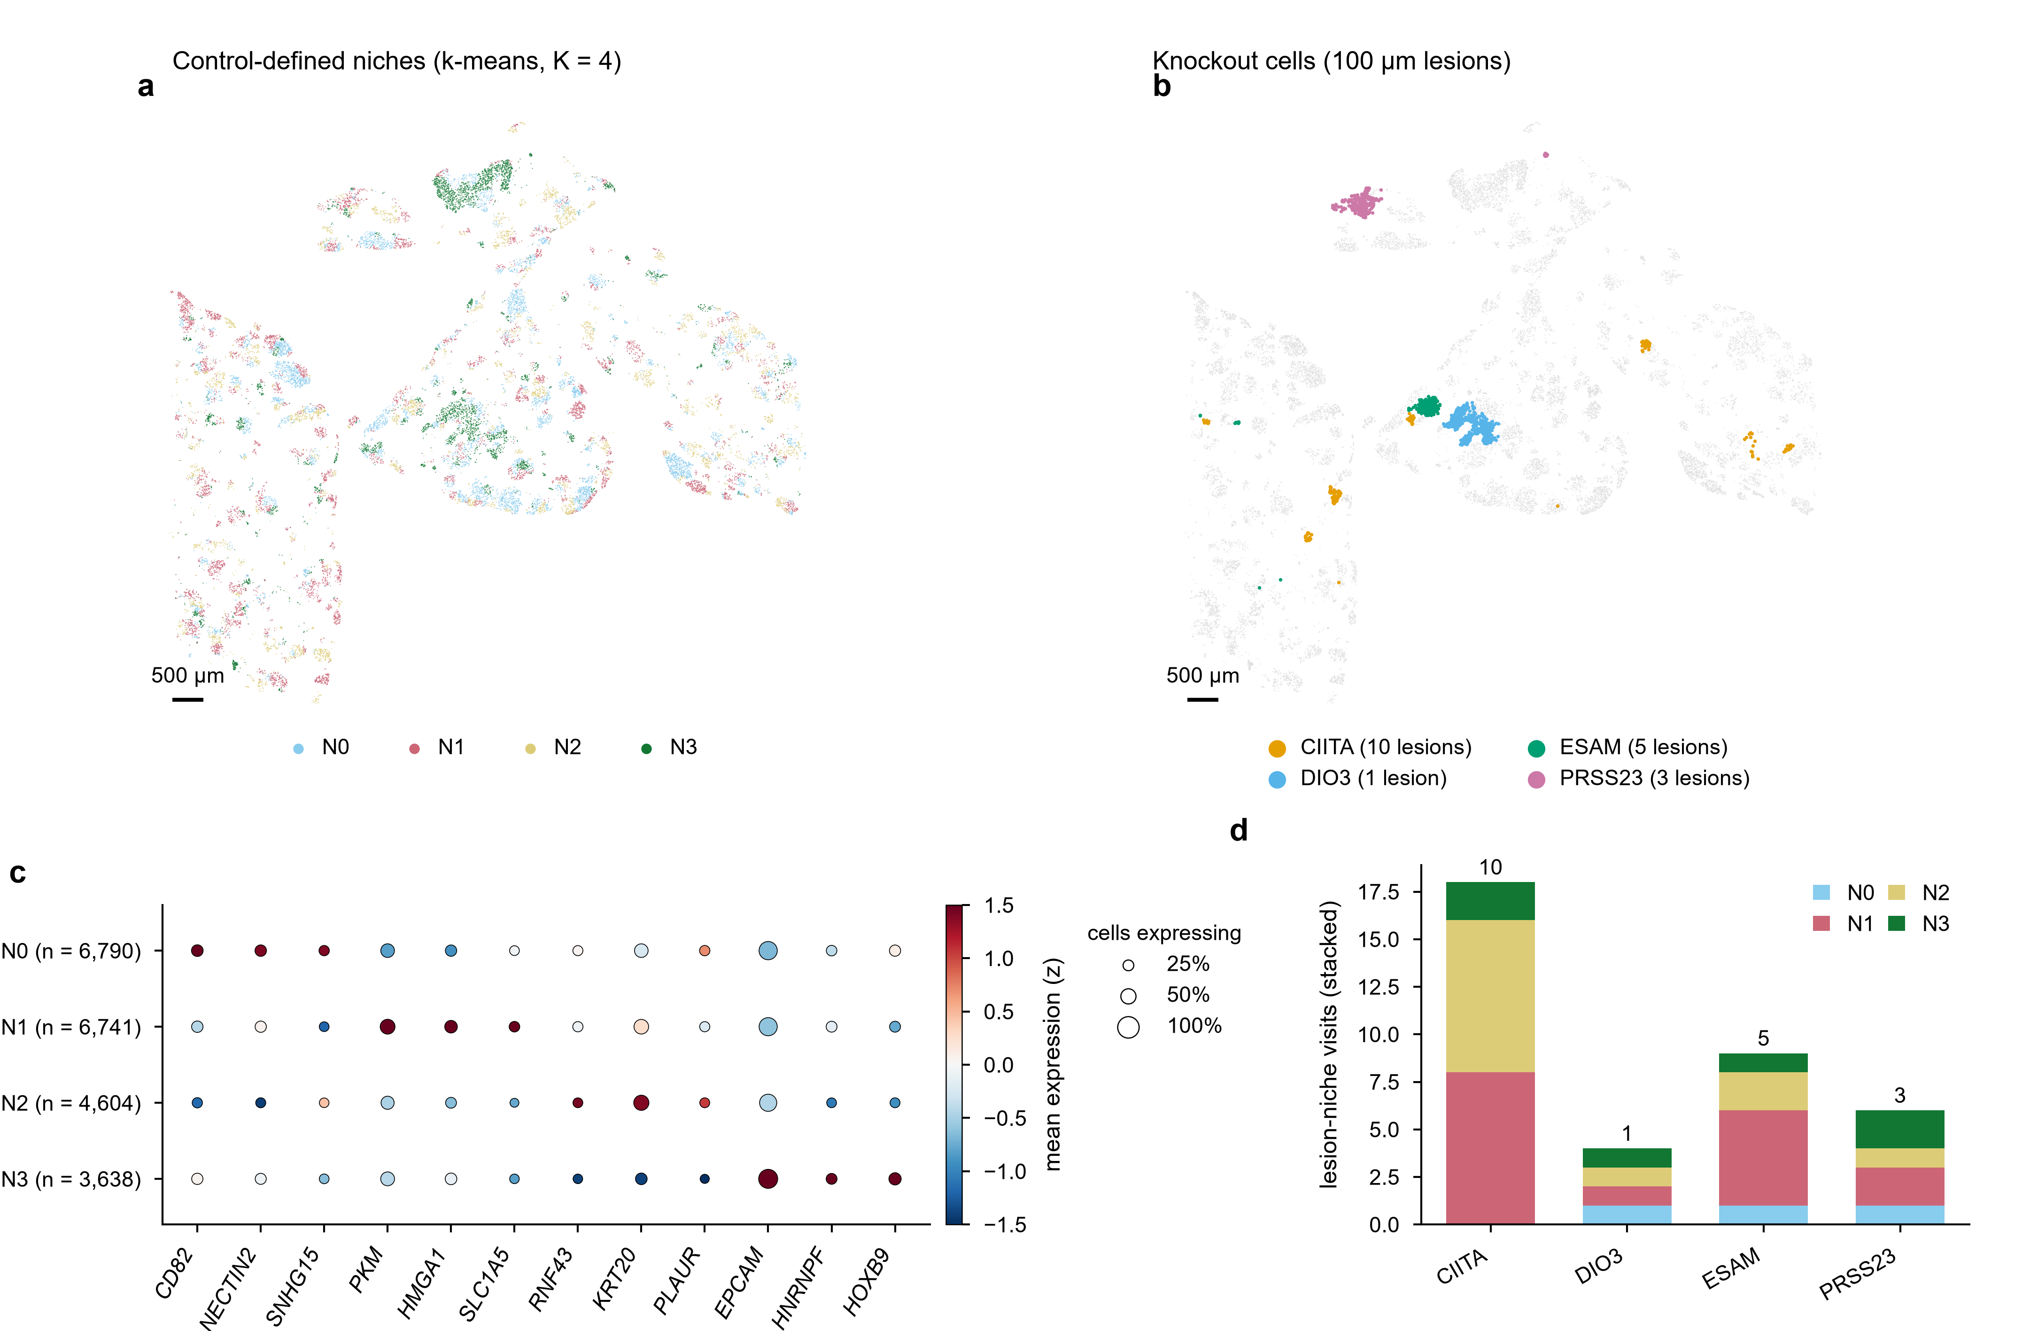
Extended Data Fig. 5 | Niches and knockout lesions in an HT-29 lung metastasis section.
a, Control-defined niches (k-means, K = 4) in the Xenium section (GSE319123). b, Cells of the four testable knockouts and their 100 µm lesions. c, Marker genes per niche in control cells; dot size, fraction of cells expressing; colour, z-scored mean expression. d, Lesion-niche visits per knockout, stacked by niche; numbers above bars are lesions per knockout. Scale bars, 500 µm.

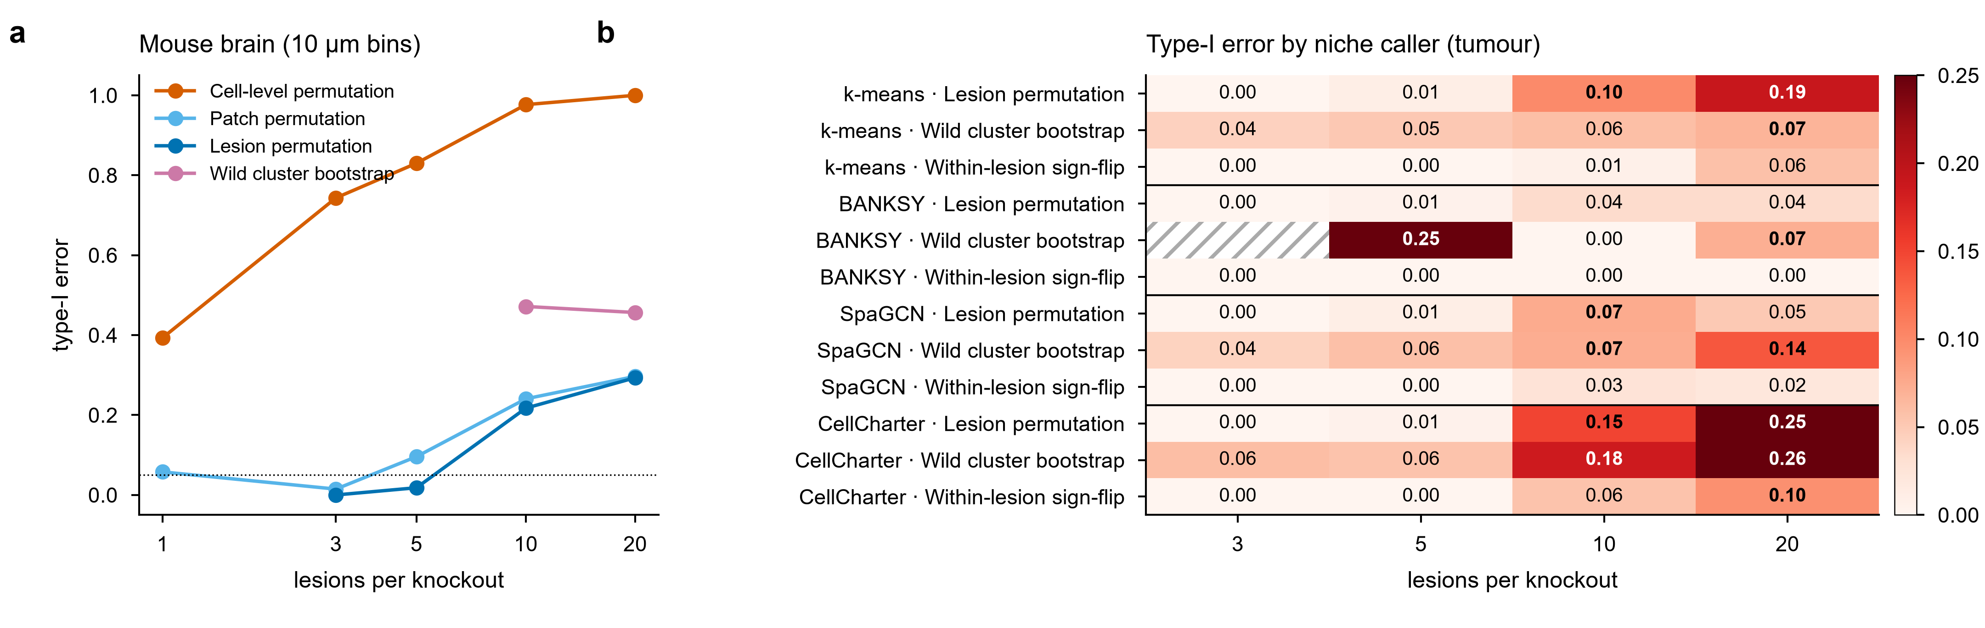
Extended Data Fig. 6 | Calibration depends on tissue and niche caller (uncalibrated tests).
a, Type-I error in a Xenium mouse brain section (10 µm bins), leave-out labels; points shown where the test was applicable in at least 10% of draws. b, Type-I error in the tumour section with niches from four callers (circular labels for all callers; 200 null draws per cell; bold, above 0.06; hatched, not applicable).

SUPPLEMENTARY NOTE 1 | PRE-REGISTRATION HISTORY
The analysis plan (RESEARCH_PROTOCOL.md, tag protocol-v1.0) was frozen before any knockout expression outcome was examined. It registered five hypotheses about the real screen and a positive control. After the first results showed that clonal structure, not biology, dominated the tests, the study was re-scoped through dated amendments, each registered before the analysis it governs: AMENDMENT-001 (implementation correction and pooled branch, before any outcome), 002 (exploratory analyses after internal review), 003 (calibration benchmark of test families), 004 (follow-up checks of one knockout), 005 (local-control residuals; not adopted), 006 (studentised tests under lesion structure; none qualified), 007 (geometry-matched null), 008 (small-cluster tests, leave-out niche labels and the adoption rule) and 008b (corrected size-adjusted critical value). After review 3, AMENDMENT-009 (exploratory, registered after the brain failure was known) covered the brain diagnosis, the matched-null calibration, effect intervals and the context encoder, and AMENDMENT-010 fixed the Perturb-map plan before any outcome was computed; 010a replaced distance-based lesions with the authors' curated lesion outlines after a structural check, also before any outcome. The original hypotheses and their status are below; none is a claim of this paper.
Hypothesis (protocol v1.0) | Registered result | Status
H1 niche dependence | p = 0.674 | Untestable at lesion level for 3 of 4 knockouts (Fig. 6)
H2 stable core effect | median r = 0.21 | Not supported; driven by one knockout
H3 microenvironment genes | p = 0.040 | Random 8-gene sets p = 0.006; not specific
H4 niche-aware prediction | p = 0.406 | Not supported
H5 cross-platform agreement | median r = -0.10 | Not supported
Positive control (Tgfbr2) | r = 0.50, p = 0.001 | Pass; validates the effect estimator

