Article
Cancer cell context reshapes genetic perturbation responses: set-based transfer of Perturb-seq effects across leukemia, hepatoblastoma, and non-transformed cells
[Author names and affiliations to be added by the authors]
Correspondence: [corresponding author e-mail]
Graphical abstract
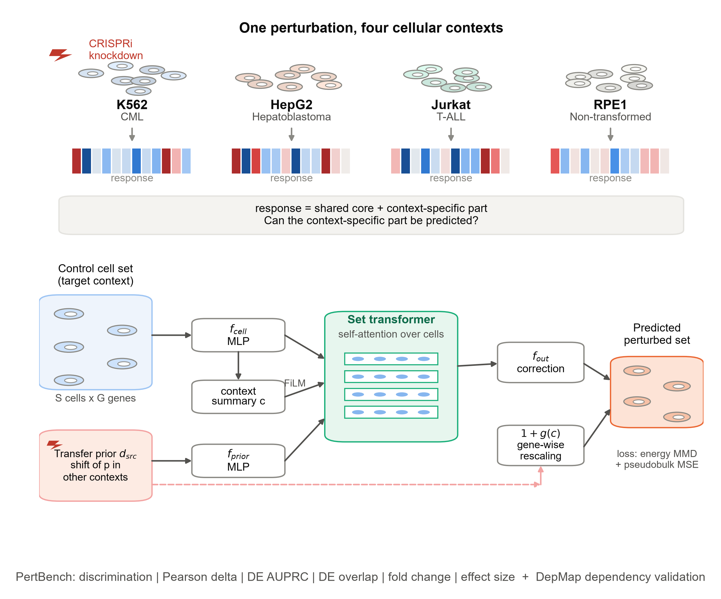
Highlights
- Responses to the same CRISPRi knockdown are only moderately shared across cell contexts
- CASTER adapts transferred perturbation responses to a context's unperturbed cells
- With partial screening of a context, CASTER outperforms mean baselines
- Knockdown response magnitude tracks DepMap dependency in all three cancer lines
In brief
Adapting perturbation responses measured in one cell type to another, CASTER and a pre-registered benchmark across leukemia, hepatoblastoma, and non-transformed cells show how much cancer context reshapes the transcriptional consequences of losing an essential gene, and how those consequences relate to cancer dependency.

SUMMARY
Genetic perturbation screens are run one cellular context at a time, yet cancers differ in lineage and state. Using CRISPRi Perturb-seq of essential genes in three cancer cell lines and a non-transformed line, we find that transcriptional responses to the same knockdown are only moderately shared across contexts (median correlation 0.31 between cancer lines), with similarity increasing for stronger responses. We introduce CASTER, a set-based transformer that transfers a perturbation's response from other contexts and adapts it to the target context's unperturbed cells. When a fraction of the target context is screened, CASTER improves on mean baselines (Pearson delta 0.28 versus 0.20 for the perturbation mean) and matches a context-adaptive linear model, while in fully unseen contexts the perturbation mean remains hard to beat. Across all three cancer lines, the magnitude of a knockdown's transcriptional response tracked the line's dependency on the gene measured by DepMap (Spearman rho -0.39 to -0.54), and predicted responses retained this dependency information. These results quantify how much cancer context reshapes perturbation responses and provide a reproducible benchmark for context-generalising virtual-cell models.
Keywords: Perturb-seq; CRISPRi; context generalization; virtual cell; set transformer; cancer dependency; DepMap; leukemia; hepatoblastoma; transfer learning

INTRODUCTION
Pooled CRISPR screens with single-cell transcriptomic readouts (Perturb-seq) measure the transcriptome-wide consequence of a genetic perturbation in thousands of cells at once^{1–4}. CRISPR interference (CRISPRi)^{5,6} has made such screens scalable to every expressed or essential gene^{7,8}, and they are now used to map gene function, genetic interactions and regulatory programs^{8–11}. In cancer research they have identified regulators of immune evasion, drug response and oncogenic variant function^{12–16}. Each screen, however, is performed in one cellular context. A tumour is not one context: cancers differ by lineage, driver, ploidy and baseline transcriptional state, and these differences shape how a cell responds to losing a gene^{17–20}. Screening every perturbation in every relevant context is not feasible, so computational models that transfer perturbation responses across contexts are needed^{21,22}.
Many models predict single-cell perturbation responses, including autoencoder and latent-arithmetic models^{23–27}, optimal-transport maps²⁸, knowledge-graph models²⁹ and single-cell foundation models^{30–32}. Recently, State, a transformer that operates on sets of cells and is trained with a distributional loss, was shown to generalise perturbation effects to new contexts better than these approaches on several large datasets³³. At the same time, careful benchmarks have shown that simple baselines, including the mean response of a perturbation across training contexts and linear models, are hard to beat^{34–36}. A community-wide challenge now asks for virtual-cell models that pass a 'Turing test' on held-out contexts³⁷. Two questions are therefore open. How much of a perturbation's response is really specific to the context, as opposed to shared? And does that context-specific part carry biological information, for example about which genes a particular cancer depends on?
Here we address both questions in the setting where context matters most for cancer biology: the same essential-gene CRISPRi library profiled in three cancer cell lines from different lineages (K562 chronic myeloid leukaemia, HepG2 hepatoblastoma and Jurkat T cell acute lymphoblastic leukaemia) and in non-transformed hTERT RPE-1 cells^{8,38}. We first quantify how similar the responses to the same knockdown are across these contexts. We then introduce CASTER (Context-Adaptive Set Transformer for pErturbation Responses). CASTER represents a perturbation by its observed effect in other contexts (a transfer prior) and learns, from the unperturbed cells of the target context alone, how that context rescales and reshapes the response. By construction CASTER starts at the strongest simple baseline and can only move away from it where held-out data support the change. This makes its comparison with baselines a direct test of whether context-specific structure is learnable.
We evaluate CASTER with a pre-registered protocol and a biologically interpretable evaluation suite (PertBench), modelled on the Cell-Eval framework³³. We test it in under-represented contexts, in completely unseen contexts and in every single-source transfer direction. Finally, we connect perturbation responses to cancer dependency, asking whether the magnitude and context specificity of a knockdown's transcriptional response track CRISPR fitness effects measured independently in the Cancer Dependency Map^{39–42}. We report every pre-declared test, including those that do not support our hypotheses.
RESULTS
Responses to the same knockdown are only moderately shared across cellular contexts
We assembled CRISPRi Perturb-seq profiles of essential-gene knockdowns in four human cell lines (Figures 1A and 1B): K562 (chronic myeloid leukemia)⁸, HepG2 (hepatoblastoma)³⁸, Jurkat (T cell acute lymphoblastic leukemia)³⁸ and the non-transformed, TP53-proficient line hTERT RPE-1^{8,43}. We used the knockdown-filtered, uniformly processed release of these data³³ and analysed 196,093 cells: up to 32 cells per perturbation per line and 3,000 controls per line (STAR Methods). After filtering, 1,383 (K562), 1,340 (HepG2), 1,537 (Jurkat) and 1,499 (RPE1) perturbations remained (2,023 distinct genes). Of these, 638 were retained in all four lines and 782 in all three cancer lines. Because on-target efficacy was filtered per line, the set of informative perturbations is itself context dependent (Figure 1B). We modelled 2,000 genes selected on control cells only, excluding every perturbation target, so that neither gene selection nor the trivial on-target signal can inflate any result.
The number of differentially expressed genes (DEGs; Wilcoxon test against held-out controls, FDR < 0.05) varied widely between knockdowns and between contexts. The median was 2 in K562, 5 in HepG2, 2 in Jurkat, 29 in RPE1; 32%, 46%, 32%, 60% of knockdowns, respectively, changed at least 10 genes (Figure S1A). Responses in the non-transformed RPE1 line were thus markedly larger than in the three cancer lines. This is consistent with an intact p53-dependent stress response to the loss of essential genes in TP53-proficient cells^{44,45}. For 706 genes whose knockdown produced >= 10 DEGs in at least two lines, we compared responses across contexts. The shifts were only moderately correlated: median Pearson r was 0.31 between cancer lines and 0.38 between a cancer line and RPE1 (Figures 1D and 1E). DEG sets overlapped little (median Jaccard 0.08 and 0.10; Figure S1C).
The most similar pair was HepG2-RPE1 (median r = 0.52); the other five pairs ranged from 0.28 to 0.33. HepG2 and RPE1 are the two adherent, epithelial-derived lines, whereas K562 and Jurkat grow in suspension, which suggests that cell morphology and growth mode, and not transformation status alone, shape the shared response. Similarity rose with response strength, from 0.31 for knockdowns with >= 10 DEGs to 0.45 for those with >= 200 DEGs in both cancer lines (Figure S1D). Much of the apparent context specificity of weak responses is therefore measurement noise, whereas strong responses share a larger core. A useful context-transfer model must therefore capture the shared core and predict at least part of a substantial context-specific component.
CASTER adapts transferred responses to the target context
These observations motivated CASTER (Figure 1C). Like State³³, CASTER operates on sets of cells and is trained with a distributional (energy-distance MMD) loss^{46,47}, so it models a perturbed population rather than a single average cell. It differs in how it represents the perturbation and the context. A perturbation is represented by its transfer prior: the mean shift it produced in the other contexts in which it was observed. The target context is never part of this prior. The context is represented only by a set of its unperturbed cells, which a transformer encoder reads through self-attention. FiLM conditioning⁴⁸ lets the same prior act differently in each context. The output adds a context-dependent, gene-wise rescaling of the prior to a cell-resolved correction. Both are initialised at zero, so an untrained CASTER is exactly the PerturbMean baseline, and any departure must be earned on held-out validation data (STAR Methods).
In simulations where the context-specific component was pure noise, CASTER stayed at the PerturbMean solution (Pearson delta 0.67 versus 0.68). When the context-specific component depended on each gene's baseline expression in that context, which is observable from control cells, CASTER recovered it (Pearson delta 0.84 versus 0.49; Figure S4). The architecture can therefore learn context structure when it exists and does not invent it when it does not.
On the K562 under-represented-context fold, validation loss and held-out accuracy changed with the size of the cell set the model reads (Figures 1F and 1G). Pearson delta was 0.178 at S = 1, 0.160 at S = 8, 0.189 at S = 32. Removing self-attention gave 0.181, removing FiLM 0.189, and replacing the transfer prior with a learned perturbation embedding 0.095. Adding an identity embedding to the prior gave 0.185. Paired comparisons of the full model with each variant (Holm-adjusted Wilcoxon) gave: single cells (S = 1): full model better on Pearson delta, DE AUPRC; variant better on discrimination; no attention: full model better on Pearson delta, discrimination, DE AUPRC; no FiLM: no significant advantage; variant better on Pearson delta; no transfer prior: full model better on Pearson delta, discrimination, DE AUPRC; added ID embedding: full model better on Pearson delta, DE AUPRC; S = 8: full model better on Pearson delta, discrimination, DE AUPRC. The transfer prior is by far the most important component. The set-level attention adds a small but significant improvement. A single-cell model (S = 1) discriminates perturbations better, at the cost of the distributional (set-level) objective.
Benchmarking context transfer in under-represented contexts
We first evaluated the common practical setting in which a new context has been screened with only a fraction of a library (Figure 2A)³³. For each of the four lines in turn, 25% of its eligible perturbations were used for training, 5% for model selection and 70% for testing; the other three lines were fully observed. We compared CASTER with PerturbMean (a perturbation's mean response in the other contexts), ContextMean (the target context's average response), a context-adaptive linear transfer model fitted on the observed fraction, and a no-change floor. The evaluation suite, PertBench, follows Cell-Eval³³. It scores expression shifts (Pearson delta, perturbation discrimination), differential expression (DEG precision-recall, top-N DEG overlap, fold-change rank correlation, direction) and effect size (rank correlation of the number of DEGs across perturbations) (Figures 2B-2E; STAR Methods).
Averaged over the four held-out contexts, CASTER reached a Pearson delta of 0.28, a discrimination score of 0.43 and a DE AUPRC of 0.19. The corresponding values were 0.20, 0.37 and 0.14 for PerturbMean, 0.28, 0.42 and 0.18 for linear transfer, and 0.21, 0.00 and 0.10 for ContextMean (Figure 2B). Of the nine pre-declared comparisons (H1), 6 favoured CASTER after Holm correction, and 0 significantly favoured a baseline. H1 was therefore supported. DE-based metrics use the amended predicted-side test (AMENDMENT-002, STAR Methods). The pre-registered Wilcoxon test on predicted cells proved invalid: it called a mean of 1333 DEGs per CASTER prediction, versus 61 observed. Under the pre-registered test, 6 of nine comparisons favoured CASTER and 0 favoured a baseline (H1 supported; Table S1); the conclusion from the expression-level metrics does not depend on this choice. Against PerturbMean: Pearson delta: 66% of perturbations improved, Holm p = 4.0 × 10⁻¹⁵²; discrimination: 46% of perturbations improved, Holm p = 1.000; DE AUPRC: 67% of perturbations improved, Holm p = 6.1 × 10⁻¹⁰³. Against Linear: Pearson delta: 50% of perturbations improved, Holm p = 1.000; discrimination: 50% of perturbations improved, Holm p = 0.117; DE AUPRC: 56% of perturbations improved, Holm p = 1.6 × 10⁻¹⁷. Against ContextMean: Pearson delta: 67% of perturbations improved, Holm p = 2.0 × 10⁻¹⁴⁹; discrimination: 80% of perturbations improved, Holm p < 1e-300; DE AUPRC: 77% of perturbations improved, Holm p = 1.8 × 10⁻²²².
Per context, CASTER and PerturbMean reached Pearson deltas of K562 0.20 versus 0.19; HepG2 0.31 versus 0.24; Jurkat 0.20 versus 0.16; RPE1 0.39 versus 0.20 (Figure 2C). Both transfer methods ranked perturbations by effect size well (Spearman rho between predicted and observed DEG counts 0.64 for CASTER and 0.63 for PerturbMean; Figure 2E). They recovered DEGs far above the no-change and context-mean baselines (Figure 2D). Among the secondary metrics compared with PerturbMean, 2 favoured CASTER and 1 favoured PerturbMean (Table S1).
Where does CASTER gain over the transfer prior? Binning held-out perturbations by the number of observed DEGs showed that the gain grows with response strength in every context (Spearman rho between gain and log response size 0.22 in K562, 0.49 in HepG2, 0.29 in Jurkat, 0.64 in RPE1; Figure S8). For knockdowns with >= 50 DEGs the median gain in Pearson delta was 0.09 (K562), 0.22 (HepG2), 0.09 (Jurkat), 0.33 (RPE1), whereas for knockdowns with < 10 DEGs it was close to zero (0.00, 0.00, 0.01, 0.03). CASTER's corrections therefore act on real, strong, context-specific responses, not on noise. In the zero-shot task, no such gradient appeared (median gain for strong responses 0.01, -0.05, -0.01, -0.01), in line with the absence of an overall advantage.
Zero-shot transfer and the cancer versus non-transformed distinction
We next asked whether responses could be transferred into a context with no perturbation data at all, using only its unperturbed cells (Figure 3A). In this zero-shot setting CASTER achieved a Pearson delta of 0.17 versus 0.20 for PerturbMean (Figure 3B). The pre-declared comparison (H2) was not supported (Pearson delta: CASTER 0.171 vs 0.197, Holm p = 1.000; discrimination: CASTER 0.214 vs 0.363, Holm p = 1.000; DE AUPRC: CASTER 0.107 vs 0.136, Holm p = 1.000). Per context, CASTER and PerturbMean reached Pearson deltas of K562 0.19 versus 0.19; HepG2 0.17 versus 0.25; Jurkat 0.14 versus 0.15; RPE1 0.19 versus 0.20. Without any perturbation data from the target, the corrections CASTER learns between source contexts did not carry over. Its discrimination fell below that of PerturbMean, indicating that the corrections pulled predictions towards a response shared across perturbations rather than adding perturbation-specific information. By Proposition 4 (STAR Methods), this means that the residual of the transfer prior was not predictable from a context's control cells alone at this data scale. Comparing the gain over PerturbMean with and without a 30% observed fraction (Figure 3E) shows that CASTER's advantage depends on a small amount of perturbation data from the target context. This has a practical design implication: screening a modest subset of a library in a new context, as in our under-represented setting, is what makes context adaptation effective.
To test whether transfer depends on how related two contexts are, we transferred every perturbation from a single source line to each other line (12 directions; Figure 3C). With the PerturbMean transfer, per-perturbation accuracy averaged over cancer-to-cancer directions was 0.14, versus 0.17 for directions involving RPE1 (n = 1,204 perturbations, paired Wilcoxon p = 9.5 × 10⁻⁵¹; Figure 3D). H3 was therefore not supported. The difference was significant in the opposite direction: transfer involving the non-transformed line was more accurate. The effect was driven by the HepG2-RPE1 pair (Pearson delta 0.23 from HepG2 to RPE1 and 0.26 from RPE1 to HepG2, the two highest entries of the matrix). This matches the higher response similarity of these two adherent, epithelial-derived lines (Figure 1D) and the larger, better-resolved responses of RPE1 (Figure S1A). CASTER showed the same pattern (0.14 versus 0.17, p = 1.4 × 10⁻⁵⁶), and in single-source transfer it was indistinguishable from PerturbMean in most directions (Figure 3C; Table S6). Transfer accuracy therefore reflects the biological similarity between two contexts, here lineage and growth mode, more than the binary distinction between transformed and non-transformed cells.
Context-specific differential expression, programs and perturbation structure
At the level of individual perturbations, CASTER and the transfer baselines were compared on DE overlap and fold-change agreement (Figures 4A and 4B). Points above the diagonal are perturbations for which CASTER recovered more of the context's actual DEGs. Figure 4C shows the knockdown with the largest CASTER gain over PerturbMean in a cancer line, illustrating a context-specific correction of the transferred response. Predicted shifts of S-phase and G2/M signature scores⁴⁹ had mean absolute errors of 0.0619 (S) and 0.0760 (G2/M) for CASTER, 0.0940 (S) and 0.1378 (G2/M) for PerturbMean (Figure 4D). When perturbations were clustered by the similarity of their responses, predicted similarity maps recovered the observed structure with mean adjusted Rand indices (over 2-20 clusters and four contexts) of 0.26 (CASTER), 0.10 (PerturbMean), 0.23 (Linear), 0.02 (ContextMean) (Figure 4E).
Which perturbations does CASTER adapt most? In each cancer line, the knockdowns with the largest gain over PerturbMean (among those with >= 30 DEGs) were dominated by regulators of ribosome biogenesis and ribosomal proteins: NVL in HepG2 (r over DEGs 0.61 versus -0.16); RBM28 in HepG2 (r over DEGs 0.60 versus 0.00); RPL26 in Jurkat (r over DEGs 0.71 versus 0.32); RRS1 in Jurkat (r over DEGs 0.61 versus 0.25); PDCD11 in K562 (r over DEGs 0.66 versus 0.50); RPL6 in K562 (r over DEGs 0.60 versus 0.36) (Figures 4C and S10). Loss of ribosome biogenesis triggers a nucleolar stress response, whose transcriptional output depends on p53 status, MYC activity and growth rate, all of which differ between these lines. The transferred response of these knockdowns is therefore a poor guide to their response in a new context, while the context's own cells, read through CASTER, carry the information needed to correct it. In HepG2, for example, the PerturbMean prediction for NVL knockdown was uncorrelated or anti-correlated with the observed DEGs, whereas CASTER recovered their direction and relative magnitude.
We identified 15 co-regulated gene programs per context from the observed responses and annotated them with Reactome⁵⁰. Predicted program activities correlated with observed ones at mean r = 0.63 (CASTER), 0.51 (PerturbMean), 0.00 (ContextMean) (Figure 5D). Response similarity between knockdowns recovered high-confidence STRING associations⁵¹ with AUROC 0.81 for observed responses, 0.80 for CASTER, 0.75 for PerturbMean (Figure 5F). Predicted responses therefore preserve much of the functional organisation of the perturbations. In an inverse-design task (identifying which perturbation produced an observed response among all candidates in a context), the correct perturbation was within the top 10 for 56% (CASTER), 26% (PerturbMean), 58% (Linear), 0% (ContextMean) of the 100 strongest perturbations (Figure 5E).
Knockdown responses and cancer dependency
Finally, we asked whether perturbation responses carry information about cancer dependency, measured independently by genome-scale CRISPR fitness screens in DepMap (Chronos gene effects)^{39,40,52}. In each cancer line, knockdowns of genes on which the line depends more strongly (more negative Chronos score) were expected to produce larger transcriptional responses (H4). Spearman correlations between log(1 + # DEGs) and Chronos were K562 rho = -0.45 (n = 1,325, Holm p = 7.3 × 10⁻⁶⁷); HepG2 rho = -0.54 (n = 1,275, Holm p = 1.0 × 10⁻⁹⁵); Jurkat rho = -0.39 (n = 1,465, Holm p = 6.8 × 10⁻⁵⁴) (Figure 5A). H4 was supported: response magnitude tracks dependency. Restricting to genes profiled in all three cancer lines, we then asked whether the context-specific part of the response (a line's response minus the mean of the other two) tracks the context-specific part of the dependency (H4b): K562 rho = -0.12 (Holm p = 0.004); HepG2 rho = -0.05 (Holm p = 0.318); Jurkat rho = -0.05 (Holm p = 0.318) (Figure 5B). H4b was not supported by the pre-declared rule (significant negative correlation in at least two lines); only K562 reached significance, with a weak effect. In these data, which genes a particular line depends on more than the others is at most weakly reflected in how strongly it responds to their knockdown. Dependency differences between lines are small for most essential genes^{53–55}, which limits the power of this test.
The dependency-response coupling itself was preserved in predicted responses. Predicted response magnitude correlated with Chronos at rho = -0.41 (K562), -0.52 (HepG2), -0.33 (Jurkat) for CASTER, compared with -0.44, -0.54, -0.43 for observed responses and -0.51, -0.46, -0.33 for PerturbMean. ContextMean, which ignores perturbation identity, lost it (Figure S12). A ridge model trained to predict Chronos from observed transcriptional shifts (10-fold cross-validation over held-out perturbations) reached a mean Pearson r of 0.57 across the three cancer lines. Applied unchanged to predicted shifts, it reached 0.50 (CASTER), 0.47 (PerturbMean), 0.52 (Linear), -0.02 (ContextMean) (Figure 5C; Figure S5). Transferred responses therefore retain part of the dependency information carried by measured responses. This connects in silico perturbation to cancer target prioritisation^{41,42}, a use that the reference State model demonstrated for cell viability³³.
Summary of pre-registered outcomes
Table 1 lists every pre-declared hypothesis, its test and its outcome.
Table 1. Pre-registered hypotheses and outcomes
 | Hypothesis | Test and decision rule | Outcome
H1 | Under-represented context: CASTER > PerturbMean, ContextMean, Linear (3 primary metrics) | One-sided paired Wilcoxon, Holm (9 tests); >= 6 significant, none opposite | Supported (6/9; 0 opposite). Pre-registered DE test: 6/9
H2 | Zero-shot context: CASTER > PerturbMean (3 primary metrics) | One-sided Wilcoxon, Holm (3 tests) | Not supported; PerturbMean significantly better on all three
H3 | Transfer more accurate among cancer lines than with RPE1 | Two-sided paired Wilcoxon | Not supported; opposite direction (p = 9.5 × 10⁻⁵¹)
H4 | Response magnitude correlates negatively with Chronos (per cancer line) | Spearman, Holm (3 lines) | Supported in all three lines (rho -0.39 to -0.54)
H4b | Context-specific response tracks context-specific dependency | Spearman, Holm (3 lines) | Not supported (significant in K562 only, rho = -0.12)
H5 | Predicted shifts retain dependency information | Exploratory; 10-fold CV ridge | Retained (CASTER r = 0.50 vs observed 0.57)

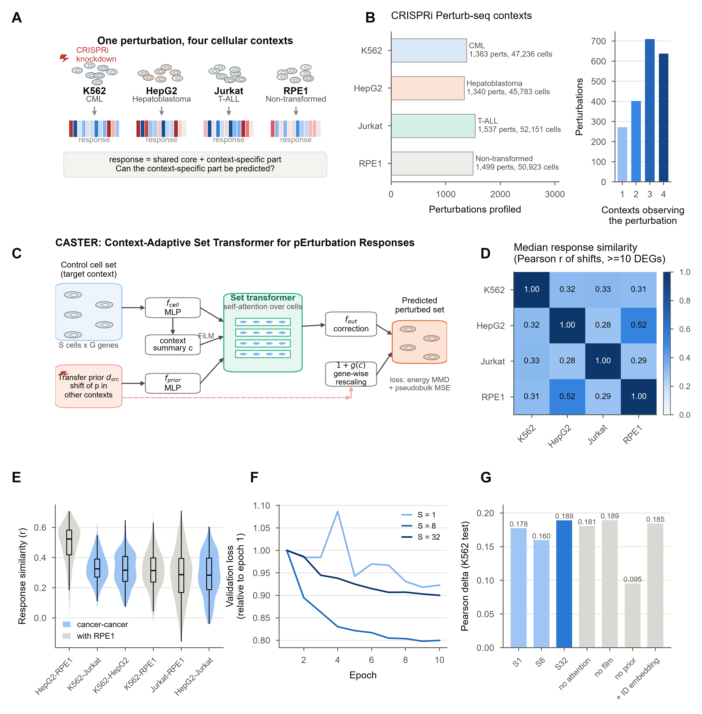
Figure 1. Context reshapes the response to the same genetic perturbation; the CASTER model
(A) The same CRISPRi knockdown, profiled in three cancer contexts and a non-transformed context, produces a shared core response plus a context-specific component.
(B) Perturbations retained after on-target knockdown filtering per context (left), and the number of contexts in which each perturbation is retained (right).
(C) CASTER architecture. A set of unperturbed target-context cells is encoded by an MLP and read by a bidirectional set transformer. The perturbation enters through its transfer prior (mean shift in other contexts), modulated by the context summary (FiLM). The output adds a context-dependent gene-wise rescaling of the prior and a cell-resolved correction; both start at zero.
(D) Median Pearson correlation of observed response shifts between contexts (perturbations with >= 10 DEGs in both).
(E) Per-perturbation response similarity for each pair of contexts; cancer-cancer pairs in blue, pairs involving RPE1 in grey.
(F) Validation loss (relative to epoch 1) for cell-set sizes S = 1-32 on the K562 fold.
(G) Held-out Pearson delta for set sizes and architectural ablations on the K562 fold.

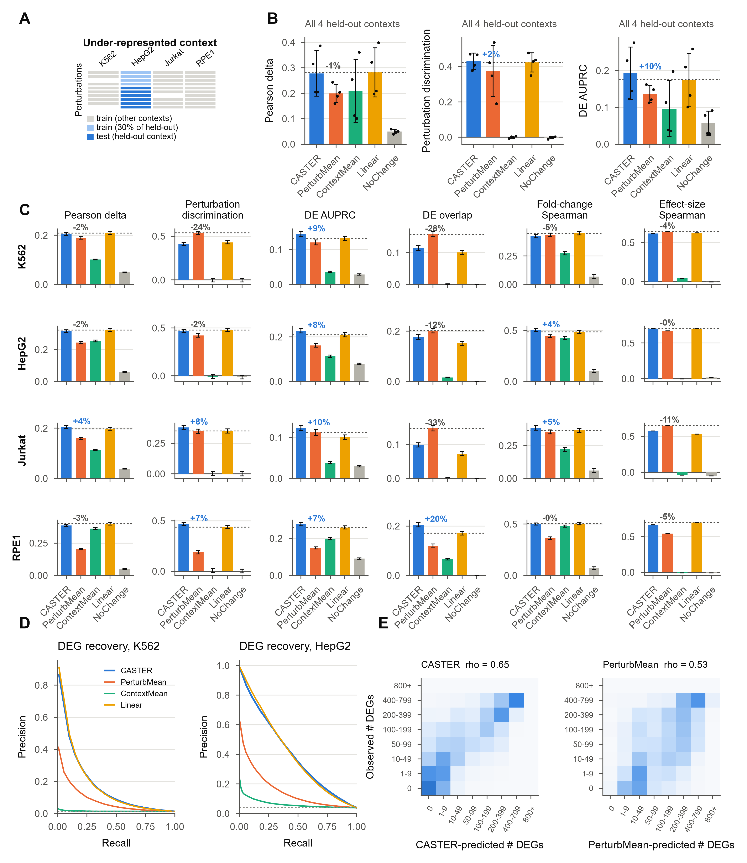
Figure 2. Context transfer in under-represented contexts
(A) Task: for each held-out context, 25% of its perturbations train, 5% validate and 70% test; other contexts are fully observed.
(B) Primary metrics averaged over the four held-out contexts. Bars, mean; error bars, SD over contexts; dots, contexts. Dashed line, best baseline; percentages, relative difference of CASTER from it.
(C) All PertBench metrics per held-out context (error bars, SEM over perturbations; effect-size Spearman is a single value per context).
(D) Precision-recall curves for recovering observed DEGs (pooled over perturbations) in K562 and HepG2, using amended predicted-side p values (AMENDMENT-002); dashed line, base rate.
(E) Observed versus predicted number of DEGs per perturbation (row-normalised), all contexts.

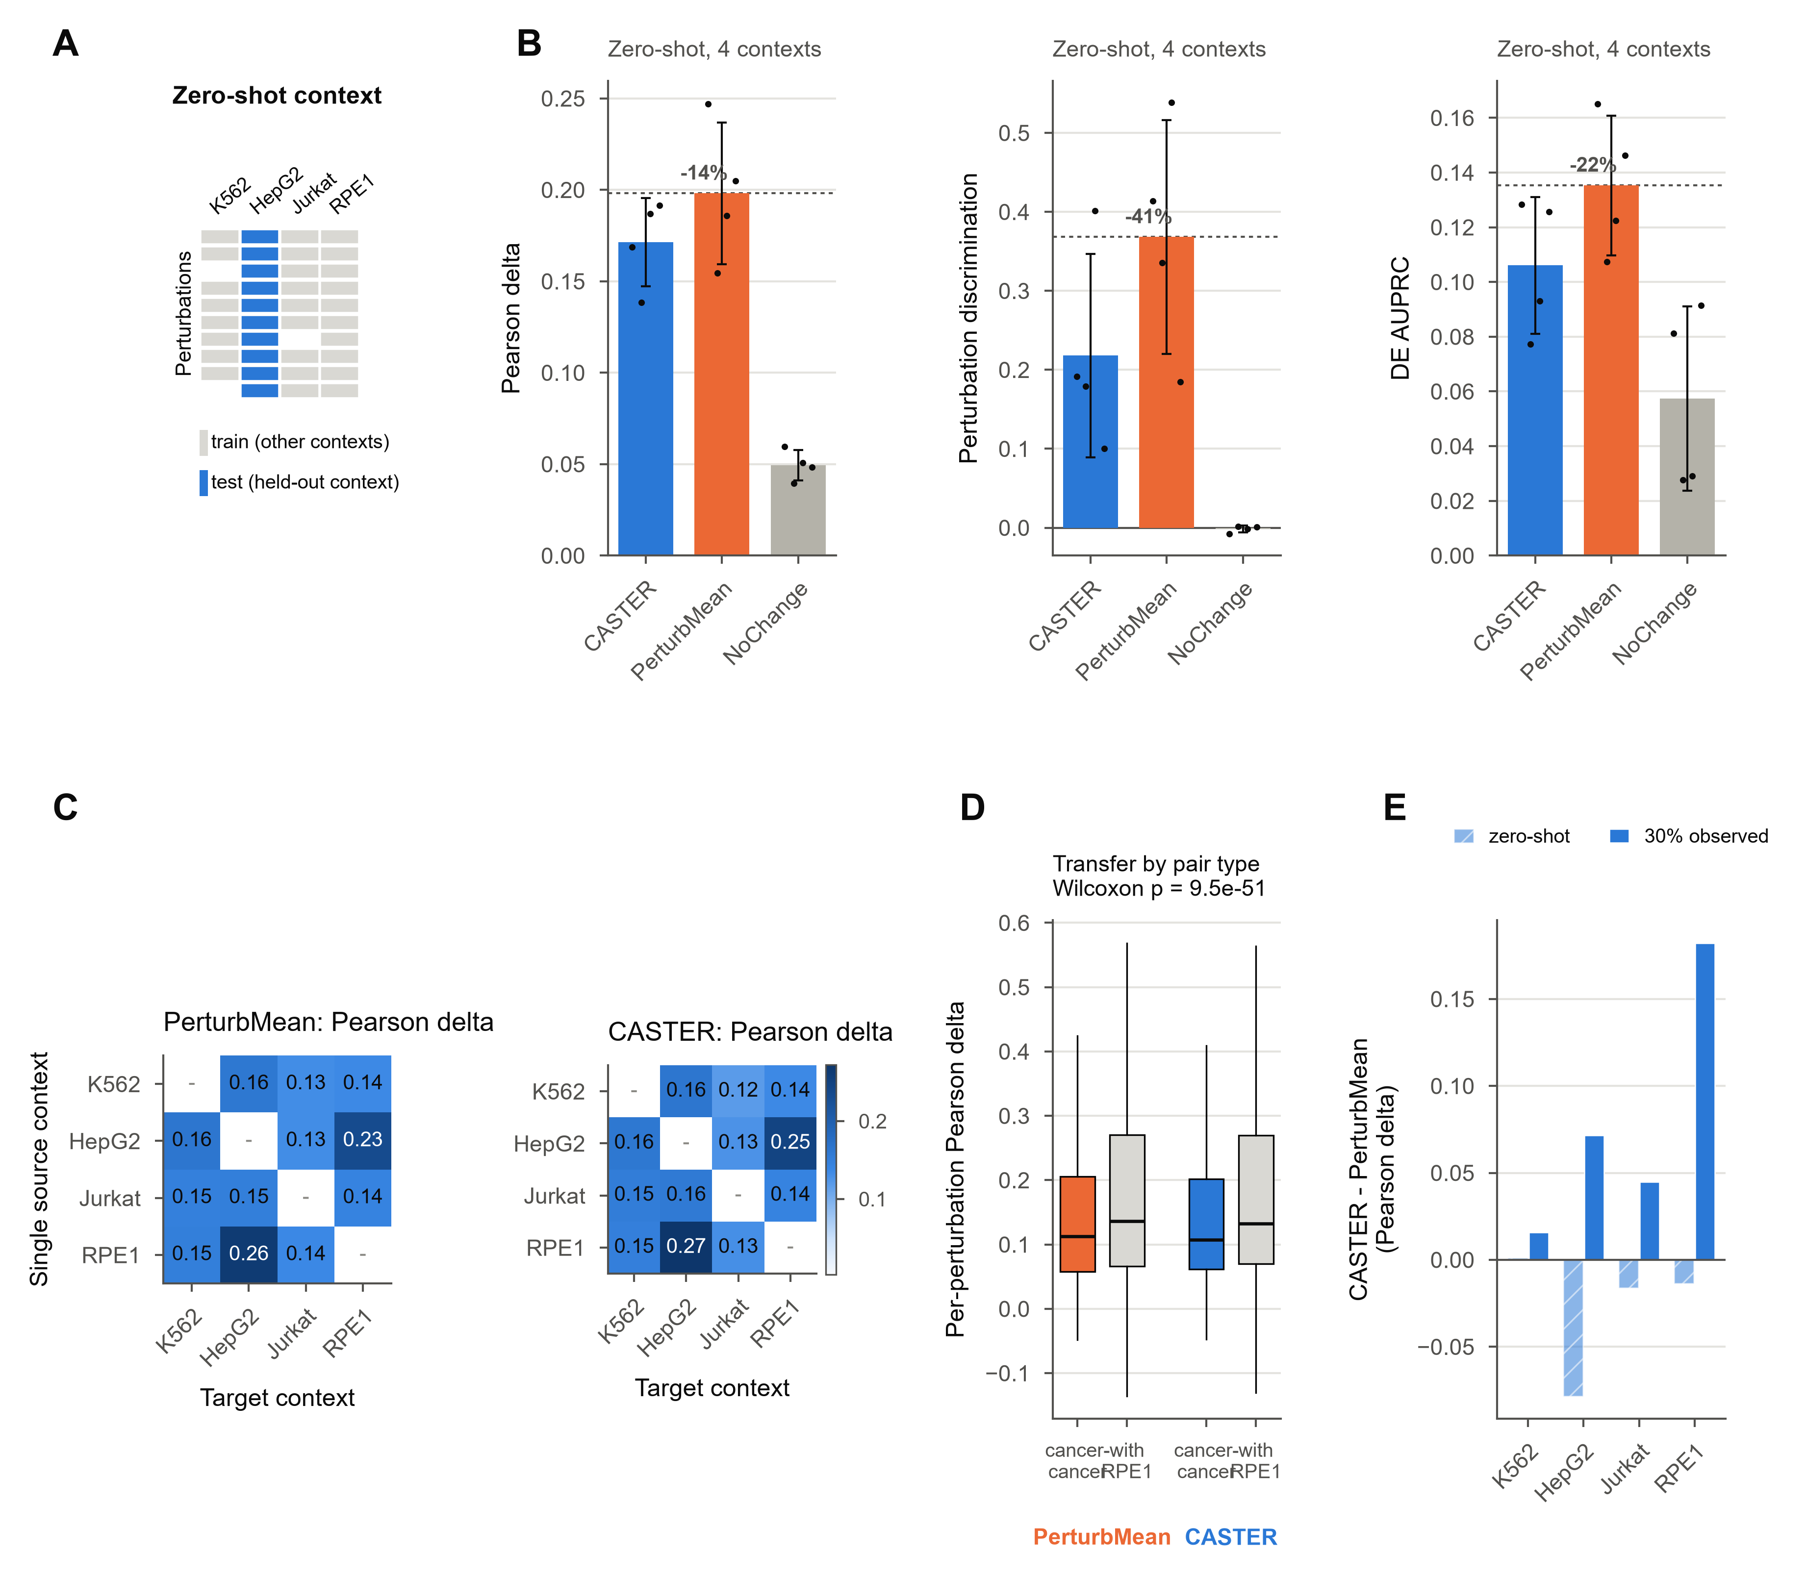
Figure 3. Zero-shot transfer and transfer between cancer and non-transformed contexts
(A) Zero-shot task: no perturbed cells of the held-out context are used.
(B) Primary metrics in the zero-shot task (mean over contexts; dots, contexts).
(C) Single-source transfer: Pearson delta for every source (rows) and target (columns) pair.
(D) Per-perturbation transfer accuracy averaged over cancer-to-cancer directions versus directions involving RPE1. Boxes, interquartile range; whiskers, 1.5x IQR; p value, two-sided paired Wilcoxon (H3).
(E) CASTER minus PerturbMean (Pearson delta) per context, with no (zero-shot) or 30% observed perturbations of the target.

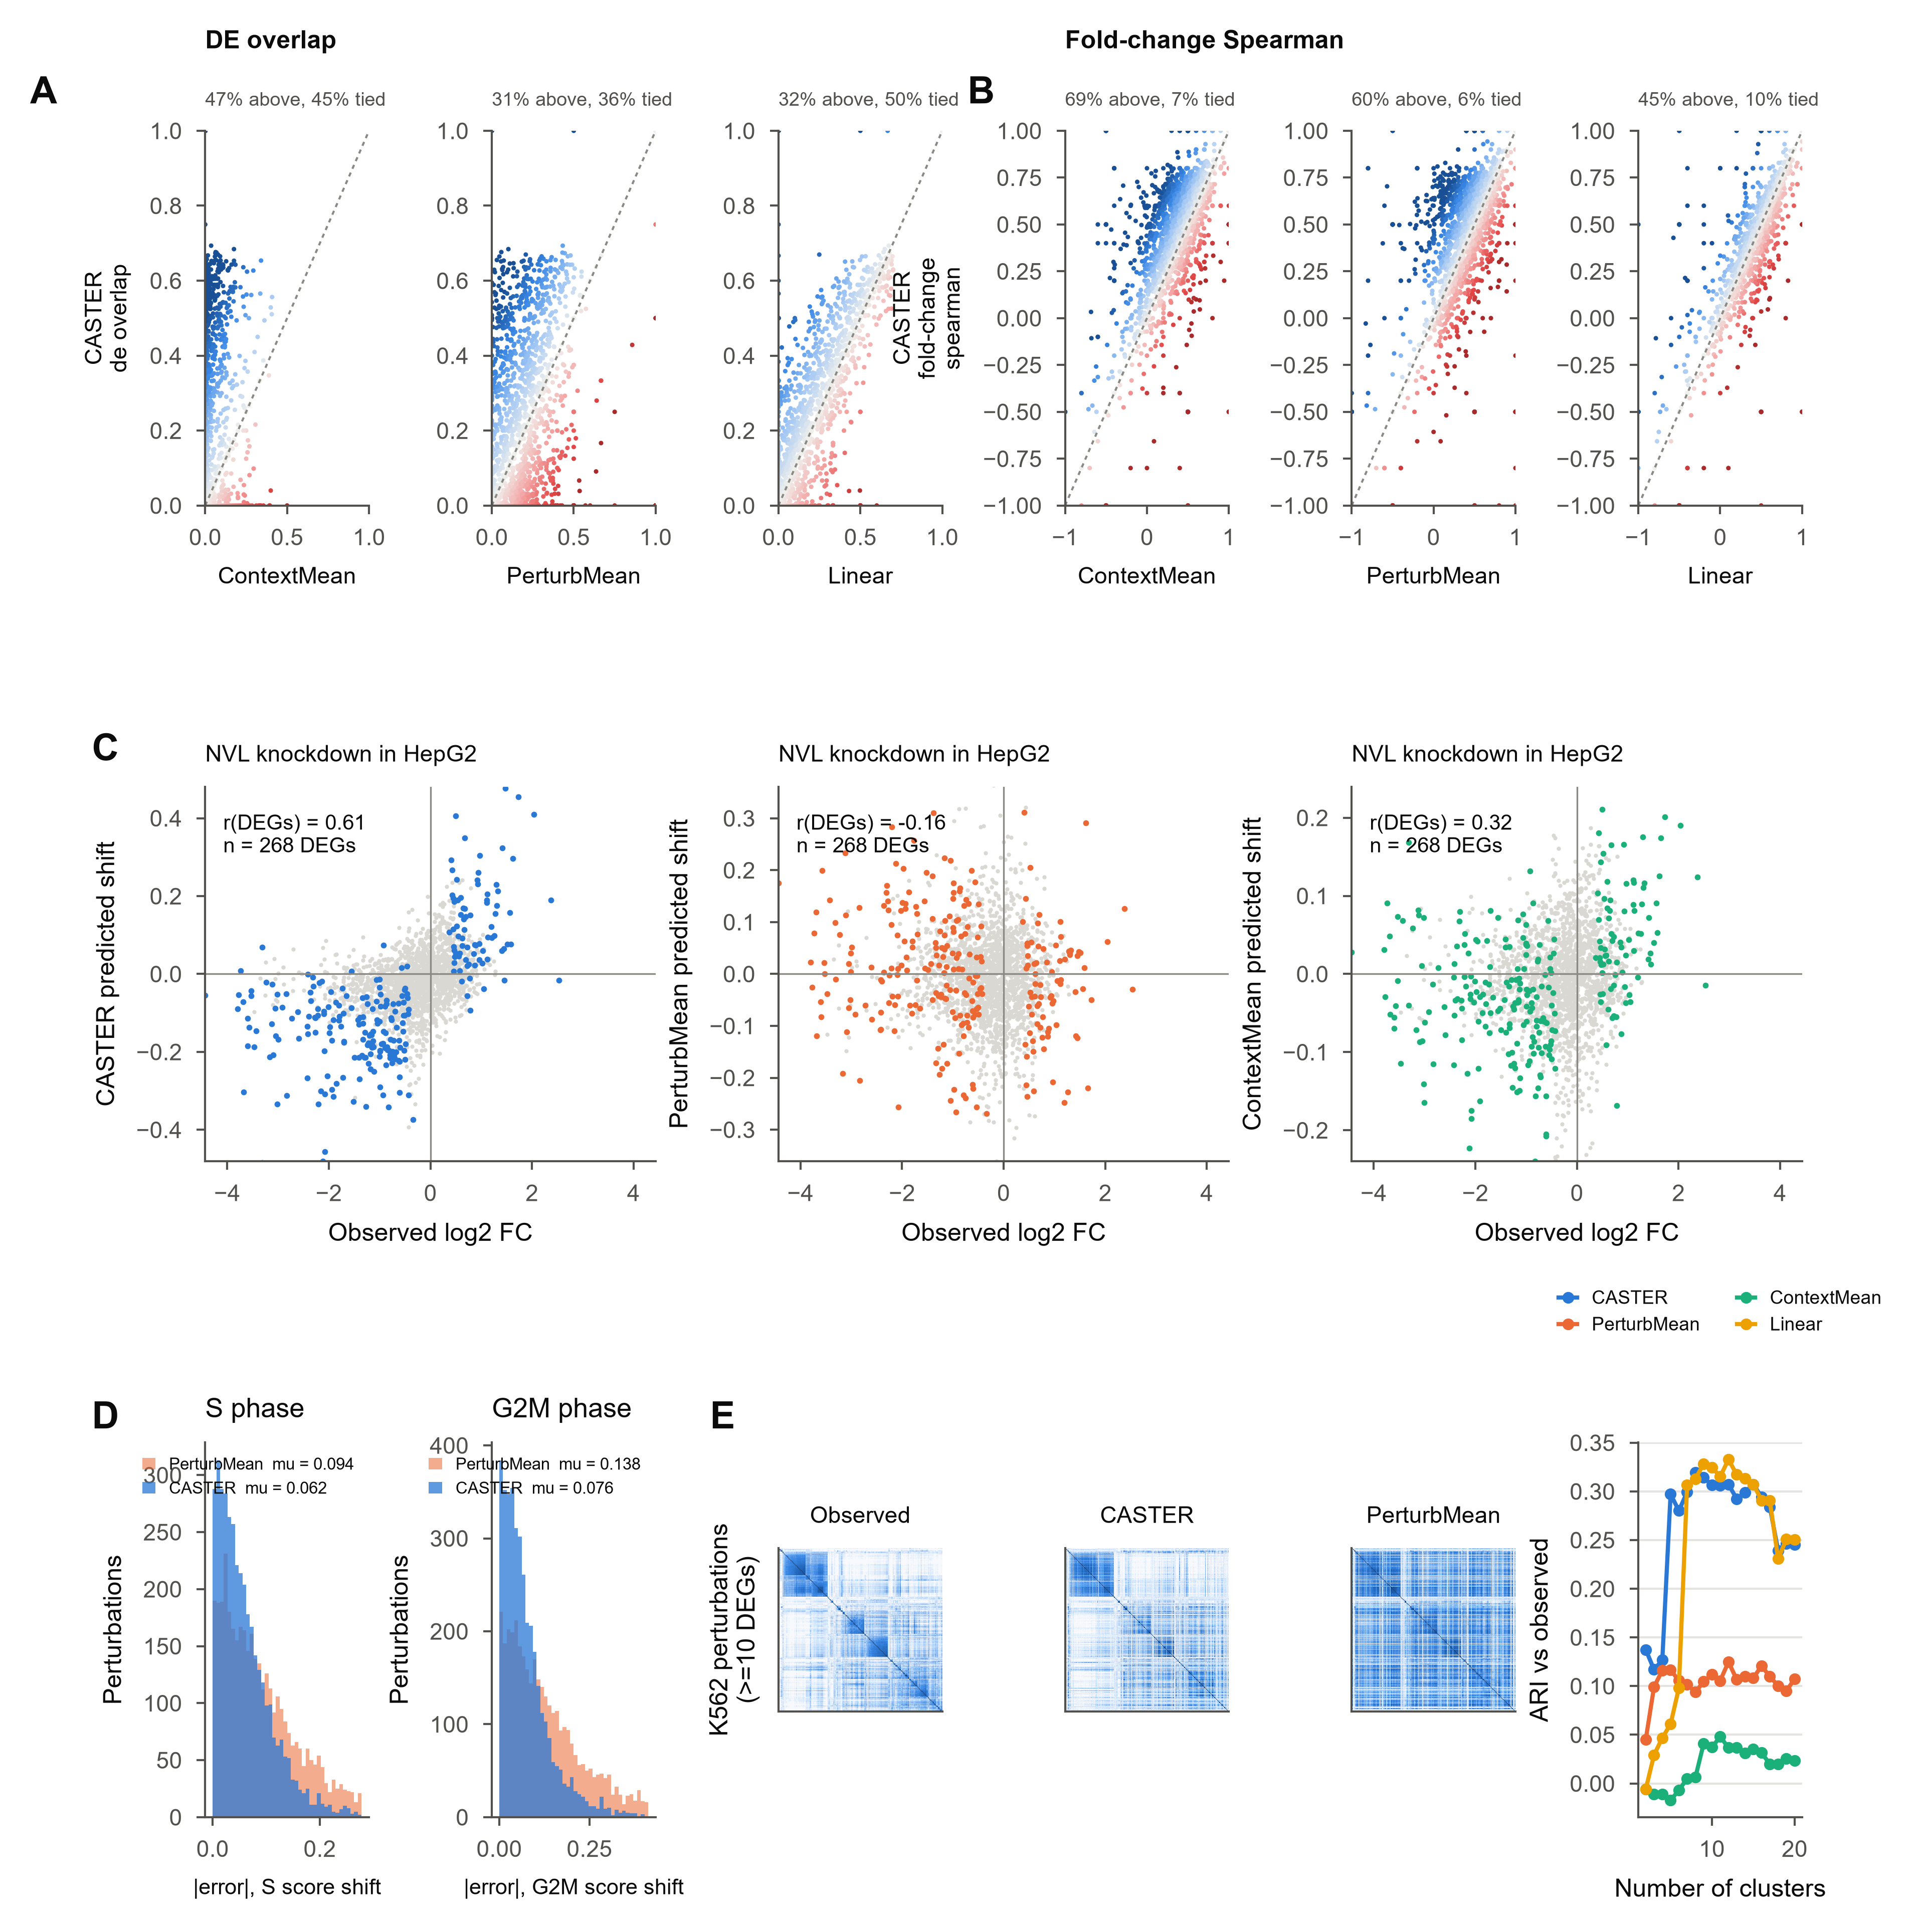
Figure 4. Context-specific differential expression, cell cycle and perturbation structure
(A and B) Per held-out perturbation, CASTER (y) versus each baseline (x) for DE overlap (A) and fold-change Spearman (B); colour, difference (blue, CASTER better).
(C) Observed log2 fold change versus predicted pseudobulk shift for the knockdown with the largest CASTER gain over PerturbMean in a cancer context (coloured, observed DEGs; r over DEGs).
(D) Absolute error of predicted S-phase and G2/M signature shifts.
(E) Perturbation-similarity (cosine) maps for K562 perturbations with >= 10 DEGs, ordered by clustering of the observed map, and adjusted Rand index between predicted and observed clusterings (mean over contexts).

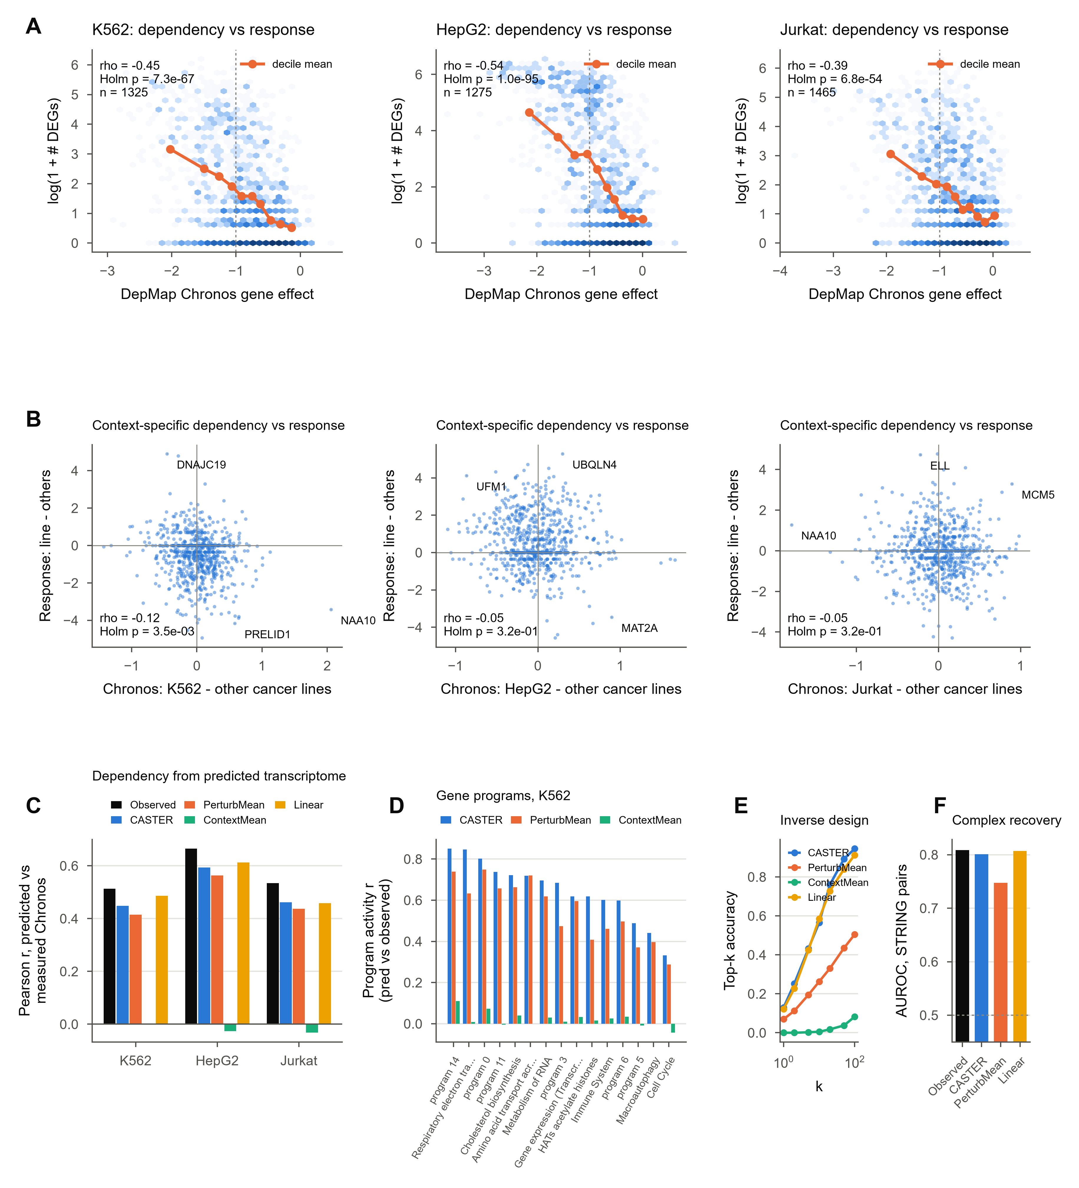
Figure 5. Perturbation responses and cancer dependency
(A) Transcriptional response magnitude (log(1 + # DEGs)) versus DepMap Chronos gene effect of the knocked-down gene in each cancer line (H4). Dashed line, Chronos = -1 (typical essential gene).
(B) Context-specific response versus context-specific dependency (line minus mean of the other two cancer lines; H4b). Labelled, most extreme genes.
(C) Pearson r between measured Chronos and Chronos predicted by a ridge model (trained on observed shifts) from observed or predicted shifts (H5).
(D) Concordance of predicted and observed gene-program activity across perturbations (K562); programs labelled by their top Reactome term when enriched (p < 1e-3).
(E) Inverse design: top-k accuracy of identifying the perturbation that produced an observed response, for the 100 strongest perturbations per context.
(F) AUROC for separating STRING-linked (combined score >= 700) perturbation pairs by response similarity (perturbations with >= 10 DEGs).

DISCUSSION
Perturbation biology is increasingly studied with models that aim to predict the outcome of an experiment before it is run^{21,22,37}. For cancer, the context in which a perturbation acts (lineage, driver, transformation state) is central: the same gene can be a vulnerability in one tumour and dispensable in another^{39,41,56}. We asked a focused version of this question with a single CRISPRi library profiled in three cancer lines and a non-transformed line. Responses to the same knockdown were only moderately correlated across contexts (median r ~ 0.31 between cancer lines). Similarity increased with response strength, and was highest for the two adherent, epithelial-derived lines. The context-specific component of a perturbation response is therefore large, but part of it reflects measurement noise in weak responses.
CASTER exploits this structure when the target context is partly screened. By anchoring on the transferred response and learning only the context-dependent adaptation, it outperformed the perturbation-mean and context-mean baselines on expression and DE metrics, and recovered gene programs, perturbation-similarity structure and the identity of perturbations far better than the perturbation mean. It matched, but did not exceed, a context-adaptive linear model fitted to the same data. This agrees with recent evidence that well-specified linear models are strong competitors for perturbation prediction^{34,35}. The value of the set-based model lies less in accuracy over a tuned linear map than in its distributional, cell-level output and in operating without per-context refitting.
The zero-shot results set a clear boundary. With no perturbation data from the target context, CASTER did not beat the perturbation mean and was worse at discriminating between perturbations. In the language of Proposition 4, the residual of the transfer prior was not predictable from a context's unperturbed cells alone. Unperturbed transcriptomes thus carry little information about how a context will reshape a response, whereas a small number of perturbation measurements in that context carry a lot. For screening design this argues for sparse, library-wide pilot screens in each new context of interest, rather than relying on control profiles alone.
We had expected transfer to be more faithful among cancer lines than to or from the non-transformed line (H3). The opposite held. Transfer involving RPE1 was more accurate, driven by the epithelial pair HepG2-RPE1, and RPE1 knockdowns produced markedly larger responses, consistent with intact p53-dependent stress signalling in TP53-proficient cells^{44,45}. Shared lineage and growth mode therefore predicted transferability better than transformation status. For drug discovery, this suggests that the choice of reference context for a perturbation atlas should be guided by lineage and cell state, and that a non-transformed line of the right lineage can be a useful reference for tumour contexts.
The perturbations whose responses CASTER reshaped most were regulators of ribosome biogenesis and ribosomal proteins. This is biologically coherent. Ribosome biogenesis is a cancer dependency that is being explored therapeutically, and impairing it triggers a nucleolar stress response whose outcome depends on p53 status and MYC-driven growth programs^{17,18}. These differ between a TP53-mutant leukaemia line, a hepatoblastoma line and TP53-proficient epithelial cells. Context-aware prediction is therefore most valuable precisely for the strong, pathway-level perturbations most relevant to cancer vulnerability, and least needed for weak perturbations, whose apparent context specificity is largely noise (Figure S8).
Compared with State³³, which pretrains on more than 100 million perturbed cells and reports gains over mean baselines across several datasets, CASTER is deliberately small and anchored on an explicit transfer prior. Under that design the comparison with PerturbMean measures the learnable context-specific residual directly (Proposition 4), rather than the combined effect of representation learning and scale. The two approaches are complementary: embeddings learned at scale could replace the control-cell encoder and the transfer prior could be combined with learned perturbation representations. Our results suggest that such models should be evaluated against strong transfer and linear baselines, stratified by response strength, and with predicted-side DE tests that respect the zero inflation of single-cell data.
Linking responses to dependency gave a mixed picture. Response magnitude tracked DepMap fitness effects, and the context-specific part of the response did not track context-specific dependency. Dependencies among the essential genes in this library are largely shared across lines, which limits the variance a context-specific test can exploit. Libraries designed around differential dependencies, such as synthetic-lethal partners of cancer drivers^{56,57}, would provide a sharper test.
Methodologically, we stress three practices that made these conclusions possible: selecting genes on control cells only and excluding perturbation targets, so that gene selection cannot leak test information; rendering every method's prediction as cells and scoring all of them with the same single-cell DE pipeline; and fixing hypotheses and decision rules before model fitting. Several published comparisons of perturbation models differ in exactly these choices^{33–36}.
Limitations of the study
This study has several limitations. First, it covers four contexts, three of them cancer lines from different lineages; with so few contexts, context generalisation cannot be separated from lineage generalisation, and conclusions about cancer in general require more cancer contexts. Second, compute and bandwidth limits led us to use at most 32 cells per perturbation and to train compact models on CPUs; State-scale models trained on far larger corpora³³ may extract more context-specific signal. Third, CASTER represents a perturbation by its observed effect elsewhere, so it cannot predict perturbations never observed in any context. Fourth, the dependency analyses rely on CRISPR knockout fitness, whereas the screens use CRISPRi knockdown; knockdown efficacy differs between genes and lines. Fifth, Wilcoxon-based single-cell DE ignores sample structure⁵⁸; we apply it identically to observed and predicted cells, but absolute DEG counts should be interpreted with care. Finally, this work used publicly available data only and did not test any prediction experimentally.
RESOURCE AVAILABILITY
Lead contact
Requests for further information should be directed to the lead contact [to be added].
Materials availability
This study did not generate new materials or new experimental data.
Data and code availability
- All data analysed are public: Replogle et al. 2022 and Nadig et al. 2025 CRISPRi Perturb-seq (Arc Institute knockdown-filtered concatenation on Hugging Face), DepMap 24Q4, STRING v12 and Reactome; identifiers are listed in the key resources table.
- All code (data ingestion, CASTER, baselines, PertBench, statistics, figures and this manuscript) is in the canpert repository [URL/DOI to be added on deposition]. Every number in the paper is generated from reports/results.json; every figure panel ships the CSV it is drawn from.
- The pre-registered protocol and its freeze point are in RESEARCH_PROTOCOL.md (git tag protocol-v1.0).
ACKNOWLEDGMENTS
We thank the authors of the Replogle et al. and Nadig et al. Perturb-seq studies, the Arc Institute for releasing the processed data, and the DepMap, STRING and Reactome teams. [Funding to be added.]
AUTHOR CONTRIBUTIONS
[To be completed by the authors.]
DECLARATION OF INTERESTS
The authors declare no competing interests. [To be confirmed by the authors.]
DECLARATION OF GENERATIVE AI AND AI-ASSISTED TECHNOLOGIES
During this work the authors used Claude (Anthropic) to write analysis code, run the computational experiments, produce figures, and draft and format the manuscript. The authors must review and edit all content and take full responsibility for the publication.
SUPPLEMENTAL INFORMATION
Tables S1-S8 and Figures S1-S12 with their legends follow the STAR Methods.
REFERENCES
1. Dixit, A., Parnas, O., Li, B., Chen, J., Fulco, C.P., Jerby-Arnon, L., Marjanovic, N.D., Dionne, D., Burks, T., Raychowdhury, R., et al. (2016). Perturb-Seq: dissecting molecular circuits with scalable single-cell RNA profiling of pooled genetic screens. Cell 167, 1853-1866.e17. https://doi.org/10.1016/j.cell.2016.11.038.
2. Adamson, B., Norman, T.M., Jost, M., Cho, M.Y., Nunez, J.K., Chen, Y., Villalta, J.E., Gilbert, L.A., Horlbeck, M.A., Hein, M.Y., et al. (2016). A multiplexed single-cell CRISPR screening platform enables systematic dissection of the unfolded protein response. Cell 167, 1867-1882.e21. https://doi.org/10.1016/j.cell.2016.11.048.
3. Jaitin, D.A., Weiner, A., Yofe, I., Lara-Astiaso, D., Keren-Shaul, H., David, E., Salame, T.M., Tanay, A., van Oudenaarden, A., and Amit, I. (2016). Dissecting immune circuits by linking CRISPR-pooled screens with single-cell RNA-seq. Cell 167, 1883-1896.e15. https://doi.org/10.1016/j.cell.2016.11.039.
4. Datlinger, P., Rendeiro, A.F., Schmidl, C., Krausgruber, T., Traxler, P., Klughammer, J., Schuster, L.C., Kuchler, A., Alpar, D., and Bock, C. (2017). Pooled CRISPR screening with single-cell transcriptome readout. Nat. Methods 14, 297-301. https://doi.org/10.1038/nmeth.4177.
5. Qi, L.S., Larson, M.H., Gilbert, L.A., Doudna, J.A., Weissman, J.S., Arkin, A.P., and Lim, W.A. (2013). Repurposing CRISPR as an RNA-guided platform for sequence-specific control of gene expression. Cell 152, 1173-1183. https://doi.org/10.1016/j.cell.2013.02.022.
6. Gilbert, L.A., Horlbeck, M.A., Adamson, B., Villalta, J.E., Chen, Y., Whitehead, E.H., Guimaraes, C., Panning, B., Ploegh, H.L., Bassik, M.C., et al. (2014). Genome-scale CRISPR-mediated control of gene repression and activation. Cell 159, 647-661. https://doi.org/10.1016/j.cell.2014.09.029.
7. Replogle, J.M., Norman, T.M., Xu, A., Hussmann, J.A., Chen, J., Cogan, J.Z., Meer, E.J., Terry, J.M., Riordan, D.P., Srinivas, N., et al. (2020). Combinatorial single-cell CRISPR screens by direct guide RNA capture and targeted sequencing. Nat. Biotechnol. 38, 954-961. https://doi.org/10.1038/s41587-020-0470-y.
8. Replogle, J.M., Saunders, R.A., Pogson, A.N., Hussmann, J.A., Lenail, A., Guna, A., Mascibroda, L., Wagner, E.J., Adelman, K., Lithwick-Yanai, G., et al. (2022). Mapping information-rich genotype-phenotype landscapes with genome-scale Perturb-seq. Cell 185, 2559-2575.e28. https://doi.org/10.1016/j.cell.2022.05.013.
9. Norman, T.M., Horlbeck, M.A., Replogle, J.M., Ge, A.Y., Xu, A., Jost, M., Gilbert, L.A., and Weissman, J.S. (2019). Exploring genetic interaction manifolds constructed from rich single-cell phenotypes. Science 365, 786-793. https://doi.org/10.1126/science.aax4438.
10. Jiang, L., Dalgarno, C., Papalexi, E., Mascio, I., Wessels, H.-H., Yun, H., Iremadze, N., Lithwick-Yanai, G., Lipson, D., and Satija, R. (2025). Systematic reconstruction of molecular pathway signatures using scalable single-cell perturbation screens. Nat. Cell Biol. 27, 505-517. https://doi.org/10.1038/s41556-025-01622-z.
11. Przybyla, L., and Gilbert, L.A. (2022). A new era in functional genomics screens. Nat. Rev. Genet. 23, 89-103. https://doi.org/10.1038/s41576-021-00409-w.
12. Frangieh, C.J., Melms, J.C., Thakore, P.I., Geiger-Schuller, K.R., Ho, P., Luoma, A.M., Cleary, B., Jerby-Arnon, L., Malu, S., Cuoco, M.S., et al. (2021). Multimodal pooled Perturb-CITE-seq screens in patient models define mechanisms of cancer immune evasion. Nat. Genet. 53, 332-341. https://doi.org/10.1038/s41588-021-00779-1.
13. Papalexi, E., Mimitou, E.P., Butler, A.W., Foster, S., Bracken, B., Mauck, W.M., Wessels, H.-H., Hao, Y., Yeung, B.Z., Smibert, P., and Satija, R. (2021). Characterizing the molecular regulation of inhibitory immune checkpoints with multimodal single-cell screens. Nat. Genet. 53, 322-331. https://doi.org/10.1038/s41588-021-00778-2.
14. Ursu, O., Neal, J.T., Shea, E., Thakore, P.I., Jerby-Arnon, L., Nguyen, L., Dionne, D., Diaz, C., Bauman, J., Mosaad, M.M., et al. (2022). Massively parallel phenotyping of coding variants in cancer with Perturb-seq. Nat. Biotechnol. 40, 896-905. https://doi.org/10.1038/s41587-021-01160-7.
15. McFarland, J.M., Paolella, B.R., Warren, A., Geiger-Schuller, K., Shibue, T., Rothberg, M., Kuksenko, O., Colgan, W.N., Jones, A., Chambers, E., et al. (2020). Multiplexed single-cell transcriptional response profiling to define cancer vulnerabilities and drug mechanisms of action. Nat. Commun. 11, 4296. https://doi.org/10.1038/s41467-020-17440-w.
16. McFaline-Figueroa, J.L., Srivatsan, S., Hill, A.J., Gasperini, M., Jackson, D.L., Saunders, L., Domcke, S., Regalado, S.G., Lazarchuck, P., Alvarez, S., et al. (2024). Multiplex single-cell chemical genomics reveals the kinase dependence of the response to targeted therapy. Cell Genom. 4, 100487. https://doi.org/10.1016/j.xgen.2023.100487.
17. Hanahan, D., and Weinberg, R.A. (2011). Hallmarks of cancer: the next generation. Cell 144, 646-674. https://doi.org/10.1016/j.cell.2011.02.013.
18. Hanahan, D. (2022). Hallmarks of cancer: new dimensions. Cancer Discov. 12, 31-46. https://doi.org/10.1158/2159-8290.CD-21-1059.
19. Kinker, G.S., Greenwald, A.C., Tal, R., Orlova, Z., Cuoco, M.S., McFarland, J.M., Warren, A., Rodman, C., Roth, J.A., Bender, S.A., et al. (2020). Pan-cancer single-cell RNA-seq identifies recurring programs of cellular heterogeneity. Nat. Genet. 52, 1208-1218. https://doi.org/10.1038/s41588-020-00726-6.
20. Gavish, A., Tyler, M., Greenwald, A.C., Hoefflin, R., Simkin, D., Tschernichovsky, R., Galili Darnell, N., Somech, E., Barbolin, C., Antman, T., et al. (2023). Hallmarks of transcriptional intratumour heterogeneity across a thousand tumours. Nature 618, 598-606. https://doi.org/10.1038/s41586-023-06130-4.
21. Bunne, C., Roohani, Y., Rosen, Y., Gupta, A., Zhang, X., Roed, M., Alexandrov, T., AlQuraishi, M., Brennan, P., Burkhardt, D.B., et al. (2024). How to build the virtual cell with artificial intelligence: priorities and opportunities. Cell 187, 7045-7063. https://doi.org/10.1016/j.cell.2024.11.015.
22. Rood, J.E., Hupalowska, A., and Regev, A. (2024). Toward a foundation model of causal cell and tissue biology with a Perturbation Cell and Tissue Atlas. Cell 187, 4520-4545. https://doi.org/10.1016/j.cell.2024.07.035.
23. Lotfollahi, M., Wolf, F.A., and Theis, F.J. (2019). scGen predicts single-cell perturbation responses. Nat. Methods 16, 715-721. https://doi.org/10.1038/s41592-019-0494-8.
24. Lotfollahi, M., Klimovskaia Susmelj, A., De Donno, C., Hetzel, L., Ji, Y., Ibarra, I.L., Srivatsan, S.R., Naghipourfar, M., Daza, R.M., Martin, B., et al. (2023). Predicting cellular responses to complex perturbations in high-throughput screens. Mol. Syst. Biol. 19, e11517. https://doi.org/10.15252/msb.202211517.
25. Lopez, R., Regier, J., Cole, M.B., Jordan, M.I., and Yosef, N. (2018). Deep generative modeling for single-cell transcriptomics. Nat. Methods 15, 1053-1058. https://doi.org/10.1038/s41592-018-0229-2.
26. Bereket, M., and Karaletsos, T. (2023). Modelling cellular perturbations with the sparse additive mechanism shift variational autoencoder. In Advances in Neural Information Processing Systems 36.
27. Piran, Z., Cohen, N., Hoshen, Y., and Nitzan, M. (2024). Disentanglement of single-cell data with biolord. Nat. Biotechnol. 42, 1678-1683. https://doi.org/10.1038/s41587-023-02079-x.
28. Bunne, C., Stark, S.G., Gut, G., del Castillo, J.S., Levesque, M., Lehmann, K.-V., Pelkmans, L., Krause, A., and Ratsch, G. (2023). Learning single-cell perturbation responses using neural optimal transport. Nat. Methods 20, 1759-1768. https://doi.org/10.1038/s41592-023-01969-x.
29. Roohani, Y., Huang, K., and Leskovec, J. (2024). Predicting transcriptional outcomes of novel multigene perturbations with GEARS. Nat. Biotechnol. 42, 927-935. https://doi.org/10.1038/s41587-023-01905-6.
30. Theodoris, C.V., Xiao, L., Chopra, A., Chaffin, M.D., Al Sayed, Z.R., Hill, M.C., Mantineo, H., Brydon, E.M., Zeng, Z., Liu, X.S., et al. (2023). Transfer learning enables predictions in network biology. Nature 618, 616-624. https://doi.org/10.1038/s41586-023-06139-9.
31. Cui, H., Wang, C., Maan, H., Pang, K., Luo, F., Duan, N., and Wang, B. (2024). scGPT: toward building a foundation model for single-cell multi-omics using generative AI. Nat. Methods 21, 1470-1480. https://doi.org/10.1038/s41592-024-02201-0.
32. Hao, M., Gong, J., Zeng, X., Liu, C., Guo, Y., Cheng, X., Wang, T., Ma, J., Zhang, X., and Song, L. (2024). Large-scale foundation model on single-cell transcriptomics. Nat. Methods 21, 1481-1491. https://doi.org/10.1038/s41592-024-02305-7.
33. Adduri, A.K., Gautam, D., Bevilacqua, B., Naghipourfar, M., Imran, A., Shah, R., Teyssier, N., Verma, R., Carpenter, C., Eraslan, B., et al. (2026). Predicting cellular responses to perturbation across diverse contexts with State. Cell 189, 5914-5931. https://doi.org/10.1016/j.cell.2026.07.052.
34. Ahlmann-Eltze, C., Huber, W., and Anders, S. (2025). Deep-learning-based gene perturbation effect prediction does not yet outperform simple linear baselines. Nat. Methods 22, 1657-1661. https://doi.org/10.1038/s41592-025-02772-6.
35. Kernfeld, E., Yang, Y., Weinstock, J.S., Battle, A., and Cahan, P. (2025). A comparison of computational methods for expression forecasting. Genome Biol. 26, 388.
36. Wu, Y., Wershof, E., Schmon, S., Nassar, M., Osinski, B., Eksi, R., Yan, Z., Stark, R., Zhang, K., and Graepel, T. (2025). PerturBench: benchmarking machine learning models for cellular perturbation analysis. In Advances in Neural Information Processing Systems 38 (Datasets and Benchmarks Track).
37. Roohani, Y.H., Hua, T.J., Tung, P.-Y., Bounds, L.R., Yu, F.B., Dobin, A., Teyssier, N., Adduri, A., Woodrow, A., Plosky, B.S., and Mehta, R. (2025). Virtual Cell Challenge: toward a Turing test for the virtual cell. Cell 188, 3370-3374.
38. Nadig, A., Replogle, J.M., Pogson, A.N., Murthy, M., McCarroll, S.A., Weissman, J.S., Robinson, E.B., and O'Connor, L.J. (2025). Transcriptome-wide analysis of differential expression in perturbation atlases. Nat. Genet. 57, 1228-1237. https://doi.org/10.1038/s41588-025-02169-3.
39. Tsherniak, A., Vazquez, F., Montgomery, P.G., Weir, B.A., Kryukov, G., Cowley, G.S., Gill, S., Harrington, W.F., Pantel, S., Krill-Burger, J.M., et al. (2017). Defining a cancer dependency map. Cell 170, 564-576.e16. https://doi.org/10.1016/j.cell.2017.06.010.
40. Dempster, J.M., Boyle, I., Vazquez, F., Root, D.E., Boehm, J.S., Hahn, W.C., Tsherniak, A., and McFarland, J.M. (2021). Chronos: a cell population dynamics model of CRISPR experiments that improves inference of gene fitness effects. Genome Biol. 22, 343. https://doi.org/10.1186/s13059-021-02540-7.
41. Behan, F.M., Iorio, F., Picco, G., Goncalves, E., Beaver, C.M., Migliardi, G., Santos, R., Rao, Y., Sassi, F., Pinnelli, M., et al. (2019). Prioritization of cancer therapeutic targets using CRISPR-Cas9 screens. Nature 568, 511-516. https://doi.org/10.1038/s41586-019-1103-9.
42. Pacini, C., Duncan, E., Goncalves, E., Gilbert, J., Bhosle, S., Horswell, S., Karakoc, E., Lightfoot, H., Curry, E., Muyas, F., et al. (2024). A comprehensive clinically informed map of dependencies in cancer cells and framework for target prioritization. Cancer Cell 42, 301-316.e9. https://doi.org/10.1016/j.ccell.2023.12.016.
43. Bodnar, A.G., Ouellette, M., Frolkis, M., Holt, S.E., Chiu, C.P., Morin, G.B., Harley, C.B., Shay, J.W., Lichtsteiner, S., and Wright, W.E. (1998). Extension of life-span by introduction of telomerase into normal human cells. Science 279, 349-352. https://doi.org/10.1126/science.279.5349.349.
44. Haapaniemi, E., Botla, S., Persson, J., Schmierer, B., and Taipale, J. (2018). CRISPR-Cas9 genome editing induces a p53-mediated DNA damage response. Nat. Med. 24, 927-930. https://doi.org/10.1038/s41591-018-0049-z.
45. Ihry, R.J., Worringer, K.A., Salick, M.R., Frias, E., Ho, D., Theriault, K., Kommineni, S., Chen, J., Sondey, M., Ye, C., et al. (2018). p53 inhibits CRISPR-Cas9 engineering in human pluripotent stem cells. Nat. Med. 24, 939-946. https://doi.org/10.1038/s41591-018-0050-6.
46. Gretton, A., Borgwardt, K.M., Rasch, M.J., Scholkopf, B., and Smola, A. (2012). A kernel two-sample test. J. Mach. Learn. Res. 13, 723-773.
47. Szekely, G.J., and Rizzo, M.L. (2013). Energy statistics: a class of statistics based on distances. J. Stat. Plan. Inference 143, 1249-1272. https://doi.org/10.1016/j.jspi.2013.03.018.
48. Perez, E., Strub, F., de Vries, H., Dumoulin, V., and Courville, A. (2018). FiLM: visual reasoning with a general conditioning layer. In Proceedings of the AAAI Conference on Artificial Intelligence 32, pp. 3942-3951.
49. Tirosh, I., Izar, B., Prakadan, S.M., Wadsworth, M.H., Treacy, D., Trombetta, J.J., Rotem, A., Rodman, C., Lian, C., Murphy, G., et al. (2016). Dissecting the multicellular ecosystem of metastatic melanoma by single-cell RNA-seq. Science 352, 189-196. https://doi.org/10.1126/science.aad0501.
50. Milacic, M., Beavers, D., Conley, P., Gong, C., Gillespie, M., Griss, J., Haw, R., Jassal, B., Matthews, L., May, B., et al. (2024). The Reactome Pathway Knowledgebase 2024. Nucleic Acids Res. 52, D672-D678. https://doi.org/10.1093/nar/gkad1025.
51. Szklarczyk, D., Kirsch, R., Koutrouli, M., Nastou, K., Mehryary, F., Hachilif, R., Gable, A.L., Fang, T., Doncheva, N.T., Pyysalo, S., et al. (2023). The STRING database in 2023: protein-protein association networks and functional enrichment analyses for any sequenced genome of interest. Nucleic Acids Res. 51, D638-D646. https://doi.org/10.1093/nar/gkac1000.
52. Meyers, R.M., Bryan, J.G., McFarland, J.M., Weir, B.A., Sizemore, A.E., Xu, H., Dharia, N.V., Montgomery, P.G., Cowley, G.S., Pantel, S., et al. (2017). Computational correction of copy number effect improves specificity of CRISPR-Cas9 essentiality screens in cancer cells. Nat. Genet. 49, 1779-1784. https://doi.org/10.1038/ng.3984.
53. Hart, T., Chandrashekhar, M., Aregger, M., Steinhart, Z., Brown, K.R., MacLeod, G., Mis, M., Zimmermann, M., Fradet-Turcotte, A., Sun, S., et al. (2015). High-resolution CRISPR screens reveal fitness genes and genotype-specific cancer liabilities. Cell 163, 1515-1526. https://doi.org/10.1016/j.cell.2015.11.015.
54. Wang, T., Birsoy, K., Hughes, N.W., Krupczak, K.M., Post, Y., Wei, J.J., Lander, E.S., and Sabatini, D.M. (2015). Identification and characterization of essential genes in the human genome. Science 350, 1096-1101. https://doi.org/10.1126/science.aac7041.
55. Blomen, V.A., Majek, P., Jae, L.T., Bigenzahn, J.W., Nieuwenhuis, J., Staring, J., Sacco, R., van Diemen, F.R., Olk, N., Stukalov, A., et al. (2015). Gene essentiality and synthetic lethality in haploid human cells. Science 350, 1092-1096. https://doi.org/10.1126/science.aac7557.
56. O'Neil, N.J., Bailey, M.L., and Hieter, P. (2017). Synthetic lethality and cancer. Nat. Rev. Genet. 18, 613-623. https://doi.org/10.1038/nrg.2017.47.
57. Lord, C.J., and Ashworth, A. (2017). PARP inhibitors: synthetic lethality in the clinic. Science 355, 1152-1158. https://doi.org/10.1126/science.aam7344.
58. Squair, J.W., Gautier, M., Kathe, C., Anderson, M.A., James, N.D., Hutson, T.H., Hudelle, R., Qaiser, T., Matson, K.J.E., Barraud, Q., et al. (2021). Confronting false discoveries in single-cell differential expression. Nat. Commun. 12, 5692. https://doi.org/10.1038/s41467-021-25960-2.
59. Lozzio, C.B., and Lozzio, B.B. (1975). Human chronic myelogenous leukemia cell-line with positive Philadelphia chromosome. Blood 45, 321-334.
60. Aden, D.P., Fogel, A., Plotkin, S., Damjanov, I., and Knowles, B.B. (1979). Controlled synthesis of HBsAg in a differentiated human liver carcinoma-derived cell line. Nature 282, 615-616. https://doi.org/10.1038/282615a0.
61. Lopez-Terrada, D., Cheung, S.W., Finegold, M.J., and Knowles, B.B. (2009). Hep G2 is a hepatoblastoma-derived cell line. Hum. Pathol. 40, 1512-1515. https://doi.org/10.1016/j.humpath.2009.07.003.
62. Schneider, U., Schwenk, H.U., and Bornkamm, G. (1977). Characterization of EBV-genome negative 'null' and 'T' cell lines derived from children with acute lymphoblastic leukemia and leukemic transformed non-Hodgkin lymphoma. Int. J. Cancer 19, 621-626. https://doi.org/10.1002/ijc.2910190505.
63. Abraham, R.T., and Weiss, A. (2004). Jurkat T cells and development of the T-cell receptor signalling paradigm. Nat. Rev. Immunol. 4, 301-308. https://doi.org/10.1038/nri1330.
64. Satija, R., Farrell, J.A., Gennert, D., Schier, A.F., and Regev, A. (2015). Spatial reconstruction of single-cell gene expression data. Nat. Biotechnol. 33, 495-502. https://doi.org/10.1038/nbt.3192.
65. Hendrycks, D., and Gimpel, K. (2016). Gaussian error linear units (GELUs). Preprint at arXiv, arXiv:1606.08415.
66. Vaswani, A., Shazeer, N., Parmar, N., Uszkoreit, J., Jones, L., Gomez, A.N., Kaiser, L., and Polosukhin, I. (2017). Attention is all you need. In Advances in Neural Information Processing Systems 30, pp. 5998-6008.
67. Lee, J., Lee, Y., Kim, J., Kosiorek, A., Choi, S., and Teh, Y.W. (2019). Set transformer: a framework for attention-based permutation-invariant neural networks. In Proceedings of the 36th International Conference on Machine Learning (PMLR 97), pp. 3744-3753.
68. Zaheer, M., Kottur, S., Ravanbakhsh, S., Poczos, B., Salakhutdinov, R.R., and Smola, A.J. (2017). Deep sets. In Advances in Neural Information Processing Systems 30, pp. 3391-3401.
69. Ba, J.L., Kiros, J.R., and Hinton, G.E. (2016). Layer normalization. Preprint at arXiv, arXiv:1607.06450.
70. Feydy, J., Sejourne, T., Vialard, F.-X., Amari, S., Trouve, A., and Peyre, G. (2019). Interpolating between optimal transport and MMD using Sinkhorn divergences. In Proceedings of the 22nd International Conference on Artificial Intelligence and Statistics (AISTATS), pp. 2681-2690.
71. Loshchilov, I., and Hutter, F. (2019). Decoupled weight decay regularization. In International Conference on Learning Representations (ICLR).
72. Paszke, A., Gross, S., Massa, F., Lerer, A., Bradbury, J., Chanan, G., Killeen, T., Lin, Z., Gimelshein, N., Antiga, L., et al. (2019). PyTorch: an imperative style, high-performance deep learning library. In Advances in Neural Information Processing Systems 32, pp. 8024-8035.
73. Hoerl, A.E., and Kennard, R.W. (1970). Ridge regression: biased estimation for nonorthogonal problems. Technometrics 12, 55-67. https://doi.org/10.1080/00401706.1970.10488634.
74. Lloyd, S. (1982). Least squares quantization in PCM. IEEE Trans. Inf. Theory 28, 129-137. https://doi.org/10.1109/TIT.1982.1056489.
75. Hubert, L., and Arabie, P. (1985). Comparing partitions. J. Classif. 2, 193-218. https://doi.org/10.1007/BF01908075.
76. Harris, C.R., Millman, K.J., van der Walt, S.J., Gommers, R., Virtanen, P., Cournapeau, D., Wieser, E., Taylor, J., Berg, S., Smith, N.J., et al. (2020). Array programming with NumPy. Nature 585, 357-362. https://doi.org/10.1038/s41586-020-2649-2.
77. Virtanen, P., Gommers, R., Oliphant, T.E., Haberland, M., Reddy, T., Cournapeau, D., Burovski, E., Peterson, P., Weckesser, W., Bright, J., et al. (2020). SciPy 1.0: fundamental algorithms for scientific computing in Python. Nat. Methods 17, 261-272. https://doi.org/10.1038/s41592-019-0686-2.
78. Pedregosa, F., Varoquaux, G., Gramfort, A., Michel, V., Thirion, B., Grisel, O., Blondel, M., Prettenhofer, P., Weiss, R., Dubourg, V., et al. (2011). Scikit-learn: machine learning in Python. J. Mach. Learn. Res. 12, 2825-2830.
79. Hunter, J.D. (2007). Matplotlib: a 2D graphics environment. Comput. Sci. Eng. 9, 90-95. https://doi.org/10.1109/MCSE.2007.55.
80. Wilcoxon, F. (1945). Individual comparisons by ranking methods. Biometrics Bull. 1, 80-83. https://doi.org/10.2307/3001968.
81. Mann, H.B., and Whitney, D.R. (1947). On a test of whether one of two random variables is stochastically larger than the other. Ann. Math. Stat. 18, 50-60. https://doi.org/10.1214/aoms/1177730491.
82. Benjamini, Y., and Hochberg, Y. (1995). Controlling the false discovery rate: a practical and powerful approach to multiple testing. J. R. Stat. Soc. B 57, 289-300.
83. Soneson, C., and Robinson, M.D. (2018). Bias, robustness and scalability in single-cell differential expression analysis. Nat. Methods 15, 255-261. https://doi.org/10.1038/nmeth.4612.
84. Davis, J., and Goadrich, M. (2006). The relationship between precision-recall and ROC curves. In Proceedings of the 23rd International Conference on Machine Learning, pp. 233-240. https://doi.org/10.1145/1143844.1143874.
85. Saito, T., and Rehmsmeier, M. (2015). The precision-recall plot is more informative than the ROC plot when evaluating binary classifiers on imbalanced datasets. PLoS One 10, e0118432. https://doi.org/10.1371/journal.pone.0118432.
86. Holm, S. (1979). A simple sequentially rejective multiple test procedure. Scand. J. Stat. 6, 65-70.

STAR★METHODS
Key resources table
REAGENT or RESOURCE | SOURCE | IDENTIFIER
Deposited data
K562 and RPE1 CRISPRi Perturb-seq | Replogle et al. 2022 | Figshare plus article 20029387
HepG2 and Jurkat CRISPRi Perturb-seq | Nadig et al. 2025 | GEO: GSE264667
Knockdown-filtered four-line concatenation (log-normalised) | Arc Institute (State) | huggingface.co/datasets/arcinstitute/State-Replogle-Filtered
DepMap CRISPR gene effect (Chronos), release 24Q4 | DepMap / Broad Institute | depmap.org/portal
STRING v12.0 human protein links | Szklarczyk et al. 2023 | string-db.org
Reactome pathways (GMT) | Milacic et al. 2024 | reactome.org
Experimental models: cell lines (data only)
K562 (CML) | Lozzio and Lozzio 1975 | RRID:CVCL_0004
HepG2 (hepatoblastoma) | Aden et al. 1979 | RRID:CVCL_0027
Jurkat (T-ALL) | Schneider et al. 1977 | RRID:CVCL_0065
hTERT RPE-1 (non-transformed) | Bodnar et al. 1998 | RRID:CVCL_4388
Software and algorithms
CASTER, PertBench and all analyses | This paper | canpert repository (code availability)
PyTorch 2.13 (CPU) | Paszke et al. 2019 | pytorch.org
scikit-learn | Pedregosa et al. 2011 | scikit-learn.org
SciPy / NumPy | Virtanen et al. 2020; Harris et al. 2020 | scipy.org; numpy.org
h5py / anndata format | Virshup et al. 2024 | anndata.readthedocs.io
Matplotlib | Hunter 2007 | matplotlib.org

EXPERIMENTAL MODEL AND STUDY PARTICIPANT DETAILS
This study generated no new experimental data. All analyses use published CRISPR interference (CRISPRi) Perturb-seq profiles of four human cell lines: K562 (chronic myeloid leukaemia, BCR-ABL1-positive)⁵⁹, HepG2 (hepatoblastoma-derived, historically described as hepatocellular carcinoma)^{60,61}, Jurkat (T cell acute lymphoblastic leukaemia)^{62,63} and hTERT RPE-1 (telomerase-immortalised, non-transformed retinal pigment epithelium)⁴³. K562 and RPE1 were profiled by Replogle et al.⁸ and HepG2 and Jurkat by Nadig et al.³⁸ with the same essential-gene CRISPRi library and protocol.
METHOD DETAILS
Data acquisition
We used the four-line concatenation released with the State model³³ (replogle_concat.h5ad). It contains library-size-normalised, log1p-transformed expression of 6,546 genes measured in all four lines. Perturbations and cells were already filtered for on-target knockdown, as described by Adduri et al.³³: perturbation median residual target expression <= 0.30, cell residual <= 0.50, and >= 30 cells. The file is 30 GB. Because compute and bandwidth were limited, we never downloaded it whole. We read the cell metadata, chose a stratified random subsample (seed 0) before any expression value was read, and fetched only those rows with HTTP byte-range requests against the contiguous dense matrix. The subsample is up to 32 cells per perturbation and line, plus 3,000 non-targeting control cells per line. Every fetched row was checked to be finite, non-negative and in the log1p range, and the set of fetched rows was checked to equal the selected set exactly. Rows fetched twice by overlapping download passes were byte-identical and were kept once.
Gene space
We modelled 2,000 genes. They were chosen as the top genes by bin-normalised dispersion (20 mean bins, Seurat v1 procedure⁶⁴) computed on the pooled control cells only, after excluding every gene that is a perturbation target in any line (1850 genes). Because no perturbed cell enters gene selection, held-out perturbation effects cannot leak through the choice of genes. Because knocked-down targets are excluded, the trivial on-target signal cannot inflate any metric.
Problem formulation
Let 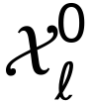 be the distribution of unperturbed cells in context (cell line) , and 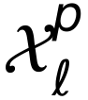 the distribution after perturbation 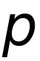. We write the pseudobulk shift of in as
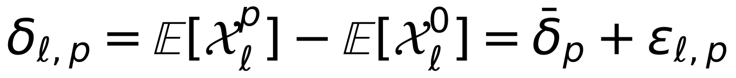 | (1)
Here 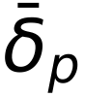 is the shared component (the mean over contexts) and 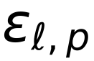 the context-specific component. Context generalisation asks for 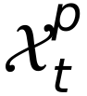 in a target context , given control cells of , observations of in other contexts and, optionally, a small set of other perturbations observed in . PerturbMean estimates only . Any method that beats it must recover part of 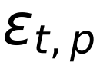.
CASTER architecture
CASTER (Context-Adaptive Set Transformer for pErturbation Responses) maps a set of  control cells 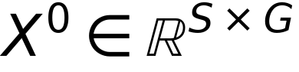 from the target context, together with a perturbation, to a set of predicted perturbed cells. It has five parts.
Transfer prior. The perturbation is represented by its observed shift in the other contexts. For an item in context with source contexts :
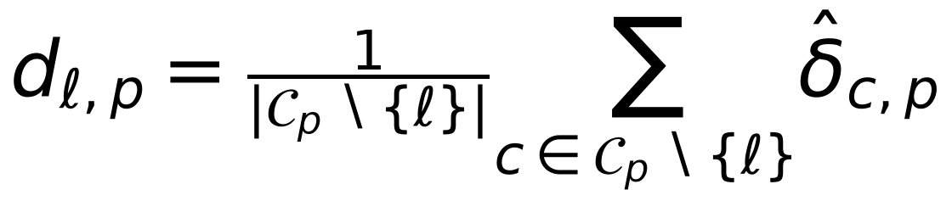 | (2)
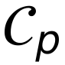 is the set of source contexts that observed , and 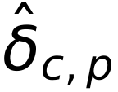 is the empirical shift relative to the control mean of . The target context never contributes to any prior. When no other source context observed (always the case in single-source transfer), the prior is computed from a random half of 's cells, and the model is trained against the disjoint other half.
Encoders. A 4-layer GELU⁶⁵ MLP  embeds each control cell into 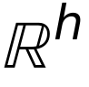 (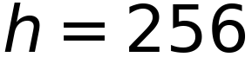). A 2-layer MLP 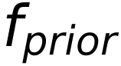 embeds the prior. A context summary is the mean of the cell embeddings, passed through a 2-layer MLP that outputs FiLM⁴⁸ parameters 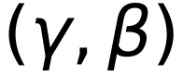:
(3)
Set transformer.  passes through a 4-layer, 8-head, pre-norm, bidirectional transformer encoder^{66,67} without positional encodings. The model is therefore permutation-equivariant over cells⁶⁸, which our tests verify.
Output. The prediction adds a context-dependent, gene-wise rescaling of the transferred shift and a cell-resolved correction:
(4)
Here  is linear in , and 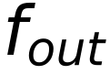 is a LayerNorm⁶⁹ followed by a linear map. Both and the output layer of are initialised at zero. Training therefore starts exactly at the PerturbMean solution and leaves it only where the validation objective improves. The ablations remove the transformer (per-cell MLP), FiLM, or the prior (a learned one-hot perturbation embedding instead), or add a one-hot ID embedding to the prior.
Training objective
For a predicted set  and an observed set  of the same perturbation and context, the loss is the squared maximum mean discrepancy⁴⁶ with the energy-distance kernel^{47,70}, plus a pseudobulk term:
(5)
We used 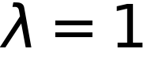 and 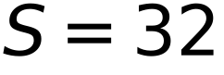. Training used AdamW⁷¹ (learning rate 3e-4, weight decay 1e-4, batch 32 sets), gradient clipping at 1.0, a 5% linear warm-up and cosine decay. The number of epochs was 20 for the context tasks and 10 for ablations and single-source transfer. The checkpoint with the lowest validation loss was kept. In the under-represented task, validation uses the 5% validation perturbations of the target. In the zero-shot and transfer tasks, it uses 5% of source-context items, so no target perturbed cell is ever used. All runs used CPU only (PyTorch⁷²).
Baselines
Every method returns a set of predicted cells, so that single-cell DE metrics are computed identically for all methods. A pseudobulk prediction  is rendered as cells by adding it to the same control cells given to CASTER.
- NoChange: 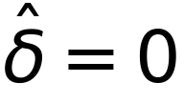; a floor.
- PerturbMean: 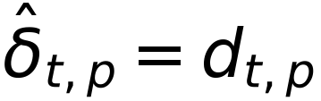, the mean shift of over the source contexts that observed it.
- ContextMean: the mean shift of the target's training perturbations, the same for every perturbation³⁵.
- Linear transfer: ridge regression⁷³ (penalty chosen by efficient leave-one-out cross-validation over 13 values) from a 64-component PCA of the concatenated source shifts of to its target shift. It is fitted on the target's support perturbations; a missing source is imputed with the mean over the observing sources. This is a strong, explicitly context-adaptive linear model of the kind recently shown to match deep models^{34,35}.
Tasks and splits
Under-represented context (T1). For each target line (four folds), the eligible perturbations are those observed in and in at least one other line. They were shuffled (seed 0) and split 25% training, 5% validation and 70% test. All perturbations of the three other lines are training data. Zero-shot context (T2). No perturbed cell of is used. Single-source transfer (T3). For each ordered pair (source , target ), training uses only and the test set is every perturbation observed in both. Unperturbed cells of every line, including , are available to all methods, as in Adduri et al.³³. Control cells of each line were split 50/50 into a model-input pool and a disjoint DE-reference pool.
Gene programs, similarity and cell-cycle analyses
Gene programs were defined per line by K-means⁷⁴ (15 programs, 10 restarts) on the z-scored observed shift matrix (perturbations x genes), clustering genes by their response profiles. Programs were annotated with their most enriched Reactome pathway⁵⁰ (hypergeometric test, background = modelled genes). Program activity is the mean shift over program genes. Perturbation-similarity structure used average-linkage hierarchical clustering of cosine distances between shifts of perturbations with >= 10 observed DEGs, compared with the adjusted Rand index⁷⁵. Recovery of functional relationships used STRING v12 pairs with combined score >= 700⁵¹, scored by effect cosine similarity (AUROC). Cell-cycle shifts are the mean shift over the Tirosh et al. S-phase and G2/M signature genes⁴⁹ present in the gene space.
Dependency analyses
Chronos gene effects⁴⁰ (DepMap 24Q4^{39,52}) were taken for K562 (ACH-000551), HepG2 (ACH-000739) and Jurkat (ACH-000995); RPE1 is not profiled. Response magnitude is 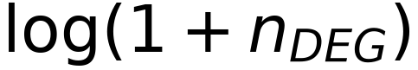. The context-specific response of a knockdown in line is its magnitude minus the mean over the other two cancer lines, and the context-specific dependency is defined the same way on Chronos scores. For dependency prediction (H5), a ridge model was trained, within 10-fold cross-validation over the held-out perturbations of each cancer line, to map observed shifts to Chronos. It was then applied unchanged to the shifts predicted by each method for the held-out fold.
Formal definition of baseline models
Let 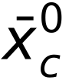 be the mean of the model-input control cells of context , and 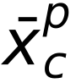 the mean of the observed cells of perturbation in . The observed shift is 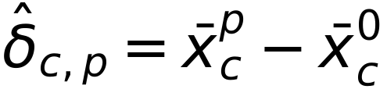. For the target context , let  be its support perturbations (training + validation) and the source contexts.
PerturbMean averages the shift of over the source contexts that observed it:
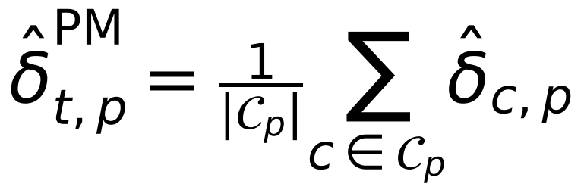 | (6)
ContextMean predicts the same shift for every perturbation of , namely the mean shift of its support perturbations:
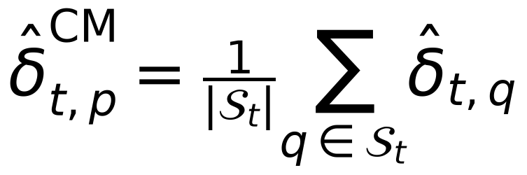 | (7)
Linear transfer. Each perturbation is described by the concatenation of its source shifts, 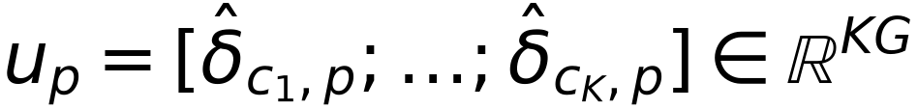. A source that did not observe contributes 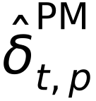. The features are reduced by PCA, fitted on source data only, to 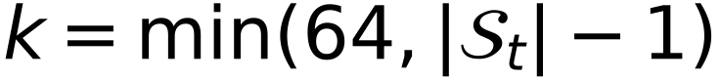 components 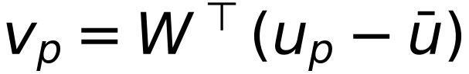. A ridge map 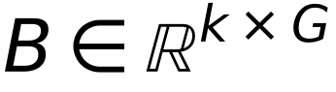 is then fitted on the support perturbations:
(8)
Here  stacks the centred 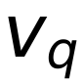 and  the centred target shifts.  is chosen from 13 log-spaced values in 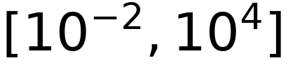 by efficient leave-one-out cross-validation. The prediction is 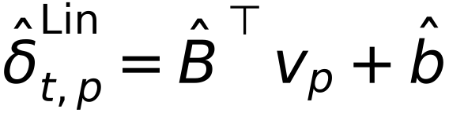. NoChange predicts . Every pseudobulk prediction is rendered as cells by adding it to the same control cells, 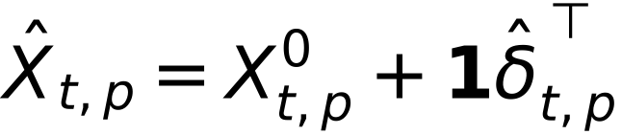.
Formal definition of downstream analyses
Inverse design. For the 100 perturbations with the most observed DEGs in a context, the rank of the correct perturbation among all predictions is
(9)
STRING-pair recovery. For perturbations with >= 10 observed DEGs, each unordered pair 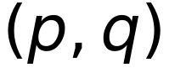 is labelled positive if STRING v12 reports a combined score >= 700 between their products. It is scored by the cosine similarity of the predicted shifts, 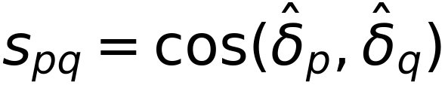, and summarised by the AUROC.
Gene programs. Let  be the observed shift matrix (perturbations x genes), z-scored per gene. K-means with 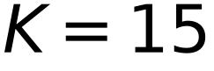 (10 restarts, seed 0) on the rows of 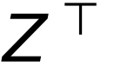 assigns each gene to a program . The activity of program under perturbation is 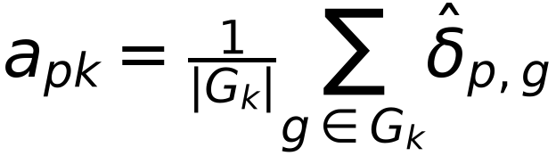. Concordance is the Pearson correlation across perturbations of predicted and observed 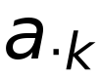. Programs are annotated by the Reactome pathway with the smallest hypergeometric p value, with the modelled genes as the background and at least 3 overlapping genes.
Perturbation-similarity structure. Cosine-distance matrices of predicted and observed shifts (perturbations with >= 10 DEGs) were clustered by average linkage into 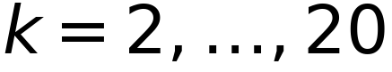 clusters, and the clusterings were compared by the adjusted Rand index.
Dependency prediction (H5). Within each cancer line, held-out perturbations with a measured Chronos score were split into 10 folds. A ridge model  (penalty chosen by leave-one-out cross-validation over 13 values in 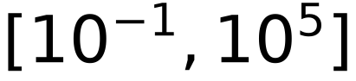) was fitted on the observed shifts of 9 folds and applied to the observed and to each method's predicted shifts of the remaining fold. The score is the Pearson correlation between the out-of-fold predictions 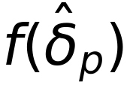 and the measured Chronos scores. Because the regressor never sees a predicted shift during training, any loss of accuracy reflects information missing from the prediction.
Context-specific dependency (H4b). For gene observed in all three cancer lines, with response magnitude 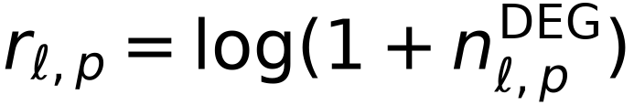 and Chronos score 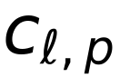, the context-specific components are
(10)
H4b tests the Spearman correlation of 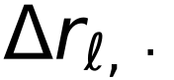 and 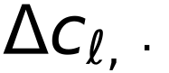 per line.
Response similarity across contexts. For each pair of contexts and each perturbation with >= 10 DEGs in both, similarity is the Pearson correlation of the two observed shift vectors over the modelled genes. DEG overlap is the Jaccard index of the two DEG sets. The stratified analysis repeats this for minimum response sizes of 10, 25, 50, 100 and 200 DEGs.
Formal properties of CASTER and of context transfer
We state four properties that frame the benchmark results. Notation follows the problem formulation above. 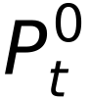 denotes the control distribution of context , 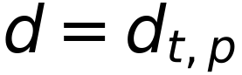 the transfer prior, and  the CASTER parameters.
Proposition 1 (CASTER contains PerturbMean)
At initialisation (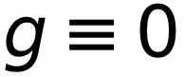, and the final linear layer of equal to zero), for any control set 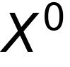 and perturbation , the CASTER prediction is
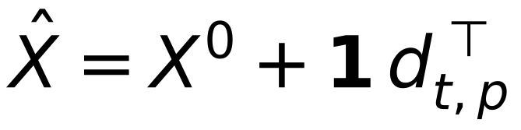 | (11)
Its pseudobulk shift therefore equals the PerturbMean prediction exactly. Proof. The output is . With 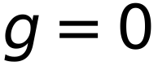 the middle term is , and 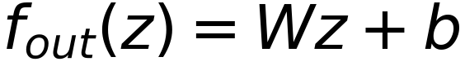 with 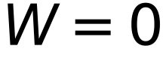 and 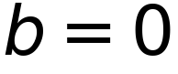 is identically zero. Because the checkpoint is chosen by validation loss, which includes the epoch-0 model, the selected CASTER can deviate from PerturbMean only when the deviation lowers the validation objective. ∎
Proposition 2 (permutation equivariance)
For any permutation matrix , . Proof. acts row-wise and commutes with . The context summary is a mean over rows and is invariant. The FiLM and prior terms are broadcast identically to every row. Self-attention without positional encodings is permutation-equivariant^{67,68}. and the residual act row-wise. A composition of equivariant and row-broadcast invariant maps is equivariant. ∎ The property is verified numerically in the test suite. It means that predictions depend on the distribution of control cells, not on their order.
Proposition 3 (the training loss identifies distributions)
For distributions  on  with finite first moments, the energy distance⁴⁷
(12)
is non-negative and equals zero if and only if 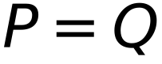. It is the squared MMD with the (conditionally negative definite) energy kernel^{46,70}. The empirical V-statistic in the loss converges almost surely to  as . Minimising the population loss therefore matches the full predicted and observed perturbed distributions, not only their means. The added pseudobulk term is minimised by the conditional mean, so the combined objective is minimised by any predictor whose distribution equals the observed one, and both terms vanish there. ∎
Proposition 4 (when can context transfer beat PerturbMean?)
Decompose the target shift as 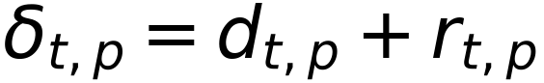, where 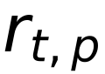 is the residual of the transfer prior. Let 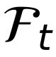 be the information available to a predictor at test time: the prior, the control cells of and, in T1, the support perturbations of . Under squared error, the optimal prediction of 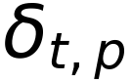 is
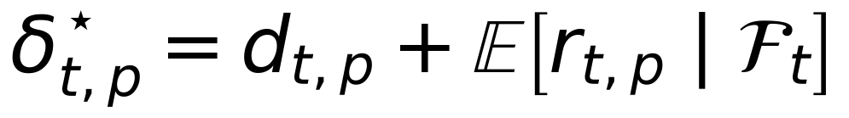 | (13)
Its risk improves on that of PerturbMean by exactly . Proof. By the orthogonality of conditional expectation, for any measurable . PerturbMean is 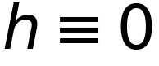. ∎ Consequently, no method, however expressive, can outperform PerturbMean in expectation unless the residual of the transfer prior is predictable from the target's control cells and support perturbations. The comparison between CASTER (and the linear transfer model) and PerturbMean is therefore an empirical estimate of . A null result means that this predictable part is small relative to estimation noise at the available data scale, not that context does not matter. Indeed 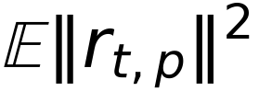 (the context-specific variance quantified in Figure 1) can be large while its predictable part is small. In the positive-control simulation the residual is constructed to be a function of the control profile, so this bound is attained.
Information available to each method (leakage audit)
Method | Target controls | Target support perts | Source contexts | Target test perts
NoChange | input pool | - | - | never
ContextMean | input pool | yes (mean) | - | never
PerturbMean | input pool | - | yes | never
Linear transfer | input pool | yes (fit) | yes | never
CASTER (T1) | input pool | yes (train/val) | yes | never
CASTER (T2/T3) | input pool | - | yes (val: 5% source) | never
Evaluation | reference pool | - | - | observed cells

Control cells of each context are split once (seed 0) into disjoint input and reference pools. Gene selection uses control cells only. Every perturbation in the held-out test set is excluded from all training and model-selection steps for that context. This is enforced in code and covered by unit tests (split disjointness, control-pool disjointness, deterministic inputs).
Software, computation and reproducibility
All analyses were run on a single workstation (4 CPU cores, 8 GB RAM, no GPU) with Python 3.12, PyTorch 2.13 (CPU build)⁷², NumPy⁷⁶, SciPy⁷⁷, scikit-learn⁷⁸, pandas, h5py and Matplotlib⁷⁹. Under-represented and zero-shot folds took about 35-50 min each to train and evaluate; single-source transfer models about 10 min each. Two jobs ran concurrently with two threads each. All randomness (cell subsampling, control-pool splits, perturbation splits, model initialisation, mini-batch sampling and the control cells given to each method) is seeded. Control input sets are derived deterministically from a hash of the perturbation, seed and context, so that every method receives identical inputs. The pipeline is a sequence of command-line steps (data build, observed DE, T1, T2, ablations, transfer, analysis, figures and manuscript), and each step writes versioned artefacts (per-perturbation metric tables, predicted pseudobulk shifts, per-gene DE arrays and training histories). Every number in this paper is read from a single results file generated from those artefacts, and every figure panel writes the table it plots.
The code base has unit and integration tests. They cover Benjamini-Hochberg correction against SciPy, the DE test on simulated shifts, perturbation discrimination at its bounds, the energy-MMD loss (zero for identical sets, positive for shifted ones), permutation equivariance of CASTER, split disjointness and determinism, control-pool disjointness, and an end-to-end synthetic run in which CASTER and PerturbMean must recover planted effects. Data integrity was verified at acquisition: every selected row was fetched exactly once in the final dataset, and 112,310 rows fetched twice by overlapping download passes were confirmed byte-identical before deduplication.
Deviations from the pre-registered protocol
- AMENDMENT-001 (before any result was seen): to fit the compute budget, training epochs were set to 20 for context tasks and 10 for ablations and transfer, and the set-size ablation was reduced to S in {1, 8, 32}.
- AMENDMENT-002 (after T1 results were first inspected): the predicted-side DE test was replaced by a moment-matched z-test because the pre-registered Wilcoxon test is invalid for continuous predictions (STAR Methods; Figure S7). Both versions of every affected test are reported.
- Data source (before freezing): the knockdown-filtered four-line release³³ replaced the per-line original files, for uniform processing and because the original repository throttled range requests.
- Seeds 1 and 2 of the under-represented task (declared secondary) were not run for compute reasons.
QUANTIFICATION AND STATISTICAL ANALYSIS
Evaluation suite (PertBench)
For test perturbation with observed cells 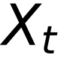, predicted cells 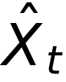 (same number of cells) and reference controls  (500 cells, disjoint from model inputs):
Pearson delta. The correlation between predicted and observed pseudobulk shifts:
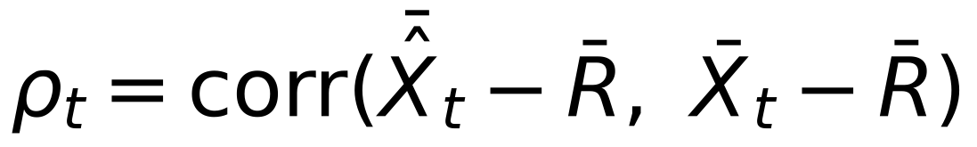 | (14)
Perturbation discrimination. Following Wu et al.³⁶ and Adduri et al.³³, with 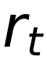 the number of other test perturbations whose observed pseudobulk is closer in L1 distance to the prediction than the true one:
(15)
A perfect model scores 1 and chance scores 0. Observed differential expression (ground truth). Observed cells of each perturbation are tested against gene by gene with the Wilcoxon rank-sum test^{80,81} (asymptotic, tie-corrected), with Benjamini-Hochberg correction⁸² at FDR < 0.05. Observed log2 fold changes are log2 ratios of mean expm1-transformed expression with pseudocount 0.01. The limitations of cell-level DE tests are well known^{58,83}.
Predicted differential expression (AMENDMENT-002). The pre-registered protocol applied the same Wilcoxon test to predicted cells. Inspection of the results showed that this is invalid for continuous predictions. Adding a shift to a control cell turns each of its exact zeros into a small positive value, and against zero-inflated reference cells the rank test then calls most genes significant whatever the shift. In the HepG2 fold, every shifted method produced 1,283-1,494 'DEGs' per perturbation, versus 0.1 for unshifted control cells. We therefore score predictions with a moment-matched z-test on the predicted pseudobulk shift 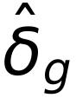, using the reference-control standard deviation  and the sample sizes of the observed experiment:
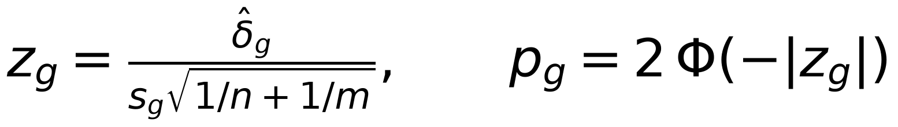 | (16)
Here  is the number of perturbed cells and 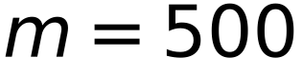, with BH adjustment. Predicted fold-change ranks and signs use . Observed ground truth is unchanged. The pre-registered Wilcoxon results are reported in full in Table S1 and flagged as invalid. DE AUPRC is the average precision^{84,85} for recovering observed DEGs from predicted -log10 adjusted p values. DE overlap is
 | (17)
Here both sets are ranked by |log2 FC| among significant genes. Fold-change Spearman is computed over observed DEGs. Direction agreement is the fraction of observed DEGs with the correct predicted sign. Effect-size Spearman is the rank correlation, across perturbations within a fold, between the predicted and observed numbers of DEGs.
Statistics
All hypotheses, tests and the decision rule were fixed in a protocol (RESEARCH_PROTOCOL.md, git tag protocol-v1.0) before any model was fitted to real data. H1 used one-sided paired Wilcoxon signed-rank tests over held-out perturbations pooled across the four folds (CASTER > baseline), with Holm correction⁸⁶ over nine tests (three baselines x three primary metrics). It was declared supported if at least six were significant and none was significant in the opposite direction. H2 used the same test against PerturbMean on T2 (Holm over three). H3 compared per-perturbation single-source transfer accuracy averaged over cancer-to-cancer pairs with the average over pairs involving RPE1 (two-sided paired Wilcoxon). H4 and H4b used Spearman correlations with Holm correction over the three cancer lines. Exploratory analyses are reported without multiplicity claims. Every number in the text is read from the results.json file written by the analysis pipeline.

SUPPLEMENTAL INFORMATION
Table S1. All paired tests, under-represented context task (one-sided Wilcoxon, CASTER > baseline; Holm within each family)
Baseline | Metric | n | CASTER | Baseline | % better | p | p (Holm)
PerturbMean | pearson_delta | 3,841 | 0.278 | 0.198 | 66 | 5.8 × 10⁻¹⁵³ | 4.0 × 10⁻¹⁵²
PerturbMean | discrimination | 3,841 | 0.430 | 0.369 | 46 | 0.648 | 1.000
PerturbMean | de_auprc | 2,666 | 0.198 | 0.137 | 67 | 1.2 × 10⁻¹⁰³ | 6.1 × 10⁻¹⁰³
ContextMean | pearson_delta | 3,841 | 0.278 | 0.208 | 67 | 3.3 × 10⁻¹⁵⁰ | 2.0 × 10⁻¹⁴⁹
ContextMean | discrimination | 3,841 | 0.430 | 0.000 | 80 | < 1e-300 | < 1e-300
ContextMean | de_auprc | 2,666 | 0.198 | 0.104 | 77 | 2.3 × 10⁻²²³ | 1.8 × 10⁻²²²
Linear | pearson_delta | 3,841 | 0.278 | 0.282 | 50 | 0.960 | 1.000
Linear | discrimination | 3,841 | 0.430 | 0.422 | 50 | 0.039 | 0.117
Linear | de_auprc | 2,666 | 0.198 | 0.181 | 56 | 4.0 × 10⁻¹⁸ | 1.6 × 10⁻¹⁷
PerturbMean | mae | 3,841 | 0.077 | 0.093 | 2 | 1.000 | 1.000
PerturbMean | de_overlap | 2,666 | 0.152 | 0.154 | 31 | 0.562 | 1.000
PerturbMean | lfc_spearman | 2,094 | 0.459 | 0.395 | 60 | 2.5 × 10⁻⁴⁰ | 2.0 × 10⁻³⁹
PerturbMean | direction | 2,666 | 0.804 | 0.756 | 52 | 1.7 × 10⁻⁸³ | 1.5 × 10⁻⁸²
ContextMean | mae | 3,841 | 0.077 | 0.082 | 24 | 1.000 | 1.000
ContextMean | de_overlap | 2,666 | 0.152 | 0.024 | 47 | 1.6 × 10⁻¹⁷¹ | 1.8 × 10⁻¹⁷⁰
ContextMean | lfc_spearman | 2,094 | 0.459 | 0.365 | 69 | 3.8 × 10⁻¹⁰⁰ | 3.8 × 10⁻⁹⁹
ContextMean | direction | 2,666 | 0.804 | 0.701 | 61 | 1.2 × 10⁻¹⁸³ | 1.5 × 10⁻¹⁸²
Linear | mae | 3,841 | 0.077 | 0.077 | 47 | 0.961 | 1.000
Linear | de_overlap | 2,666 | 0.152 | 0.127 | 32 | 5.1 × 10⁻²⁸ | 3.5 × 10⁻²⁷
Linear | lfc_spearman | 2,094 | 0.459 | 0.456 | 45 | 0.266 | 1.000
Linear | direction | 2,666 | 0.804 | 0.803 | 30 | 0.481 | 1.000
PerturbMean (pre-reg. Wilcoxon) | de_auprc | 2,666 | 0.039 | 0.035 | 73 | 1.6 × 10⁻¹⁵² | 7.8 × 10⁻¹⁵²
ContextMean (pre-reg. Wilcoxon) | de_auprc | 2,666 | 0.039 | 0.036 | 85 | 5.8 × 10⁻²⁴⁶ | 4.6 × 10⁻²⁴⁵
Linear (pre-reg. Wilcoxon) | de_auprc | 2,666 | 0.039 | 0.037 | 85 | 5.1 × 10⁻²⁴⁴ | 3.6 × 10⁻²⁴³

Table S2. CASTER hyperparameters and training settings
Component | Setting
Cell encoder f_cell | 4-layer MLP, GELU, 2,000 -> 256 -> 256 -> 256 -> 256
Prior encoder f_prior | 2-layer MLP, GELU, 2,000 -> 256 -> 256
Context summary / FiLM | mean of cell embeddings -> 2-layer MLP -> (gamma, beta) in R^256 x R^256
Set transformer | 4 layers, 8 heads, d_model 256, feed-forward 512, pre-norm, GELU, dropout 0, no positional encoding
Output | LayerNorm + linear 256 -> 2,000 (zero-initialised); g(c): linear 256 -> 2,000 (zero-init)
Cell-set size S | 32 (ablation: 1, 8)
Loss | energy-distance MMD^2 + 1.0 x pseudobulk squared error
Optimiser | AdamW, lr 3e-4, weight decay 1e-4, batch 32 sets, grad-norm clip 1.0
Schedule | 5% linear warm-up, cosine decay to 5% of peak
Epochs | 20 (T1, T2); 10 (ablations, single-source transfer)
Model selection | lowest validation loss (T1: 5% target perturbations; T2/T3: 5% source items)
Hardware | CPU only (4 cores, 8 GB RAM), 2 threads per job, PyTorch 2.13
Parameters | 4.6 M (excluding the one-hot embedding, used only in ablations)

Table S3. Dataset after subsampling and filtering
Context | Cells | Controls | Perturbations | Median cells/pert | Median # DEGs | % with >= 10 DEGs
K562 | 47,236 | 3,000 | 1,383 | 32 | 2 | 32
HepG2 | 45,783 | 3,000 | 1,340 | 32 | 5 | 46
Jurkat | 52,151 | 3,000 | 1,537 | 32 | 2 | 32
RPE1 | 50,923 | 3,000 | 1,499 | 32 | 29 | 60

Table S4. All metrics per held-out context, under-represented task (mean over held-out perturbations)
Context | Method | Pearson d | Discrim. | MAE | DE AUPRC | DE overlap | FC Spearman | Direction | Effect rho
HepG2 | CASTER | 0.315 | 0.470 | 0.070 | 0.227 | 0.177 | 0.506 | 0.813 | 0.703
HepG2 | ContextMean | 0.254 | -0.007 | 0.076 | 0.114 | 0.016 | 0.428 | 0.730 | -0.003
HepG2 | Linear | 0.322 | 0.478 | 0.069 | 0.210 | 0.151 | 0.488 | 0.814 | 0.703
HepG2 | NoChange | 0.060 | -0.012 | 0.078 | 0.078 | 0.000 | 0.103 | 0.549 | 0.017
HepG2 | PerturbMean | 0.243 | 0.423 | 0.086 | 0.162 | 0.201 | 0.445 | 0.785 | 0.671
Jurkat | CASTER | 0.205 | 0.378 | 0.085 | 0.123 | 0.099 | 0.386 | 0.777 | 0.575
Jurkat | ContextMean | 0.113 | 0.002 | 0.088 | 0.039 | 0.002 | 0.221 | 0.627 | -0.040
Jurkat | Linear | 0.197 | 0.349 | 0.085 | 0.101 | 0.073 | 0.367 | 0.766 | 0.529
Jurkat | NoChange | 0.039 | 0.001 | 0.090 | 0.029 | 0.000 | 0.060 | 0.516 | -0.050
Jurkat | PerturbMean | 0.160 | 0.348 | 0.098 | 0.112 | 0.148 | 0.354 | 0.757 | 0.650
K562 | CASTER | 0.205 | 0.408 | 0.072 | 0.145 | 0.115 | 0.426 | 0.815 | 0.617
K562 | ContextMean | 0.101 | -0.003 | 0.075 | 0.036 | 0.001 | 0.276 | 0.655 | 0.043
K562 | Linear | 0.209 | 0.429 | 0.072 | 0.133 | 0.101 | 0.450 | 0.805 | 0.626
K562 | NoChange | 0.049 | -0.002 | 0.076 | 0.029 | 0.000 | 0.069 | 0.553 | -0.005
K562 | PerturbMean | 0.189 | 0.537 | 0.089 | 0.121 | 0.158 | 0.436 | 0.789 | 0.643
RPE1 | CASTER | 0.386 | 0.468 | 0.082 | 0.276 | 0.205 | 0.501 | 0.812 | 0.668
RPE1 | ContextMean | 0.361 | 0.006 | 0.088 | 0.198 | 0.065 | 0.480 | 0.773 | -0.009
RPE1 | Linear | 0.399 | 0.438 | 0.081 | 0.259 | 0.171 | 0.503 | 0.823 | 0.701
RPE1 | NoChange | 0.050 | 0.002 | 0.095 | 0.092 | 0.000 | 0.071 | 0.541 | -0.010
RPE1 | PerturbMean | 0.204 | 0.190 | 0.098 | 0.148 | 0.121 | 0.364 | 0.710 | 0.544

Table S5. All metrics per held-out context, zero-shot task
Context | Method | Pearson d | Discrim. | MAE | DE AUPRC | DE overlap | FC Spearman | Direction | Effect rho
HepG2 | CASTER | 0.169 | 0.191 | 0.081 | 0.128 | 0.109 | 0.331 | 0.715 | 0.672
HepG2 | NoChange | 0.060 | -0.008 | 0.079 | 0.081 | 0.000 | 0.099 | 0.549 | 0.010
HepG2 | PerturbMean | 0.247 | 0.414 | 0.087 | 0.165 | 0.204 | 0.458 | 0.784 | 0.666
Jurkat | CASTER | 0.138 | 0.179 | 0.089 | 0.077 | 0.071 | 0.305 | 0.717 | 0.581
Jurkat | NoChange | 0.039 | 0.001 | 0.089 | 0.028 | 0.000 | 0.054 | 0.531 | -0.010
Jurkat | PerturbMean | 0.155 | 0.335 | 0.097 | 0.107 | 0.144 | 0.352 | 0.756 | 0.635
K562 | CASTER | 0.187 | 0.401 | 0.081 | 0.093 | 0.105 | 0.409 | 0.769 | 0.635
K562 | NoChange | 0.051 | -0.001 | 0.075 | 0.029 | 0.000 | 0.067 | 0.552 | -0.009
K562 | PerturbMean | 0.186 | 0.538 | 0.089 | 0.122 | 0.159 | 0.416 | 0.784 | 0.643
RPE1 | CASTER | 0.191 | 0.100 | 0.091 | 0.126 | 0.053 | 0.316 | 0.683 | 0.556
RPE1 | NoChange | 0.048 | 0.001 | 0.095 | 0.091 | 0.000 | 0.063 | 0.541 | 0.002
RPE1 | PerturbMean | 0.205 | 0.185 | 0.099 | 0.146 | 0.118 | 0.363 | 0.715 | 0.533

Table S6. Single-source transfer (mean over shared perturbations)
Source | Target | Method | Pearson d | Discrim. | DE AUPRC | DE overlap
HepG2 | Jurkat | CASTER | 0.127 | 0.153 | 0.054 | 0.066
HepG2 | Jurkat | PerturbMean | 0.132 | 0.286 | 0.064 | 0.112
HepG2 | K562 | CASTER | 0.160 | 0.287 | 0.077 | 0.096
HepG2 | K562 | PerturbMean | 0.162 | 0.475 | 0.087 | 0.134
HepG2 | RPE1 | CASTER | 0.246 | 0.138 | 0.154 | 0.089
HepG2 | RPE1 | PerturbMean | 0.235 | 0.270 | 0.150 | 0.159
Jurkat | HepG2 | CASTER | 0.157 | 0.117 | 0.098 | 0.090
Jurkat | HepG2 | PerturbMean | 0.150 | 0.262 | 0.096 | 0.166
Jurkat | K562 | CASTER | 0.152 | 0.313 | 0.090 | 0.104
Jurkat | K562 | PerturbMean | 0.148 | 0.521 | 0.096 | 0.139
Jurkat | RPE1 | CASTER | 0.143 | 0.068 | 0.107 | 0.047
Jurkat | RPE1 | PerturbMean | 0.144 | 0.190 | 0.107 | 0.136
K562 | HepG2 | CASTER | 0.164 | 0.066 | 0.107 | 0.059
K562 | HepG2 | PerturbMean | 0.161 | 0.206 | 0.104 | 0.145
K562 | Jurkat | CASTER | 0.119 | 0.096 | 0.073 | 0.057
K562 | Jurkat | PerturbMean | 0.132 | 0.274 | 0.085 | 0.127
K562 | RPE1 | CASTER | 0.135 | 0.027 | 0.118 | 0.033
K562 | RPE1 | PerturbMean | 0.135 | 0.103 | 0.118 | 0.106
RPE1 | HepG2 | CASTER | 0.272 | 0.411 | 0.180 | 0.201
RPE1 | HepG2 | PerturbMean | 0.262 | 0.558 | 0.177 | 0.230
RPE1 | Jurkat | CASTER | 0.130 | 0.211 | 0.084 | 0.100
RPE1 | Jurkat | PerturbMean | 0.136 | 0.363 | 0.100 | 0.140
RPE1 | K562 | CASTER | 0.149 | 0.283 | 0.087 | 0.101
RPE1 | K562 | PerturbMean | 0.150 | 0.430 | 0.102 | 0.140

Table S7. Ablations (under-represented task, K562 held out)
Variant | Pearson d | Discrim. | DE AUPRC | DE overlap | FC Spearman
S1 | 0.178 | 0.472 | 0.123 | 0.160 | 0.426
S32 | 0.189 | 0.323 | 0.127 | 0.093 | 0.423
S32_noattn | 0.181 | 0.276 | 0.124 | 0.089 | 0.404
S32_nofilm | 0.189 | 0.321 | 0.128 | 0.093 | 0.421
S32_noprior | 0.095 | -0.003 | 0.035 | 0.004 | 0.225
S32_pertid | 0.185 | 0.314 | 0.124 | 0.092 | 0.416
S8 | 0.160 | 0.211 | 0.100 | 0.070 | 0.386

Table S8. Gene programs and their top Reactome enrichment
Context | Program | Genes | Top Reactome pathway | p
HepG2 | 0 | 199 | Cell Cycle | 5.0e-23
HepG2 | 14 | 109 | Cholesterol biosynthesis | 7.5e-07
HepG2 | 6 | 83 | Metabolism | 9.0e-06
HepG2 | 2 | 127 | mRNA Splicing | 3.2e-05
HepG2 | 10 | 68 | DNA Double Strand Break Response | 4.5e-05
HepG2 | 1 | 85 | Metabolism | 4.6e-05
HepG2 | 5 | 180 | Anchoring of the basal body to the plasma membrane | 5.9e-05
HepG2 | 3 | 78 | Generic Transcription Pathway | 6.0e-05
HepG2 | 4 | 193 | CDC42 GTPase cycle | 3.1e-04
HepG2 | 13 | 86 | Hemostasis | 7.6e-04
HepG2 | 8 | 133 | Protein-protein interactions at synapses | 1.1e-03
HepG2 | 7 | 161 | Immune System | 1.8e-03
HepG2 | 12 | 186 | Transcriptional and post-translational regulation of MITF-M expression | 2.0e-03
HepG2 | 9 | 142 | RSV-host interactions | 2.3e-03
HepG2 | 11 | 170 | tRNA modification in the nucleus and cytosol | 2.7e-03
Jurkat | 2 | 62 | Cell Cycle, Mitotic | 1.1e-17
Jurkat | 5 | 106 | Cell Cycle | 9.4e-12
Jurkat | 8 | 100 | Cholesterol biosynthesis | 1.2e-08
Jurkat | 7 | 122 | Metabolism of RNA | 3.0e-08
Jurkat | 11 | 183 | Sensory processing of sound by outer hair cells of the cochlea | 1.3e-05
Jurkat | 3 | 271 | RNA Polymerase II Transcription | 4.2e-05
Jurkat | 10 | 113 | Muscle contraction | 4.4e-05
Jurkat | 9 | 37 | Amino acid transport across the plasma membrane | 5.7e-05
Jurkat | 1 | 183 | RIPK1-mediated regulated necrosis | 3.2e-04
Jurkat | 6 | 151 | Metabolism | 7.3e-04
Jurkat | 4 | 229 | Glutamate and glutamine metabolism | 2.1e-03
Jurkat | 12 | 246 | Stimuli-sensing channels | 5.8e-03
Jurkat | 14 | 125 | ER to Golgi Anterograde Transport | 0.05
Jurkat | 0 | 13 | Signal Transduction | 0.34
Jurkat | 13 | 59 | Cytokine Signaling in Immune system | 0.52
K562 | 12 | 55 | Cell Cycle | 1.4e-14
K562 | 10 | 128 | Immune System | 1.6e-07
K562 | 13 | 132 | Metabolism of RNA | 1.6e-05
K562 | 7 | 79 | Macroautophagy | 3.1e-05
K562 | 1 | 129 | Cholesterol biosynthesis | 4.3e-05
K562 | 9 | 48 | Amino acid transport across the plasma membrane | 1.3e-04
K562 | 2 | 152 | Respiratory electron transport | 3.0e-04
K562 | 8 | 172 | Gene expression (Transcription) | 5.6e-04
K562 | 4 | 264 | HATs acetylate histones | 9.7e-04
K562 | 14 | 192 | Signaling by FGFR3 | 1.1e-03
K562 | 11 | 104 | Anchoring of the basal body to the plasma membrane | 2.1e-03
K562 | 5 | 108 | Biological oxidations | 2.6e-03
K562 | 6 | 256 | SUMOylation of ubiquitinylation proteins | 6.7e-03
K562 | 3 | 152 | Collagen formation | 0.02
K562 | 0 | 29 | (none) | 1.00
RPE1 | 8 | 283 | Cell Cycle | 7.2e-28
RPE1 | 7 | 70 | Asparagine N-linked glycosylation | 3.3e-08
RPE1 | 0 | 38 | Cellular response to chemical stress | 7.5e-07
RPE1 | 12 | 133 | Intraflagellar transport | 2.7e-05
RPE1 | 9 | 47 | Amino acid transport across the plasma membrane | 1.2e-04
RPE1 | 3 | 109 | Nervous system development | 4.3e-04
RPE1 | 10 | 149 | mRNA Splicing | 7.3e-04
RPE1 | 2 | 234 | NR1H2 and NR1H3-mediated signaling | 8.3e-04
RPE1 | 13 | 186 | Axon guidance | 9.8e-04
RPE1 | 4 | 29 | Platelet degranulation | 1.9e-03
RPE1 | 5 | 155 | Maternal to zygotic transition (MZT) | 2.0e-03
RPE1 | 6 | 165 | Negative Regulation of CDH1 Gene Transcription | 2.7e-03
RPE1 | 1 | 285 | ATP-dependent chromatin remodelers | 9.5e-03
RPE1 | 11 | 93 | Extracellular matrix organization | 0.01
RPE1 | 14 | 24 | (none) | 1.00

Table S9. Fold sizes and training summary
Task | Held-out context | Train perts | Val perts | Test perts | Selected epoch | Minutes
Under-represented | HepG2 | 320 | 64 | 894 | 18 | 34.6
Under-represented | Jurkat | 366 | 73 | 1,027 | 18 | 36.3
Under-represented | K562 | 327 | 65 | 917 | 18 | 36.0
Under-represented | RPE1 | 358 | 72 | 1,003 | 14 | 31.3
Zero-shot | HepG2 | 0 | 0 | 1,278 | 15 | 29.7
Zero-shot | Jurkat | 0 | 0 | 1,466 | 6 | 55.9
Zero-shot | K562 | 0 | 0 | 1,309 | 17 | 33.7
Zero-shot | RPE1 | 0 | 0 | 1,433 | 18 | 19.3

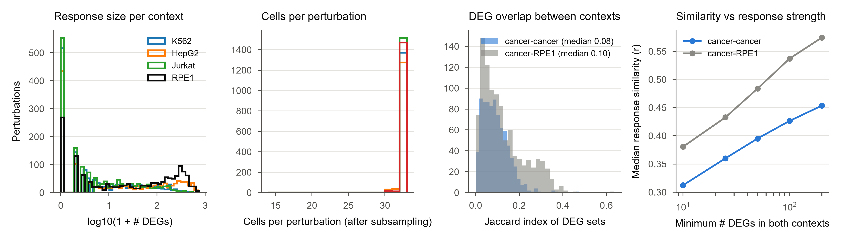
Figure S1. Response sizes and context overlap, related to Figure 1
(A) Distribution of the number of DEGs per perturbation in each context. (B) Cells per perturbation after subsampling. (C) Jaccard overlap of DEG sets between contexts. (D) Median cross-context response similarity as a function of response strength (minimum number of DEGs in both contexts).

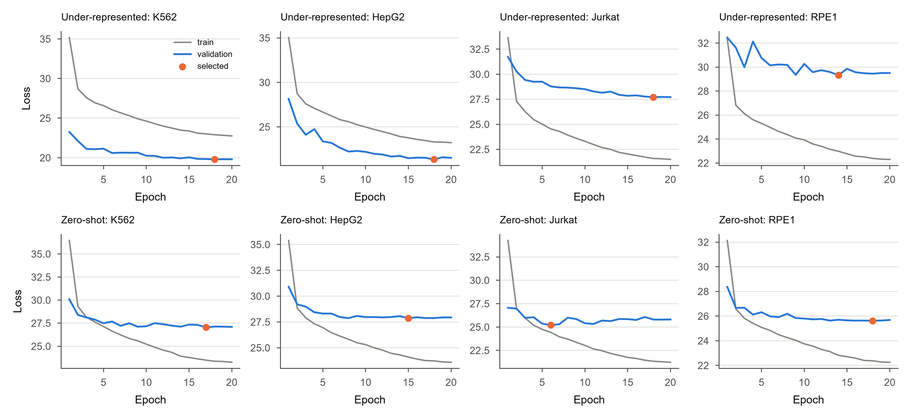
Figure S2. Training curves, related to Figures 2 and 3
Training and validation loss per epoch for every under-represented (top) and zero-shot (bottom) fold; the selected checkpoint is marked.

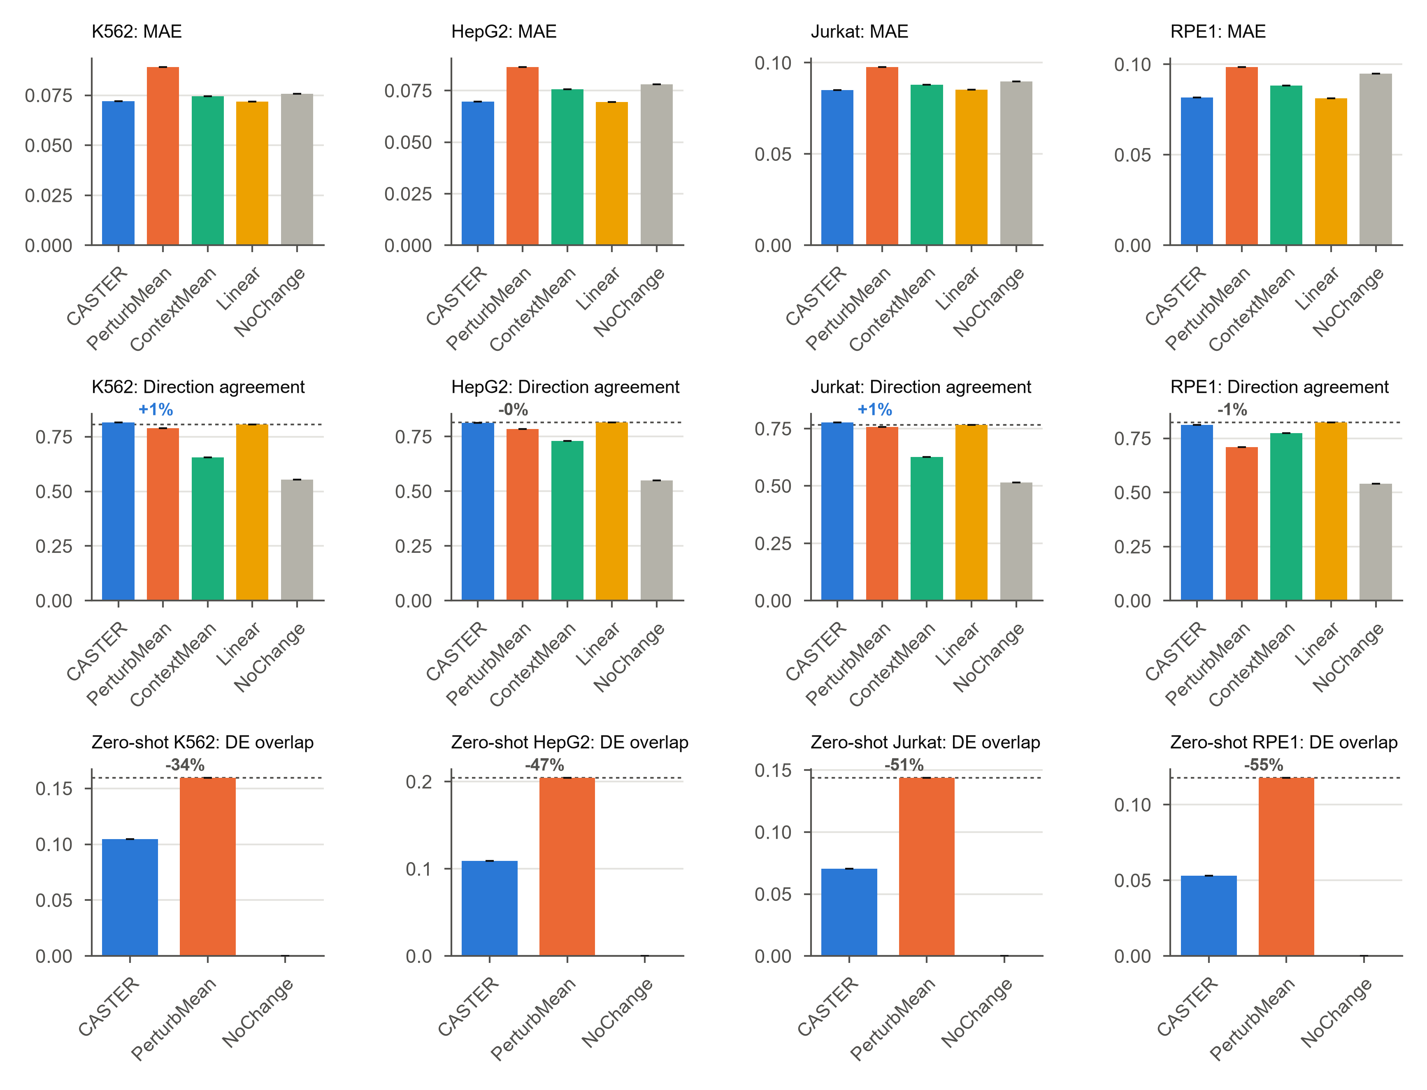
Figure S3. Secondary metrics, related to Figures 2 and 3
Mean absolute error and direction agreement per context (under-represented task), and DE overlap per context in the zero-shot task.

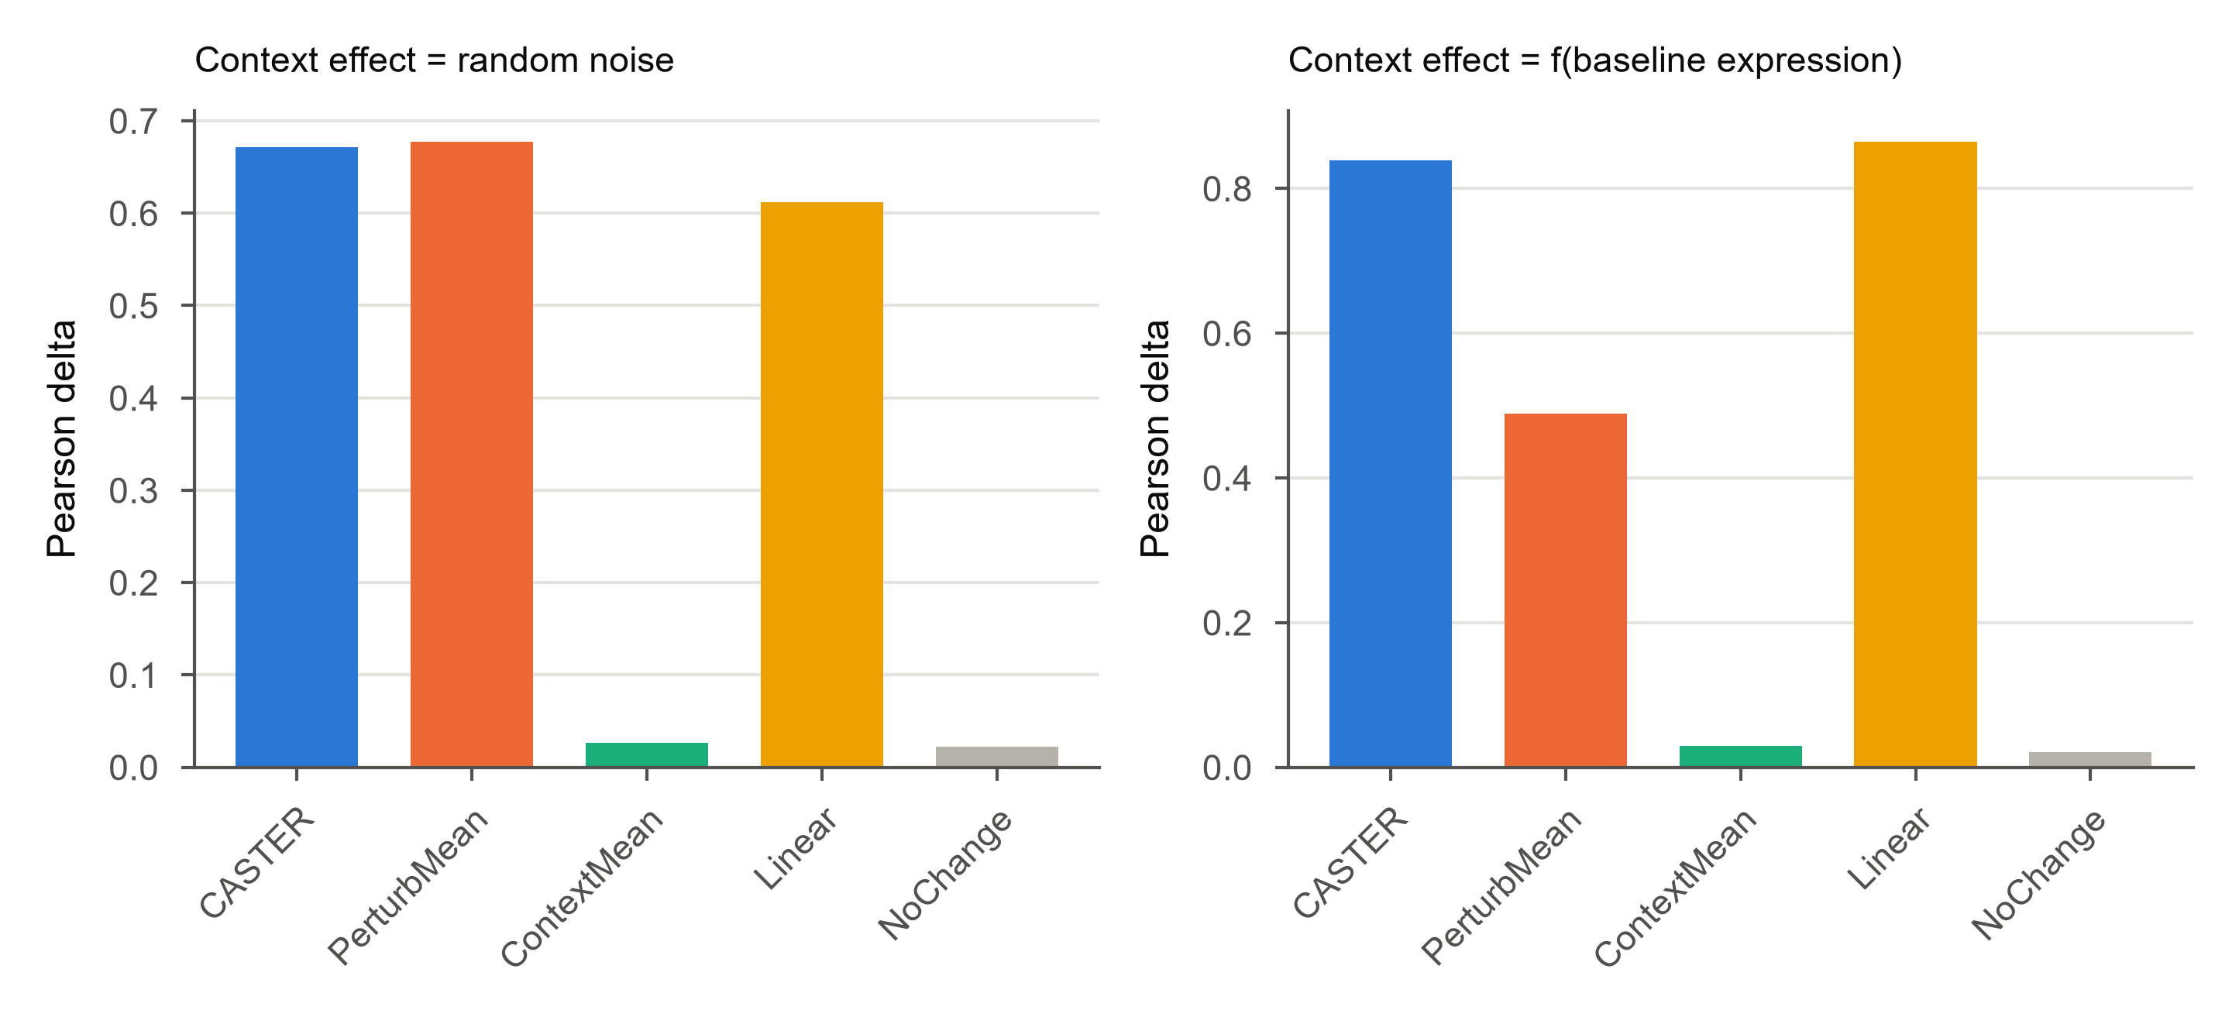
Figure S4. Positive-control simulation, related to Figure 1
Synthetic four-context data in which the context-specific component is random noise (left) or a function of baseline expression observable from control cells (right).

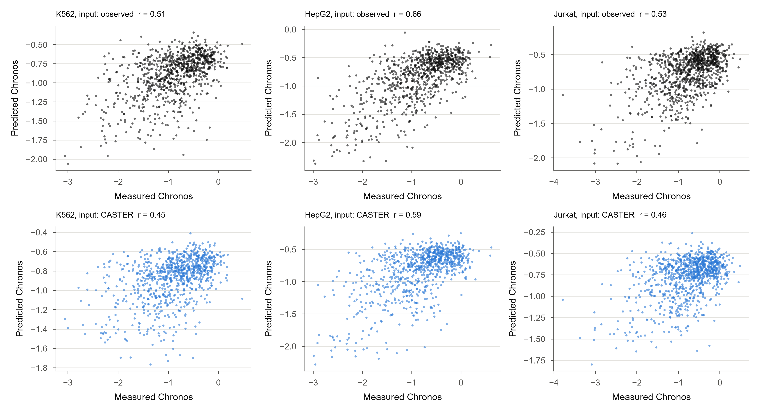
Figure S5. Dependency prediction from transcriptional shifts, related to Figure 5
Measured versus predicted Chronos gene effect per cancer line, from observed shifts (top) and from CASTER-predicted shifts (bottom).

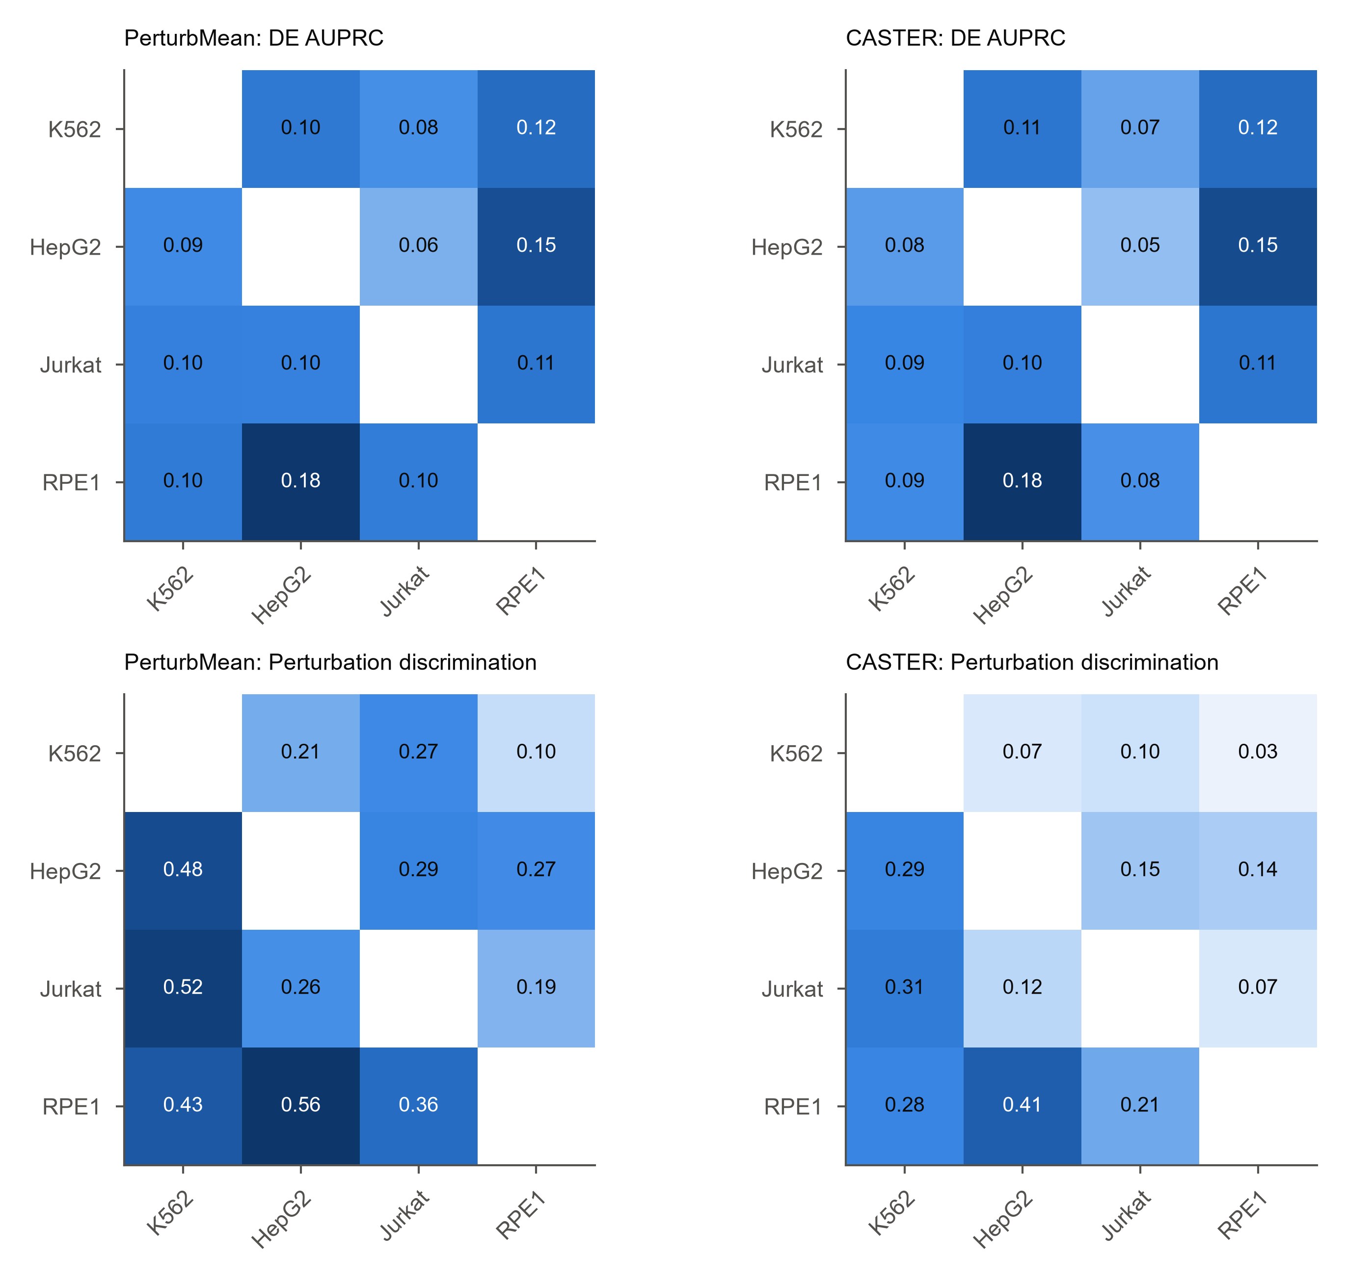
Figure S6. Single-source transfer, all metrics, related to Figure 3
DE AUPRC and perturbation discrimination for every source and target pair.

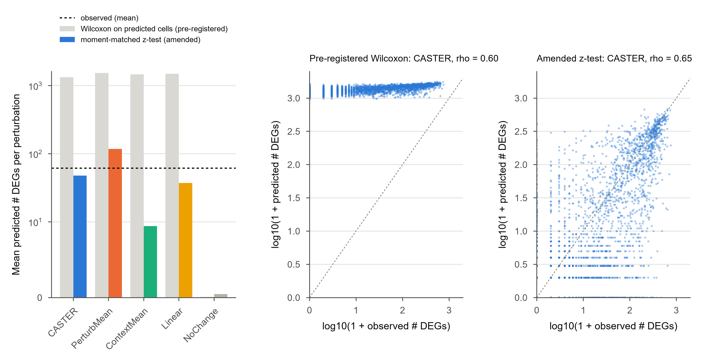
Figure S7. Predicted-side differential expression: pre-registered versus amended test, related to STAR Methods (AMENDMENT-002)
(Left) Mean number of predicted DEGs per perturbation under the pre-registered Wilcoxon test on predicted cells (grey) and the amended moment-matched z-test (colour); dashed line, observed mean. Shifted predictions turn exact zeros into small positive values, so the rank test calls most genes significant; unshifted control cells (NoChange) are unaffected. (Middle, right) Observed versus CASTER-predicted DEG counts per perturbation under the two tests.

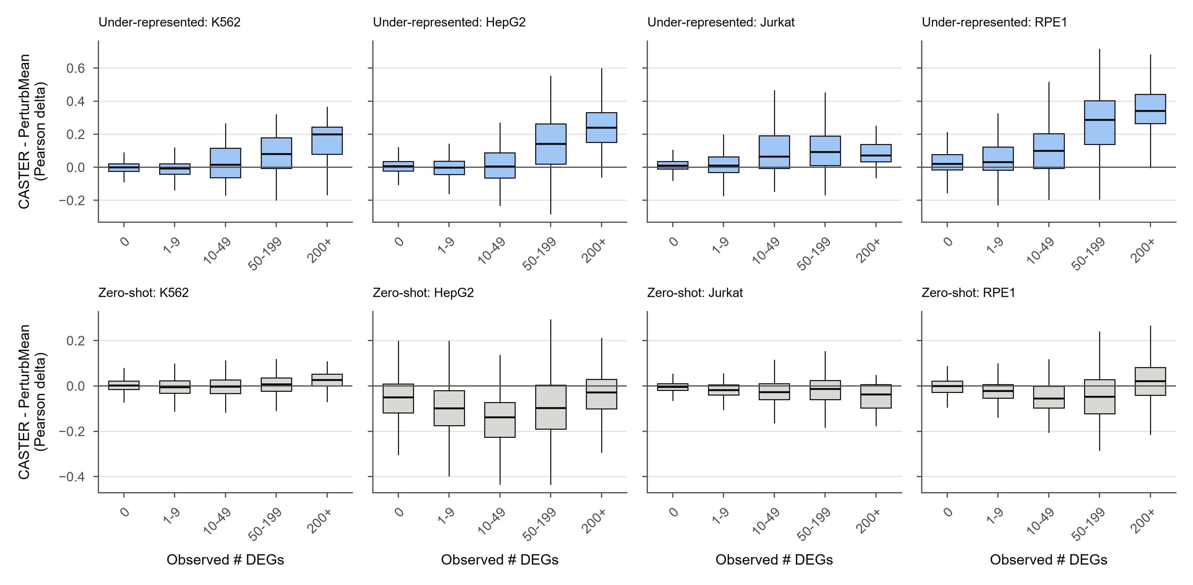
Figure S8. CASTER's gain over PerturbMean as a function of response strength, related to Figures 2 and 3
Per-perturbation difference in Pearson delta (CASTER minus PerturbMean), binned by the observed number of DEGs, for the under-represented (top) and zero-shot (bottom) tasks. Boxes, IQR; whiskers, 1.5x IQR.

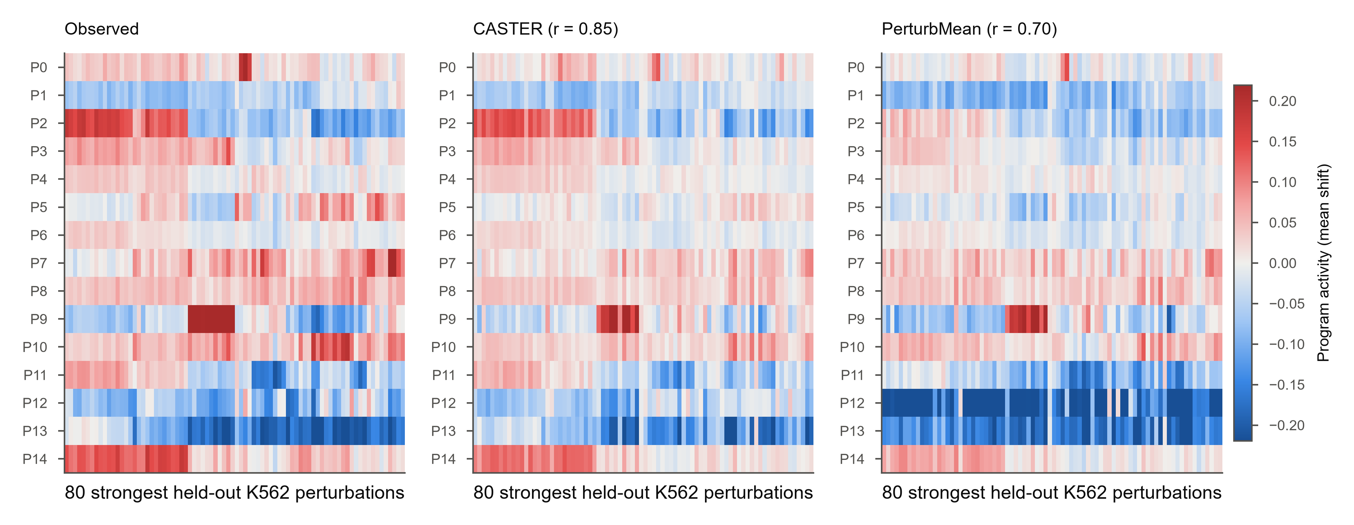
Figure S9. Gene-program activity of held-out perturbations, related to Figure 5
Activity of the 15 K562 gene programs (rows) for the 80 strongest held-out K562 perturbations (columns, clustered on the observed matrix): observed, CASTER and PerturbMean. r, Pearson correlation with the observed matrix.

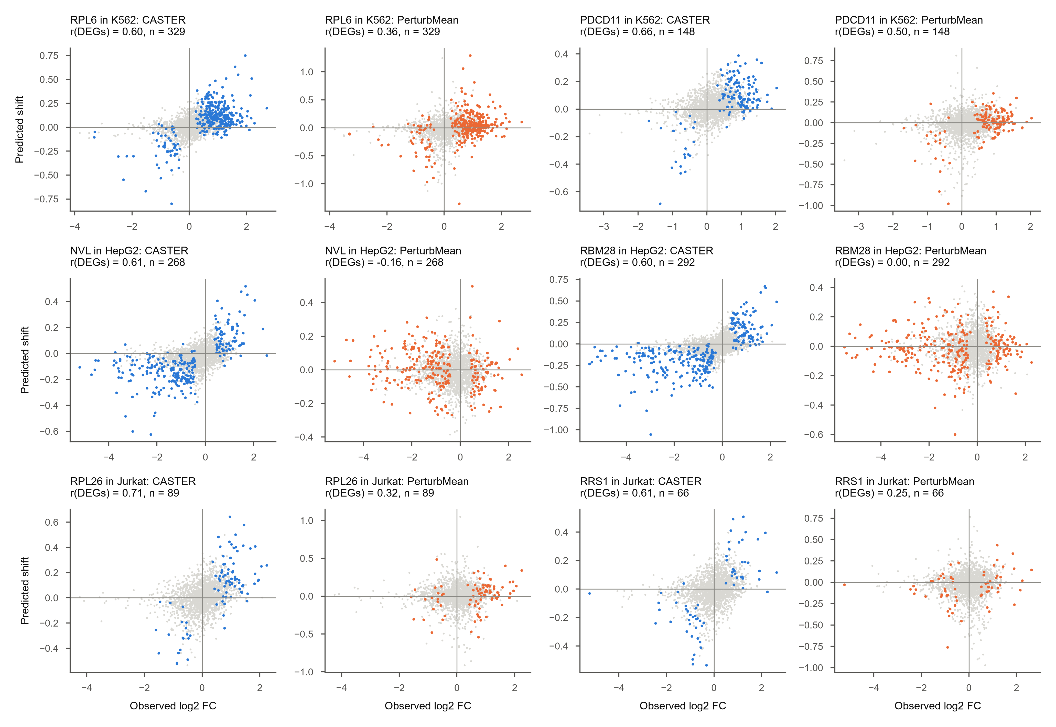
Figure S10. Context-specific example knockdowns, related to Figure 4
For each cancer line, the two knockdowns (>= 30 DEGs) with the largest CASTER gain over PerturbMean: observed log2 fold change versus predicted pseudobulk shift; coloured, observed DEGs.

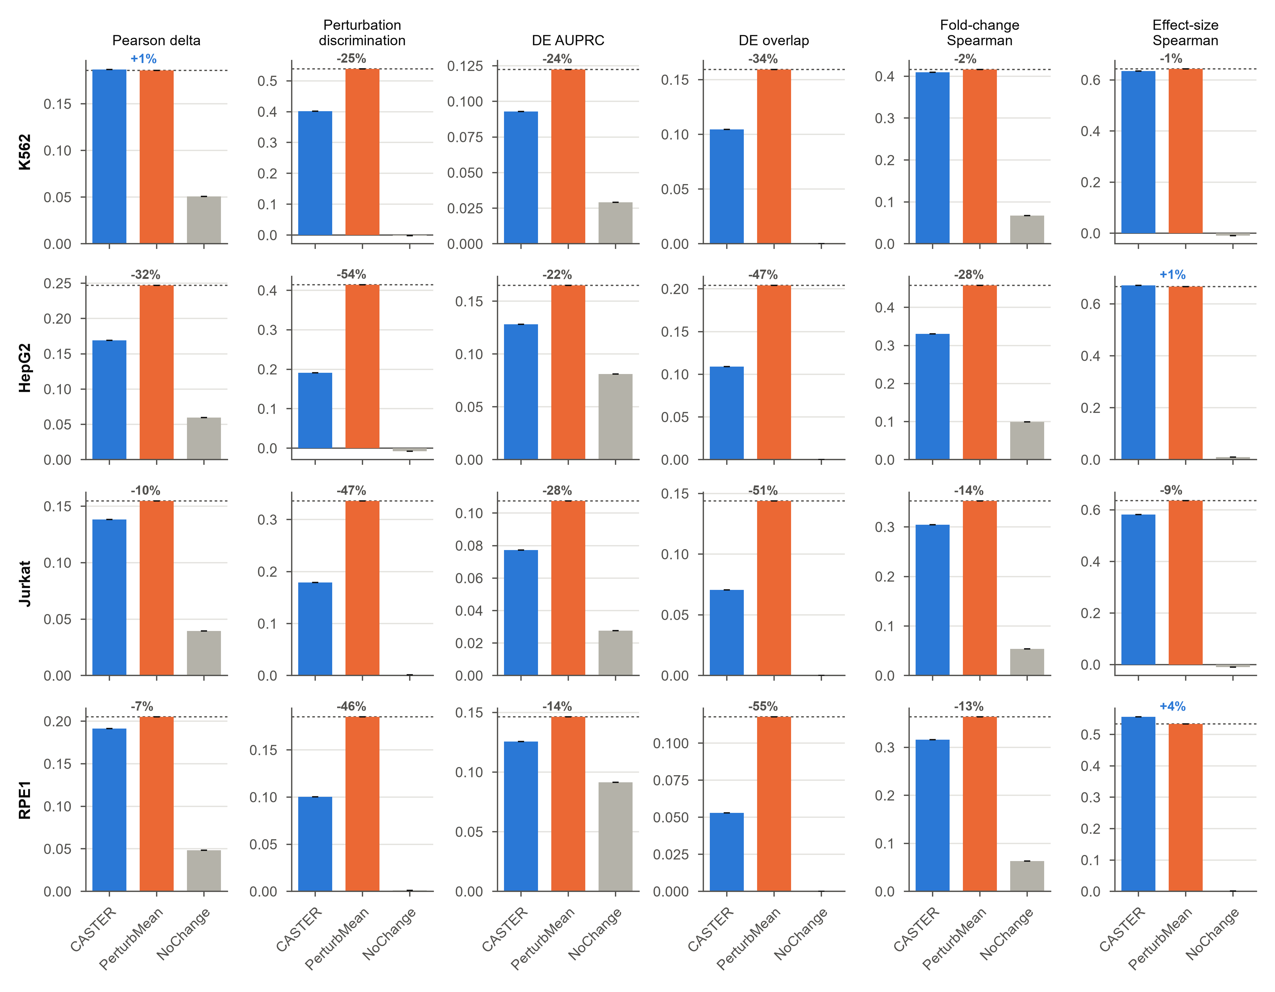
Figure S11. All metrics per held-out context in the zero-shot task, related to Figure 3
As Figure 2C, for the zero-shot task (CASTER, PerturbMean and NoChange).

Figure S12. Dependency-response coupling in predicted responses, related to Figure 5
Spearman correlation between response magnitude (log(1 + # DEGs)) and DepMap Chronos gene effect for observed responses and for the responses predicted by each method (held-out perturbations, under-represented task).

