Article
Cell line context reshapes genetic perturbation responses: set-based transfer of Perturb-seq effects across leukemia, hepatoblastoma, and non-transformed cells
[Author names and affiliations to be added by the authors]
Correspondence: [corresponding author e-mail]
Graphical abstract
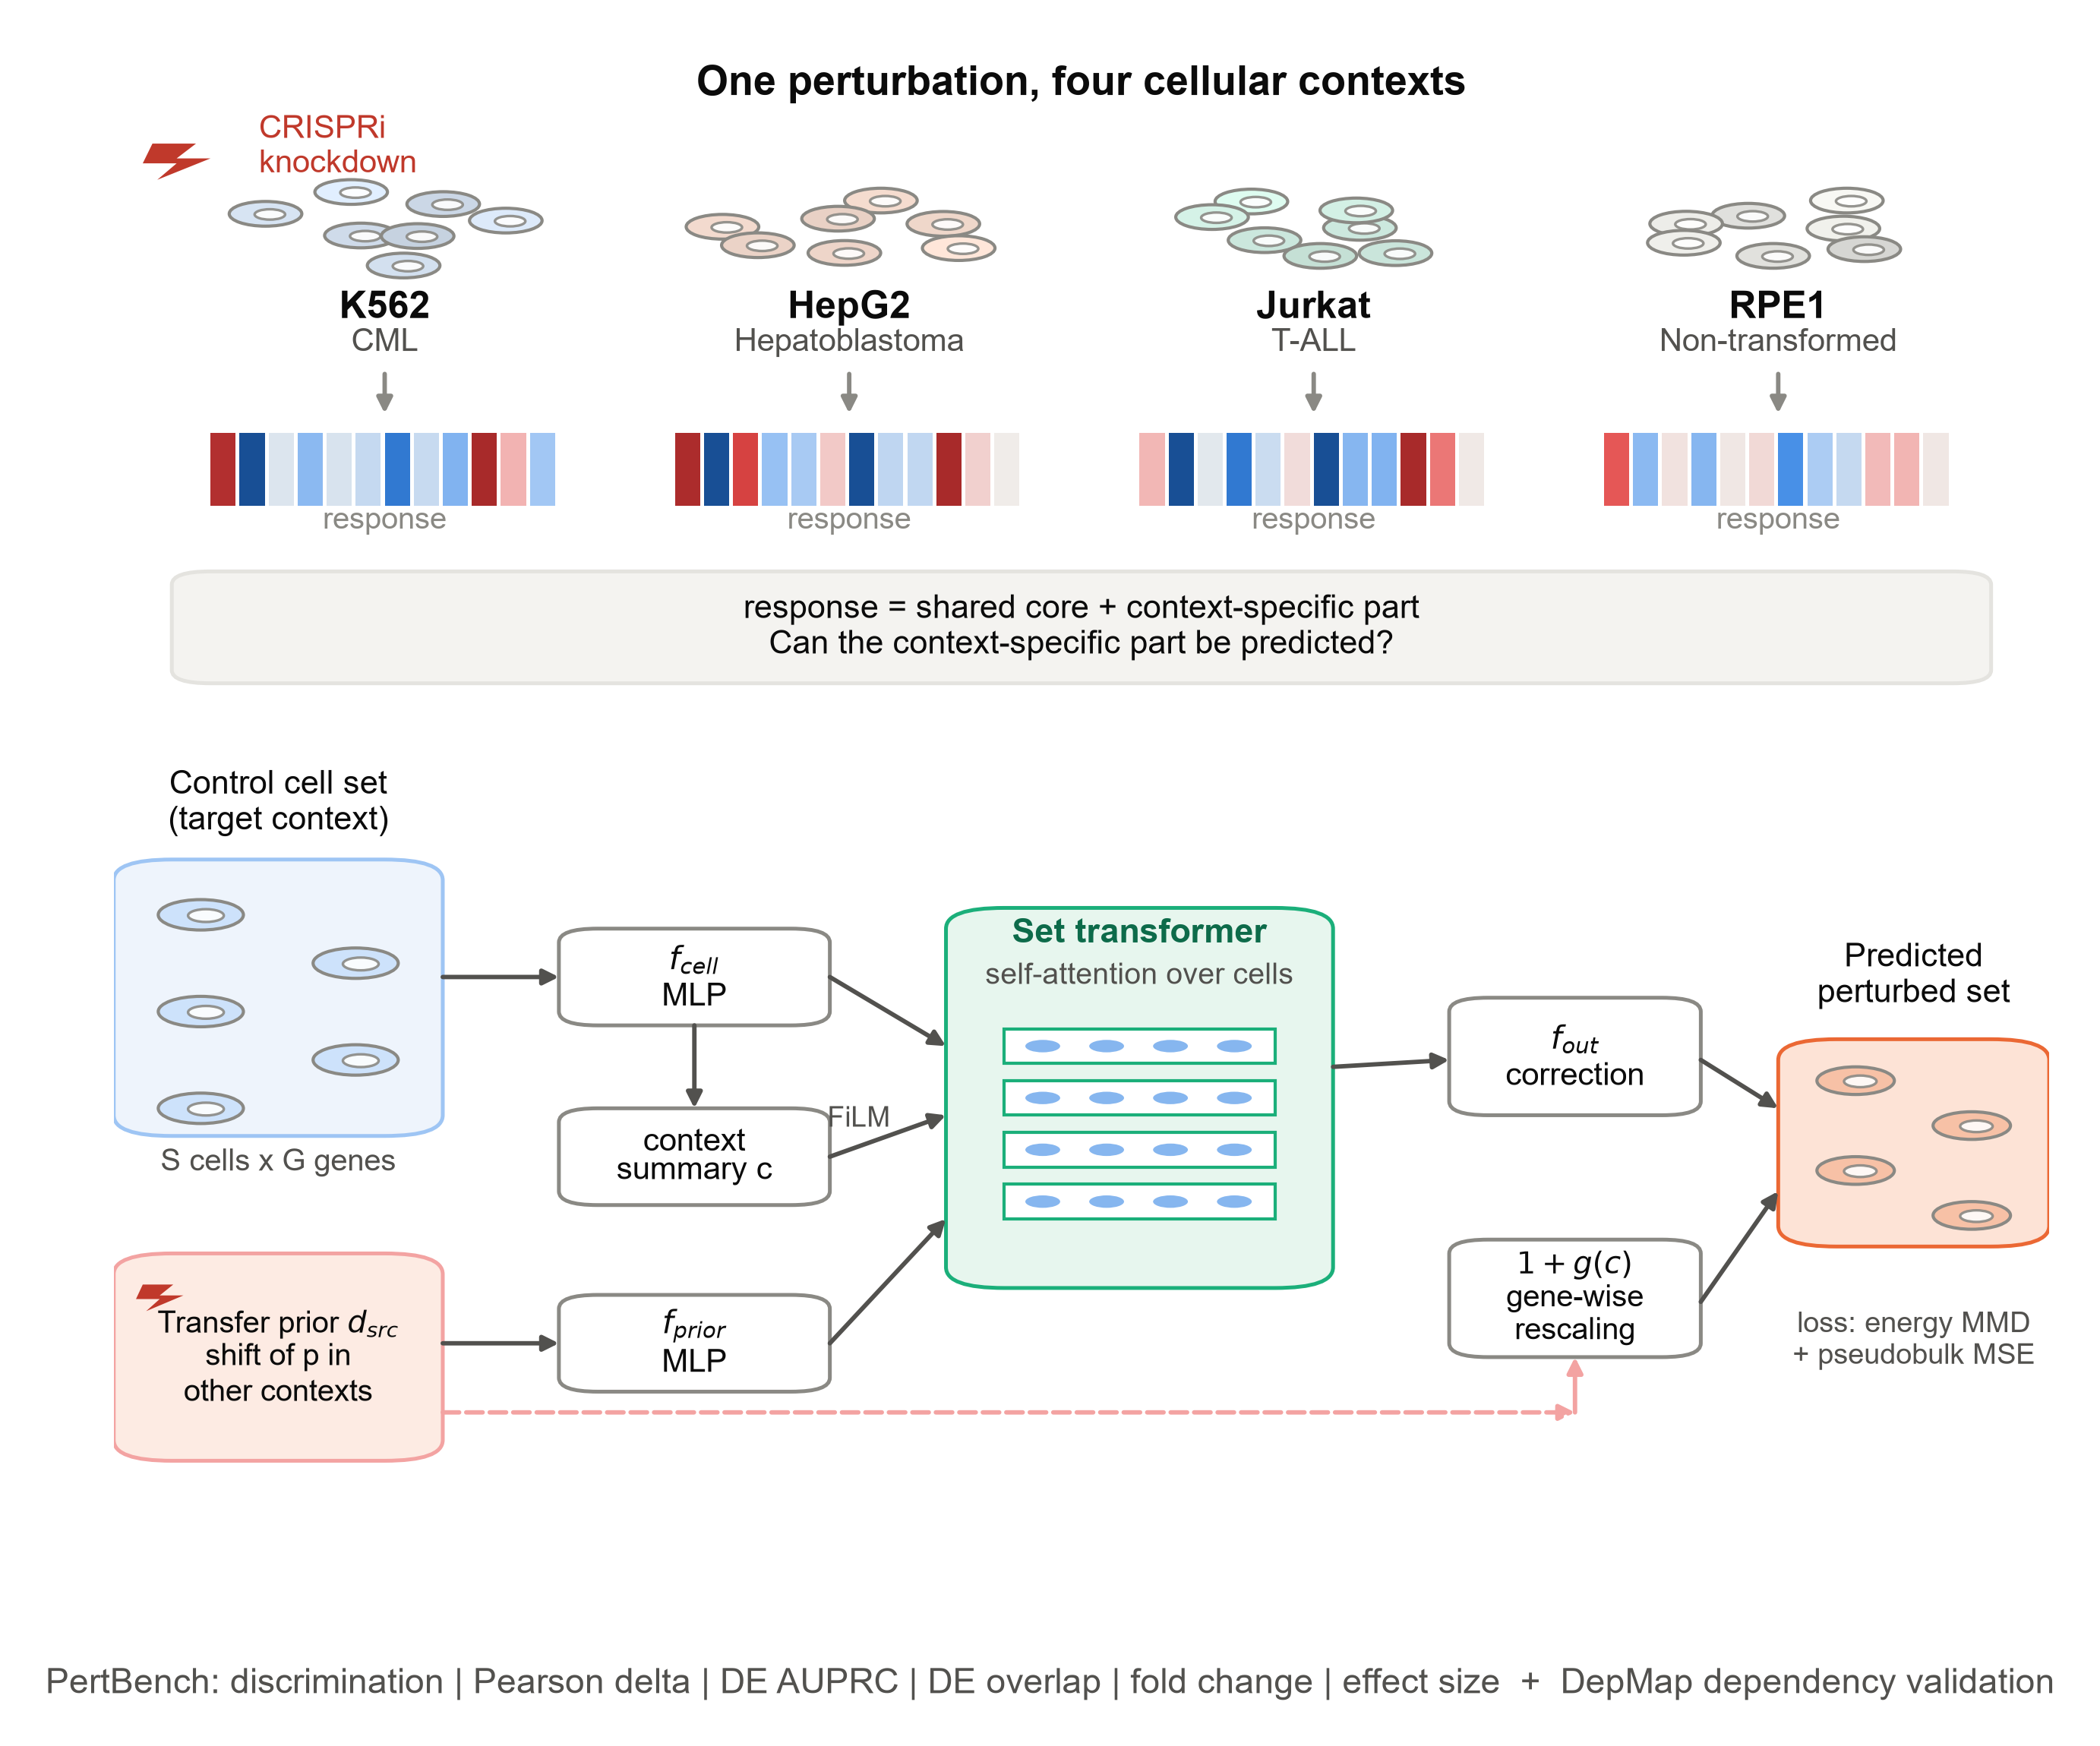
Highlights
- Responses to the same CRISPRi knockdown are only moderately shared across cell lines
- CASTER corrects transferred responses when part of the target line is screened
- CASTER outperforms mean baselines and matches a linear model; it fails in unseen lines
- Knockdown response magnitude tracks general gene essentiality, not line-specific dependency
In brief
Using Perturb-seq of essential genes in leukemia, hepatoblastoma, and non-transformed cells, this study measures how much cell line context reshapes the response to losing a gene, tests whether a set-based model can transfer responses between lines, and relates response size to gene essentiality.

SUMMARY
Genetic perturbation screens are run one cellular context at a time, yet cell lines differ in lineage and state. Using CRISPRi Perturb-seq of essential genes in three cancer cell lines and a non-transformed line, we find that transcriptional responses to the same knockdown are only moderately shared across lines (median correlation 0.31 between cancer lines), with similarity increasing for stronger responses and tracking shared p53 activity. We introduce CASTER, a set-based transformer that transfers a perturbation's response from other lines and corrects it for the target line. When part of the target line is screened, CASTER outperforms mean baselines (Pearson delta 0.28 versus 0.20 for the perturbation mean, over seeds and lines) and matches a linear transfer model (0.28); its gains concentrate on strong, ribosome-related responses. In lines with no screening data, CASTER is worse than the perturbation mean. Response magnitude tracked general gene essentiality measured by DepMap (Spearman rho -0.39 to -0.54), but not line-specific dependency. Noise ceilings, calibrated metrics, noise-free re-scoring and per-line controls define what context transfer can and cannot currently achieve from these data.
Keywords: Perturb-seq; CRISPRi; cell line context; set transformer; transfer learning; calibrated metrics; p53; gene essentiality; DepMap; leukemia; hepatoblastoma

INTRODUCTION
Pooled CRISPR screens with single-cell transcriptomic readouts (Perturb-seq) measure the transcriptome-wide consequence of a genetic perturbation in thousands of cells at once^{1–4}. CRISPR interference (CRISPRi)^{5,6} has made such screens scalable to every expressed or essential gene^{7,8}, and they are now used to map gene function, genetic interactions and regulatory programs^{8–11}. In cancer research they have identified regulators of immune evasion, drug response and oncogenic variant function^{12–16}. Each screen, however, is performed in one cellular context. A tumour is not one context: cancers differ by lineage, driver, ploidy and baseline transcriptional state, and these differences shape how a cell responds to losing a gene^{17–20}. Screening every perturbation in every relevant context is not feasible, so computational models that transfer perturbation responses across contexts are needed^{21,22}.
Many models predict single-cell perturbation responses, including autoencoder and latent-arithmetic models^{23–27}, optimal-transport maps²⁸, knowledge-graph models²⁹ and single-cell foundation models^{30–32}. Recently, State, a transformer that operates on sets of cells and is trained with a distributional loss, was shown to generalise perturbation effects to new contexts better than these approaches on several large datasets³³. At the same time, careful benchmarks have shown that simple baselines, including the mean response of a perturbation across training contexts and linear models, are hard to beat^{34–36}. A community-wide challenge now asks for virtual-cell models that pass a 'Turing test' on held-out contexts³⁷. Two questions are therefore open. How much of a perturbation's response is really specific to the context, as opposed to shared? And does that context-specific part carry biological information, for example about which genes a particular cancer depends on?
Here we address both questions in the setting where context matters most for cancer biology: the same essential-gene CRISPRi library profiled in three cancer cell lines from different lineages (K562 chronic myeloid leukaemia, HepG2 hepatoblastoma and Jurkat T cell acute lymphoblastic leukaemia) and in non-transformed hTERT RPE-1 cells^{8,38}. We first quantify how similar the responses to the same knockdown are across these contexts. We then introduce CASTER (Context-Adaptive Set Transformer for pErturbation Responses). CASTER represents a perturbation by its observed effect in other contexts (a transfer prior) and learns, from the unperturbed cells of the target context and, when available, a screened fraction of its perturbations, how that context rescales and reshapes the response. By construction CASTER starts at the PerturbMean transfer baseline and moves away from it only where held-out data support the change. We compare it with mean, offset and linear baselines, with calibrated metrics and noise ceilings, and with controls that remove the control cells or swap them between lines.
We evaluate CASTER with a pre-specified protocol and a biologically interpretable evaluation suite (PertBench), modelled on the Cell-Eval framework³³. We test it in under-represented contexts, in completely unseen contexts and in every single-source transfer direction. Finally, we connect perturbation responses to cancer dependency, asking whether the magnitude and context specificity of a knockdown's transcriptional response track CRISPR fitness effects measured independently in the Cancer Dependency Map^{39–42}. We report every pre-declared test, including those that do not support our hypotheses.
RESULTS
Responses to the same knockdown are only moderately shared across cell lines
We assembled CRISPRi Perturb-seq profiles of essential-gene knockdowns in four human cell lines (Figures 1A and 1B): K562 (chronic myeloid leukemia; TP53 null)⁸, HepG2 (hepatoblastoma; TP53 wild type)³⁸, Jurkat (T cell acute lymphoblastic leukemia; TP53 mutant)³⁸ and the non-transformed, TP53 wild-type line hTERT RPE-1^{8,43}. We used the knockdown-filtered, uniformly processed release of these data³³ and analysed 196,093 cells: up to 32 cells per perturbation per line and 3,000 controls per line (STAR Methods; Table S3). After filtering, 1,383 (K562), 1,340 (HepG2), 1,537 (Jurkat) and 1,499 (RPE1) perturbations remained (2,023 distinct target genes). Of these, 638 were retained in all four lines and 782 in all three cancer lines. Because on-target efficacy was filtered per line, the set of informative perturbations is itself line dependent (Figure 1B). We modelled 2,000 genes selected on control cells only. All 1,850 target genes that are among the 6,546 measured genes were excluded from this gene space (the remaining 173 targets are not measured), so neither gene selection nor the on-target signal can inflate any result.
The number of differentially expressed genes (DEGs; Wilcoxon test against held-out controls, FDR < 0.05) varied widely between knockdowns and between lines. The median was 2 in K562, 5 in HepG2, 2 in Jurkat, 29 in RPE1; 32%, 46%, 32%, 60% of knockdowns, respectively, changed at least 10 genes (Figure S1A). Responses were largest in the two TP53 wild-type lines, RPE1 and HepG2. This agrees with Nadig et al., who found the transcriptome-wide impact of these knockdowns to be largest in RPE1 and correlated across the four lines (average r = 0.62 for impact magnitude)³⁸. For 706 genes whose knockdown produced >= 10 DEGs in at least two lines, we compared response profiles. They were only moderately correlated: median Pearson r was 0.31 between cancer lines and 0.38 between a cancer line and RPE1 (Figures 1D and 1E), and DEG sets overlapped little (median Jaccard 0.08 and 0.10; Figure S1C). Profile correlation and magnitude correlation answer different questions, so the two studies are consistent.
The most similar pair was HepG2-RPE1 (median r = 0.52); the other five pairs ranged from 0.28 to 0.33. Similarity rose with response strength, from 0.31 for knockdowns with >= 10 DEGs to 0.45 for those with >= 200 DEGs in both cancer lines (Figure S1D). Part of the apparent line specificity of weak responses is therefore measurement noise. A split-half analysis quantified this noise. With 32 cells per knockdown, the best Pearson delta any predictor could reach against the observed response (the noise ceiling, STAR Methods) had a median of 0.50 in K562, 0.65 in HepG2, 0.53 in Jurkat, 0.77 in RPE1 (Figure 6A). Absolute accuracies in this study should be read against these ceilings. Because HepG2 and RPE1 are the two TP53 wild-type lines, we scored the activity of 14 consensus p53 target genes⁴⁴ for every knockdown (Figure S13). p53 targets were induced by 0.0% of knockdowns in K562, 28.4% of knockdowns in HepG2, 0.1% of knockdowns in Jurkat, 47.1% of knockdowns in RPE1, and the p53 response to individual knockdowns was most strongly shared between HepG2 and RPE1 (Spearman rho = 0.63, versus 0.06 to 0.21 for other pairs). Knockdowns inducing p53 in both lines had more similar HepG2 and RPE1 responses (median r = 0.57 versus 0.45, p = 1.9 × 10⁻²²). Among knockdowns that induced p53 in neither line, HepG2-RPE1 remained the most similar pair (median r = 0.42), so shared p53 status explains part, but not all, of their similarity; lineage and growth mode (both adherent and epithelial-derived) may contribute the rest. A useful transfer model must therefore capture the shared core of a response and predict at least part of a substantial line-specific component.
CASTER corrects a transferred response for the target line
These observations motivated CASTER (Figure 1C). Like State³³, CASTER operates on sets of cells and is trained with a distributional (energy-distance MMD) loss^{45,46}, so it models a perturbed population rather than a single average cell. A perturbation is represented by its transfer prior: the mean shift it produced in the other lines in which it was observed. The target line is never part of this prior. The target line is represented by a set of its unperturbed cells, read by a transformer encoder; FiLM conditioning⁴⁷ lets the same prior act differently in each line. The output adds a line-dependent, gene-wise rescaling of the prior and a cell-resolved correction. Both start at zero, so an untrained CASTER equals the PerturbMean baseline and any departure must be earned on validation data (STAR Methods; hyperparameters in Table S2). PerturbMean is not the strongest baseline on these data (ContextMean and the linear model beat it in some lines; Figure 2C), so this initialisation guarantees only a reasonable starting point, not an advantage.
In simulations where the line-specific component was pure noise, CASTER stayed at the PerturbMean solution (Pearson delta 0.67 versus 0.68; linear transfer 0.61). When the line-specific component depended on each gene's baseline expression, which is observable from control cells, CASTER recovered it (Pearson delta 0.84 versus 0.49), and so did the linear transfer model (0.86; Figure S4; simulation design in STAR Methods). The simulation therefore shows that CASTER can learn such structure without inventing it, not that it learns more than a linear model.
We ablated CASTER on the K562 under-represented fold with 20 training epochs, as in the main analysis, and two seeds for the main variants (Figure 1G). The full model (S = 32) reached a Pearson delta of 0.201, compared with 0.187 for PerturbMean and 0.206 for linear transfer on the same split. Variants: single cells (S = 1) 0.177; S = 8 0.179; no attention 0.189; no FiLM 0.201; no transfer prior (learned perturbation embedding) 0.100; prior plus ID embedding 0.199. On Pearson delta (paired Wilcoxon, Holm), the full model was significantly better than: single cells (S = 1), no attention, no transfer prior (learned perturbation embedding), prior plus ID embedding, S = 8. Runs were capped at 60 min of training; no transfer prior (learned perturbation embedding) stopped after 14 of 20 epochs, which may understate it slightly. Removing the transfer prior was by far the most damaging change; the contributions of attention and FiLM were small (Table S7). These ablations come from a single held-out line and should be read as indicative.
Under-represented lines: CASTER outperforms mean baselines and matches a linear model
We first evaluated the setting in which a new line has been screened with only part of a library (Figure 2A)³³. For each of the four lines in turn, 25% of its eligible perturbations were used for training, 5% for model selection and 70% for testing; the other three lines were fully observed. We compared CASTER with PerturbMean (a perturbation's mean response in the other lines), ContextMean (the target line's average response), LineOffset (PerturbMean plus the target line's average deviation from it, estimated on the screened 25% + 5%), a linear transfer model fitted on the screened fraction, and a no-change floor. The evaluation suite follows Cell-Eval³³ (Figures 2B-2E; STAR Methods; training curves in Figure S2). The pre-specified analysis used one split (seed 0); we added two more seeds, each with its own split and initialisation.
Over 3 seeds and four held-out lines, Pearson delta was 0.28 +- 0.00 for CASTER, 0.28 +- 0.00 for Linear, 0.25 +- 0.00 for LineOffset, 0.20 +- 0.00 for PerturbMean, 0.21 +- 0.00 for ContextMean (mean +- SD over seeds; Figure 2B). Restricted to the three cancer lines it was 0.24 for CASTER, 0.24 for Linear, 0.21 for LineOffset, 0.20 for PerturbMean. CASTER therefore improved on the mean baselines in every seed, but was tied with linear transfer, and much of its average gain over PerturbMean comes from RPE1, where PerturbMean is weak. In the pre-specified analysis (seed 0, H1), 6 of nine comparisons favoured CASTER after Holm correction and 0 favoured a baseline, so H1 was supported by its decision rule; all significant comparisons were against PerturbMean or ContextMean, or concerned DE AUPRC against Linear. Against Linear: Pearson delta 0.278 versus 0.282 (Holm p = 1.000); discrimination 0.430 versus 0.422 (Holm p = 0.117); DE AUPRC 0.198 versus 0.181 (Holm p = 1.6 × 10⁻¹⁷). Across seeds, CASTER beat PerturbMean on Pearson delta in every seed (two-sided paired Wilcoxon p 1.2 × 10⁻¹⁵², 1.3 × 10⁻¹²⁵, 1.5 × 10⁻¹⁵⁷), whereas the comparison with Linear was inconsistent (p 0.081, 1.9 × 10⁻⁵¹, 0.755; median differences 0.000, -0.007, 0.001). DE-based metrics use the amended predicted-side test (AMENDMENT-002): the pre-specified Wilcoxon test on predicted cells called a mean of 1333 DEGs per CASTER prediction versus 61 observed. Under the pre-specified test, 6 of nine comparisons favoured CASTER (Table S1, which lists both versions of every affected test).
Per line (seed 0), CASTER, PerturbMean and Linear reached Pearson deltas of K562 0.20 versus 0.19 and 0.20; HepG2 0.32 versus 0.25 and 0.33; Jurkat 0.20 versus 0.16 and 0.20; RPE1 0.39 versus 0.20 and 0.40 (Figure 2C; all metrics in Table S4 and Figure S3). Pooled over lines, the predicted and observed numbers of DEGs per knockdown were rank-correlated at rho = 0.65 for CASTER, 0.53 for PerturbMean and 0.66 for Linear (Figure 2E). Of the secondary metrics, 3 favoured CASTER over PerturbMean and 0 favoured PerturbMean (Table S1); MAE favoured CASTER (lower error).
Where does CASTER gain over the transfer prior? Binning held-out perturbations by the number of observed DEGs showed that the gain grows with response strength in every context (Spearman rho between gain and log response size 0.22 in K562, 0.49 in HepG2, 0.29 in Jurkat, 0.64 in RPE1; Figure S8). For knockdowns with >= 50 DEGs the median gain in Pearson delta was 0.09 (K562), 0.22 (HepG2), 0.09 (Jurkat), 0.33 (RPE1), whereas for knockdowns with < 10 DEGs it was close to zero (0.00, 0.00, 0.01, 0.03). CASTER's corrections therefore concentrate on strong responses; the same holds for its gain over Linear in some lines (Figure S8). In the zero-shot task, no such gradient appeared (median gain for strong responses 0.01, -0.05, -0.01, -0.01), in line with the absence of an overall advantage.
CASTER's gain is not a single offset per line
A reviewer-style concern is that CASTER might learn little more than one constant shift per line, which ContextMean alone captures well in RPE1. We tested this with three controls (Figure 6E). First, LineOffset adds the target line's average deviation from PerturbMean to every prediction. It reached a mean Pearson delta of 0.25, versus 0.28 for CASTER (CASTER better for 56% of perturbations, two-sided p = 3.1 × 10⁻⁸⁴). Second, a line-identity-only CASTER, which receives the line's mean control profile instead of a set of cells, reached 0.27 versus 0.28 for full CASTER on the same split (p = 1.1 × 10⁻²⁸). Third, the trained CASTER given another line's control cells reached 0.15 versus 0.27 with the correct cells (p < 1e-300). The line-identity-only model performed nearly as well as the full model. CASTER's gain therefore comes from line-specific information carried by the line's average control profile, which it uses to adapt the transferred response gene by gene (more than a single offset, as LineOffset shows), and not mainly from cell-to-cell variation within the control set; given the wrong line's profile, it adapts to the wrong line. The set-based design was therefore not necessary for this gain on these data.
A reviewer asked whether CASTER might gain by cancelling the noise of the control cells: every pseudobulk-level baseline was rendered as 32 sampled control cells plus its predicted shift, so its prediction inherits the sampling noise of those cells, which CASTER sees and could learn to remove. We re-scored every method after removing this noise (the mean of its input control cells minus the mean of the whole input pool; STAR Methods). All methods improved by a similar amount, CASTER included (Pearson delta over seeds and lines: CASTER 0.28 to 0.42, Linear 0.28 to 0.44, LineOffset 0.25 to 0.31, PerturbMean 0.20 to 0.25; Figure 6G). CASTER therefore does not gain by cancelling input noise; instead, the pre-specified rendering depressed the absolute accuracy of every method by a similar margin. With noise-free rendering, CASTER remained above PerturbMean (91% of perturbations better, p < 1e-300) and LineOffset (88%, p < 1e-300), and was again close to Linear (39% better, median difference -0.010, p = 9.0 × 10⁻¹³⁶). The ranking of the methods is the same under both renderings.
Calibrated metrics and noise ceilings
Miller et al. showed that several standard metrics barely separate a perfect from a useless prediction on these four datasets, and proposed calibrating metrics with positive and negative controls^{48,49}. We therefore re-scored every held-out perturbation against one random half of its cells, with the other half as a technical duplicate (positive control), an interpolated duplicate as a second positive control, and the line's mean perturbation response (or a zero shift, for metrics relative to the perturbed mean) as the negative control (STAR Methods). The dynamic range fraction (DRF; 0 = the metric cannot separate the controls, 1 = it separates them fully) averaged over lines was 0.29 for Pearson delta on the top 100 DEGs relative to the perturbed mean, 0.67 for NIR, 0.64 for PDS, but zero or negative for Pearson delta, weighted R2, weighted R2 relative to the perturbed mean, WMSE, MSE, MAE (Figure 6B). With only 16 cells per half, the technical duplicate is no closer to the truth than the mean response on these metrics, so they cannot validate a predictor at this cell count. This strengthens the case of Miller et al. that Pearson delta and MAE are poorly calibrated, and it applies to our pre-specified primary metric. On the calibrated metrics, scaled from negative control (0) to technical duplicate (1), CASTER scored 0.61 (Pearson delta on the top 100 DEGs relative to the perturbed mean), 0.49 (NIR), 0.48 (PDS); linear transfer 0.55, 0.48, 0.47; LineOffset 0.46, 0.50, 0.48; and PerturbMean 0.46, 0.43, 0.42 (Figure 6C; Table S10). Paired against Linear on these metrics, CASTER was better for 57% of perturbations on Pearson delta on the top 100 DEGs relative to the perturbed mean (p = 4.0 × 10⁻⁸⁶); 50% of perturbations on NIR (p = 6.1 × 10⁻⁴); 49% of perturbations on PDS (p = 0.137). On the metric that removes the shift shared by all knockdowns, CASTER therefore did better than linear transfer, whereas on the identity-retrieval metrics (NIR, PDS) the two were close. The calibrated metrics were added after the pre-specified analysis and are reported as exploratory.
CASTER is worse than the perturbation mean in unseen lines
We next asked whether responses could be transferred into a line with no perturbation data at all, using only its unperturbed cells (Figure 3A). They could not, by this model: CASTER was worse than PerturbMean in 21 of 24 line-by-metric panels (Figures 3B and S11), and the pre-specified comparison (H2) was significant in the opposite direction on all three primary metrics (Table S5; Pearson delta: CASTER 0.171 versus 0.197, two-sided p = 2.4 × 10⁻¹⁰⁵; discrimination: CASTER 0.214 versus 0.363, two-sided p = 2.3 × 10⁻²⁶⁹; DE AUPRC: CASTER 0.107 versus 0.136, two-sided p = 2.9 × 10⁻⁴⁵). Its discrimination fell furthest, which indicates that the corrections learned between source lines pulled predictions towards a response shared across perturbations. By Proposition 4 (STAR Methods), the residual of the transfer prior was not predictable from a line's control cells by this model, trained on three lines; whether richer models or more training lines could predict it remains open. CASTER's advantage in the under-represented setting depended on a small amount of perturbation data from the target line (Figure 3E).
To test whether transfer depends on how related two contexts are, we transferred every perturbation from a single source line to each other line (12 directions; Figure 3C). With the PerturbMean transfer, per-perturbation accuracy averaged over cancer-to-cancer directions was 0.14, versus 0.17 for directions involving RPE1 (n = 1,204 perturbations, paired Wilcoxon p = 9.5 × 10⁻⁵¹; Figure 3D). H3 was therefore not supported. The difference was significant in the opposite direction: transfer involving the non-transformed line was more accurate. The effect was driven by the HepG2-RPE1 pair (Pearson delta 0.23 from HepG2 to RPE1 and 0.26 from RPE1 to HepG2, the two highest entries of the matrix). This matches the higher response similarity of these two adherent, epithelial-derived lines (Figure 1D) and the larger, better-resolved responses of RPE1 (Figure S1A). CASTER showed the same pattern (0.14 versus 0.17, p = 1.4 × 10⁻⁵⁶), In single-source transfer CASTER was close to PerturbMean on Pearson delta (worse in 7 of 12 directions) but worse in 12 of 12 on discrimination and 12 of 12 on DE overlap (Figures 3C and S6; Table S6). Transfer accuracy therefore reflects the biological similarity between two lines, including p53 status, more than the binary distinction between transformed and non-transformed cells.
Line-specific responses, ribosome biogenesis and perturbation structure
At the level of individual perturbations, CASTER and the transfer baselines were compared on DE overlap and fold-change agreement (Figures 4A and 4B). Points above the diagonal are perturbations for which CASTER recovered more of the context's actual DEGs. Figure 4C shows the knockdown with the largest CASTER gain over PerturbMean in a cancer line; Figure S10 shows the best and the worst case in each cancer line, with linear transfer for comparison. Predicted shifts of S-phase and G2/M signature scores⁵⁰ had mean absolute errors of 0.0619 (S) and 0.0760 (G2/M) for CASTER, 0.0940 (S) and 0.1378 (G2/M) for PerturbMean (Figure 4D). When perturbations were clustered by the similarity of their responses, predicted similarity maps recovered the observed structure with mean adjusted Rand indices (over 2-20 clusters and four contexts) of 0.26 (CASTER), 0.10 (PerturbMean), 0.23 (Linear), 0.02 (ContextMean) (Figure 4E).
Which perturbations does CASTER adapt most? In each cancer line, the knockdowns with the largest gain over PerturbMean (among those with >= 30 DEGs) included regulators of ribosome biogenesis and ribosomal proteins: NVL in HepG2 (r over DEGs 0.61 versus -0.16); SKP1 in HepG2 (r over DEGs -0.51 versus 0.15); RPL26 in Jurkat (r over DEGs 0.71 versus 0.32); SUDS3 in Jurkat (r over DEGs 0.18 versus 0.46); OGFOD1 in K562 (r over DEGs 0.43 versus 0.62); RPL6 in K562 (r over DEGs 0.60 versus 0.36) (Figures 4C and S10). Loss of ribosome biogenesis triggers a nucleolar stress response that activates p53 through the 5S RNP-MDM2 axis, with outputs that depend on p53 status and growth programs, which differ between these lines^{51–53}. The transferred response of these knockdowns is therefore a poor guide to their response in a new context, while the context's own cells, read through CASTER, carry the information needed to correct it. In HepG2, for example, the PerturbMean prediction for NVL knockdown was uncorrelated or anti-correlated with the observed DEGs, whereas CASTER recovered their direction and relative magnitude. Six examples are not evidence, so we tested all held-out knockdowns. After adjusting for response strength, the gain over PerturbMean was larger for ribosome-biogenesis and ribosomal-protein knockdowns in every line (regression coefficient 0.149 in HepG2 (p = 1.9 × 10⁻¹⁹), 0.130 in Jurkat (p = 3.4 × 10⁻³³), 0.125 in K562 (p = 1.8 × 10⁻⁴²), 0.077 in RPE1 (p = 2.5 × 10⁻⁴)). Because members of the same complex respond similarly, a held-out ribosome gene could benefit from siblings in the training fraction. The gain correlated with the number of same-complex genes in training in Jurkat (rho = 0.38) but not clearly in the other lines (Figure S15C). Holding out whole complexes also tests the overall benchmark for leakage between related genes. Under complex-grouped splits (seed 0), Pearson delta was 0.27 for CASTER, 0.20 for PerturbMean, 0.26 for Linear and 0.25 for LineOffset (CASTER vs PerturbMean p = 1.4 × 10⁻¹²⁴; vs Linear p = 3.3 × 10⁻¹⁷). Part of the learned methods' advantage under random splits therefore comes from related genes in the training fraction.When whole STRING-defined complexes were held out together, so that no sibling was in training, the median gain for ribosome knockdowns was 0.171 in K562, 0.169 in HepG2, 0.106 in Jurkat, 0.430 in RPE1, versus -0.003, 0.023, 0.010, 0.122 for other knockdowns (Figure S15B).
We identified 15 co-regulated gene programs per context from the observed responses and annotated them with Reactome⁵⁴. Predicted program activities correlated with observed ones at mean r = 0.63 (CASTER), 0.62 (Linear), 0.51 (PerturbMean), 0.00 (ContextMean) (Figures 5D and S9; Table S8). Response similarity between knockdowns recovered high-confidence STRING associations⁵⁵ with AUROC 0.81 for observed responses, 0.80 for CASTER, 0.75 for PerturbMean (Figure 5F). Predicted responses therefore preserve much of the functional organisation of the perturbations. In an inverse-design task (identifying which perturbation produced an observed response among all candidates in a context), the correct perturbation was within the top 10 for 56% (CASTER), 26% (PerturbMean), 58% (Linear), 0% (ContextMean) of the 100 strongest perturbations (Figure 5E).
Response magnitude tracks general gene essentiality
Finally, we asked whether perturbation responses carry information about cancer dependency, measured independently by genome-scale CRISPR fitness screens in DepMap (Chronos gene effects)^{39,40,56}. In each cancer line, knockdowns of genes on which the line depends more strongly (more negative Chronos score) were expected to produce larger transcriptional responses (H4). Spearman correlations between log(1 + # DEGs) and Chronos were K562 rho = -0.45 (n = 1,325, Holm p = 7.3 × 10⁻⁶⁷); HepG2 rho = -0.54 (n = 1,275, Holm p = 1.0 × 10⁻⁹⁵); Jurkat rho = -0.39 (n = 1,465, Holm p = 6.8 × 10⁻⁵⁴) (Figure 5A). H4 was supported: response magnitude tracks dependency. Restricting to genes profiled in all three cancer lines, we then asked whether the context-specific part of the response (a line's response minus the mean of the other two) tracks the context-specific part of the dependency (H4b): K562 rho = -0.12 (Holm p = 0.004); HepG2 rho = -0.05 (Holm p = 0.318); Jurkat rho = -0.05 (Holm p = 0.318) (Figure 5B). H4b was not supported by the pre-declared rule (significant negative correlation in at least two lines); only K562 reached significance, with a weak effect. In these data, which genes a particular line depends on more than the others is at most weakly reflected in how strongly it responds to their knockdown. The coupling was not line-specific. A line's response size correlated about as strongly with another line's Chronos scores as with its own (own: -0.45 in K562, -0.54 in HepG2, -0.39 in Jurkat; other lines, mean: -0.40, -0.49, -0.38; Figure S14), and the mean Chronos score of the other two lines predicted each line's own score with Pearson r = 0.82, 0.85, 0.83. The response-dependency link therefore reflects general gene essentiality: knockdowns of broadly essential genes cause large transcriptional responses everywhere. Dependency differences between lines are small for most essential genes^{57–59}, which limits line-specific tests in this library.
The dependency-response coupling itself was preserved in predicted responses. Predicted response magnitude correlated with Chronos at rho = -0.41 (K562), -0.52 (HepG2), -0.33 (Jurkat) for CASTER, compared with -0.44, -0.54, -0.43 for observed responses and -0.51, -0.46, -0.33 for PerturbMean. ContextMean, which ignores perturbation identity, lost it (Figure S12). A ridge model trained to predict Chronos from observed transcriptional shifts (10-fold cross-validation over held-out perturbations) reached a mean Pearson r of 0.57 across the three cancer lines. Applied unchanged to predicted shifts, it reached 0.50 (CASTER), 0.47 (PerturbMean), 0.52 (Linear), -0.02 (ContextMean) (Figure 5C; Figure S5). Transferred responses therefore retain part of the essentiality information carried by measured responses. Because Chronos is largely shared between lines (Figure S14), this exploratory analysis (H5) speaks to general essentiality, not to line-specific dependency.
Summary of pre-specified outcomes
Table 1 lists every pre-specified hypothesis, its test and its outcome. Exploratory analyses (H5, calibrated metrics, controls, p53, ribosome) are reported in the text and supplement.
Table 1. Pre-specified hypotheses and outcomes
 | Hypothesis | Test and decision rule | Outcome
H1 | Under-represented line: CASTER > PerturbMean, ContextMean, Linear (3 primary metrics) | One-sided paired Wilcoxon, Holm (9 tests); >= 6 significant, none opposite (seed 0) | Supported (6/9; 0 opposite), driven by PerturbMean and ContextMean; tied with Linear. Pre-specified DE test: 6/9
H2 | Unseen line: CASTER > PerturbMean (3 primary metrics) | One-sided Wilcoxon, Holm (3 tests) | Not supported. Opposite direction, two-sided: Pearson delta p = 2.4 × 10⁻¹⁰⁵; discrimination p = 2.3 × 10⁻²⁶⁹; DE AUPRC p = 2.9 × 10⁻⁴⁵
H3 | Transfer more accurate among cancer lines than with RPE1 | Two-sided paired Wilcoxon | Not supported; opposite direction (p = 9.5 × 10⁻⁵¹)
H4 | Response magnitude correlates negatively with Chronos (per cancer line) | Spearman, Holm (3 lines) | Supported in all three lines (rho -0.39 to -0.54); not line-specific (Figure S14)
H4b | Line-specific response tracks line-specific dependency | Spearman, Holm (3 lines) | Not supported (significant in K562 only, rho = -0.12)

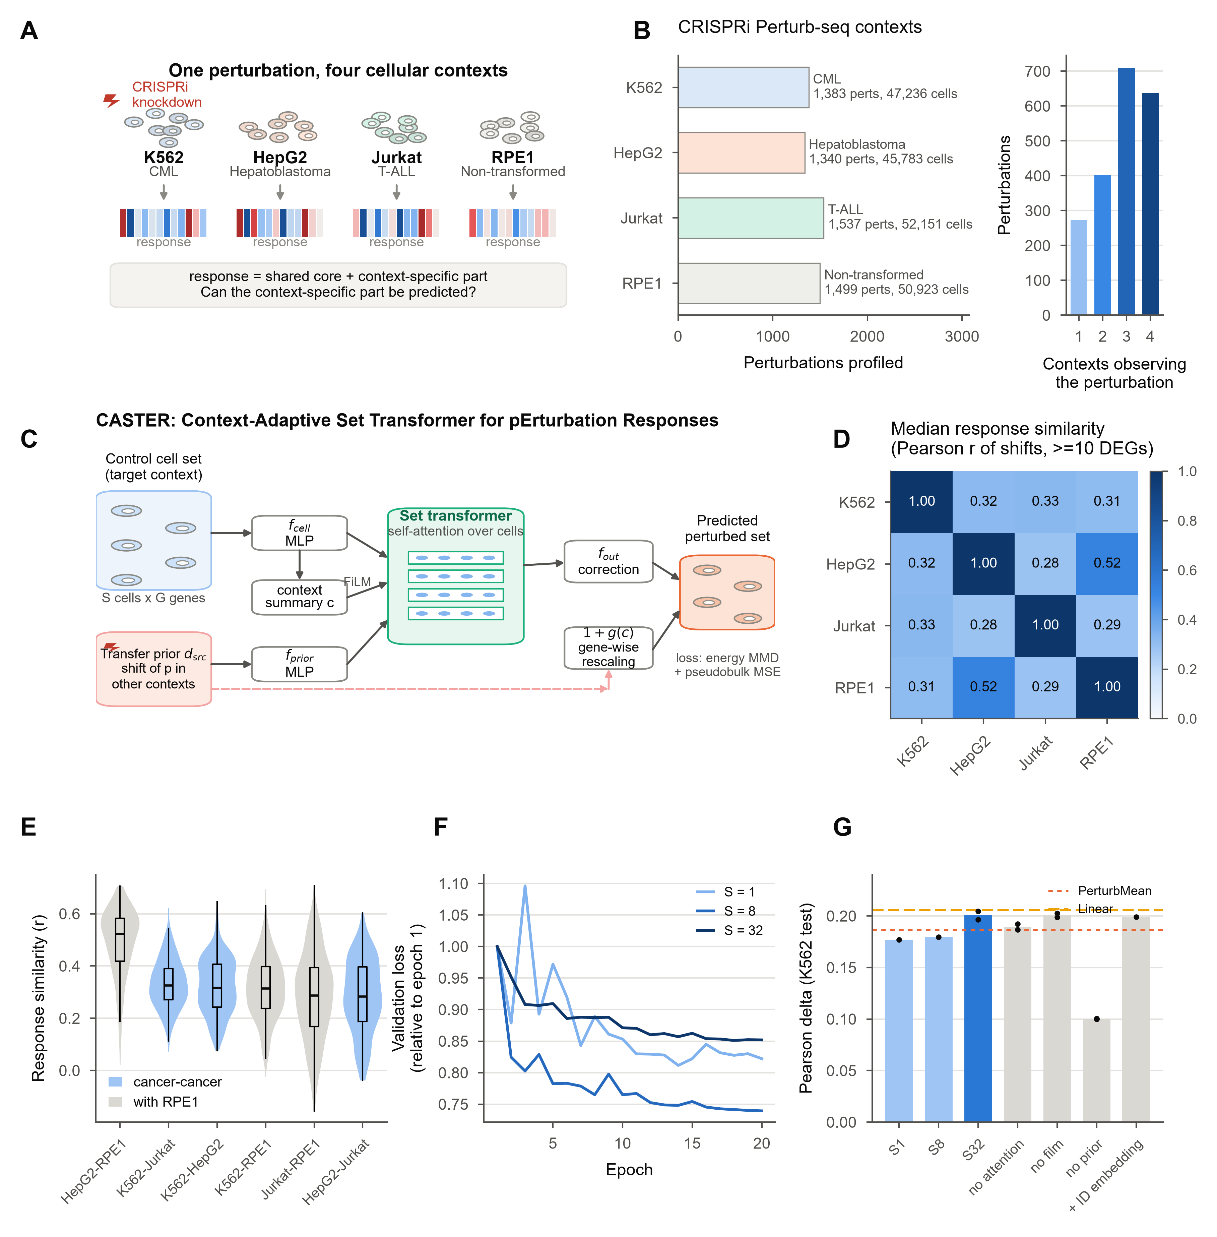
Figure 1. Context reshapes the response to the same genetic perturbation; the CASTER model
(A) The same CRISPRi knockdown, profiled in three cancer contexts and a non-transformed context, produces a shared core response plus a context-specific component.
(B) Perturbations retained after on-target knockdown filtering per context (left), and the number of contexts in which each perturbation is retained (right).
(C) CASTER architecture. A set of unperturbed target-context cells is encoded by an MLP and read by a bidirectional set transformer. The perturbation enters through its transfer prior (mean shift in other contexts), modulated by the context summary (FiLM). The output adds a context-dependent gene-wise rescaling of the prior and a cell-resolved correction; both start at zero.
(D) Median Pearson correlation of observed response shifts between contexts (perturbations with >= 10 DEGs in both).
(E) Per-perturbation response similarity for each pair of contexts; cancer-cancer pairs in blue, pairs involving RPE1 in grey.
(F) Validation loss (relative to epoch 1) for cell-set sizes S = 1, 8 and 32 on the K562 fold (20 epochs).
(G) Held-out Pearson delta for set sizes and architectural ablations on the K562 fold (20 epochs; bars, mean over seeds; dots, seeds), with PerturbMean (dashed) and Linear (long dashes) on the same split.

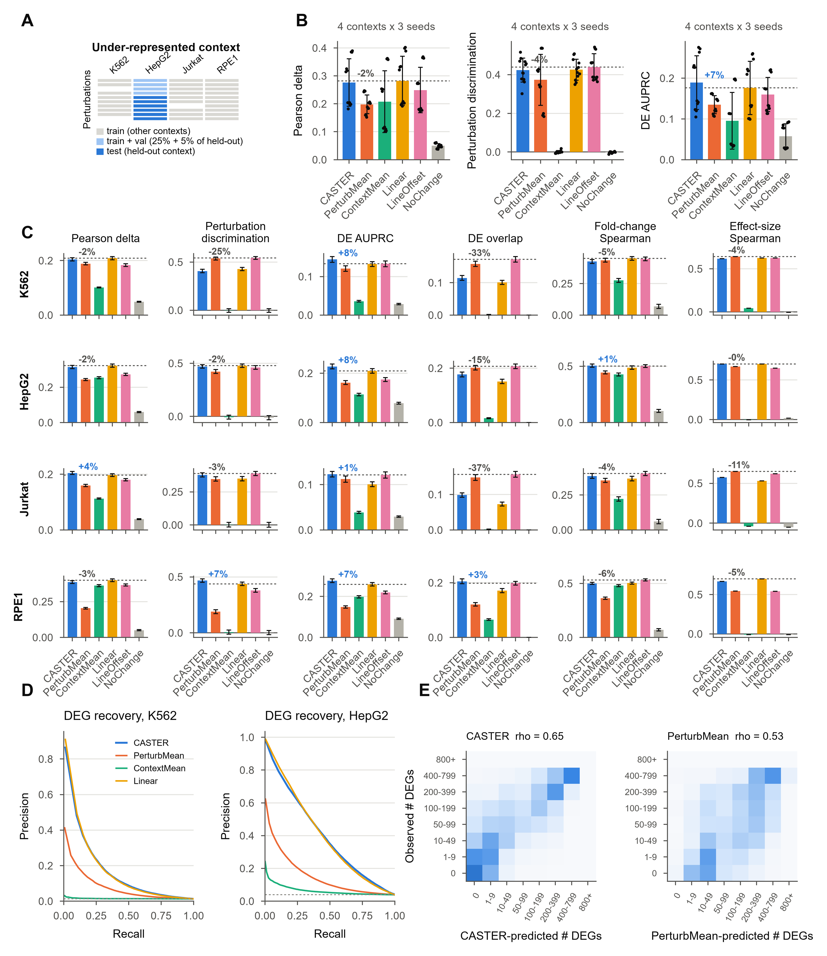
Figure 2. Context transfer in under-represented contexts
(A) Task: for each held-out context, 25% of its perturbations train, 5% validate and 70% test; other contexts are fully observed.
(B) Primary metrics averaged over the four held-out contexts. Bars, mean; error bars, SD over contexts; dots, contexts. Dashed line, best baseline; percentages, relative difference of CASTER from it.
(C) All PertBench metrics per held-out context (error bars, SEM over perturbations; effect-size Spearman is a single value per context).
(D) Precision-recall curves for recovering observed DEGs (pooled over perturbations) in K562 and HepG2, using amended predicted-side p values (AMENDMENT-002); dashed line, base rate.
(E) Observed versus predicted number of DEGs per perturbation (row-normalised), all contexts.

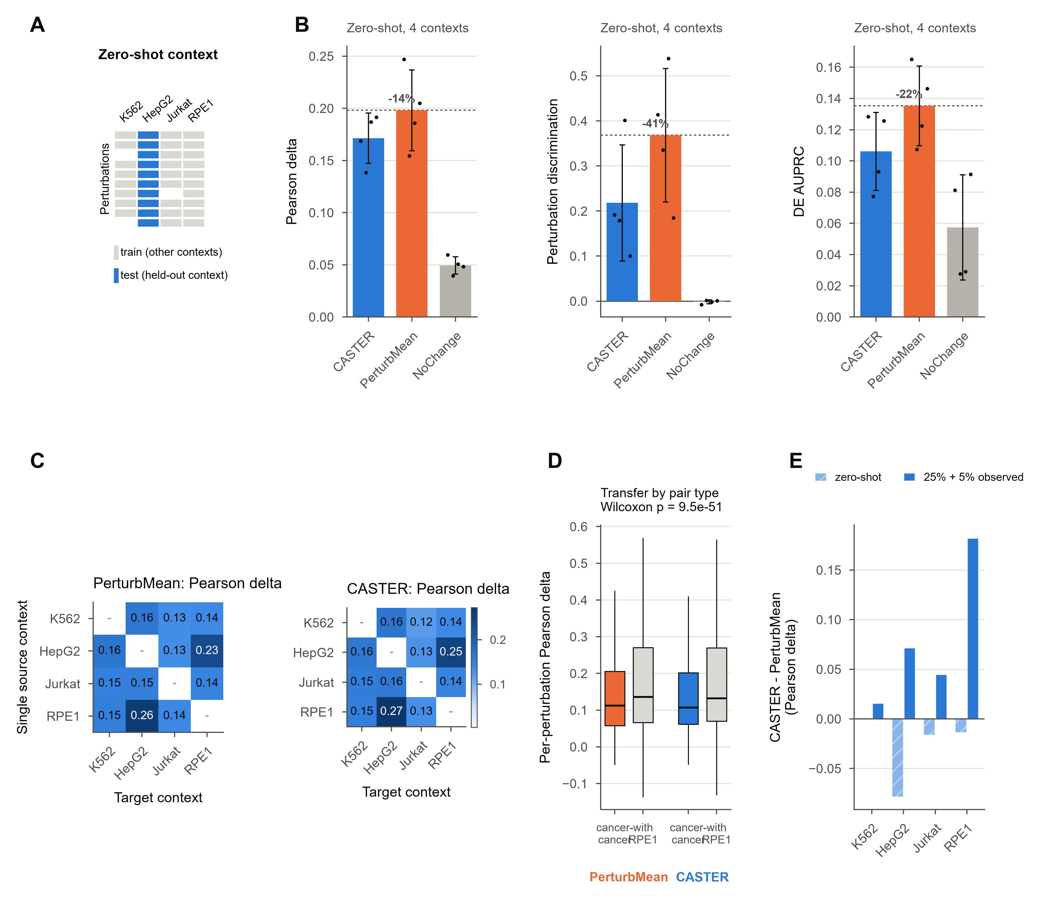
Figure 3. Zero-shot transfer and transfer between cancer and non-transformed contexts
(A) Zero-shot task: no perturbed cells of the held-out context are used.
(B) Primary metrics in the zero-shot task (mean over contexts; dots, contexts).
(C) Single-source transfer: Pearson delta for every source (rows) and target (columns) pair.
(D) Per-perturbation transfer accuracy averaged over cancer-to-cancer directions versus directions involving RPE1. Boxes, interquartile range; whiskers, 1.5x IQR; p value, two-sided paired Wilcoxon (H3).
(E) CASTER minus PerturbMean (Pearson delta) per context, with no (zero-shot) or 30% observed perturbations of the target.

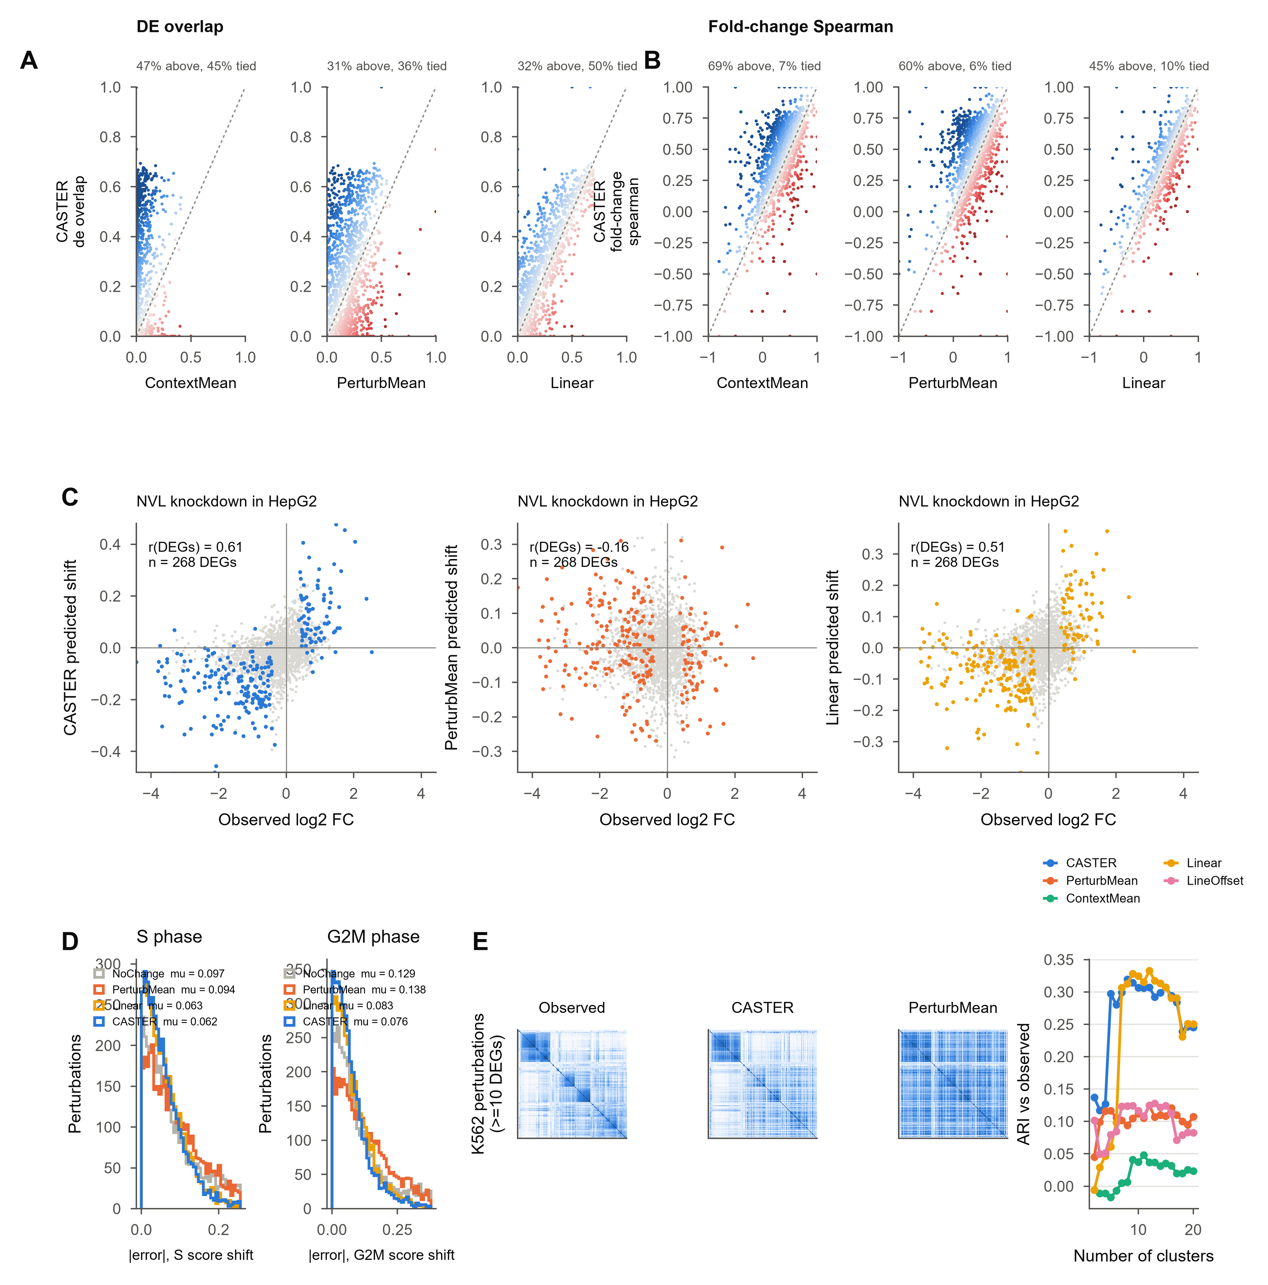
Figure 4. Context-specific differential expression, cell cycle and perturbation structure
(A and B) Per held-out perturbation, CASTER (y) versus each baseline (x) for DE overlap (A) and fold-change Spearman (B); colour, difference (blue, CASTER better).
(C) Observed log2 fold change versus predicted pseudobulk shift for the knockdown with the largest CASTER gain over PerturbMean in a cancer context (coloured, observed DEGs; r over DEGs).
(D) Absolute error of predicted S-phase and G2/M signature shifts.
(E) Perturbation-similarity (cosine) maps for K562 perturbations with >= 10 DEGs, ordered by clustering of the observed map, and adjusted Rand index between predicted and observed clusterings (mean over contexts).

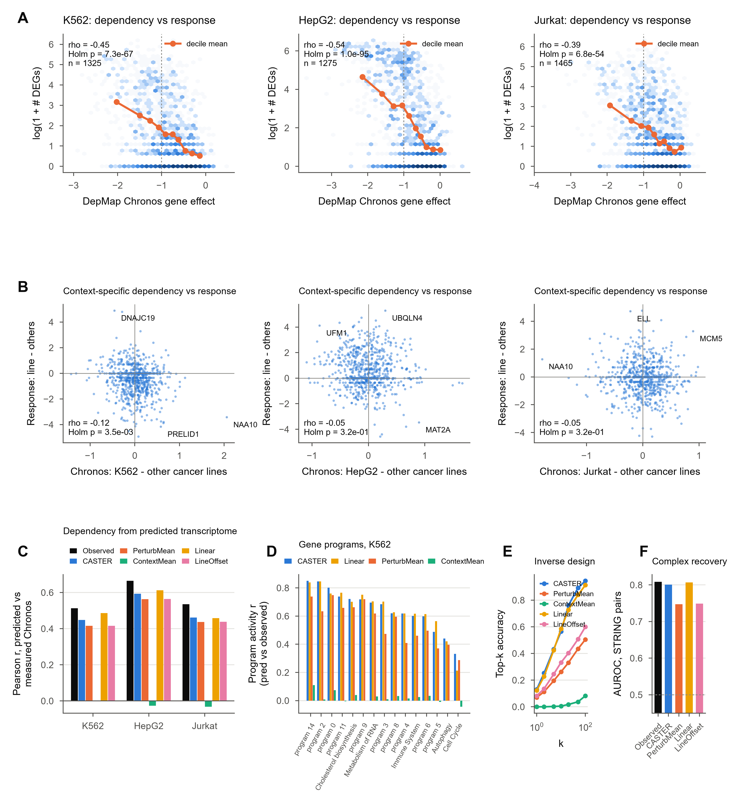
Figure 5. Perturbation responses and cancer dependency
(A) Transcriptional response magnitude (log(1 + # DEGs)) versus DepMap Chronos gene effect of the knocked-down gene in each cancer line (H4). Dashed line, Chronos = -1 (typical essential gene).
(B) Context-specific response versus context-specific dependency (line minus mean of the other two cancer lines; H4b). Labelled, most extreme genes.
(C) Pearson r between measured Chronos and Chronos predicted by a ridge model (trained on observed shifts) from observed or predicted shifts (H5).
(D) Concordance of predicted and observed gene-program activity across perturbations (K562); programs labelled by their top Reactome term when enriched (p < 1e-3).
(E) Inverse design: top-k accuracy of identifying the perturbation that produced an observed response, for the 100 strongest perturbations per context.
(F) AUROC for separating STRING-linked (combined score >= 700) perturbation pairs by response similarity (perturbations with >= 10 DEGs).

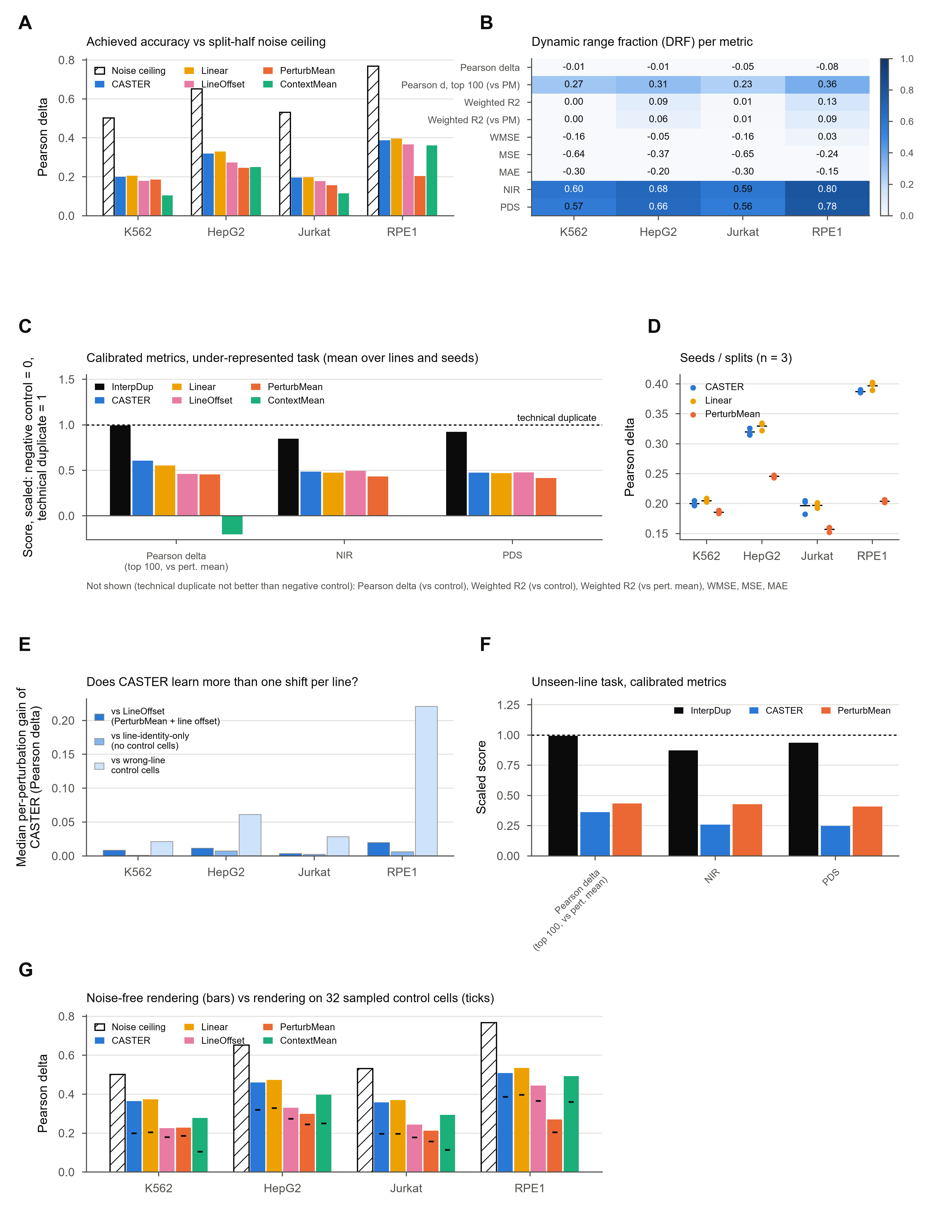
Figure 6. Calibrated evaluation, noise ceilings, seeds and per-line controls
(A) Pearson delta of each method per held-out line (mean over seeds) and the split-half noise ceiling (Spearman-Brown corrected; hatched).
(B) Dynamic range fraction (DRF) of each metric per line: how well the metric separates the technical duplicate from the negative control (mean line response).
(C) Calibrated metrics on a scale from negative control (0) to technical duplicate (1; dashed); InterpDup, interpolated duplicate. Under-represented task, mean over lines and seeds.
(D) Pearson delta per held-out line and seed (dots; bar = mean) for CASTER, Linear and PerturbMean.
(E) Median per-perturbation gain of CASTER over LineOffset, over a line-identity-only CASTER (no control cells) and over CASTER given another line's control cells.
(F) Calibrated metrics in the zero-shot task.
(G) Pearson delta when every method's predicted shift is freed of the sampling noise of the 32 control cells it was rendered on (bars; mean over seeds), compared with the evaluation as rendered (ticks) and the noise ceiling (hatched).

DISCUSSION
Perturbation biology increasingly relies on models that aim to predict an experiment before it is run^{21,22,37}. We asked a focused version of this question with one CRISPRi library profiled in three cancer lines and a non-transformed line. Responses to the same knockdown were only moderately correlated across lines (median r ~ 0.31 between cancer lines). Similarity increased with response strength and was highest for the two TP53 wild-type lines, HepG2 and RPE1, partly through a shared p53 response. With 32 cells per knockdown, noise ceilings were well below 1, so part of the apparent line specificity is measurement noise.
When part of the target line was screened, CASTER outperformed mean baselines across seeds and matched, but did not beat, a linear transfer model fitted to the same data. This agrees with evidence that well-specified linear models are strong competitors for perturbation prediction^{34,35} and with the warning that average-shift effects can dominate standard metrics⁶⁰. Controls for a per-line offset, line identity and the control cells themselves, together with calibrated metrics, describe what the model adds beyond such effects. Rendering pseudobulk predictions on a small sample of control cells lowered every method's accuracy by a similar margin; benchmarks that render predictions this way should remove that noise before comparing absolute accuracies. Its gains concentrated on strong responses, in particular knockdowns of ribosome-biogenesis genes, whose nucleolar-stress output depends on p53 and growth state^{51,53}.
A line-identity-only version of CASTER, which sees the line's average control profile instead of individual cells, performed nearly as well as the full model. The adaptation that CASTER learns therefore relies on what distinguishes one line's average state from another's, not on the cell-to-cell variation that a set-based model can in principle exploit; with 32 cells per perturbation and four lines, the data may simply not support learning more.
In lines with no screening data, CASTER was worse than the perturbation mean. This model, trained on three lines, did not find information in unperturbed transcriptomes that predicts how a new line reshapes a response; a small amount of perturbation data from that line was what made adaptation work. Models trained on many more lines might learn such a mapping, but on current data a sparse pilot screen in each new line of interest appears more useful than control profiles alone.
We had expected transfer to be more faithful among cancer lines than to or from the non-transformed line (H3). The opposite held, driven by HepG2-RPE1. Shared p53 status and lineage predicted transferability better than transformation status, which suggests that reference lines for perturbation atlases should be chosen by lineage and cell state, including p53 status.
Response magnitude tracked DepMap gene effects in all three cancer lines, but the link was not line-specific: other lines' Chronos scores predicted it about as well. It reflects general essentiality. Libraries designed around differential dependencies, such as synthetic-lethal partners of cancer drivers^{61,62}, would be needed to test line-specific dependency.
Methodologically, three practices made these conclusions possible: selecting genes on control cells only and excluding perturbation targets; scoring every method's prediction with the same pseudobulk pipeline, including the amended predicted-side DE test; and fixing hypotheses and decision rules before model fitting. We also found that the Wilcoxon test is invalid for continuous predicted cells, a pitfall worth checking in other benchmarks. We did not run a large pretrained model such as State on the same splits, so we make no claim about how CASTER compares with them.
Limitations of the study
This study has several limitations. First, it covers four lines, three of them cancer lines from different lineages; with so few lines, line generalisation cannot be separated from lineage or p53 status, and conclusions about cancer in general require many more lines. Second, compute and bandwidth limits led us to use at most 32 cells per perturbation, which caps the achievable accuracy (noise ceilings), and to train compact models on CPUs. Third, CASTER represents a perturbation by its observed effect elsewhere, so it cannot predict perturbations never observed in any line. Fourth, the dependency analyses rely on CRISPR knockout fitness, whereas the screens use CRISPRi knockdown, and the four screens differ in effector construct, time point and sequencing depth. Fifth, the calibrated metrics and several controls were added after the pre-specified analysis and are exploratory. Sixth, we did not compare with a large pretrained perturbation model. Finally, this work used public data only and did not test any prediction experimentally.
RESOURCE AVAILABILITY
Lead contact
Requests for further information should be directed to the lead contact [to be added].
Materials availability
This study did not generate new materials or new experimental data.
Data and code availability
- All data analysed are public: Replogle et al. 2022 and Nadig et al. 2025 CRISPRi Perturb-seq (Arc Institute knockdown-filtered concatenation on Hugging Face), DepMap 24Q4, STRING v12 and Reactome; identifiers are listed in the key resources table.
- All code (data ingestion, CASTER, baselines, PertBench, statistics, figures and this manuscript) is in the canpert repository [URL/DOI to be added on deposition]. Every number in the paper is generated from reports/results.json; every figure panel ships the CSV it is drawn from.
- The pre-specified protocol and its freeze point are in RESEARCH_PROTOCOL.md (git tag protocol-v1.0).
ACKNOWLEDGMENTS
We thank the authors of the Replogle et al. and Nadig et al. Perturb-seq studies, the Arc Institute for releasing the processed data, and the DepMap, STRING and Reactome teams. [Funding to be added.]
AUTHOR CONTRIBUTIONS
[To be completed by the authors.]
DECLARATION OF INTERESTS
The authors declare no competing interests. [To be confirmed by the authors.]
DECLARATION OF GENERATIVE AI AND AI-ASSISTED TECHNOLOGIES
The authors used Claude (Anthropic), an AI assistant, as a coding and writing tool. It wrote the analysis code (data access, CASTER, baselines, evaluation and statistics), ran the computational experiments on the authors' workstation, produced the figures, and drafted and formatted the manuscript and its revisions, under the authors' direction. The study design, the pre-specified protocol and its amendments, and the interpretation were reviewed by the authors, who checked the results against the code and take full responsibility for the content.
SUPPLEMENTAL INFORMATION
Tables S1-S11 and Figures S1-S15 with their legends follow the STAR Methods.
REFERENCES
1. Dixit, A., Parnas, O., Li, B., Chen, J., Fulco, C.P., Jerby-Arnon, L., Marjanovic, N.D., Dionne, D., Burks, T., Raychowdhury, R., et al. (2016). Perturb-Seq: dissecting molecular circuits with scalable single-cell RNA profiling of pooled genetic screens. Cell 167, 1853-1866.e17. https://doi.org/10.1016/j.cell.2016.11.038.
2. Adamson, B., Norman, T.M., Jost, M., Cho, M.Y., Nunez, J.K., Chen, Y., Villalta, J.E., Gilbert, L.A., Horlbeck, M.A., Hein, M.Y., et al. (2016). A multiplexed single-cell CRISPR screening platform enables systematic dissection of the unfolded protein response. Cell 167, 1867-1882.e21. https://doi.org/10.1016/j.cell.2016.11.048.
3. Jaitin, D.A., Weiner, A., Yofe, I., Lara-Astiaso, D., Keren-Shaul, H., David, E., Salame, T.M., Tanay, A., van Oudenaarden, A., and Amit, I. (2016). Dissecting immune circuits by linking CRISPR-pooled screens with single-cell RNA-seq. Cell 167, 1883-1896.e15. https://doi.org/10.1016/j.cell.2016.11.039.
4. Datlinger, P., Rendeiro, A.F., Schmidl, C., Krausgruber, T., Traxler, P., Klughammer, J., Schuster, L.C., Kuchler, A., Alpar, D., and Bock, C. (2017). Pooled CRISPR screening with single-cell transcriptome readout. Nat. Methods 14, 297-301. https://doi.org/10.1038/nmeth.4177.
5. Qi, L.S., Larson, M.H., Gilbert, L.A., Doudna, J.A., Weissman, J.S., Arkin, A.P., and Lim, W.A. (2013). Repurposing CRISPR as an RNA-guided platform for sequence-specific control of gene expression. Cell 152, 1173-1183. https://doi.org/10.1016/j.cell.2013.02.022.
6. Gilbert, L.A., Horlbeck, M.A., Adamson, B., Villalta, J.E., Chen, Y., Whitehead, E.H., Guimaraes, C., Panning, B., Ploegh, H.L., Bassik, M.C., et al. (2014). Genome-scale CRISPR-mediated control of gene repression and activation. Cell 159, 647-661. https://doi.org/10.1016/j.cell.2014.09.029.
7. Replogle, J.M., Norman, T.M., Xu, A., Hussmann, J.A., Chen, J., Cogan, J.Z., Meer, E.J., Terry, J.M., Riordan, D.P., Srinivas, N., et al. (2020). Combinatorial single-cell CRISPR screens by direct guide RNA capture and targeted sequencing. Nat. Biotechnol. 38, 954-961. https://doi.org/10.1038/s41587-020-0470-y.
8. Replogle, J.M., Saunders, R.A., Pogson, A.N., Hussmann, J.A., Lenail, A., Guna, A., Mascibroda, L., Wagner, E.J., Adelman, K., Lithwick-Yanai, G., et al. (2022). Mapping information-rich genotype-phenotype landscapes with genome-scale Perturb-seq. Cell 185, 2559-2575.e28. https://doi.org/10.1016/j.cell.2022.05.013.
9. Norman, T.M., Horlbeck, M.A., Replogle, J.M., Ge, A.Y., Xu, A., Jost, M., Gilbert, L.A., and Weissman, J.S. (2019). Exploring genetic interaction manifolds constructed from rich single-cell phenotypes. Science 365, 786-793. https://doi.org/10.1126/science.aax4438.
10. Jiang, L., Dalgarno, C., Papalexi, E., Mascio, I., Wessels, H.-H., Yun, H., Iremadze, N., Lithwick-Yanai, G., Lipson, D., and Satija, R. (2025). Systematic reconstruction of molecular pathway signatures using scalable single-cell perturbation screens. Nat. Cell Biol. 27, 505-517. https://doi.org/10.1038/s41556-025-01622-z.
11. Przybyla, L., and Gilbert, L.A. (2022). A new era in functional genomics screens. Nat. Rev. Genet. 23, 89-103. https://doi.org/10.1038/s41576-021-00409-w.
12. Frangieh, C.J., Melms, J.C., Thakore, P.I., Geiger-Schuller, K.R., Ho, P., Luoma, A.M., Cleary, B., Jerby-Arnon, L., Malu, S., Cuoco, M.S., et al. (2021). Multimodal pooled Perturb-CITE-seq screens in patient models define mechanisms of cancer immune evasion. Nat. Genet. 53, 332-341. https://doi.org/10.1038/s41588-021-00779-1.
13. Papalexi, E., Mimitou, E.P., Butler, A.W., Foster, S., Bracken, B., Mauck, W.M., Wessels, H.-H., Hao, Y., Yeung, B.Z., Smibert, P., and Satija, R. (2021). Characterizing the molecular regulation of inhibitory immune checkpoints with multimodal single-cell screens. Nat. Genet. 53, 322-331. https://doi.org/10.1038/s41588-021-00778-2.
14. Ursu, O., Neal, J.T., Shea, E., Thakore, P.I., Jerby-Arnon, L., Nguyen, L., Dionne, D., Diaz, C., Bauman, J., Mosaad, M.M., et al. (2022). Massively parallel phenotyping of coding variants in cancer with Perturb-seq. Nat. Biotechnol. 40, 896-905. https://doi.org/10.1038/s41587-021-01160-7.
15. McFarland, J.M., Paolella, B.R., Warren, A., Geiger-Schuller, K., Shibue, T., Rothberg, M., Kuksenko, O., Colgan, W.N., Jones, A., Chambers, E., et al. (2020). Multiplexed single-cell transcriptional response profiling to define cancer vulnerabilities and drug mechanisms of action. Nat. Commun. 11, 4296. https://doi.org/10.1038/s41467-020-17440-w.
16. McFaline-Figueroa, J.L., Srivatsan, S., Hill, A.J., Gasperini, M., Jackson, D.L., Saunders, L., Domcke, S., Regalado, S.G., Lazarchuck, P., Alvarez, S., et al. (2024). Multiplex single-cell chemical genomics reveals the kinase dependence of the response to targeted therapy. Cell Genom. 4, 100487. https://doi.org/10.1016/j.xgen.2023.100487.
17. Hanahan, D., and Weinberg, R.A. (2011). Hallmarks of cancer: the next generation. Cell 144, 646-674. https://doi.org/10.1016/j.cell.2011.02.013.
18. Hanahan, D. (2022). Hallmarks of cancer: new dimensions. Cancer Discov. 12, 31-46. https://doi.org/10.1158/2159-8290.CD-21-1059.
19. Kinker, G.S., Greenwald, A.C., Tal, R., Orlova, Z., Cuoco, M.S., McFarland, J.M., Warren, A., Rodman, C., Roth, J.A., Bender, S.A., et al. (2020). Pan-cancer single-cell RNA-seq identifies recurring programs of cellular heterogeneity. Nat. Genet. 52, 1208-1218. https://doi.org/10.1038/s41588-020-00726-6.
20. Gavish, A., Tyler, M., Greenwald, A.C., Hoefflin, R., Simkin, D., Tschernichovsky, R., Galili Darnell, N., Somech, E., Barbolin, C., Antman, T., et al. (2023). Hallmarks of transcriptional intratumour heterogeneity across a thousand tumours. Nature 618, 598-606. https://doi.org/10.1038/s41586-023-06130-4.
21. Bunne, C., Roohani, Y., Rosen, Y., Gupta, A., Zhang, X., Roed, M., Alexandrov, T., AlQuraishi, M., Brennan, P., Burkhardt, D.B., et al. (2024). How to build the virtual cell with artificial intelligence: priorities and opportunities. Cell 187, 7045-7063. https://doi.org/10.1016/j.cell.2024.11.015.
22. Rood, J.E., Hupalowska, A., and Regev, A. (2024). Toward a foundation model of causal cell and tissue biology with a Perturbation Cell and Tissue Atlas. Cell 187, 4520-4545. https://doi.org/10.1016/j.cell.2024.07.035.
23. Lotfollahi, M., Wolf, F.A., and Theis, F.J. (2019). scGen predicts single-cell perturbation responses. Nat. Methods 16, 715-721. https://doi.org/10.1038/s41592-019-0494-8.
24. Lotfollahi, M., Klimovskaia Susmelj, A., De Donno, C., Hetzel, L., Ji, Y., Ibarra, I.L., Srivatsan, S.R., Naghipourfar, M., Daza, R.M., Martin, B., et al. (2023). Predicting cellular responses to complex perturbations in high-throughput screens. Mol. Syst. Biol. 19, e11517. https://doi.org/10.15252/msb.202211517.
25. Lopez, R., Regier, J., Cole, M.B., Jordan, M.I., and Yosef, N. (2018). Deep generative modeling for single-cell transcriptomics. Nat. Methods 15, 1053-1058. https://doi.org/10.1038/s41592-018-0229-2.
26. Bereket, M., and Karaletsos, T. (2023). Modelling cellular perturbations with the sparse additive mechanism shift variational autoencoder. In Advances in Neural Information Processing Systems 36.
27. Piran, Z., Cohen, N., Hoshen, Y., and Nitzan, M. (2024). Disentanglement of single-cell data with biolord. Nat. Biotechnol. 42, 1678-1683. https://doi.org/10.1038/s41587-023-02079-x.
28. Bunne, C., Stark, S.G., Gut, G., del Castillo, J.S., Levesque, M., Lehmann, K.-V., Pelkmans, L., Krause, A., and Ratsch, G. (2023). Learning single-cell perturbation responses using neural optimal transport. Nat. Methods 20, 1759-1768. https://doi.org/10.1038/s41592-023-01969-x.
29. Roohani, Y., Huang, K., and Leskovec, J. (2024). Predicting transcriptional outcomes of novel multigene perturbations with GEARS. Nat. Biotechnol. 42, 927-935. https://doi.org/10.1038/s41587-023-01905-6.
30. Theodoris, C.V., Xiao, L., Chopra, A., Chaffin, M.D., Al Sayed, Z.R., Hill, M.C., Mantineo, H., Brydon, E.M., Zeng, Z., Liu, X.S., et al. (2023). Transfer learning enables predictions in network biology. Nature 618, 616-624. https://doi.org/10.1038/s41586-023-06139-9.
31. Cui, H., Wang, C., Maan, H., Pang, K., Luo, F., Duan, N., and Wang, B. (2024). scGPT: toward building a foundation model for single-cell multi-omics using generative AI. Nat. Methods 21, 1470-1480. https://doi.org/10.1038/s41592-024-02201-0.
32. Hao, M., Gong, J., Zeng, X., Liu, C., Guo, Y., Cheng, X., Wang, T., Ma, J., Zhang, X., and Song, L. (2024). Large-scale foundation model on single-cell transcriptomics. Nat. Methods 21, 1481-1491. https://doi.org/10.1038/s41592-024-02305-7.
33. Adduri, A.K., Gautam, D., Bevilacqua, B., Naghipourfar, M., Imran, A., Shah, R., Teyssier, N., Verma, R., Carpenter, C., Eraslan, B., et al. (2026). Predicting cellular responses to perturbation across diverse contexts with State. Cell 189, 5914-5931. https://doi.org/10.1016/j.cell.2026.07.052.
34. Ahlmann-Eltze, C., Huber, W., and Anders, S. (2025). Deep-learning-based gene perturbation effect prediction does not yet outperform simple linear baselines. Nat. Methods 22, 1657-1661. https://doi.org/10.1038/s41592-025-02772-6.
35. Kernfeld, E., Yang, Y., Weinstock, J.S., Battle, A., and Cahan, P. (2025). A comparison of computational methods for expression forecasting. Genome Biol. 26, 388.
36. Wu, Y., Wershof, E., Schmon, S., Nassar, M., Osinski, B., Eksi, R., Yan, Z., Stark, R., Zhang, K., and Graepel, T. (2025). PerturBench: benchmarking machine learning models for cellular perturbation analysis. In Advances in Neural Information Processing Systems 38 (Datasets and Benchmarks Track).
37. Roohani, Y.H., Hua, T.J., Tung, P.-Y., Bounds, L.R., Yu, F.B., Dobin, A., Teyssier, N., Adduri, A., Woodrow, A., Plosky, B.S., and Mehta, R. (2025). Virtual Cell Challenge: toward a Turing test for the virtual cell. Cell 188, 3370-3374.
38. Nadig, A., Replogle, J.M., Pogson, A.N., Murthy, M., McCarroll, S.A., Weissman, J.S., Robinson, E.B., and O'Connor, L.J. (2025). Transcriptome-wide analysis of differential expression in perturbation atlases. Nat. Genet. 57, 1228-1237. https://doi.org/10.1038/s41588-025-02169-3.
39. Tsherniak, A., Vazquez, F., Montgomery, P.G., Weir, B.A., Kryukov, G., Cowley, G.S., Gill, S., Harrington, W.F., Pantel, S., Krill-Burger, J.M., et al. (2017). Defining a cancer dependency map. Cell 170, 564-576.e16. https://doi.org/10.1016/j.cell.2017.06.010.
40. Dempster, J.M., Boyle, I., Vazquez, F., Root, D.E., Boehm, J.S., Hahn, W.C., Tsherniak, A., and McFarland, J.M. (2021). Chronos: a cell population dynamics model of CRISPR experiments that improves inference of gene fitness effects. Genome Biol. 22, 343. https://doi.org/10.1186/s13059-021-02540-7.
41. Behan, F.M., Iorio, F., Picco, G., Goncalves, E., Beaver, C.M., Migliardi, G., Santos, R., Rao, Y., Sassi, F., Pinnelli, M., et al. (2019). Prioritization of cancer therapeutic targets using CRISPR-Cas9 screens. Nature 568, 511-516. https://doi.org/10.1038/s41586-019-1103-9.
42. Pacini, C., Duncan, E., Goncalves, E., Gilbert, J., Bhosle, S., Horswell, S., Karakoc, E., Lightfoot, H., Curry, E., Muyas, F., et al. (2024). A comprehensive clinically informed map of dependencies in cancer cells and framework for target prioritization. Cancer Cell 42, 301-316.e9. https://doi.org/10.1016/j.ccell.2023.12.016.
43. Bodnar, A.G., Ouellette, M., Frolkis, M., Holt, S.E., Chiu, C.P., Morin, G.B., Harley, C.B., Shay, J.W., Lichtsteiner, S., and Wright, W.E. (1998). Extension of life-span by introduction of telomerase into normal human cells. Science 279, 349-352. https://doi.org/10.1126/science.279.5349.349.
44. Fischer, M. (2017). Census and evaluation of p53 target genes. Oncogene 36, 3943-3956. https://doi.org/10.1038/onc.2016.502.
45. Gretton, A., Borgwardt, K.M., Rasch, M.J., Scholkopf, B., and Smola, A. (2012). A kernel two-sample test. J. Mach. Learn. Res. 13, 723-773.
46. Szekely, G.J., and Rizzo, M.L. (2013). Energy statistics: a class of statistics based on distances. J. Stat. Plan. Inference 143, 1249-1272. https://doi.org/10.1016/j.jspi.2013.03.018.
47. Perez, E., Strub, F., de Vries, H., Dumoulin, V., and Courville, A. (2018). FiLM: visual reasoning with a general conditioning layer. In Proceedings of the AAAI Conference on Artificial Intelligence 32, pp. 3942-3951.
48. Miller, H.E., Mejia, G.M., et al. (2026). Deep learning perturbation models can outperform baselines on calibrated metrics. Nat. Biotechnol. Code: github.com/shiftbioscience/Perturbation-Models-Outperform-Baselines.
49. Mejia, G.M., et al. (2025). Diversity by design: addressing mode collapse improves scRNA-seq perturbation modeling on well-calibrated metrics. Preprint at arXiv, arXiv:2506.22641.
50. Tirosh, I., Izar, B., Prakadan, S.M., Wadsworth, M.H., Treacy, D., Trombetta, J.J., Rotem, A., Rodman, C., Lian, C., Murphy, G., et al. (2016). Dissecting the multicellular ecosystem of metastatic melanoma by single-cell RNA-seq. Science 352, 189-196. https://doi.org/10.1126/science.aad0501.
51. Golomb, L., Volarevic, S., and Oren, M. (2014). p53 and ribosome biogenesis stress: the essentials. FEBS Lett. 588, 2571-2579. https://doi.org/10.1016/j.febslet.2014.04.014.
52. Pelava, A., Schneider, C., and Watkins, N.J. (2016). The importance of ribosome production, and the 5S RNP-MDM2 pathway, in health and disease. Biochem. Soc. Trans. 44, 1086-1090. https://doi.org/10.1042/BST20160106.
53. Lindstrom, M.S., Bartek, J., and Maya-Mendoza, A. (2022). p53 at the crossroad of DNA replication and ribosome biogenesis stress pathways. Cell Death Differ. 29, 972-982. https://doi.org/10.1038/s41418-022-00999-w.
54. Milacic, M., Beavers, D., Conley, P., Gong, C., Gillespie, M., Griss, J., Haw, R., Jassal, B., Matthews, L., May, B., et al. (2024). The Reactome Pathway Knowledgebase 2024. Nucleic Acids Res. 52, D672-D678. https://doi.org/10.1093/nar/gkad1025.
55. Szklarczyk, D., Kirsch, R., Koutrouli, M., Nastou, K., Mehryary, F., Hachilif, R., Gable, A.L., Fang, T., Doncheva, N.T., Pyysalo, S., et al. (2023). The STRING database in 2023: protein-protein association networks and functional enrichment analyses for any sequenced genome of interest. Nucleic Acids Res. 51, D638-D646. https://doi.org/10.1093/nar/gkac1000.
56. Meyers, R.M., Bryan, J.G., McFarland, J.M., Weir, B.A., Sizemore, A.E., Xu, H., Dharia, N.V., Montgomery, P.G., Cowley, G.S., Pantel, S., et al. (2017). Computational correction of copy number effect improves specificity of CRISPR-Cas9 essentiality screens in cancer cells. Nat. Genet. 49, 1779-1784. https://doi.org/10.1038/ng.3984.
57. Hart, T., Chandrashekhar, M., Aregger, M., Steinhart, Z., Brown, K.R., MacLeod, G., Mis, M., Zimmermann, M., Fradet-Turcotte, A., Sun, S., et al. (2015). High-resolution CRISPR screens reveal fitness genes and genotype-specific cancer liabilities. Cell 163, 1515-1526. https://doi.org/10.1016/j.cell.2015.11.015.
58. Wang, T., Birsoy, K., Hughes, N.W., Krupczak, K.M., Post, Y., Wei, J.J., Lander, E.S., and Sabatini, D.M. (2015). Identification and characterization of essential genes in the human genome. Science 350, 1096-1101. https://doi.org/10.1126/science.aac7041.
59. Blomen, V.A., Majek, P., Jae, L.T., Bigenzahn, J.W., Nieuwenhuis, J., Staring, J., Sacco, R., van Diemen, F.R., Olk, N., Stukalov, A., et al. (2015). Gene essentiality and synthetic lethality in haploid human cells. Science 350, 1092-1096. https://doi.org/10.1126/science.aac7557.
60. Vinas Torne, R., et al. (2025). Systema: evaluating perturbation response prediction beyond systematic variation. Nat. Biotechnol. 44, 1050-1059.
61. Lord, C.J., and Ashworth, A. (2017). PARP inhibitors: synthetic lethality in the clinic. Science 355, 1152-1158. https://doi.org/10.1126/science.aam7344.
62. O'Neil, N.J., Bailey, M.L., and Hieter, P. (2017). Synthetic lethality and cancer. Nat. Rev. Genet. 18, 613-623. https://doi.org/10.1038/nrg.2017.47.
63. Lozzio, C.B., and Lozzio, B.B. (1975). Human chronic myelogenous leukemia cell-line with positive Philadelphia chromosome. Blood 45, 321-334.
64. Aden, D.P., Fogel, A., Plotkin, S., Damjanov, I., and Knowles, B.B. (1979). Controlled synthesis of HBsAg in a differentiated human liver carcinoma-derived cell line. Nature 282, 615-616. https://doi.org/10.1038/282615a0.
65. Lopez-Terrada, D., Cheung, S.W., Finegold, M.J., and Knowles, B.B. (2009). Hep G2 is a hepatoblastoma-derived cell line. Hum. Pathol. 40, 1512-1515. https://doi.org/10.1016/j.humpath.2009.07.003.
66. Schneider, U., Schwenk, H.U., and Bornkamm, G. (1977). Characterization of EBV-genome negative 'null' and 'T' cell lines derived from children with acute lymphoblastic leukemia and leukemic transformed non-Hodgkin lymphoma. Int. J. Cancer 19, 621-626. https://doi.org/10.1002/ijc.2910190505.
67. Abraham, R.T., and Weiss, A. (2004). Jurkat T cells and development of the T-cell receptor signalling paradigm. Nat. Rev. Immunol. 4, 301-308. https://doi.org/10.1038/nri1330.
68. Satija, R., Farrell, J.A., Gennert, D., Schier, A.F., and Regev, A. (2015). Spatial reconstruction of single-cell gene expression data. Nat. Biotechnol. 33, 495-502. https://doi.org/10.1038/nbt.3192.
69. Hendrycks, D., and Gimpel, K. (2016). Gaussian error linear units (GELUs). Preprint at arXiv, arXiv:1606.08415.
70. Vaswani, A., Shazeer, N., Parmar, N., Uszkoreit, J., Jones, L., Gomez, A.N., Kaiser, L., and Polosukhin, I. (2017). Attention is all you need. In Advances in Neural Information Processing Systems 30, pp. 5998-6008.
71. Lee, J., Lee, Y., Kim, J., Kosiorek, A., Choi, S., and Teh, Y.W. (2019). Set transformer: a framework for attention-based permutation-invariant neural networks. In Proceedings of the 36th International Conference on Machine Learning (PMLR 97), pp. 3744-3753.
72. Zaheer, M., Kottur, S., Ravanbakhsh, S., Poczos, B., Salakhutdinov, R.R., and Smola, A.J. (2017). Deep sets. In Advances in Neural Information Processing Systems 30, pp. 3391-3401.
73. Ba, J.L., Kiros, J.R., and Hinton, G.E. (2016). Layer normalization. Preprint at arXiv, arXiv:1607.06450.
74. Feydy, J., Sejourne, T., Vialard, F.-X., Amari, S., Trouve, A., and Peyre, G. (2019). Interpolating between optimal transport and MMD using Sinkhorn divergences. In Proceedings of the 22nd International Conference on Artificial Intelligence and Statistics (AISTATS), pp. 2681-2690.
75. Loshchilov, I., and Hutter, F. (2019). Decoupled weight decay regularization. In International Conference on Learning Representations (ICLR).
76. Paszke, A., Gross, S., Massa, F., Lerer, A., Bradbury, J., Chanan, G., Killeen, T., Lin, Z., Gimelshein, N., Antiga, L., et al. (2019). PyTorch: an imperative style, high-performance deep learning library. In Advances in Neural Information Processing Systems 32, pp. 8024-8035.
77. Hoerl, A.E., and Kennard, R.W. (1970). Ridge regression: biased estimation for nonorthogonal problems. Technometrics 12, 55-67. https://doi.org/10.1080/00401706.1970.10488634.
78. Lloyd, S. (1982). Least squares quantization in PCM. IEEE Trans. Inf. Theory 28, 129-137. https://doi.org/10.1109/TIT.1982.1056489.
79. Hubert, L., and Arabie, P. (1985). Comparing partitions. J. Classif. 2, 193-218. https://doi.org/10.1007/BF01908075.
80. Harris, C.R., Millman, K.J., van der Walt, S.J., Gommers, R., Virtanen, P., Cournapeau, D., Wieser, E., Taylor, J., Berg, S., Smith, N.J., et al. (2020). Array programming with NumPy. Nature 585, 357-362. https://doi.org/10.1038/s41586-020-2649-2.
81. Virtanen, P., Gommers, R., Oliphant, T.E., Haberland, M., Reddy, T., Cournapeau, D., Burovski, E., Peterson, P., Weckesser, W., Bright, J., et al. (2020). SciPy 1.0: fundamental algorithms for scientific computing in Python. Nat. Methods 17, 261-272. https://doi.org/10.1038/s41592-019-0686-2.
82. Pedregosa, F., Varoquaux, G., Gramfort, A., Michel, V., Thirion, B., Grisel, O., Blondel, M., Prettenhofer, P., Weiss, R., Dubourg, V., et al. (2011). Scikit-learn: machine learning in Python. J. Mach. Learn. Res. 12, 2825-2830.
83. Hunter, J.D. (2007). Matplotlib: a 2D graphics environment. Comput. Sci. Eng. 9, 90-95. https://doi.org/10.1109/MCSE.2007.55.
84. Wilcoxon, F. (1945). Individual comparisons by ranking methods. Biometrics Bull. 1, 80-83. https://doi.org/10.2307/3001968.
85. Mann, H.B., and Whitney, D.R. (1947). On a test of whether one of two random variables is stochastically larger than the other. Ann. Math. Stat. 18, 50-60. https://doi.org/10.1214/aoms/1177730491.
86. Benjamini, Y., and Hochberg, Y. (1995). Controlling the false discovery rate: a practical and powerful approach to multiple testing. J. R. Stat. Soc. B 57, 289-300.
87. Squair, J.W., Gautier, M., Kathe, C., Anderson, M.A., James, N.D., Hutson, T.H., Hudelle, R., Qaiser, T., Matson, K.J.E., Barraud, Q., et al. (2021). Confronting false discoveries in single-cell differential expression. Nat. Commun. 12, 5692. https://doi.org/10.1038/s41467-021-25960-2.
88. Soneson, C., and Robinson, M.D. (2018). Bias, robustness and scalability in single-cell differential expression analysis. Nat. Methods 15, 255-261. https://doi.org/10.1038/nmeth.4612.
89. Davis, J., and Goadrich, M. (2006). The relationship between precision-recall and ROC curves. In Proceedings of the 23rd International Conference on Machine Learning, pp. 233-240. https://doi.org/10.1145/1143844.1143874.
90. Saito, T., and Rehmsmeier, M. (2015). The precision-recall plot is more informative than the ROC plot when evaluating binary classifiers on imbalanced datasets. PLoS One 10, e0118432. https://doi.org/10.1371/journal.pone.0118432.
91. Holm, S. (1979). A simple sequentially rejective multiple test procedure. Scand. J. Stat. 6, 65-70.

STAR★METHODS
Key resources table
REAGENT or RESOURCE | SOURCE | IDENTIFIER
Deposited data
K562 and RPE1 CRISPRi Perturb-seq | Replogle et al. 2022 | Figshare plus article 20029387
HepG2 and Jurkat CRISPRi Perturb-seq | Nadig et al. 2025 | GEO: GSE264667
Knockdown-filtered four-line concatenation (log-normalised) | Arc Institute (State) | huggingface.co/datasets/arcinstitute/State-Replogle-Filtered
DepMap CRISPR gene effect (Chronos), release 24Q4 | DepMap / Broad Institute | depmap.org/portal
STRING v12.0 human protein links | Szklarczyk et al. 2023 | string-db.org
Reactome pathways (GMT) | Milacic et al. 2024 | reactome.org
Experimental models: cell lines (data only)
K562 (CML) | Lozzio and Lozzio 1975 | RRID:CVCL_0004
HepG2 (hepatoblastoma) | Aden et al. 1979 | RRID:CVCL_0027
Jurkat (T-ALL) | Schneider et al. 1977 | RRID:CVCL_0065
hTERT RPE-1 (non-transformed) | Bodnar et al. 1998 | RRID:CVCL_4388
Software and algorithms
CASTER, PertBench and all analyses | This paper | canpert repository (code availability)
PyTorch 2.13 (CPU) | Paszke et al. 2019 | pytorch.org
scikit-learn | Pedregosa et al. 2011 | scikit-learn.org
SciPy / NumPy | Virtanen et al. 2020; Harris et al. 2020 | scipy.org; numpy.org
h5py / anndata format | Virshup et al. 2024 | anndata.readthedocs.io
Matplotlib | Hunter 2007 | matplotlib.org

EXPERIMENTAL MODEL AND STUDY PARTICIPANT DETAILS
This study generated no new experimental data. All analyses use published CRISPR interference (CRISPRi) Perturb-seq profiles of four human cell lines: K562 (chronic myeloid leukaemia, BCR-ABL1-positive)⁶³, HepG2 (hepatoblastoma-derived, historically described as hepatocellular carcinoma)^{64,65}, Jurkat (T cell acute lymphoblastic leukaemia)^{66,67} and hTERT RPE-1 (telomerase-immortalised, non-transformed retinal pigment epithelium)⁴³. K562 and RPE1 were profiled by Replogle et al.⁸ and HepG2 and Jurkat by Nadig et al.³⁸ with the same essential-gene CRISPRi sgRNA library. The four screens differ in CRISPRi effector construct, time point after transduction and sequencing depth, which adds technical differences between lines to the biological ones.
METHOD DETAILS
Data acquisition
We used the four-line concatenation released with the State model³³ (replogle_concat.h5ad). It contains library-size-normalised, log1p-transformed expression of 6,546 genes measured in all four lines. Perturbations and cells were already filtered for on-target knockdown, as described by Adduri et al.³³: perturbation median residual target expression <= 0.30, cell residual <= 0.50, and >= 30 cells. The file is 30 GB. Because compute and bandwidth were limited, we never downloaded it whole. We read the cell metadata, chose a stratified random subsample (seed 0) before any expression value was read, and fetched only those rows with HTTP byte-range requests against the contiguous dense matrix. The subsample is up to 32 cells per perturbation and line, plus 3,000 non-targeting control cells per line. Every fetched row was checked to be finite, non-negative and in the log1p range, and the set of fetched rows was checked to equal the selected set exactly. Rows fetched twice by overlapping download passes were byte-identical and were kept once.
Gene space
We modelled 2,000 genes. They were chosen as the top genes by bin-normalised dispersion (20 mean bins, Seurat v1 procedure⁶⁸) computed on the pooled control cells only, after excluding every gene that is a perturbation target in any line (1850 genes). Because no perturbed cell enters gene selection, held-out perturbation effects cannot leak through the choice of genes. Because knocked-down targets are excluded, the trivial on-target signal cannot inflate any metric.
Problem formulation
Let 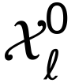 be the distribution of unperturbed cells in context (cell line) , and 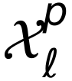 the distribution after perturbation 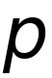. We write the pseudobulk shift of in as
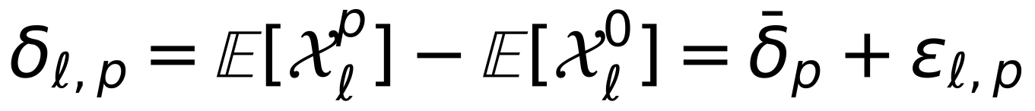 | (1)
Here 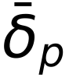 is the shared component (the mean over contexts) and 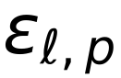 the context-specific component. Context generalisation asks for 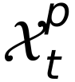 in a target context , given control cells of , observations of in other contexts and, optionally, a small set of other perturbations observed in . PerturbMean estimates only . Any method that beats it must recover part of 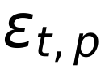.
CASTER architecture
CASTER (Context-Adaptive Set Transformer for pErturbation Responses) maps a set of  control cells 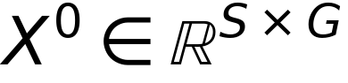 from the target context, together with a perturbation, to a set of predicted perturbed cells. It has five parts.
Transfer prior. The perturbation is represented by its observed shift in the other contexts. For an item in context with source contexts :
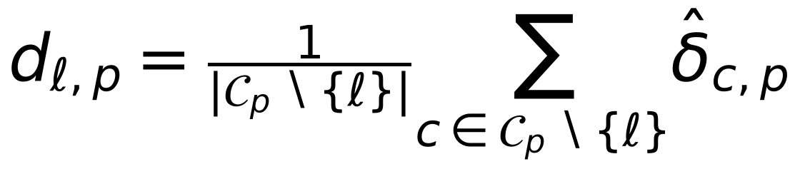 | (2)
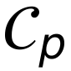 is the set of source contexts that observed , and 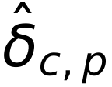 is the empirical shift relative to the control mean of . The target context never contributes to any prior. When no other source context observed (always the case in single-source transfer), the prior is computed from a random half of 's cells, and the model is trained against the disjoint other half.
Encoders. A 4-layer GELU⁶⁹ MLP  embeds each control cell into 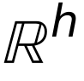 (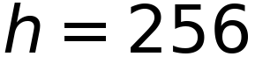). A 2-layer MLP 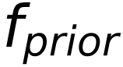 embeds the prior. A context summary is the mean of the cell embeddings, passed through a 2-layer MLP that outputs FiLM⁴⁷ parameters 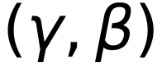:
(3)
Set transformer. 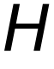 passes through a 4-layer, 8-head, pre-norm, bidirectional transformer encoder^{70,71} without positional encodings. The model is therefore permutation-equivariant over cells⁷², which our tests verify.
Output. The prediction adds a context-dependent, gene-wise rescaling of the transferred shift and a cell-resolved correction:
(4)
Here  is linear in , and 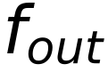 is a LayerNorm⁷³ followed by a linear map. Both and the output layer of are initialised at zero. Training therefore starts exactly at the PerturbMean solution and leaves it only where the validation objective improves. The ablations remove the transformer (per-cell MLP), FiLM, or the prior (a learned one-hot perturbation embedding instead), or add a one-hot ID embedding to the prior.
Training objective
For a predicted set  and an observed set  of the same perturbation and context, the loss is the squared maximum mean discrepancy⁴⁵ with the energy-distance kernel^{46,74}, plus a pseudobulk term:
(5)
We used 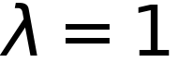 and 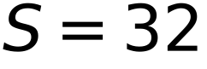. Training used AdamW⁷⁵ (learning rate 3e-4, weight decay 1e-4, batch 32 sets), gradient clipping at 1.0, a 5% linear warm-up and cosine decay. The number of epochs was 20 for the context tasks and 10 for ablations and single-source transfer. The checkpoint with the lowest validation loss was kept. In the under-represented task, validation uses the 5% validation perturbations of the target. In the zero-shot and transfer tasks, it uses 5% of source-context items, so no target perturbed cell is ever used. All runs used CPU only (PyTorch⁷⁶).
Baselines
Every method returns a set of predicted cells, so that single-cell DE metrics are computed identically for all methods. A pseudobulk prediction  is rendered as cells by adding it to the same control cells given to CASTER.
- NoChange: 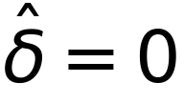; a floor.
- PerturbMean: 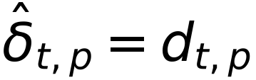, the mean shift of over the source contexts that observed it.
- ContextMean: the mean shift of the target's training perturbations, the same for every perturbation³⁵.
- LineOffset (added in the review round): PerturbMean plus one constant shift per target line, the mean residual 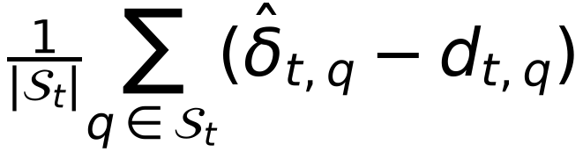 of the support perturbations. It tests whether a model's gain is a single per-line offset.
- Linear transfer: ridge regression⁷⁷ (penalty chosen by efficient leave-one-out cross-validation over 13 values) from a 64-component PCA of the concatenated source shifts of to its target shift. It is fitted on the target's support perturbations; a missing source is imputed with the mean over the observing sources. This is a strong, explicitly context-adaptive linear model of the kind recently shown to match deep models^{34,35}.
Tasks and splits
Under-represented context (T1). For each target line (four folds), the eligible perturbations are those observed in and in at least one other line. They were shuffled (seed 0) and split 25% training, 5% validation and 70% test. All perturbations of the three other lines are training data. Zero-shot context (T2). No perturbed cell of is used. Single-source transfer (T3). For each ordered pair (source , target ), training uses only and the test set is every perturbation observed in both. Unperturbed cells of every line, including , are available to all methods, as in Adduri et al.³³. Control cells of each line were split 50/50 into a model-input pool and a disjoint DE-reference pool.
Seeds. The pre-specified analysis used seed 0. In the review round the under-represented task was repeated with seeds 1 and 2; each seed changes the perturbation split, the model initialisation and the mini-batch order. Controls for per-line effects. (i) LineOffset (above). (ii) A line-identity-only CASTER: identical architecture and training, but every control set is replaced by the line's mean control profile repeated times, so the model knows which line it is in but sees no cell-to-cell variation. (iii) Wrong-line control cells: the trained CASTER is given the control cells of another line (the next line in the order K562, HepG2, Jurkat, RPE1); its predicted shift (prediction minus its input) is added to the target line's own control cells, so only the model's use of the control set changes. Complex-grouped splits. Perturbations were grouped by Louvain communities (resolution 1, seed 0) of the STRING v12 graph with combined score >= 950 among the 2,023 targets (500 groups, the largest 157 genes; all 73 ribosomal-protein targets fall in one group). Whole groups were assigned to training, validation or test, so no held-out gene had a same-group sibling in training.
Gene programs, similarity and cell-cycle analyses
Gene programs were defined per line by K-means⁷⁸ (15 programs, 10 restarts) on the z-scored observed shift matrix (perturbations x genes), clustering genes by their response profiles. Programs were annotated with their most enriched Reactome pathway⁵⁴ (hypergeometric test, background = modelled genes). Program activity is the mean shift over program genes. Perturbation-similarity structure used average-linkage hierarchical clustering of cosine distances between shifts of perturbations with >= 10 observed DEGs, compared with the adjusted Rand index⁷⁹. Recovery of functional relationships used STRING v12 pairs with combined score >= 700⁵⁵, scored by effect cosine similarity (AUROC). Cell-cycle shifts are the mean shift over the Tirosh et al. S-phase and G2/M signature genes⁵⁰ present in the gene space.
p53 activity
p53 activity was scored with 14 consensus p53 target genes⁴⁴ measured in all four lines (MDM2, BAX, TP53I3, RRM2B, ZMAT3, FDXR, AEN, TRIAP1, XPC, RPS27L, CCNG1, GADD45A, PPM1D, APAF1; CDKN1A and GDF15 are not among the shared measured genes). Each gene was z-scored against the line's control cells and the score was the mean z over the 14 genes. A knockdown was called p53-inducing when its cells' score exceeded the controls' (Welch t-test, BH FDR < 0.05, positive shift). TP53 status: K562 TP53 null, Jurkat TP53 mutant (DepMap damaging-mutation calls), HepG2 and RPE1 TP53 wild type.
Simulation (positive control)
Four synthetic lines shared 160 perturbations and 400 genes. Perturbation effects were sparse combinations of 12 gene programs (program loadings ~ N(0, 0.5^2) with 30% non-zero; program weights ~ N(0, 1) with 15% non-zero). Each line observed a random 80% of the perturbations, with 24 cells per perturbation and 600 controls drawn from N(baseline + effect, 0.4^2), clipped at 0. In the 'unlearnable' scenario each line added independent noise to the loadings (N(0, 0.25^2) on 20% of entries). In the 'learnable' scenario a gene's effect in a line was the shared effect scaled by its baseline expression in that line (baselines ~ Gamma(1.2, 0.9) with 25% of genes silent), which is observable from control cells. All methods were run on the HepG2-like line with the under-represented split (25% + 5% screened) and 60 epochs.
Dependency analyses
Chronos gene effects⁴⁰ (DepMap 24Q4^{39,56}) were taken for K562 (ACH-000551), HepG2 (ACH-000739) and Jurkat (ACH-000995); RPE1 is not profiled. Response magnitude is 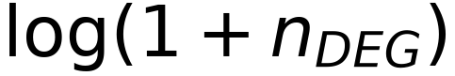. The context-specific response of a knockdown in line is its magnitude minus the mean over the other two cancer lines, and the context-specific dependency is defined the same way on Chronos scores. For dependency prediction (H5), a ridge model was trained, within 10-fold cross-validation over the held-out perturbations of each cancer line, to map observed shifts to Chronos. It was then applied unchanged to the shifts predicted by each method for the held-out fold. As a control for line specificity, each line's response magnitude was also correlated with the other lines' Chronos scores, and each line's Chronos scores were predicted by the mean Chronos score of the other two lines.
Formal definition of baseline models
Let 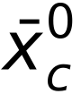 be the mean of the model-input control cells of context , and 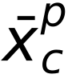 the mean of the observed cells of perturbation in . The observed shift is 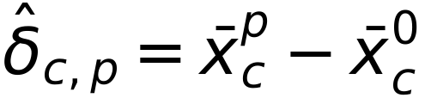. For the target context , let  be its support perturbations (training + validation) and the source contexts.
PerturbMean averages the shift of over the source contexts that observed it:
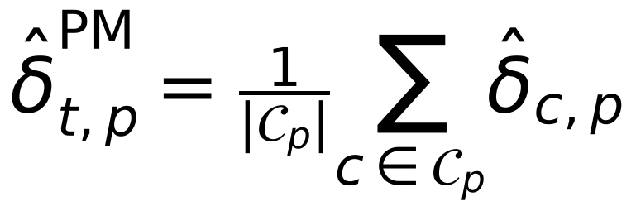 | (6)
ContextMean predicts the same shift for every perturbation of , namely the mean shift of its support perturbations:
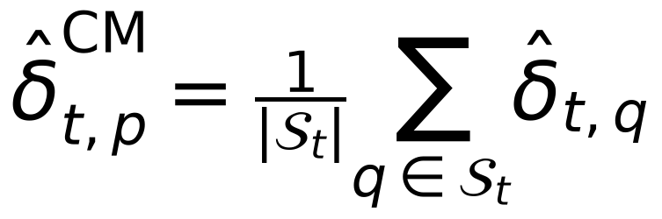 | (7)
Linear transfer. Each perturbation is described by the concatenation of its source shifts, 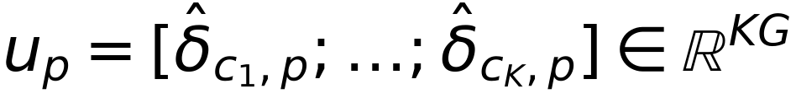. A source that did not observe contributes 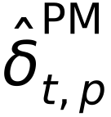. The features are reduced by PCA, fitted on source data only, to 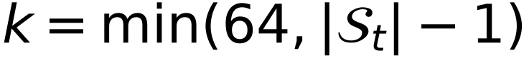 components 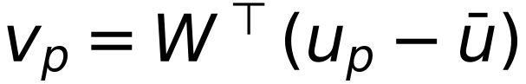. A ridge map 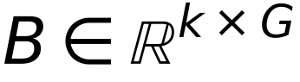 is then fitted on the support perturbations:
(8)
Here  stacks the centred 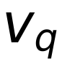 and  the centred target shifts.  is chosen from 13 log-spaced values in 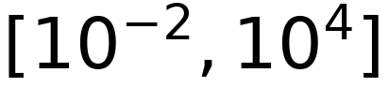 by efficient leave-one-out cross-validation. The prediction is 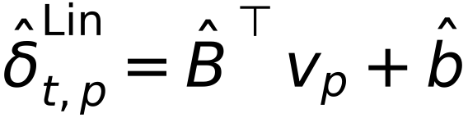. NoChange predicts . Every pseudobulk prediction is rendered as cells by adding it to the same control cells, 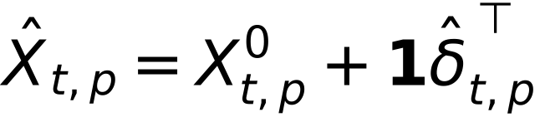.
Formal definition of downstream analyses
Inverse design. For the 100 perturbations with the most observed DEGs in a context, the rank of the correct perturbation among all predictions is
(9)
STRING-pair recovery. For perturbations with >= 10 observed DEGs, each unordered pair 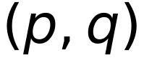 is labelled positive if STRING v12 reports a combined score >= 700 between their products. It is scored by the cosine similarity of the predicted shifts, 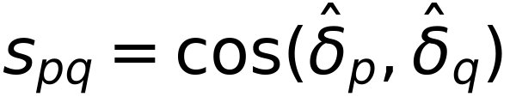, and summarised by the AUROC.
Gene programs. Let  be the observed shift matrix (perturbations x genes), z-scored per gene. K-means with 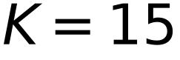 (10 restarts, seed 0) on the rows of 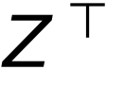 assigns each gene to a program . The activity of program under perturbation is 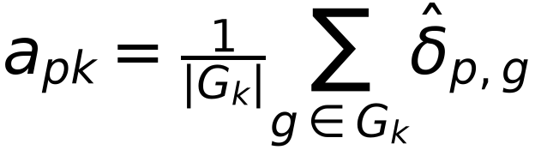. Concordance is the Pearson correlation across perturbations of predicted and observed 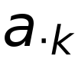. Programs are annotated by the Reactome pathway with the smallest hypergeometric p value, with the modelled genes as the background and at least 3 overlapping genes.
Perturbation-similarity structure. Cosine-distance matrices of predicted and observed shifts (perturbations with >= 10 DEGs) were clustered by average linkage into 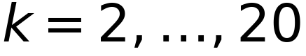 clusters, and the clusterings were compared by the adjusted Rand index.
Dependency prediction (H5). Within each cancer line, held-out perturbations with a measured Chronos score were split into 10 folds. A ridge model  (penalty chosen by leave-one-out cross-validation over 13 values in 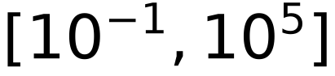) was fitted on the observed shifts of 9 folds and applied to the observed and to each method's predicted shifts of the remaining fold. The score is the Pearson correlation between the out-of-fold predictions 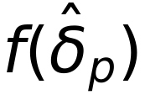 and the measured Chronos scores. Because the regressor never sees a predicted shift during training, any loss of accuracy reflects information missing from the prediction.
Context-specific dependency (H4b). For gene observed in all three cancer lines, with response magnitude 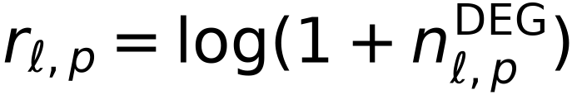 and Chronos score 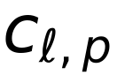, the context-specific components are
(10)
H4b tests the Spearman correlation of 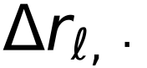 and 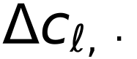 per line.
Response similarity across contexts. For each pair of contexts and each perturbation with >= 10 DEGs in both, similarity is the Pearson correlation of the two observed shift vectors over the modelled genes. DEG overlap is the Jaccard index of the two DEG sets. The stratified analysis repeats this for minimum response sizes of 10, 25, 50, 100 and 200 DEGs.
Formal properties of CASTER and of context transfer
We state four properties that frame the benchmark results. Notation follows the problem formulation above. 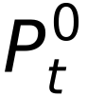 denotes the control distribution of context , 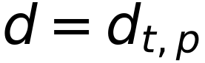 the transfer prior, and  the CASTER parameters.
Proposition 1 (CASTER contains PerturbMean)
At initialisation (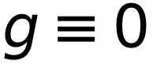, and the final linear layer of equal to zero), for any control set 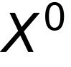 and perturbation , the CASTER prediction is
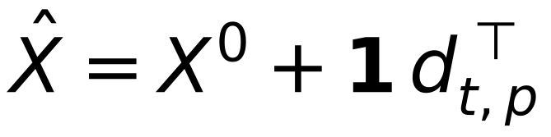 | (11)
Its pseudobulk shift therefore equals the PerturbMean prediction exactly. Proof. The output is . With 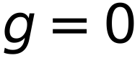 the middle term is , and 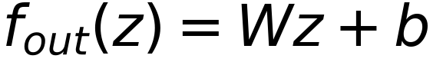 with 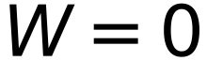 and 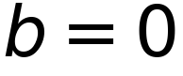 is identically zero. Because the checkpoint is chosen by validation loss, which includes the epoch-0 model, the selected CASTER can deviate from PerturbMean only when the deviation lowers the validation objective. ∎
Proposition 2 (permutation equivariance)
For any permutation matrix 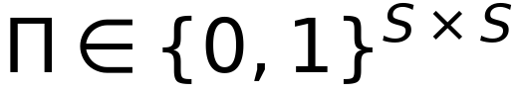, . Proof. acts row-wise and commutes with . The context summary is a mean over rows and is invariant. The FiLM and prior terms are broadcast identically to every row. Self-attention without positional encodings is permutation-equivariant^{71,72}. and the residual act row-wise. A composition of equivariant and row-broadcast invariant maps is equivariant. ∎ The property is verified numerically in the test suite. It means that predictions depend on the distribution of control cells, not on their order.
Proposition 3 (the training loss identifies distributions)
For distributions  on  with finite first moments, the energy distance⁴⁶
(12)
is non-negative and equals zero if and only if 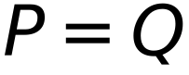. It is the squared MMD with the (conditionally negative definite) energy kernel^{45,74}. The empirical V-statistic in the loss converges almost surely to  as 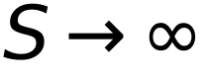. Minimising the population loss therefore matches the full predicted and observed perturbed distributions, not only their means. The added pseudobulk term is minimised by the conditional mean, so the combined objective is minimised by any predictor whose distribution equals the observed one, and both terms vanish there. ∎
Proposition 4 (when can context transfer beat PerturbMean?)
Decompose the target shift as 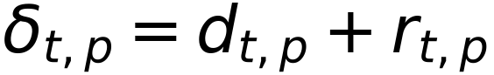, where 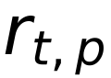 is the residual of the transfer prior. Let 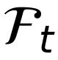 be the information available to a predictor at test time: the prior, the control cells of and, in T1, the support perturbations of . Under squared error, the optimal prediction of 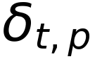 is
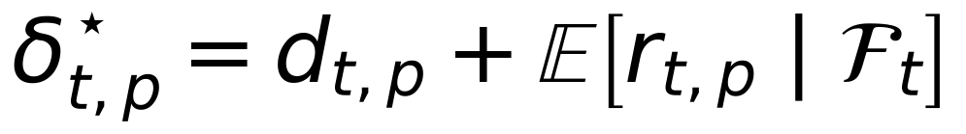 | (13)
Its risk improves on that of PerturbMean by exactly 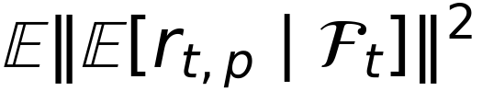. Proof. By the orthogonality of conditional expectation, for any measurable . PerturbMean is 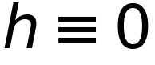. ∎ Consequently, no method, however expressive, can outperform PerturbMean in expectation unless the residual of the transfer prior is predictable from the target's control cells and support perturbations. The comparison between CASTER (and the linear transfer model) and PerturbMean is therefore an empirical estimate of . A null result means that this predictable part is small relative to estimation noise at the available data scale, not that context does not matter. Indeed 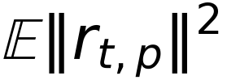 (the context-specific variance quantified in Figure 1) can be large while its predictable part is small. In the positive-control simulation the residual is constructed to be a function of the control profile, so this bound is attained.
Information available to each method (leakage audit)
Method | Target controls | Target support perts | Source contexts | Target test perts
NoChange | input pool | - | - | never
ContextMean | input pool | yes (mean) | - | never
PerturbMean | input pool | - | yes | never
Linear transfer | input pool | yes (fit) | yes | never
CASTER (T1) | input pool | yes (train/val) | yes | never
CASTER (T2/T3) | input pool | - | yes (val: 5% source) | never
Evaluation | reference pool | - | - | observed cells

Control cells of each context are split once (seed 0) into disjoint input and reference pools. Gene selection uses control cells only. Every perturbation in the held-out test set is excluded from all training and model-selection steps for that context. This is enforced in code and covered by unit tests (split disjointness, control-pool disjointness, deterministic inputs).
Software, computation and reproducibility
All analyses were run on a single workstation (4 CPU cores, 8 GB RAM, no GPU) with Python 3.12, PyTorch 2.13 (CPU build)⁷⁶, NumPy⁸⁰, SciPy⁸¹, scikit-learn⁸², pandas, h5py and Matplotlib⁸³. Under-represented and zero-shot folds took 19-56 min each to train and evaluate (Table S9); single-source transfer models about 10 min each. Two jobs ran concurrently with two threads each. All randomness (cell subsampling, control-pool splits, perturbation splits, model initialisation, mini-batch sampling and the control cells given to each method) is seeded. Control input sets are derived deterministically from a hash of the perturbation, seed and context, so that every method receives identical inputs. The pipeline is a sequence of command-line steps (data build, observed DE, T1, T2, ablations, transfer, analysis, figures and manuscript), and each step writes versioned artefacts (per-perturbation metric tables, predicted pseudobulk shifts, per-gene DE arrays and training histories). Every number in this paper is read from a single results file generated from those artefacts, and every figure panel writes the table it plots.
The code base has unit and integration tests. They cover Benjamini-Hochberg correction against SciPy, the DE test on simulated shifts, perturbation discrimination at its bounds, the energy-MMD loss (zero for identical sets, positive for shifted ones), permutation equivariance of CASTER, split disjointness and determinism, control-pool disjointness, and an end-to-end synthetic run in which CASTER and PerturbMean must recover planted effects. Data integrity was verified at acquisition: every selected row was fetched exactly once in the final dataset, and 112,310 rows fetched twice by overlapping download passes were confirmed byte-identical before deduplication.
Deviations from the pre-specified protocol
- AMENDMENT-001 (before any result was seen): to fit the compute budget, training epochs were set to 20 for context tasks and 10 for ablations and transfer, and the set-size ablation was reduced to S in {1, 8, 32}.
- AMENDMENT-002 (after T1 results were first inspected): the predicted-side DE test was replaced by a moment-matched z-test because the pre-specified Wilcoxon test is invalid for continuous predictions (STAR Methods; Figure S7). Both versions of every affected test are reported.
- Data source (before freezing): the knockdown-filtered four-line release³³ replaced the per-line original files, for uniform processing and because the original repository throttled range requests.
- Seeds 1 and 2 of the under-represented task (declared secondary) were run in the review round.
- AMENDMENT-003 (review round, 2026-10-08, after all pre-specified results were known): added the LineOffset baseline, a line-identity-only CASTER, wrong-line control cells, complex-grouped splits, ablations at 20 epochs with two seeds, calibrated metrics with technical and interpolated duplicates and noise ceilings^{48,49}, the p53 and DepMap control analyses, and corrected the direction of the paired test for lower-is-better metrics (MAE), which had been tested as higher-is-better. All are exploratory and labelled as added later. Predicted-side Wilcoxon tests were not recomputed for the new runs because AMENDMENT-002 replaced them.
QUANTIFICATION AND STATISTICAL ANALYSIS
Evaluation suite (PertBench)
For test perturbation with observed cells 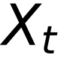, predicted cells 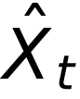 (same number of cells) and reference controls  (500 cells, disjoint from model inputs):
Pearson delta. The correlation between predicted and observed pseudobulk shifts:
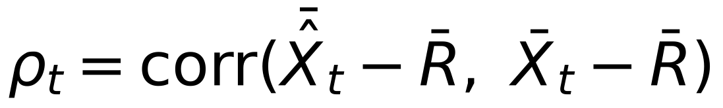 | (14)
Perturbation discrimination. Following Wu et al.³⁶ and Adduri et al.³³, with 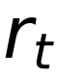 the number of other test perturbations whose observed pseudobulk is closer in L1 distance to the prediction than the true one:
(15)
A perfect model scores 1 and chance scores 0. Observed differential expression (ground truth). Observed cells of each perturbation are tested against gene by gene with the Wilcoxon rank-sum test^{84,85} (asymptotic, tie-corrected), with Benjamini-Hochberg correction⁸⁶ at FDR < 0.05. Observed log2 fold changes are log2 ratios of mean expm1-transformed expression with pseudocount 0.01. The limitations of cell-level DE tests are well known^{87,88}.
Predicted differential expression (AMENDMENT-002). The pre-specified protocol applied the same Wilcoxon test to predicted cells. Inspection of the results showed that this is invalid for continuous predictions. Adding a shift to a control cell turns each of its exact zeros into a small positive value, and against zero-inflated reference cells the rank test then calls most genes significant whatever the shift. In the HepG2 fold, every shifted method produced 1,283-1,494 'DEGs' per perturbation, versus 0.1 for unshifted control cells. We therefore score predictions with a moment-matched z-test on the predicted pseudobulk shift 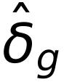, using the reference-control standard deviation 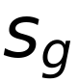 and the sample sizes of the observed experiment:
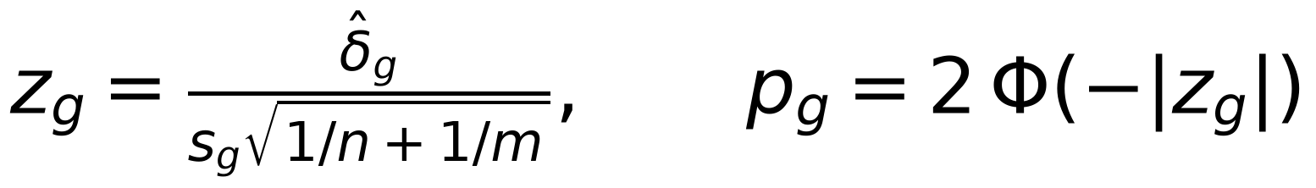 | (16)
Here  is the number of perturbed cells and 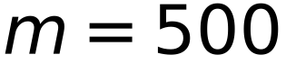, with BH adjustment. Predicted fold-change ranks and signs use . Observed ground truth is unchanged. The pre-specified Wilcoxon results are reported in full in Table S1 and flagged as invalid. DE AUPRC is the average precision^{89,90} for recovering observed DEGs from predicted -log10 adjusted p values. DE overlap is
 | (17)
MAE and MSE are the mean absolute and mean squared differences between predicted and observed pseudobulk shifts over the 2,000 modelled genes, 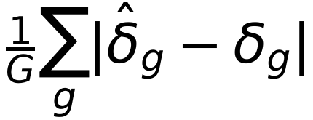 and 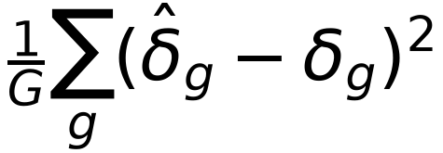; lower is better, and paired tests are oriented accordingly.
Calibrated metrics (review round). Following Miller et al.⁴⁸ and Mejia et al.⁴⁹, each held-out perturbation's cells were split into two random halves (seeded per perturbation). Half A defines the truth; half B is the technical duplicate (positive control). A Welch t-test of half A against all other cells of the line gives per-gene statistics 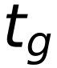 and BH-adjusted p values 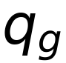. DEG weights are , the interpolated duplicate is 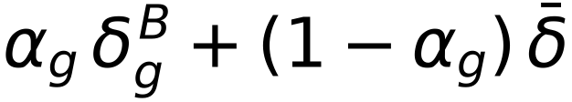 with 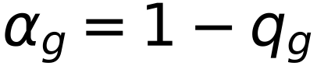, and the negative control  is the mean shift of the line's screened perturbations (the perturbed mean). Metrics: Pearson delta; Pearson delta relative to the perturbed mean on the 100 genes with largest 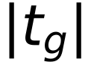; MSE; MAE; WMSE 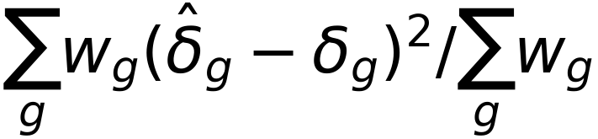; weighted 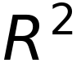 relative to control and to the perturbed mean (clipped at -1); NIR (fraction of other held-out perturbations whose truth is farther, in Euclidean distance, from the prediction than the correct truth) and PDS (the same with Manhattan distance). The dynamic range fraction of a metric is (technical duplicate - negative control) / (perfect - negative control), or (negative control - technical duplicate) / negative control for lower-is-better metrics, clipped to [-1, 1] and averaged over perturbations; for metrics relative to the perturbed mean the zero-shift prediction is the negative control. Methods are also reported on a scale from negative control (0) to technical duplicate (1).
Noise-free re-scoring (review round). Every method's prediction is rendered as cells derived from control cells sampled from the input pool ( = number of observed cells of the perturbation), so its pseudobulk shift contains the sampling noise 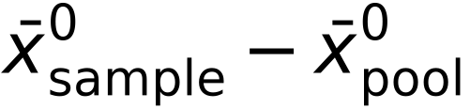. We subtracted this term from every method's predicted shift (for CASTER, this treats its output relative to its own input as the predicted effect) and re-computed all pseudobulk metrics. These 'noise-free' scores are reported alongside the pre-specified ones.
Noise ceiling. The Pearson correlation 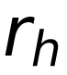 between the shifts of the two halves estimates the split-half reliability; by Spearman-Brown, the reliability of the full-cell shift is 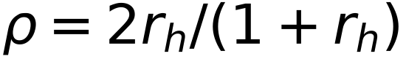, and the highest Pearson delta any predictor can reach against the full-cell truth is 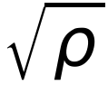.
Here both sets are ranked by |log2 FC| among significant genes. Fold-change Spearman is computed over observed DEGs. Direction agreement is the fraction of observed DEGs with the correct predicted sign. Effect-size Spearman is the rank correlation, across perturbations within a fold, between the predicted and observed numbers of DEGs.
Statistics
All hypotheses, tests and the decision rule were fixed in a protocol (RESEARCH_PROTOCOL.md, git tag protocol-v1.0) before any model was fitted to real data. H1 used one-sided paired Wilcoxon signed-rank tests over held-out perturbations pooled across the four folds (CASTER > baseline), with Holm correction⁹¹ over nine tests (three baselines x three primary metrics). It was declared supported if at least six were significant and none was significant in the opposite direction. H2 used the same test against PerturbMean on T2 (Holm over three). H3 compared per-perturbation single-source transfer accuracy averaged over cancer-to-cancer pairs with the average over pairs involving RPE1 (two-sided paired Wilcoxon). H4 and H4b used Spearman correlations with Holm correction over the three cancer lines. Exploratory analyses are reported without multiplicity claims. Every number in the text is read from the results.json file written by the analysis pipeline.

SUPPLEMENTAL INFORMATION
Table S1. All paired tests, under-represented context task (one-sided Wilcoxon, CASTER > baseline; Holm within each family)
Baseline | Metric | n | CASTER | Baseline | % better | p | p (Holm)
PerturbMean | pearson_delta | 3,841 | 0.278 | 0.198 | 66 | 5.8 × 10⁻¹⁵³ | 4.0 × 10⁻¹⁵²
PerturbMean | discrimination | 3,841 | 0.430 | 0.369 | 46 | 0.648 | 1.000
PerturbMean | de_auprc | 2,666 | 0.198 | 0.137 | 67 | 1.2 × 10⁻¹⁰³ | 6.1 × 10⁻¹⁰³
ContextMean | pearson_delta | 3,841 | 0.278 | 0.208 | 67 | 3.3 × 10⁻¹⁵⁰ | 2.0 × 10⁻¹⁴⁹
ContextMean | discrimination | 3,841 | 0.430 | 0.000 | 80 | < 1e-300 | < 1e-300
ContextMean | de_auprc | 2,666 | 0.198 | 0.104 | 77 | 2.3 × 10⁻²²³ | 1.8 × 10⁻²²²
Linear | pearson_delta | 3,841 | 0.278 | 0.282 | 50 | 0.960 | 1.000
Linear | discrimination | 3,841 | 0.430 | 0.422 | 50 | 0.039 | 0.117
Linear | de_auprc | 2,666 | 0.198 | 0.181 | 56 | 4.0 × 10⁻¹⁸ | 1.6 × 10⁻¹⁷
PerturbMean | mae | 11,523 | 0.078 | 0.093 | 98 | < 1e-300 | < 1e-300
PerturbMean | de_overlap | 7,977 | 0.149 | 0.150 | 30 | 0.577 | 1.000
PerturbMean | lfc_spearman | 6,267 | 0.462 | 0.396 | 59 | 8.1 × 10⁻¹²⁰ | 4.9 × 10⁻¹¹⁹
PerturbMean | direction | 7,977 | 0.808 | 0.755 | 52 | 1.8 × 10⁻²⁵⁰ | 1.3 × 10⁻²⁴⁹
ContextMean | mae | 11,523 | 0.078 | 0.082 | 75 | < 1e-300 | < 1e-300
ContextMean | de_overlap | 7,977 | 0.149 | 0.023 | 47 | < 1e-300 | < 1e-300
ContextMean | lfc_spearman | 6,267 | 0.462 | 0.362 | 70 | < 1e-300 | < 1e-300
ContextMean | direction | 7,977 | 0.808 | 0.702 | 60 | < 1e-300 | < 1e-300
Linear | mae | 11,523 | 0.078 | 0.077 | 48 | 1.000 | 1.000
Linear | de_overlap | 7,977 | 0.149 | 0.126 | 30 | 1.1 × 10⁻⁵⁰ | 5.3 × 10⁻⁵⁰
Linear | lfc_spearman | 6,267 | 0.462 | 0.459 | 46 | 0.052 | 0.208
Linear | direction | 7,977 | 0.808 | 0.803 | 28 | 1.000 | 1.000
PerturbMean (pre-spec. Wilcoxon) | de_auprc | 2,666 | 0.039 | 0.035 | 73 | 1.6 × 10⁻¹⁵² | 1.6 × 10⁻¹⁵²
ContextMean (pre-spec. Wilcoxon) | de_auprc | 2,666 | 0.039 | 0.036 | 85 | 5.8 × 10⁻²⁴⁶ | 1.7 × 10⁻²⁴⁵
Linear (pre-spec. Wilcoxon) | de_auprc | 2,666 | 0.039 | 0.037 | 85 | 5.1 × 10⁻²⁴⁴ | 1.0 × 10⁻²⁴³
PerturbMean (pre-spec. Wilcoxon) | de_overlap | 2,666 | 0.078 | 0.055 | 28 | 5.4 × 10⁻²⁵ | 5.4 × 10⁻²⁵
ContextMean (pre-spec. Wilcoxon) | de_overlap | 2,666 | 0.078 | 0.034 | 35 | 6.2 × 10⁻¹²⁰ | 1.9 × 10⁻¹¹⁹
Linear (pre-spec. Wilcoxon) | de_overlap | 2,666 | 0.078 | 0.066 | 28 | 1.2 × 10⁻⁴⁸ | 2.3 × 10⁻⁴⁸
PerturbMean (pre-spec. Wilcoxon) | lfc_spearman | 2,094 | 0.509 | 0.435 | 62 | 2.7 × 10⁻⁵⁰ | 5.4 × 10⁻⁵⁰
ContextMean (pre-spec. Wilcoxon) | lfc_spearman | 2,094 | 0.509 | 0.342 | 76 | 2.1 × 10⁻¹⁸² | 6.2 × 10⁻¹⁸²
Linear (pre-spec. Wilcoxon) | lfc_spearman | 2,094 | 0.509 | 0.496 | 53 | 5.4 × 10⁻¹⁴ | 5.4 × 10⁻¹⁴
PerturbMean (pre-spec. Wilcoxon) | direction | 2,666 | 0.796 | 0.756 | 49 | 4.6 × 10⁻⁶⁵ | 9.2 × 10⁻⁶⁵
ContextMean (pre-spec. Wilcoxon) | direction | 2,666 | 0.796 | 0.691 | 60 | 4.0 × 10⁻¹⁹² | 1.2 × 10⁻¹⁹¹
Linear (pre-spec. Wilcoxon) | direction | 2,666 | 0.796 | 0.793 | 30 | 0.073 | 0.073

Table S2. CASTER hyperparameters and training settings
Component | Setting
Cell encoder f_cell | 4-layer MLP, GELU, 2,000 -> 256 -> 256 -> 256 -> 256
Prior encoder f_prior | 2-layer MLP, GELU, 2,000 -> 256 -> 256
Context summary / FiLM | mean of cell embeddings -> 2-layer MLP -> (gamma, beta) in R^256 x R^256
Set transformer | 4 layers, 8 heads, d_model 256, feed-forward 512, pre-norm, GELU, dropout 0, no positional encoding
Output | LayerNorm + linear 256 -> 2,000 (zero-initialised); g(c): linear 256 -> 2,000 (zero-init)
Cell-set size S | 32 (ablation: 1, 8)
Loss | energy-distance MMD^2 + 1.0 x pseudobulk squared error
Optimiser | AdamW, lr 3e-4, weight decay 1e-4, batch 32 sets, grad-norm clip 1.0
Schedule | 5% linear warm-up, cosine decay to 5% of peak
Epochs | 20 (T1, T2); 10 (ablations, single-source transfer)
Model selection | lowest validation loss (T1: 5% target perturbations; T2/T3: 5% source items)
Hardware | CPU only (4 cores, 8 GB RAM), 2 threads per job, PyTorch 2.13
Parameters | 4.6 M (excluding the one-hot embedding, used only in ablations)

Table S3. Dataset after subsampling and filtering
Context | Cells | Controls | Perturbations | Median cells/pert | Median # DEGs | % with >= 10 DEGs
K562 | 47,236 | 3,000 | 1,383 | 32 | 2 | 32
HepG2 | 45,783 | 3,000 | 1,340 | 32 | 5 | 46
Jurkat | 52,151 | 3,000 | 1,537 | 32 | 2 | 32
RPE1 | 50,923 | 3,000 | 1,499 | 32 | 29 | 60

Table S4. All metrics per held-out context, under-represented task (mean over held-out perturbations)
Context | Method | Pearson d | Discrim. | MAE | DE AUPRC | DE overlap | FC Spearman | Direction | Effect rho
HepG2 | CASTER | 0.315 | 0.470 | 0.070 | 0.227 | 0.177 | 0.506 | 0.813 | 0.703
HepG2 | CASTER_clean | 0.455 | 0.489 | 0.055 | 0.333 | 0.151 | 0.546 | 0.898 | 0.736
HepG2 | ContextMean | 0.254 | -0.007 | 0.076 | 0.114 | 0.016 | 0.428 | 0.730 | -0.003
HepG2 | ContextMean_clean | 0.393 | 0.000 | 0.061 | 0.251 | 0.000 | 0.519 | 0.840 | 0.000
HepG2 | LineOffset | 0.273 | 0.461 | 0.085 | 0.174 | 0.207 | 0.501 | 0.808 | 0.651
HepG2 | LineOffset_clean | 0.330 | 0.496 | 0.072 | 0.209 | 0.195 | 0.536 | 0.850 | 0.675
HepG2 | Linear | 0.322 | 0.478 | 0.069 | 0.210 | 0.151 | 0.488 | 0.814 | 0.703
HepG2 | Linear_clean | 0.468 | 0.506 | 0.054 | 0.324 | 0.118 | 0.540 | 0.895 | 0.733
HepG2 | NoChange | 0.060 | -0.012 | 0.078 | 0.078 | 0.000 | 0.103 | 0.549 | 0.017
HepG2 | PerturbMean | 0.243 | 0.423 | 0.086 | 0.162 | 0.201 | 0.445 | 0.785 | 0.671
HepG2 | PerturbMean_clean | 0.297 | 0.452 | 0.074 | 0.188 | 0.186 | 0.490 | 0.824 | 0.686
Jurkat | CASTER | 0.205 | 0.378 | 0.085 | 0.123 | 0.099 | 0.386 | 0.777 | 0.575
Jurkat | CASTER_clean | 0.364 | 0.379 | 0.066 | 0.234 | 0.076 | 0.446 | 0.904 | 0.597
Jurkat | ContextMean | 0.113 | 0.002 | 0.088 | 0.039 | 0.002 | 0.221 | 0.627 | -0.040
Jurkat | ContextMean_clean | 0.296 | 0.000 | 0.068 | 0.130 | 0.000 | 0.391 | 0.793 | 0.000
Jurkat | LineOffset | 0.181 | 0.388 | 0.096 | 0.121 | 0.157 | 0.403 | 0.783 | 0.620
Jurkat | LineOffset_clean | 0.247 | 0.393 | 0.078 | 0.159 | 0.140 | 0.440 | 0.835 | 0.647
Jurkat | Linear | 0.197 | 0.349 | 0.085 | 0.101 | 0.073 | 0.367 | 0.766 | 0.529
Jurkat | Linear_clean | 0.370 | 0.361 | 0.065 | 0.216 | 0.047 | 0.444 | 0.887 | 0.520
Jurkat | NoChange | 0.039 | 0.001 | 0.090 | 0.029 | 0.000 | 0.060 | 0.516 | -0.050
Jurkat | PerturbMean | 0.160 | 0.348 | 0.098 | 0.112 | 0.148 | 0.354 | 0.757 | 0.650
Jurkat | PerturbMean_clean | 0.216 | 0.350 | 0.080 | 0.143 | 0.139 | 0.404 | 0.813 | 0.667
K562 | CASTER | 0.205 | 0.408 | 0.072 | 0.145 | 0.115 | 0.426 | 0.815 | 0.617
K562 | CASTER_clean | 0.370 | 0.422 | 0.055 | 0.261 | 0.093 | 0.506 | 0.923 | 0.638
K562 | ContextMean | 0.101 | -0.003 | 0.075 | 0.036 | 0.001 | 0.276 | 0.655 | 0.043
K562 | ContextMean_clean | 0.283 | 0.000 | 0.058 | 0.107 | 0.000 | 0.508 | 0.808 | 0.000
K562 | LineOffset | 0.183 | 0.543 | 0.086 | 0.133 | 0.172 | 0.447 | 0.808 | 0.626
K562 | LineOffset_clean | 0.231 | 0.560 | 0.072 | 0.159 | 0.179 | 0.494 | 0.833 | 0.646
K562 | Linear | 0.209 | 0.429 | 0.072 | 0.133 | 0.101 | 0.450 | 0.805 | 0.626
K562 | Linear_clean | 0.378 | 0.450 | 0.055 | 0.271 | 0.065 | 0.503 | 0.916 | 0.616
K562 | NoChange | 0.049 | -0.002 | 0.076 | 0.029 | 0.000 | 0.069 | 0.553 | -0.005
K562 | PerturbMean | 0.189 | 0.537 | 0.089 | 0.121 | 0.158 | 0.436 | 0.789 | 0.643
K562 | PerturbMean_clean | 0.232 | 0.558 | 0.075 | 0.147 | 0.176 | 0.475 | 0.814 | 0.656
RPE1 | CASTER | 0.386 | 0.468 | 0.082 | 0.276 | 0.205 | 0.501 | 0.812 | 0.668
RPE1 | CASTER_clean | 0.507 | 0.460 | 0.065 | 0.388 | 0.183 | 0.563 | 0.891 | 0.694
RPE1 | ContextMean | 0.361 | 0.006 | 0.088 | 0.198 | 0.065 | 0.480 | 0.773 | -0.009
RPE1 | ContextMean_clean | 0.488 | 0.000 | 0.072 | 0.344 | 0.027 | 0.549 | 0.856 | -0.133
RPE1 | LineOffset | 0.365 | 0.379 | 0.094 | 0.219 | 0.198 | 0.533 | 0.828 | 0.543
RPE1 | LineOffset_clean | 0.442 | 0.393 | 0.079 | 0.292 | 0.164 | 0.585 | 0.871 | 0.622
RPE1 | Linear | 0.399 | 0.438 | 0.081 | 0.259 | 0.171 | 0.503 | 0.823 | 0.701
RPE1 | Linear_clean | 0.531 | 0.446 | 0.063 | 0.386 | 0.139 | 0.559 | 0.896 | 0.736
RPE1 | NoChange | 0.050 | 0.002 | 0.095 | 0.092 | 0.000 | 0.071 | 0.541 | -0.010
RPE1 | PerturbMean | 0.204 | 0.190 | 0.098 | 0.148 | 0.121 | 0.364 | 0.710 | 0.544
RPE1 | PerturbMean_clean | 0.268 | 0.176 | 0.084 | 0.199 | 0.094 | 0.441 | 0.771 | 0.580

Table S5. All metrics per held-out context, zero-shot task
Context | Method | Pearson d | Discrim. | MAE | DE AUPRC | DE overlap | FC Spearman | Direction | Effect rho
HepG2 | CASTER | 0.169 | 0.191 | 0.081 | 0.128 | 0.109 | 0.331 | 0.715 | 0.672
HepG2 | CASTER_clean | 0.227 | 0.199 | 0.068 | 0.172 | 0.083 | 0.386 | 0.799 | 0.699
HepG2 | NoChange | 0.060 | -0.008 | 0.079 | 0.081 | 0.000 | 0.099 | 0.549 | 0.010
HepG2 | PerturbMean | 0.247 | 0.414 | 0.087 | 0.165 | 0.204 | 0.458 | 0.784 | 0.666
HepG2 | PerturbMean_clean | 0.301 | 0.438 | 0.074 | 0.191 | 0.186 | 0.506 | 0.826 | 0.684
Jurkat | CASTER | 0.138 | 0.179 | 0.089 | 0.077 | 0.071 | 0.305 | 0.717 | 0.581
Jurkat | CASTER_clean | 0.252 | 0.176 | 0.070 | 0.148 | 0.058 | 0.395 | 0.822 | 0.610
Jurkat | NoChange | 0.039 | 0.001 | 0.089 | 0.028 | 0.000 | 0.054 | 0.531 | -0.010
Jurkat | PerturbMean | 0.155 | 0.335 | 0.097 | 0.107 | 0.144 | 0.352 | 0.756 | 0.635
Jurkat | PerturbMean_clean | 0.209 | 0.336 | 0.080 | 0.138 | 0.135 | 0.405 | 0.807 | 0.652
K562 | CASTER | 0.187 | 0.401 | 0.081 | 0.093 | 0.105 | 0.409 | 0.769 | 0.635
K562 | CASTER_clean | 0.262 | 0.409 | 0.066 | 0.118 | 0.099 | 0.443 | 0.832 | 0.635
K562 | NoChange | 0.051 | -0.001 | 0.075 | 0.029 | 0.000 | 0.067 | 0.552 | -0.009
K562 | PerturbMean | 0.186 | 0.538 | 0.089 | 0.122 | 0.159 | 0.416 | 0.784 | 0.643
K562 | PerturbMean_clean | 0.228 | 0.559 | 0.075 | 0.146 | 0.175 | 0.458 | 0.808 | 0.657
RPE1 | CASTER | 0.191 | 0.100 | 0.091 | 0.126 | 0.053 | 0.316 | 0.683 | 0.556
RPE1 | CASTER_clean | 0.308 | 0.095 | 0.075 | 0.214 | 0.039 | 0.439 | 0.778 | 0.579
RPE1 | NoChange | 0.048 | 0.001 | 0.095 | 0.091 | 0.000 | 0.063 | 0.541 | 0.002
RPE1 | PerturbMean | 0.205 | 0.185 | 0.099 | 0.146 | 0.118 | 0.363 | 0.715 | 0.533
RPE1 | PerturbMean_clean | 0.271 | 0.175 | 0.084 | 0.196 | 0.092 | 0.446 | 0.776 | 0.570

Table S6. Single-source transfer (mean over shared perturbations)
Source | Target | Method | Pearson d | Discrim. | DE AUPRC | DE overlap
HepG2 | Jurkat | CASTER | 0.127 | 0.153 | 0.054 | 0.066
HepG2 | Jurkat | PerturbMean | 0.132 | 0.286 | 0.064 | 0.112
HepG2 | K562 | CASTER | 0.160 | 0.287 | 0.077 | 0.096
HepG2 | K562 | PerturbMean | 0.162 | 0.475 | 0.087 | 0.134
HepG2 | RPE1 | CASTER | 0.246 | 0.138 | 0.154 | 0.089
HepG2 | RPE1 | PerturbMean | 0.235 | 0.270 | 0.150 | 0.159
Jurkat | HepG2 | CASTER | 0.157 | 0.117 | 0.098 | 0.090
Jurkat | HepG2 | PerturbMean | 0.150 | 0.262 | 0.096 | 0.166
Jurkat | K562 | CASTER | 0.152 | 0.313 | 0.090 | 0.104
Jurkat | K562 | PerturbMean | 0.148 | 0.521 | 0.096 | 0.139
Jurkat | RPE1 | CASTER | 0.143 | 0.068 | 0.107 | 0.047
Jurkat | RPE1 | PerturbMean | 0.144 | 0.190 | 0.107 | 0.136
K562 | HepG2 | CASTER | 0.164 | 0.066 | 0.107 | 0.059
K562 | HepG2 | PerturbMean | 0.161 | 0.206 | 0.104 | 0.145
K562 | Jurkat | CASTER | 0.119 | 0.096 | 0.073 | 0.057
K562 | Jurkat | PerturbMean | 0.132 | 0.274 | 0.085 | 0.127
K562 | RPE1 | CASTER | 0.135 | 0.027 | 0.118 | 0.033
K562 | RPE1 | PerturbMean | 0.135 | 0.103 | 0.118 | 0.106
RPE1 | HepG2 | CASTER | 0.272 | 0.411 | 0.180 | 0.201
RPE1 | HepG2 | PerturbMean | 0.262 | 0.558 | 0.177 | 0.230
RPE1 | Jurkat | CASTER | 0.130 | 0.211 | 0.084 | 0.100
RPE1 | Jurkat | PerturbMean | 0.136 | 0.363 | 0.100 | 0.140
RPE1 | K562 | CASTER | 0.149 | 0.283 | 0.087 | 0.101
RPE1 | K562 | PerturbMean | 0.150 | 0.430 | 0.102 | 0.140

Table S7. Ablations (under-represented task, K562 held out)
Variant | Pearson d | Discrim. | DE AUPRC | DE overlap | FC Spearman
S1 | 0.178 | 0.472 | 0.123 | 0.160 | 0.426
S32 | 0.189 | 0.323 | 0.127 | 0.093 | 0.423
S32_noattn | 0.181 | 0.276 | 0.124 | 0.089 | 0.404
S32_nofilm | 0.189 | 0.321 | 0.128 | 0.093 | 0.421
S32_noprior | 0.095 | -0.003 | 0.035 | 0.004 | 0.225
S32_pertid | 0.185 | 0.314 | 0.124 | 0.092 | 0.416
S8 | 0.160 | 0.211 | 0.100 | 0.070 | 0.386

Table S10. Calibrated metrics against one half of each knockdown's cells, under-represented task (mean over lines and seeds). TechDup and InterpDup are positive controls, MeanBaseline the negative control (exploratory; added in the review round)
Method | Pearson d | Top-100 Pearson d (vs pert. mean) | wR2 (vs pert. mean) | WMSE | MSE | MAE | NIR | PDS
TechDup | 0.291 | 0.457 | -0.920 | 0.0139 | 0.0180 | 0.101 | 0.900 | 0.884
InterpDup | 0.419 | 0.455 | -0.920 | 0.0139 | 0.0103 | 0.074 | 0.843 | 0.858
CASTER | 0.236 | 0.308 | -0.953 | 0.0143 | 0.0157 | 0.093 | 0.696 | 0.684
Linear | 0.241 | 0.286 | -0.957 | 0.0146 | 0.0155 | 0.092 | 0.691 | 0.681
LineOffset | 0.211 | 0.242 | -0.977 | 0.0166 | 0.0197 | 0.104 | 0.697 | 0.682
PerturbMean | 0.167 | 0.242 | -0.985 | 0.0178 | 0.0212 | 0.106 | 0.670 | 0.656
ContextMean | 0.175 | 0.000 | -0.996 | 0.0168 | 0.0177 | 0.096 | 0.500 | 0.501
CASTER_wrongctrl | 0.127 | 0.181 | -0.993 | 0.0191 | 0.0208 | 0.102 | 0.589 | 0.577
MeanBaseline | 0.304 | n/a | -0.997 | 0.0150 | 0.0136 | 0.083 | 0.500 | 0.500
NoChange | 0.039 | 0.074 | -0.997 | 0.0190 | 0.0196 | 0.099 | 0.500 | 0.500

Table S11. Robustness checks requested in review
Check | Result
PerturbMean rendered on sampled vs noise-free control cells (Pearson delta, seed 0) | 0.198 vs 0.252 (CASTER 0.278)
Linear rendered on sampled vs noise-free control cells (Pearson delta, seed 0) | 0.282 vs 0.437 (CASTER 0.278)
LineOffset rendered on sampled vs noise-free control cells (Pearson delta, seed 0) | 0.251 vs 0.314 (CASTER 0.278)
Cross-line response similarity on all 6,546 genes, cancer-cancer (median r) | 0.36 (n = 813)
Cross-line response similarity on all 6,546 genes, with RPE1 (median r) | 0.40 (n = 988)

Table S8. Gene programs and their top Reactome enrichment
Context | Program | Genes | Top Reactome pathway | p
HepG2 | 0 | 199 | Cell Cycle | 5.0e-23
HepG2 | 14 | 109 | Cholesterol biosynthesis | 7.5e-07
HepG2 | 6 | 83 | Metabolism | 9.0e-06
HepG2 | 10 | 68 | DNA Double Strand Break Response | 4.5e-05
HepG2 | 1 | 85 | Metabolism | 4.6e-05
HepG2 | 2 | 127 | Metabolism of RNA | 4.6e-05
HepG2 | 5 | 180 | Anchoring of the basal body to the plasma membrane | 5.9e-05
HepG2 | 3 | 78 | Generic Transcription Pathway | 6.0e-05
HepG2 | 4 | 193 | (none) | 1.00
HepG2 | 7 | 161 | (none) | 1.00
HepG2 | 8 | 133 | (none) | 1.00
HepG2 | 9 | 142 | (none) | 1.00
HepG2 | 11 | 170 | (none) | 1.00
HepG2 | 12 | 186 | (none) | 1.00
HepG2 | 13 | 86 | (none) | 1.00
Jurkat | 2 | 62 | Cell Cycle, Mitotic | 1.1e-17
Jurkat | 5 | 106 | Cell Cycle | 9.4e-12
Jurkat | 8 | 100 | Cholesterol biosynthesis | 1.2e-08
Jurkat | 7 | 122 | Metabolism of RNA | 3.0e-08
Jurkat | 10 | 113 | Muscle contraction | 4.4e-05
Jurkat | 3 | 271 | Gene expression (Transcription) | 6.8e-05
Jurkat | 11 | 183 | FCGR3A-mediated phagocytosis | 8.3e-05
Jurkat | 0 | 13 | (none) | 1.00
Jurkat | 1 | 183 | (none) | 1.00
Jurkat | 4 | 229 | (none) | 1.00
Jurkat | 6 | 151 | (none) | 1.00
Jurkat | 9 | 37 | (none) | 1.00
Jurkat | 12 | 246 | (none) | 1.00
Jurkat | 13 | 59 | (none) | 1.00
Jurkat | 14 | 125 | (none) | 1.00
K562 | 12 | 55 | Cell Cycle | 1.4e-14
K562 | 10 | 128 | Immune System | 1.6e-07
K562 | 13 | 132 | Metabolism of RNA | 1.6e-05
K562 | 7 | 79 | Autophagy | 4.1e-05
K562 | 1 | 129 | Cholesterol biosynthesis | 4.3e-05
K562 | 0 | 29 | (none) | 1.00
K562 | 2 | 152 | (none) | 1.00
K562 | 3 | 152 | (none) | 1.00
K562 | 4 | 264 | (none) | 1.00
K562 | 5 | 108 | (none) | 1.00
K562 | 6 | 256 | (none) | 1.00
K562 | 8 | 172 | (none) | 1.00
K562 | 9 | 48 | (none) | 1.00
K562 | 11 | 104 | (none) | 1.00
K562 | 14 | 192 | (none) | 1.00
RPE1 | 8 | 283 | Cell Cycle | 7.2e-28
RPE1 | 7 | 70 | Asparagine N-linked glycosylation | 3.3e-08
RPE1 | 0 | 38 | Cellular response to chemical stress | 7.5e-07
RPE1 | 12 | 133 | Intraflagellar transport | 2.7e-05
RPE1 | 1 | 285 | (none) | 1.00
RPE1 | 2 | 234 | (none) | 1.00
RPE1 | 3 | 109 | (none) | 1.00
RPE1 | 4 | 29 | (none) | 1.00
RPE1 | 5 | 155 | (none) | 1.00
RPE1 | 6 | 165 | (none) | 1.00
RPE1 | 9 | 47 | (none) | 1.00
RPE1 | 10 | 149 | (none) | 1.00
RPE1 | 11 | 93 | (none) | 1.00
RPE1 | 13 | 186 | (none) | 1.00
RPE1 | 14 | 24 | (none) | 1.00

Table S9. Fold sizes and training summary
Task | Held-out context | Seed | Train perts | Val perts | Test perts | Selected epoch | Minutes
Under-represented | HepG2 | 0 | 320 | 64 | 894 | 18 | 34.6
Under-represented | HepG2 | 1 | 320 | 64 | 894 | 16 | 46.2
Under-represented | HepG2 | 2 | 320 | 64 | 894 | 15 | 40.3
Under-represented | Jurkat | 0 | 366 | 73 | 1,027 | 18 | 36.3
Under-represented | Jurkat | 1 | 366 | 73 | 1,027 | 11 | 44.0
Under-represented | Jurkat | 2 | 366 | 73 | 1,027 | 14 | 31.7
Under-represented | K562 | 0 | 327 | 65 | 917 | 18 | 36.0
Under-represented | K562 | 1 | 327 | 65 | 917 | 16 | 62.1
Under-represented | K562 | 2 | 327 | 65 | 917 | 16 | 32.6
Under-represented | RPE1 | 0 | 358 | 72 | 1,003 | 14 | 31.3
Under-represented | RPE1 | 1 | 358 | 72 | 1,003 | 9 | 47.8
Under-represented | RPE1 | 2 | 358 | 72 | 1,003 | 13 | 31.8
Zero-shot | HepG2 | 0 | 0 | 0 | 1,278 | 15 | 29.7
Zero-shot | Jurkat | 0 | 0 | 0 | 1,466 | 6 | 55.9
Zero-shot | K562 | 0 | 0 | 0 | 1,309 | 17 | 33.7
Zero-shot | RPE1 | 0 | 0 | 0 | 1,433 | 18 | 19.3
Under-repr., ID-only | HepG2 | 0 | 320 | 64 | 894 | 14 | 33.1
Under-repr., ID-only | Jurkat | 0 | 366 | 73 | 1,027 | 16 | 31.9
Under-repr., ID-only | K562 | 0 | 327 | 65 | 917 | 20 | 32.3
Under-repr., ID-only | RPE1 | 0 | 358 | 72 | 1,003 | 8 | 32.8
Under-repr., grouped | HepG2 | 0 | 320 | 64 | 894 | 15 | 33.0
Under-repr., grouped | Jurkat | 0 | 396 | 83 | 987 | 19 | 32.3
Under-repr., grouped | K562 | 0 | 337 | 82 | 890 | 18 | 32.9
Under-repr., grouped | RPE1 | 0 | 377 | 96 | 960 | 12 | 48.9

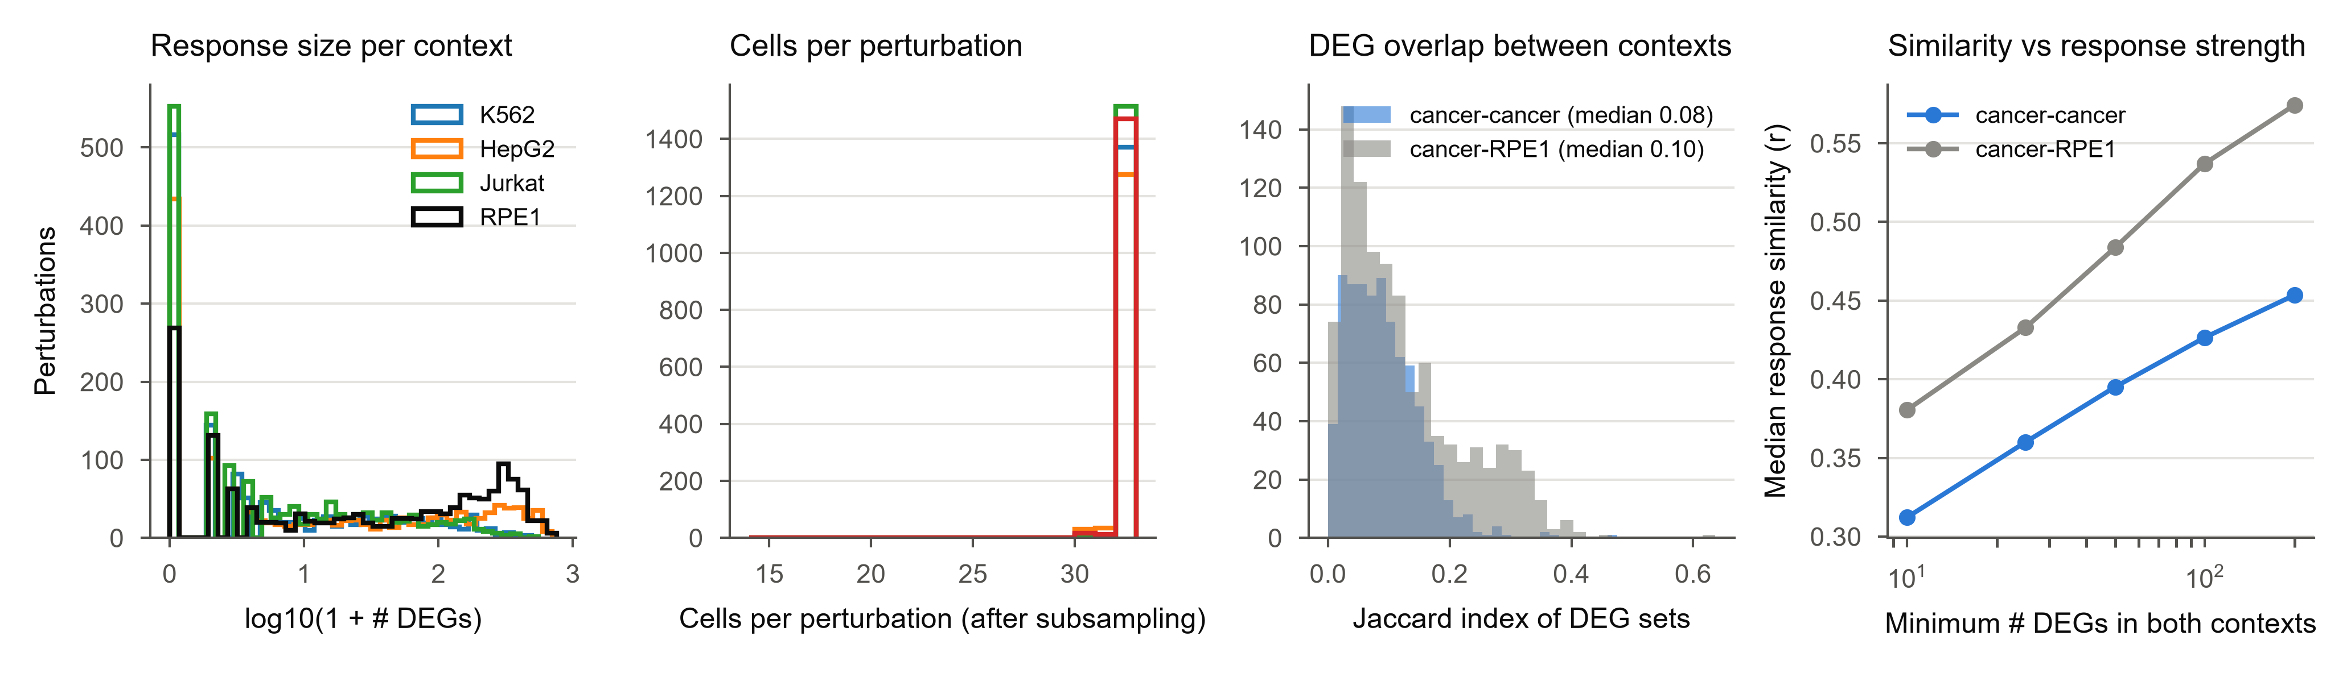
Figure S1. Response sizes and context overlap, related to Figure 1
(A) Distribution of the number of DEGs per perturbation in each context. (B) Cells per perturbation after subsampling. (C) Jaccard overlap of DEG sets between contexts. (D) Median cross-context response similarity as a function of response strength (minimum number of DEGs in both contexts).

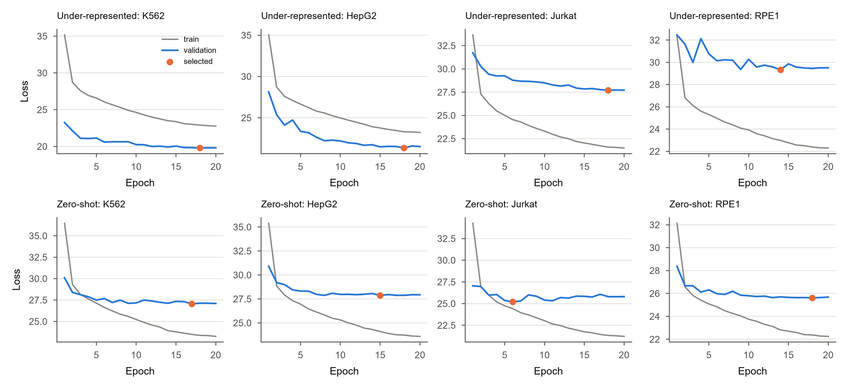
Figure S2. Training curves, related to Figures 2 and 3
Training and validation loss per epoch for every under-represented (top) and zero-shot (bottom) fold; the selected checkpoint is marked.

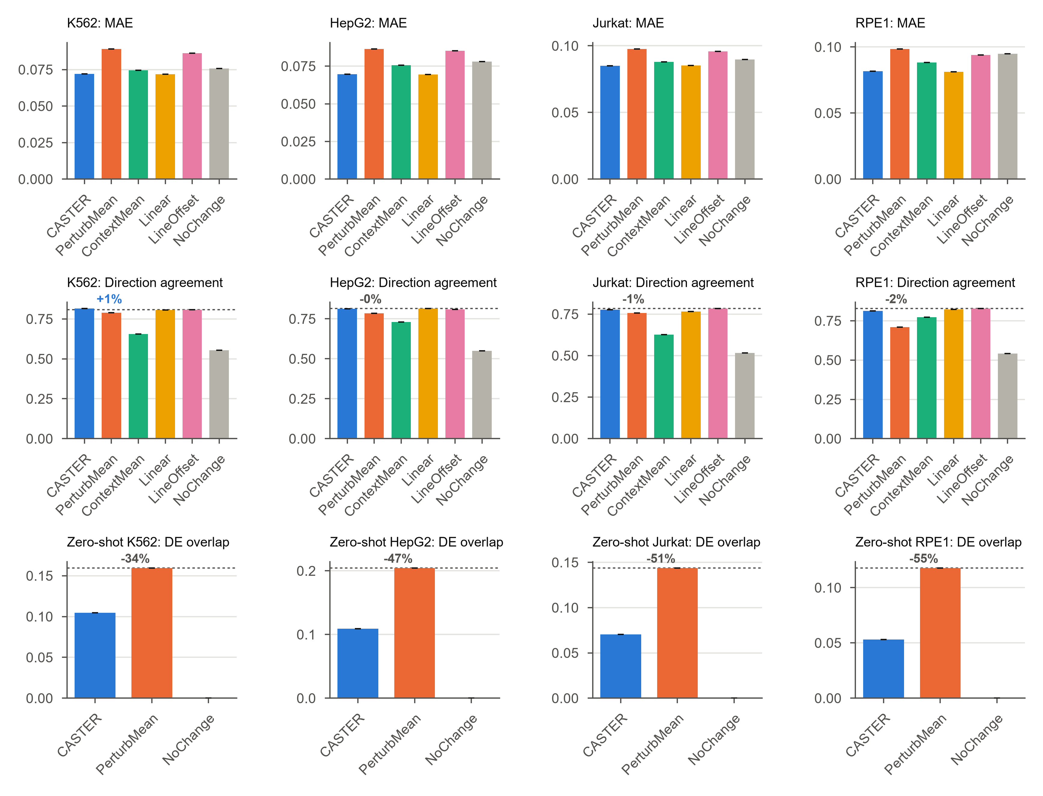
Figure S3. Secondary metrics, related to Figures 2 and 3
Mean absolute error and direction agreement per context (under-represented task), and DE overlap per context in the zero-shot task.

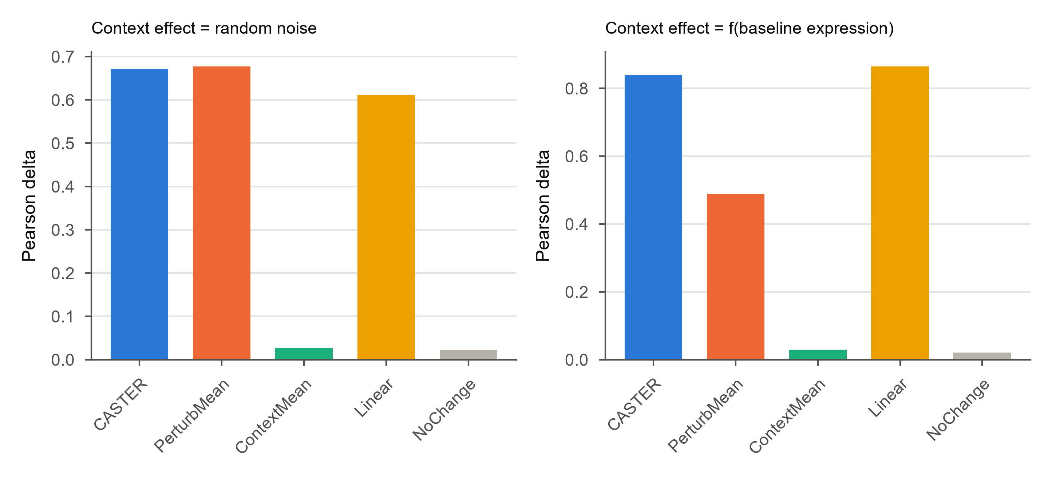
Figure S4. Positive-control simulation, related to Figure 1
Synthetic four-context data in which the context-specific component is random noise (left) or a function of baseline expression observable from control cells (right).

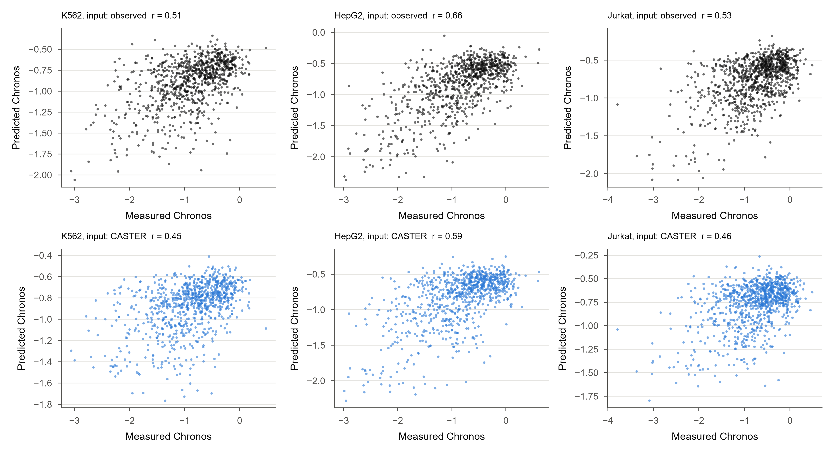
Figure S5. Dependency prediction from transcriptional shifts, related to Figure 5
Measured versus predicted Chronos gene effect per cancer line, from observed shifts (top) and from CASTER-predicted shifts (bottom).

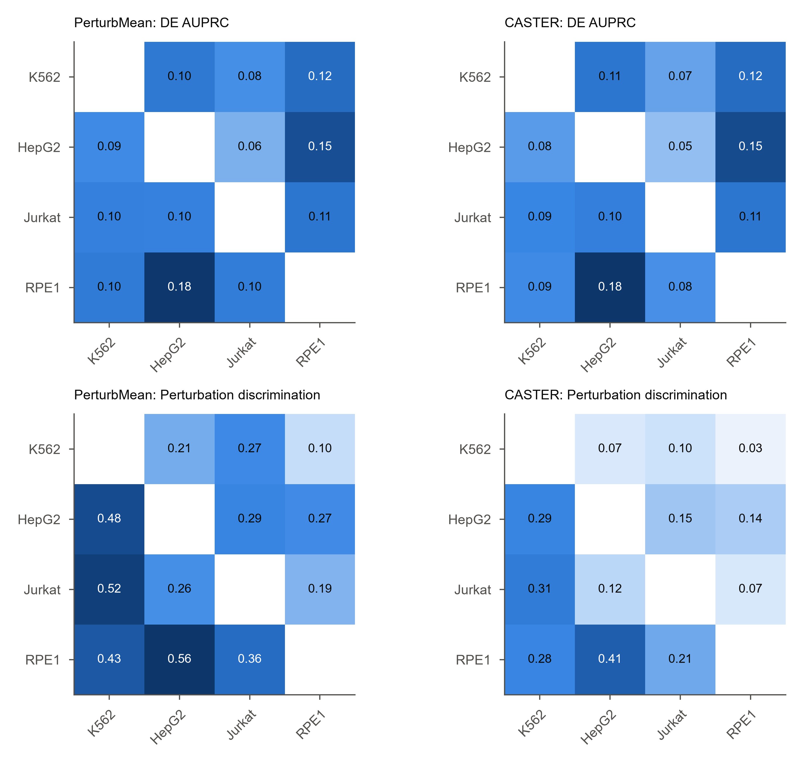
Figure S6. Single-source transfer, all metrics, related to Figure 3
DE AUPRC and perturbation discrimination for every source and target pair.

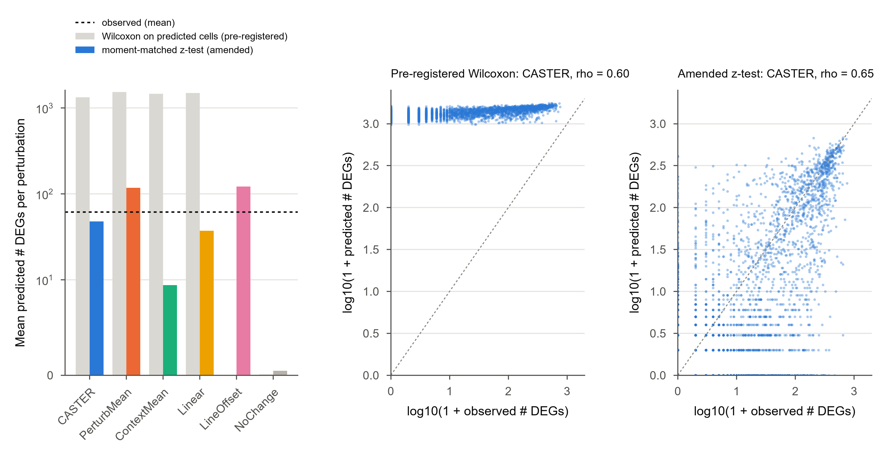
Figure S7. Predicted-side differential expression: pre-registered versus amended test, related to STAR Methods (AMENDMENT-002)
(Left) Mean number of predicted DEGs per perturbation under the pre-registered Wilcoxon test on predicted cells (grey) and the amended moment-matched z-test (colour); dashed line, observed mean. Shifted predictions turn exact zeros into small positive values, so the rank test calls most genes significant; unshifted control cells (NoChange) are unaffected. (Middle, right) Observed versus CASTER-predicted DEG counts per perturbation under the two tests.

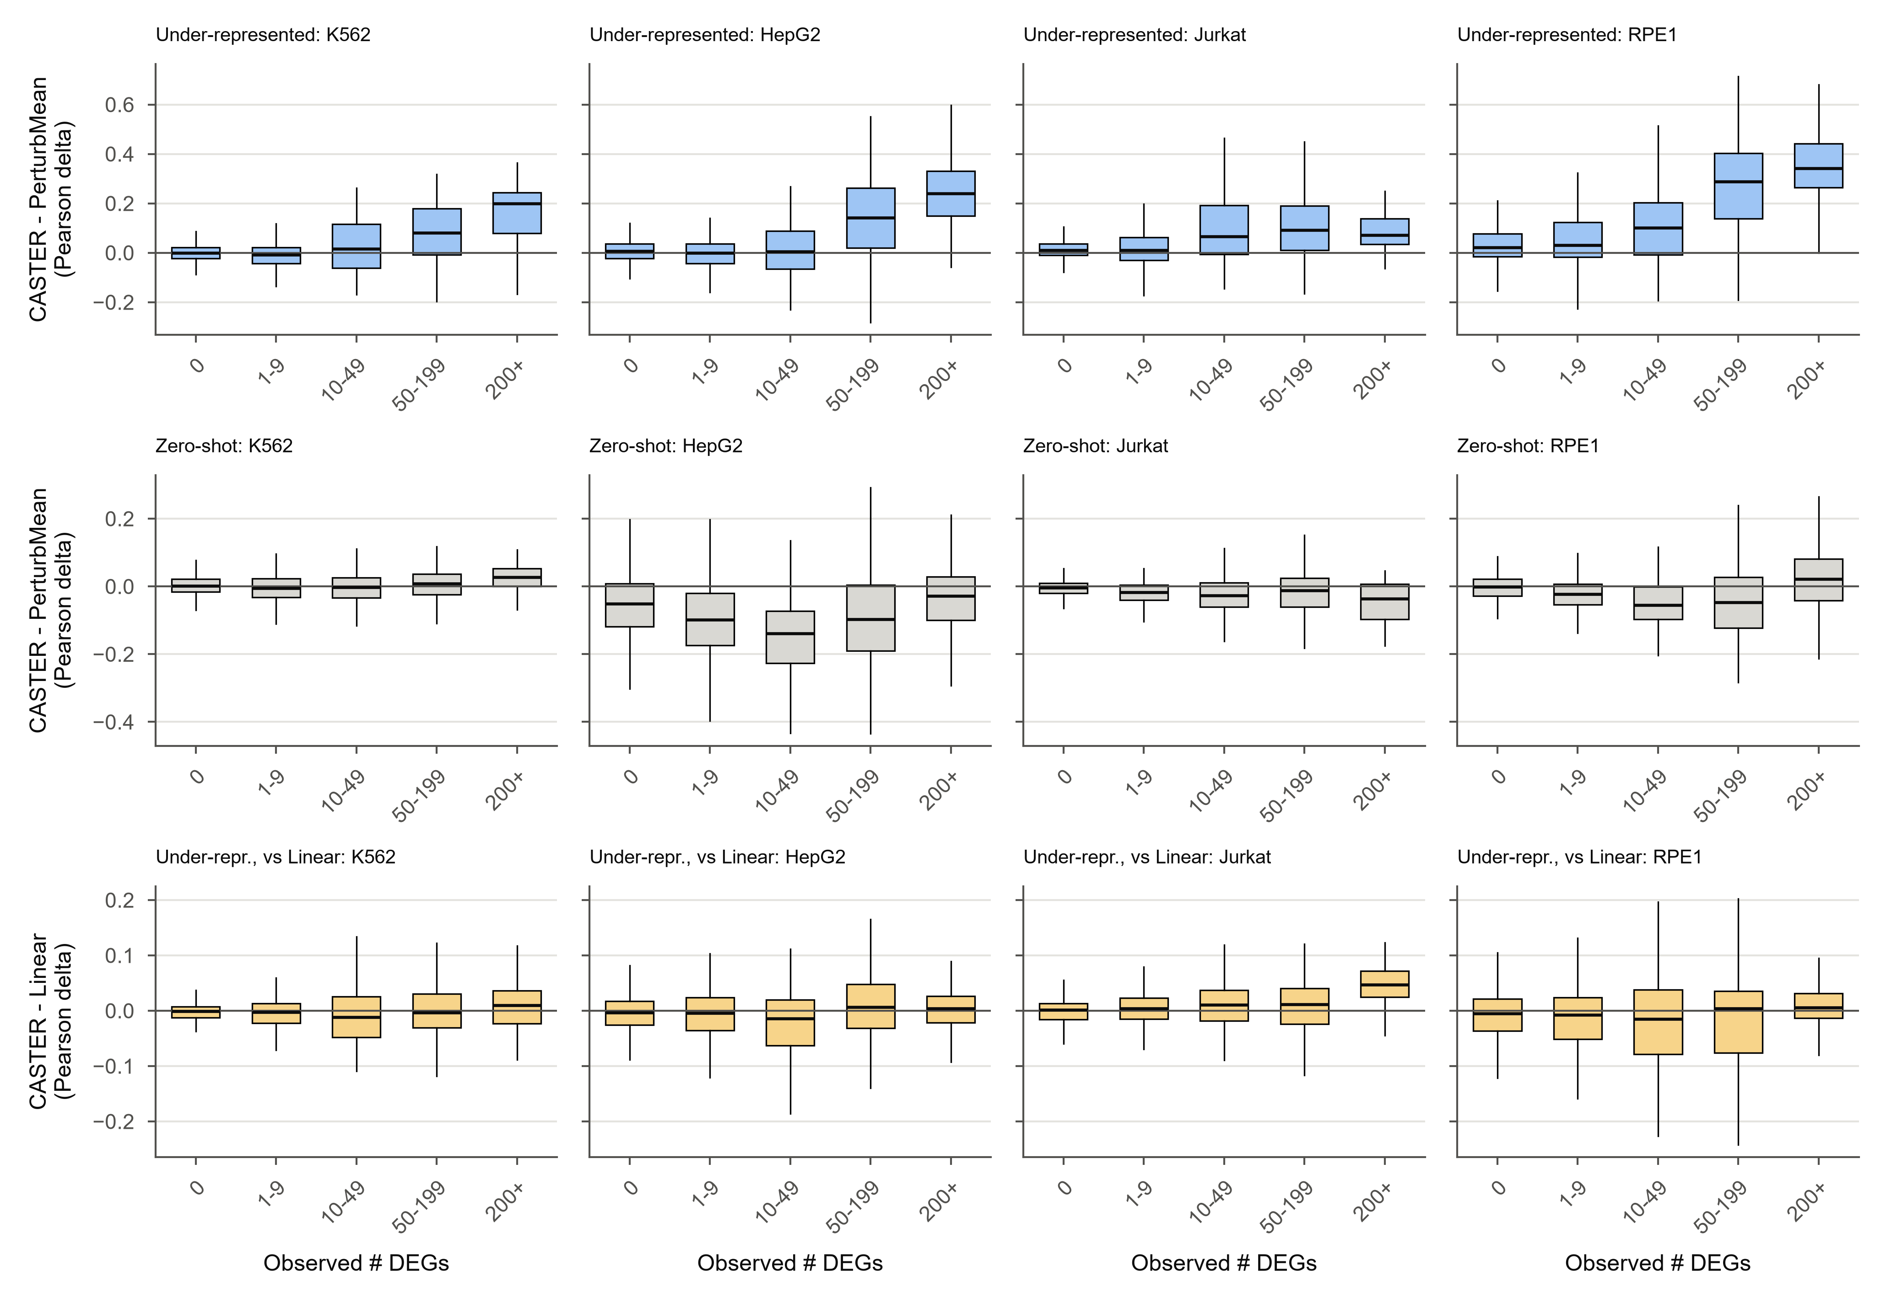
Figure S8. CASTER's gain over PerturbMean as a function of response strength, related to Figures 2 and 3
Per-perturbation difference in Pearson delta (CASTER minus PerturbMean), binned by the observed number of DEGs, for the under-represented (top) and zero-shot (bottom) tasks. Boxes, IQR; whiskers, 1.5x IQR.

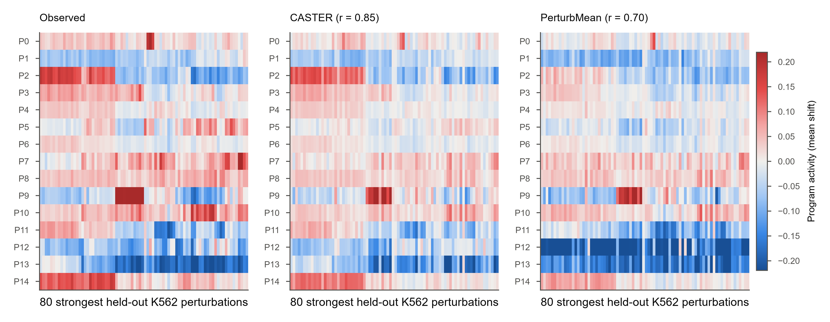
Figure S9. Gene-program activity of held-out perturbations, related to Figure 5
Activity of the 15 K562 gene programs (rows) for the 80 strongest held-out K562 perturbations (columns, clustered on the observed matrix): observed, CASTER and PerturbMean. r, Pearson correlation with the observed matrix.

Figure S10. Context-specific example knockdowns, related to Figure 4
For each cancer line, the two knockdowns (>= 30 DEGs) with the largest CASTER gain over PerturbMean: observed log2 fold change versus predicted pseudobulk shift; coloured, observed DEGs.

Figure S11. All metrics per held-out context in the zero-shot task, related to Figure 3
As Figure 2C, for the zero-shot task (CASTER, PerturbMean and NoChange).

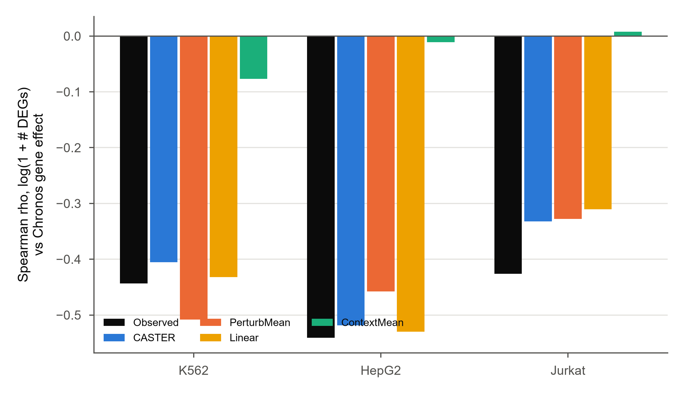
Figure S12. Dependency-response coupling in predicted responses, related to Figure 5
Spearman correlation between response magnitude (log(1 + # DEGs)) and DepMap Chronos gene effect for observed responses and for the responses predicted by each method (held-out perturbations, under-represented task).

Figure S13. p53 activity across lines, related to Figures 1 and 3
(A) Percentage of knockdowns inducing the 14-gene p53 target score (FDR < 0.05), with TP53 status. (B) Rank correlation of p53-score shifts between lines. (C) HepG2-RPE1 response similarity for knockdowns inducing p53 in both lines versus others (Mann-Whitney p). (D) Median response similarity per line pair among knockdowns inducing p53 in neither line.

Figure S14. The dependency-response link is not line-specific, related to Figure 5
(A) Spearman rho between response magnitude in one line (rows) and Chronos gene effect in each line (columns). (B) Pearson r between each line's Chronos scores and the mean of the other two lines.

Figure S15. Ribosome knockdowns and complex leakage, related to Figure 4
(A) CASTER gain over PerturbMean for ribosome-biogenesis and ribosomal-protein knockdowns versus others (random split, seed 0). (B) Median gain under complex-grouped splits, where no same-complex gene is in training. (C) Gain versus the number of same-complex genes in training (random split).

