EE P 596 Computer Vision
Classification, Deep learning, Convolutional Neural Networks
Report #3 Report, University of Washington

1. Basic tensor arithmetic
(a) Convert to a PyTorch tensor
Original OpenCV Image shape: (321, 433, 3)
Original OpenCV Image dtype: uint8
Torch Image shape: torch.Size([321, 433, 3])
Torch Image dtype: torch.float32
Torch Image Pixel dtype: torch.float32
(b) Brighten
Torch Image shape: torch.Size([321, 433, 3])
Torch Image dtype: torch.float32
Torch Image Pixel dtype: torch.float32
Max value: 351.0
(c) Saturation arithmetic
Saturated Image dtype: torch.uint8
min = 123, max = 255
  (a) Torch image (RGB, float32, shown ÷255) | 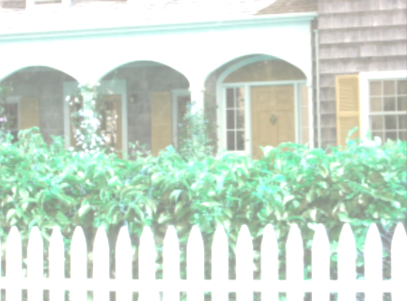  (b) Brightened (+100), clipped to 255 for display
(c) Saturation arithmetic: int16 + 100, clamp 0–255, uint8

2. Data augmentation — Gaussian noise
Noisy Image dtype: torch.float32
min = 0.0, max = 1.0
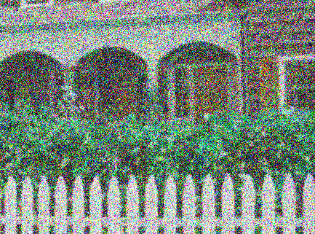
Image with Gaussian noise (mean 0, σ 100), range [0, 1]

3. Image normalization
(a) Using the image's own statistics
Image mean (R, G, B): [119.262, 139.6622, 123.3738]
Image std (R, G, B): [60.5137, 54.6588, 60.5748]
After normalization mean: [0.0, 0.0, 0.0]
After normalization std : [1.0, 1.0, 1.0]
dtype: torch.float64
(b) ImageNet statistics
ImageNet-normalized dtype: torch.float64
min = 0.0, max = 1.0
  (a) Own-image normalization (min–max stretched for display only) |   (b) ImageNet normalization, clamped to [0, 1]

4. Dimension rearranging
Before (H, W, C): torch.Size([321, 433, 3])
After (N, C, H, W): torch.Size([1, 3, 321, 433])
dtype: torch.float32

5. Stride convolution (Scharr_x, stride 2)
Input shape: (610, 914)
Output shape: torch.Size([305, 457])
Output type: torch.FloatTensor
min = -2600.0, max = 3485.0
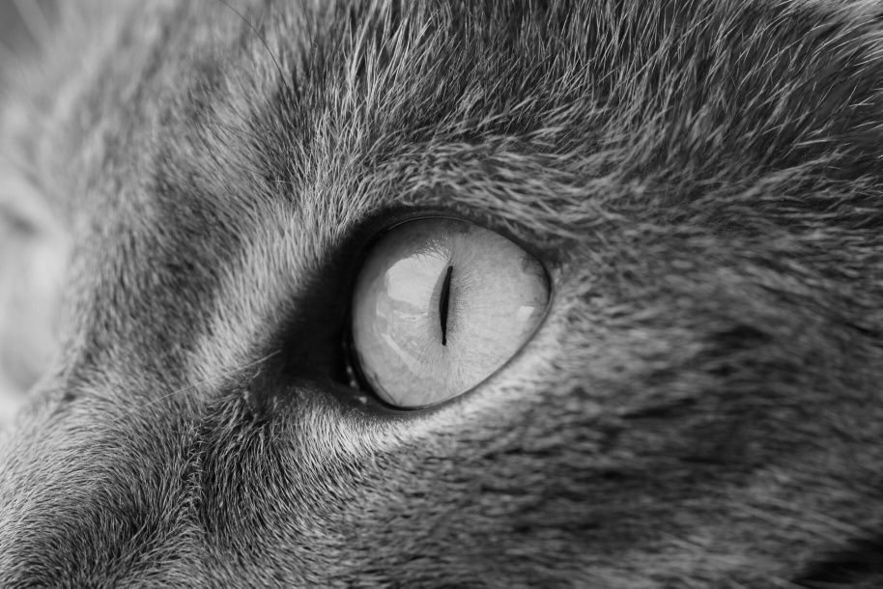  Input: cat_eye.jpg (grayscale) | 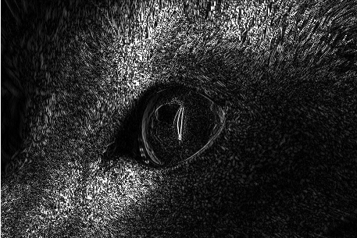  Output: |Scharr_x| response, stride 2 (contrast boosted for display)

