Static Website on AWS
1.Create a bucket and uploading Files :
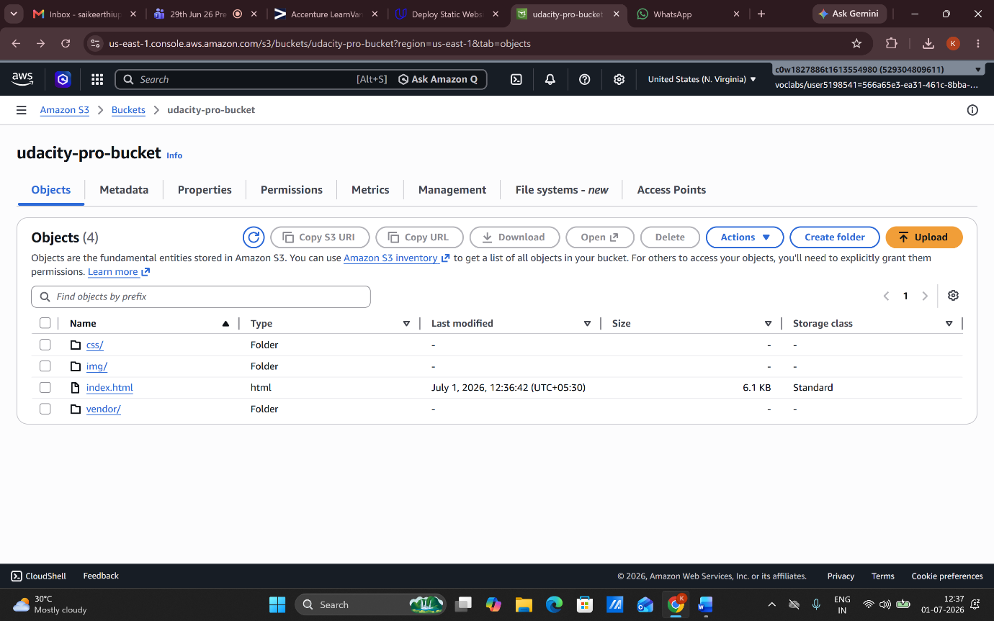
- Block public assess->off
- Bucket policy added
- Static website hosted by enabling

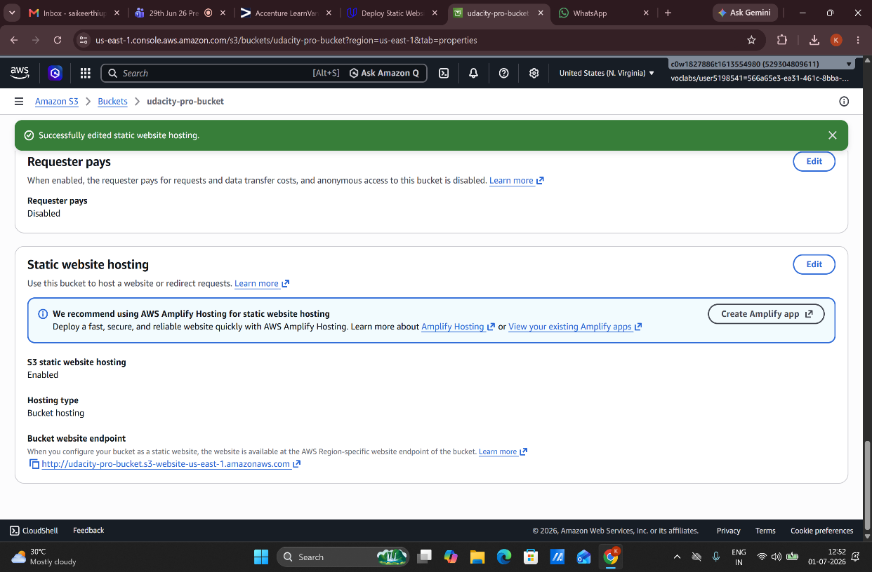


3.Distribute website via cloudfront:
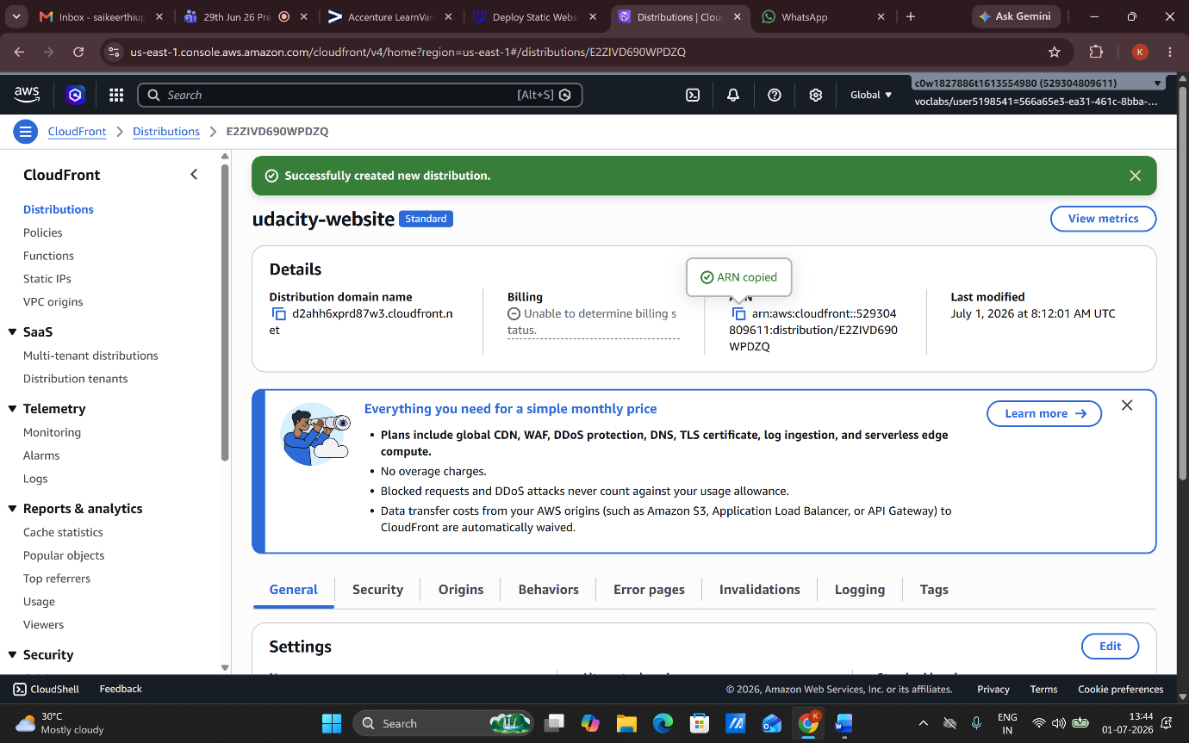

Website link:
http://udacity-pro-bucket.s3-website-us-east-1.amazonaws.com
S3 Bucket Name: udacity-pro-bucket

S3 Website Endpoint: http://udacity-pro-bucket.s3-website-us-east-1.amazonaws.com

CloudFront Distribution ID: E2ZIVD690WPDZQ

