**Team details:**

Sarath Chandra Kolisetty – [sk83g@umsystem.edu](mailto:sk83g@umsystem.edu)  
Github links:  
Presenation: <https://github.com/sarath98-lab/spring-2022/tree/main/Mobile/ICP-Presentation>  
Source code: <https://github.com/sarath98-lab/spring-2022/tree/main/Mobile>

Eeshwara Sai Tota – ettkv@umsystem.edu  
Github links:  
Presenation: [[https://github.com/SaiKicks/WebMobile-Spring2022/tree/main/mobile/](https://github.com/sarath98-lab/spring-2022/tree/main/Mobile/ICP-Presentation)](https://github.com/SaiKicks/WebMobile-Spring2022/tree/main/mobile/)[ICP-Presentation](https://github.com/sarath98-lab/spring-2022/tree/main/Mobile/ICP-Presentation)  
Source code: <https://github.com/SaiKicks/WebMobile-Spring2022/tree/main/mobile/>

Presentation Video:

**Introduction:**

In the ICPs 8-11, the following are the key tasks to be done for each mobile applicaiton:

Login application – Input validations, redirect from one activity intent to another.

Pizza delivery application – Liner layout, ACTION_SEND intent to send email

Display data using public APIs – Grant user permission to access internet, retrofit to fetch data from APIs

Text to speech application – Converting text to audio format

**Features:**

**Login application:**

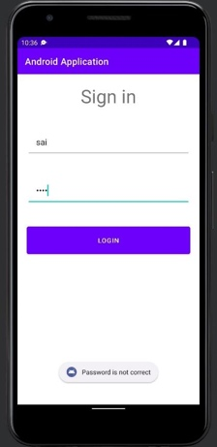 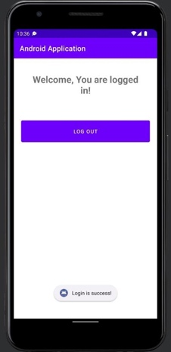

* The sign in screen has input validations if login is done using either blank fields or incorrect username or password toast message is shown.
* During a successful login, screen is redirect to a new intent screen where log out button is displayed.

Toast message:



Redirect to another activity intent:

**Pizza delivery application:**

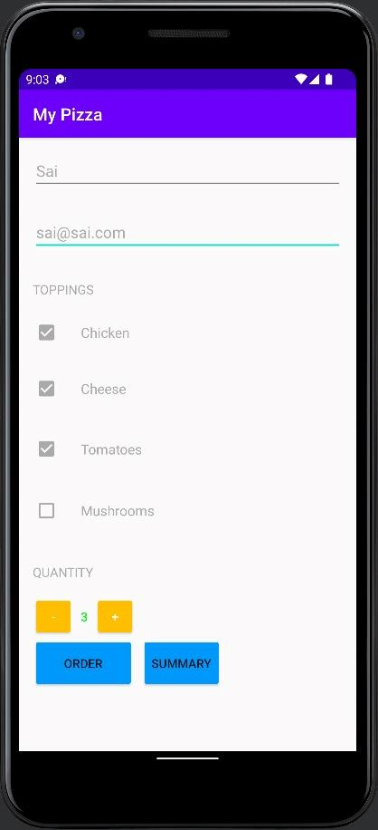 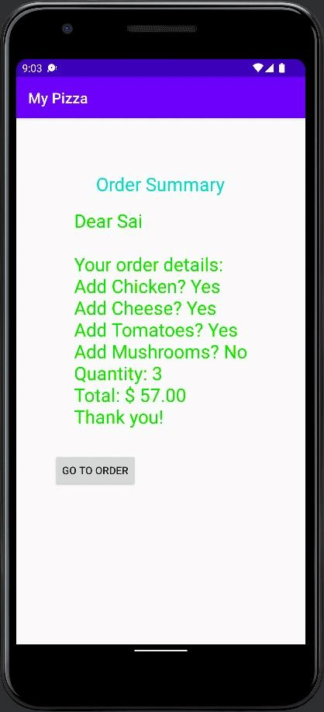 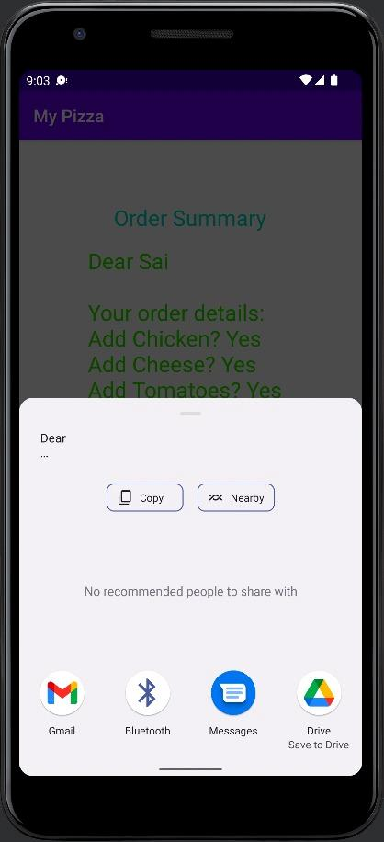

* Using the liner layout, we have designed form to order pizzas.
* To view the summary, we redirect to new intent where we calculate price associated with each item and display final bill.
* ACTION_SEND intent is used with extra information which include recipient email, subject, and content of email to send email.

Code snippet to send mail:

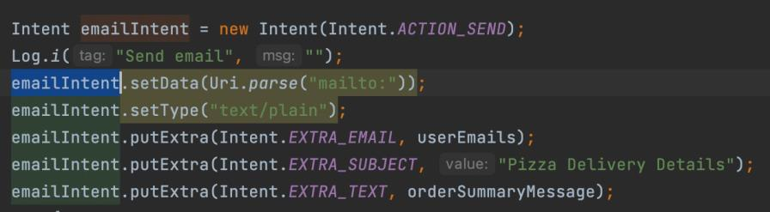

**Display data from public APIs:**

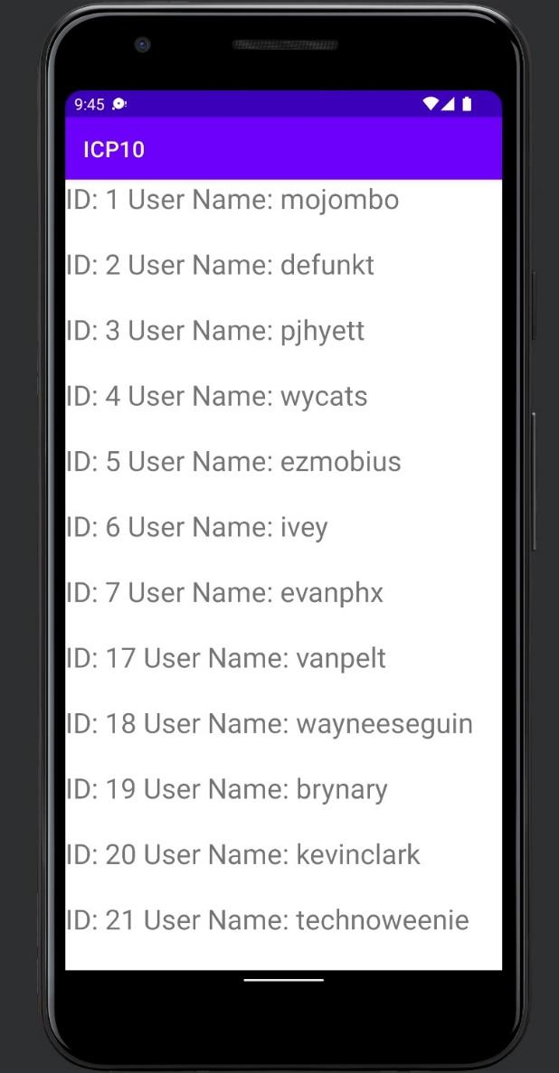

* In order to fetch data from internet, user permission is added in manifest file.
* Retrofit

Using retrofit we construct the API endpoint and fetch data from GIT public API.

Permission to access data from internet:

page1image40632320

Fetch data from GIT API

**Text to speech:**

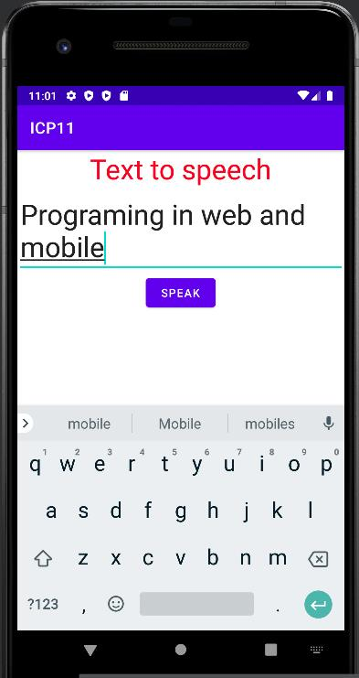

* User input is converted to text when clicked on speak button
* Using TextToSpeech listener is successfully initialized we set the desired speech rate
* and add the text to Queue.
* The input text entered is heard in audio format.

Text to speech code snippet:



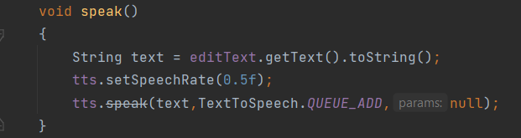

**Conclusion:**

By completing the above ICPs we have learnt:

* Develop an android application using android studio.
* The project structure followed i.e., activity_main.xml for design, MainAcitity.java for functionality and manifest file for meta data.
* Redirect from one activity intent to another.
* Access APIs using retrofit.
* To grant user permission to access hardware components like mic and speakers and interact with them.