**Quick Weather Report**

Climatic conditions play a key role in our daily work. It’s tough to undergo our daily schedule without knowing the climate. Our application “Quick Weather Report” gives you a quick information about the weather i.e. about the temperature and brief note on situation. The location is not specific to particular region it can be any place in the world.

**Technology Used:**

These application is developed for Android devices. The minimum Android version required is Froyo and it supports up to JellyBean i.e. Android 4.3.x.

In order to retrieve the weather information we have used the “OpenWeatherMap”1 web services.

Data from the weather services has been obtained in the form of JSON and parsing of JSON is done using Java techniqes.

**Tools:**

Android Tool Kit, Java 7.0.

Operating System: Windows8

**Hardware Specifications:**

* RAM required : 512MB or above
* SD Card size 51MB or above( To run the app on mobile device)

**Working Model:**

The default page consists of a text box where we need to enter the location for which we need to track the weather information.

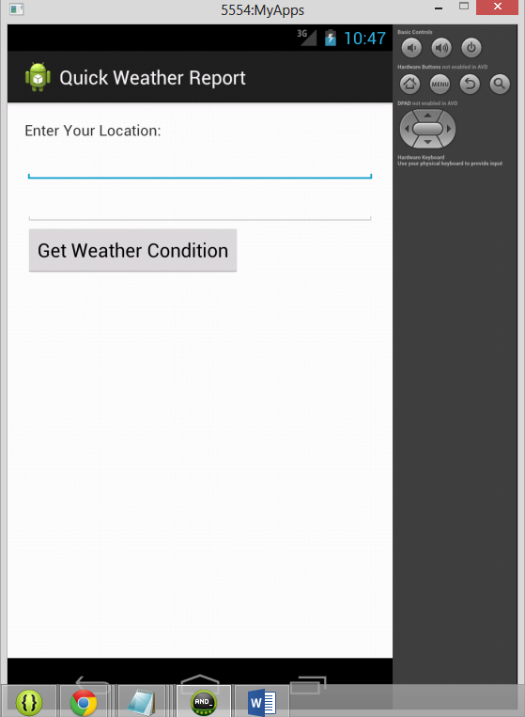

Figure Default WebPage

Under the “Enter the location” text we need to specify the address.

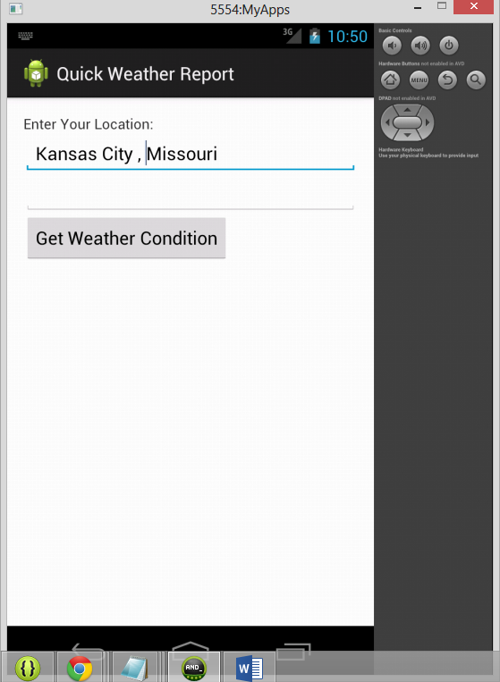

Figure enter the location

After specifying the location we need to click the button “Get Weather Condition “. After clicking this button a brief information about the climate will be displayed below the location text box.

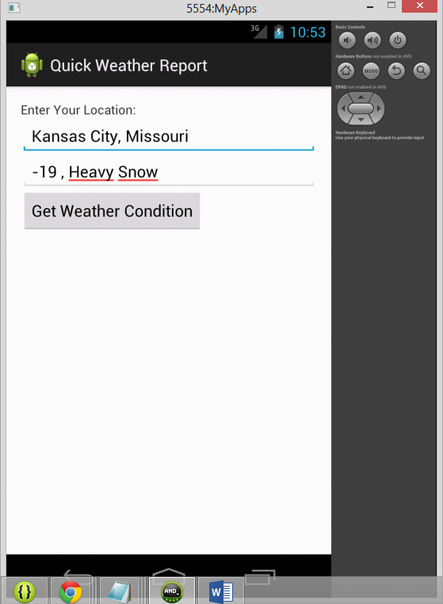

Figure Expected Result

Due to issues within the “HttpResponse” calls, we were unable to get the expected result. An exception is being occurred whenever we are trying to extract the content from weather services. As of now we were unable to run the code as the network thread is within the UI thread, we are trying to create a new thread using “AsyncTask” and trying to run the network thread in the background.

**Enhancements:**

The application will be included with some more graphics with the images of snow, wind and sun depending on the weather information and also with 3D graphics.

**Bibliography:**

1. Weather Services -- <http://openweathermap.org/API>