**EMOTION DETECTING SENSOR**

**Bandaru Sai Kishore**

**Degala Laxman Dutt**

**Arapally Ebenezer Anand**

**Kapa Avani**

**Pasala SaiKiran**

**Summary:**

As part of third increment major focus was made on the activity recognition. We were able to train the data and generate the sequence files for each trained data and were able to receive accurate results for the test data when imposed on the trained sequence files. Some part of work was done on the parsing of JSON information retrieved from the web service in the front end. We used the Http calls to retrieve the data recognition from glassfish server. Certain amount of time was spend on investigating on R java.

**Design and Implementation of Mobile Client:**

With respect to the mobile client, major focus was kept on retrieving data from the web service using the android application. No further modifications were made to the user interaction model and also none of the recommendation algorithms have been implemented in these phase. We used the traditional HttpCLient calls to retrieve the information from the web server. These data typically consists of the probabilities, and also the recognized motion. The code has been updated to the github url. Further tasks include the completion of GUI and also the respective recommendation algorithms that are insisted for each emotion.

**Design and Implementation of BigDataAnalytics:**

**Motion/activity Models and Machine Learning:**

Majority of the work in the third increment has been spent on activity recognition. We have made significant progress in detecting the respective motions. We used HMM methodology to detect the motions. Here we basically use the K-means clustering to detect the activity. Each activity here i.e. each hand movement is divided into 10 segments and is being clustered. The process basically consists of three steps. In the first step we have collected the training data for two hand movements i) Facepalm ii) Stomp. We have taken the trained data for each hand movement for twelve times each. Now these trained is moved to the local cloudera machine using the WinSCP tool. The following are the snapshots of trained data collected:

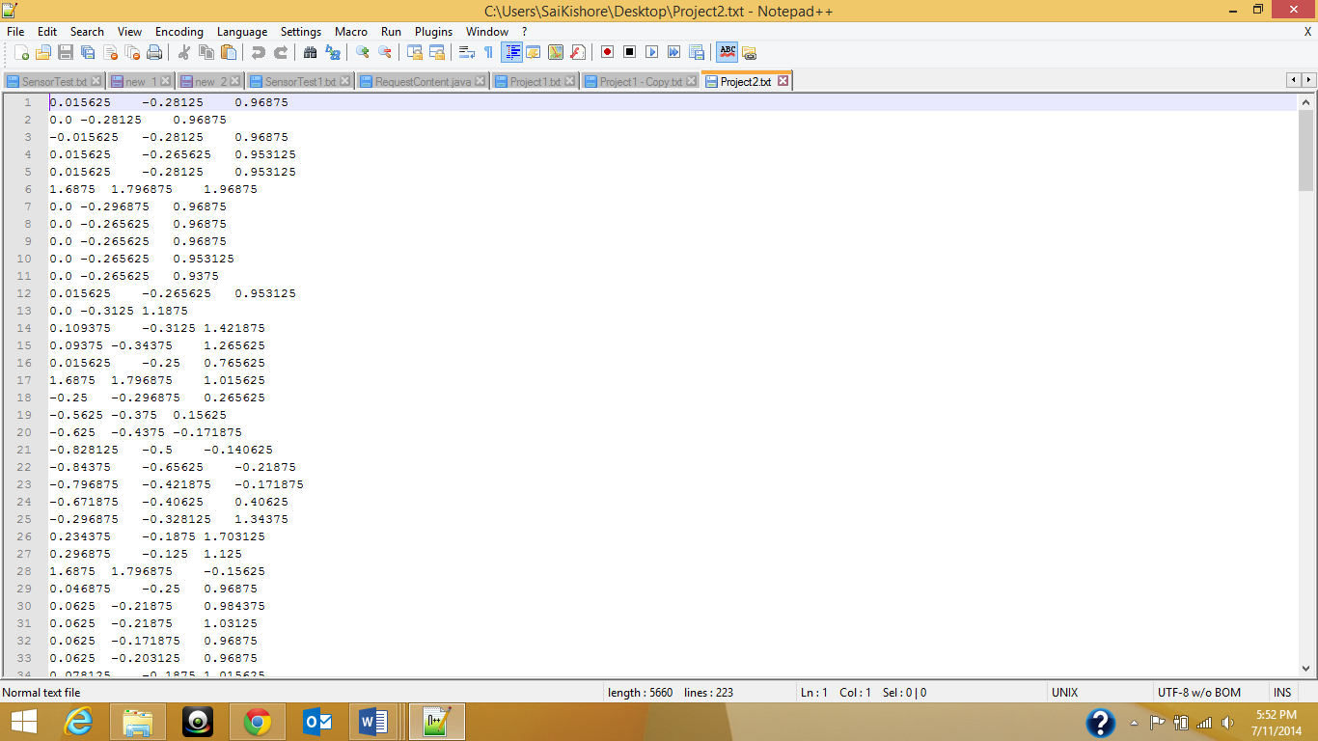

Figure Trained data for facepalm

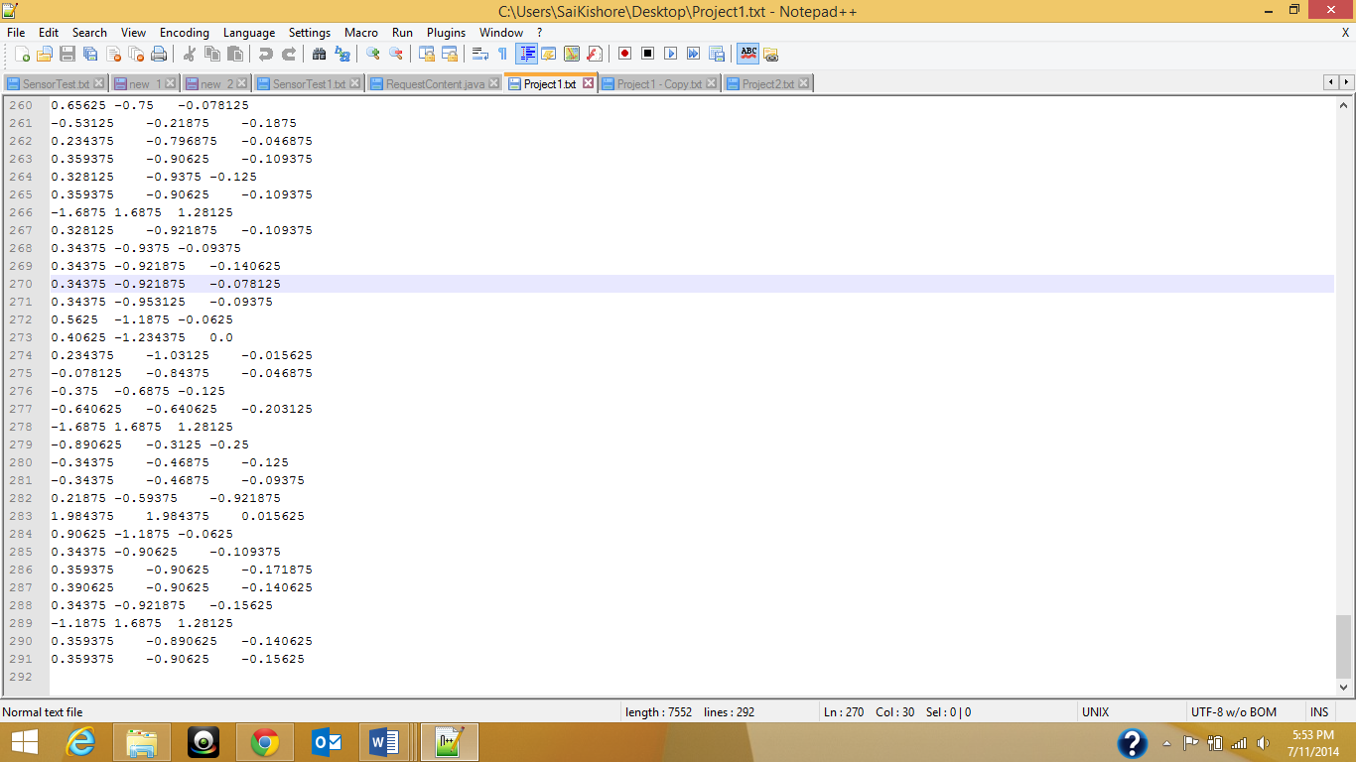

Figure Trained data for stomp

In the second step we need to generate the sequence files for each of the motions respectively. After generating the sequence files, store them in an accessible location. Now once you are done with getting training data you need take the testing data. Now take the testing data for stomp or facepalm and the data should contain the hand movements only for single time. Now generate the sequence files for the testing data too. The following are the snapshots for the sequence files generated:

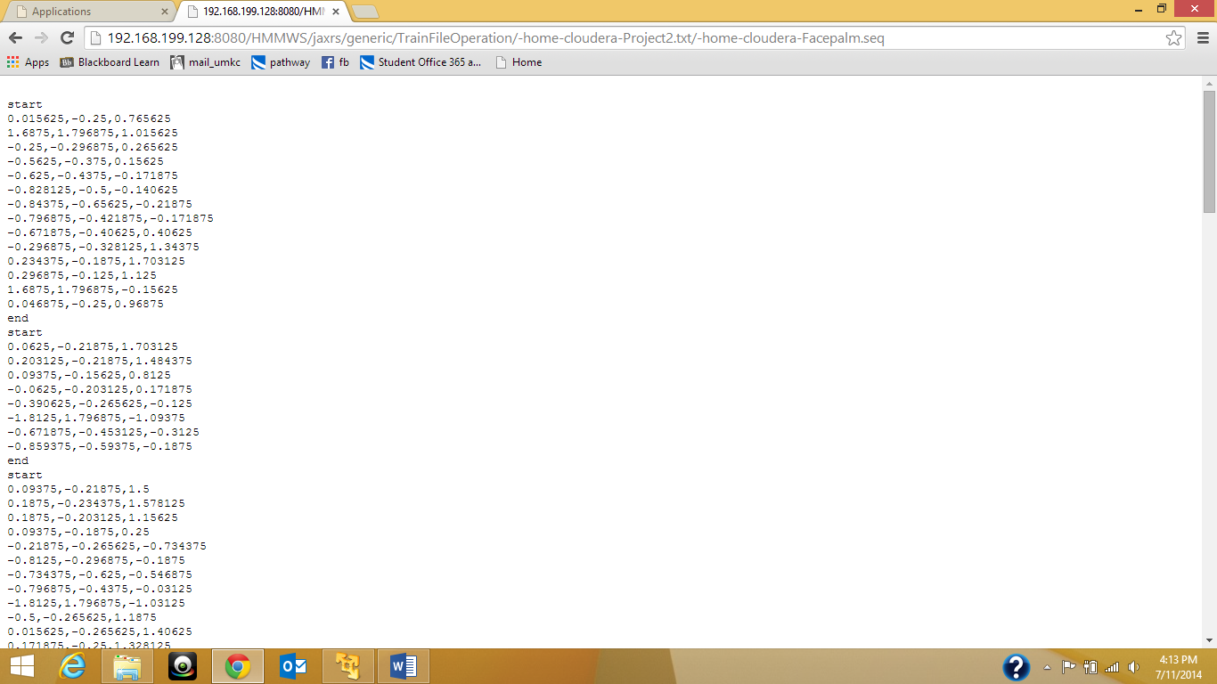

Figure Sequence file for face palm

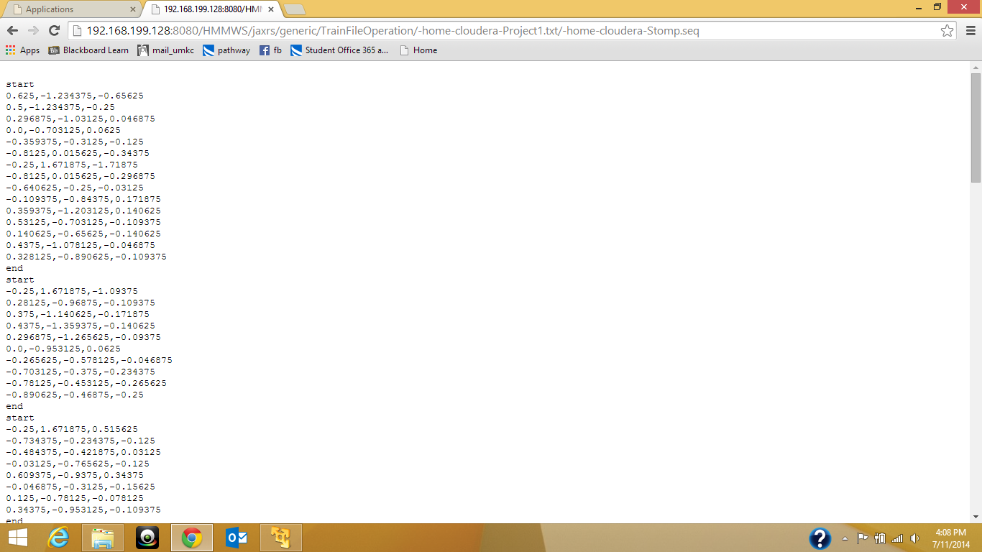

Figure Sequence file for stomp

After generating the sequence files for the test data, apply these test data sequence file on the trained data sequence files and trace out which motion it represents i.e. either stomp or facepalm. The following snapshots shows the activity recognition for both stomp and facepalm test data:

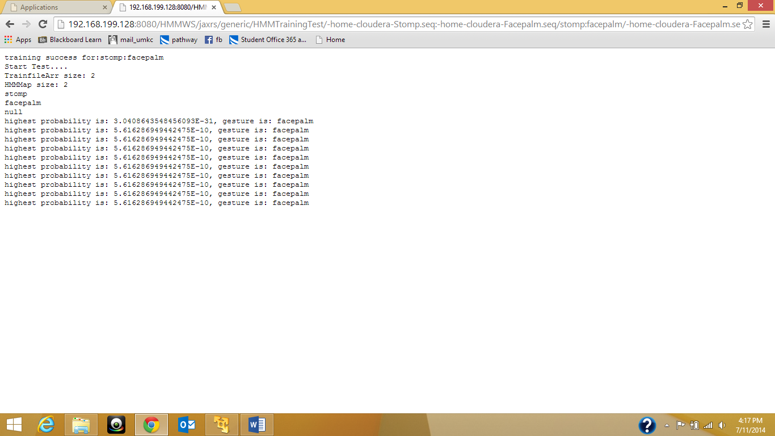

Figure Activity Recognition for facepalm

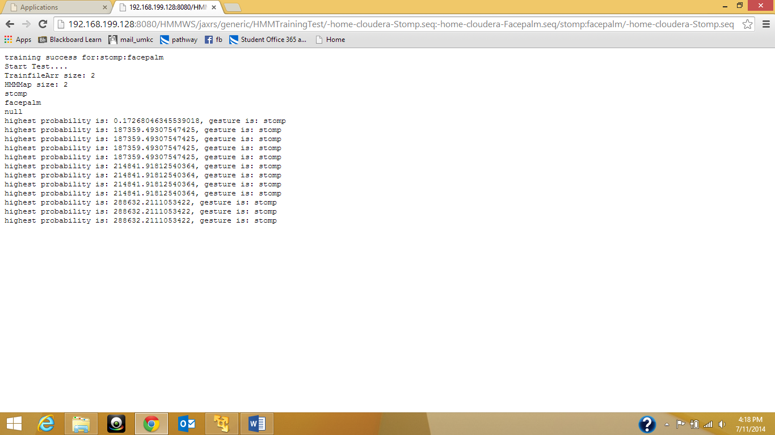

Figure Activity Recognition for Stomp

**Data Model:**

Now our data model basically keeps every three dimensional coordinate as a key, and each movement is dealt separately. So to address these kind of approach we have used each column family as one kind of emotion resembling movement. The following table Is the data model we have used for HBase storage:

|  |  |  |  |  |  |  |  |  |
| --- | --- | --- | --- | --- | --- | --- | --- | --- |
| RowKey | TimeStamp | Motion1 | | | Motion2 | | | ……. |
|  |  | X | y | Z | X | y | Z | ….. |
|  |  |  |  |  |  |  |  |  |
|  |  |  |  |  |  |  |  |  |

Detector

We are re-iterating on the implication of using HBase for the data transitions. With further investigation and as per requirement we may or may not use the HBase data transitions as a web service for the project. We also done investigation on R but due to the compatibility issues we couldn’t much concentrate on the R java implementation and suspended the relative tasks.

**Project Management:**

Since some of the tasks were yet to be completed, we have moved the completion of these tasks to the next increment. All the tasks and their increments are being updated in the scrumdo.

* [https://www.scrumdo.com/organization/umkc95/dashboard#](https://www.scrumdo.com/organization/umkc95/dashboard)​

**Fourth Increment:**

The tasks that will be included for fourth increment are:

* Activity recognition for the rest of three hand movement’s – Avani Kapa
* Embedding the implementation for detecting the sensor tag attributes in Android application, on button click and performing certain unit tests– Sai Kishore Bandaru.
* Implementation of recommendation algorithms for each emotion – Sai Kiran Pasala
* Completing the entire GUI with necessary emotion pictures and with eased user interaction and performing certain unit tests – Laxman Dutt Degala
* Implementing the ssh code for transferring the test data to cloudera – Ebenezer Anand Arapally.

The above mentioned tasks will be uploaded the scrumdo tool with specified timelines.