**EMOTION DETECTING SENSOR**

**Bandaru Sai Kishore**

**Degala Laxman Dutt**

**Arapally Ebenezer Anand**

**Kapa Avani**

**Pasala SaiKiran**

**Summary:**

As part of second increment major focus is made on the data analysis part. We used certain tools like R and investigated on certain clustering mechanisms like k-means and certain naïve Bayes classification algorithm. Our back end work majorly consists of detecting the hand movements and analyzing certain patterns for each movement. Initially we started with three movements and we have used HBase as our back end storage for collected data. Some part of work has also been spent on designing the GUI part, but not yet conclusive.

**Design and Implementation of Mobile Client:**

As mentioned prior most of our work in increment was confined to Data Analysis part and investigation on certain analytical tools. But the basic design of the GUI is being made. Basically the front page consists of two buttons which says Start and End. When you start the application you need to start your hand movement and while your movement was completed you need to click on End button. After the motion detection the user needs to click on the Detect Emotion button, which thereafter displays the kind of emotion and also certain suggestions for you in order revive yourself. The following are the screen shots of basic GUI of our application:

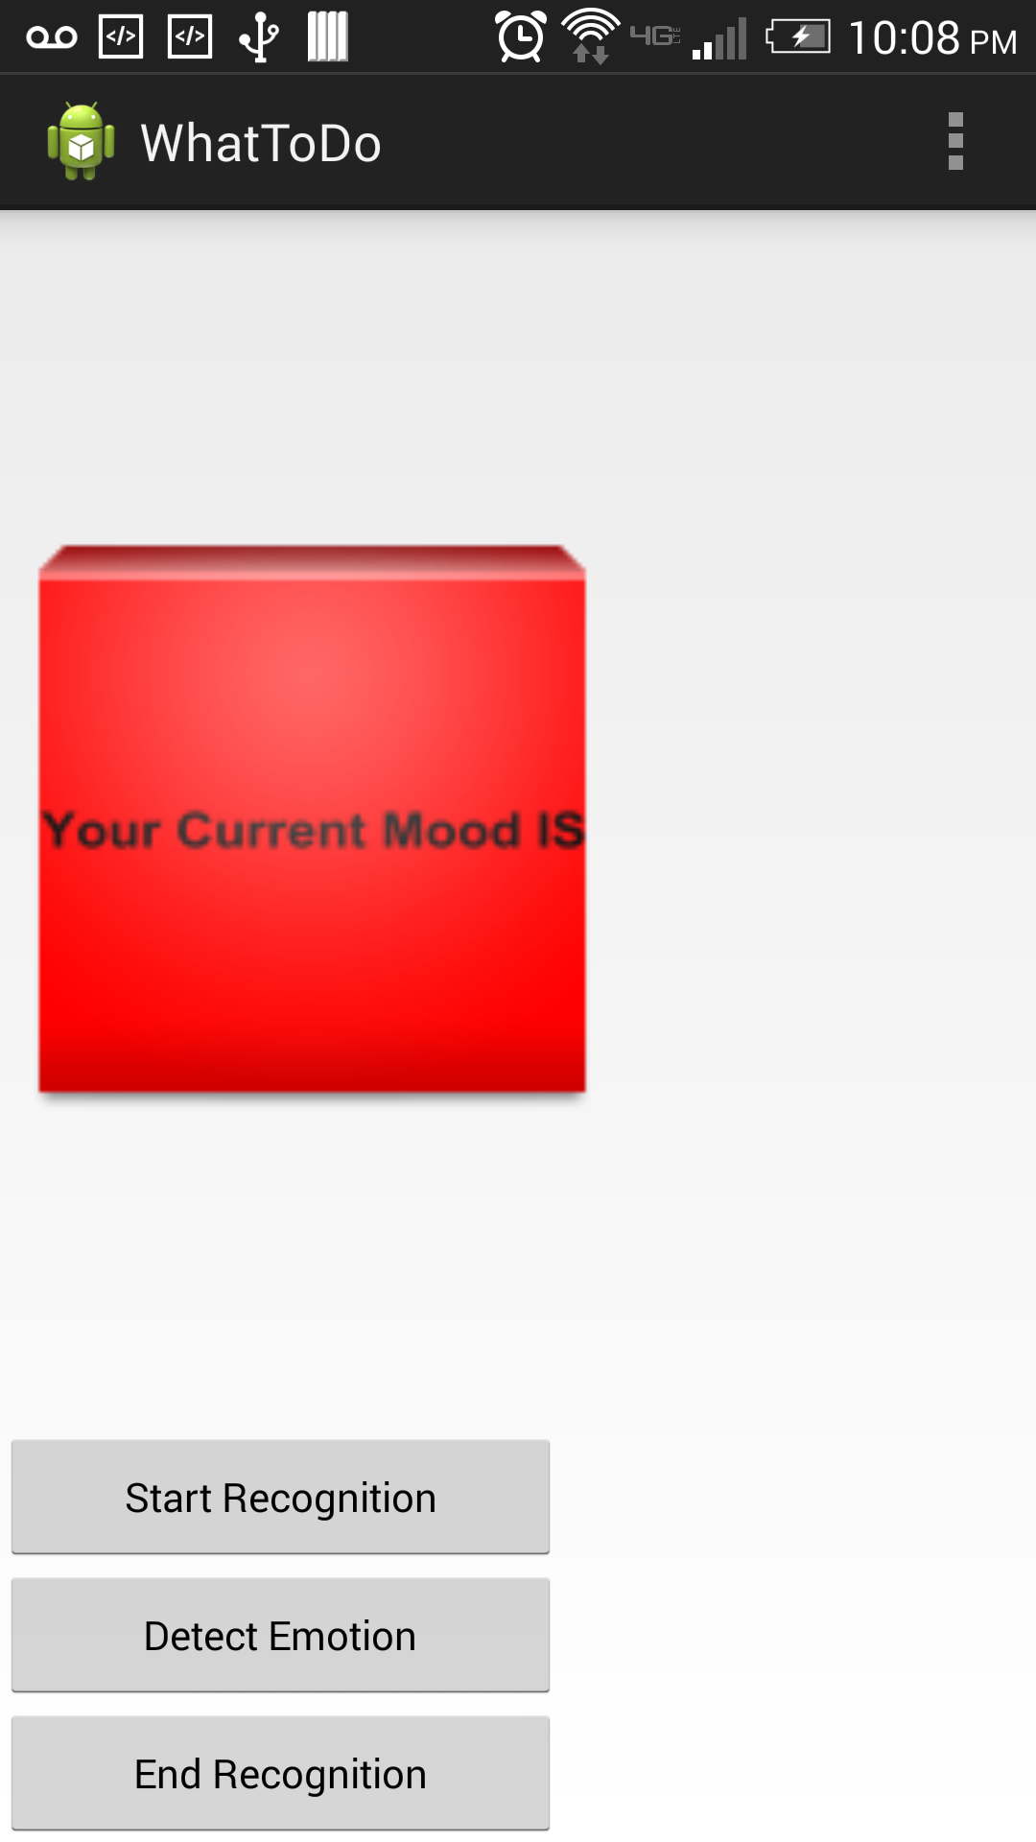

Figure GUI interface

**Design and Implementation of BigDataAnalytics:**

The major of analytics was done on detecting certain motions. We tried to analyze the patterns for each movement made by the user. So to start with we have considered “facepalm”, “High Five”, “Irritated”. In order to detect these movement’s we have sued sensor tag and traced all the hand movements using accelerometer and stored them in a file. Now these data will be stored in the HBase. The following are some of the snapshots of traced data using sensor tag:

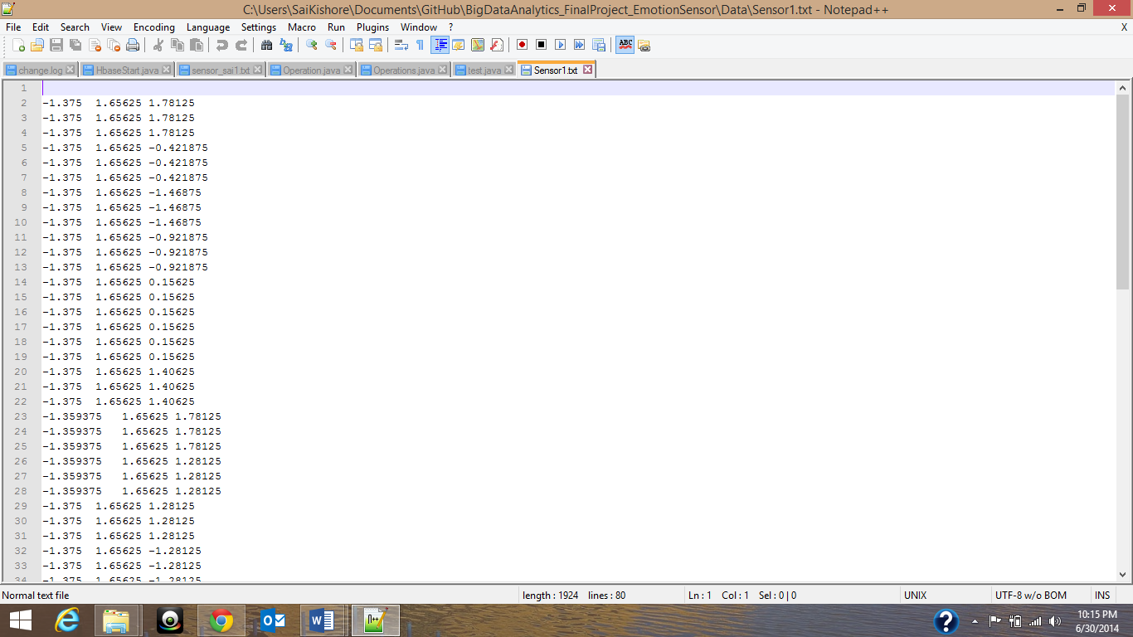

Figure Data for facepalm

**Data Model:**

Now our data model basically keeps every three dimensional coordinate as a key, and each movement is dealt separately. So to address these kind of approach we have used each column family as one kind of emotion resembling movement. The following table Is the data model we have used for HBase storage:

|  |  |  |  |  |  |  |  |  |
| --- | --- | --- | --- | --- | --- | --- | --- | --- |
| RowKey | TimeStamp | Motion1 | | | Motion2 | | | ……. |
|  |  | X | y | z | x | y | z | ….. |
|  |  |  |  |  |  |  |  |  |
|  |  |  |  |  |  |  |  |  |

Detector

So in this we will be storing the data in HBase. We have created a table named “Detector” in HBase with respective column names using the HBase shell. We have also completed the code for storing the data in HBase and has been checked into the GitHub. Once the final data is stored and accurate techniques of machine learning are done, we will be hosting these HBase data transitions as web services.

We also started investigation of using R or Mahout for our data analysis on the collected data. We have divided these work as classification and clustering. We primarily investigating on selecting the best algorithms either the Naïve Bayes or the K-means clustering so as to detect the patterns for each movement resembling the emotion. The issues while we are using K-means clustering is the entity ‘K’ , which determines different kinds of hand movements. And also we need to cluster a set of recorded three dimensional co-ordinates to each pattern. The above issues are temporal and yet to be concluded on the machine learning technique.

**Project Management:**

Since some of the tasks were yet to be completed, we have moved the completion of these tasks to the next increment. All the tasks and their increments are being updated in the scrumdo.

* [https://www.scrumdo.com/organization/umkc95/dashboard#](https://www.scrumdo.com/organization/umkc95/dashboard)​

**Third Increment:**

The tasks that will be included for third increment are:

1. Completion of the basic GUI and required validations – Avani
2. Analyzing and implementing the web services– Ebenezer Anand Arapally
3. Data Classification based on the data available and retrieving the output from classification algorithms – Sai Kishore Bandaru, Ebenezer Anand Arapally
4. Investigating and implementation of HBase data transitions and detecting patterns for traced data from sensor tag – Laxman Dutt
5. Investigating on R and K-means clustering – Sai Kiran

The above mentioned tasks will be uploaded the scrumdo tool with specified timelines.