**Lab 3 – Hbase CRUD operations and Web services**

**Summary**:

To create a Hbase program and run it as a web service in order perform the CRUD operations i.e. creation, deletion, update, retreival. For this we need to use the glassfish web server in order to host the HBase program as a service. After the hosting , we need to create an Anroid application which can access these web services from the mobile client.

**Implementation**:

The following are the steps to be followed to create a war file and to host the Hbase program as a web service on glass fish:

* Please downlaod the glassfish from the following url:
  + <http://glassfish.java.net/downloads/v3-final.html>
* Now go to the bin folder of the glassfish and run “asadmin start-domain” to start the service.
* Now right click on the HbaseWS code and export it as a war file.
* Once you have completed the creation of war file deploy it using the glassfish server console. The following figure shows the deployed war file:
* 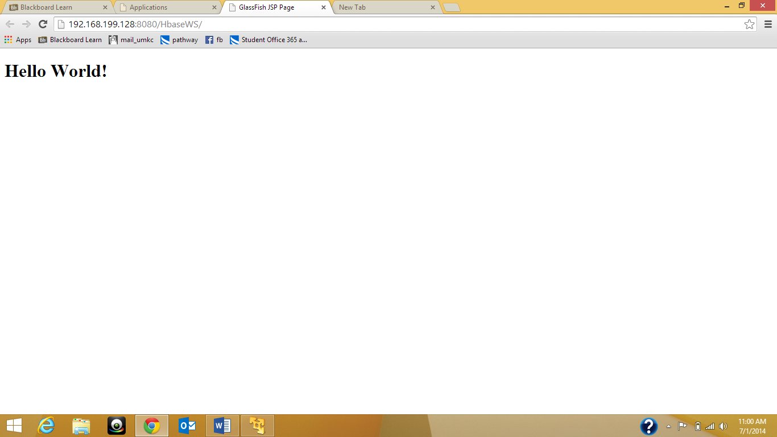

Figure 1Server Deployment

* Now you can check your web service by executing the following command for creation of a table in hbase:
  + http://localhost.localdomain:8080/HbaseWS/jaxrs/generic/hbaseCreate/Sensor3/coordinates:accelerometer:humidity:temperature:Date
* 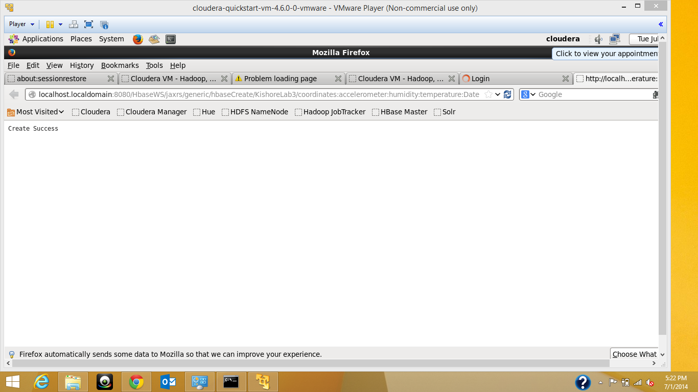

Figure 2Creation of table

* Execute the following command to insert a table:
  + <http://localhost.localdomain:8080/HbaseWS/jaxrs/generic/hbaseCreate/Sensor3/coordinates:accelerometer:humidity:temperature:Date>
* 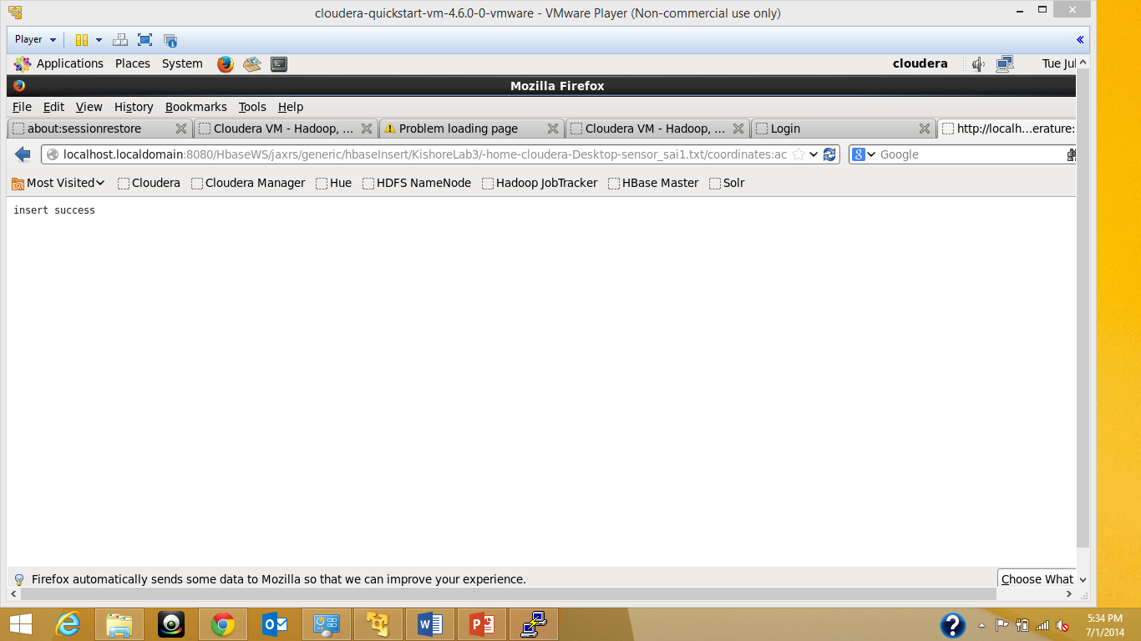

Figure 3Insert success

* Execute the following command to retrieve data from table:
  + <http://localhost.localdomain:8080/HbaseWS/jaxrs/generic/hbaseRetrieveAll/KishoreLab3>
* 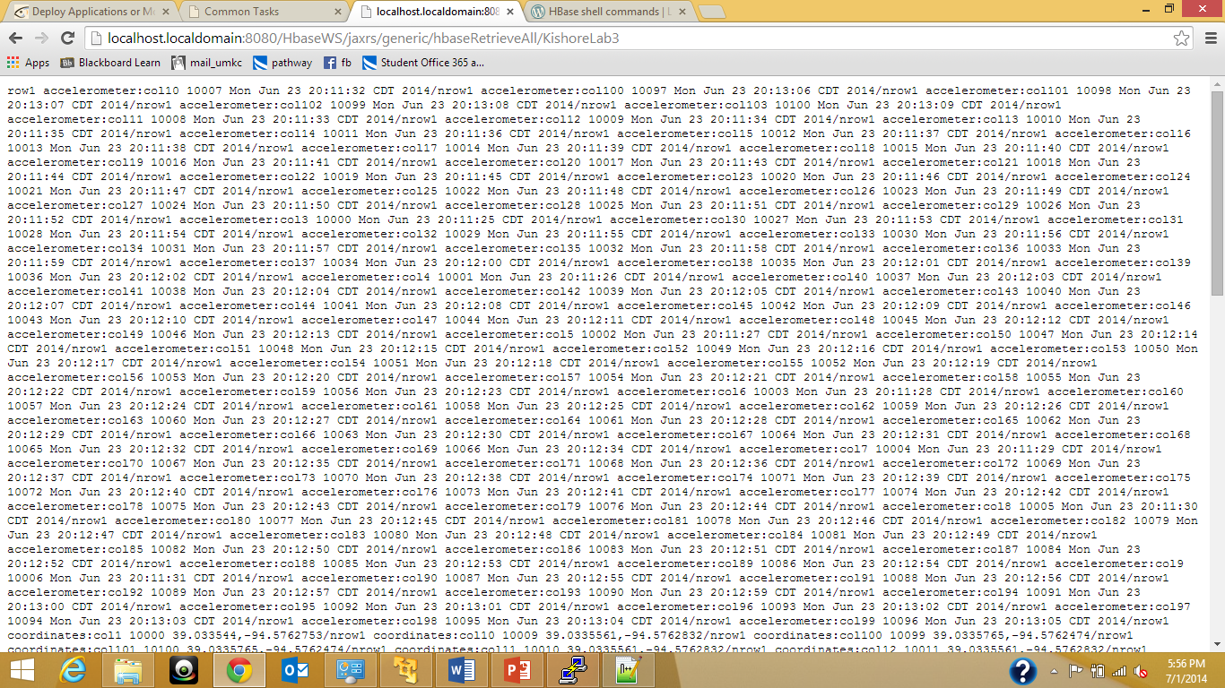

Figure 4Data Retreival

* 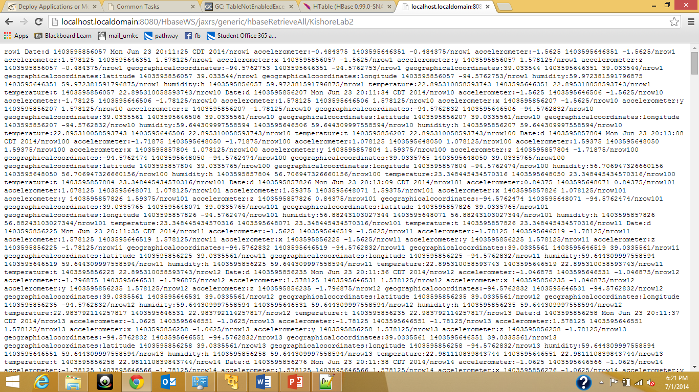

Figure 5Data Retrieval 2

The data model that I have sued will be in the following manner:

|  |  |  |  |  |  |  |  |  |  |
| --- | --- | --- | --- | --- | --- | --- | --- | --- | --- |
| Row key | Timestamp | Geographical coordinates | | date | Accelerometer readings | | | humidity | temperature |
|  |  | longitudes | latitudes |  | X | y | z | h | T |
|  |  |  |  |  |  |  |  |  |  |

KishoreLab3

**Android Implementation:**

The following is the design of the Android application, it typically consists of four buttons each one si to delete table, update data, insert data, create table into hbase respectively.

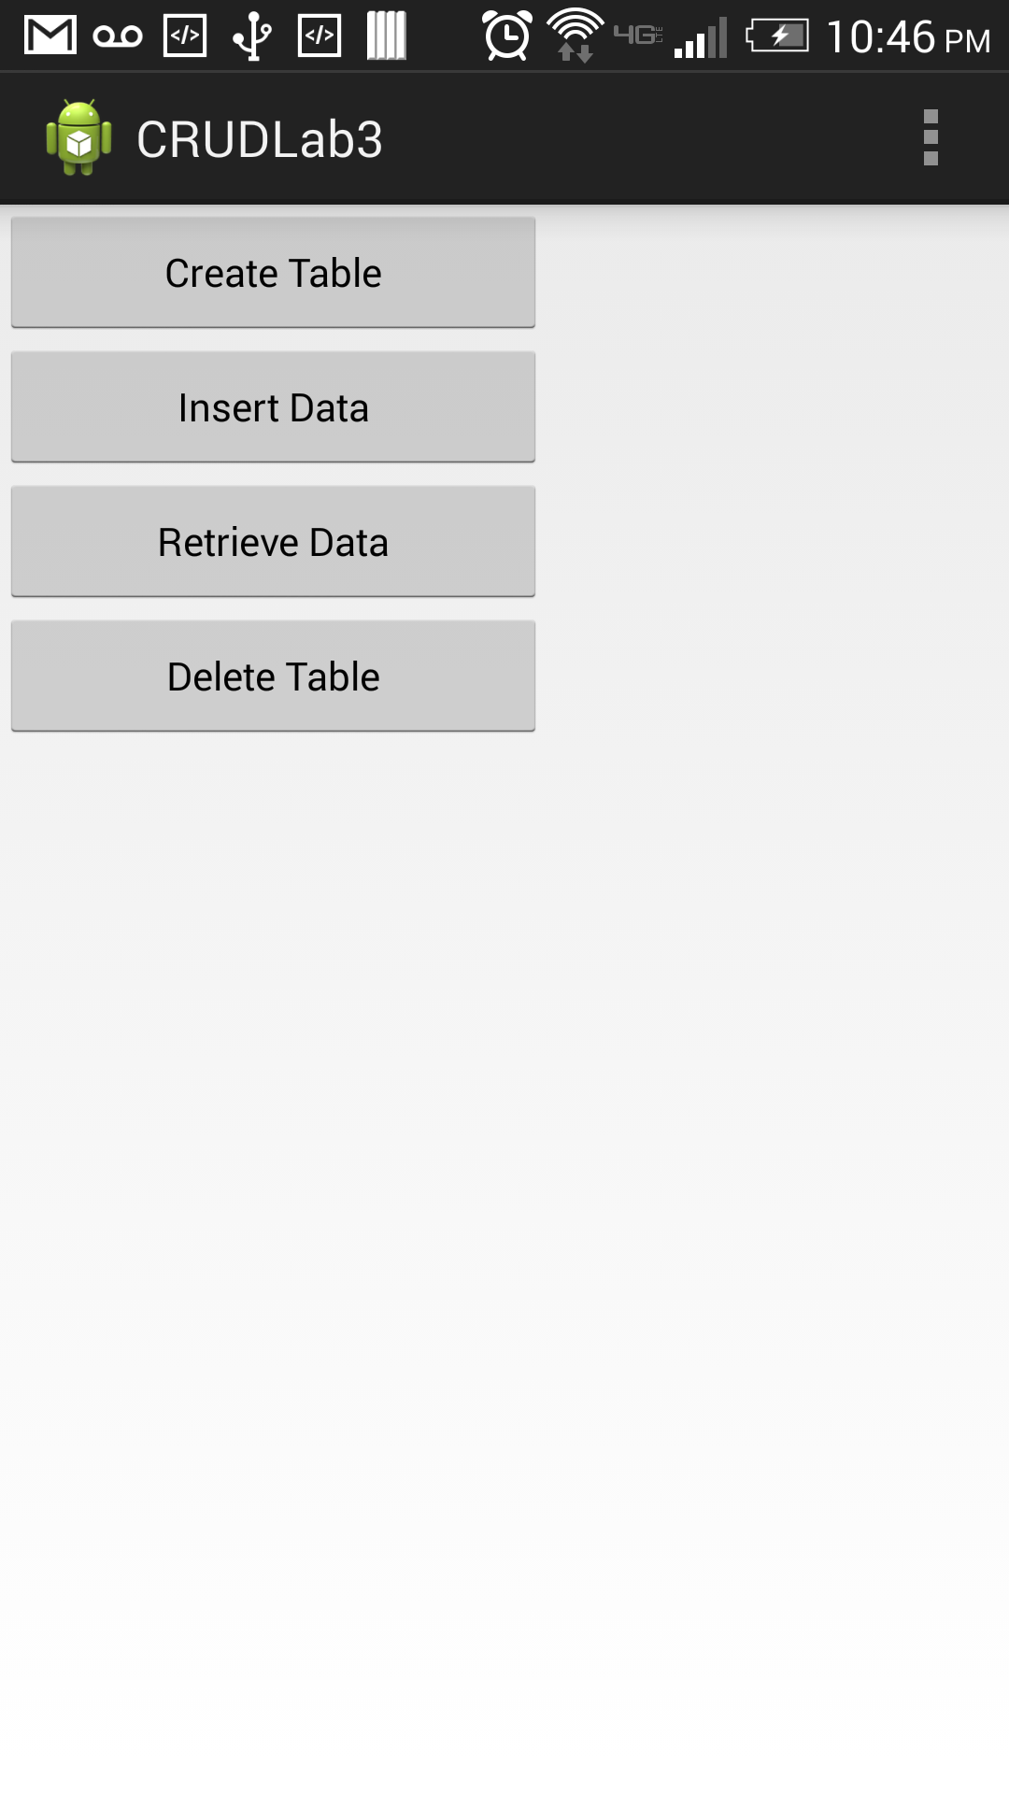

Figure 6Android GUI

Now clicking on each button you can create table, insert data, retrieve data, and delete table respectively.

Now let us see some of the outputs. The following snapshot shows the creation of a table in hbase:

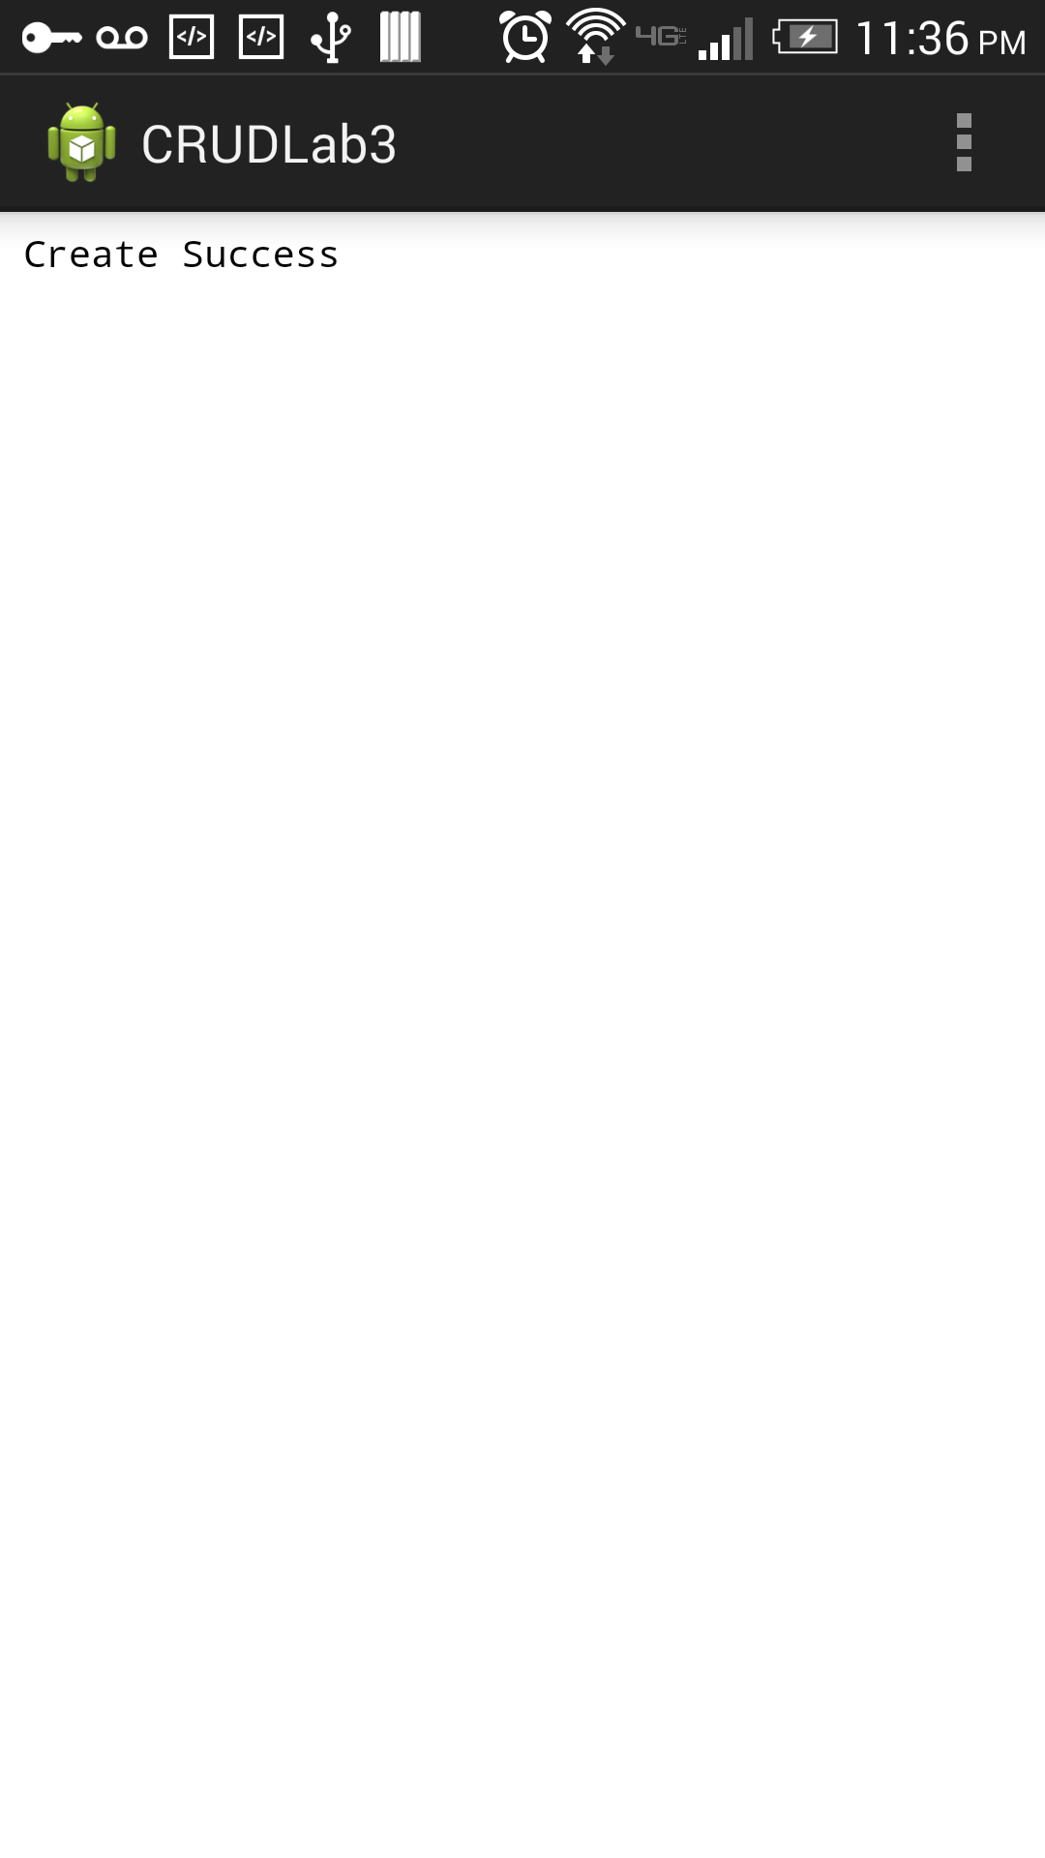

Figure 7Create Table

The following is the snapshot for deletion of a table:

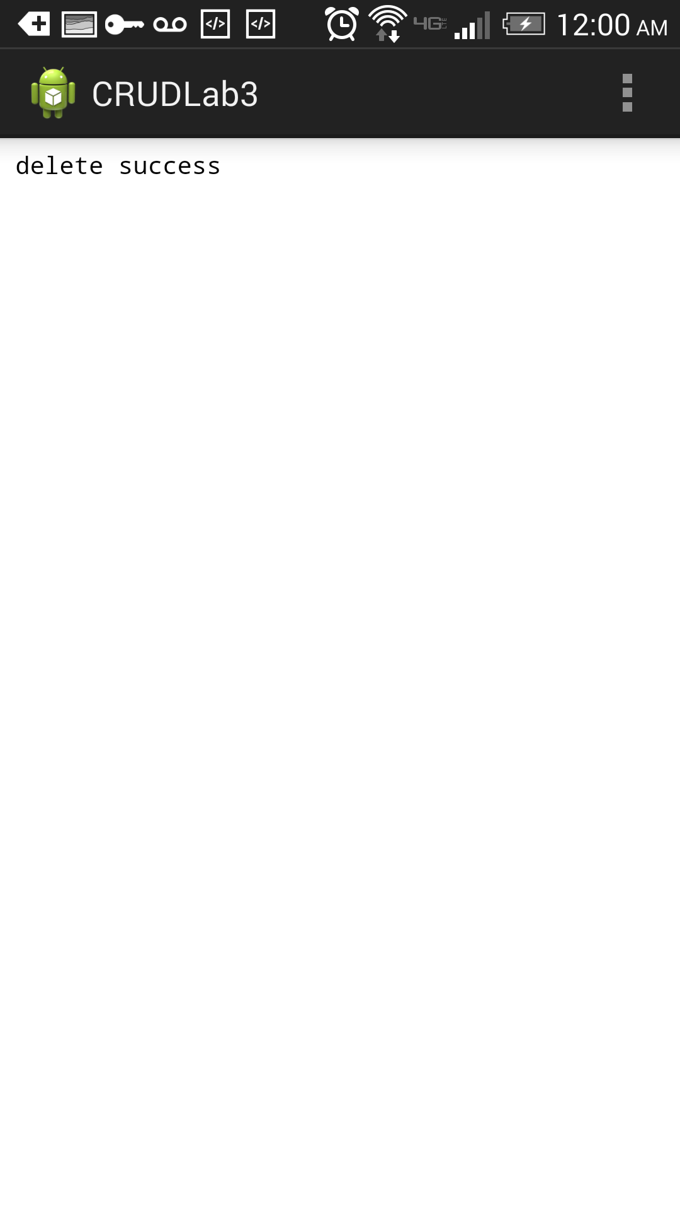

Figure 8Deletion of table

**Troubleshooting**:

* Make sure that you have access to the VMware cloud so as to access the file, otherwise the following error occurs:
* 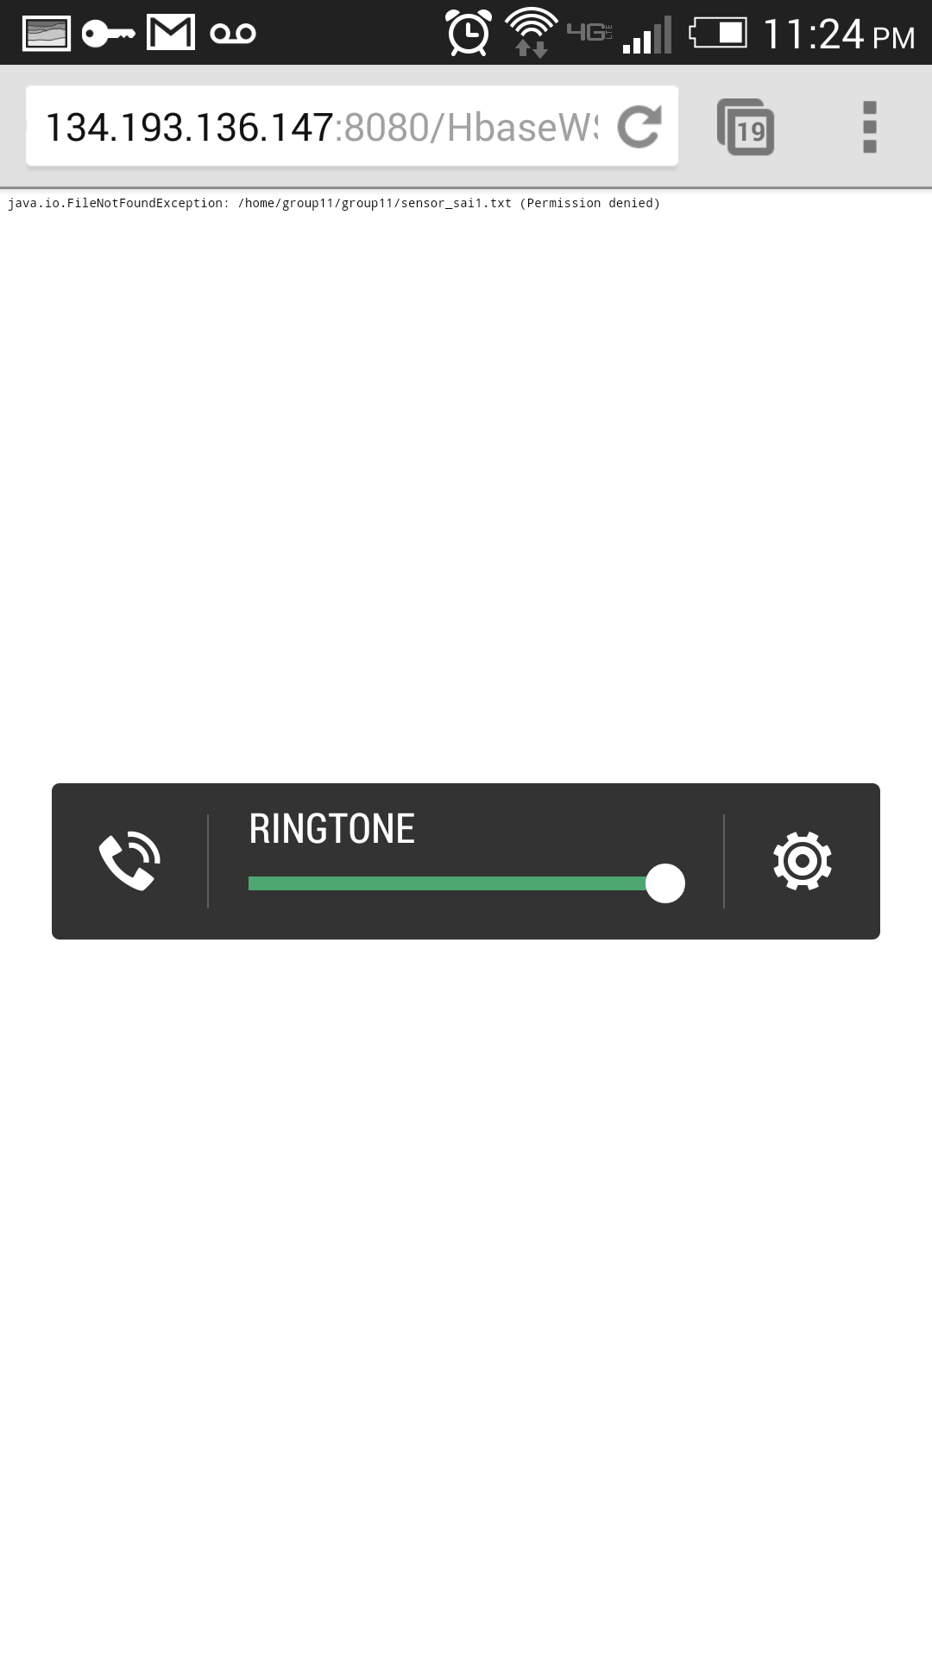

Figure 9Permission denied

* Make sure your cloudera runs on NAT network system not on vmnet.x, otherwise you will not be able to access the network
* Make sure internet permission is given in android project
* If an error occurs like ”glassfish port 4848 is in use” make sure you stop the yarn process in linux using the commands
  + Ps –ef
  + Check the processed of yarn process
  + Kill -1 ‘processid’