**Lab 1**

**Summary:**

To run the sensor related applications using Android SDK manager and visualize the outputs in the Android mobile device for the respective applications.

**Sensor Tag:**

The purpose of this device is to detect the motion in the Android application using the inbuilt accelerometer in the sensor tag. The following are the steps need to be followed for detecting the values from the sensor tag:

* Download the BLE Sensor Tag onto your local Android mobile device and install it.
* Please start the BLE Sensor Tag application and also the Sensor tag device.
* The application in the mobile device will detect the nearby sensor tags.
* Please select the respective sensor tag in the mobile device. After the selection of the sensor tag the following display will be shown on the screen of the mobile device.

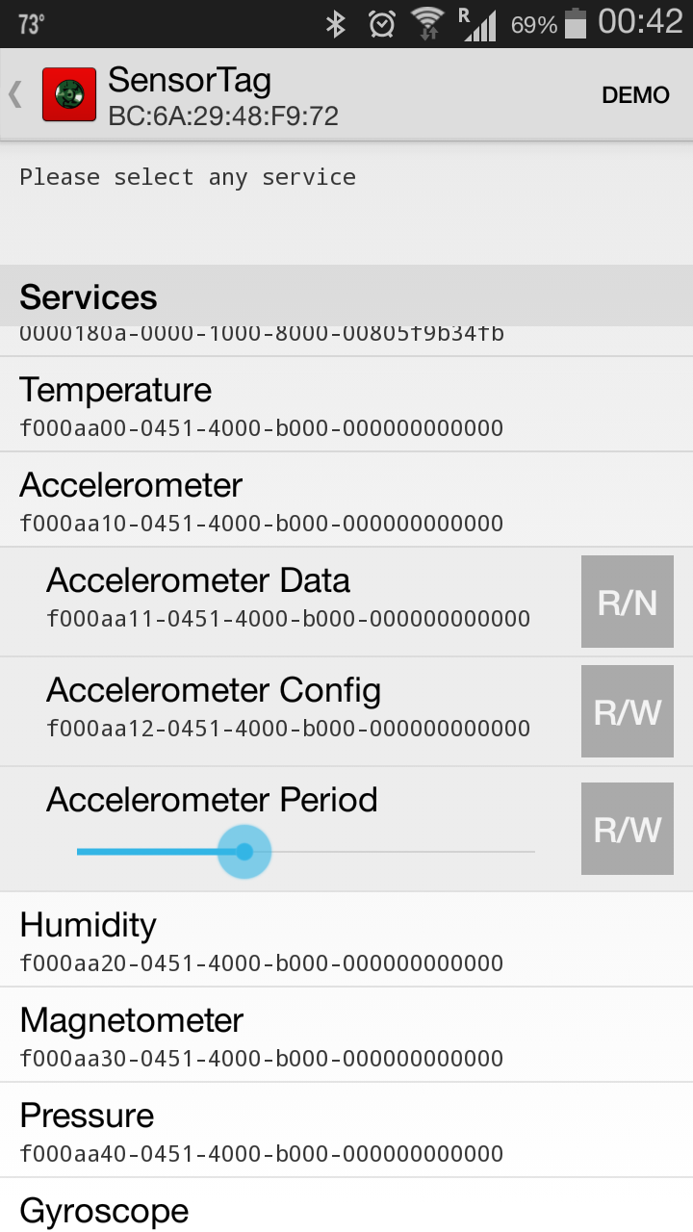

Figure 1Sensor Tag Details

* Now run the Sensor Code project from the ADK manager, to detect the motion related co-ordinates from the mobile device.
* After running the application you can view the following output in the LogCat of the respective project.

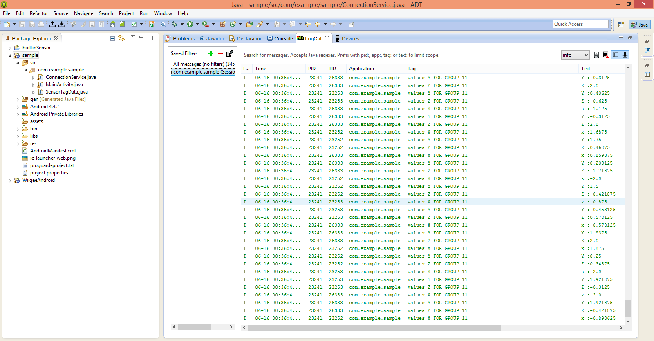

Figure 2x,y,z co-ordinates of the motion

**Mobile Sensor:**

The following is inbuilt mobile sensor in the Android device and doesn’t require any external sensor tags or so. The following are the steps to detect the motions using the inbuilt mobile sensor:

* Run the BuilInSensor project from the ADK Manger, which will prompt for the device to run the project. Select the appropriate connected Android device.
* Now when the application is run initially it will display the color of the screen to be green as shown below.

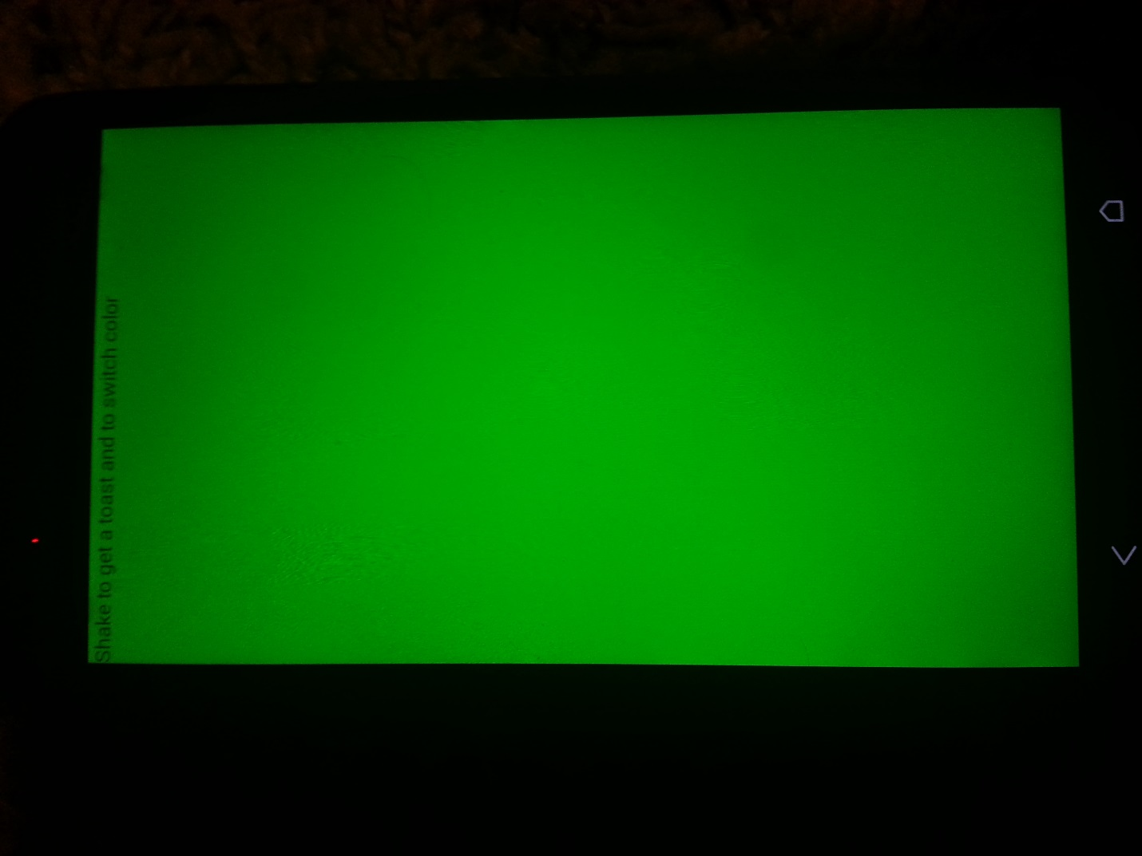

Figure 3Initial display

* Now as you turn your Android mobile device the color of the screen changes as per your hand motion.
* The following figure shows the color change due to the change in the position of the device

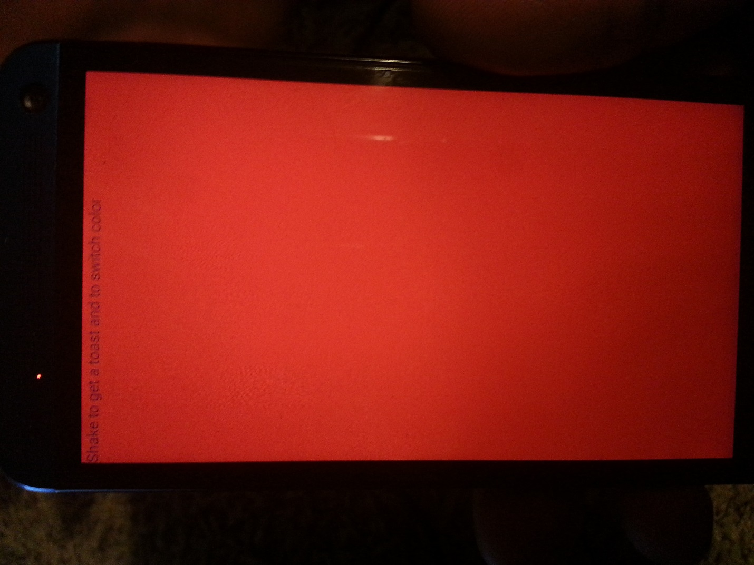

Figure 4Change in color due to the hand motion change respectively

**Wiigee Sensor:**

This sensor is used to train your motions and save it. So that any of the further motions can be detected and its resemblance can be measured for accuracy. The following are the steps to be followed for usage of the Wiigee sensor:

* Run the application WiigeeMobile project from the Android SDK Manager and select your mobile device for running the application.
* Now once the application started is started please select “Train Start” button and train your actions at least ten times. You can see the following message in the log cat whenever you start the training

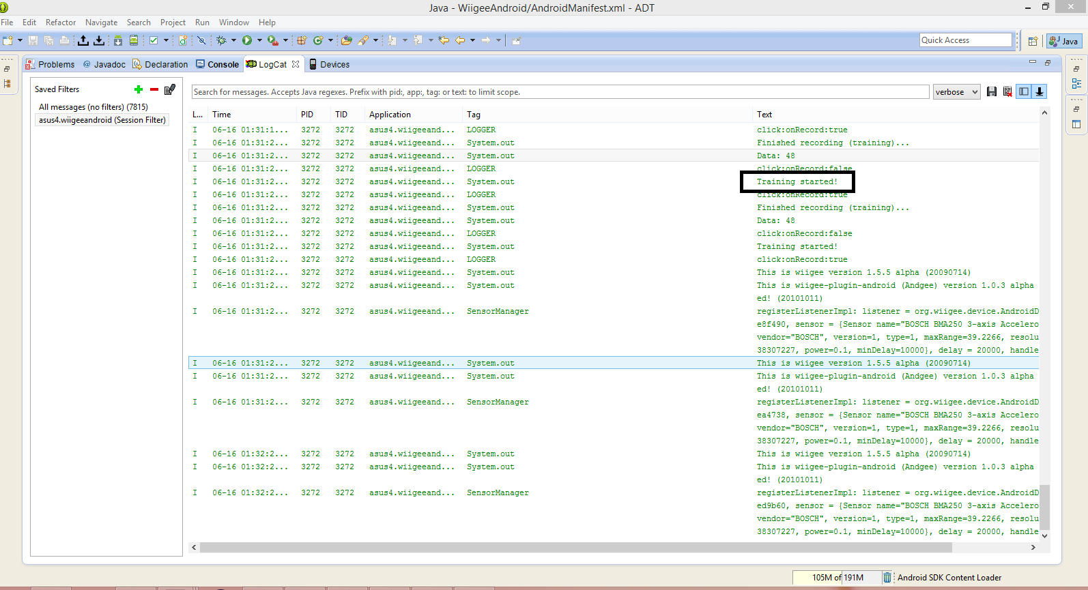

Figure 5LogCat message for training data

* Once you are done with the training please store the trained data by clicking gesture save
* Once you have stored the data now recognize your motion by clicking on Recognize Start button, now you can see the resemblance of your motion with the trained data. In the below figure we have used the same trained motion so the probability is given as “1.0”.

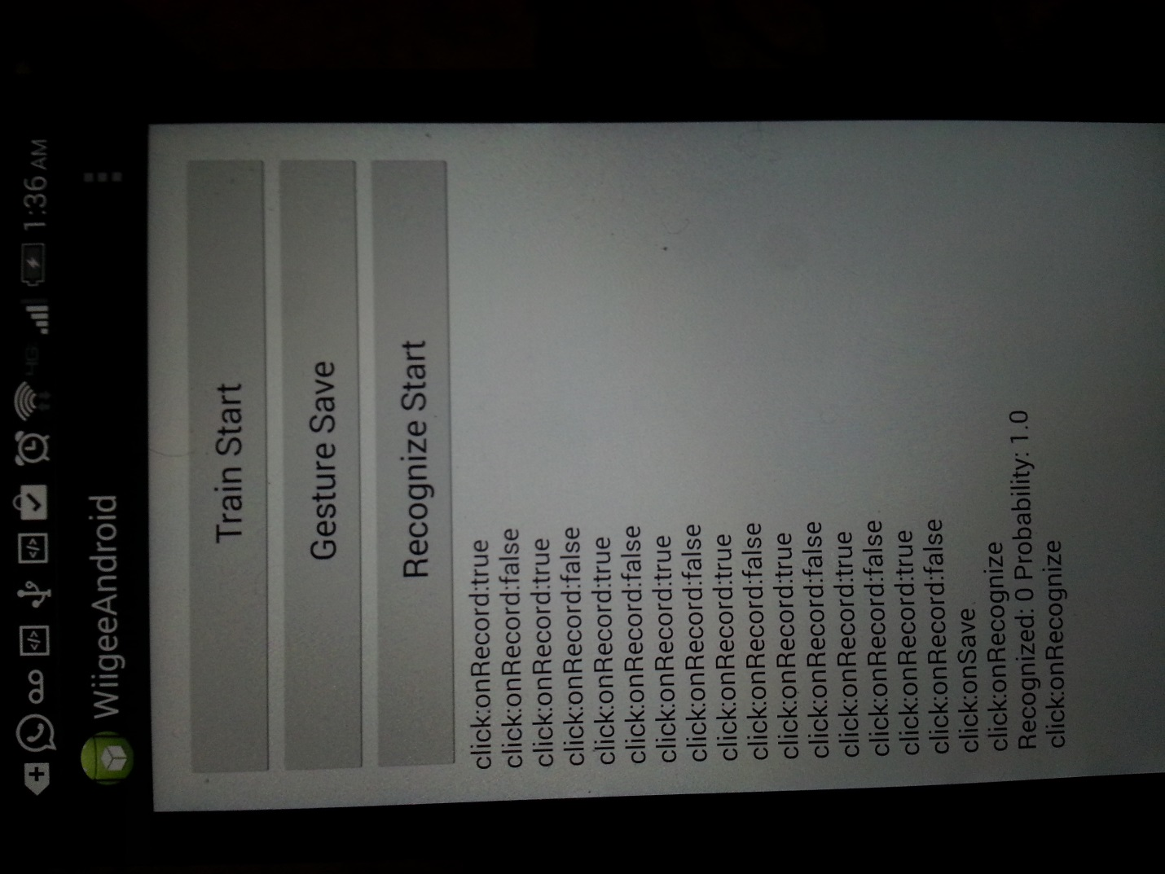

Figure 6WiiGee trained data resemblance

**AndroidGPS:**

This application is used to detect the latitude and longitude of the location and also display the address. The following are the steps need to be followed for running the application:

* Run the application from Android SDK manager using your android mobile device.
* Once you have the application running please move your mobile device so that you can identify the latitudes, longitudes, position of the location on your screen as shown in the figures below.

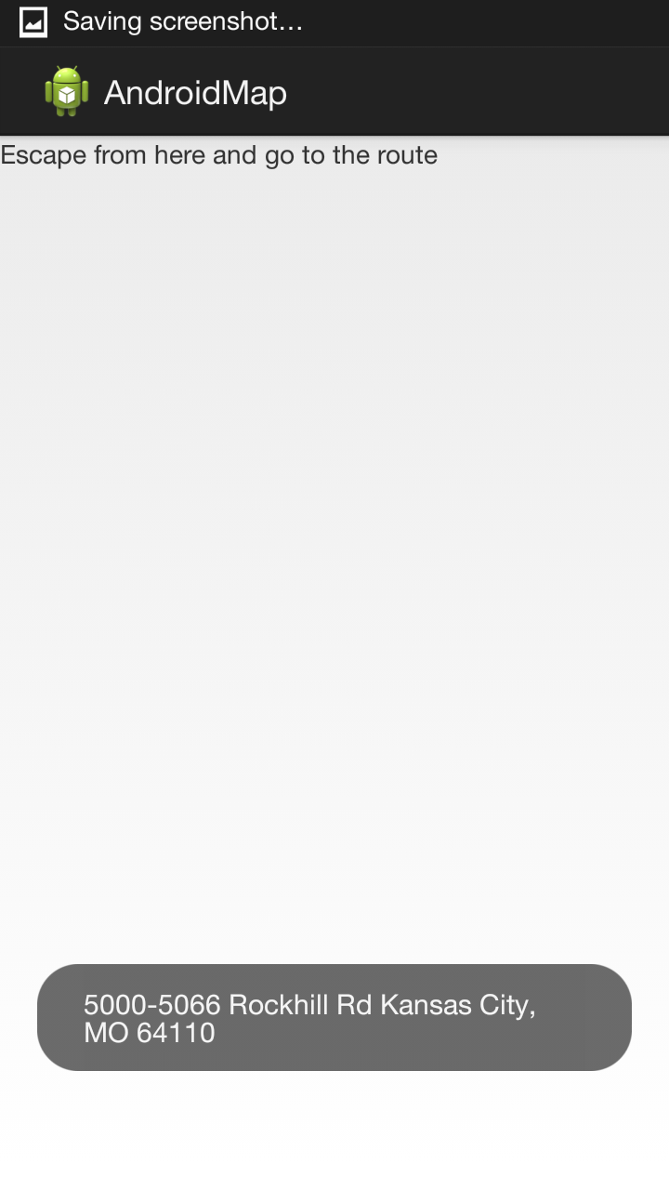

Figure 7 Location in the GPS

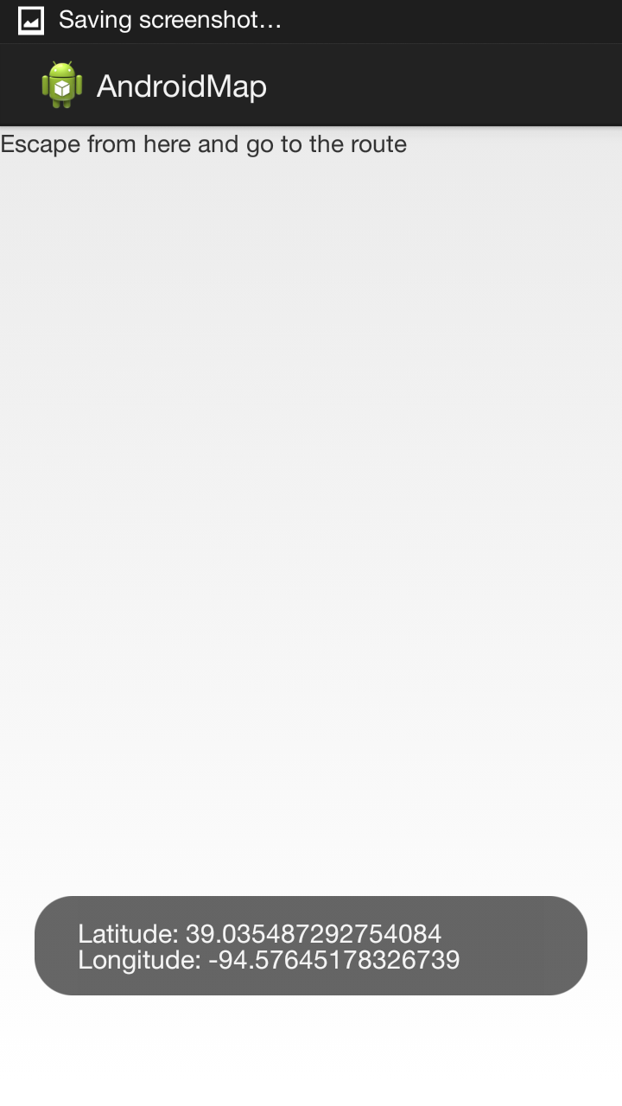

Figure 8Latitude and Longitude of the GPS

**Troubleshooting:**

* In case if you were unable to run the application either download the Google play services jar file and add it in build path
* Else re-install the Android SDK manager with Google Play Services.

**Chronos Watch:**

This sensor is used to detect the motion using the watch as the motion sensor. It basically runs suing the Bluetooth technique. The following are the steps need to be followed to use the Chronos Watch:

* Install the Chronos watch setup using the disk available with device.
* Once you are done with the installation please put on the usb hard drive that is present along with the watch to your computer and switch on the watch.
* Once you have switch on the watch please change the mode of the watch to ACC mode and then run the application on your desktop.
* Based on your hand moment the device will capture the related x,y,z co-ordinates and display on the app in desktop.
* Please follow the figure below for the variations detected in the motion using the Chronos Watch.

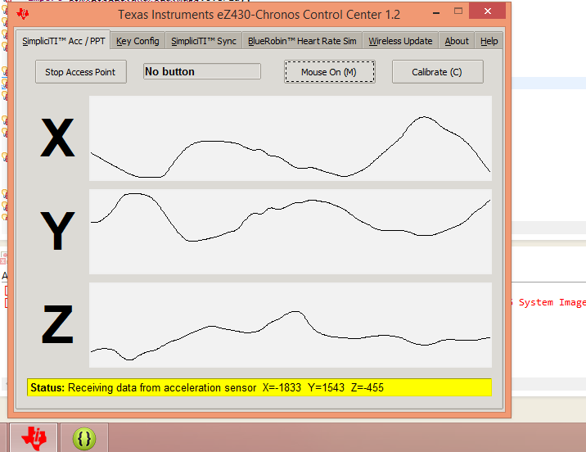

Figure Chronos Watch observations

Troubleshooting:

* In case if you face any trouble while using the disk for installation of chromos application please use the following link to download the installation software:
  + <http://processors.wiki.ti.com/index.php/EZ430-Chronos>