**Find Your Destination and Weather Report of Your Destination**

Whenever we come to a new place it is important to know new locations and sites. The sites may be within your place or outside. So it is important to know the route and also the climatic conditions for your travel. Our application serves as a source for finding the directions to the destination and also gives a pictorial view of climate at your destination and also within the drive.

**Technology Used:**

These application is a web based application and is developed in JSFiddle. The languages used in the development are JavaScript and HTML5.

The information retrieved is through Google Maps and Google Weather Services.

Geocoding techniques have been used to trace the latitude and longitude points and also to place the destination markers, for weather reporting

**Tools:**

1. JSFiddle
2. Operating System: Windows 8

**Hardware Specifications:**

* RAM required : 512MB or above
* SD Card size 51MB or above( To run the app on mobile device)

**Working Model:**

The default page consists of two tabs

* Source Address
* Destination Address

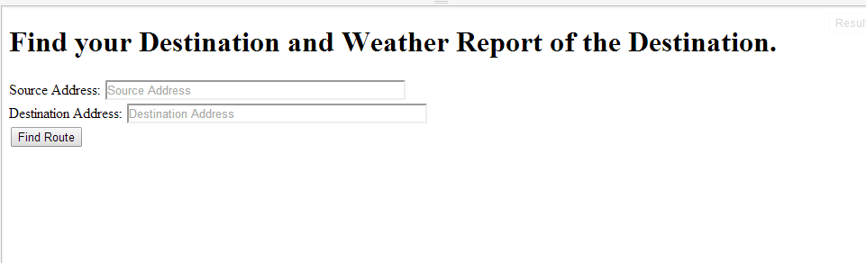

Figure Default Page

We need to provide the source and destination details inside the two tabs respectively.

The address can be precise or in a detailed format. Then click Find Route

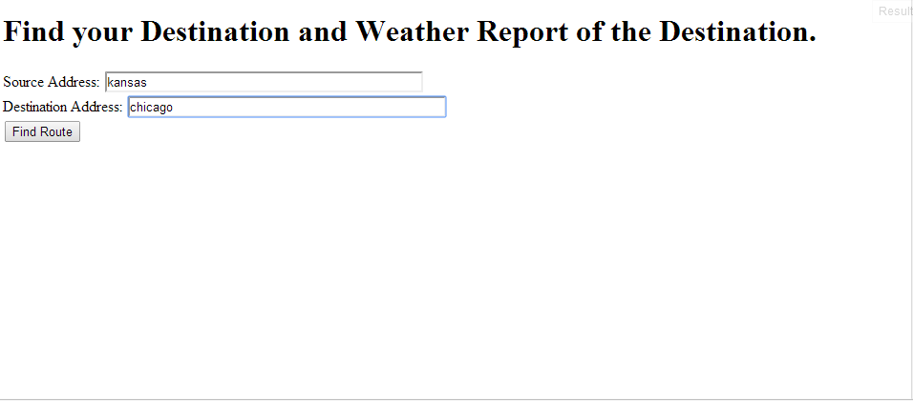

Figure Enter the details

Now there will be two images displayed under the button, the initial image consists of the route map and the second image consists of the weather details.

In weather details map your destination will be located with a marker for easy identification.

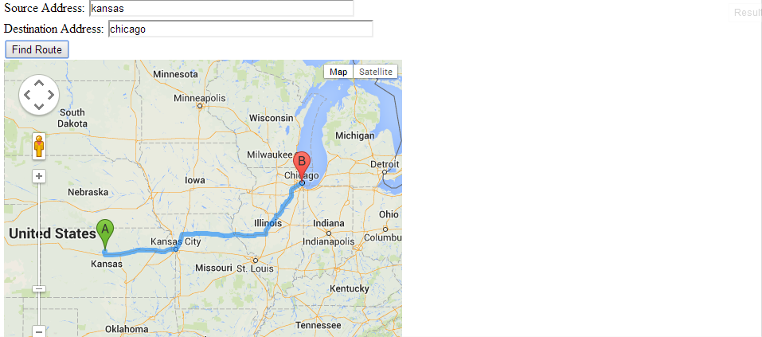

Figure Route Map

Below the route map there will be the weather report of your destination which is represented in the pictorial format.

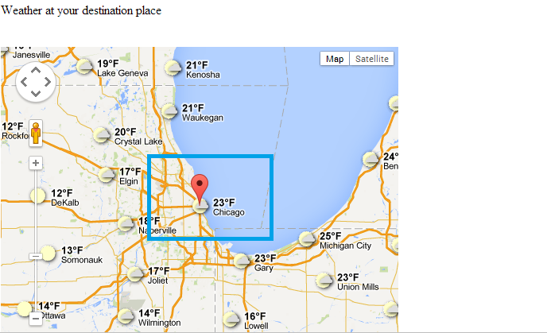

Figure Weather Report

You can see the marker in the highlighted area, which represents your destination. The temperature is represented in Fahrenheit

**Source Code:**

The source code is present in the following link:

* <http://jsfiddle.net/SaiKishoreBandaru/aN2hS/1/>

**Enhancements:**

The application will be included with some search mechanisms which include Google Search services. Which helps in finding the hotels in the way and at your destination place.

**Bibliography:**

1. Google Maps Development : <https://developers.google.com/maps/‎>
2. Google Weather APIs : <https://developers.google.com/maps/documentation/javascript/examples/layer-weather>
3. JSFiddle Development : <http://doc.jsfiddle.net/tutorial.html>