**Recommendation System**

It is useful to provide certain recommendations to the users prior to their selection, which makes their navigation easier. Our recommendation system application provides an easier way to find the recommendations to the user. Here we need to select an item from the list and can find out to which users this item can be suggested. Based on this we can make further enhancements in such a way using this data we can send e-mails or prompts to the users.

**Technology Used:**

We have used Hadoop to store the data of recommendations and purchases. Mahout is being used for getting the recommendations. The output from the Mahout is stored in Solr.

The front end has been developed in HTML5 and jquery using JSFiddle.

**Hardware Specifications:**

* RAM required : 512MB or above
* SD Card size 51MB or above( To run the app on mobile device)

**Working Model:**

Initially we have prepared data for audio recommendations and electronic good recommendation. Due to the issues with audio data file, we have restricted the application to only electronic goods recommendation. The snapshot of the data files are shown below for both audio and electronic goods:

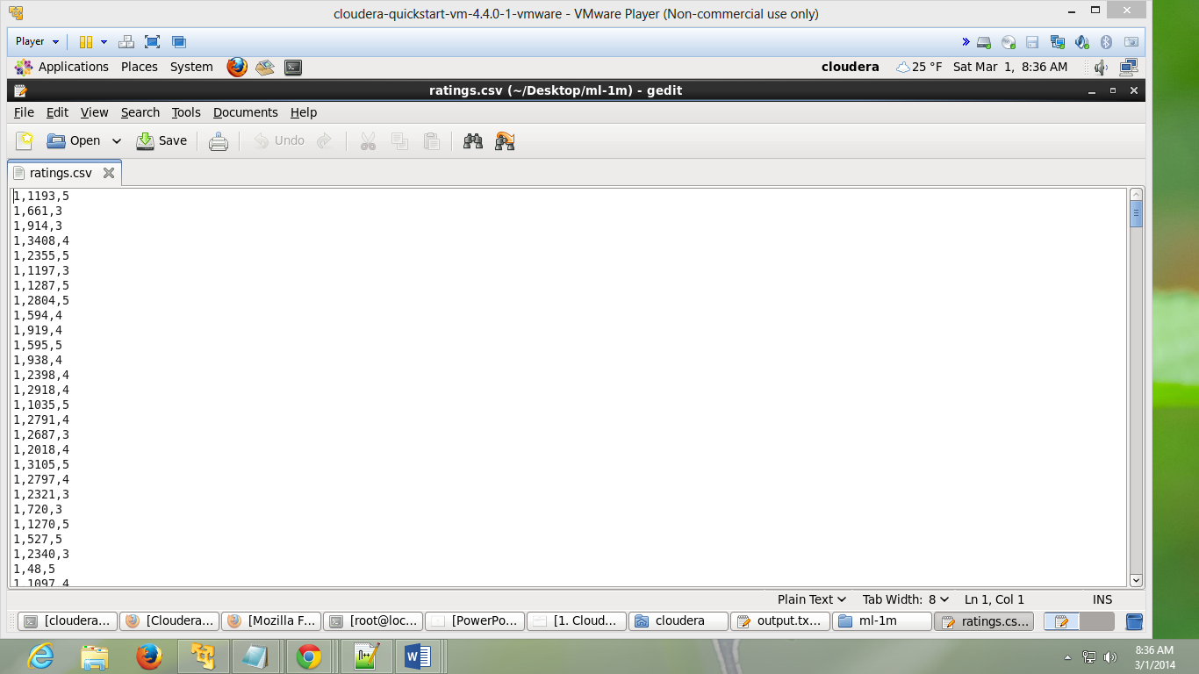

Figure 1Audio ratings file

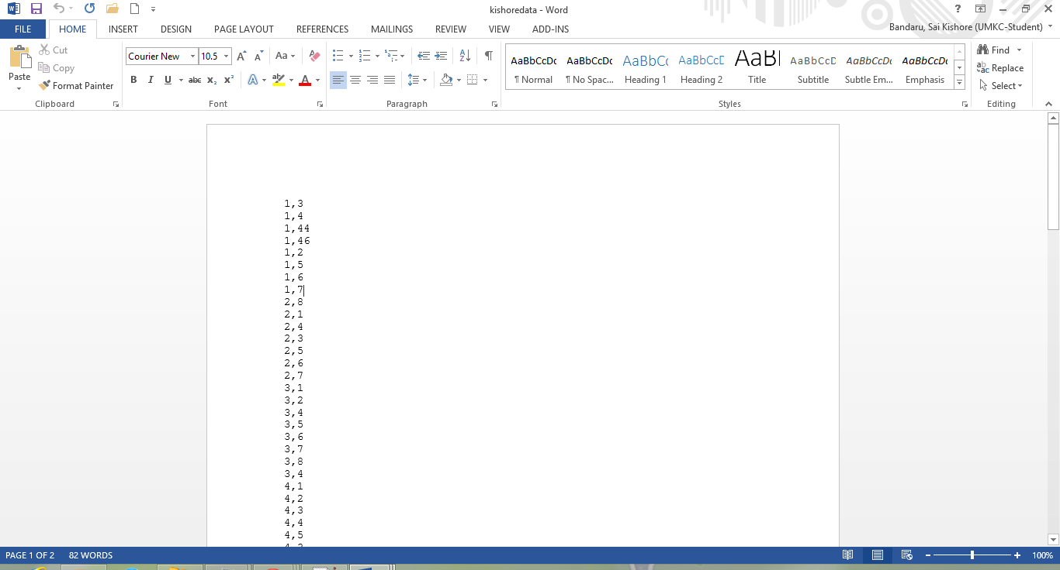

Figure 2Electronic goods details

We have given this input to Hadoop using the “put” command. Then we need to create a maven directory and introduce these files. Now after running the mahout command the following results will be displayed which are stored in a text file.

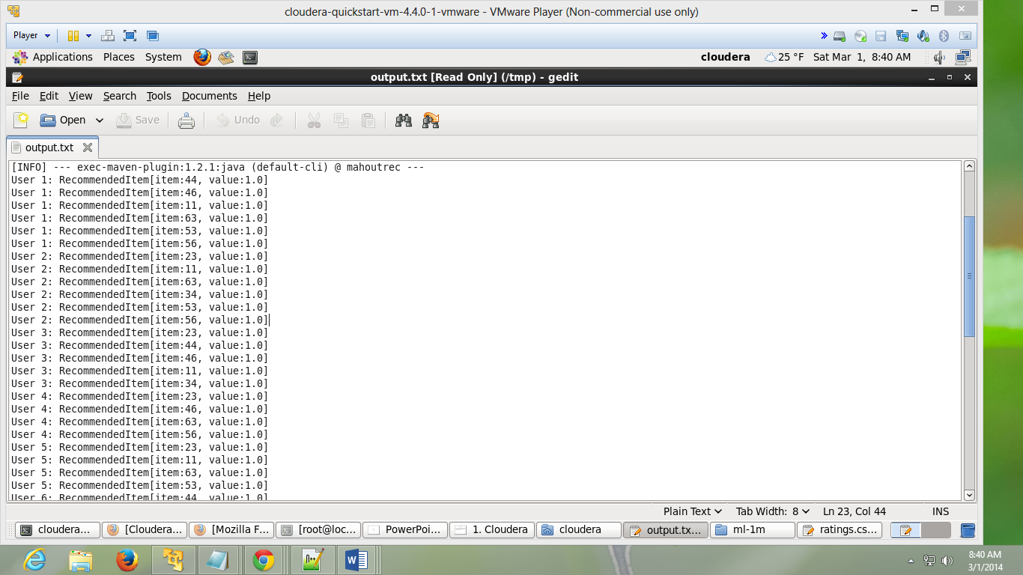

Figure 3Recommendation lists

Now this output files has to be given to Solr. But due to certain errors we were unable to direct the output file to Solr. So we have manually entered the values into Solr. The following snapshot shows the data created in Solr instance.

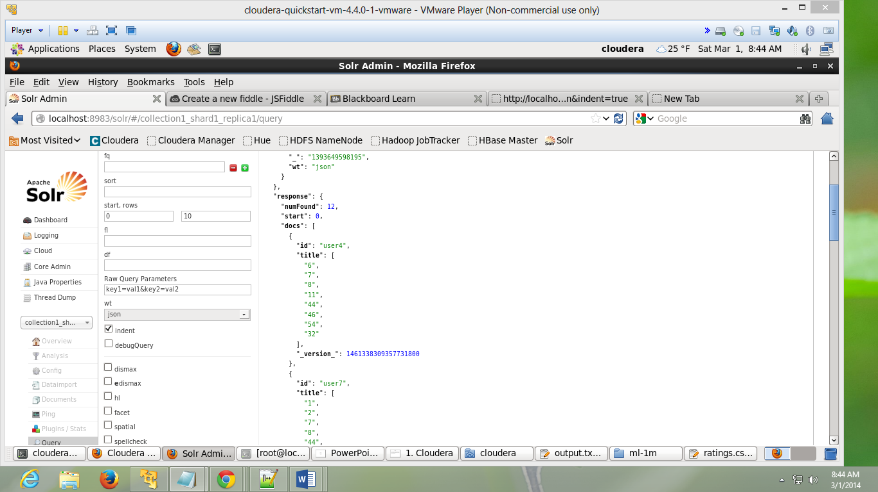

Figure 4Data in Solr

Now we need to extract this data into our GUI of client side. So we have used HTML5 and JQuery to fulfill this tasks. We will be calling the URL as a “Get” method and retrieving the data in form of JSON. We need to send the id of the electronic good that is being selected from drop box provided to the user. After selecting the item if we click the search button then we will get the list of users to whom we should recommend the items. Default webpage looks like the below snapshot.

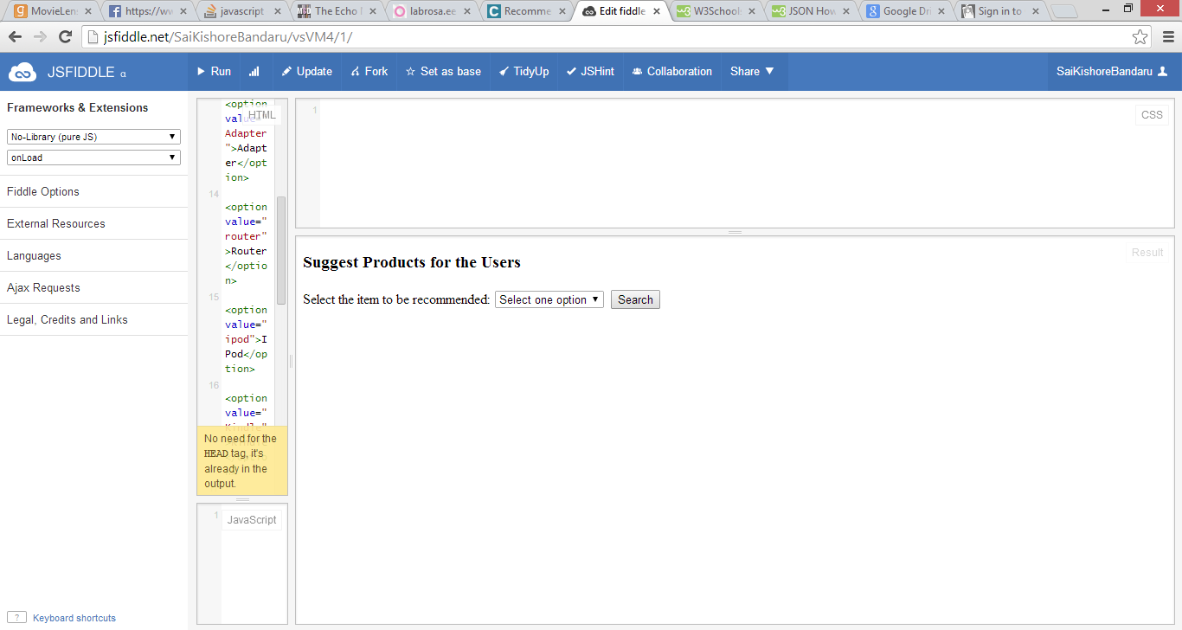

Figure 5Default webpage

Now from the drop down “Select the item to be recommended” we need to select and electronic good.

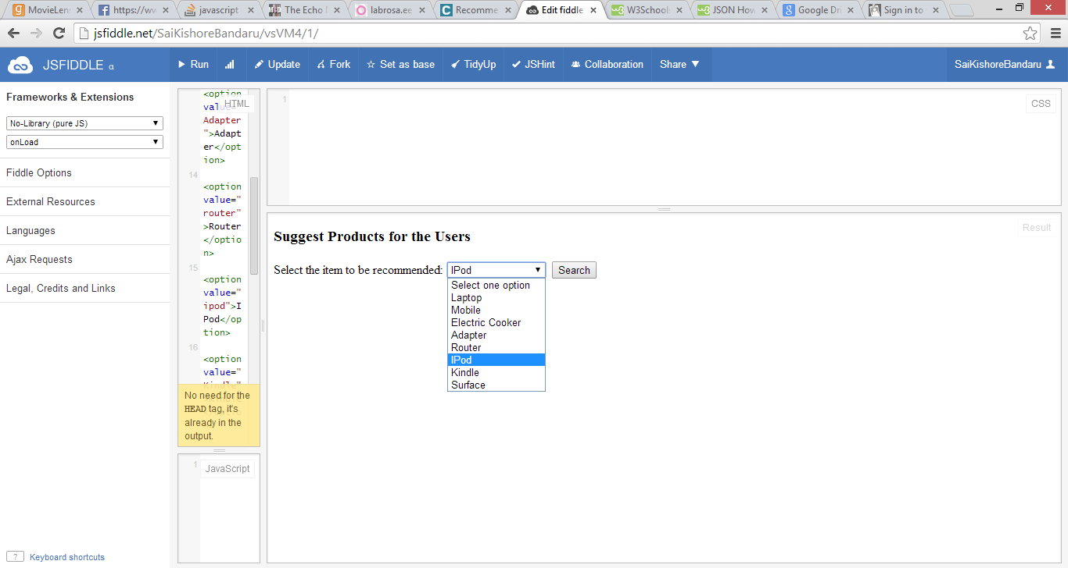

Figure 6 Select an item

Then the end output will be displayed with the list of users who should be recommended the items.

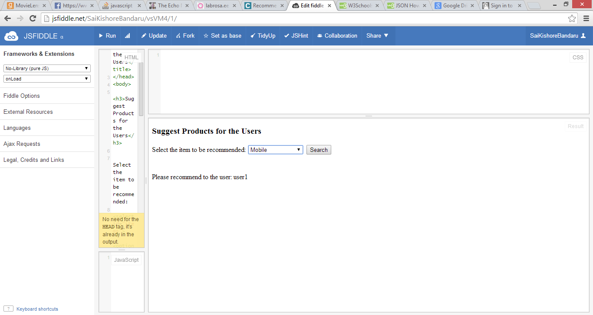

Figure 7Expected Result

There are certain issues while retrieving the data from Solr. The initial issue is parsing the JSON file, since it is a manually inputted data in Solr. We are facing errors while executing the search button. The data formats are not accurate. So further enhancements include addition of automatically sending data to Solr. And also including higher implementation of webservers like Glassfish and REST services, in order to resolve the errors.

The music data ratings has been taken from the following website:

* <http://grouplens.org/datasets/movielens/>

The data can be viewed in the following link in jsfiddle:

* <http://jsfiddle.net/SaiKishoreBandaru/vsVM4/1/>