**Lab 4 – Activity Recognition using Android Applications and Hadoop**

**Summary**:

To generate data using the sensor tag and store them in a file. Exporting the data file to the Linux server and applying Hadoop techniques to generate the sequence files to recognize the activities.

**Implementation:**

The following are the steps to be followed to generate the sequence files from data taken:

* Switch on the sensor tag and make certain actions to record the data. Ensure that you store the data of different actions in different files.
* The following are the snapshots of some of the activities that has been taken using the sensor tag for certain activities:
* 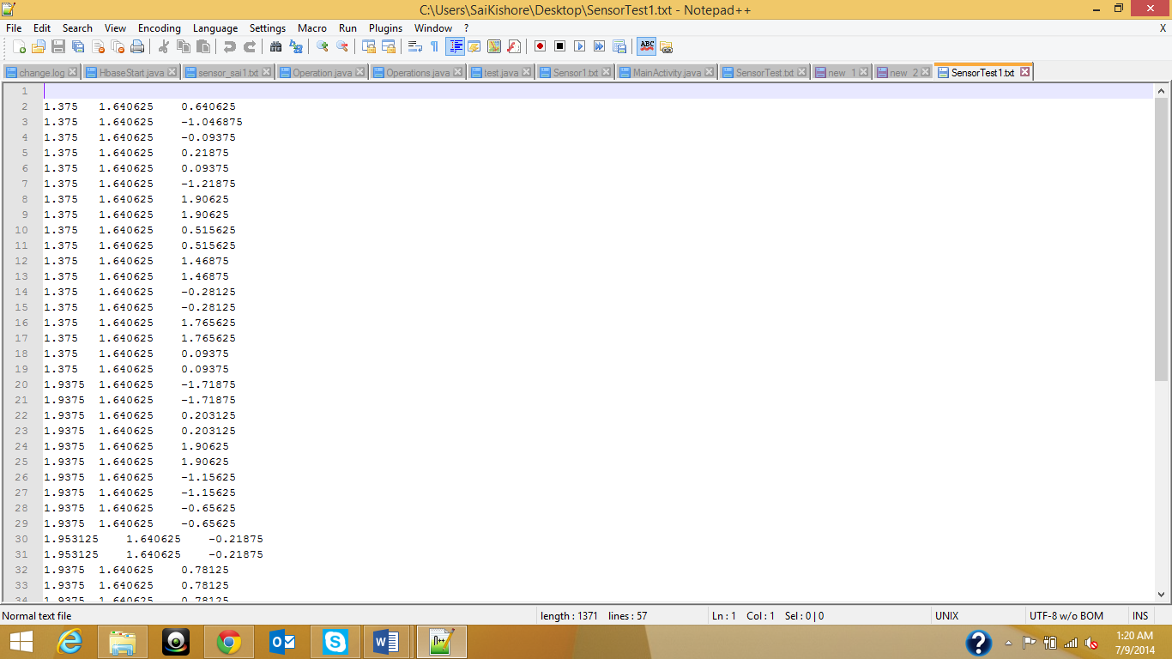

Figure Circle movement

* 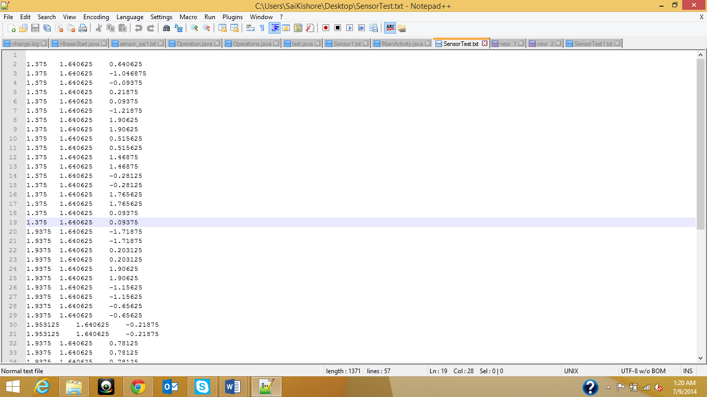

Figure Triangular movement

* Now move these data to one of the Linux servers either by using the ssh program that has been used previously or using the winscp tool.
* Now execute the following command in order to train the data and generate a sequence file:
  + <http://134.193.136.147:8080/HMMWS/jaxrs/generic/TrainFileOperation/-home-group8-SensorTest.txt/-home-group8-Circle.seq/>
* Now once you have the sequence file generated execute the following command to test data:
  + <http://134.193.136.147:8080/HMMWS/jaxrs/generic/TestFileOperation/-home-group8-SensorTest.txt/-home-group8-Circle.seq/>
* Now execute final command for the retrieval results from sequence files that are being generated for classification:
  + <http://134.193.136.147:8080/HMMWS/jaxrs/generic/HMMTrainingTest/-home-group8-Circle.seq/>
  + This procedure has been repeated for several other motion activities too.
* Now we need to create and android application to access these data from android mobile device. For this we use the function called “ load weburl “ in order to move the prompt to the respective web location.
* Make sure you are in UMKC network while running the application on android mobile device.
* There will be 3 buttons in the GUI where one button is used to train data and one is used to test data and the last button to recognize the activities.
* We call the above urls for the respective button clicks.
* The following is the home page of the android application:
* 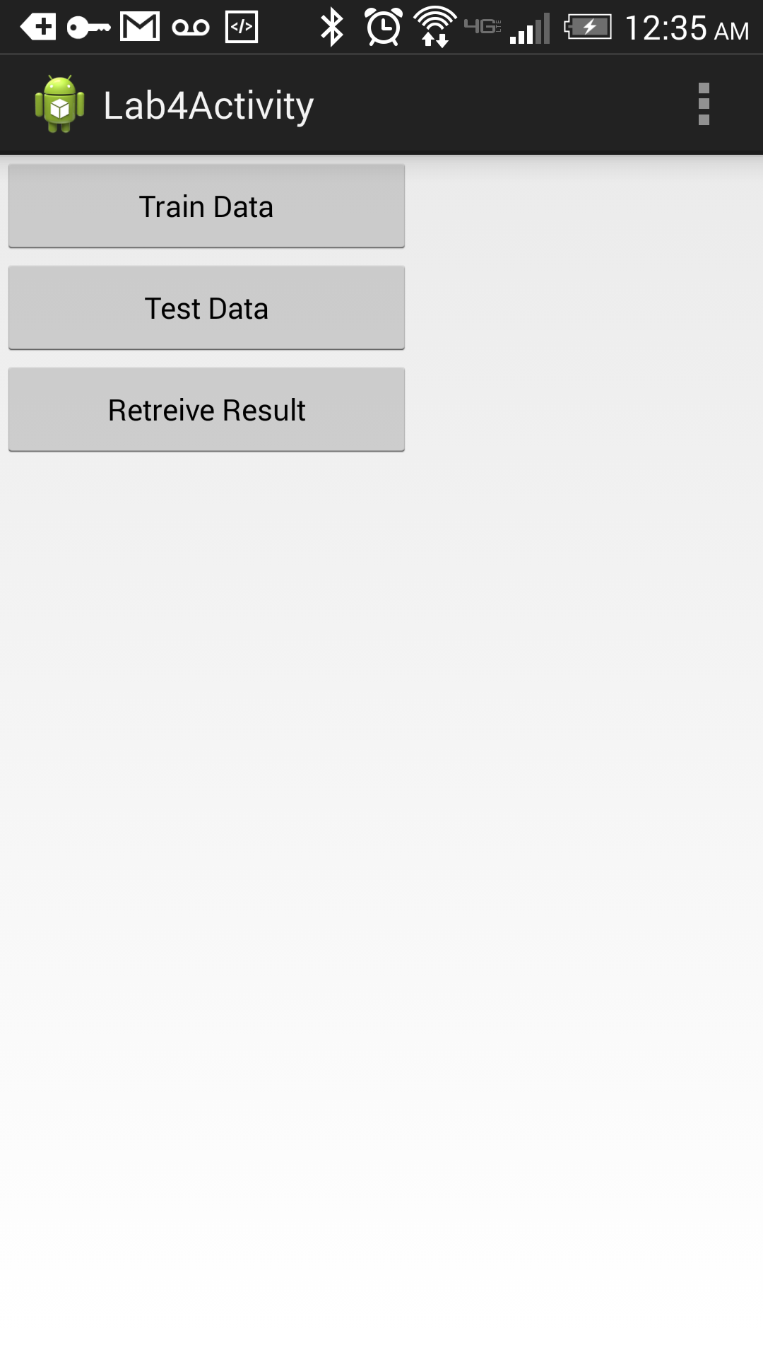

Figure Android Application Home Page

The following is the sequence file:

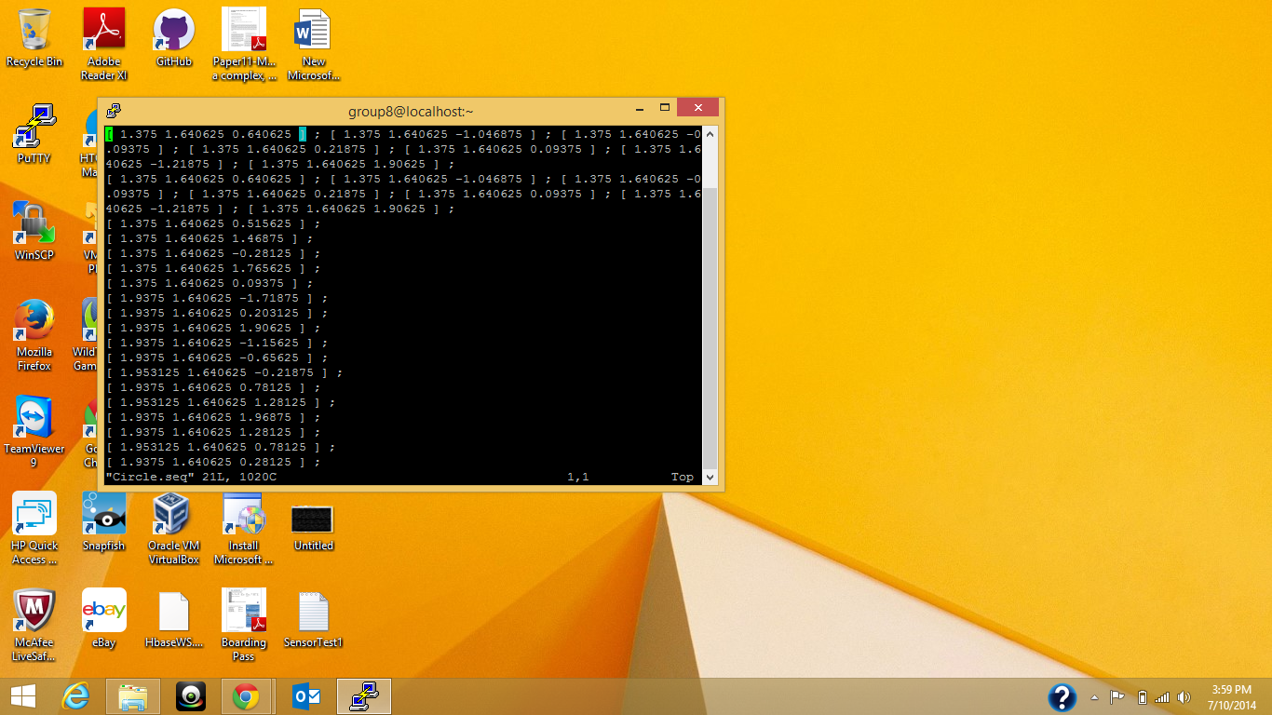

Figure Sequence file

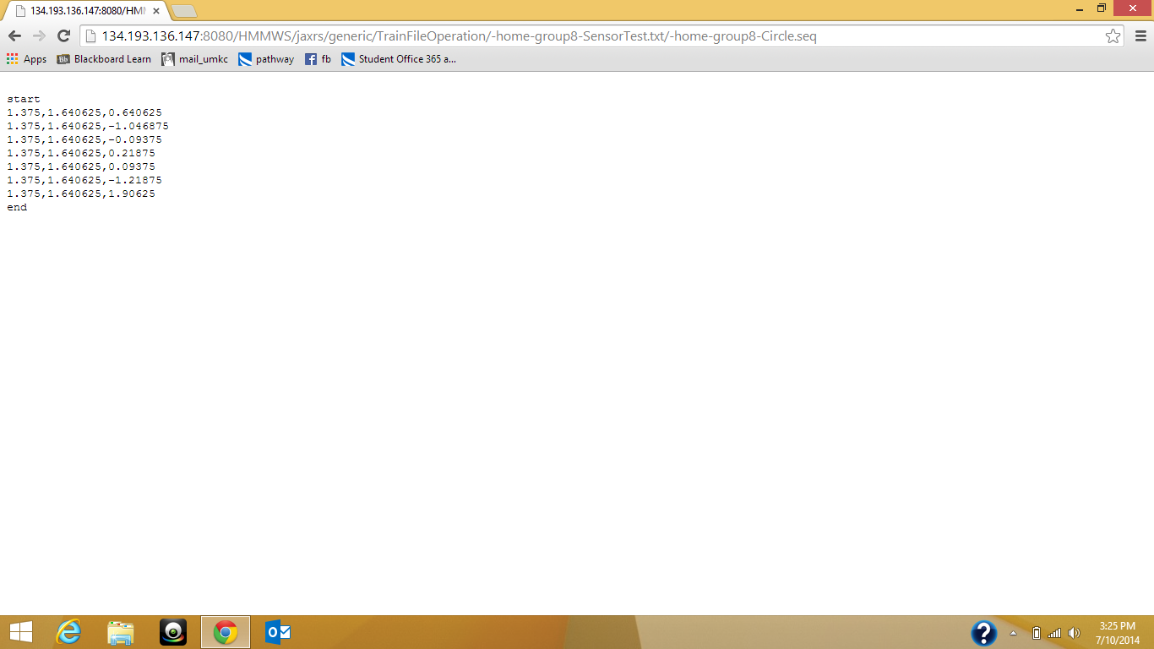

Figure 5Train Data

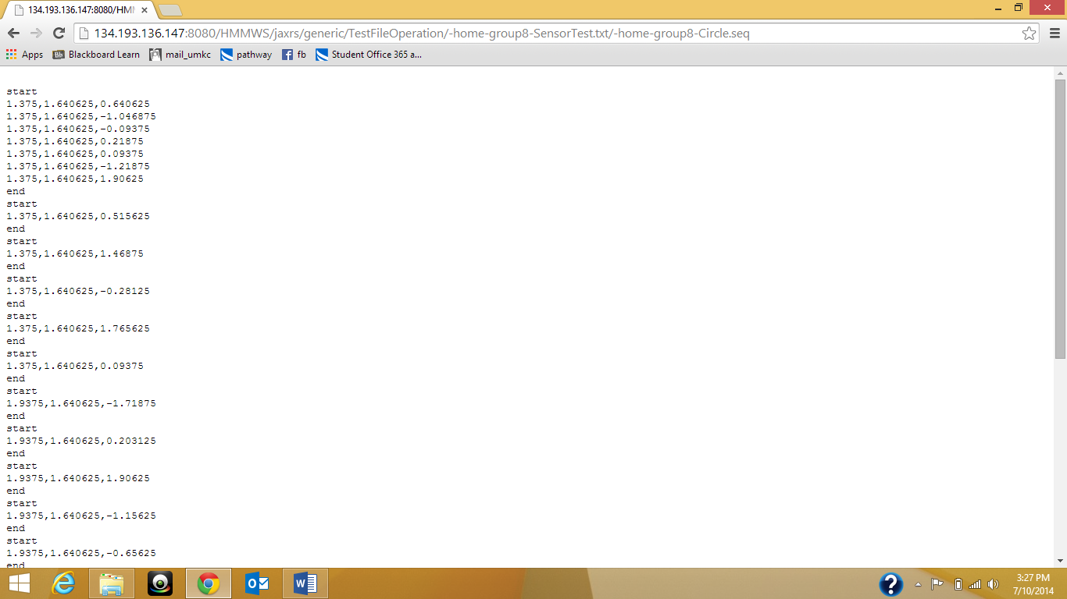

Figure 6Test File

**Troubleshooting:**

Sometimes you may be encountered with an issue while accessing the urls from android application. The following is one kind of error that is visible while running this application:



Figure Errors

During such situations please make sure you are in UMKC network and also the glassfish server is up if not change the location of your files to any of the other groups in the network.