**Lab 5: Work Artifact**

**Summary:**

The main focus of this lab application is to process the real time data and trace the appropriate actions and develop some handful operations or themes using those recognized activities. Here we have used the web services in order to trace the actions we depicted and the SensorTest application to get the sequence files for trained data. Our application basically depicts the emotions of the users and displays appropriate emotion symbols on screen.

**Implementation**:

The first task involved in the application development is getting the sequence files for the trained data. Now for this purpose we have used Sensor test application to directly train the data and generate sequence files. The following are the steps to be followed for generating sequence files for trained data:

* Enter the output sequence file name
* Click on Train your own gesture and train your gestures for at least 10 times.
* Once you are done with training of data click on stop and your sequence files will be generated Data folder of your mobile with the respective name.
* The following are the snapshots of our work.
* 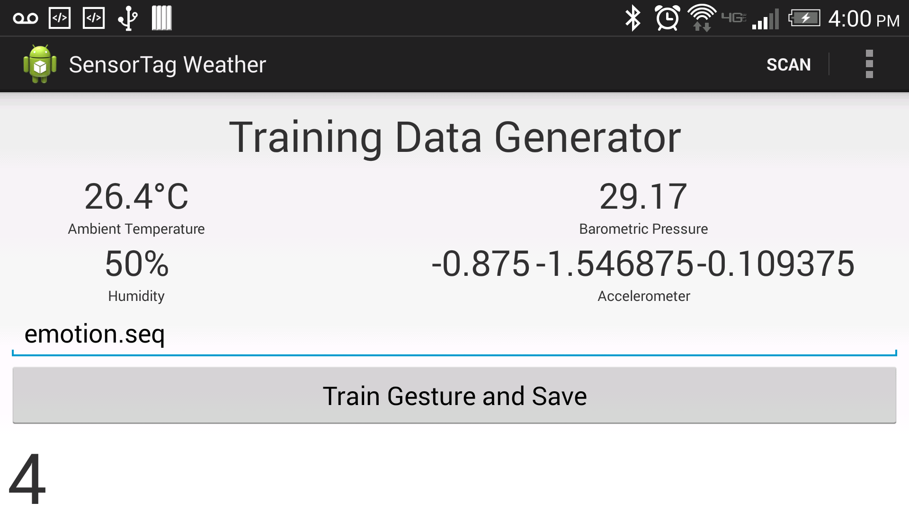

Figure training Data

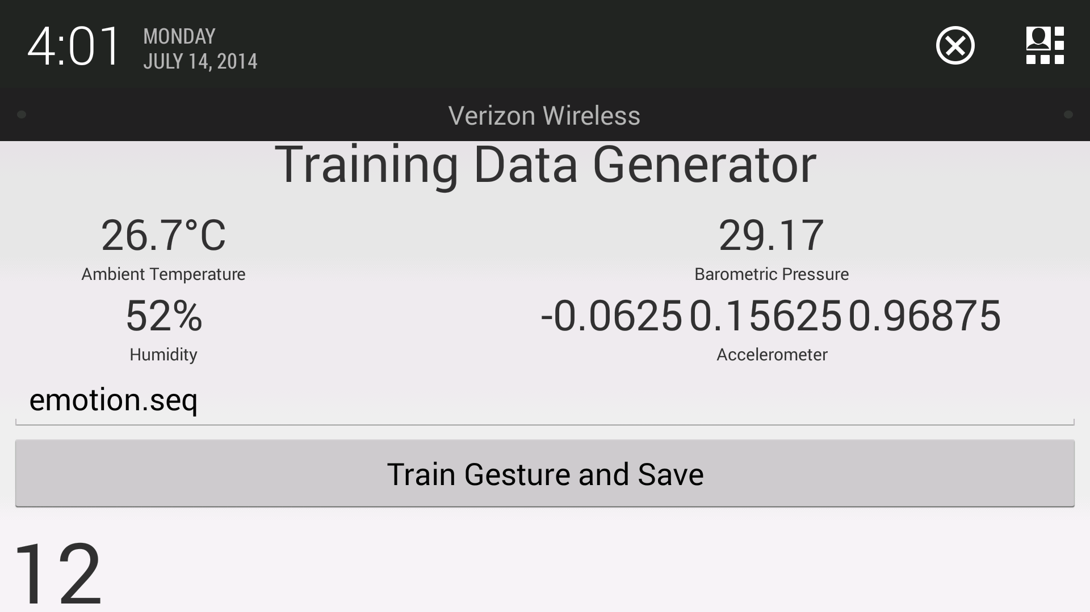

Figure training data 12 times

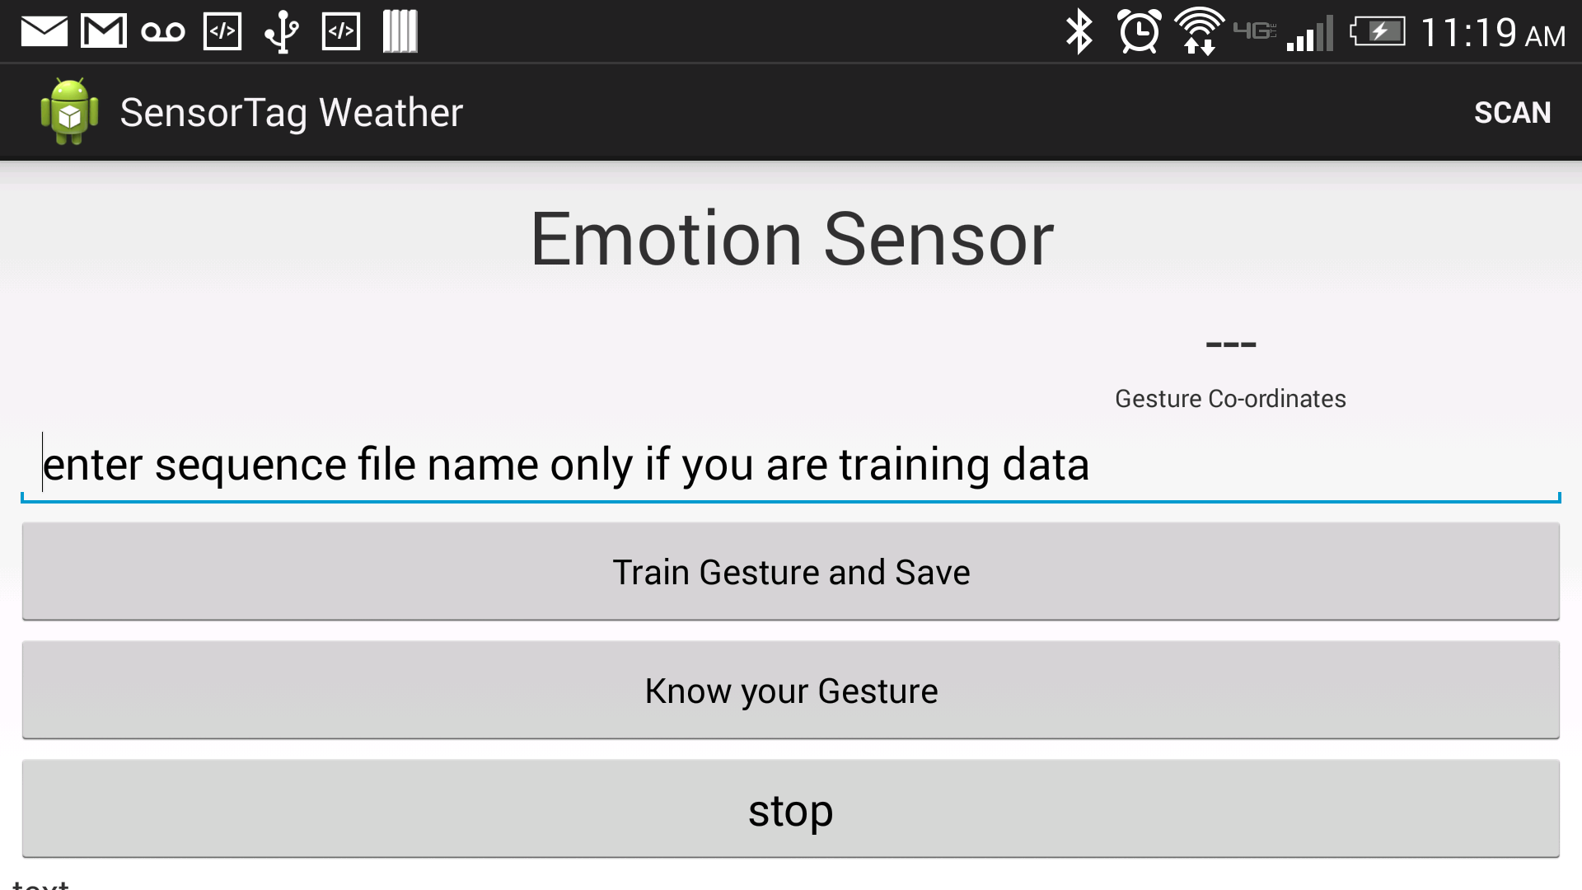

Figure Initial Page

Now once you have your sequence using the SSH methodology transfer your files into your cloudera image where you have the web service running. The command used for running the glassfish server is

* “./asadmin start-domain”

Now after transferring the files and starting the web service, you can now test your gesture. For this click on Know your gesture button. Before that initially you need to click on train gesture and save button and make an action for once and click stop. Only after then you were supposed to click on the Know your gesture button, to identify your action. Make sure you always mention your sequence file as “emotion.seq” while detecting your gesture. The following is the expected result of one of the outputs for a particular say a high five if you are happy and revived:

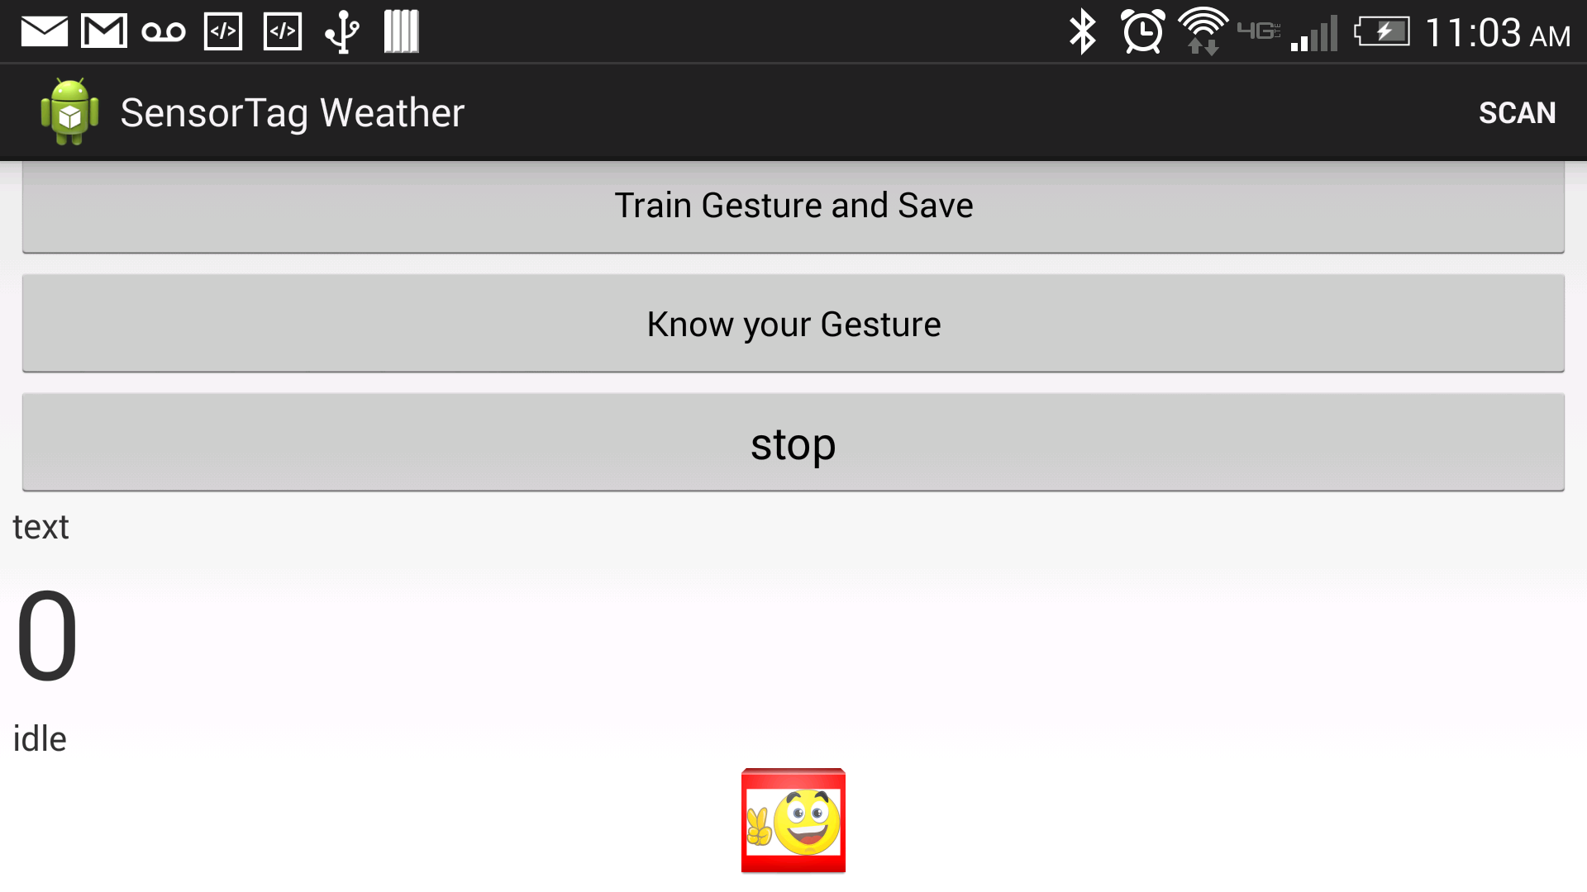

Figure Expected Result

The symbol below indicates you are happy. Here we use the web services to detect these emotions. However due to thread based issues we were facing certain issues while calling the web services and parsing the JSON output. Here we need to maintain separate threads to address these issues, which we are continuing to do.

**Future Enhancement:**

As this is done as part of our project, we can add recommendations for each emotion and also additional button while testing your gesture rather using same button “Train gesture and Save”.

**Troubleshooting & Issues:**

* Make sure the images are drawable otherwise there will be errors while loading.
* Jars need to be downloaded for the execution of the SSH code.
* Due to the thread based issues we couldn’t be able to parse the JSON outputs properly and results are sometimes found to be vague.