**Lab 6: Reporting Tool**

**Summary:**

The main focus of these work is to report the data analysis part using certain pictorial representations. Here we used a jar named “achart engine” in order to design the charts based on the data. The data here will be sequence files and the plotting of charts will be done based on the values in the sequence files versus the time. So based on the timeline basis the readings will be plotted and we can view the graphs.

**Implementation:**

The program has two activities namely MainActivity and ordercsreen activity. Whenever you click on a button named “View Statistics” you will be displayed with a series of plotted graphs using the trained sequence files and tested sequence files. Here we used certain chart renderers in order to plot the graphs and the jars being used is achart engine. The following steps are to be executed in order retrieve the results:

* Create a main activity and use a “view statistics” button in it.
* Create another activity so as to create an intent which displays the graphs for the sequence files and also plot the matching graph for the test file.

The following is the snapshot of GUI interface:

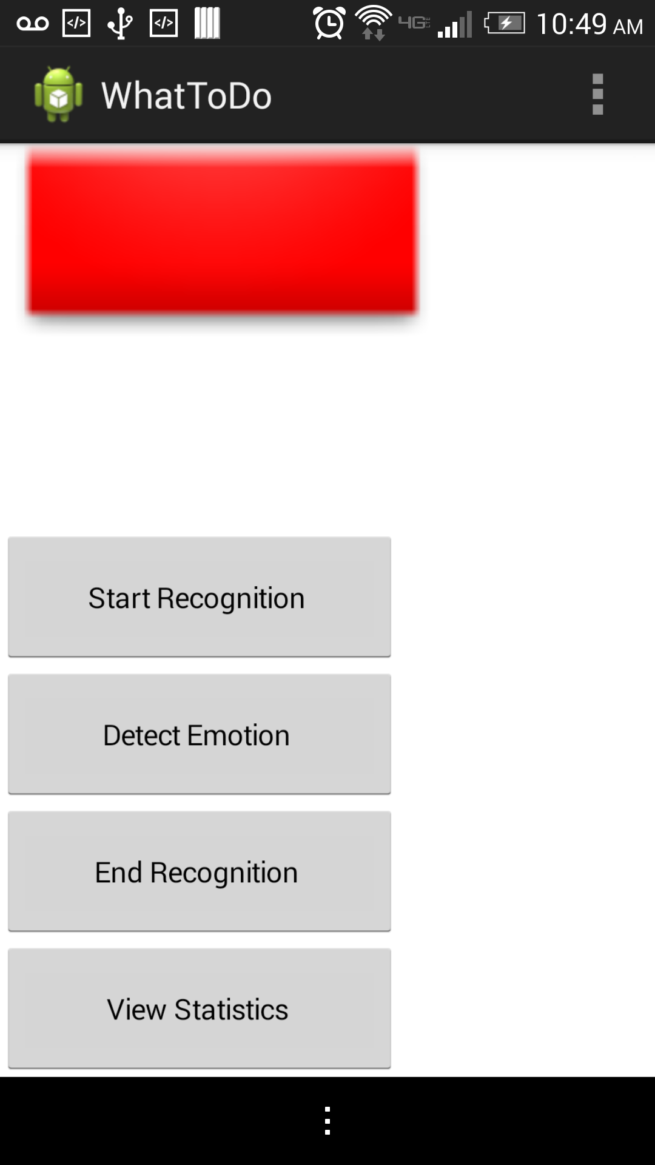

Figure GUI interface for View Statistics

**Issues:**

When we create a separate android projects and try to plot the sequence files we were able to execute successfully. But when we are trying to execute the code within the original emotion sensor application we are getting an error saying “ trace file not found “ and the application is getting terminated. The following is the snapshot of the graph plotted using the android application which exclusively developed for the sensor values plotting:

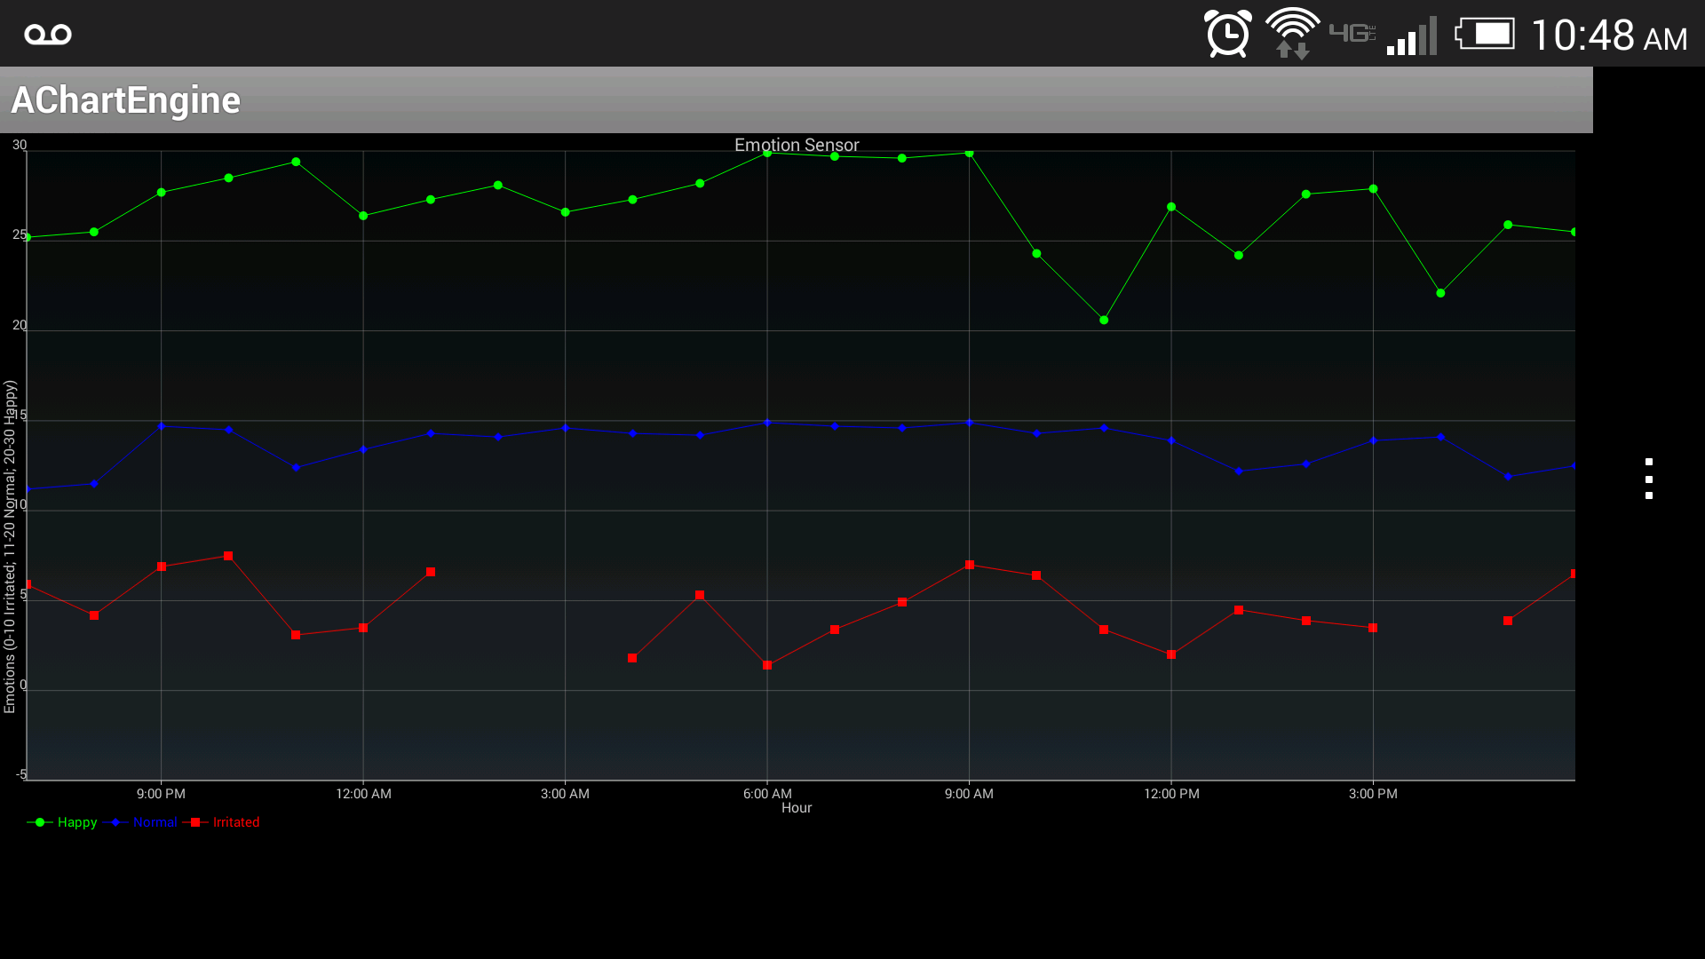

Figure Emotion plotting

The above graph contains values plotted for three different emotions they are happy, irritated and worried. The following blank screen has been displayed if we are trying to execute the reporting implementation for the Emotion Sensor project:

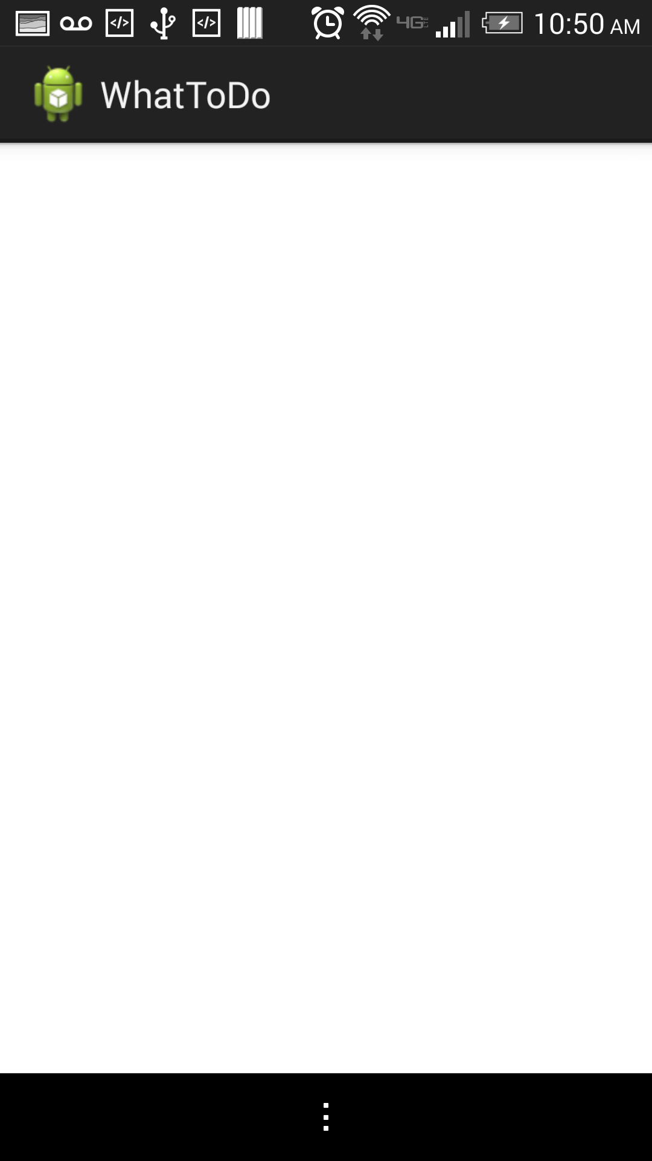

Figure Blank Page

**Troubleshooting:**

* While using the achart engine make sure the jar is imported and also make sure you check the option in “Order and Export” in the configured build path.
* Make sure the application is the main activity and the second intent page as activity.