**UStudy**

**A complete educational portal**

**Arapally Ebenezer Anand**

**Bandaru Sai Kishore**

**Kommineni Sivakrishna**

**Ponnam Balakrishna**

**Summary:**

For the current iteration we have planned to complete the initial user interface development using Android and also collection of data and hosting them onto the Hadoop. We were able to finish the initial screens for the User login, registration, and partial development of user interface and guest user interface. We have completed the collection of data from various data resources and will be uploading it into google drive and share the link. Analysis on merging the collected data has also been started and implementing them locally before hosting them to main server allotted for us.

**Framework Specification:**

The framework typically consists of three stages GUI, parser, and database. The database will deal with the required data analysis, data storage. The GUI part is being developed in Android. The parser includes the task of sending input to the database in such a way it can understand and analyze the information. And also parser is used to convert the return format of output from database to user format.

**System Architecture:**



Figure System Architecture

**Domain Model:**

* **Data Sources:**
  + Data is being collected from various web resources and being deployed to google drive for easy access to all team members.
* **Methodologies and Algorithms:**
  + For storing the user profile and his history we have used the local sdk database as of now.
  + And all the front end is developed in Android using ADK and the code for the database connections and other user validations are done using Java.
  + The data that is being collected is in different csv formats. So we are going to merge all the data files in Hadoop using the getmerge command and will apply the Naïve Bayes algorithm to classify data. Once the data is being classified we shall further write the code for recommendations to the user about the colleges based on his user profile.

**Application Specification:**

* **Software Specification**
  + Tools: Mahout, Solr, Android Development Kit.
  + Operating System: Android
  + Development Operating System: Windows 8
  + Programming Language: Java 7.0
  + Databases: Oracle, Hadoop
* **Class Diagram**



Figure Class Diagram

* + In the above class diagram the implementation of user validation and the guest user has been completed. Currently working on the data analysis part.
* **Activity Diagram:**



Figure Activity Diagram

* The services majorly consists of assisting the students in choosing right colleges. So for a guest user the services provided are less. Based on simple search criteria the colleges will be projected to him. But if a user gets registered then there will be colleges recommended to him based on his previous search, user profile. The colleges list will classified prior in the database.

The mobile client is entirely developed in Android and it is a native application for android users. The version supports from Froyo to JellyBeans.

**Implementation:**

* **Current Implementation:**

Current implementation includes user authentication and storing of all user related information in database i.e. in a relational database. Data has been collected and being tested on local machines to verify which classification algorithm can be applied. And in how best we can use the Lucene or Solr key value index to retrieve these classified data. The implemented code has been uploaded into github with the current first increment report

The following are the screenshots of user login page, user registration and other registration validations:

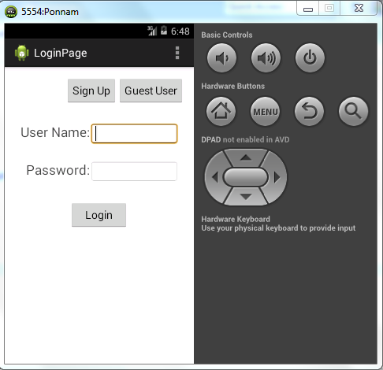

Figure Login page

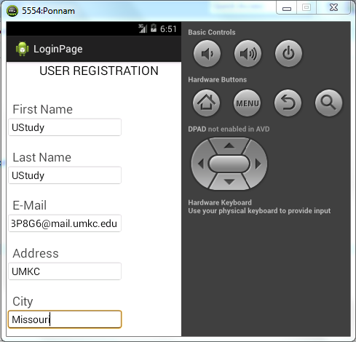

Figure User Registration

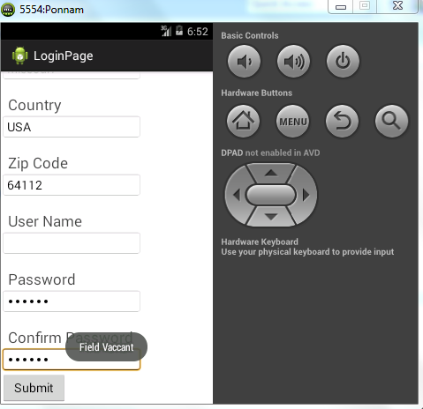

Figure Projects a message if necessary field is empty

**Project Management:**

All the tasks and their day today increments are being updated in the scrumdo.

* <https://www.scrumdo.com/organization/university-of-missouri-kansas-city5/dashboard>

The tasks which will be moved to next iteration will be designing the user and guest interface and also hosting the data onto Hadoop. We have completed the user login and user registration tasks. And also collected the data that is required for the project. So out of 4 we have completed two tasks and two tasks are being forwarded which have been already started.

The work has been equally distributed between the four members of the data with two members dealing with back end and two members dealing with GUI design.

Back End: Ebenezer Anand Arapally, Sai Kishore Bandaru

Front End: Kommineni Sivakrishna, Ponnam Balakrishna.

**Second Increment:**

The tasks that will be included in second increment will be:

* Completing the entire GUI design with certain animations and color texting – Sai Kishore Bandaru.
* How to link the data that Is being classified to Solr, which parameters to consider and how the indexing to be done for retrieval of data – Sai Kishore Bandaru.
* Hosting the data onto Hadoop – Kommineni Sivakrishna
* Testing the the available data with certain parameters like financial aid, age, location on Hadoop and also merging all the files on Hadoop – Ponnam Balakrishna
* Data analyzing and classifying the data using pre-defined algorithms or by writing new Map reduce programs. – Ponnam Balakrishna, Kommineni Sivakrishna
* Creating the web services i.e. web server creation using web services like Glassfish – Ebenezer Anand
* Also using external Databases like HBase,MongoDB for storing the history of searches made by registered user and also certain user validations if necessary – Ebenezer Anand

All the stories with time allocations will be updated in the scrum do for the second phase increment also.