Github

1.Initialize a new Git repository and configure your username and email.

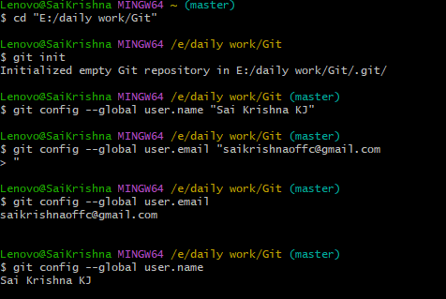

2.Clone a remote repository and explain what happens in the .git folder.

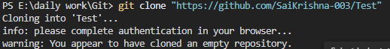

The .git folder is brain of our git project. When you clone it it creates a hidden folder to keep everything on tracks inside it it stores all the commits,branches,tags. Without .git will just a folder with no track record on it.

3.Show how to view and edit the remote URL for your repository.

To view:



To Edit:

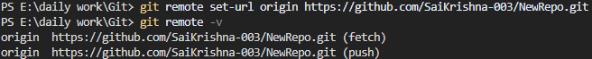

4.Add a .gitignore file to exclude certain files (e.g., *.log, node_modules/).

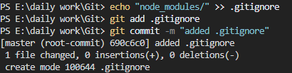

5.View the current configuration settings using git config.

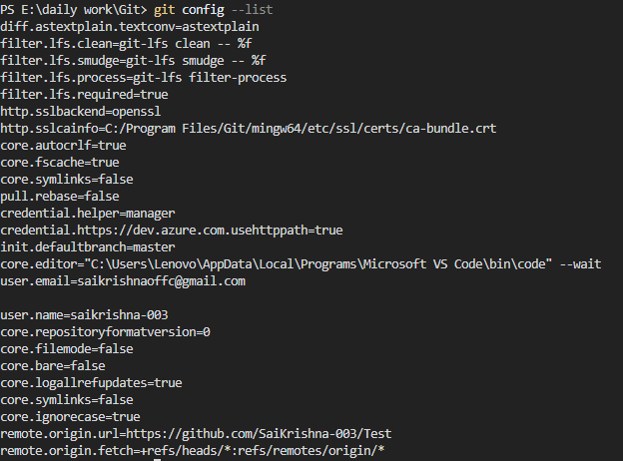

6. Stage only specific changes from a file (use git add -p or git add --patch).



7. Commit changes with a message and then amend the last commit to update the message.

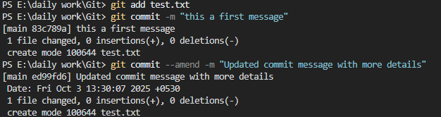

8. Show how to view differences between your working directory and the last commit.

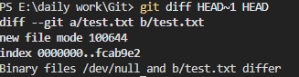

9. Undo staged changes without affecting the working directory.

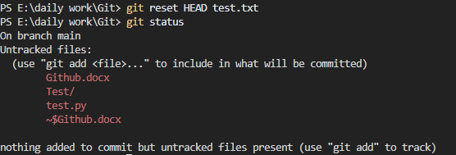

10. Create a signed commit with GPG (if keys are available).

11. Create a new branch, make changes, and merge it into the main branch.

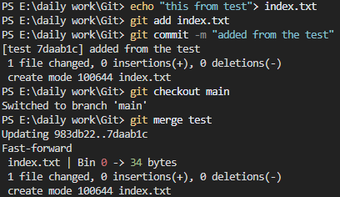

12. Simulate a merge conflict, then resolve it and commit the resolution.

13. Use git rebase to move your changes on top of the latest main branch.

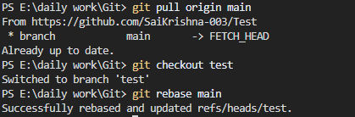

14. Cherry-pick a specific commit from another branch.

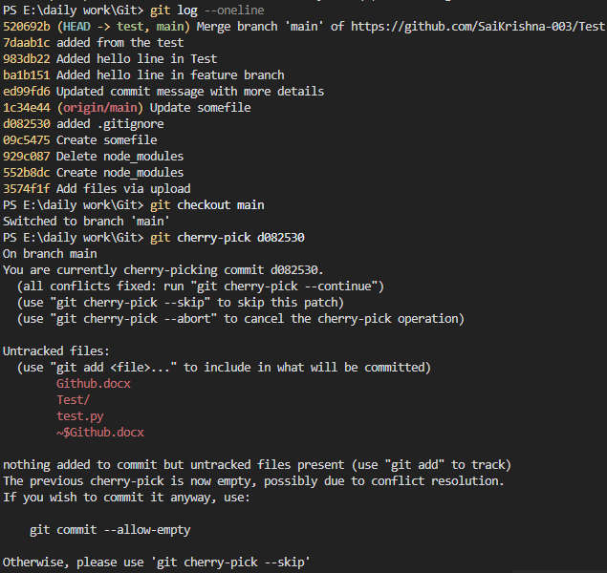

15.Delete a branch locally and remotely after it has been merged.

Locally:



Remotely:



16.Push an existing local branch to a remote repository with a new name.

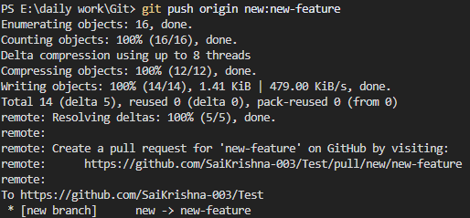

17.Fetch changes from the remote repository and inspect them without merging.



18.Set an upstream branch for a local branch and explain the purpose.

19.Show how to revert a commit that has already been pushed to remote.

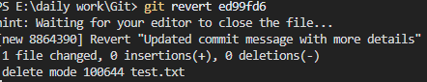

Why it is deletes because that when I create it

20.Tag a commit (lightweight & annotated), push the tag, and list all tags.

