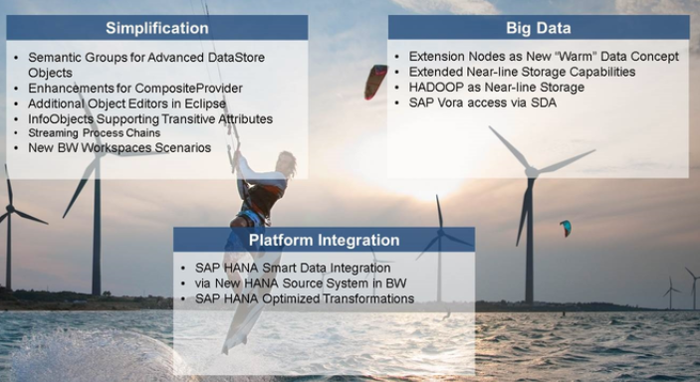
Main features relevant to data acquisition are the editors for modelling Bw/4HANA transformations and DTP's in Eclipse
The web based cockpit for process chains and data load request administration
In comparision to BW 7.5 on any database, modelling and data load process are simplified
Number of Object Types have been reduced
There is no PSA any more, whenever the data is loaded, the target is ADSO or InfoObject table (Attribute. Text, hierarchy)
The recommendation is to use Virtual access wherever possible
Transitive attributes and Composite provider features help to re-use existing data via joins. This helps to reduce the data volume that has to be loaded
With SAP BW/4HANA, it is possible to connect large data volumes via new source system types such as Big Data and SAP Vora access via Smart Data Access(SDA)
Other BW/4HANA features are designed to integrate the SAP HANA Platform into BW/4HANA: BW Queries and transformations can be processed in SAP HANA to process elaborate calculations, and existing sources can be integrated via HANA Source system types
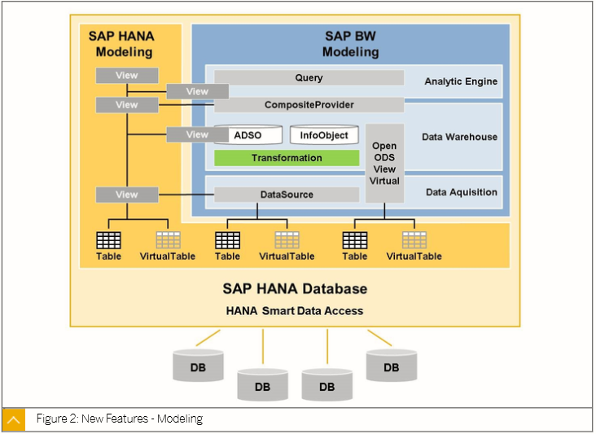

Info objects Use case:
which basic entities do you include in BW/4HANA models?
1. Use Simple fields ( if local format definition is sufficient, no semantics needed)
2. Use Info objects ( When Semantics or a central definition are needed), especially
a. Use a Key figure to provide values to be calculated or evaluated such as Quantity, Amount
b. Use a unit to represent units of measure or currencies
c. use a Characteristic for business reference objects with master data (Attributes, texts, hierarchies) such as Cost Center and Material used to analyze keyfigures
d. Use Time characteristics as time frame for data evaluations such as fiscal period(0fiscper) or calendar year (0calyear)
Characteristics can have related infoobjects called attributes. A Characteristic can have 3 types of master data which are usually loaded from different sources : Attributes, texts and hierarchies
Infoproviders are objects that contain fields or info objects to provide data for reports using most typically , the BW Query
Infoproviders can be tables that contain data or they can be views on tables
There are 4 main types of Info providers:
1. Composite Provider - Join or union of BW Info providers or HANA Calculation views
2. ADSO - To store transaction data in BW/4HANA
3. Open ODS View - To view data from an external source in real time
4. Characteristic InfoObject - For Master data
Characteristics can either store the data or they can access data virtually
Keyfigures never store the data. The Keyfigure values for evaluation are stored together with their reference characteristics as transactional data in a ADSO as an Info Provider
Loading and Manipulating data
1. Only ADSO and Characteristics with their own master data tables have to be filled physically. They are usually loaded from different sources seperately for Attributes, Text, Hierarchies and transactional data
2. Reference Characteristic access values from another (referenced) Characteristic. Data is loaded in to referenced characteristic only
3. Characteristics with Virtual Access read values from HANA Calculation views. No data load is involved
4. Transformations map fieilds or infoobjects from one BW Object to another
5. DTP's define how data is moved from one physical object to another, to BW/4HANA or within BW/4HANA
6. Source systems are connections that are normally external to SAP BW/4HANA
7. A Data Source Organizes data into collections of fields/tables from one source system
Info providers and Infoobjects are grouped by InfoArea
Data Sources within a Source system are grouped by Appication Components
Source Sytems are Grouped by Source System types
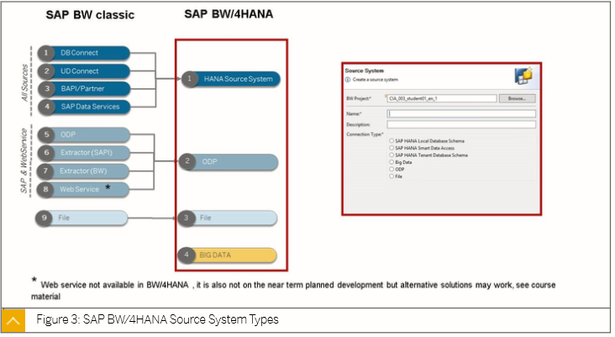

With SAP BW/4HANA, there are 4 Source system types:
1. SAP HANA for sources that are accessed using the underlying SAP HANA Platform
2. ODP is a context that is mainly used to connect to other SAP Sources such as another BW , SAP ECC or SAP SLT as a source
3. Special source types, use a flat file or a big data interface
Operational Data Provisioning framework
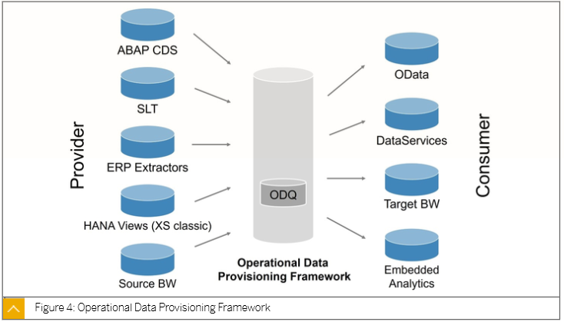

1. With SAP BW/4HANA, the main important data provisioning framework is Operational Data Provisioning (ODP)
2. It’s Central Component, the Operational Delta Queue (ODQ) keeps the order of records
3. ODQ is used as a common intermediate storage to fill different targets such as many BW or SAP BW/4HANA applications, SAP Data Service, an Odata Interface and even embedded analytics applications
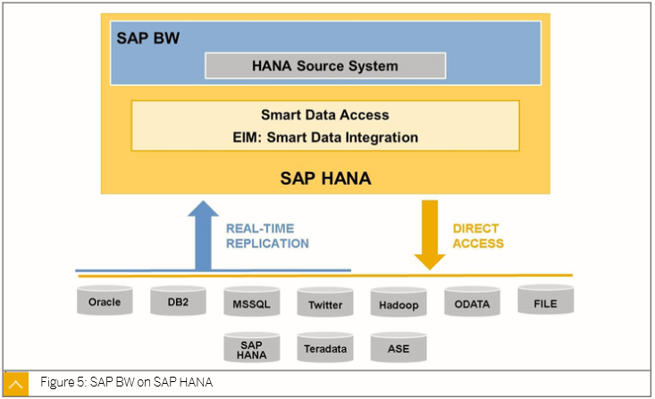

With SDA and SDI, SAP HANA Provides interfaces to many other applications. Many of these adapters support real time replication (Streaming) or Direct access (Virtual access) for real time analysis
From BW/4HANA Perspective, use the source system type HANA.
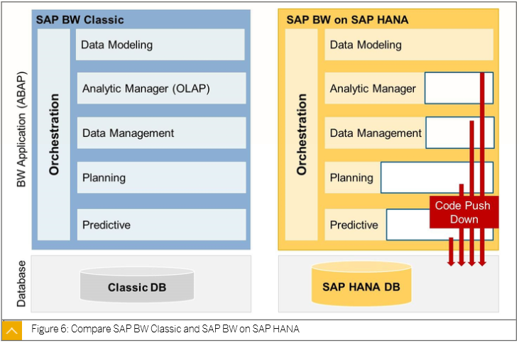

For Data Management, Analytics and Predictive Analytics, BW/4HANA leverages the SAP HANA performance improvement via Code Push Down, even more than in SAP BW powered by SAP HANA
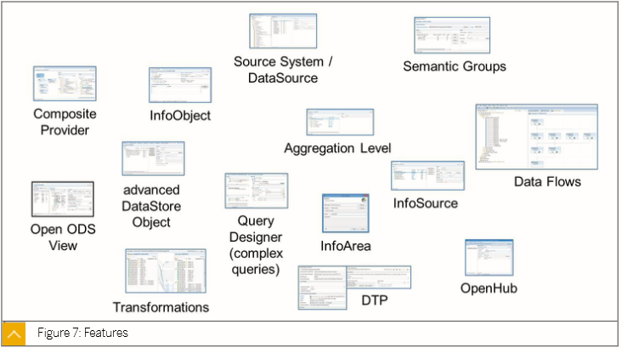

Compared to BW on HANA, more modelling tasks can now be done in the Eclipse based BW Modelling tool. Especially the Data flow objects, transformations and DTP's are edited using Eclipse based user interface
Older Data Flow Objects are not allowed with BW/4HANA
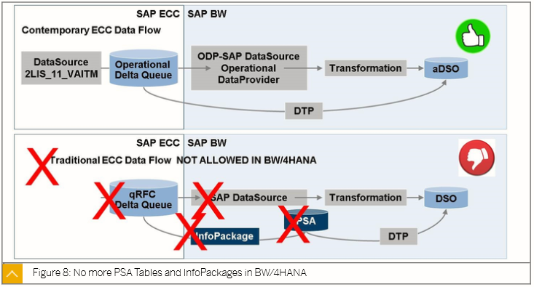

1. The use of the older data flow objects such as Infopackages and PSA tables is not allowed in BW/4HANA
2. with a Contemporary ECC or S/4HANA data flow, qRFC Delta Queue is no longer used
3. Instead, changes are written to Operational Delta Queue and all data is loaded directly from the Source System's ODQ to the data target via the DTP
4. This Process is much simpler and most often more efficient than the previous traditional approach, even including transformations
5. This is because ODQ is more highly compressed than the PSA (by up to 99%) so, why would you want to use PSA
For Full disclosure, the older PSA did allow a little used but nice to have deletion/modify feature for individual records and this is not possible with ODQ
Instead, a similar feature exists in inbound table data display
How the control parameters of the table ROIDOCPRMS are replaced during the data transfer using the ODP framework
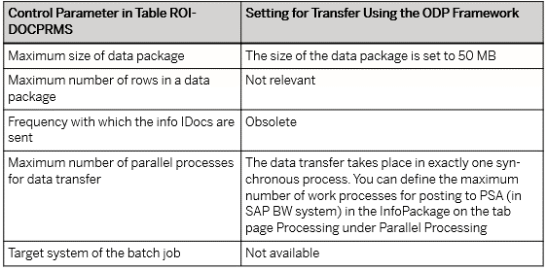

Strategy of BW/4HANA
