COWRIE HONEYPOT
THREAT INTELLIGENCE REPORT
September 10, 2025 — March 10, 2026
Generated: 2026-03-20 06:32
Author: Sai Krishna Masetti

Table of Contents
1. Executive Summary
2. Attack Volume & Trends
3. Source IP Analysis
4. Geographic Distribution
5. Credential Analysis
6. Post-Compromise Activity
7. Malware & Payload Analysis
8. SSH Client Fingerprinting
9. MITRE ATT&CK Mapping
10. Recommendations

1. Executive Summary
This report presents the analysis of 1,001,468 events collected by a Cowrie SSH/Telnet honeypot over a 181-day period from September 10, 2025 to March 10, 2026. The honeypot recorded activity from 7,241 unique source IP addresses across 139,027 sessions.

Key Findings
Metric | Value
Total Events | 1,001,468
Date Range | 2025-09-10 to 2026-03-10 (181 days)
Unique Source IPs | 7,241
Total Sessions | 139,027
Login Attempts | 126,042
Successful Logins | 86,431
Failed Logins | 39,611
File Downloads (total) | 15,235
Unique Malware Samples | 3,824
Avg Session Duration | 5.5 sec

2. Attack Volume & Trends
The honeypot averaged 5,533 events per day. Peak day was 2025-12-16 with 210,913 events.
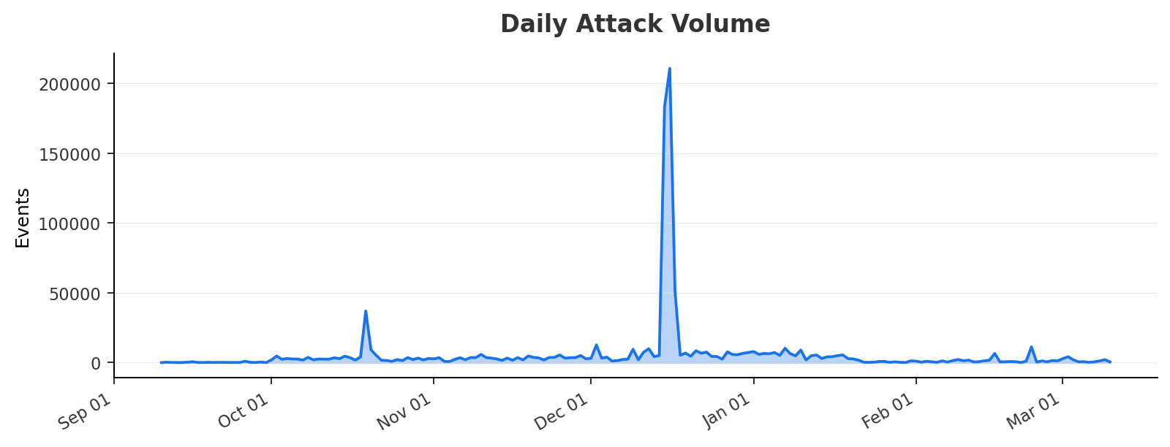

Event Type Breakdown
Event ID | Count
cowrie.session.connect | 139,027
cowrie.session.closed | 139,026
cowrie.client.version | 132,770
cowrie.client.kex | 129,980
cowrie.command.input | 108,773
cowrie.session.params | 98,104
cowrie.log.closed | 98,056
cowrie.login.success | 86,431
cowrie.login.failed | 39,611
cowrie.session.file_download | 15,048
cowrie.command.failed | 13,899
cowrie.client.fingerprint | 218
cowrie.session.file_upload | 187
cowrie.client.size | 117
cowrie.direct-tcpip.request | 113

3. Source IP Analysis
7,241 unique IPs observed. Top 15 most active:
Source IP | Events | Country | ISP
223.241.23.212 | 250,016 | China | Chinanet
152.32.132.189 | 175,928 | Hong Kong | UCLOUD INFORMATION TECHNOLOGY (HK) LIMITED
61.155.10.209 | 34,021 | China | Chinanet
36.94.116.243 | 9,043 | Indonesia | PT. Telekomunikasi Indonesia
45.179.216.18 | 8,836 | Brazil | Iktelecom Ltda
46.101.237.234 | 5,352 | Germany | DigitalOcean, LLC
102.88.137.80 | 5,133 | Nigeria | MTN NIGERIA Communication limited
102.205.237.2 | 4,509 | Kenya | VOS AFRICA
102.88.137.213 | 4,145 | Nigeria | MTN NIGERIA Communication limited
112.18.12.136 | 3,843 | China | China Mobile
197.5.145.150 | 2,334 | Tunisia | SOCIETE NATIONALE DES TELECOMMUNICATIONS (Tunisie Telecom)
103.153.190.105 | 2,275 | Indonesia | WANET
102.210.149.121 | 2,082 | South Africa | THE KONZA TECHNOPOLIS DEVELOPMENT AUTHORITY
102.23.122.235 | 1,979 | Zambia | Infratel Corporation Limited
197.199.224.52 | 1,917 | Egypt | Etisalat Misr

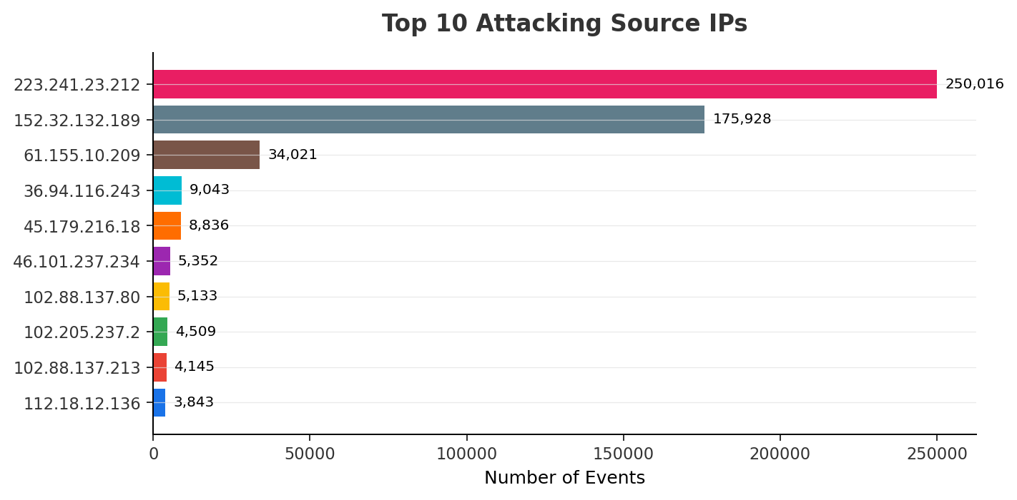

4. Geographic Distribution
Attacks from 30 countries. Top source: China.
Country | Events
China | 287,882
Hong Kong | 175,929
Indonesia | 11,321
Nigeria | 9,279
Brazil | 8,839
United States | 5,467
Germany | 5,352
Kenya | 4,512
Tunisia | 2,336
South Africa | 2,083
Zambia | 1,979
Egypt | 1,918
India | 1,909
Italy | 1,644
Vietnam | 3

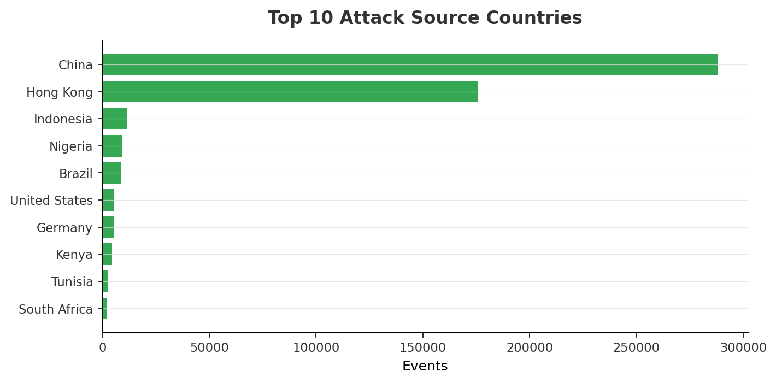

5. Credential Analysis
126,042 login attempts: 86,431 successful (68.6%).
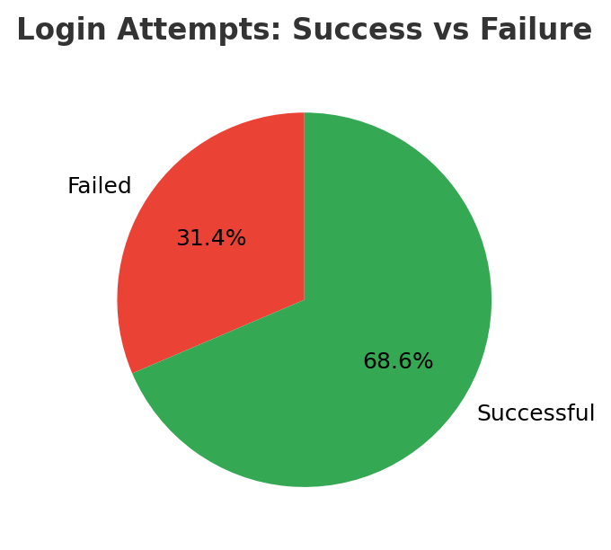

Top Username/Password Combinations
Username | Password | Attempts
root | 3245gs5662d34 | 9,703
345gs5662d34 | 345gs5662d34 | 9,701
root | root | 581
root | admin | 503
root | 123456 | 474
root | password | 435
root | 12345 | 341
root | nPSpP4PBW0 | 332
root | 12345678 | 293
root | qwerty | 255
root | 1234 | 251
root |  | 248
root | 123 | 224
root | 123456789 | 223
root | ubuntu | 204
root | 1 | 164
root | 12 | 145
admin | admin | 107
root | root123 | 106
root | 123123 | 85

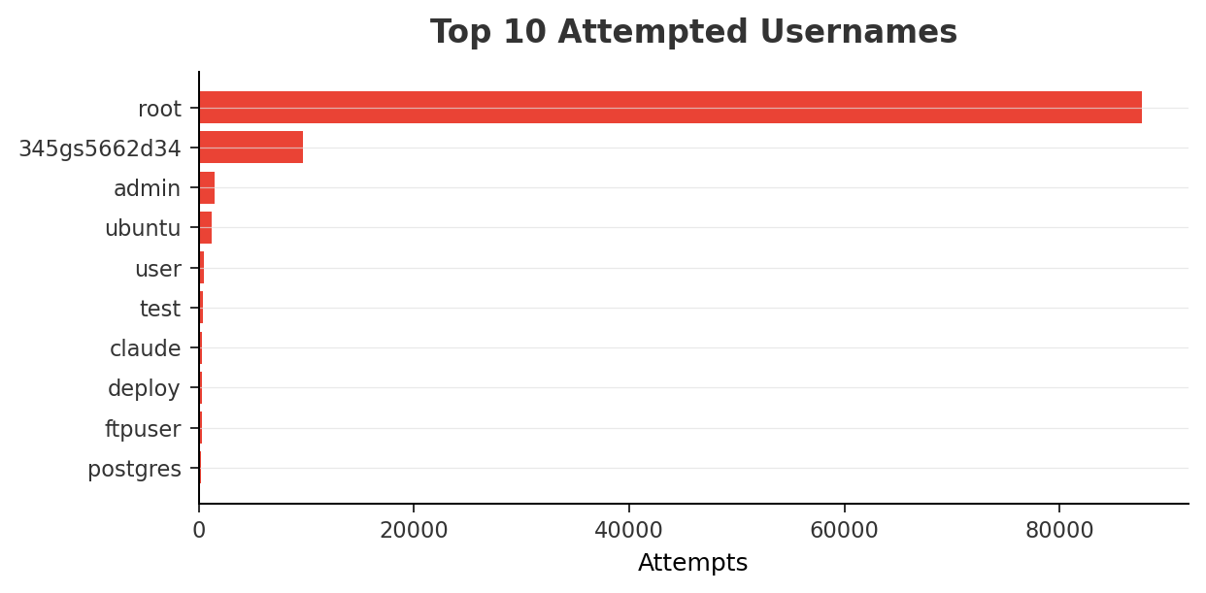

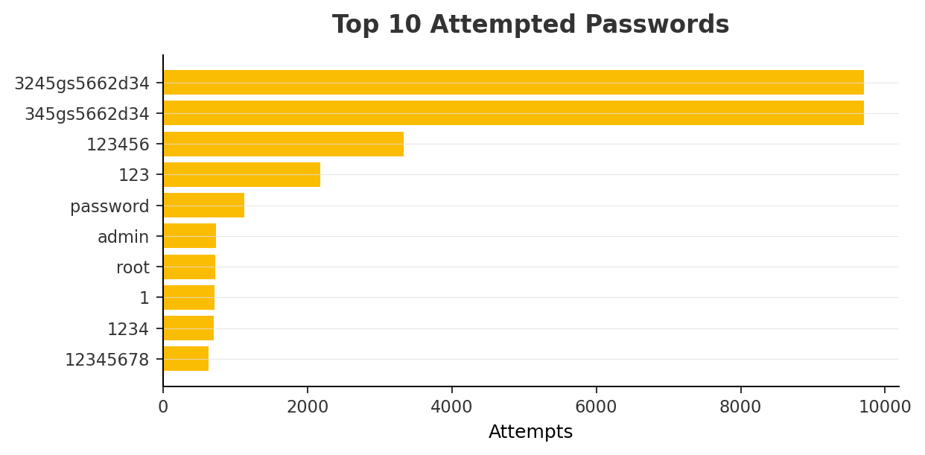

6. Post-Compromise Activity
102,632 commands captured.

Top Commands Executed
Command | Count
echo -e "\x6F\x6B" | 60,355
cd ~; chattr -ia .ssh; lockr -ia .ssh | 10,485
cd ~ && rm -rf .ssh && mkdir .ssh && echo "ssh-rsa AAAAB3NzaC1yc2EA... | 10,432
uname -s -v -n -m 2 > /dev/null | 3,237
uname -m 2 > /dev/null | 3,237
cat /proc/uptime 2 > /dev/null | cut -d. -f1 | 3,222
export PATH=/usr/local/sbin:/usr/local/bin:/usr/sbin:/usr/bin:/sbin... | 2,235
uname -a | 1,283
export PATH=/usr/local/sbin:/usr/local/bin:/usr/sbin:/usr/bin:/sbin... | 987
cat /proc/cpuinfo | grep name | wc -l | 711
whoami | 668
rm -rf /tmp/secure.sh; rm -rf /tmp/auth.sh; pkill -9 secure.sh; pki... | 657
cat /proc/cpuinfo | grep name | head -n 1 | awk '{print $4,$5,$6,$7... | 655
free -m | grep Mem | awk '{print $2 ,$3, $4, $5, $6, $7}' | 645
crontab -l | 642
ls -lh $(which ls) | 641
which ls | 641
w | 635
top | 632
uname | 632

Command Intent Categories
Category | Count
Other | 61,823
Reconnaissance | 21,193
Persistence | 11,176
Navigation | 10,489
Environment Setup | 3,237
Defense Evasion | 657
Lateral Movement | 93
Malware Download | 55
Execution | 1

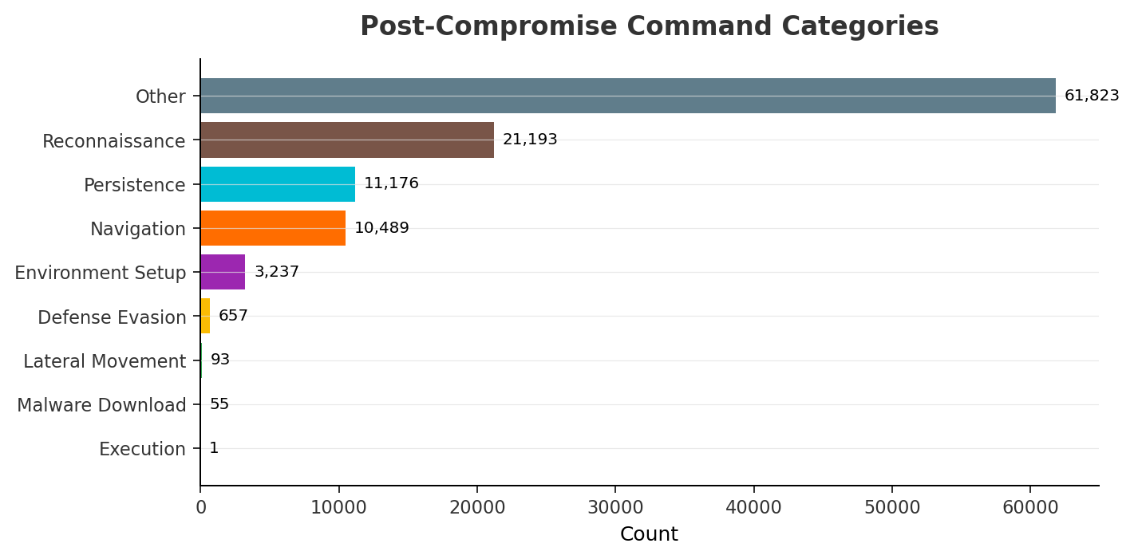

7. Malware & Payload Analysis
15,235 file downloads captured (3824 unique samples by SHA256+IP):
URL / Filename | SHA256 (partial) | Source IP
null | 1b20a210fe96e5a8... | 170.64.198.66
null | 1b20a210fe96e5a8... | 170.64.227.12
null | 1b20a210fe96e5a8... | 134.199.166.246
authorized_keys | a8460f446be54041... | 172.173.117.246
null | 1b20a210fe96e5a8... | 196.251.84.92
sshd | 94f2e4d8d4436874... | 158.51.96.38
sshd | 94f2e4d8d4436874... | 188.239.32.192
sshd | 94f2e4d8d4436874... | 58.229.253.85
sshd | 72ce5b00ca4bfa0c... | 14.103.127.2
sshd | 6e08a9b19df98e36... | 115.190.90.107
sshd | 94f2e4d8d4436874... | 93.84.91.25
null | 4355a46b19d348dc... | 223.86.55.37
null | 1b20a210fe96e5a8... | 104.248.95.186
xinetd | b9e643a8e78d2ce7... | 111.68.111.100
xinetd | b9e643a8e78d2ce7... | 113.90.27.151
sshd | e3b0c44298fc1c14... | 14.103.138.129
sshd | 94f2e4d8d4436874... | 196.251.87.36
sshd | 36e70b9c5271aefe... | 115.190.9.8
sshd | 2f1e559bf4f9e0be... | 180.110.205.200
sshd | 5274a5e6c1146ad4... | 111.160.133.62

Extracted URLs from Commands
18 unique URLs extracted from attacker commands:
http://1.234.82.104:60141/linux
http://111.229.103.213:60140/linux
http://154.91.83.11:60135/linux
http://185.41.162.55:60135/linux
http://194.58.100.55:60103/linux
http://194.67.104.145:60117/linux
http://194.67.111.43:60116/linux
http://47.104.228.56:60145/linux
http://47.112.186.32:60116/linux
http://47.242.224.97:60147/linux
http://47.76.78.160:60105/linux
http://47.86.2.149:60122/linux
http://47.86.29.170:60119/linux
http://47.89.232.185:60131/linux
http://47.97.40.154:60144/linux
http://8.222.174.150:60111/linux
http://80.78.243.167:60129/linux
http://95.47.239.28:60134/linux

8. SSH Client Fingerprinting
SSH client version strings observed:
Client Version | Count
SSH-2.0-Go | 71,083
SSH-2.0-libssh_0.11.1 | 58,369
SSH-2.0-OpenSSH_10.0 | 486
GET / HTTP/1.1 | 317
SSH-2.0-ZGrab ZGrab SSH Survey | 313
SSH-2.0-libssh_0.9.6 | 172
MGLNDD_18.116.162.221_22 | 158
SSH-2.0-libssh_0.7.4 | 115
SSH-2.0-libssh2_1.11.1 | 98
SSH-2.0-libssh_0.11.2 | 94

9. MITRE ATT&CK Mapping
MITRE ATT&CK techniques identified from observed activity:
Technique ID | Technique | Tactic | Event ID | Count
T1595 | Active Scanning | Reconnaissance | cowrie.client.version | 132,770
T1059 | Command & Scripting Interpreter | Execution | cowrie.command.input | 108,773
T1078 | Valid Accounts | Initial Access | cowrie.login.success | 86,431
T1110 | Brute Force | Credential Access | cowrie.login.failed | 39,611
T1105 | Ingress Tool Transfer | Command & Control | cowrie.session.file_download | 15,048
T1105 | Ingress Tool Transfer | Command & Control | cowrie.session.file_upload | 187
T1572 | Protocol Tunneling | Command & Control | cowrie.direct-tcpip.request | 113

10. Recommendations

Block Prolific Attackers
Implement IP blocklists or rate limiting for top attacking IPs. Consider fail2ban with aggressive thresholds.

Strengthen Authentication
Enforce key-based SSH auth, disable password login, use non-standard ports.

Monitor for Known Malware
Submit captured downloads to VirusTotal. Block malicious URLs at the perimeter.

Geo-Block Where Appropriate
Block SSH from countries with no legitimate need to connect.

Expand Honeypot Coverage
Deploy honeypots on HTTP, RDP, SMB ports for broader visibility.

Integrate with SIEM
Feed logs into Splunk / QRadar / Microsoft Sentinel for real-time alerting.

Regular Reporting Cadence
Generate this report weekly/monthly to track attacker behavior trends.

