**Tablet Recognition System Using Convolutional Neural Networks**

Vivek Yadav Baira¹, Sachin Beniwal², Sai Krishna Nugur3

**Abstract –** A pressing need in improving tablet device usability and accessibility for those with low reading skills is addressed by the Tablet Recognition System (TRS) for illiterate users. A major obstacle to the adoption and efficient use of technology, particularly tablets, which have enormous promise for education, communication, and empowerment, is illiteracy in many communities throughout the world. This research introduces a revolutionary TRS specifically designed to meet the demands of illiterate people, allowing them to independently and intuitively engage with tablet devices. To help with medicine administration, we demonstrated a real-time drug packet detection system based on deep learning. In order to automate the tablet identification procedure, we present in this research a tablet recognition system built on convolutional neural networks (CNNs). The system's objective is to recognize tablets accurately and efficiently so that workflows may be optimized and human error can be minimized.

**Keywords –** Convolutional Neural Networks, Classification, Recognition

**Introduction**

Globally, almost 28% of individuals are 65 years of age or older. Medication provision requires a significant amount of labor and

material resources due to the large number of inhabitants. As deep learning technology advances, high-performance computers may eventually replace occupations involving supervision. This research proposes a pharmaceutical distribution system that provides users with drug information upon entering their name, hence eliminating the need for third-party monitoring operations. To enable smooth interaction between the user and the tablet, the suggested TRS makes use of computer vision methods and user-friendly interfaces. Simplified user interfaces with clear icons and images, as well as visual identification of common tablet tasks and apps, are among the system's key characteristics. Through the integration of these components, the TRS hopes to enable illiterate individuals to fully utilize tablet devices for a range of daily functions, including learning, communication, and accessing critical services.

With its simple and intuitive design, the TRS workflow makes it easy for users to engage with the system. The user is presented with a visually intuitive interface consisting of familiar icons that represent various functions and programs when running the TRS application. The system recognizes the photographs provided by the users using computer vision techniques.

**Motivation**

1. Globally, almost 28% of individuals are 65 years of age or older.

2.Medication provision requires a significant amount of labor and

material resources due to the large number of inhabitants. As deep learning technology advances, high-performance computers may eventually replace occupations involving supervision.

In medical treatment, every little detail counts. Understanding medication tablets is essential for both patient safety and efficient care. Patients may experience negative reactions or problems if symptoms are not accurately recognized. Accurate identification is difficult yet essential in the age of pharmaceutical products.  
  
AI and image recognition technologies, among others, provide answers. Imagine portable gadgets quickly scanning tablets and providing instantaneous information retrieval. These kinds of instruments not only increase productivity but also boost patient assurance.  
  
Additionally, drug tablet recognition supports pharmacovigilance initiatives by tracking adherence and identifying adverse responses. Public health is protected and focused interventions are made possible by comprehensive data.  
  
To put it simply, being the best at identifying medication tablets represents our dedication to accuracy, security, and empathy in healthcare. By embracing innovation and giving patient-centered solutions top priority, we open the door to a future in which each tablet is valued for its healing potential

**Contribution**

I have collected different type of tablets which helps a person to heal from particular diseases, In addition to that I have designed the plan on executing the project in from intial stage to final stage.

I have selected the type of methodology we use in the project

**Objective**

1.The system's objective is to recognize tablets accurately and efficiently so that workflows may be optimized and human error can be minimized.

2.In order to automate the tablet identification procedure, we present in this research a tablet recognition system built on convolutional neural networks (CNNs).

Ensuring accurate pharmaceutical product identification is the goal of medication tablet recognition, which will improve patient safety, maximize treatment outcomes, and further public health initiatives. Accurately identifying medication tablets is essential for productive and successful clinical practice in the constantly changing healthcare environment.   
  
  
Priority one should be given to reducing the hazards related to drug mistakes. We hope to reduce adverse drug responses, dosing errors, and medication-related difficulties by giving medical personnel trustworthy tools for quick and accurate identification of pharmaceutical tablets. In addition to preserving patient safety, this boosts trust in the medical system.

Additionally, the goal encompasses enhancing treatment procedures and enhancing the provision of healthcare services. Clinicians are able to monitor pharmaceutical efficacy, assure adherence to prescribed regimens, and customize therapies to meet the specific needs of each patient by using comprehensive tablet recognition. This individualized strategy improves treatment results, lowers medical expenses related to pointless procedures or extended hospital stays, and promotes a patient-centered care culture.

Moreover, the objective encompasses broader public health goals, including pharmacovigilance and medication management initiatives. Accurate identification of medicine tablets facilitates the timely detection of adverse drug reactions, enables surveillance of medication utilization patterns, and enhances pharmacoeconomic analyses. By leveraging data-driven insights derived from medicine tablet recognition, healthcare authorities can implement targeted interventions, optimize medication formularies, and promote rational prescribing practices, thereby safeguarding population health and promoting medication safety on a global scale.

In summary, the objective of medicine tablet recognition is multifaceted, encompassing patient safety, treatment optimization, and public health advancement. By harnessing the power of technology, data, and collaborative innovation, we strive to ensure that every medicine tablet is accurately recognized, revered for its healing potential, and instrumental in shaping a healthier, more resilient society.

**Related work**

1. A real-time medicine packet identification system for senior medication dispensing   
  
This project aims to develop a real-time medicine packet detection system based on deep learning to help in medication delivery. The suggested slight convolutional neural network is used for character recognition, while binarization and morphological operations are used for character segmentation. The system has three stages: medical information arrangements, which include the patient's name and time, and character recognition. Real-time processing is the goal of parallel processing. The system achieved 100% accuracy in real-time processing at five frames per second, according to the testing data.

2. MedGlasses: A Deep Learning-Based Wearable Smart Glasses Drug Pill Recognition System for Chronic Visually Impaired Patients

A set of wearable smart glasses, an intelligent medication pill detection box powered by artificial intelligence (AI), a mobile device app, and a cloud-based information management platform make up the proposed MedGlasses system. The MedGlasses system combines cloud and Internet of Things (IoT) technologies with deep learning to recognize medication pills in images. According to experimental data, up to 95.1% identification accuracy can be attained.

3. A three-phase method for identifying medication boxes.

This study suggests a three-staged method for approaching the problem of medication box identification in a fresh way. We outline the feature matching, text recognition, and barcode recognition algorithms that will be applied at each step. The system's ultimate objective is to accurately recognize pharmaceutical boxes using a camera installed on an Android-powered device and then deliver pertinent information about them to individuals who have difficulty (older, visually impaired, etc.). When recognizing boxes using their barcodes (in still images) or by using an OCR to find the medicine name, we claim an 80% success rate. When recognizing boxes using their barcodes (in still images) or by using an OCR to find the medicine name, we claim an 80% success rate. In the case of feature matching, the success rate is 100%, although the established approach is currently sluggish.

**Proposed System**

The several convolutional layers in the suggested CNN architecture for injury diagnosis are followed by pooling layers for spatial down sampling and non-linear activation functions to provide non-linearity to the model. To increase the network's convergence and speed up training, batch normalization layers are included. Usually, the last layers are completely linked layers that have SoftMax activation to classify injuries into various groups.

Convolutional Layers: These layers are made up of many filters that convolve across the input picture to capture various scales of spatial characteristics. Each filter uses element-wise multiplication and summation operations to identify particular patterns, such edges or textures.

Input Layer: The medical picture data is received by the input layer, usually as matrices that indicate the intensities of the pixels.

Activation Function (ReLU): Rectified Linear Unit (ReLU) activation functions facilitate the learning of complicated connections in the data by introducing non-linearity to the model by substituting zero for negative pixel values.

Pooling Layers: By combining data from specific areas of the input feature maps, pooling layers carry out spatial down sampling. In order to minimize computational complexity and preserve the most important properties, max pooling is frequently utilized.

Batch Normalization: By guaranteeing steady gradients across the network, batch normalization layers normalize the activations of every layer, minimizing internal covariate changes and speeding up the training process.

Fully Connected Layers: Using densely connected neurons, these layers combine features discovered by the convolutional layers to generate final predictions. To create probability distributions across the damage classes, SoftMax activation is used.

Output Layer: This layer allows the input medical picture to be classified into one of the established classes by giving the probability distribution over several damage types.

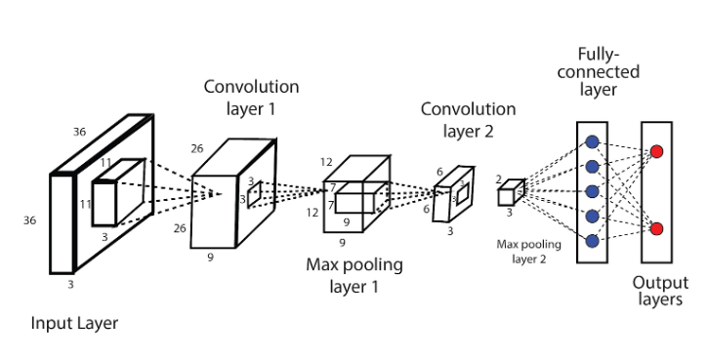

Fig: Convolutional Neural Network

**Proposed Methodology**

Neural networks are trained on a set of tablet samples. Initially, the tablet backdrop of the imprinted sign in the tablet pictures is eliminated using a tablet segmentation technique. The tablet pictures are then oriented and positioned in relation to the reference tablet. The neural network training method then makes use of the characteristics that were derived from the imprinted symbols. In order to recognize fresh inputs from the user without requiring additional training, the weights of the learned neural networks are saved.

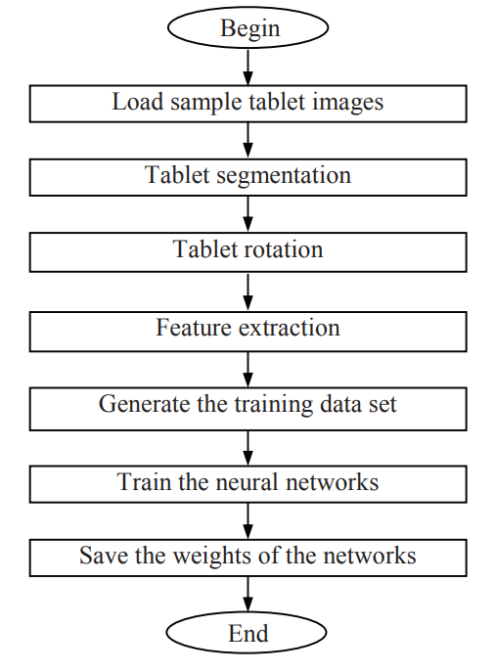

Fig: Neural network training flowchart

The following actions take place when the user provides new input.

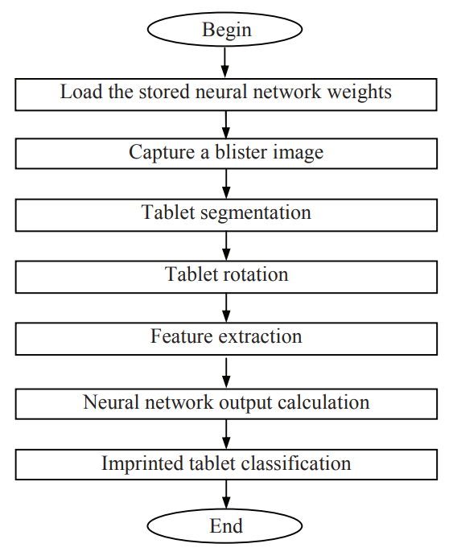

Fig: Tablet packet classification using neural networks

**Evaluation of the Algorithm**

A number of characteristics contribute to CNNs' effectiveness, including as their scalability to huge datasets and demanding tasks, their ability to learn hierarchical representations of features, and their ability to generalize effectively to unknown data. CNNs have therefore emerged as a key component of contemporary artificial intelligence and are still driving developments in computer vision and related fields.

**References**

Real-time medicine packet recognition system in dispensing medicines for the elderly by Xuebin Yue, Bing Lyu, Hengyi Li, Lin Meng, Katsuyuki Furumoto published in Measurement: Sensors 18 (2021) 100072

MedGlasses: A Wearable Smart-Glasses-Based Drug Pill Recognition System Using Deep Learning for Visually Impaired Chronic Patients by Wan-Jung Chang, Liang-Bi Chen, Chia-Hao Hsu, Jheng-Hao Chen, Tzu-Chin Yang, Cheng-Pei Lin published in IEEE

A three-staged approach to medicine box recognition by Luis Magalhães, Bruno Ribeiro, Nelson Alves, Miguel Guevara published in IEE

K. Simonyan and A. Zisserman, "Very deep convolutional networks for large-scale image recognition", 2014.

C. Szegedy et al., "Going deeper with convolutions", *2015 IEEE Conference on Computer Vision and Pattern Recognition (CVPR)*, pp. 1-9, 2015.

K. He, X. Zhang, S. Ren and J. Sun, "Deep residual learning for image recognition", *Proceedings of the IEEE conference on computer vision and pattern recognition*, pp. 770-778, 2016.

S. Ren, K. He, R. Girshick and J. Sun, "Faster R-CNN: Towards Real-Time Object Detection with Region Proposal Networks", *IEEE Transactions on Pattern Analysis and Machine Intelligence*, vol. 39, no. 6, pp. 1137-1149, 2017.

F. Chollet, "Xception: Deep learning with depthwise separable convolutions", pp. 1610.02357, 2017.

M. Rockville, "Reducing and preventing adverse drug events to decrease hospital costs", *Research in Action Agency for Healthcare Researchand Quality*, no. 1, March 2001.

*Drugs.com*, [online] Available: <https://www.drugs.com/pill_identification.htm>.

A. Torralba and A. A. Efros, "Unbiased look at dataset bias", *Proceedings of the IEEE Conference on ComputerVision and Pattern Recognition*, pp. 1521-1528, June 2011

O. Russakovsky, J. Deng, H. Su, J. Krause, S. Satheesh, S. Ma, Z. Huang, A. Karpathy, A. Khosla, M. Bernstein et al., "Imagenet large scale visual recognition challenge", International Journal of Computer Vision, vol. 115, no. 3, pp. 211-252, 2015.

Z. Du, L. Sun and L. Fu, "An Overview Of Medical Robots", Transducer and Microsystem Technologies, no. 6, pp. 90-93, 2017.

Healthline. Medication Safety: Pill Identification, Storage, and More. 2021. Available online: [**https://www.healthline.com/health/pill-identification**](https://www.healthline.com/health/pill-identification) (accessed on 31 July 2022).

Aditya Wagh, Kantian Dhoti and Karmic Ingle, "Real Time Image Processing on Single Board Computer", Imperial Journal of Interdisciplinary Research, vol. 2, no. 7, 2016.

Khalil Al-Hussaeni, Ioannis Karamitsos, Ezekiel Adewumi, Rema M. Amawi, "CNN-Based Pill Image Recognition for Retrieval Systems", *Applied Sciences*, vol.13, no.8, pp.5050, 2023

B. R. South, F. J. Friedlin, S. Shen, M. H. Samore and S. M. Meystre, "Automatic De-identification of textual documents in the electronic health record: a review of recent research", BMC Med. Res. Methodol, vol. 10, pp. 70, Aug. 2010

R. Girshick, "Fast R-CNN", 2015 IEEE International Conference on Computer Vision, pp. 1440-1448, 2015.

J. Redmon, S. Divvala, R. Girshick and A. Farhadi, "You only look once: Unified real-time object detection", Proceedings of the IEEE Conference on Computer Vision and Pattern Recognition, pp. 779-788, 2016.

Pitchaya Chotivatunyu, Narit Hnoohom, "Medicine Identification System on Mobile Devices for the Elderly", *2020 15th International Joint Symposium on Artificial Intelligence and Natural Language Processing (iSAI-NLP)*, pp.1-6, 2020.