Knowledge-Enhanced Explainable Machine Learning for Predicting Startup Success
Short Communication
Sai Krishna Bhagam
saikrishbhagamus@gmail.com
Abstract
Predicting whether a venture-backed startup will reach a successful exit is a central decision problem for investors, accelerators and innovation policy, yet most machine-learning models learn only from raw funding records and ignore what venture-finance research already knows. This Short Communication presents KEXS, a knowledge-enhanced explainable model that injects five layers of prior knowledge into gradient-boosted trees: an expert sector ontology, a category knowledge graph embedded from 49,436 firms, venture-staging rules, entrepreneurial-ecosystem statistics, and monotone constraints that encode directional domain priors. On 6,295 resolved Crunchbase startups (acquired vs. closed), KEXS reaches a cross-validated ROC-AUC of 0.812, improving the identical data-only model by 0.012 AUC points (corrected resampled t-test, p < 0.001), and the gain persists on a strict temporal hold-out of startups first funded in 2010–2014 (+0.012, 95% CI [+0.003, +0.022]). The monotone constraints remove every individual-level violation of the encoded priors—violations that affect 25–60% of firms in the unconstrained model—at no cost in accuracy. An exact group-Shapley decomposition over all 32 feature-group coalitions attributes 63% of the model's discriminative power to the knowledge layers, led by venture-staging and ecosystem knowledge. Code, data and every figure are openly reproducible.
Keywords: knowledge-based systems; informed machine learning; startup success prediction; knowledge graph; explainable artificial intelligence; venture capital; decision support

1. Introduction
Startups are a primary vehicle through which innovation and digital transformation reach the economy, yet most of them fail, and investors must decide under severe uncertainty which ventures to back. Machine learning (ML) on large venture databases such as Crunchbase has therefore become an active research area, ranging from outcome classifiers [1,2] and decision-support benchmarks for venture capital [3] to bias-free evaluation protocols [4,5], exit-prediction systems [6] and portfolio simulation [7]. A recent meta-analysis finds funding history, investor structure and firm characteristics to be the most consistent predictors, with importance shifting across outcome definitions and data sources [8].
Almost all of these models are purely data-driven: they feed raw funding amounts, round counts and categorical labels to a classifier and leave it to rediscover regularities that venture-finance research has documented for decades—staged financing [9], investor signalling [10] and regional agglomeration effects [11,12]. Such models are hard to audit, may encode economically implausible relationships, and give decision-makers little reason to trust an individual score [13]. Informed machine learning addresses this gap by integrating prior knowledge into the training data, the hypothesis space or the learning algorithm [14]. Graph-based knowledge has begun to enter venture analytics [15], but no systematic test exists of whether structured domain knowledge improves startup-success prediction, which knowledge sources matter, and whether knowledge can make predictions verifiably consistent with expert priors.
This paper proposes KEXS (Knowledge-Enhanced eXplainable Startup-success model). KEXS differs from existing Crunchbase predictors in two structural ways. First, knowledge enters through two complementary channels: as four knowledge-derived representations (K1–K4) that change what the learner sees, and as monotone constraints (K5) that change which functions it may learn. Second, explanation is performed at the level of knowledge sources rather than individual features: an exact group-Shapley decomposition quantifies how much predictive power each knowledge layer contributes and splits redundant information fairly. The contribution is threefold: (i) a compact, reusable knowledge layer for startup analytics that combines an expert ontology, a category knowledge graph, venture-staging rules and ecosystem statistics; (ii) a knowledge-constrained, explainable predictor whose individual predictions provably respect directional domain priors; and (iii) a conservative, fully reproducible evaluation with frozen hyper-parameters, corrected significance tests, a strict temporal hold-out, a 32-coalition attribution study and an individual-level consistency audit.

2. Proposed KEXS Framework

2.1 Data and prediction task
The study uses the public Crunchbase export distributed on Kaggle [16], which describes 49,436 organisations with their categories, location, founding date and funding history by instrument (seed, angel, Series A–H, debt, grants, crowdfunding and others) up to 2014. Following prior work [4,6], success is defined as acquisition (y = 1) and failure as closure (y = 0); firms that are still operating are unresolved and are not labelled. This yields 6,295 labelled startups (3,692 acquired, 2,603 closed). The Base representation contains the 70 features a standard pipeline would use: log amounts per funding instrument, number of rounds, founding and first-funding year, and indicators for the 30 most frequent markets and 15 most frequent countries. The task is to estimate p(y = 1 | x) for a startup described by x; Figure 1 gives an overview of how KEXS enriches and constrains this estimate.
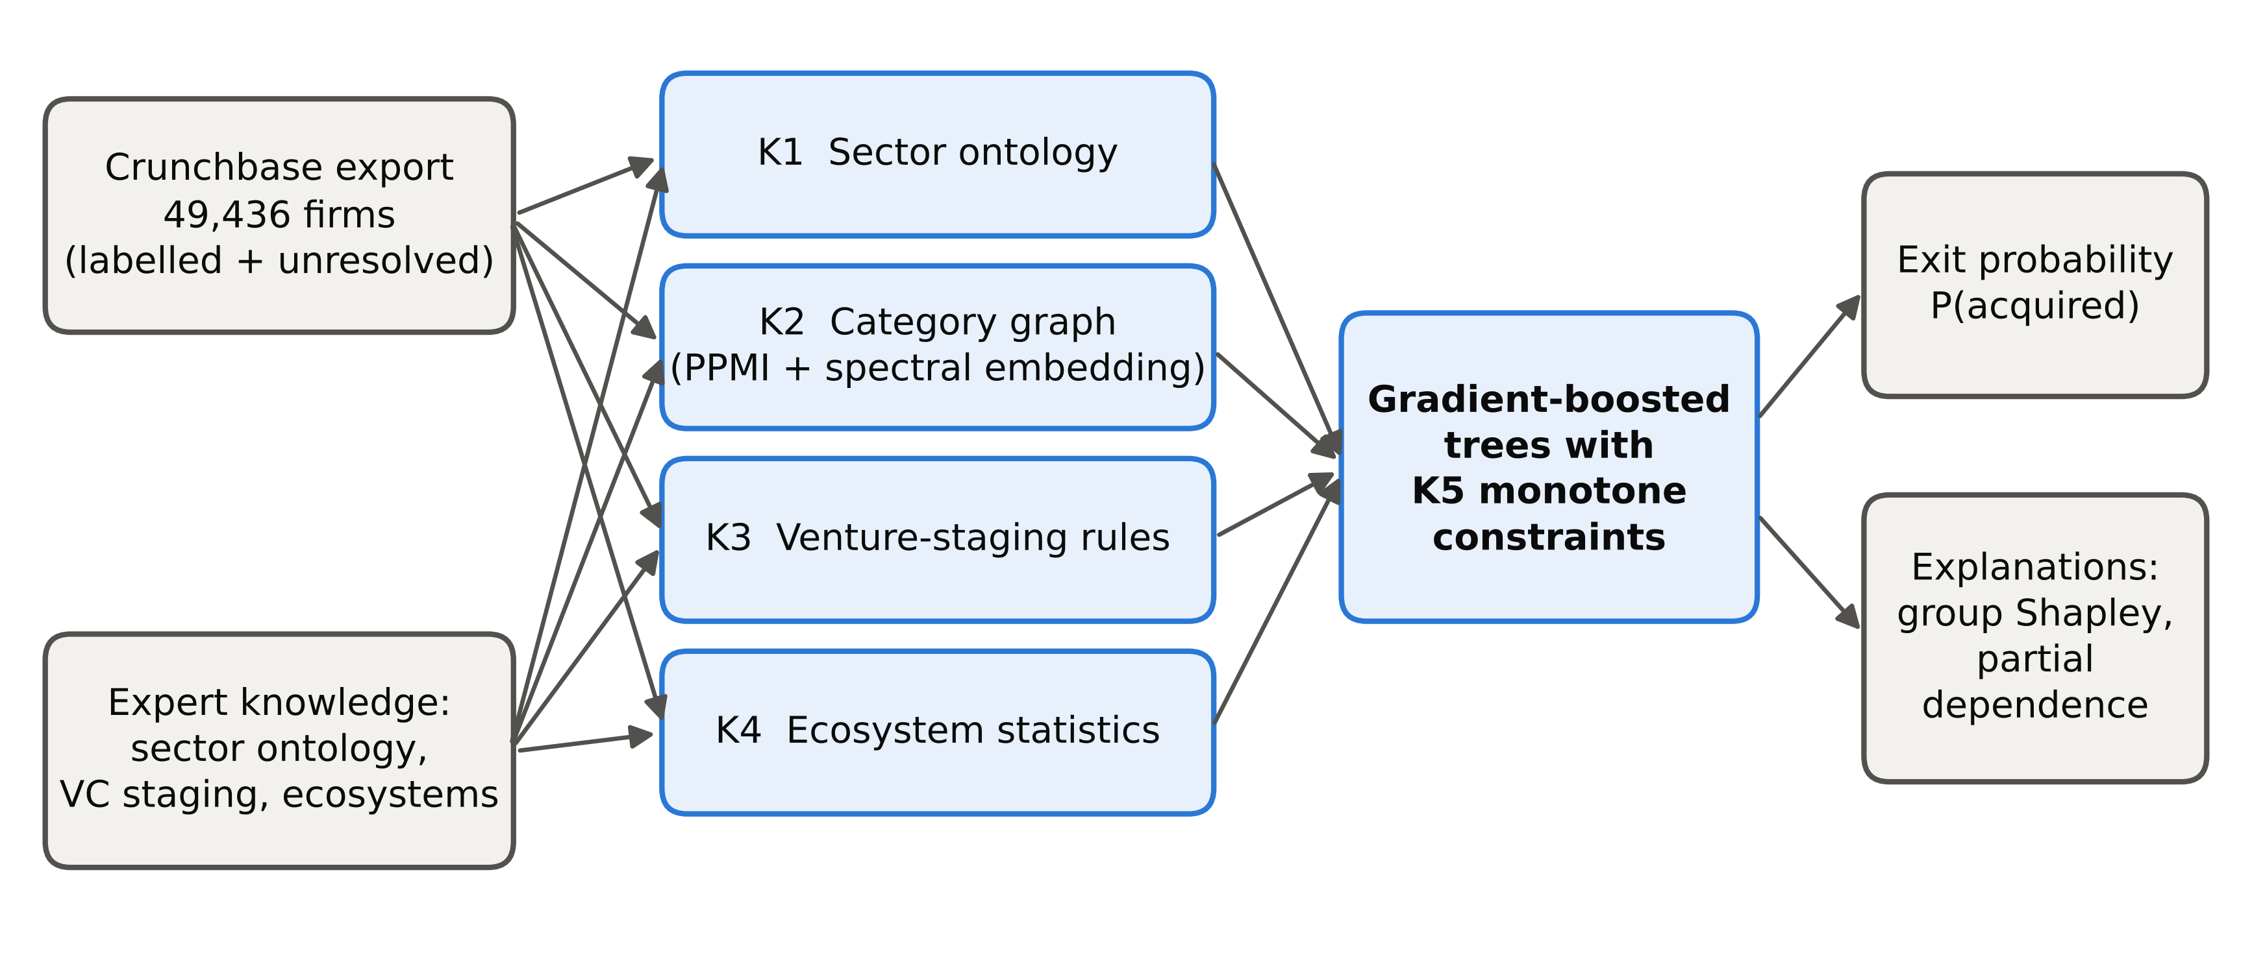
Figure 1. Overview of the KEXS framework. Raw Crunchbase records and expert knowledge produce four knowledge layers (K1–K4); gradient-boosted trees learn from them under knowledge-based monotone constraints (K5) and output an exit probability with group-level and feature-level explanations.

2.2 Knowledge layers K1–K4
Table 1 summarises the 44 knowledge features. K1 (sector ontology) maps more than 800 free-text Crunchbase categories onto ten macro-sectors through an expert keyword taxonomy with explicit overrides that covers 92.9% of category mentions, and annotates each sector with a capital-intensity level. K2 (category knowledge graph) builds a weighted graph whose nodes are categories and whose edges count co-assignment to the same firm. Edges are re-weighted by positive pointwise mutual information (PPMI), Eq. (1):
PPMI(i, j) = max{ log [ C_{ij} · C / ( C_{i} · C_{j} ) ], 0 } (1)
where C_{ij} is the co-occurrence count of categories i and j, C_{i} and C_{j} are marginal sums and C is the total; a truncated SVD of a PPMI matrix is a well-established count-based counterpart of skip-gram embeddings, which implicitly factorise a shifted PMI matrix [17]. A 16-dimensional spectral embedding of the PPMI matrix (truncated SVD) places related markets close together, and each firm is represented by the mean embedding of its categories. The graph is built from all 49,436 firms, including the unresolved ones, but uses no outcome label. K3 (venture-staging knowledge) operationalises staged financing [9] and signalling [10]: highest stage reached (none, seed/angel, A, B, C, D+), institutional, informal and non-dilutive shares of capital, instrument diversity, round velocity, funding span and time from founding to first funding. K4 (ecosystem knowledge) encodes agglomeration theory [11,12] through regional and national startup density, regional capital, market crowding, membership of the ten largest hubs, and a sector location quotient, Eq. (2):
LQ_{r,s} = ( n_{r,s} / n_{r} ) / ( n_{s} / n ) (2)
which measures how specialised a firm's region r is in its macro-sector s relative to the whole population (n_{r,s} firms of sector s in region r, n_{r} firms in r, n_{s} firms in s, n firms in total).
Table 1. Knowledge layers of KEXS.
Layer | Content | No. | Knowledge source
Base | Raw Crunchbase fields: log amounts per funding instrument, rounds, founding and first-funding year, top-30 market and top-15 country dummies | 70 | Data only (no knowledge)
K1 | Expert sector ontology: 800+ categories mapped to 10 macro-sectors, sector breadth, capital-intensity level | 13 | Industry taxonomy; capital-intensity view of venture finance
K2 | Category knowledge graph: co-occurrence graph of categories, PPMI weighting, 16-d spectral embedding averaged per firm | 16 | Market relatedness / knowledge-graph embedding
K3 | Venture-staging knowledge: highest stage reached, institutional / informal / non-dilutive capital shares, instrument diversity, round velocity, time to first funding | 9 | Staged financing and investor-signalling theory
K4 | Ecosystem knowledge: regional and national start-up density, regional capital, market crowding, hub membership, sector location quotient | 6 | Agglomeration / entrepreneurial-ecosystem theory
K5 | Monotone constraints on stage, institutional share, total funding and rounds (non-decreasing effect on exit odds) | 4 | Prior domain knowledge as model constraint
K2 and K4 are computed without outcome labels; K5 constrains the learner rather than adding features.

2.3 Monotone knowledge constraints (K5)
K5 (monotone knowledge constraints) encodes the expert prior that, other things being equal, a higher financing stage, a larger institutional share of capital, more total funding and more rounds should never lower the predicted probability of exit. For each constrained feature k ∈ 𝒦, KEXS enforces Eq. (3) for every firm, not only on average:
x_{k} ≤ x′_{k} and x_{−k} = x′_{−k} ⇒ f(x) ≤ f(x′), ∀ k ∈ 𝒦 (3)
KEXS learns gradient-boosted decision trees [18,19] on Base + K1–K4 and imposes Eq. (3) as monotonic split constraints, so that no tree can create a region in which the score decreases along a constrained feature. All other features remain unconstrained.

2.4 Group-Shapley attribution of knowledge sources
To quantify each knowledge source, the five feature groups g ∈ G = {Base, K1, K2, K3, K4} are treated as players in a cooperative game whose value v(S) is the out-of-fold ROC-AUC of the model trained on the groups in coalition S, with v(∅) = 0.5. Exact Shapley values are computed over all 2⁵ = 32 coalitions [20,21], Eq. (4):
φ_{g} = Σ_{S ⊆ G∖g} [ |S|! (|G| − |S| − 1)! / |G|! ] · [ v(S ∪ {g}) − v(S) ] (4)
Unlike feature-level SHAP values, this decomposition answers the design question directly—how much predictive power each knowledge layer adds—and distributes the credit for information that two groups share. Global behaviour is visualised with partial dependence [18]. Algorithm 1 summarises the complete procedure.
Algorithm 1. KEXS training and explanation
Input: firm records D (labelled and unresolved); expert ontology O; constrained feature set 𝒦
Output: exit-probability model f; group-Shapley values φ; partial-dependence curves
1: Build Base features x_B from the labelled firms.
2: K1 ← map every category to a macro-sector of O; add capital intensity and sector breadth.
3: K2 ← category co-occurrence graph over all firms in D → PPMI (Eq. 1) → truncated SVD; average per firm.
4: K3 ← venture-staging rules (stage reached, investor mix, velocity, time to first funding).
5: K4 ← ecosystem statistics over all firms in D, including the location quotient (Eq. 2).
6: Train gradient-boosted trees f on [x_B, K1, K2, K3, K4] with monotone constraints on 𝒦 (Eq. 3).
7: for every coalition S ⊆ G do v(S) ← out-of-fold ROC-AUC of the model trained on S
8: φ_g ← Shapley value of each group g from {v(S)} (Eq. 4).
9: return f, φ and partial-dependence curves of f.

3. Experimental Design
All models were evaluated by 5-fold stratified cross-validation repeated three times (15 folds). The baselines are logistic regression (LR), a multilayer perceptron (MLP), a random forest (RF) and the same gradient-boosted trees (GBDT) used by KEXS; each is trained once on the Base features and once on Base + K1–K4, so every knowledge effect is measured against an otherwise identical model. GBDT hyper-parameters (learning rate 0.03, 300 trees, 7 leaves, minimum leaf size 80, L2 penalty 5) were selected once on the Base features with a different random split and then frozen for every feature set, which favours the baseline rather than KEXS (the selection grid is reproduced by run.py --tune). Differences in fold-level AUC are tested with the Nadeau–Bengio corrected resampled t-test [22], which accounts for the overlap between training sets that inflates naive paired tests.
Because cross-validation mixes cohorts, a strict temporal hold-out was added. Models are trained on the 4,003 startups first funded up to 2009 and tested on the 2,291 first funded in 2010–2014 (one startup without a first-funding date is excluded). Here the K2 graph, K4 statistics and Base vocabularies are rebuilt from the training period only, so no test-cohort information enters the knowledge layers; 95% confidence intervals come from 2,000 paired bootstrap resamples. Metrics are ROC-AUC, PR-AUC, Brier score and balanced accuracy. All experiments use scikit-learn [23] with a fixed seed and are reproduced end-to-end by a single script [24].

4. Results and Discussion
Table 2 and Figure 2 report the predictive results. KEXS attains a ROC-AUC of 0.812 and a PR-AUC of 0.851, statistically indistinguishable from the unconstrained GBDT with the same knowledge layers and above every data-only learner: 0.800 for the identical data-only GBDT and 0.798 for the strongest data-only alternative (RF). The gain of +0.012 AUC is consistent across folds (p < 0.001) and carries over to the 2010–2014 cohort (+0.012 [+0.003, +0.022]), whose confidence interval excludes zero even though the test cohort has a markedly different base rate (51% acquired vs. 59% overall). The Brier score falls together with discrimination, so the improvement is not a ranking artefact.
Table 2. Predictive performance on 6,295 resolved startups (mean ± s.d. over 15 cross-validation folds) and on the temporal hold-out (trained on startups first funded ≤ 2009, tested on 2010–2014).
Model | features | ROC-AUC | PR-AUC | Brier | Bal. acc. | Temp. AUC | ΔAUC CV (p) | ΔAUC temporal [95% CI]
LR | Base | 0.775 ± 0.014 | 0.814 ± 0.013 | 0.188 | 0.697 | 0.747 | — | —
LR | Base + K1–K4 | 0.783 ± 0.012 | 0.822 ± 0.013 | 0.185 | 0.705 | 0.754 | +0.008 (0.006) | +0.007 [-0.002, +0.015]
MLP | Base | 0.772 ± 0.013 | 0.812 ± 0.015 | 0.192 | 0.694 | 0.734 | — | —
MLP | Base + K1–K4 | 0.771 ± 0.012 | 0.814 ± 0.015 | 0.192 | 0.694 | 0.721 | -0.001 (0.866) | -0.013 [-0.029, +0.004]
RF | Base | 0.798 ± 0.012 | 0.837 ± 0.013 | 0.179 | 0.714 | 0.767 | — | —
RF | Base + K1–K4 | 0.803 ± 0.013 | 0.838 ± 0.016 | 0.177 | 0.724 | 0.773 | +0.005 (0.039) | +0.006 [-0.003, +0.016]
GBDT | Base | 0.800 ± 0.014 | 0.842 ± 0.013 | 0.178 | 0.721 | 0.771 | — | —
GBDT | Base + K1–K4 | 0.812 ± 0.013 | 0.853 ± 0.013 | 0.173 | 0.727 | 0.782 | +0.012 (< 0.001) | +0.011 [+0.001, +0.020]
KEXS (GBDT + K1–K5) | 0.812 ± 0.013 | 0.851 ± 0.013 | 0.173 | 0.727 | 0.783 | +0.012 (< 0.001) | +0.012 [+0.003, +0.022]
Δ = difference to the same learner on Base features; p from the Nadeau–Bengio corrected resampled t-test; temporal intervals from 2,000 paired bootstrap resamples; balanced accuracy at threshold 0.5. Higher is better for all metrics except the Brier score.
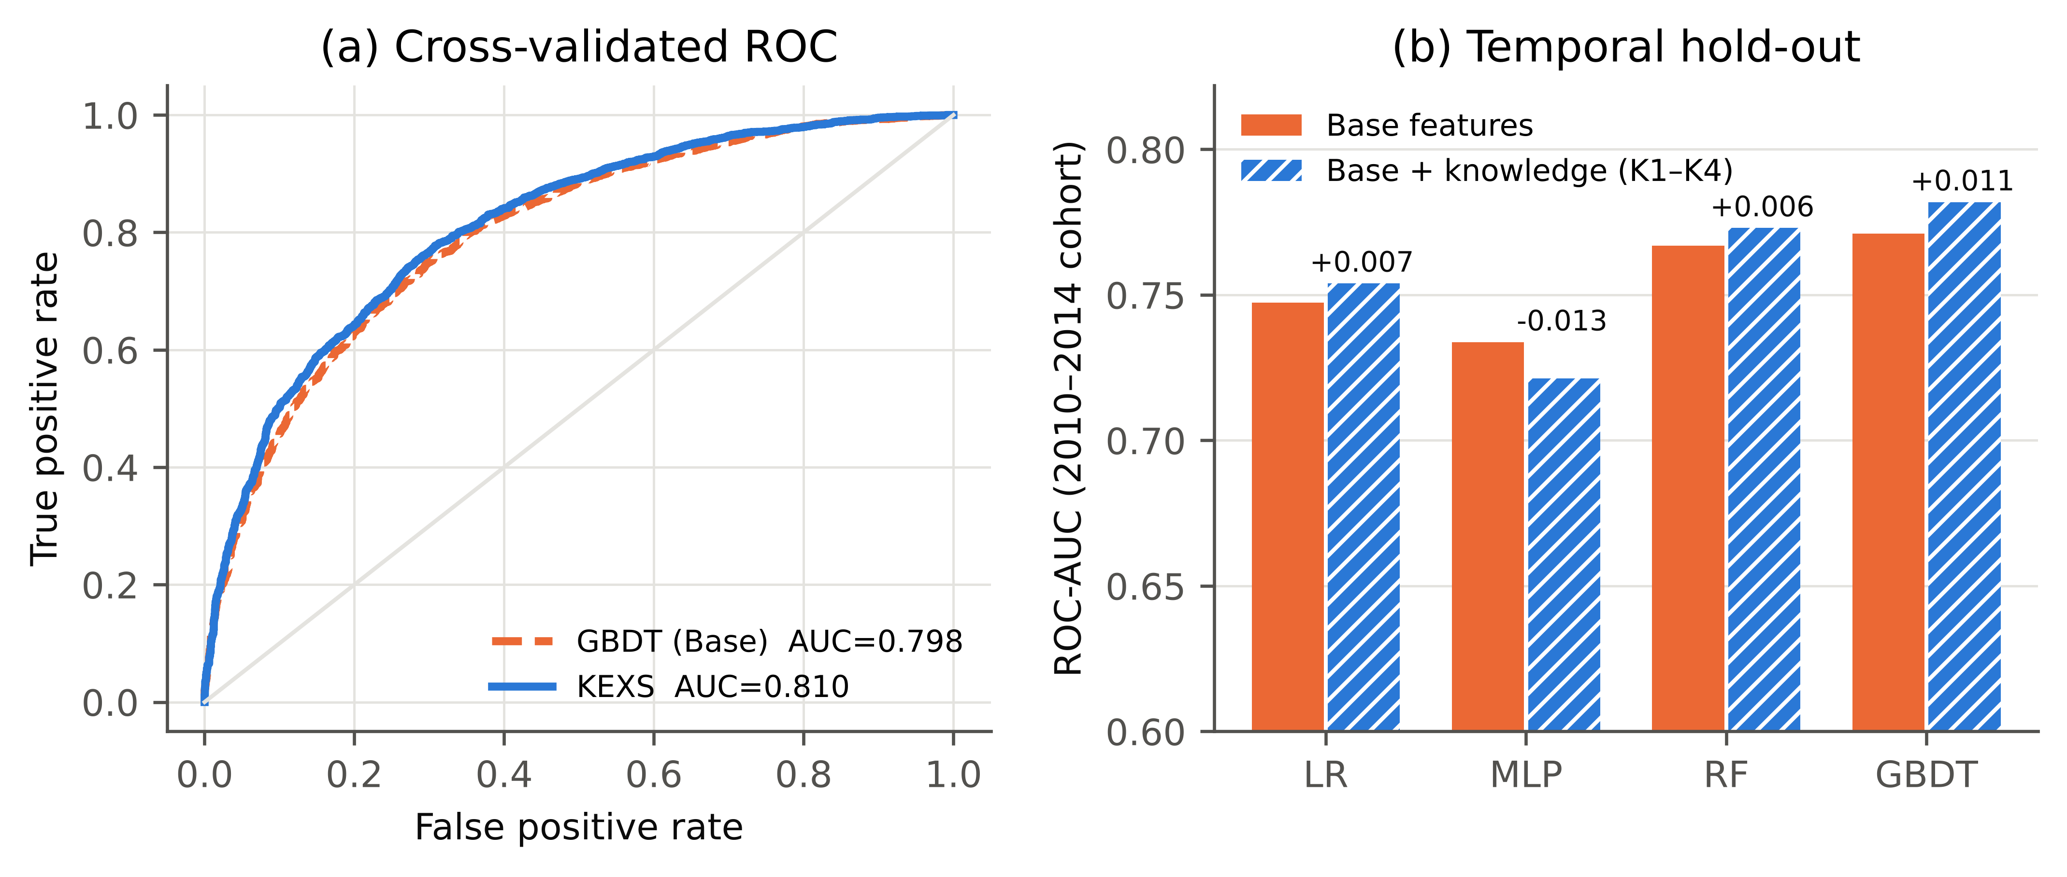
Figure 2. Predictive performance. (a) Pooled out-of-fold ROC curves (first repetition) of the data-only GBDT and KEXS. (b) ROC-AUC on the 2010–2014 temporal hold-out for each learner with Base features and with knowledge layers; labels show the change.
The knowledge layers also help LR (+0.008, p = 0.006) and RF (+0.005, p = 0.039), showing that the effect is not specific to one learner. They do not help the MLP (-0.001): adding 44 correlated dense features to a small tabular network did not improve it, a negative result reported here rather than tuned away. The absolute improvement is modest, as expected when the baseline already observes the raw funding history from which part of K3 is derived; the stronger evidence for the value of knowledge comes from the attribution analysis.
Figure 3 decomposes the full model. The attribution game uses the unconstrained GBDT and one 5-fold split. In it, a model given only K1–K4, without any raw Base feature, reaches an AUC of 0.793, close to the 0.798 of the Base features alone, so the knowledge layers form an almost complete alternative description of a startup. The exact group-Shapley values attribute 63% of the full model's discriminative power above chance to knowledge layers—K3 31%, K4 15%, K2 10% and K1 8%—against 37% for Base. Leave-one-group-out drops (Figure 3b) are much smaller than the Shapley values because K3 and Base share information; removal tests credit shared information to neither group, whereas Shapley values split it fairly, which is why the group-level game is the more informative design tool.
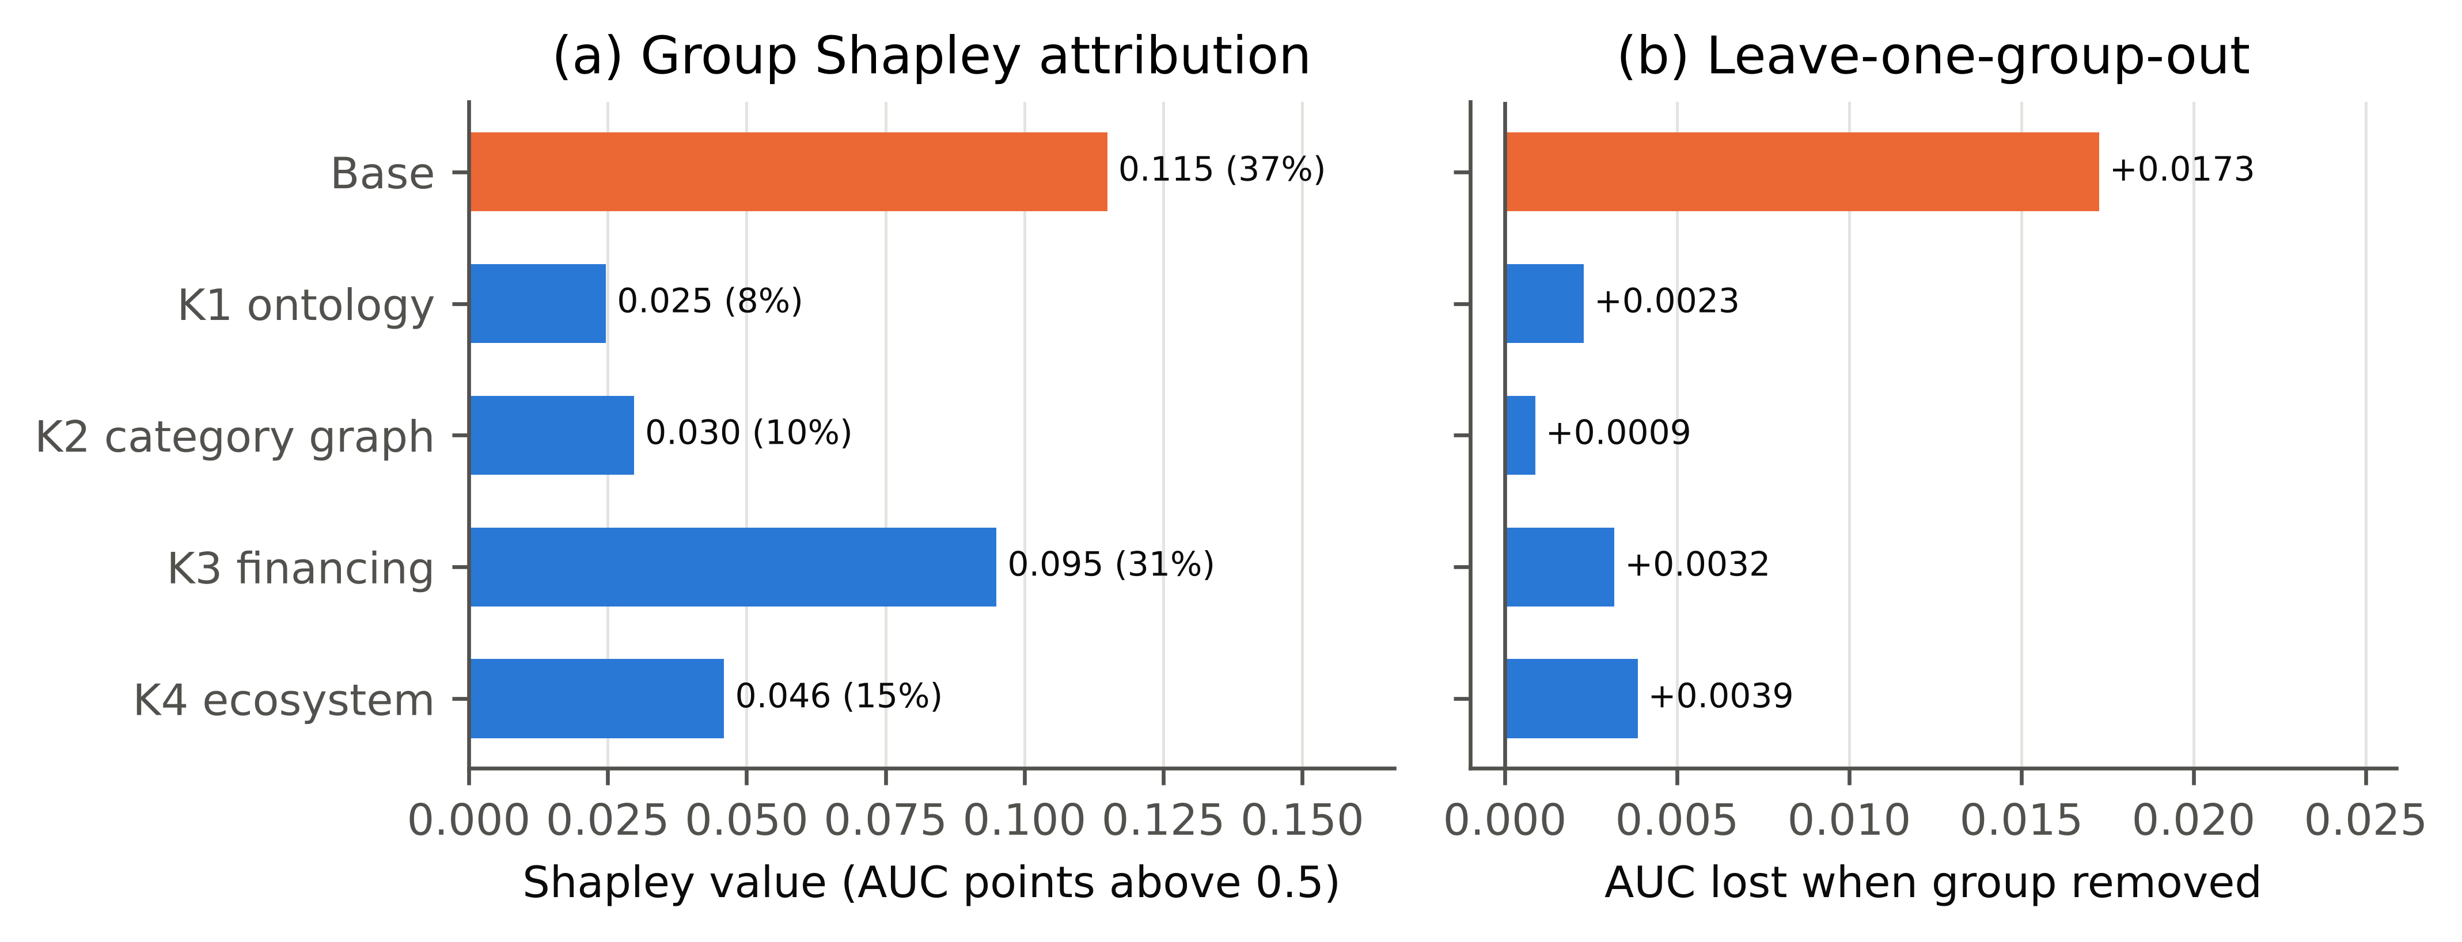
Figure 3. Contribution of knowledge sources. (a) Exact group-Shapley values of the five feature groups over all 32 coalitions (cross-validated AUC above 0.5; share of the total in brackets). (b) AUC lost when one group is removed from the full model.
Figure 4 shows what K5 adds. Without constraints, the same model produces individual predictions that fall as a firm advances a financing stage for 25% of startups, as total funding rises for 39% and as the number of rounds rises for 60% (Figure 4a). KEXS eliminates all of these violations by construction with an unchanged AUC (Table 2), so an analyst can explain any individual score without encountering an implausible reversal. The partial-dependence curves (Figure 4b–d) are economically interpretable: exit odds rise sharply once a startup reaches Series C or later, increase with the time a firm operates before raising external capital, and are higher in dense regional ecosystems, consistent with staging, signalling and agglomeration theory [9–12].
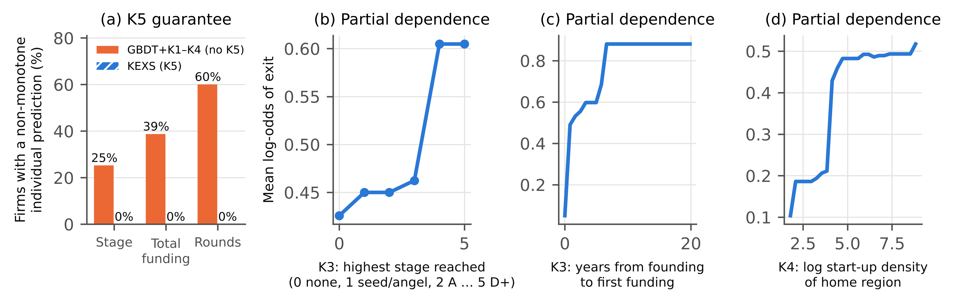
Figure 4. Knowledge-consistent behaviour. (a) Share of startups whose individual predicted exit probability decreases somewhere along a constrained feature, without and with K5. (b–d) Partial dependence of KEXS on three knowledge features (mean log-odds of exit).
These results place KEXS within knowledge-based decision support: each knowledge source's contribution is measurable and the model's behaviour provably respects explicit expert rules. For investors and accelerators this yields an auditable first-stage screening score that can be defended to an investment committee, because no startup is ever penalised for raising more capital or reaching a later stage. For researchers, the group-Shapley protocol is a reusable test of whether a theory-derived feature set adds information beyond raw data, in line with calls for inherently trustworthy models in high-stakes decisions [13].

5. Limitations
The Crunchbase export ends in 2014, and the label is an imperfect proxy for success: acquisitions include distressed sales, and initial public offerings are not recorded separately. Aggregate funding variables may partly reflect how long a firm survived; the temporal hold-out mitigates but does not eliminate this risk, and the partial dependence on time to first funding should be read as an association rather than a causal effect. The K1 taxonomy and the direction of the K5 constraints were specified by the author and should be validated by independent domain experts. K2 and K4 are computed transductively from unlabelled firms in the cross-validation setting; the temporal experiment, which rebuilds them from the training period only, shows that this does not drive the result.
The accuracy gain is statistically robust but small in absolute terms, and deep tabular and large language model-based predictors were not evaluated. Future work should test KEXS on recent data and extend K2 to a heterogeneous knowledge graph of firms, investors and founders.

6. Conclusion
This Short Communication presented KEXS, a knowledge-enhanced explainable model for startup-success prediction that integrates an expert sector ontology, a category knowledge graph, venture-staging rules, ecosystem statistics and monotone domain constraints into gradient-boosted trees. On 6,295 resolved Crunchbase startups, KEXS was statistically more accurate than the same model trained on raw data, generalised to a later cohort, and never contradicted the encoded expert priors for any individual firm. The 32-coalition group-Shapley analysis showed that knowledge layers carry 63% of the model's discriminative power, led by venture-staging and ecosystem knowledge.

Data Availability
The data and code are openly available at https://github.com/SaiKrishnaBhagam/ai-sdi [24]. The dataset is a public Crunchbase export redistributed via Kaggle [16]. A single script (run.py) regenerates every table, figure and statistic reported here from the raw data with a fixed random seed; the CSV result files and metrics are included in the repository.

Declaration of Competing Interest
The author declares that there are no known competing financial interests or personal relationships that could have appeared to influence the work reported in this paper.

Declaration of Generative AI and AI-Assisted Technologies in the Manuscript Preparation Process
During the preparation of this work the author used Claude (Anthropic) to assist with code development, data analysis and drafting of the manuscript. After using this tool, the author reviewed and edited the content as needed and takes full responsibility for the content of the published article.

Funding
This research did not receive any specific grant from funding agencies in the public, commercial, or not-for-profit sectors.

CRediT Authorship Contribution Statement
Sai Krishna Bhagam: Conceptualization, Methodology, Software, Validation, Formal analysis, Investigation, Data curation, Visualization, Writing – original draft, Writing – review & editing.

References
[1] A. Krishna, A. Agrawal, A. Choudhary, Predicting the outcome of startups: less failure, more success, in: 2016 IEEE 16th Int. Conf. Data Mining Workshops (ICDMW), IEEE, 2016, pp. 798–805. https://doi.org/10.1109/ICDMW.2016.0118.
[2] M. Razaghzadeh Bidgoli, I. Raeesi Vanani, M. Goodarzi, Predicting the success of startups using a machine learning approach, J. Innov. Entrep. 13 (2024) 80. https://doi.org/10.1186/s13731-024-00436-x.
[3] J. Arroyo, F. Corea, G. Jiménez-Díaz, J.A. Recio-García, Assessment of machine learning performance for decision support in venture capital investments, IEEE Access 7 (2019) 124233–124243. https://doi.org/10.1109/ACCESS.2019.2938659.
[4] K. Żbikowski, P. Antosiuk, A machine learning, bias-free approach for predicting business success using Crunchbase data, Inf. Process. Manag. 58 (4) (2021) 102555. https://doi.org/10.1016/j.ipm.2021.102555.
[5] J. Park, S. Choi, Y. Feng, Predicting startup success using two bias-free machine learning: resolving data imbalance using generative adversarial networks, J. Big Data 11 (2024) 122. https://doi.org/10.1186/s40537-024-00993-8.
[6] G. Ross, S.R. Das, D. Sciro, H. Raza, CapitalVX: A machine learning model for startup selection and exit prediction, J. Finance Data Sci. 7 (2021) 94–114. https://doi.org/10.1016/j.jfds.2021.04.001.
[7] M. Potanin, A. Chertok, K. Zorin, C. Shtabtsovsky, Startup success prediction and VC portfolio simulation using CrunchBase data, arXiv preprint (2023). https://doi.org/10.48550/arXiv.2309.15552.
[8] S.M.A. Jafari, A. Mobini Dehkordi, E. Chitsaz, Y. Yaghoobzadeh, What matters most? A quantitative meta-analysis of AI-based predictors for startup success, arXiv preprint (2025). https://doi.org/10.48550/arXiv.2507.09675.
[9] P.A. Gompers, Optimal investment, monitoring, and the staging of venture capital, J. Finance 50 (5) (1995) 1461–1489. https://doi.org/10.1111/j.1540-6261.1995.tb05185.x.
[10] B.L. Connelly, S.T. Certo, R.D. Ireland, C.R. Reutzel, Signaling theory: a review and assessment, J. Manag. 37 (1) (2011) 39–67. https://doi.org/10.1177/0149206310388419.
[11] M. Delgado, M.E. Porter, S. Stern, Clusters and entrepreneurship, J. Econ. Geogr. 10 (4) (2010) 495–518. https://doi.org/10.1093/jeg/lbq010.
[12] E. Stam, Entrepreneurial ecosystems and regional policy: a sympathetic critique, Eur. Plan. Stud. 23 (9) (2015) 1759–1769. https://doi.org/10.1080/09654313.2015.1061484.
[13] C. Rudin, Stop explaining black box machine learning models for high stakes decisions and use interpretable models instead, Nat. Mach. Intell. 1 (5) (2019) 206–215. https://doi.org/10.1038/s42256-019-0048-x.
[14] L. von Rueden, S. Mayer, K. Beckh, B. Georgiev, S. Giesselbach, R. Heese, B. Kirsch, J. Pfrommer, A. Pick, R. Ramamurthy, M. Walczak, J. Garcke, C. Bauckhage, J. Schuecker, Informed machine learning – a taxonomy and survey of integrating prior knowledge into learning systems, IEEE Trans. Knowl. Data Eng. 35 (1) (2023) 614–633. https://doi.org/10.1109/TKDE.2021.3079836.
[15] Z. Gao, Y. Xiao, Enhancing startup success predictions in venture capital: a GraphRAG augmented multivariate time series method, arXiv preprint (2024). https://doi.org/10.48550/arXiv.2408.09420.
[16] arindam235 (Kaggle user), StartUp Investments (Crunchbase) [dataset], Kaggle. https://www.kaggle.com/datasets/arindam235/startup-investments-crunchbase, (accessed 23 October 2026).
[17] O. Levy, Y. Goldberg, Neural word embedding as implicit matrix factorization, in: Adv. Neural Inf. Process. Syst. 27, 2014, pp. 2177–2185.
[18] J.H. Friedman, Greedy function approximation: a gradient boosting machine, Ann. Stat. 29 (5) (2001) 1189–1232. https://doi.org/10.1214/aos/1013203451.
[19] G. Ke, Q. Meng, T. Finley, T. Wang, W. Chen, W. Ma, Q. Ye, T.-Y. Liu, LightGBM: a highly efficient gradient boosting decision tree, in: Adv. Neural Inf. Process. Syst. 30, 2017, pp. 3146–3154.
[20] S.M. Lundberg, S.-I. Lee, A unified approach to interpreting model predictions, in: Adv. Neural Inf. Process. Syst. 30, 2017, pp. 4765–4774.
[21] I. Covert, S.M. Lundberg, S.-I. Lee, Understanding global feature contributions with additive importance measures, in: Adv. Neural Inf. Process. Syst. 33, 2020, pp. 17212–17223.
[22] C. Nadeau, Y. Bengio, Inference for the generalization error, Mach. Learn. 52 (3) (2003) 239–281. https://doi.org/10.1023/A:1024068626366.
[23] F. Pedregosa, G. Varoquaux, A. Gramfort, V. Michel, B. Thirion, O. Grisel, et al., Scikit-learn: machine learning in Python, J. Mach. Learn. Res. 12 (2011) 2825–2830.
[24] S.K. Bhagam, KEXS: Knowledge-Enhanced eXplainable Startup-success model [software], GitHub, 2026. https://github.com/SaiKrishnaBhagam/ai-sdi.

