Project 1: Deploy a Static Portfolio Website Using Amazon S3
Cloud Platform: Amazon Web Services (AWS) Service Used: Amazon S3 – Static Website Hosting Bucket: personalportfolio2026

Project Overview
This project demonstrates the deployment of a static personal portfolio website using Amazon S3. The website files are stored in an S3 bucket and served through the S3 static website hosting endpoint. The project also demonstrates bucket permissions and public object access required for a public static website.

Objectives
  - Learn how to host a static website using Amazon S3.
  - Understand cloud storage and static website hosting concepts.
  - Configure S3 bucket permissions for public website access.
  - Configure the S3 static website endpoint.
  - Deploy a personal portfolio website in the AWS cloud.
  - Gain practical hands-on experience with AWS cloud deployment.

Technologies Used
HTML, CSS, JavaScript, Git/GitHub, Amazon S3.

AWS S3 Bucket Configuration
The S3 bucket named personalportfolio2026 was created in the US East (Ohio) region (us-east-2). Static website hosting was enabled using bucket hosting.

Static Website Hosting
S3 static website hosting was enabled for the bucket. The bucket website endpoint was generated by AWS. The index document is configured as index.html, which serves as the main page of the portfolio.

Public Access Configuration
For this S3 website-endpoint implementation, Block all public access is configured as Off so that the bucket policy can grant public read access to the website objects.

Bucket Policy
A bucket policy was configured to allow anonymous users to retrieve objects from the portfolio bucket. The policy grants the s3:GetObject action to the public for objects under the bucket.

{
"Version": "2012-10-17",
"Statement": [
{
"Sid": "PublicReadGetObject", "Effect": "Allow",
"Principal": "*", "Action": "s3:GetObject",
"Resource": "arn:aws:s3:::personalportfolio2026/*"
}
]
}

Website Files
The S3 bucket contains the website's index.html file. The portfolio can be expanded with CSS, JavaScript, images, and a 404.html error document as required by the website configuration.

Screenshots / Evidence

Screenshot 1 – S3 bucket permissions and public access configuration.
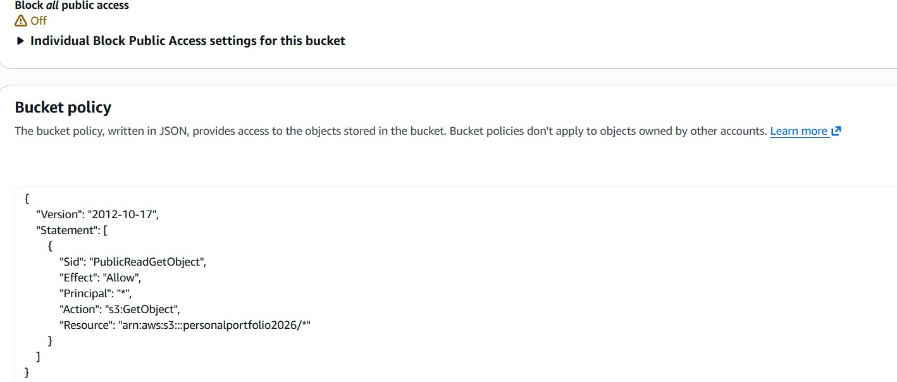

Screenshot 2 – Objects stored in the personalportfolio2026 bucket.
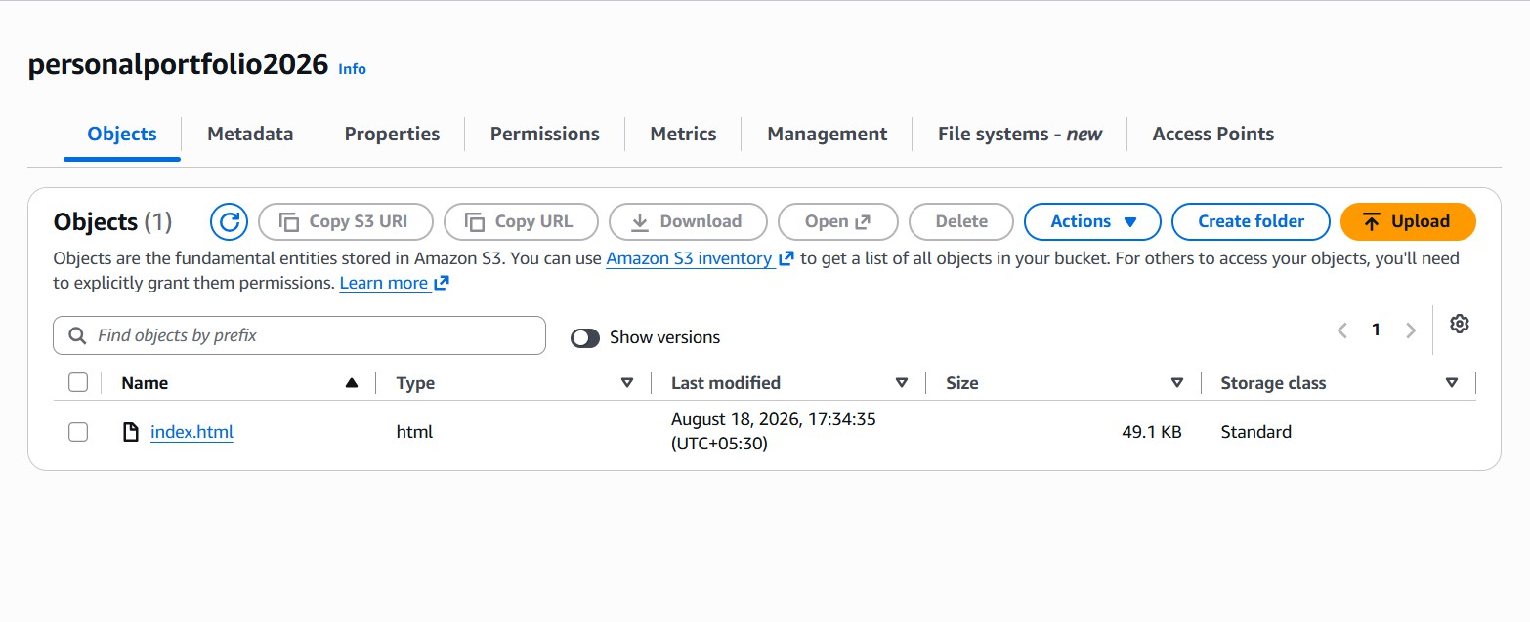

Screenshot 3 – index.html object details and S3 website object URL.
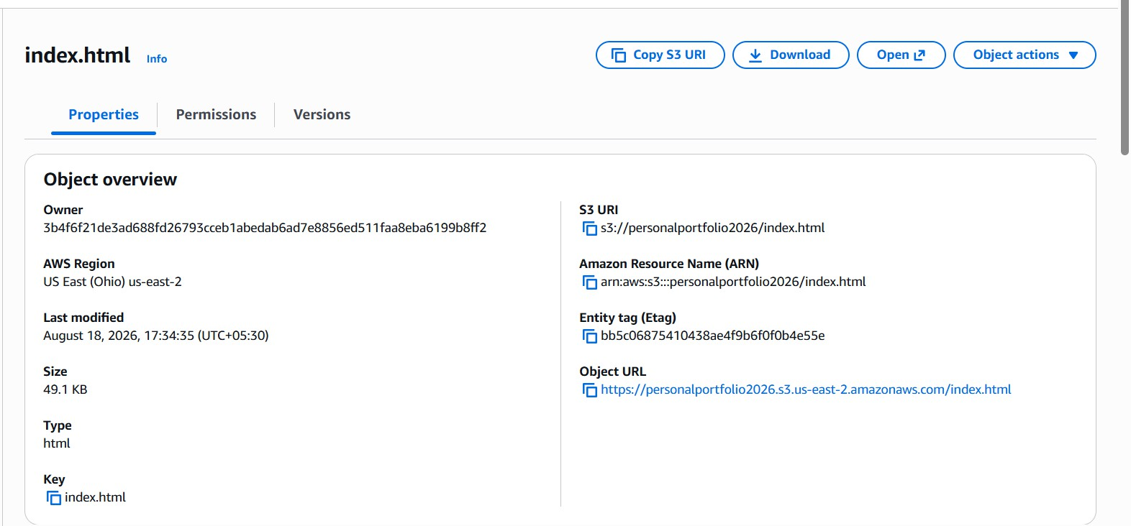

Screenshot 4 – Final bucket policy configured for public object read access.
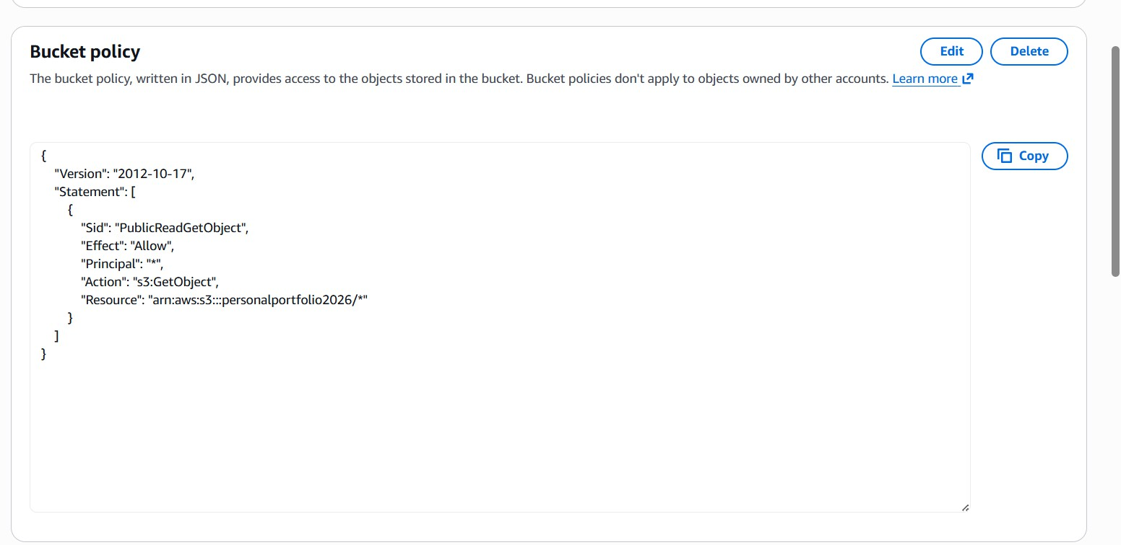

Deployment Verification
The S3 static website hosting configuration and bucket permissions were verified using the AWS Management Console. The website endpoint should be tested in a browser after confirming that index.html is directly available in the bucket and that the public-read bucket policy is saved successfully.

Live Website URL
S3 Website Endpoint: http://personalportfolio2026.s3-website.us-east-2.amazonaws.com

GitHub Repository

GitHub Repository: https://github.com/SaiKrishnaKasimalla-839/portfolio2026

Conclusion
The project demonstrates how a static portfolio website can be hosted on Amazon S3. The bucket was configured for static website hosting, website objects were uploaded, and a bucket policy was configured to allow public read access required by the S3 website endpoint.

