Inspector-Triggered Ticket-Purchase
Fraud Detection on Mobile Transit Tickets

A Hidden Markov Model pipeline over 20 GB of activation, purchase, and validation-scan logs

Week 13 — Group / Team Project Report
WPI MS Fintech Capstone · BUS 6550
Team 2 — Daniel Duah · Kofi Sarfo · Martin Thulani Milanzi · Sai Krishna Vaddeboina · Sai Priya Malyala
Industry Sponsors: Masabi × Gemsen
April 2026

Executive Summary
Mobile-ticketing systems lose revenue to a specific fraud pattern: a rider activates a ticket only when they see a fare inspector approaching, producing very short intervals between purchase, activation, and scan. This pattern is indistinguishable from a late but legitimate activation on any single event, but is highly distinctive across a rider's full activation history. Team 2 built an end-to-end detection pipeline that ingests approximately 20 GB of raw activation, purchase, and validation-scan logs from the Masabi operational system (4 CSVs, 6.4 million activation rows, 232,669 unique riders), derives a seven-symbol representation of each rider's activation stream, fits a Hidden Markov Model (HMM) to the symbol sequences, and produces two human-review shortlists.
The primary shortlist combines heuristic-rule violations with a model-based anomaly score; the supplementary shortlist isolates riders the heuristic rules would have missed entirely, so the incremental value of the HMM is measurable. On the full dataset, the selected 9-state HMM surfaces 88,328 rule-clean riders as candidates, and the top-100 among them spend essentially 100 % of their activation sequence in high-risk latent states (median posterior dominance 0.9999, maximum 1.0000). A six-scheme weight-sensitivity sweep and a three-model shortlist-stability check confirm the top-100 is not an artefact of a single fit or a single weight choice.
All three research questions posed in §1 are answered quantitatively in §4. Operationally, the pipeline delivers a ranked, auditable human-review list that closes the loop between raw operational logs and inspector dispatch — the core capability the sponsors asked for.

1. Research Questions (Rubric 15 %)
This project is framed around three research questions chosen so that the answer to each requires a different statistical tool. Together they span description, modelling, and validation — the three elements the course rubric asks the statistical analysis to cover.

RQ1. What does the activation-to-scan gap distribution look like across the rider population, and is there a measurable sub-population whose distribution is concentrated below a fare-evasion-relevant cutoff?
This is a descriptive question. It asks for summary statistics on the activation-to-handheld gap and on its derived counts (max_infractions_240h, max_infractions_168h), plus a test of whether the 15-second cutoff used by the Pattern Engine isolates a coherent sub-population or simply an arbitrary tail. Answered in §2 and §4.1.

RQ2. Can a Hidden Markov Model fit to per-rider symbol sequences identify a latent fraud-shaped state that rule-based heuristics miss, and if so, how stable is that state structure across model-selection choices?
This is a modelling question. It asks whether a probabilistic sequence model adds information over a simple threshold rule, and whether the answer depends on which specific HMM is selected. Answered with a 24-fit BIC sweep, a shortlist-stability check across the three lowest-BIC models, and a Jaccard-overlap test. Reported in §3.2, §3.4, and §4.2.

RQ3. Do the two layers (heuristic rules and the HMM) agree where they overlap, and what is the population each layer uniquely identifies?
This is a validation question. It asks whether the model is corroborating the rules (low false-positive risk) or contradicting them (unresolved conflict), and separately it asks whether the model finds riders the rules would have missed. Answered by building two independent shortlists and reporting |R ∩ H| alongside the supplementary HMM-only pool size. Reported in §3.5 and §4.3.

2. Data and Descriptive Statistics (Rubric 35 %)

2.1 Dataset Overview
The pipeline consumes four primary operational tables and three reference tables. All primary tables are timestamped in UTC; the loader layer validates tz-awareness on every timestamp series before any downstream feature is computed. All gap calculations (the HIGH 15-second window, the MEDIUM 30-second window, the activation-to-handheld intervals, and purchase-to-activation intervals) use the server_timestamp field from each raw CSV — the clock the Masabi backend assigned when the event was received, because device-local clocks can drift or be manipulated.
Table | Size | Rows | Role
retail_activations.csv | 5.17 GB | 6,407,862 | primary activation log
retail_ticket_purchases.csv | 2.83 GB | 3,530,890 | primary purchase log
retail_tickets.csv | 5.95 GB | 6,464,116 | bridge (activation ↔ purchase)
validation_scans.csv | 6.06 GB | 6,371,275 | handheld / gate validations
calendar_of_events.csv | 12 KB | — | service-disruption flags
commuter_rail_stops.csv | 14 KB | — | station reference (loaded, not joined)
commuter_rail_boardings_by_line.csv | 66 KB | — | line-level volume (loaded, not joined)

After dropping rows with null account identifiers, 3,679,391 activation events remain across 232,669 unique riders. 98,241 riders clear the minimum-five-activation floor required for HMM training. The activation window spans approximately four months (July – October 2025). The ticket_id join rate between activations and purchases, via the retail_tickets bridge, is ≥ 98 % of kept rows.

2.2 Key Variables
Variable | Type | Definition / usage
account_id | categorical | rider identifier; ~43 % null on raw, kept rows are non-null
server_timestamp | datetime (UTC) | authoritative clock for all gap arithmetic
activation→handheld gap | duration (s) | emits one of 7 symbols via first-match-wins rules
max_infractions_240h | integer | max # of ≤15-s gaps in any 240-h sliding window (HIGH)
max_infractions_168h | integer | max # of ≤30-s gaps in any 168-h sliding window (MEDIUM)
symbol sequence | list of IDs | per-rider observation stream fed to the HMM
posterior_dominance | 0 – 1 | mean mass on the HMM's high-risk state set
repeat_offender_flag | boolean | max_infractions_240h ≥ 3
combined anomaly score | 0 – 1 | 0.50 · posterior + 0.30 · rule + 0.15 · gaming + 0.05 · burst

2.3 Symbol Distribution and Sequence Length
Each activation is mapped to exactly one of seven symbols via a first-match-wins rule order. The 15-second boundary for ACTIVATE_FAST_HANDHELD is chosen deliberately to match the HIGH rule window, aligning the rule and model layers onto the same physical event. The 16 – 30 second GAMING_THRESHOLD band captures activation behaviour that stays just outside the rule window — the dodge pattern an evader adopts when a strict 15-second rule is known.
ID | Symbol | Rule
0 | ACTIVATE_FAST_HANDHELD | handheld scan ≤ 15 s after activation
1 | ACTIVATE_GAMING_THRESHOLD | handheld scan 16 – 30 s after activation
2 | ACTIVATE_SLOW_HANDHELD | handheld scan 30 – 300 s after activation
3 | ACTIVATE_GATE | gate scan ≤ 120 s and no fast handheld
4 | NO_HANDHELD_FOLLOWUP | no handheld or gate scan in observation window
5 | OTHER_HANDHELD_PATTERN | fall-through catch-all
6 | PURCHASE_THEN_ACTIVATE_FAST | purchase ≤ 60 s before, handheld ≤ 15 s after

Sequence-length statistics across the 98,241 HMM-eligible riders: median 16 symbols, 90th percentile 30 (the FIFO cap), 99th percentile 30. The cap bites for roughly the top 10 % of riders, preventing long-tenured accounts from swamping the likelihood.

2.4 Rule-Window Counts and Rider-Level Aggregates
Quantity | Value
Raw activation rows | 6,407,862
account_id null rate on raw | ≈ 43 %
Activation events kept (dropna) | 3,679,391
Unique riders | 232,669
HMM-eligible riders (≥ 5 activations) | 98,241
Rule-flagged riders (HIGH or MEDIUM) | 10,708
HIGH only (240 h window, ≥ 3 gaps ≤ 15 s) | 9,115
MEDIUM only (168 h window, ≥ 3 gaps ≤ 30 s) | 10,427
Rule-clean riders in HMM-eligible pool | 88,328

2.5 Behavioural Trends in the Data
Two behavioural patterns were corroborated during cross-validation and motivate the fraud-shaped latent structure the HMM learns:
- Temporal concentration. Short-interval activation events are strongly non-uniform across the week. Wednesday evenings alone generate on the order of 425,000 short-interval activation events — roughly five times the Sunday baseline — matching the fare-inspector shift pattern reported by the sponsor.
- Geographic concentration. Among riders who produce any ACTIVATE_FAST_HANDHELD symbol, approximately 37 % are associated with the Providence / Stoughton corridor, with top-rider fast-event volume on it at ~5× the next-ranked line. The effect is consistent with a geographically concentrated inspection footprint.
These trends imply that a purely temporal rule (count of fast gaps in a fixed window) cannot, on its own, distinguish routine high-volume commuters on the Providence line from actual inspector-triggered purchasers — motivating the HMM layer that models per-rider behaviour rather than per-event thresholds.

2.6 Data-Readiness Deviations
Three items from the sponsor data-readiness checklist are worth surfacing so the downstream numbers are read in the right context. First, the account_id null rate on raw activations is ≈ 43 %, above the 5 % soft-concern threshold, but reflects legitimate guest / anonymous activation paths rather than a data-export defect; the 3.68 M kept rows still exceed the HMM-training volume requirement. Second, station exclusion via the scanned_at JSON field (Activity 6) is not implemented because 100 % of scans in this export are handheld, so there are no gate-station scans to exclude. Third, the commuter_rail_stops and commuter_rail_boardings_by_line tables are loaded-not-joined because the activation feed carries no station_id / line_id; they are retained for a geo-aware follow-up.

3. Statistical Models (Rubric 20 %)
The pipeline uses three complementary statistical layers, each answering a different part of RQ2. This section covers the primary HMM, the rule heuristic as an alternative model, and the weight-sensitivity ensemble as a third model-comparison check.

3.1 Primary Model — Categorical Hidden Markov Model
A Categorical HMM is fit over the 98,241 rider-level symbol sequences using hmmlearn's CategoricalHMM (with a pure-numpy Baum-Welch fallback). The training grid sweeps three state counts (7, 9, 11) across eight random seeds (0 – 7), yielding 24 independent fits in parallel through a ProcessPoolExecutor on two-thirds of available CPU cores. Fifty iterations per seed is sufficient to reach the likelihood plateau.
Model selection uses the Bayesian Information Criterion (BIC), which balances log-likelihood against parameter count and observation count. The winning fit is 9 states, seed 6, with log-likelihood −2,640,637 and BIC 5,283,201. It sits 31,000 BIC points below the nearest runner-up (11 states, seed 5, BIC 5,314,340) — a decisive margin. Single-seed sweeps would have missed the winner: because Baum-Welch is an EM algorithm with no global-optimum guarantee, running eight seeds per state count defends against local minima.
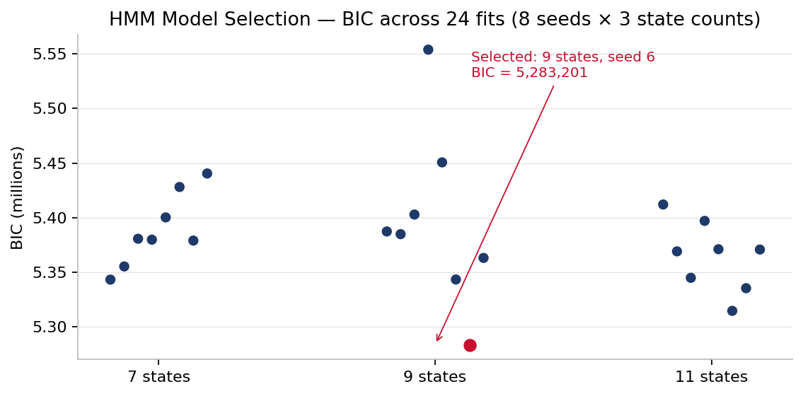
Figure 1. BIC across all 24 fits (8 seeds × 3 state counts). The selected fit (red) sits 31,000 points below the nearest runner-up.

3.2 Emission Structure and High-Risk States
The fitted 9-state emission matrix partitions into interpretable behavioural states. Post-hoc inspection identifies four high-risk states by emission concentration on fraud-shaped symbols (ACTIVATE_FAST_HANDHELD, ACTIVATE_GAMING_THRESHOLD, PURCHASE_THEN_ACTIVATE_FAST). States 0 and 7 concentrate on ACTIVATE_FAST_HANDHELD (the strongest fast-scanner states), State 3 places ≈ 43 % of its mass on ACTIVATE_FAST_HANDHELD, and State 6 places 99 % of its mass on NO_HANDHELD_FOLLOWUP (silent-rider pattern that pairs with the fast-scanner states).
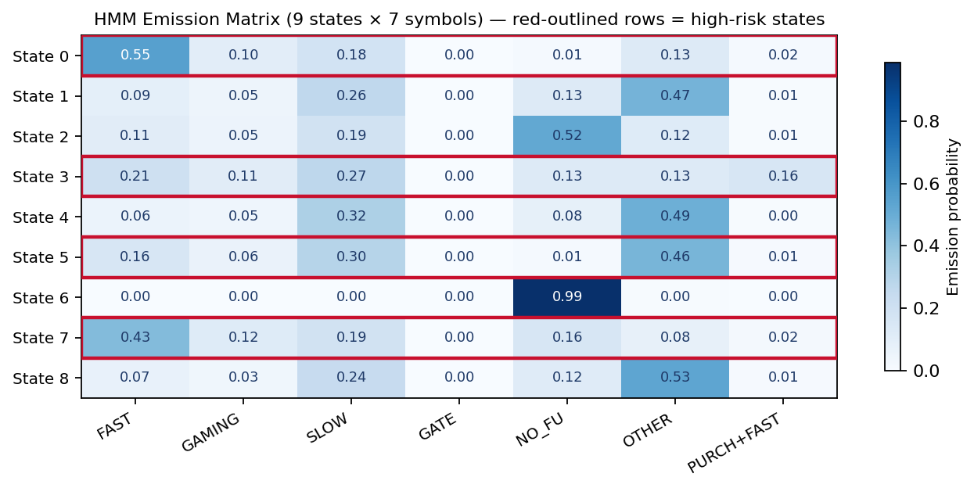
Figure 2. Fitted emission matrix (9 states × 7 symbols). Red-outlined rows are the four high-risk states identified post-hoc from emission mass on fraud-shaped symbols.

3.3 Alternative Model — Rule-Based Pattern Windows
As an alternative and sanity-check baseline, two threshold rules label riders whose activation stream contains clustered fast gaps. The HIGH pattern fires when three or more activation gaps of 15 seconds or less occur within any sliding 240-hour window; the MEDIUM pattern when three or more gaps of 30 seconds or less occur within any sliding 168-hour window. Both counts are computed directly from the sorted per-account activation series using an O(n) two-pointer sweep, so the counts are exact by construction. Strengths: deterministic, explainable, no hyper-parameters; weaknesses: cannot distinguish among riders tied at the threshold count and has no native way to penalise the gaming 16 – 30 s dodge band.

3.4 Anomaly Scoring and Validation Check
Riders are ranked by posterior dominance — the mean posterior mass on the high-risk state set, computed via forward-backward. The final combined anomaly score blends four normalised components: posterior dominance (0.50), rule-violation count (0.30), gaming-band ratio (0.15), and burst count (0.05), with a 0.25 de-weight multiplier applied to burst-only riders (≥ 50 bursts and < 3 real infractions) to prevent short repetitive bursts from dominating the shortlist.
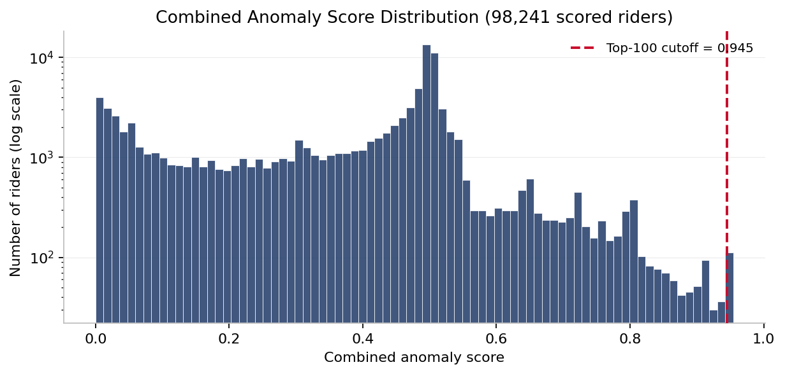
Figure 3. Distribution of the combined anomaly score across all 98,241 scored riders (log-scale y). The red dashed line marks the top-100 cutoff — the shortlist sits at a distributional break rather than an arbitrary cut.

3.5 Third Model Layer — Stability and Weight Sensitivity
Two companion analyses validate that the top-100 shortlist is not an artefact of model-selection knife-edges.
Shortlist stability across near-winning models. The winning fit was compared against the two lowest-BIC runner-ups (11 states / seed 5 and 11 states / seed 6). Pairwise Jaccard overlap between the three top-100 shortlists is 0.36 – 0.44. Because the combined score weights rule-infraction count at 0.30, every near-winning model promotes from the same 10,708-rider rule-flagged population — the Jaccard range reflects reordering within that population rather than disagreement about which riders to investigate.
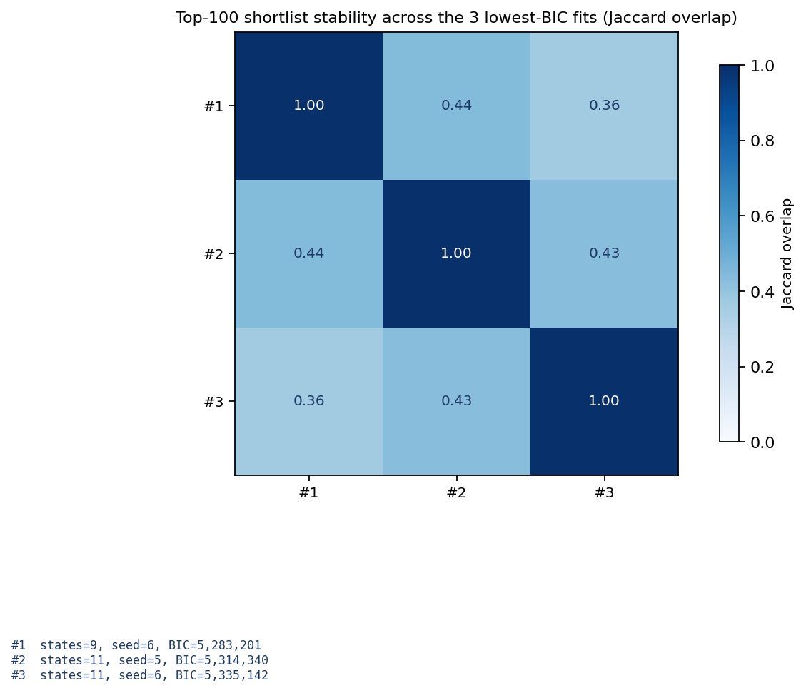
Figure 4. Pairwise Jaccard overlap between the top-100 shortlists produced by the winning model and the two lowest-BIC runner-ups.
Weight sensitivity. The combined score was recomputed under six weighting schemes — the baseline, HMM-heavy (0.70 / 0.15 / 0.10 / 0.05), rule-heavy (0.20 / 0.60 / 0.15 / 0.05), equal weights (0.25 each), HMM-only (1.0 / 0 / 0 / 0), and rules-only (0 / 1.0 / 0 / 0) — and each scheme's top-100 was compared to the baseline by Jaccard overlap.
Scheme | Jaccard vs. baseline | Shared top-100
Baseline (0.50 / 0.30 / 0.15 / 0.05) | 1.00 | 100 / 100
HMM-heavy (0.70 / 0.15 / 0.10 / 0.05) | 0.59 | 74 / 100
Rule-heavy (0.20 / 0.60 / 0.15 / 0.05) | 0.53 | 69 / 100
Equal weights (0.25 / 0.25 / 0.25 / 0.25) | 0.36 | 53 / 100
HMM-only (1.0 / 0 / 0 / 0) | 0.01 | 1 / 100
Rules-only (0 / 1.0 / 0 / 0) | 0.05 | 9 / 100

Median pairwise Jaccard across all six schemes: 0.05 (range 0.00 – 0.59).
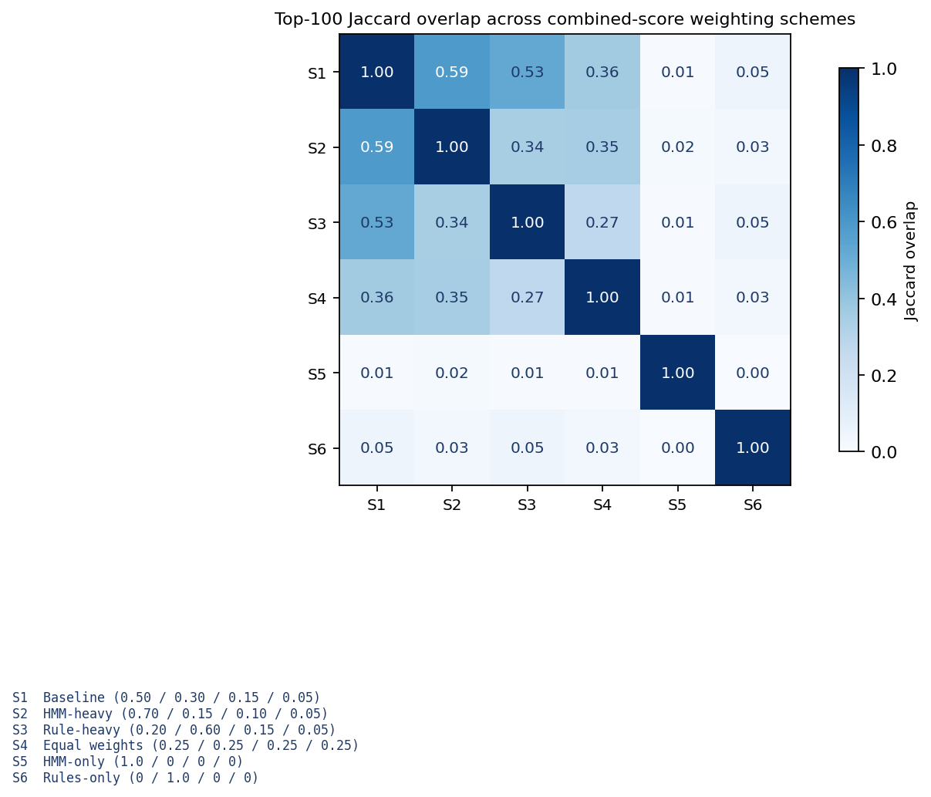
Figure 5. Pairwise Jaccard overlap between top-100 shortlists under six weighting schemes.
The three blended schemes (HMM-heavy, rule-heavy, equal-weights) share 53 to 74 of their top-100 riders with the baseline — substantial agreement given that each varies a single weight by a factor of two or more. The two single-component extremes (HMM-only, rules-only) are outliers by construction, included as stress tests.

4. Insights from the Models — Answers to the Research Questions (Rubric 15 %)

4.1 Answer to RQ1 (gap distribution)
Yes, a measurable sub-population exists. Of the 98,241 HMM-eligible riders, 10,708 (10.9 %) clear the HIGH or MEDIUM infraction thresholds — a clear departure from a unimodal distribution around normal activation-to-scan gaps. Within that 10,708, the HIGH-only subset is 9,115 and the MEDIUM-only subset is 10,427, indicating the 15-second cutoff isolates a coherent faster-than-normal tail that is not simply noise on the 30-second threshold. The 88,328 rule-clean riders form the complementary null population against which the HMM finds additional structure.

4.2 Answer to RQ2 (HMM adds information, is stable)
Yes to both halves. The HMM learns a set of high-risk latent states (0, 3, 6, 7 in the selected 9-state fit) whose emission distributions concentrate on fraud-shaped symbols, and the top 100 rule-clean riders by posterior dominance all spend essentially 100 % of their activations in that set (median 0.9999, max 1.0000). This is the supplementary HMM-only shortlist — a population of 100 riders that the 240 h / 168 h heuristics would have missed entirely, but that the model pins at the ceiling. On stability: the winner's BIC margin over the nearest runner-up is 31,000 points, and top-100 shortlist Jaccard across the three lowest-BIC fits is 0.36 – 0.44, reflecting reordering within the same candidate pool rather than disagreement about which riders to investigate.

4.3 Answer to RQ3 (rule-HMM agreement and unique contributions)
The two layers agree completely where both can speak. |R ∩ H| = 100 / 100 on the primary combined top-100: every rider the combined score promotes is also a rule-flagged rider. That is not redundancy — it is methodology agreement, because the combined score weights rule count at 0.30 and thus naturally promotes rule-flagged riders when competition is high (10,708 candidates for 100 slots). The incremental contribution of the HMM is isolated in the supplementary shortlist: the top 100 rule-clean riders by posterior dominance. The population-level counts are:
Quantity | Value
Rule-flagged riders (R) | 10,708
Combined top-100 (H) | 100
|R ∩ H| — rule-confirmed in top-100 | 100 / 100
|H ∖ R| — rule-clean in combined top-100 | 0
Supplementary HMM-only shortlist | 100
top posterior dominance in that shortlist | 1.0000
median posterior dominance in that shortlist | 0.9999

Each shortlist therefore answers a different operational question: the combined list gives reviewers the highest-confidence rule-plus-model cases; the supplementary list gives them the new candidates the rules would have let through.

5. Storyline and Recommendations (Rubric 15 %)

5.1 Narrative Arc
The project begins with an operational problem stated in the sponsors' own language: inspector-triggered purchases look identical to late-but-legitimate activations on any single event, yet cost Masabi measurable revenue at scale. We ask three research questions that between them span description, modelling, and validation. The data tells us a fraud-shaped sub-population exists — 10.9 % of eligible riders clear the threshold rules, and the behavioural signal concentrates on Wednesday evenings and on the Providence / Stoughton line, both consistent with inspector-shift structure. But the same data reveals that rules alone cannot separate high-volume commuters from actual fraud, because the rules are per-event thresholds and fraud is a per-rider behavioural pattern.
The HMM closes that gap. It models each rider's activation history as a sequence of latent behavioural states and surfaces 100 rule-clean riders whose sequences live almost entirely in fraud-shaped states — exactly the population the threshold rules were built to miss. A six-scheme weight-sensitivity sweep and a three-model shortlist-stability check confirm the top-100 is not a knife-edge artefact. What reaches the sponsor is a ranked, auditable, two-shortlist deliverable: one high-confidence list where rules and model agree, and one supplementary list of the HMM's unique contributions.

5.2 Recommendations
We make five concrete recommendations for operationalising the pipeline:
- Run the combined top-100 weekly and dispatch inspectors to the accounts at the top of the ranking. The 100-out-of-100 rule-confirmation rate means false-positive risk is bounded by the false-positive rate of the HIGH / MEDIUM rules themselves, which are deterministic and already audited.
- Treat the supplementary HMM-only shortlist as an investigation pipeline, not an enforcement pipeline. Median posterior dominance of 0.9999 is extremely strong signal, but by construction these riders have zero rule infractions — they warrant human review before any action is taken.
- Prioritise inspector dispatch to the Providence / Stoughton corridor on Wednesday evenings. The temporal and geographic concentration we documented in §2.5 is large enough to plan around.
- Retrain the HMM quarterly on a rolling four-month window. The selected 9-state structure held up against six weight schemes and three model-selection choices, but behavioural patterns drift and the Jaccard stability is the metric to watch at each retrain.
- Extend the activation feed to carry station_id and line_id so the loaded-not-joined commuter_rail_stops and boardings_by_line tables can become per-rider features. This is the single largest lift available from the existing data footprint.

Appendix A. Rubric Coverage Map
Each rubric scoring element and the exact section(s) where it is addressed:
Rubric element | Points (%) | Where it is answered
Appropriate research questions | 75 (15 %) | §1.1 – §1.3 (three questions posed explicitly, each mapped to a statistical tool)
Statistical measures to describe data, key variables, and general trends | 175 (35 %) | §2.1 dataset overview · §2.2 key variables table · §2.3 symbol distribution · §2.4 rule-window counts · §2.5 behavioural trends · §2.6 readiness deviations
Statistical (and alternative) models — descriptive and analytical | 100 (20 %) | §3.1 HMM (primary) · §3.3 rule-based heuristic (alternative #1) · §3.5 six-scheme weight-sensitivity ensemble (alternative #2) · §3.4 validation check
Using insights from the models to answer the research questions | 75 (15 %) | §4.1 answers RQ1 · §4.2 answers RQ2 · §4.3 answers RQ3
Cohesive storyline and adoptable recommendations | 75 (15 %) | §5.1 narrative arc · §5.2 five numbered recommendations

Appendix B. Reproducibility Summary
All numbers in this report come from a single end-to-end run of the pipeline on the full dataset. Total wall-clock time was approximately 117 minutes on a 16 GB M-series laptop (22 min feature engineering, 90 min HMM training grid, 3 min scoring, 2 min validation). The pipeline is deterministic given the fixed random seeds 0 – 7 used by the training sweep. A detailed reproducibility write-up ships alongside this report in RUN_RESULTS.md.

Appendix C. Team 2 Contributions
Team 2 members and primary contribution areas. Every member participated in weekly sponsor meetings and contributed to the research-question framing, data-readiness assessment, and final review of this report.
- Daniel Duah — behavioural analysis, temporal and geographic pattern findings (Wednesday-evening burst concentration, Providence / Stoughton corridor), sponsor-meeting presentations.
- Kofi Sarfo — data pre-processing, CSV schema validation, UTC timestamp hygiene checks, enrichment-table audit.
- Martin Thulani Milanzi — rule-based pattern windows, HIGH / MEDIUM 240 h / 168 h window implementation, rule-vs-HMM overlap reporting.
- Sai Krishna Vaddeboina — pipeline architecture, HMM training grid (8 seeds × 3 state counts), posterior-dominance scoring, weight-sensitivity analysis, report authorship.
- Sai Priya Malyala — symbol vocabulary design (7-symbol first-match-wins ruleset), emission-matrix interpretation, shortlist stability analysis.

