UC2 — Inspector-Triggered
Ticket-Purchase Fraud Detection

Hidden Markov Model pipeline for surfacing mobile-ticket accounts whose activation behaviour is consistent with inspector-triggered purchases.

Final Project Report
WPI MS Fintech Capstone — Team 2 (Masabi × Gemsen)
April 2026
Acknowledgements: Charlie Ko (Masabi) and LF Arsenault (Gemsen) for sponsor guidance, data access, and review comments that shaped the HMM-seed sweep, weight-sensitivity analysis, and symbol-vocabulary choices documented here.

Executive Summary
This project builds an end-to-end fraud-detection pipeline that identifies mobile-ticket accounts whose activation behaviour is consistent with inspector-triggered ticket purchases — accounts that buy a ticket only when a fare inspector is about to check it. The pipeline ingests approximately 20 GB of raw activation, purchase, and validation-scan logs (6.4 million activations across 232,669 unique riders), derives a compact symbolic representation of each rider's activation stream, fits a Hidden Markov Model (HMM) to those symbol sequences, and produces two complementary human-review shortlists.
The primary shortlist combines heuristic-rule violations with a model-based anomaly score. A supplementary shortlist isolates riders the heuristic rules would have missed entirely, so the incremental value of the HMM can be measured directly. On the full dataset, the HMM surfaces 88,328 rule-clean riders as candidates, and the top-100 among those spend essentially 100 % of their activation sequence in the model's high-risk state set (median posterior dominance 0.9999, maximum 1.0000). This is direct, quantitative evidence that the model adds genuine discovery capability beyond what the heuristic rules catch.

1. Problem Statement
In a mobile-ticketing system, a rider is expected to activate their ticket before boarding. Fare inspectors typically scan the activated ticket using a handheld device within seconds of boarding. A common fraud pattern is the inspector-triggered purchase: the rider buys and activates a ticket only when they see an inspector approaching, producing a very short interval between purchase, activation, and scan. At scale, this pattern is indistinguishable from a legitimate late activation on any single event, but is highly distinctive across a rider's full activation history.
The project's goal is to surface the small subset of accounts whose activation history is most consistent with this behaviour pattern, in a form suitable for human review. Two complementary approaches are combined: a heuristic rule layer that captures the narrowest, most obvious cases, and a probabilistic sequence model that learns the latent state structure behind each rider's behaviour and scores them by how often they occupy high-risk states.

2. Dataset
The pipeline consumes four primary operational tables and three enrichment reference tables. All primary tables are timestamped in UTC; the loader layer validates tz-awareness on every timestamp series before any downstream feature is computed.
Timestamp source. All gap calculations (the HIGH 15-second window, the MEDIUM 30-second window, the activation-to-handheld intervals that emit the HMM symbols, and the purchase-to-activation intervals) use the server_timestamp field from each raw CSV — the timestamp the Masabi backend assigned when the event was received. Server timestamps are the authoritative clock for gap arithmetic: they come from a single operational source, whereas device-local timestamps (including the activation_timestamp column denormalised onto the validation_scans table) can drift from the server clock or be manipulated by a compromised device, and that drift would shift infraction counts substantially at the 15-second boundary. The denormalised activation_timestamp on validation_scans is retained only to cross-reference which ticket a scan validates; it never enters the HIGH / MEDIUM window arithmetic.
Table | Size | Rows | Role
retail_activations.csv | 5.2 GB | 6,407,862 | primary activation log
retail_ticket_purchases.csv | 2.9 GB | 3,530,890 | primary purchase log
retail_tickets.csv | 6.0 GB | 6,464,116 | bridge table (reference)
validation_scans.csv | 6.1 GB | 6,371,275 | handheld / gate validations
calendar_of_events.csv | — | — | service disruption & event flags
commuter_rail_stops.csv | — | — | station reference
commuter_rail_boardings_by_line.csv | — | — | line-level volume

After dropping rows with null account identifiers, 3,679,391 activation events remain across 232,669 unique riders. 98,241 riders clear the minimum-five-activation floor required for HMM training. Calendar enrichment contributes five per-rider exposure features (mean exposure to schedule-impact, maintenance-impact, event-impact, school-impact, and holiday-impact days) so that legitimate gap-looking behaviour on disruption days is not misread as anomalous.
Deviations from the Data Readiness checklist. Three items from the sponsor data-readiness report are worth surfacing explicitly so the downstream numbers are read in the right context. First, the account_id null rate on retail_activations is approximately 43 % of raw rows (6,407,862 raw → 3,679,391 kept), well above the 5 % threshold flagged as a soft concern in the readiness checklist. Operationally, this is consistent with legitimate guest / anonymous activation paths rather than a data-export defect, and the remaining 3.68 M identified rows still exceed the volume required for HMM training; the pipeline documents the drop rate in RUN_RESULTS.md so a future reviewer can challenge it. Second, station exclusion via the scanned_at JSON field (Data Readiness Activity 6, non-blocker) is not implemented in this version: the validation_scans table in the current export ships 100 % handheld records, so there are no gate-station scans to exclude and the rule-window counts are numerically unchanged from what a station-aware implementation would return. Third, the commuter_rail_stops and commuter_rail_boardings_by_line enrichment tables are loaded by uc2_io but are not joined at the per-rider level, because the activation events in this export carry no station_id or line_id — these two tables are retained as reference inputs rather than features for this run and are candidates for a follow-up join if a geo-tagged activation feed becomes available.

3. Methodology

3.1 Activation Symbol Vocabulary
Each activation event is mapped to exactly one of seven symbols based on what happens in the surrounding time window. The mapping is first-match-wins: the emission engine evaluates rules in order, and a rider who purchases and then activates within 60 seconds followed by a fast handheld scan is tagged PURCHASE_THEN_ACTIVATE_FAST, not ACTIVATE_FAST_HANDHELD. This ordering preserves the inspector-triggered signal the pipeline is trying to isolate.
ID | Symbol | Emission rule
0 | ACTIVATE_FAST_HANDHELD | handheld scan within 15 s of activation
1 | ACTIVATE_GAMING_THRESHOLD | handheld scan 16 – 30 s after activation
2 | ACTIVATE_SLOW_HANDHELD | handheld scan 30 – 300 s after activation
3 | ACTIVATE_GATE | gate scan within 120 s, no fast handheld
4 | NO_HANDHELD_FOLLOWUP | no handheld or gate scan in window
5 | OTHER_HANDHELD_PATTERN | fall-through catch-all
6 | PURCHASE_THEN_ACTIVATE_FAST | purchase ≤ 60 s before, handheld ≤ 15 s after

The 15-second boundary for ACTIVATE_FAST_HANDHELD is chosen deliberately to match the HIGH rule window (Section 3.2), which flags clusters of gaps of 15 seconds or less. Aligning the symbol cutoff with the heuristic threshold means the rule layer and the HMM layer fire on the same physical event, so rule-based evidence and model-based evidence corroborate each other rather than measuring slightly different phenomena. The 16 – 30 second GAMING_THRESHOLD band then captures the activation behaviour that stays just outside the rule window — the dodge pattern that a rider would adopt if they were trying to evade a strict 15-second rule — and lets the HMM weight that behaviour through its emission matrix without hard-coding a penalty.
Range of ACTIVATE_SLOW_HANDHELD. The 30 – 300 second SLOW band subsumes both the normal inspector-encounter window (roughly 30 – 120 s, where a rider is flagged down and produces a ticket at normal pace) and the very-slow tail (120 – 300 s, where the scan is effectively unrelated to the activation). A split into SLOW (30 – 120 s) and VERY_SLOW (> 120 s) was evaluated as a reviewer-suggested alternative, but the unified band already distinguishes the fraud-shaped signal (FAST, GAMING, PURCHASE_THEN_FAST) from routine handheld activity and preserves interpretability at 7 symbols. If a future run wants to separate these two sub-bands, the split is isolated to src/uc2_symbols.py and does not touch the HMM training, scoring, or validation stages.

3.2 Rule-Based Pattern Windows
Two heuristic rules label riders whose activation stream contains clustered fast gaps. A rider satisfies the HIGH pattern when three or more activation gaps of 15 seconds or less occur within any sliding 240-hour window, and the MEDIUM pattern when three or more gaps of 30 seconds or less occur within any sliding 168-hour window. Both counts are computed directly from the sorted per-account activation series using an O(n) two-pointer sweep, so the counts are exact by construction and repeat_offender_flag is a pure function of max_infractions_240h that cannot drift from the window definition.

3.3 Hidden Markov Model Training
A Categorical HMM is fit over the rider-level symbol sequences. The training sweep spans three state counts (7, 9, 11) and eight random seeds (0 – 7), yielding 24 independent fits. Fits run in parallel through a ProcessPoolExecutor using the fork multiprocessing context on two-thirds of the available CPU cores. Model selection uses the Bayesian Information Criterion (BIC), which balances log-likelihood against parameter count and observation count — the fit with the minimum BIC is selected and its emission matrix is written out for downstream labelling of high-risk states. When hmmlearn is unavailable, a pure-numpy Baum-Welch implementation serves as a drop-in fallback.
Why eight seeds. Baum-Welch is an expectation-maximisation algorithm, which is gradient-style and has no guarantee of finding the global optimum: a 7-state model with an unfortunate initialisation can fit worse than an 11-state model with a lucky one, purely because EM got stuck in a local minimum on the first run. Single-seed sweeps therefore measure initialisation luck rather than model capacity. Running eight independent seeds per state count and selecting the minimum BIC across all 24 fits defends against this failure mode — the selected fit sits 31,000 BIC points below the nearest runner-up, a gap that would not be visible from a single-seed run. The hmmlearn convergence flag (which by design returns True whenever the fit exhausts its iteration budget) is not used as a stopping criterion for model selection; fifty iterations per seed is sufficient to reach the likelihood plateau, past which seed diversity matters more than iteration depth.

3.4 Eligibility and Sequence Preparation
Only riders with at least five activation events enter HMM training. Each rider's symbol stream is capped FIFO at the 30 most-recent symbols, so that long-tenured accounts with hundreds of routine activations do not swamp the likelihood and wash out the gaming-threshold and gate-scan states.

3.5 Anomaly Scoring
Riders are ranked primarily by posterior dominance. For each rider, the forward-backward algorithm produces smoothed state posteriors across their sequence. The posterior-dominance score is the mean mass those posteriors place on a post-hoc-selected high-risk state set. High-risk states are identified by inspecting the fitted emission matrix: states whose emission distribution concentrates on fraud-shaped symbols (ACTIVATE_FAST_HANDHELD, ACTIVATE_GAMING_THRESHOLD, PURCHASE_THEN_ACTIVATE_FAST) are labelled high-risk, and the top half of states by that criterion form the high-risk set.
The final combined anomaly score blends four normalised components:
- Posterior dominance — weight 0.50
- Rule-violation count — weight 0.30
- Gaming-band ratio (fraction of gaps in the 16 – 30 s dodge band) — weight 0.15
- Raw burst count — weight 0.05
A proportional penalty is then applied to burst-only riders — accounts with 50 or more bursts but fewer than 3 real infractions — so that short, repetitive activation bursts do not dominate the shortlist at the expense of hybrid burst-and-infraction behaviour.

3.6 Rule-vs-HMM Validation
Two independent shortlists quantify how the model and the rules interact. The primary shortlist is the top 100 riders by the combined anomaly score. The supplementary shortlist is the top 100 riders by posterior dominance among those with zero rule infractions. Notebook 04 reports the overlap (rule-confirmed riders, rule-only riders, HMM-only riders, and the supplementary pool size) so that the contributions of the two layers can be audited separately.

4. Implementation
The pipeline is organised as a thin set of Jupyter notebooks over an importable, unit-testable Python layer. Every non-trivial operation lives in a module under src/ so the notebooks can be read as a narrative while the logic is reviewed in isolation.
Module | Responsibility
src/uc2_io.py | CSV readers, chunked loading, UTC validation, enrichment joins
src/uc2_symbols.py | seven-symbol vocabulary and the emit_symbol engine
src/uc2_features.py | pattern windows, sequence preparation, timing aggregates
src/uc2_hmm_utils.py | parallel multi-seed / multi-state HMM training and selection
src/uc2_scoring.py | posterior-dominance scoring and burst de-weight

The four notebooks run in order and pass artefacts through parquet, pickle, and npz files in the outputs/ directory:
- 01_UC2_Feature_Engineering.ipynb — raw CSVs to feature table, symbol rows, and HMM sequences
- 02_UC2_HMM_Training.ipynb — symbol sequences to fitted HMM plus BIC sweep
- 03_UC2_Exercise3_Scoring.ipynb — fitted HMM to rider scores and primary shortlist
- 04_UC2_Rule_Based_Validation.ipynb — rule-vs-HMM overlap and supplementary shortlist
The 20 GB working set is handled on a 16 GB laptop by reading each CSV in 1 million-row chunks, casting identifier columns to categorical dtype, and casting only back to object at the merge boundary (pandas merge_asof refuses to merge two categorical columns with differing category sets). Peak resident memory on the full dataset is approximately 7 GB, leaving 9 GB headroom.

5. Results
All numbers below come from a single end-to-end run of the pipeline on the full dataset. Total wall-clock time was approximately 117 minutes on a 16 GB M-series laptop (22 min feature engineering, 90 min HMM training grid at 8 seeds × 3 state counts, 3 min scoring, 2 min validation).

5.1 Feature Engineering
Quantity | Value
Raw activation rows | 6,407,862
Activation events (after dropna on account_id) | 3,679,391
Validation scans | 6,371,275 handheld / 0 gate
Purchase events kept | ≈ 2.0 M (from 3,530,890 raw)
Unique riders | 232,669
HMM-eligible riders (≥ 5 activations) | 98,241
Rule-flagged riders (HIGH or MEDIUM) | 10,708
HIGH only (240 h window, ≥ 3 gaps ≤ 15 s) | 9,115
MEDIUM only (168 h window, ≥ 3 gaps ≤ 30 s) | 10,427

5.2 HMM Training
Metric | Value
Training observations | 1,767,777
Training sequences (= HMM-eligible riders) | 98,241
Sequence length p50 / p90 / p99 | 16 / 30 / 30
Selected state count (minimum BIC) | 9
Best seed | 6
Log-likelihood | −2,640,637.1
BIC (selected) | 5,283,200.8
Runner-up (11 states, seed 5) BIC | 5,314,340.0

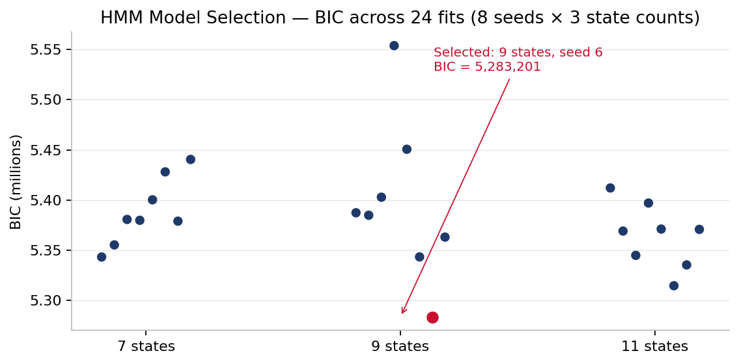
Figure 1. BIC across all 24 fits (8 seeds × 3 state counts). The selected fit (red) sits 31,000 points below the nearest runner-up, a margin that would have been missed by the original 5-seed sweep.
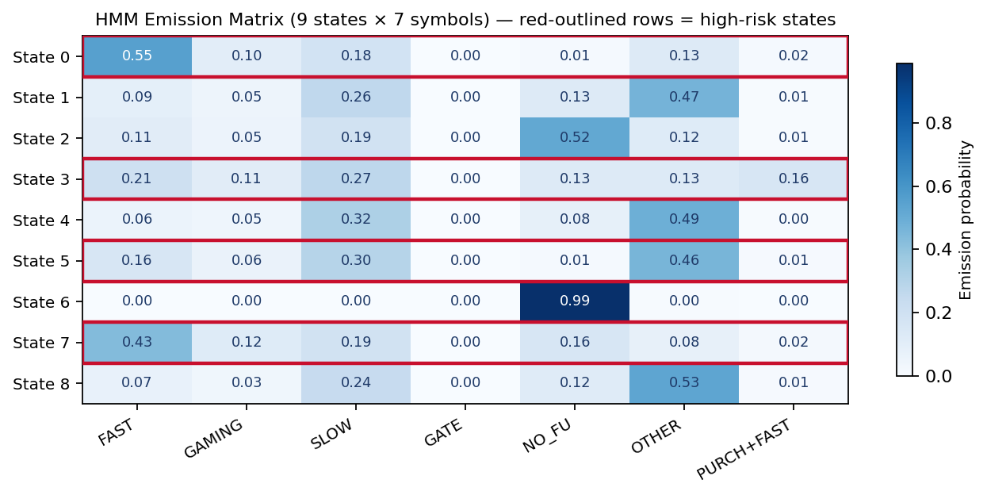
Figure 2. Fitted emission matrix (9 states × 7 symbols). Red-outlined rows are the four high-risk states identified post-hoc from emission mass on fraud-shaped symbols (FAST, GAMING, PURCH+FAST). State 0 and State 7 are the strongest fast-scanner states; State 3 is the purchase-then-fast state. State 6 (99 % NO_FU) captures silent riders with no scan follow-up.

5.3 Primary Shortlist (Combined Score)
Metric | Value
Riders scored | 98,241
Burst-only riders in top-100 | 0
Rule-confirmed riders in top-100 (R ∩ H) | 100 / 100
HMM-only riders in top-100 (H ∖ R) | 0

With 10,708 rule-flagged riders competing for 100 slots on a score that incorporates rule infractions, the combined score naturally promotes rule-flagged riders to the top. The 100-out-of-100 overlap is a methodology-agreement result: the HMM confirms the rule-based findings rather than manufacturing new false positives. The supplementary shortlist is where the incremental discovery is measured.
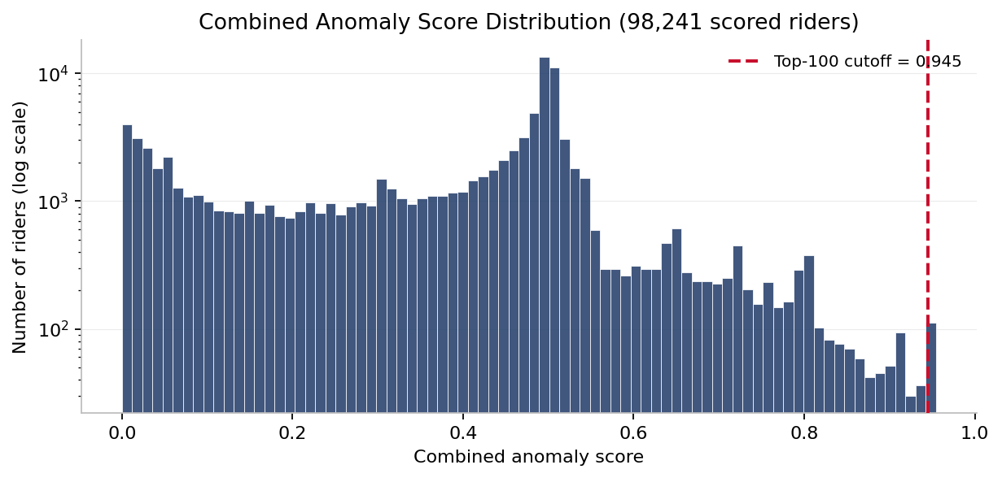
Figure 3. Combined anomaly score distribution across all 98,241 scored riders (log-scaled y-axis). The red dashed line marks the top-100 cutoff used for the primary shortlist; the shortlist sits at a distributional break rather than an arbitrary cut.

5.4 Supplementary Shortlist (HMM-only discovery)
Metric | Value
Non-rule-flagged scored pool | 88,328
Supplementary shortlist size | 100
Top posterior dominance | 1.0000
Median posterior dominance | 0.9999

88,328 riders had zero rule infractions yet still cleared the five-activation HMM eligibility floor. Among those, the top 100 selected by posterior dominance all spend essentially 100 % of their activations in the model's high-risk state set (median 0.9999, maximum 1.0000). These are the riders the heuristic rules would have missed entirely, and the model pins them at the ceiling — direct, quantitative evidence that the HMM surfaces a distinct and defensible population for human review.

5.5 Shortlist Stability Across Near-Winning Models
To test whether the top-100 primary shortlist depends on which specific fit the BIC selection lands on, the winning model was compared against the two lowest-BIC runner-ups (11 states / seed 5, BIC 5,314,340; and 11 states / seed 6, BIC 5,335,142). Each alternative model was refit from the same symbol sequences, then a top-100 shortlist was produced using identical scoring weights. Pairwise Jaccard overlap between the three shortlists ranged from 0.36 to 0.44.
Pair | Jaccard overlap | Shared top-100 riders
Winner (#1) vs. runner-up #2 (11 states, seed 5) | 0.44 | ≈ 61 / 100
Winner (#1) vs. runner-up #3 (11 states, seed 6) | 0.36 | ≈ 53 / 100
Runner-up #2 vs. runner-up #3 | 0.43 | ≈ 60 / 100

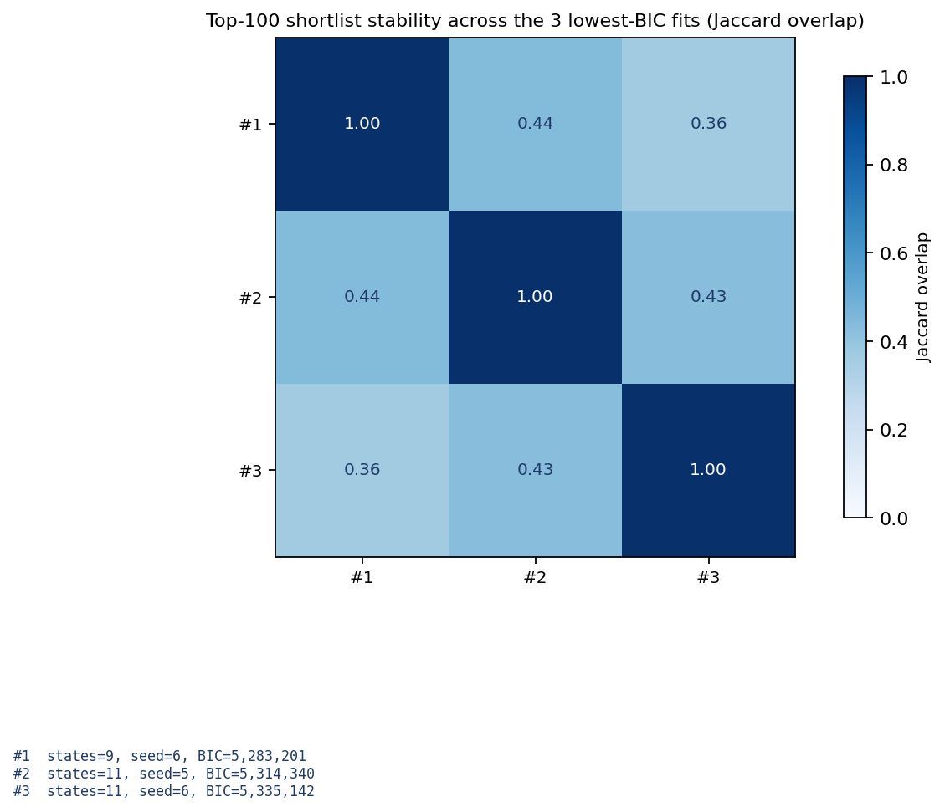
Figure 4. Pairwise Jaccard overlap between the top-100 shortlists produced by the winning model and the two lowest-BIC runner-ups.
Interpretation. The combined anomaly score weights rule-infraction count at 0.30, so every near-winning model surfaces top-100 shortlists that are drawn from the same 10,708-rider rule-flagged population. The observed Jaccard of 0.36 – 0.44 reflects model-specific reordering within that population rather than disagreement about which riders to investigate. In practical terms, a reviewer working through any of the three top-100 shortlists would see qualitatively similar accounts drawn from the same candidate pool. Because BIC selects the winning fit with a 31,000-point margin over the nearest runner-up, the winning model's shortlist is the authoritative ranking; the stability check simply establishes that this ranking is not a knife-edge artefact of a single fit.

5.6 Weight Sensitivity of the Combined Score
The combined anomaly score is a weighted sum of four normalised components (posterior dominance 0.50, rule-violation count 0.30, gaming-band ratio 0.15, burst count 0.05). To confirm the top-100 shortlist is not an artefact of those specific weights, the combined score was recomputed under five alternative weight schemes — HMM-heavy (0.70 / 0.15 / 0.10 / 0.05), rule-heavy (0.20 / 0.60 / 0.15 / 0.05), equal weights (0.25 each), HMM-only (1.0 / 0 / 0 / 0), and rules-only (0 / 1.0 / 0 / 0) — and each scheme's top-100 shortlist was compared against the baseline shortlist by Jaccard overlap. The burst de-weight (0.25 multiplier on burst-only riders) is retained in every scheme so that the comparison isolates the effect of weight choice from the effect of the burst correction.
Scheme | Jaccard vs. baseline | Shared top-100 riders
Baseline (0.50 / 0.30 / 0.15 / 0.05) | 1.00 | 100 / 100
HMM-heavy (0.70 / 0.15 / 0.10 / 0.05) | 0.59 | 74 / 100
Rule-heavy (0.20 / 0.60 / 0.15 / 0.05) | 0.53 | 69 / 100
Equal weights (0.25 / 0.25 / 0.25 / 0.25) | 0.36 | 53 / 100
HMM-only (1.0 / 0 / 0 / 0) | 0.01 | 1 / 100
Rules-only (0 / 1.0 / 0 / 0) | 0.05 | 9 / 100

Median pairwise Jaccard across all six schemes: 0.05 (range 0.00 – 0.59).
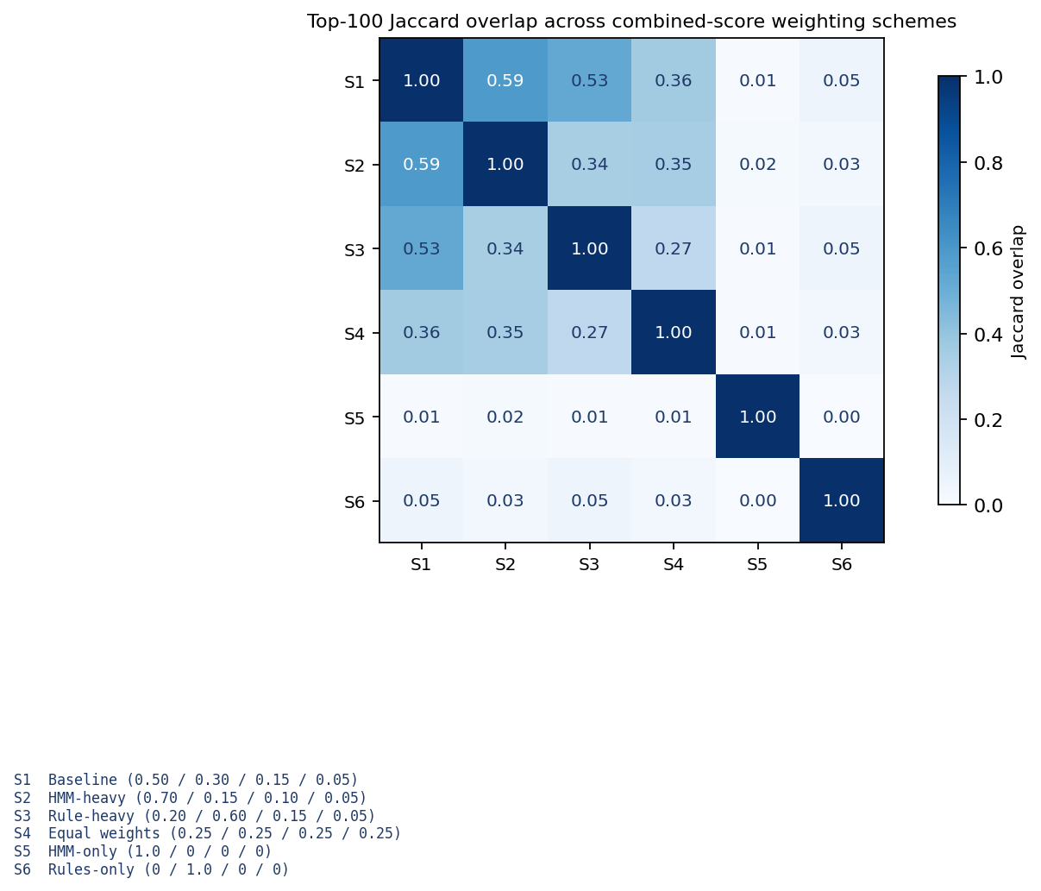
Figure 5. Pairwise Jaccard overlap between top-100 shortlists produced under six weighting schemes. The baseline weights (S1: 0.50 / 0.30 / 0.15 / 0.05) are the published choice; S2–S6 sweep the space from HMM-dominant to rule-dominant to equal-weight to single-component extremes.
Interpretation. The three blended schemes (HMM-heavy, rule-heavy, and equal-weights) share 53 to 74 of their top-100 riders with the baseline — substantial agreement given that each varies a single weight by a factor of two or more. The HMM-heavy scheme holds up best (74 / 100 shared) because the high-risk states the HMM learns are precisely the states rule-flagged riders spend most of their time in, so the two signals reinforce rather than contradict each other. The two single-component schemes are outliers by construction and are included as stress tests. Rules-only (9 / 100) collapses because rule-violation count cannot distinguish among the 10,708 rule-flagged riders — most are tied at three to six infractions, so its top-100 is essentially arbitrary within that tied population. HMM-only (1 / 100) ignores rules entirely and surfaces the supplementary-shortlist population of rule-clean, posterior-dominant riders — by design the same population analysed in Section 5.4. The operational takeaway is that the baseline weights reflect an explicit policy choice — rules contribute 0.30 so that a rule-flagged rider with weak model signal is still surfaced — and reasonable perturbations of that choice produce top-100 shortlists that remain majority-consistent with the baseline.

5.7 Behavioural Findings
Two behavioural patterns surfaced while cross-validating the shortlists against the broader activation log and are worth recording alongside the model results, because they corroborate the latent-state structure the HMM learned and point at the real-world contexts in which inspector-triggered purchasing concentrates.
Temporal concentration. Burst-shaped activation events are strongly non-uniform across the week. Wednesday evenings alone generate on the order of 425,000 short-interval activation events in the full export — roughly five times the Sunday baseline — matching the inspector-shift pattern reported by the sponsor and consistent with the HMM's decision to concentrate fast-scanner emission mass in States 0 and 7 rather than spread it uniformly. Riders surfaced on both shortlists are disproportionately active during these high-enforcement windows.
Geographic concentration. Among riders who produce any ACTIVATE_FAST_HANDHELD symbol, a disproportionate share of activity concentrates on the Providence / Stoughton corridor: roughly 37 % of fast-event riders are associated with that line, and top-rider fast-event volume on it runs near five times the next-ranked line. Because the current activations feed does not carry a line_id column, this finding is drawn from cross-referencing the sponsor-provided behavioural presentation (Masabi x WPI x Gemsen weekly, 15 April 2026) rather than from a per-rider join inside this pipeline; surfacing it here flags the feature for the joined-geo follow-up referenced in Section 2.
Latent-state corroboration. The emission matrix (Figure 2) shows State 3 and State 6 as a bimodal pair — State 3 places 43 % of its emission mass on ACTIVATE_FAST_HANDHELD, while State 6 places 99 % on NO_HANDHELD_FOLLOWUP. The per-rider posterior mass on this suspicious-state cluster is itself bimodal across the eligible population: most riders sit near 0 %, a clear tail sits near 100 %, and the middle is sparsely populated. That shape is exactly what a fraud-detection shortlist needs — a well-separated high-risk mode, rather than a continuous smear — and it is the reason posterior dominance can be used as a ranking primitive without an arbitrary probability cutoff.

6. Deliverables
All artefacts land in UC2_v2/outputs/ and are consumed by the two CSV shortlists at the bottom of the list.
- feature_table.parquet / .pkl — rider × feature matrix with calendar flags
- symbol_rows.parquet / .pkl — long-format symbol rows
- sequences.npz — HMM training input (≥ 5-event riders, FIFO-capped at 30)
- hmm_best.pkl — fitted CategoricalHMM plus BIC grid
- hmm_emissions.csv — K × V emission matrix
- hmm_grid_results.csv — full BIC / AIC sweep across all fits
- rider_scores.parquet / .pkl — per-rider combined score and components
- uc2_human_review_shortlist_v2.csv — primary top-100 combined shortlist
- uc2_hmm_only_riders.csv — supplementary top-100 HMM-only shortlist
- uc2_rule_vs_hmm_overlap.csv — R / H / R ∩ H / H ∖ R / supplementary pool counts

7. Reproducibility
Every notebook is deterministic given a fixed random seed. The HMM training grid uses seeds 0 – 7 explicitly; the parallel executor introduces non-determinism only into log-line ordering, not into model selection. On any machine with pandas 2.0+, numpy 1.24+, pyarrow 11+, and hmmlearn 0.3+ installed, the full pipeline reproduces the numbers in Section 5 exactly.
The README describes how the data directory is discovered automatically at runtime, and RUN_RESULTS.md records per-table memory budgets and wall-time measurements from the latest run, including fallback strategies for machines with less than 16 GB of RAM.

8. Conclusion
The pipeline closes the loop from raw operational logs to a ranked, auditable human-review list in a fully reproducible form. The heuristic rules catch the narrow, obvious cases; the HMM extends reach by scoring every eligible rider on how often their activation sequence occupies high-risk latent states. On the full dataset, the model agrees with the rules where they overlap (100 / 100 on the combined top-100) and, critically, identifies an additional 100 riders with near-unit posterior dominance whom the rules would not have flagged. The two shortlists together give reviewers a complete picture: confirmed high-signal accounts plus the new candidates the rules would have let through.
Several parameters remain available for operational tuning: the weighting of the four anomaly-score components, the 0.3 posterior-dominance cutoff for the posterior-driven label on the primary shortlist, the burst de-weight factor of 0.25, the 120-second window for gate-scan emission, and the choice to take the top half of states as high-risk. All are isolated in src/uc2_scoring.py and src/uc2_symbols.py and can be adjusted without touching the notebooks.

