BANKING MANAGEMENT UNIT (BMU)

BANK

DSC 2CC PROJECT

Submitted by- Sai Krishnan P

Registration No: 18BCE0383

**Contents**

# Introduction

1. **Approach**
2. **Hardware and software specifications**
3. **Database design**
4. **E-R diagram**
5. **Screenshots**
6. **Sample code**
7. **Limitations**
8. **Conclusion**

## Introduction

Through this project work, we aim to create a abridged version of a banking application. The application will act as a portal which provides it’s users with various banking facilities like account management and transaction management. The aim is to learn how to generate an application which uses a database in its backend. We also plan to make the application safe and protected so that it is not susceptible to vulnerabilities and security attacks.

**Approach**

We have divided the project work in the following stages:

* We will first decide the tables and the separate attributes needed for our database.
* We will then draw an ER diagram of the database.
* We will then plan out the suitable screens needed for our application.
* We will then proceed on to the programming part of the application.
* We will then create the associated tests for our project to ensure that it works correctly.

**Hardware Specification**

* PC with minimum 1.5 GB hard-disk and 256 MB RAM

## Software Specification

* Xampp - 7.4.6
* MySQL
* Sublime Text Editor

## Database Design

Our database will consist of the following tables:

|  |  |  |
| --- | --- | --- |
| **Table Name** | **Attributes** | **Functionality** |
| Accounts | Id, accname, accno,accifsc, accemail, accpassword, acctype,accbalance, accdate | Details of all types of customer accounts |
| Branch | Ifsccode, branchname, city, branchaddress, state, country, pincode | Details of the branches of the bank |
| Loan | Id, accno, loantype, loanamt, loan_rem, interest, loandate | Details of all the loans issued by the bank |
| Loanpayment | Id, loantype, amount, from_acc, payment_date | Details of the all the loan payments by customers |
| Payee | Id, name, accno, acctype, ifsccode, registered_in | Details of payee registered by customers |
| Transactions | Id, payee_name, from_acc, Amount, trans_date | Details of all the transactions by customers |
| Users | Id, name, email, password | Login details of the customers |

**E-R Diagram**

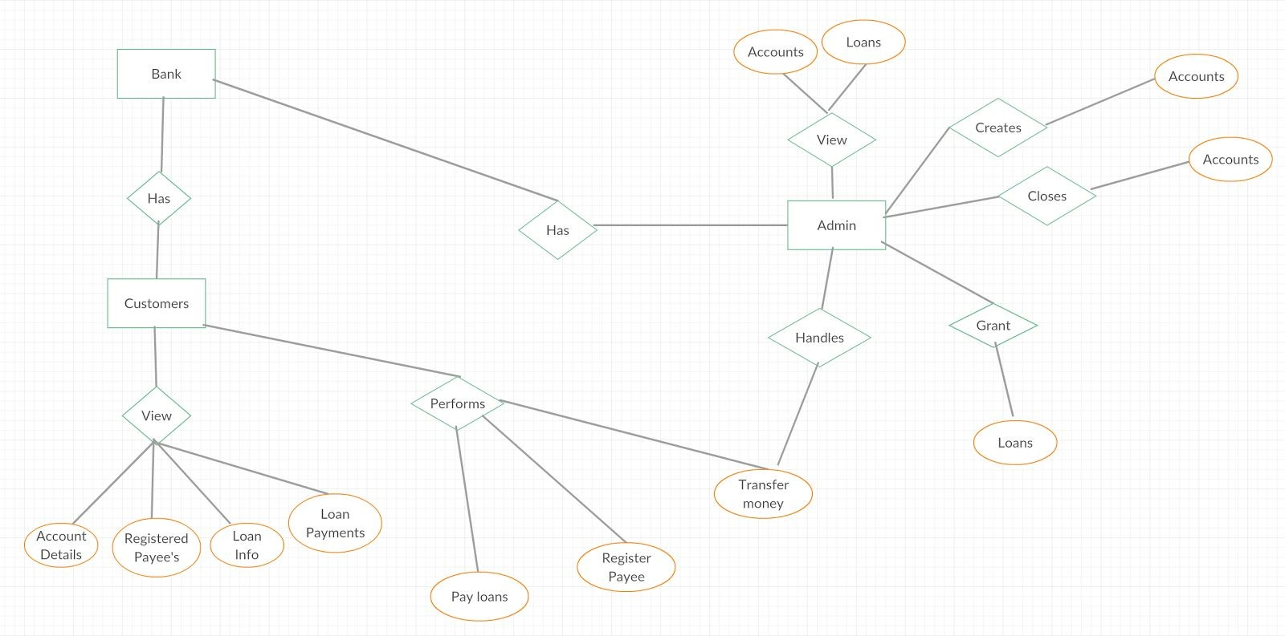

**Screenshots**

**Homepage**

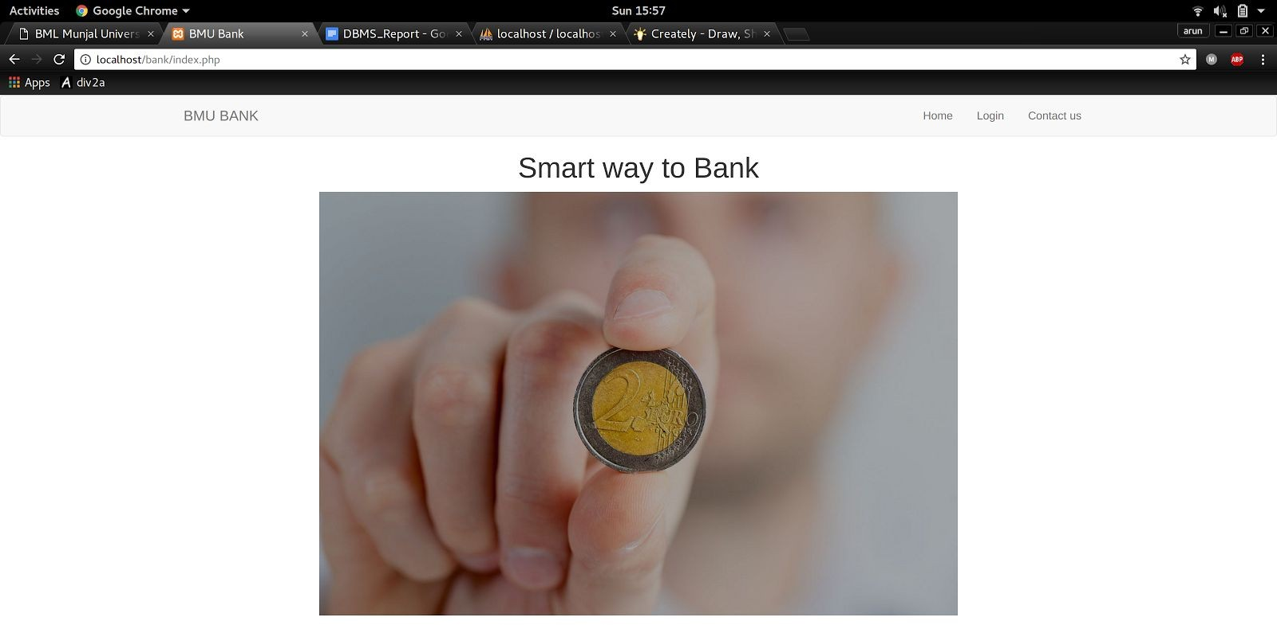

**Login Screen**

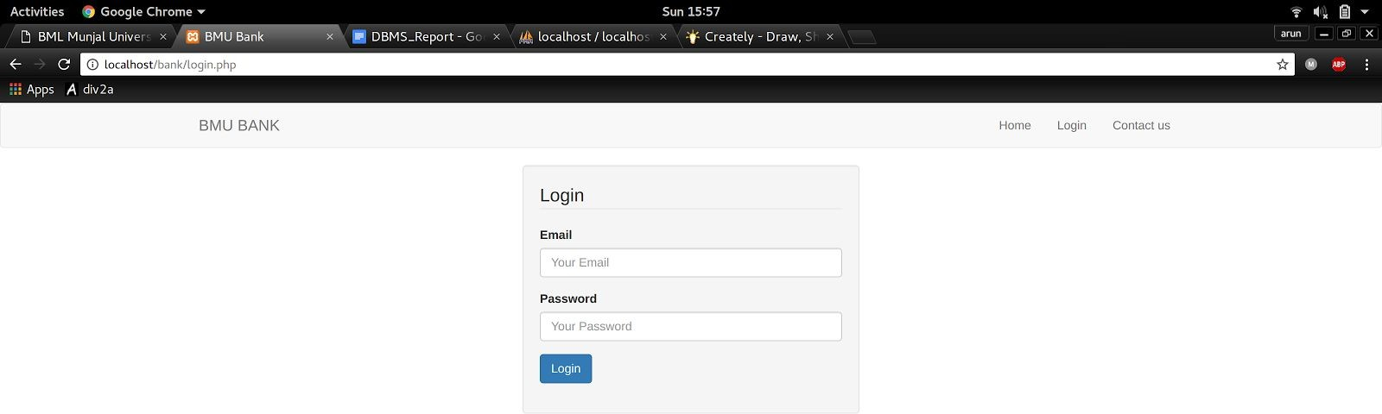

**Contact Us**

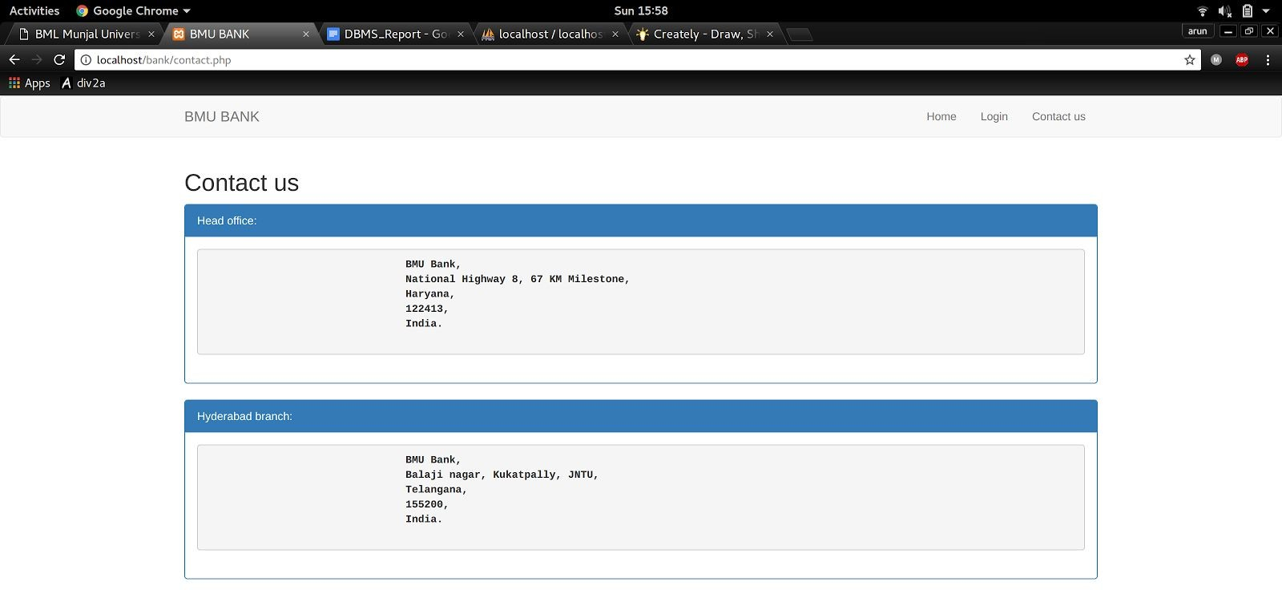

**Admin Panel**

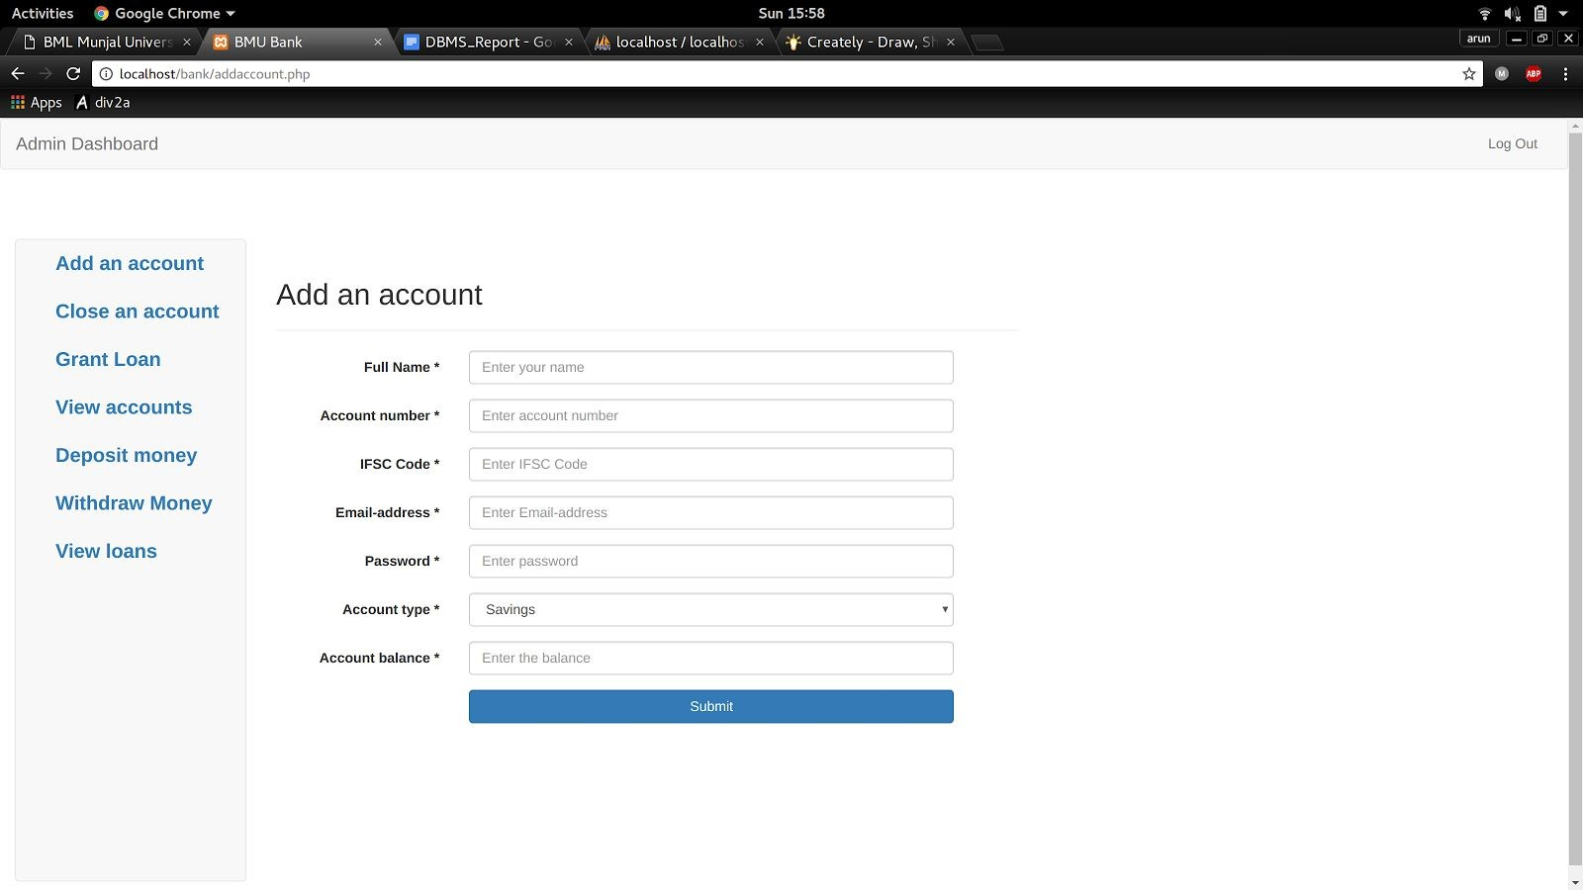

**Customer DashBoard**

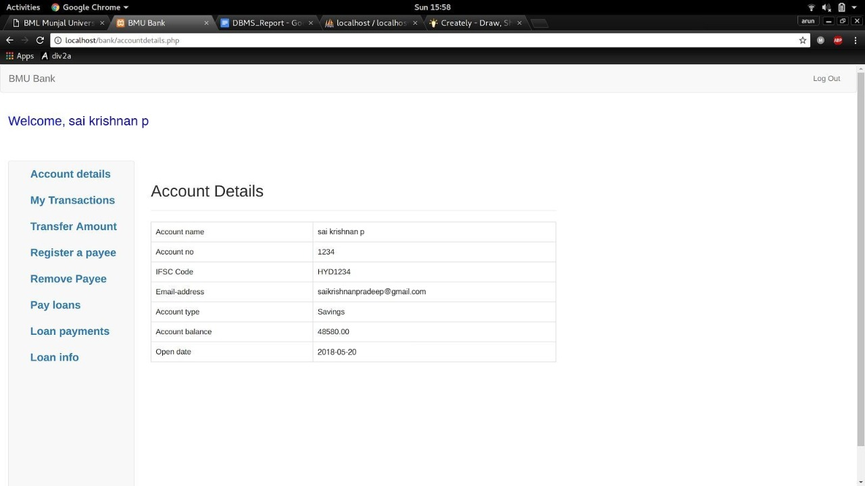

**Sample Codes Addaccount.php**

<?php session_start();

include 'includes/dbconnect.php';

$success = ""; if(isset($_POST['submit'])){

$accname = $_POST['accname'];

$accno = $_POST['accno'];

$accifsc = $_POST['accifsc'];

$accemail = $_POST['accemail'];

$accpassword = $_POST['accpassword'];

$acctype = $_POST['acctype'];

$accbalance = $_POST['accbalance'];

$accdate = date('y-m-d');

$ins_sql = "INSERT INTO accounts(accname, accno, accifsc, accemail, accpassword, acctype, accbalance, accdate) VALUES ('".$accname."', '".$accno."', '".$accifsc."', '".$accemail."', '".md5($accpassword)."', '".$acctype."', '".$accbalance."', '".$accdate."')";

$run_sql = mysqli_query($con,$ins_sql);

$in_sql = "INSERT INTO users(name, email, password) VALUES ('".$accname."', '".$accemail."', '".md5($accpassword)."')";

$ru_sql = mysqli_query($con,$in_sql);

$success = "Account added successfully!";

}

?>

<!DOCTYPE html>

<html>

<head>

<title>BMU Bank</title>

<link rel="stylesheet" href="css/custom.css">

<link rel="stylesheet" href="https://maxcdn.bootstrapcdn.com/bootstrap/3.3.7/css/bootstrap.min.css">

<script src="https://ajax.googleapis.com/ajax/libs/jquery/3.2.0/jquery.min.js"></script>

<script src="https://maxcdn.bootstrapcdn.com/bootstrap/3.3.7/js/bootstrap.min.js"></script>

</head>

<body>

<nav class="navbar navbar-default" role="navigation">

<div class="container-fluid">

<div class="navbar-header">

<button type="button" class="navbar-toggle" data-toggle="collapse" data-target="#navbar1">

<span class="sr-only">Toggle navigation</span>

<span class="icon-bar"></span>

<span class="icon-bar"></span>

<span class="icon-bar"></span>

</button>

<a class="navbar-brand" href="admin.php">Admin Dashboard</a>

</div>

<div class="collapse navbar-collapse" id="navbar1">

<ul class="nav navbar-nav navbar-right">

<?php if (isset($_SESSION['usr_id'])) { ?>

</nav>

</div>

</div>

</ul>

<li><a href="logout.php">Log Out</a></li>

<?php } else { ?>

<li><a href="login.php">Login</a></li>

<?php } ?>

<div style="width: 50px; height: 50px;"></div>

<div class="col-lg-2">

<ul class="navbar navbar-default nav" style="height: 650px;">

<li><a href="addaccount.php"><span style="margin-left: 25px; margin-top:20px; font-size: 20px;"><b>Add an account</b></span></a></li>

<li><a href="deleteaccount.php"><span style="margin-left: 25px; margin-top: 20px; font-size: 20px;"><b>Close an account</b></span></a></li>

<li><a href="grantloan.php"><span style="margin-left: 25px; margin-top: 20px; font-size: 20px;"><b>Grant Loan</b></span></a></li>

<li><a href="viewaccounts.php"><span style="margin-left: 25px; margin-top: 20px; font-size: 20px;"><b>View accounts</b></span></a></li>

<li><a href="depositmoney.php"><span style="margin-left: 25px; margin-top: 20px; font-size: 20px;"><b>Deposit money</b></span></a></li>

<li><a href="withdrawmoney.php"><span style="margin-left: 25px; margin-top: 20px; font-size: 20px;"><b>Withdraw Money</b></span></a></li>

<li><a href="viewloans.php"><span style="margin-left: 25px; margin-top: 20px; font-size: 20px;"><b>View loans</b></span></a></li>

</ul>

</div>

<div class="container">

<article class="row">

<section class="col-lg-8">

<div class="page-header">

<h2>Add an account</h2>

</div>

role="form">

Name *</label>

<form class="form-horizontal" action="addaccount.php" method="post"

<div class="form-group">

<label for="name" class="col-sm-3 control-label">Full

<div class="col-sm-8">

<input type="text" name="accname"

class="form-control" placeholder="Enter your name" id="accname" required>

</div>

</div>

<div class="form-group">

<label for="number" class="col-sm-3 control-label">Account number *</label>

<div class="col-sm-8">

<input type="text" name="accno" class="form-control" placeholder="Enter account number" id="accnumber" required>

</div>

Code *</label>

</div>

<div class="form-group">

<label for="number" class="col-sm-3 control-label">IFSC

<div class="col-sm-8">

<input type="text" name="accifsc"

class="form-control" placeholder="Enter IFSC Code" id="accifsc" required>

</div>

</div>

<div class="form-group">

<label for="number" class="col-sm-3 control-label">Email-address *</label>

<div class="col-sm-8">

<input type="email" name="accemail" class="form-control" placeholder="Enter Email-address" id="accemail" required>

</div>

</div>

<div class="form-group">

<label for="number" class="col-sm-3

control-label">Password *</label>

<div class="col-sm-8">

<input type="password"

name="accpassword" class="form-control" placeholder="Enter password" id="accpassword" required>

</div>

</div>

type *</label>

<div class="form-group">

<label for="name" class="col-sm-3 control-label">Account

name="acctype" id="acctype">

<div class="col-sm-8">

<select class="form-control"

<option>Savings</option>

<option>Current</option>

</div>

</div>

</select>

<div class="form-group">

<label for="number" class="col-sm-3 control-label">Account balance *</label>

<div class="col-sm-8">

<input type="text" name="accbalance" class="form-control" placeholder="Enter the balance" id="accbalance" required>

</div>

</div>

<div class="form-group">

<label class="col-sm-3 control-label"></label>

<div class="col-sm-8">

<input type="submit" id="submit" name="submit" value = "Submit" class="btn btn-block btn-primary">

</div>

</div>

<div class="form-group">

<label class="col-sm-3 control-label"></label>

<div class="col-sm-8">

<h4><?php echo $success ?></h4>

</div>

</div>

</article></form></section></article></div>

</body>

</html>

## Conclusion

This was a small yet creative attempt from my side to create a model of a system, vital nowadays in everyone’s life. Although this is not an efficiently coded program there is proper procedure that one expect in a banking system