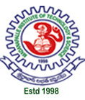
Madanapalle institute of
Technology & Science
(ugc-autonomous)
Madanapalle

PEDDI NENI.SAI KUMAR NAIDU
Email: sainani0911@gmail.com
Contact: +91-8309499354

CAREER OBJECTIVE
As a dynamic, team spirited and self-driven person seeking for a position which challenges my calibers to reach topnotch position, in order to achieve organizational goals.

EDUCATION

Degree/ Examination | Year of Passing | School/Institute | Board/University | Percentage/Grade
B. TECH  (ECE) | 2020 | Madanapalle Institute of Technology & Science  Madanapalle | JNTU Anantapur | 9.05
Intermediate | 2016 | Sri Chaitanya Junior Kalasala  Tirupathi, | Board of Intermediate Education,  Andhra Pradesh | 91.7
Class X | 2014 | R R High School  Tirupathi | Board of Secondary Education,  Andhra Pradesh | 9.2

PROJECT WORK / TRAINING

- Completed a 6- months Short-term Research Internship on “Characterization of TIO2 Nanoparticles on different wafers” at National Chiao Tung University, Taiwan.
- Completed a 4-week internship on “Synthesis and characterization of TIO2 Nanoparticles” at MEMS Laboratory, Tezpur Central University, Tezpur, Assam.
Online based attendance system using QR Code:

- In this project we generated QR codes for each student from their unique college register number using college LOGO as a watermark. We developed the entire project with Python foundation. Moto of this project is to overcome the paper waste i.e., achievement of Go Green Go Clean policy.
- Completed a 12-week online certification courses in “Computer Architecture” & “Introduction to Research” with excellence award from NPTEL, IIT Madras.

AREAS OF INTEREST

- JAVA Programming.
- Python Programming.
- Digital Design.

SOFTWARE SKILL SET

- Languages : C, C++, JAVA, Python, SQL.
- Operating System : WINDOWS, Linux
- Packages : Microsoft Word, Excel, Power point.
- Certifications : Certification from Smart India hackathon 2K18,2K19.

ACADEMIC ACHIEVEMENTS & CO-CURRICULAR Activities

- Campus Ambassador for Aparoksha fest, IIIT Allahabad through Internshala.
- Campus Ambassador for National sports fest “AAHVAAN’18” through Internshala.
- Campus Ambassador for NIT Delhi through Internshala.
- Received first prize in Paper and poster presentations on Photon 2k17, a one-day National symposium at “Madanapalle Institute of Technology and Science”.
- Participated in Paper presentation on Infinity 2k17, a one-day National symposium at “Aditya College of Engineering”, Madanapalle.

EXTRA CURRICULAR ACTIVITIES

- Served as a volunteer for NSS (National Service Scheme).
- Member in Entrepreneurship Development Cell [EDC].
- Coordinator of English literacy club.
- Chess player.

PERSONAL DETAILS

- Father Name : Mr. P. Ravindra Naidu
- Date of Birth : 9th July 1999
- Linguistic Proficiency : Telugu, English, Hindi.
- Address : 7/30, Katarupalli, Rajampet, YSR District, Andhra Pradesh.

DECLARATION

I hereby declare that the information furnished above is true to best of my knowledge.

Date:  13 Oct. 2020 | 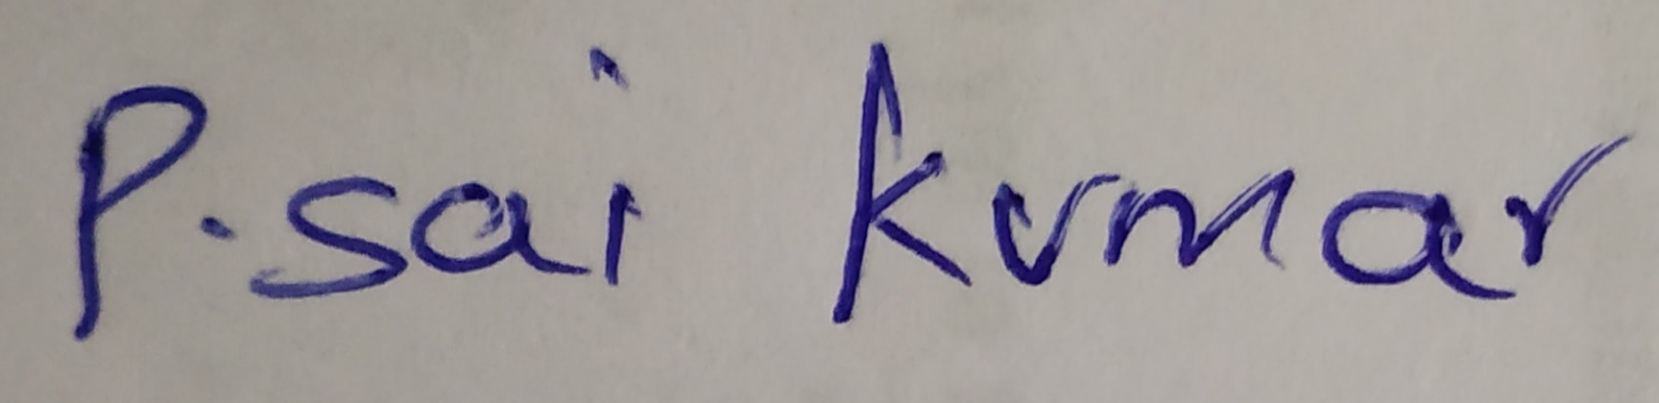  P. SAI KUMAR NAIDU

