**Sales Performance Analysis Dashboard using Power BI**

**Abstract:**

This document presents the development and deployment of a Sales Performance Analysis Dashboard using Power BI. The dashboard consolidates and visualizes critical sales data to provide insights into customer segments, product popularity, and customer satisfaction. Utilizing DAX calculations and Power BI's interactive capabilities, this project aims to support strategic decision-making by identifying high-value customers, popular products, and trends in sales performance. Additionally, this report outlines the data transformation steps, calculated metrics, and suggestions for future enhancements, such as geographical segmentation and churn prediction.

**1.Introduction:**

In today’s competitive business environment, data-driven insights are essential for informed decision-making. The Sales Performance Analysis Dashboard was created to address this need by delivering a comprehensive view of sales data. The dashboard serves as a central hub for monitoring key metrics, such as total sales, customer satisfaction, and product popularity, which are crucial for understanding business health and customer behaviour. By leveraging Power BI and DAX calculations, this project transforms raw data into meaningful visuals that empower stakeholders to make strategic sales and marketing decisions.

This document outlines the data model, transformation steps, calculated columns, and measures used in the dashboard. It also presents the visualizations created and interprets the insights they provide, making it a valuable tool for managing customer relationships and optimizing sales strategies.

**2.Objectives:**

* **Analysis Sales Trends**: Tracks total sales, quantity sold, and customer purchase behaviour over time.
* **Segments Customers**: Classifies customers into segments based on purchase amounts to identify high-value customers and tailor marketing efforts.
* **Monitors Customer Satisfaction**: Analysis customer ratings to assess satisfaction levels and identify areas for improvement.
* **Identifies Popular Products**: Highlights top-selling products to optimize inventory management and marketing strategies.
* **Supports Strategic Decision-Making**: Provides actionable insights that help sales and management teams make data-informed decisions.

**3.Data Model Overview:**

* The data model integrates information from three main tables:

**1.Orders:** Includes order details such as customer_id, Customer_Name, OrderDate and Order Number.

**2. Main:** Contains comprehensive customer and sales data, including customer_id, Customer Name, product_id, customer rating, discount percentage, actual price, discounted price, ship mode, rating count, customer rating.

**3. Product:** Stores product-related attributes such as category, productid, and ProductName.

**Relationships**

* The tables are linked as follows:

-Orders_table is connected to Main_table via customer_id.

-Product_table is connected to Main_table via product_id.

**4. Data Transformation Process:**

To ensure data consistency and readiness for analysis, the following transformations were applied in Power Query:

- **Removed Unnecessary Columns**: Cleaned the dataset by dropping irrelevant columns.

- **Merged Queries**: Combined data from multiple sources to create a unified dataset.

- **Text and Row Trimming**: Removed excess whitespace and filtered rows to standardize the data.

- **Duplicate Removal**: Ensured data uniqueness by eliminating duplicate entries.

- **Data Type Changes**: Applied type transformations to match analysis requirements.

**5. Calculated Columns (DAX Formulas):**

Several calculated columns were created using DAX to enhance data insight:

**i. Total Price:**

Total Price = Main[actual_price] - Main[discounted_price]

🡪 Calculates the effective price after discounts.

**ii. Total Sales:**

Total Sales = Main[Quantity] * Main[TotalPrice]

🡪 Computes the total revenue per transaction.

**iii. AvgRating:**

AvgRating = DIVIDE([customer rating], [rating_count])

🡪 Calculates the average customer rating.

**iv.CustomerSatisfactionScore**:

CustomerSatisfactionScore = Main[customer rating] * LOG([rating_count] + 1)

🡪Determines customer satisfaction, factoring in logarithmic rating adjustments.

**v. CustomerSegment:**

CustomerSegment =

SWITCH(TRUE(),

[TotalSales] >= 10000, "Platinum",

[TotalSales] >= 3000, "Gold",

"Silver")

🡪 Categorizes customers into Platinum, Gold and Silver segments based on total sales.

**vi.Customer Rank:**

Customer Rank = RANKX(ALL(Main), [Total Sales])

🡪 Ranks customers according to their total sales performance.

**6.Measures for Aggregation:**

The following DAX measures provide key insights into overall performance:

**i.OrderCount :**

OrderCount = COUNT(Main[Order Number])

🡪 Counts the total number of orders.

**ii.TotalQuantitySold:**

TotalQuantitySold = SUM('Main'[Quantity])

🡪 Sums the quantity of all products sold.

**iii.TotalSales:**

TotalSales = SUM('Main'[Total Sales])

🡪 Aggregates total sales revenue.

**7. Visualizations and Insights:**

The dashboard includes a series of visual elements to present the data insights effectively:

🡪Total Quantity Sold: Displays the aggregate number of units sold.

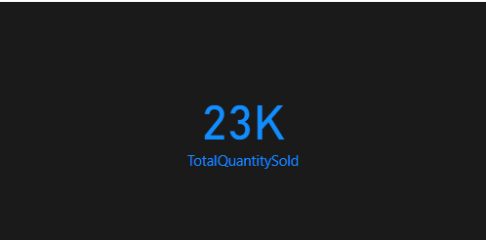

🡪 Customer Count: Shows the total number of unique customers.

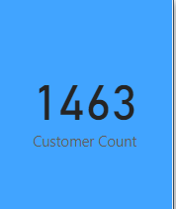

🡪Revenue Per Customer Table: Lists customer names by revenue contribution.

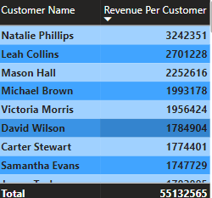

🡪Top 10 Customer: Lists the Top ten customers based on total sales.

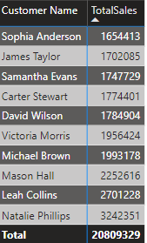

**8. Future Enhancements:**

Potential additions to further enhance the dashboard's value include:

🡪Geographical Segmentation: Incorporating customer location data to analyse regional sales trends.

🡪Product Recommendations: Use data mining techniques to provide product recommendations based on customer purchase history and behaviour.

**9.Conclusion:**

The Sales Performance Dashboard provides actionable insights into sales, customer satisfaction, and product popularity. The calculated metrics and DAX-powered measures enable dynamic data exploration, supporting data-driven strategies for sales and customer management.