***Title***: **MediChat: A Conversational Health Companion**

***Abstract:*** MediChat is an innovative medical chatbot designed to provide personalized, accessible, and accurate healthcare information and support to users. Leveraging advanced **Natural Language Processing** and **Database Integration**, MediChat aims to bridge the gap between patients and healthcare services, offering reliable advice and guidance for various medical queries and concerns.

***Software Requirements:*** The project primarily utilized Python Programming Language and framework FastAPI for Functionality and Database Connectivity. The chatbot was built using conversational AI platform Google Dialogflow for its conversational capabilities. Additionally, a database management system MySQL has been employed to store and manage data securely. Backend running tools like uvicorn (code execution on local host) and ngrok (conversion of local host to https).

***Hardware Requirements:*** The hardware setup for the project included a standard computer with sufficient processing power to handle natural language processing tasks.

***Plan of Action:***

**1.Research and Requirement Analysis**:

Conducted an in-depth analysis of my target audience's common medical queries and concerns. Determined the scope and limitations of my capabilities to provide accurate and reliable medical information.

**2.Design Conversational Flow:**

Defined an intuitive and user-friendly conversational flow that allows users to navigate easily through various medical inquiries. Created a comprehensive dialogue map outlining potential user scenarios and appropriate responses. Established a hierarchy of responses based on the severity and urgency of different medical concerns.

**3.Natural Language Understanding (NLU) Implementation:**

Selected a suitable NLU framework called FastAPI and developed a robust natural language understanding model with suitable intent hierarchy and entity recognition plan.

**4.Integration with Conversational AI Platform:**

Integrated the NLU model with a conversational AI platform, Dialogflow to enable smooth and coherent interactions with users. Implement features like context handling and intent recognition to ensure a seamless conversation flow that caters to the evolving needs of users.

**5.Secure Database Implementation**:

a. Chose a secure and scalable DBMS MySQL to store and retrieve data as required. Design an efficient database schema to relate to different symptoms to their diagnosis and conditions.

**6.Rigorous Testing and Performance Evaluation:**

Conduct extensive testing to assess my responsiveness and accuracy in addressing various medical queries and concerns.

**7.User Interface (UI) and User Experience (UX) Enhancement:**

a. Designed an intuitive and user-friendly interface using HTML and CSS that facilitates seamless and engaging interactions with users.

**Application Logic and Analysis for the MediChat Project: (Minimum Viable Product)**

***Symptom Checker Functionality***:

***INTENT:*** Symptom Description

*Example:* User inputs "I have a headache and my throat hurts."

*Entities Extracted:* Symptoms (headache, throat pain)

*Medichat :* Based on the symptom, I think you have Common Cold(recognised the symptom and identified the condition.)

***INTENT***: Condition Info

*User :*  Can you tell me something about it?

Entities Extracted: Condition (common cold)

*Medichat:* Here is what I know: The common cold is a viral infection of the upper respiratory tract. It is typically characterized by symptoms like runny nose, sneezing, coughing, mild headache and sore throat. Most colds are mild and resolve on their own within a week.

***INTENT***: Medical Advice

*User*: general medical advice.

*Medichat:* Get plenty of rest, stay hydrated, and consider over-the-counter cold remedies.

***INTENT***: Medications

*User*: Suggest some medications

*MediChat:* Medication you could try: Acetaminophen

***INTENT***: Self Care

*User:* Get me some self-care tips

*MediChat:* Get plenty of rest and stay hydrated. Over-the-counter cold medications may help alleviate symptoms.

***Mood Checker Functionality:***

***INTENT***: Mood Description

*User:* I am feeling sad and hopeless for a long time

*MediChat:* Based on the mood description I think you are feeling Depressed.

***INTENT***: Coping Strategy

*User:* provide me some coping strategies

*MediChat:* Reach out for support from friends and family. Consider therapy or counseling. Establish a daily routine.

***INTENT***: Support Resources

*User*: mental health support resources.

*MediChat:*  NAMI Helpline , National Alliance on Mental Illness helpline for information, referrals, and support., Call 1-800-950-NAMI (1-800-950-6264)

***Data Insertion Functionality:***

***INTENT***: data_insert

*User:* add patient data

*MediChat:* I understand that you need to add a patient record. Kindly specify your symptoms, duration and severity of your condition.

***INTENT:*** add_data

*User:* I have been having a mild back-pain for a while now

*Entities Recognised : Duration (Long- Time)*

*Severity (Mild, Moderate)*

*Symptoms ( Back Pain)*

*MediChat:* Patient Record inserted Successfully. Patient Id is #4

**Architecture and Block Diagram of the Project:**

***Basic Architecture and DataFlow***

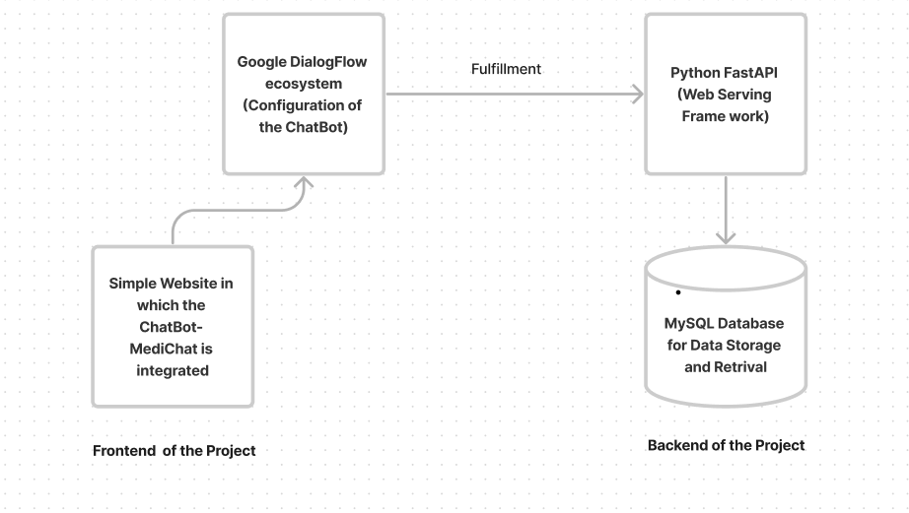

***Block Diagram:***

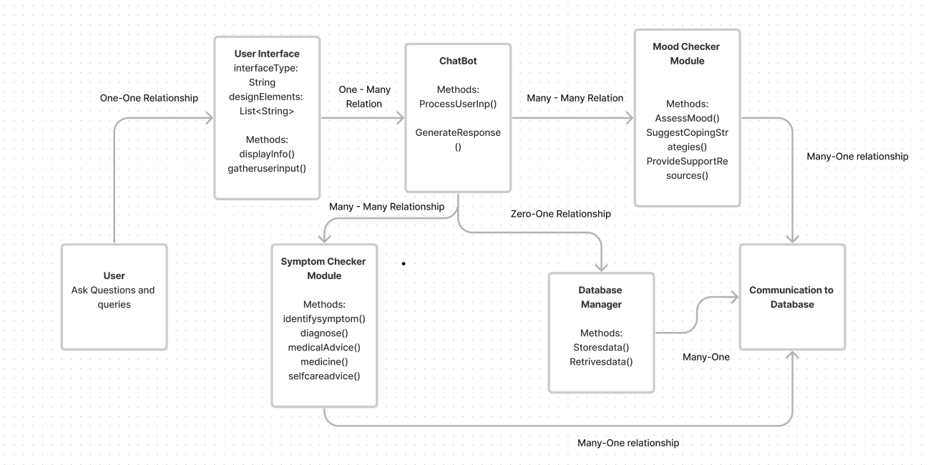

**Future Enhancements (To be included in Major Project Work): (Total Scope of Work)**

1.Personalized Health Recommendations:

*Brief Description*: Enhance user engagement by providing personalized health recommendations based on historical health data, current weather conditions, and the duration and severity of illnesses.

*How to Do It*: Implement an advanced recommendation system that considers user health history, real-time weather information, and illness characteristics to offer tailored health advice.

2.Appointment Scheduling in the Hospital:

*Brief Description*: Streamline the user experience by allowing users to schedule medical appointments directly through the chatbot, improving accessibility and convenience.

How to Do It: Integrate a scheduling module within the chatbot that connects to the hospital's appointment system, allowing users to book appointments seamlessly.

3.Medication Reminders:

*Brief Description*: Improve medication adherence by incorporating a reminder system within the chatbot, notifying users about their prescribed medications and dosages.

*How to Do It*: Develop a medication reminder feature that utilizes push notifications or in-chat reminders to alert users about their medication schedule.

4.Feedback Database:

*Brief Description*: Gather valuable user feedback to enhance the chatbot's performance and user satisfaction, allowing continuous improvement based on user input.

*How to Do It*: Create a feedback collection mechanism within the chatbot, storing user feedback in a database for analysis, and use the insights to iteratively enhance the system.

5.Stored Procedure for Admin:

*Brief Description*: Streamline administrative tasks by implementing stored procedures, enabling efficient data management, system maintenance, and user support.

*How to Do It*: Develop stored procedures for administrative tasks, such as managing user accounts, analyzing system usage, and ensuring database integrity, simplifying overall system maintenance.

**Screen Shots of Output:**

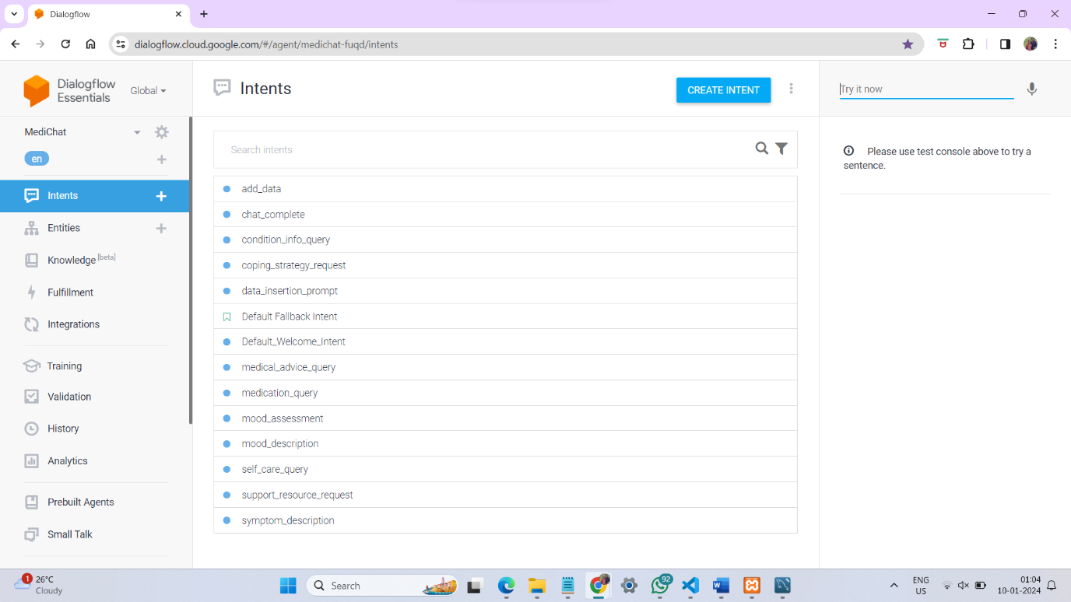

The intents used for training.

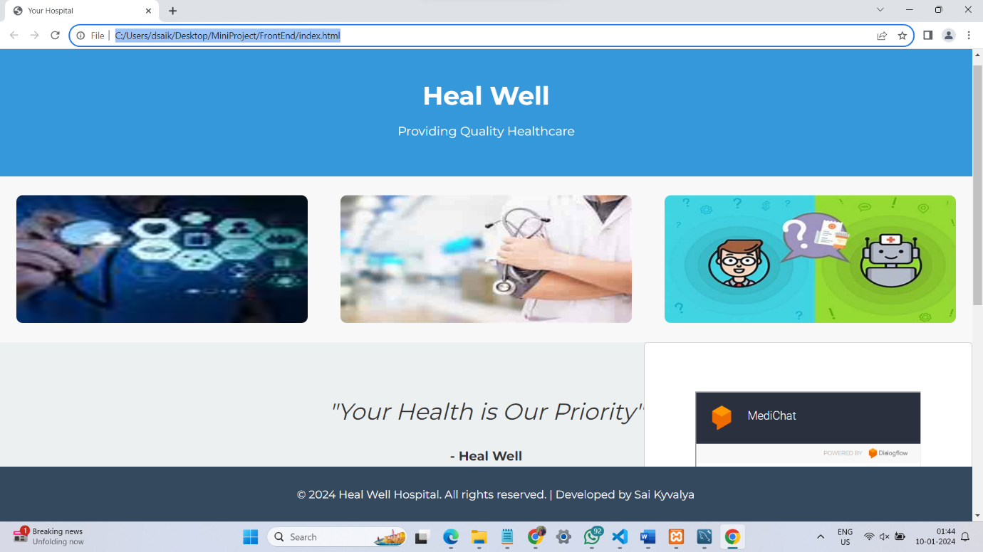

Website Integration

New Context: Intent: Welcome Intent: Symptom Description

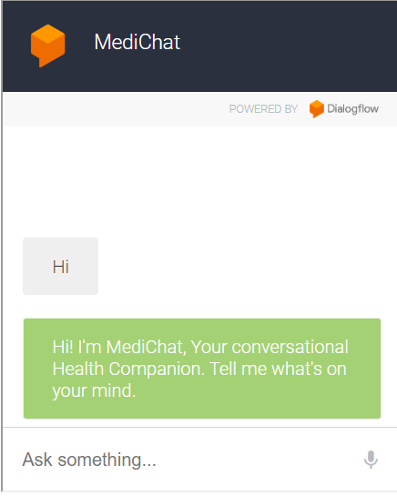 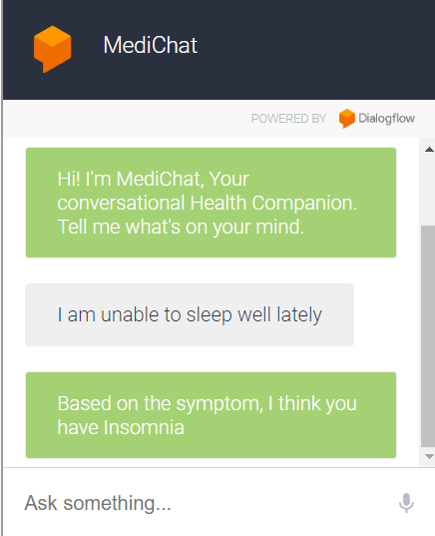

Intent: Condition Information Intent: Medical Advice

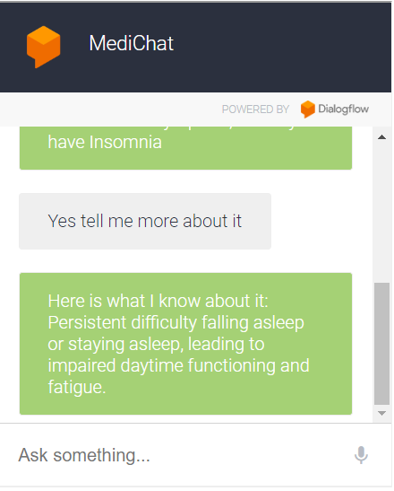 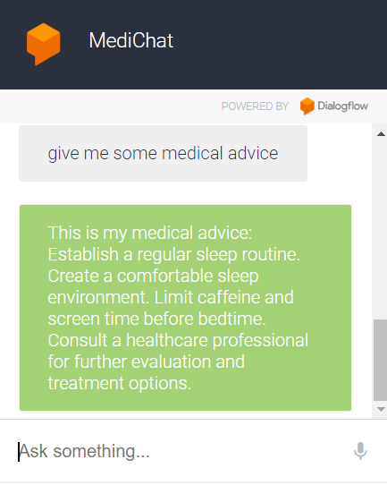

Intent: Medications Intent : Self Care Tips

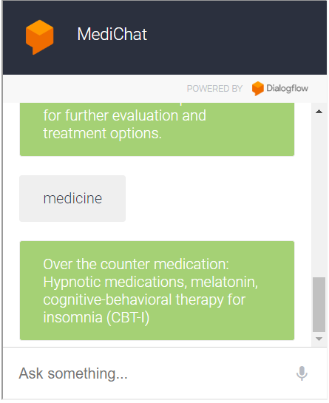 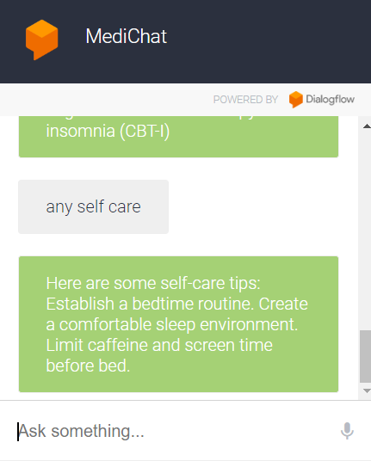

Intent: Chat Complete. New Context: Intent Mood description

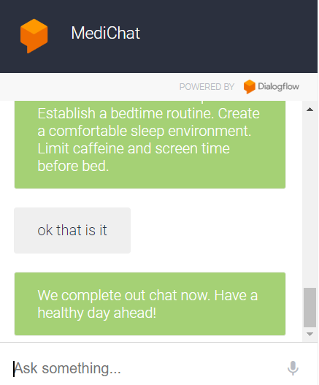 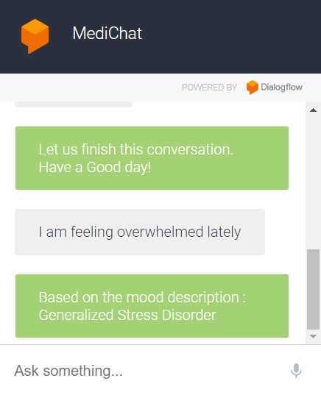

Intent: Coping Strategies Intent: Support Resources

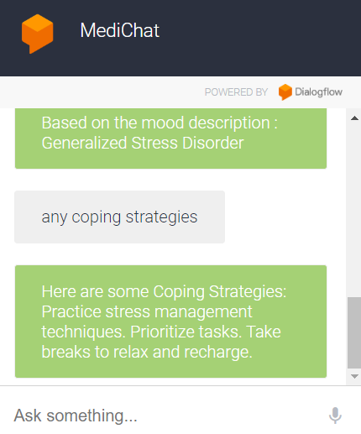 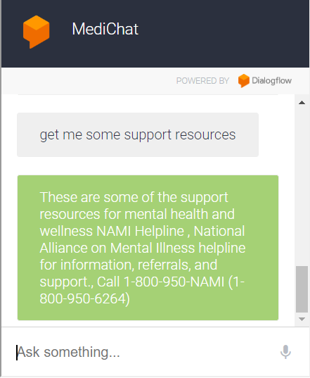

New Context: Data Insertion into DataBase

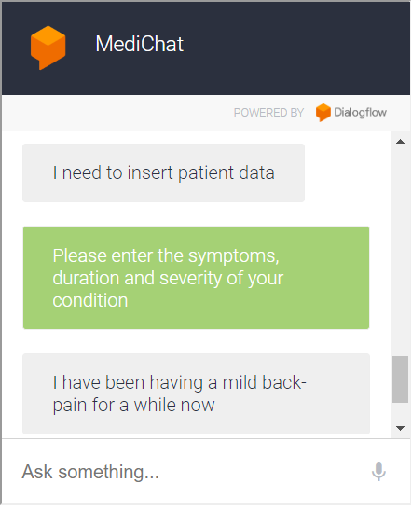 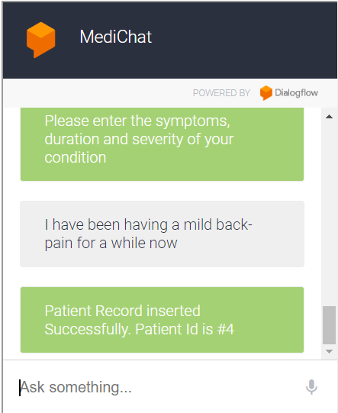

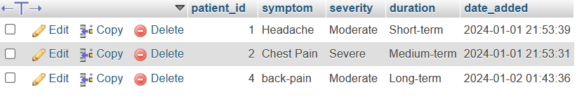Database Screen Shot