**HADOOP COMMANDS**

1. List the contents of the root directory.

**hadoop fs -ls**

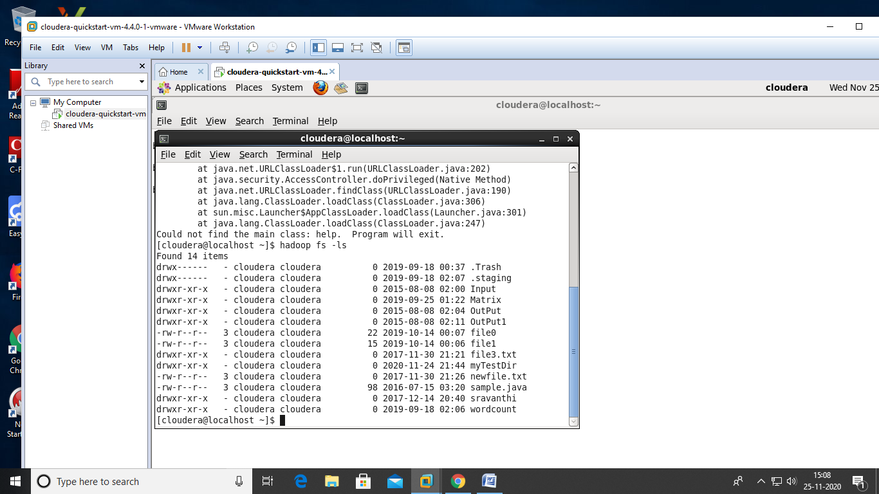

1. To list the contents of the /user/biadmin directory, execute:

**hadoop fs -ls**



1. To create the directory ***myTestDir*** you can issue the following command:

**hadoopfs –mkdir myTestDir**

directory is created.

1. Issue the ls command again to see the subdirectory myTestDir:

**hadoopfs -ls**

or

**hadoop fs -ls /user/biadmin**

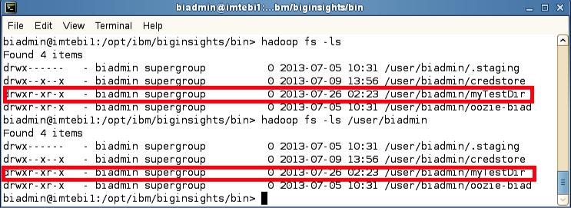

1. For example, to do a recursive listing we’ll use the –lsr command rather than just –ls, like the examples below:

**hadoop fs -ls /user**

**(OR)**

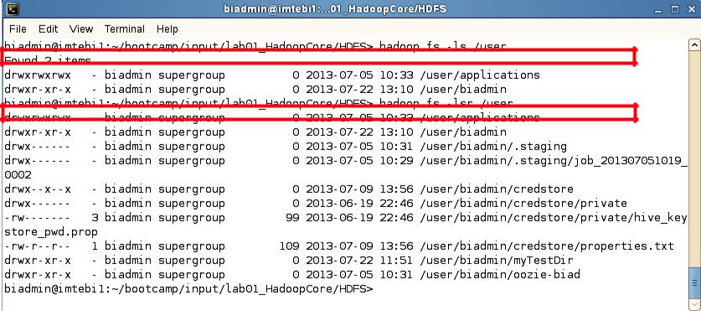**hadoop fs -lsr /user**

1. You can pipe (using the | character) any HDFS command to be used with the Linux shell. For example, you can easily use *grep* with HDFS by doing the following:

**hadoop fs -mkdir myTestDir2**

**hadoop fs -ls | grep Test**

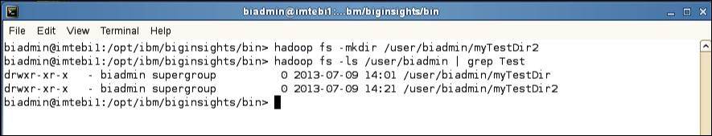

1. To move files between your regular Linux filesystem and HDFS you can use the put and get commands. For example, move the text file README to the hadoopfilesystem.

**hadoopfs -put /home/biadmin/bootcamp/input/lab01_HadoopCore/HDFS/README README**

**(OR)**

**hadoopfs -ls /user/biadmin**

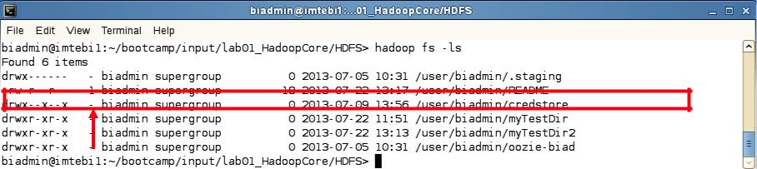

1. In order to view the contents of this file use the –cat command as follows:

**hadoopfs -cat durga**

You should see the output of the README file (that is stored in HDFS). We can also use the linux diff command to see if the file we put on HDFS is actually the same as the original on the local filesystem.

1. Execute the commands below to use the diff command:

**cd /home/biadmin/bootcamp/input/lab01_HadoopCore/HDFS/**

**diff<( hadoopfs -cat README ) README**

Since the diff command produces no output we know that the files are the same (the diff command prints all the lines in the files that differ).

To find the size of files you need to use the –du or –dus commands. Keep in mind that these commands return the file size in bytes.

1. To find the size of the README file use the following command:

**hadoopfs -du README**

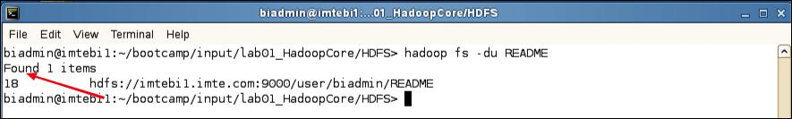

11. To find the size of all files individually in the /user/biadmin directory use the following command:



**hadoopfs -du /user/biadmin**

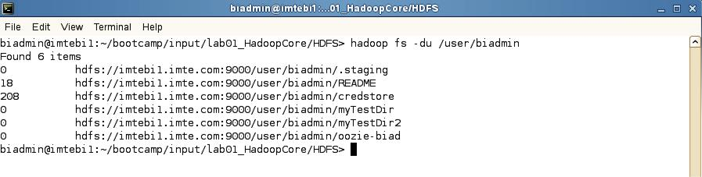

12. To find the size of all files in total of the /user/biadmin directory use the following command:



**hadoopfs -dus /user/biadmin**

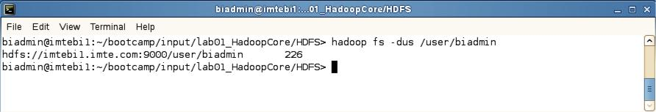

13. If you would like to get more information about hadoopfs commands, invoke –help as follows:



**hadoopfs -help**

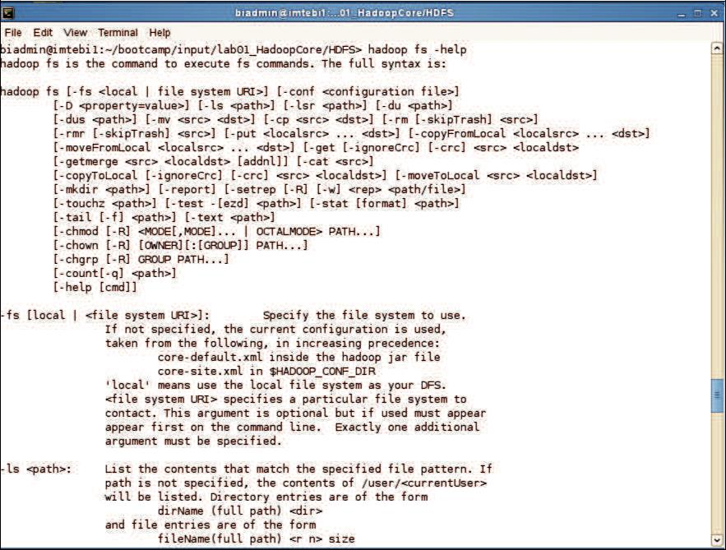

1. For specific help on a command, add the command name after help. For example, to get help on the dus command you’d do the following:



**hadoopfs -help dus**

