FK-PK CASCADE,NO ACTION

**USF_ID:U72254994(Venkata Satya Sai Lakshmi Lavanya)**

**Subject_ID:ISM6218(Advanced Database Management System)**

**Questions**

1. Match the rows of your PK (Primary Key) table with the FK (Foreign Key) table and demonstrate the effect of setting Delete and Update specification associated with the Foreign Key Relationships to Cascade and No Action.

**Primary Key Table Being Used For demonstrating the affect of NO ACTION,CASCADE, SET NULL AND DEFAULT**

1. Patient (Table with my Primary key)

Rows

1.Patient_No(Primary Key that is used as reference for the Foreign Key in Treatement_Administration )

2.FirstName

3.LastName

4.Gender

5.DOB

6.Age

7.Street

8.City

9.Zip

10.Bed_No

11.phone_no

**Foreign Key Table Being Used For demonstrating the affect of NO ACTION,CASCADE, SET NULL AND DEFAULT**

1. Treatement_Administration

Rows

1.Patient_No (Composite Primary key) (FK_Treatement_Administration_Patient= Foreign key that refers to Primary key in Patient table)

2.Doctor_Id (Composite Primary key) (FK_Treatement_Administration_Physician = Foreign key that refers to Primary key in Physician table)

3.Treatment_No (Composite Primary key) (FK_Treatement_Administration_Treatment = Foreign key that refers to Primary key in Treatment table)

4.Date (Composite Primary key)

5.Time

6.Results

**Data Collection (Finding out the values of Patient_No in Patient table that do not exist in Patient_No column of Treatement_administration table)**

Query 4: select Patient_No from Patient except select Patient_No from Treatement_Administration;

Output: 51

64

69

70

71

76

94

95

96

97

**NO ACTION CASE**

**CASCADE CASE**

**

Output Before Executing Delete Statement Output After Executing Delete Statement



**Conclusion:** From the above-mentioned screenshots we can see that the Patient_No 8 No more exists in the table

that has a foreign key that refers to the Primary key (Patient_No) in Patient table

**SET NULL CASE**



Output Before Executing Delete Statement Output After Executing Delete Statement



**Conclusion:**  From the above-mentioned screenshots we can see that in case the value in the foreign key column

is 1 then the value in these foreign key columns is set to NULL since the Patient_No 1 has been deleted from the

table that consists of my primary key.

**DEFAULT CASE (BY SETTING DEFAULT VALUE=90 IN PATIENT_NO(FK) OF TREATEMENT_ADMINISTRATION TABLE**

Delete Rule Specification set to Default Output of my Delete Statement

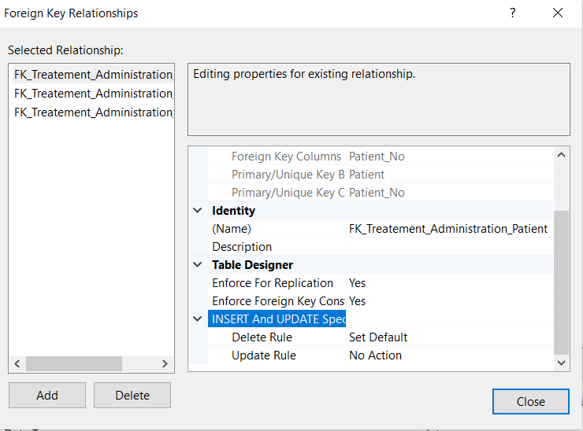 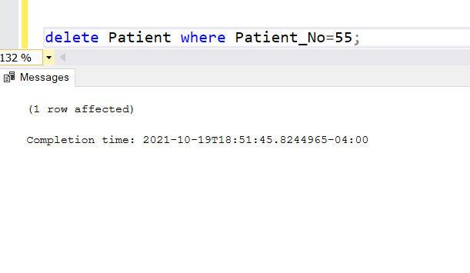

Output Before Executing Delete Statement Output After Executing Delete Statement

**



**Conclusion:**  From the above-mentioned screenshots we can see that in case the value in the foreign key column

is 55 then the value in these foreign key columns is set to Default value i..e, 90 in the above case

since the Patient_No 55 has been deleted from the table that consists of my primary key.

**NOTE:** As per functionality, the Delete Rule of the relationship associated with the foreign key column can be set to NULL if

and only if my foreign key column accepts NULL value. Therefore, in this document the Composite Primary key

(Patient_No,Doctor_Id,Treatment_No,Date) has been removed from Treatement_Administration table in order to

facilitate the demonstration of delete Rule “NULL” i.e., In case my FK Patient_No in Treatement Administration is part

of Composite Primary Key then it does not allow NULL values hence delete rule cannot be set to NULL here.